_________________________________________________________________
EFFECT OF AGE ON NONDESTRUCTIVE TESTS RESULTS FOR EXISTING CONCRETE
Eng. Mushtaq S. Radhi* | Asst. Prof. Dr. Hasan H.Joni* | Prof. Dr. Shakir A. Al-Mishhadani *
_________________________________________________________________
Abstract
The aim of this study is to investigate the influence of the concrete age on the measurement of the nondestructive tests. This study involves two types of the Investigational work; first type deals with field investigation on existing concrete, which the effect of concrete age on measurements of two types of nondestructive, rebound hammer and ultrasonic pulse velocity tests, was investigated in concrete structure of a multistory buildings under construction. Repetitive nondestructive measurements were taken from the same location in different ages, the age of concrete under test at ranging 90 to 365 days. Measurements results of the nondestructive testes exhibit slight growing with age, the average increase rate in the rebound number is 14.75% and the average increase rate in the ultrasonic pulse velocity is 2.4%. Second type was the laboratory investigation for effect of concrete age on the nondestructive tests , where numbers of specimens from concrete mixes with 28 days strength ranging from 25-55 MPa were prepared and tested with nondestructive , rebound hammer and ultrasonic pulse velocity tests, were investigated for all mixes at 7, 28, 60, 90, 120 , and 180 days . Results demonstrate that in general, nondestructive exhibit continuous increase with increasing in curing age and the mainly of was there increasing in the early ages, the increase percentage for rebound number and ultrasonic pulse velocity at age of 180 days are ranged between (15-19) % and (6.4-10.9) %, respectively as compared with that of 28 days age.
Keywords: concrete age; nondestructive tests; rebound hammer; ultrasonic pulse velocity.

تأثير العمرعلى نتائج الفحوصات اللاإتلافية لخرسانة مُنفّذة
أ. د. شاكر أحمد صالح المشهداني | أ.م. د حســــن حمــــودي جونــي | المهـندس مشــتاق صـادق راضـي
الخلاصة
الهدف من هذا البحث هو دراسة تاثير عمر الخرسانة على نتائج الفحوصات اللاإتلافية حيث تم استخدام اكثر الفحوصات اللاإتلافية شيوعا في العراق والعالم وهما فحص مطرقة الارتداد السطحي وفحص الموجات الفوق الصوتية. هذا البحث يتكون من جزئين ,الجزء الاول يتضمن دراسة تاثير العمرعلى خرسانة موقعية حيث تم اجراء الفحوصات اللاإتلافية على بنايات قيد الإنشاء وتكرار الفحوصات عليها في اعمار مختلفة ( اعمار الخرسانة عند الفحوصات تراوحت بين 90-365 يوم ). اظهرت النتائج ان قياسات الفحوصات اللاإتلافية قد ازدادت بصورة طفيفة , حيث كان معدل النسبة المئوية للزيادة في قياسات مطرقة الارتداد السطحي للخرسانة هو 14,75 % ومعدل النسبة المئوية للزيادة في قياسات الموجات الفوق الصوتية هو 2,4 %.اما الجزء الثاني من البحث فيتضمن دراسة مختبرية لتاثير عمر الخرسانة على نتائج الفحوصات اللااتلافية حيث تم اعداد نماذج خرسانية بمقاومة مستهدفة تتراوح بين 25-55 ميكاباسكال بعمر 28 يوم , وتم اجراء الفحوصات اللااتلافية لها باعمار معالجة 7, 28, 60, 90, 120 و 180 يوم . بينت النتائج ان الفحوصات اللااتلافية ( مطرقة الارتداد وفحص الموجات فوق الصوتية) اظهرت زيادة بصورة عامة بازدياد العمر للخرسانة الا ان النسبة الاكبر في هذه الزيادة كانت في الاعمار المبكرة , حيث النسبة المئوية للزيادة في القياسات عند عمر 180 يوم لمطرقة الارتداد السطحي والموجات الفوق الصوتية تراوحت بين (15-19)%,(6,4-10,9)% على التــوالــي مقارنة مع تلك في عمر 28 يوم.
1. Introduction
Concrete is the most commonly used construction materials in structures. Determination of strength has become the most important concern of the researchers since it has been used as a construction material. The compressive strength is usually considered as the main property to judge the quality of concrete. The strength of concrete is traditionally characterized by 28 days value. However, strength of concrete is expected to increase with time at continuously diminishing rate. Knowledge of the strength-time relationship is of importance when a structure is subjected to certain type of loading at a later age. Many factors can significantly influence the compressive strength of the concrete. These include cement type, water-cement ratio, aggregate content, water curing period, and exposure condition (Neville, 2005). Nondestructive test (NDT) methods are used to determine hardened concrete properties and to evaluate the condition of concrete in buildings and other concrete construction. Nondestructive testing is defined as testing that causes no structurally significant damage to concrete. Nondestructive test methods are applied to concrete construction for four primary reasons (ACI 228, 2004):
- Quality control of new construction.
- Troubleshooting of problems with new construction.
- Condition evaluation of older concrete for rehabilitation purposes.
- Quality assurance of concrete repairs
It is important to realize the relationship between the 28-day strength and other test ages. Seven-day strengths are often estimated to be about 75% of the 28-day strength and 56-day and 90-day strengths are about 10% to 15% greater than 28-day .Increase in strength with age continues only if un-hydrated cement is still present, the concrete remains moist or has a relative humidity above approximately 80%, the concrete temperature remains favorable, and sufficient space is available for hydration products to form (Kosmatka et al., 2003) and (Kosmatka, 2008).
To maintain this increase in strength, concrete must be properly cured. Curing means that not only must a favorable temperature be present but also moisture loss will not be permitted or extra water will be provided at the surface. In the presence of moisture, concrete will continue to gain strength for many years, although, of course, the rate of increase after such times will be very small. The fact that the strength of concrete increases with the progress of hydration of cement, coupled with the fact that the rate of hydration of cement increases with an increases in temperature, leads to the proposition that strength can be expressed as a function of the time-temperature combination .The water-cement ratio also affects the rate of gain of strength of concrete. Mixes with a low water-cement ratio gain strength more rapidly than the mixes with higher water-cement .This is because in the former case the cement grains are closer to one another and a continuous system of gel is established more rapidly (Neville, 2005).
Traditionally, quality assurance of concrete construction has been performed largely by visual inspection of the construction process and by sampling the concrete for performing standard tests on fresh and hardened specimens. This approach does not provide data on the in-place properties of concrete. Nondestructive test methods offer the advantage of providing information on the in-place properties of hardened concrete, such as the elastic constants, density, resistivity, moisture content, and penetrability characteristics in addition to the strength. Also the destructive methods are expensive and time consuming. Thus researches have nondestructive test methods to find in situ compressive strength of concrete. The nondestructive test methods are faster and more economical, alternative to the destructive test methods. Nevertheless these advantages are of no value if the results are not reliable, representative and as close as possible to the actual strength the tested part of the structure. The nondestructive test methods have some limitations. To reduce these limitations of the nondestructive test methods test result has to be correlated with results of destructive test methods (Malhotra, 2006).Really the correlation provided by the nondestructive test equipment manufacturers and recommends users strength calibration curves. But the curves have been made up using 28 days or 120 days concrete specimens. However an existing construction may be decades when investigating in situ concrete quality in construction. As well as, the concrete in the existing building have different curing conditions from the standard concrete specimens (Aydin and Saribiyik, 2006).
Locally, the in-situ nondestructive tests like ultrasonic pulse velocity, and rebound hardness hammer are widespread in the assessing the concrete in the existing buildings, particularly in the troubleshooting of problems with new construction, If the strength of standard compression test specimens found to be below the specified 28 days value, frequently, these nondestructive tests are undertaken at later ages exceeding the age of 28 days.
This study includes an attempt to find the influence of the long term concrete age on the existing buildings and laboratory concrete development by using the well-known locally in-situ nondestructive test methods (Schmidt Hammer Test and Ultrasonic Pulse Velocity). These two nondestructive tests methods have also been preferred as combined methods to compare the destructive test outcomes.
2. Schmidt Hammer Test Method
Among the available nondestructive methods, the Schmidt Hammer test is the most commonly used one in practice. It has been used world-wide as an index test for a testing equipment to estimate strength of concrete due to its rapidity and easiness in execution, simplicity, portability, low cost and non-destructiveness. This method consists of the indentation type and those based on the rebound principle (Malhotra, 2004). The rebound hammer test is described in ASTM C805 (ASTM C805, 2006) and BS 1881: Part 202 (BS1881 Part 202, 1991). The test is based on the principle that the rebound of an elastic mass depends on the hardness of the surface against which the mass impinges. The energy absorbed by the concrete is related to its strength However, this relationship is dependent upon the concrete surface effecting factors, such as degree of saturation, carbonation, temperature, surface preparation, and type of surface finish. The result is also affected by type of aggregate, mix proportions, hammer type and inclination. (Shetty, 2009). The results obtained are only representative of the outer concrete layer with a thickness of 30±50 mm. Due to the difficulty of acquiring the appropriate correlation data in a given instant, Schmidt hammer test is most useful for rapidly surveying large areas of similar types of concrete in the construction being considered (Grantham, 2003).
3. Ultrasonic Pulse Velocity Method
The ultrasonic pulse velocity method is an extremely versatile and popular test for both in-situ and laboratory use. It involves measuring the time taken for an ultrasonic pulse to travel through a known distance in concrete, from which the velocity is calculated. Various test arrangements are possible, direct transmission is preferred, but for in situ measurements, semi-direct or indirect operation can be used if access to opposite faces is limited. The detail of the test and it is theoretical background and techniques are available in many references (Bungey et al., 2006), (Gupta, 2005), and (Neville and Brooks, 2010) .The test method is described in ASTM C597 (ASTM C597, 2006) and BS 1881: Part 203(BS1881 Part 202, 1991).
The ultrasonic pulse velocity results can be used to check the concrete uniformity, detect cracking and voids inside concrete, control the quality of concrete and concrete products by comparing results to a similarly made concrete, detect the condition and deterioration, depth of a surface crack, and determine the strength if previous data are available. Because of the strength is the major property in structural concrete, measured velocity was related to strength, and plots of velocity versus strength were obtained. However, the test result is sensitive to surface properties, presence of steel reinforcement, presence of voids and cracks, properties of aggregates and mix proportions (Naik et al., 2004).
4. Combined Methods
Use of one method alone would not be sufficient to evaluate the required concrete property when variations in properties affect the test results. Therefore, the use of more than one method yields more reliable results. For example, increase in moisture content of concrete increases the ultrasonic pulse velocity but decreases the rebound number (Samarin, 2004). Hence, using both methods together will reduce the errors produced by using one method alone. Attempts have been done to relate Schmidt rebound number and ultrasonic pulse velocity to concrete strength (Nash't et al., 2005), (Soshiroda et al., 2006), and (Rehman, 2008).

5. Experimental Studies
In order to achieve the aim of the study, the influence of the concrete age on the measurement of the nondestructive concrete tests, the investigational work was separated into two types; first type deals with the field investigation and the second type deals with the laboratory study on the nondestructive tests.
The Field Investigation. The field investigation was executed on the existing concrete in building, engineering affairs department and maintenance department under construction buildings, two of presidency of Kerbala University buildings, were inspected using two of the nondestructive testing techniques , they has area 1000 m² approximately for each building.
A general testing program agreeing with BS 6089 (BS6089, 1999) was planned to evaluate the development of the measurements of the nondestructive testing on existing concrete in building with age ranging from 90 to 365 days. The tests were implemented on columns of the two buildings, at the same structural type (mainly compression element) and the details for the reinforcement for all selected columns are comparable. The tests were distributed to four sets each set considered a homogenous area that cast in place at the same circumstances (work day, floor of the columns, the buildings, the ingredients of the concrete for the two buildings). They were executed by the same contractor and the concrete mix was provided from same supplier for all concrete works, Table 1 show details of the testing programs, which M denote to maintenance department building , E denote to engineering affairs department building, 0 and 1 denote to ground and first floors respectively.
Skill and care were taken throughout all the test procedures, all measurements were executed with the same instrumentation. The height of the testes was chosen to be at the same level, about 1500 mm from the bottom of the column, for all measurements to eliminate the effect of the variations in concrete vertical elements.
Correspondingly, set of tests contain twelve locations disseminated at every floor of the buildings. For ultrasonic pulse velocity test most reliable measurement the direct transmission arrangement, was used. The pulse transmission was at right angles to the direction of the steel to diminish the effect of steel on the measurement of the pulse velocity, according BS EN 12504-4, cited by Bungey et al. (Bungey et al., 2006), for practical purposes, with concrete pulse velocities of 4.0 km/s or above, 20mm diameter bars running transversely to the pulse path will have no significant influence upon measured values. One measurement per location was considered.
For Surface hardness test, the horizontal direction was used, at least ten readings were taken in a small area about 300mm square and the average of the records was considered for each location.
The Laboratory Study. In the experimental study, three concrete mixes with 28 days specified strength ranging from 25 to 55 MPa were produced by using ordinary Portland cement manufactured by united cement company commercially known (Tasluja-Bazian) ,the chemical composition and physical properties of this cement are given in Tables 2 and 3, respectively, AL-Ekhaider natural sand of 4.75mm maximum size with grading limited zone 2,Tables 4 and 5 illustrate the grading of the fine aggregate and some properties of the used fine aggregate respectively. Crushed gravel of 20 mm maximum size from Al-Nebai quarry, Tables 6 and 7 show the grading of the coarse aggregate and some properties of the used coarse aggregate respectively. Tap water and superplasticizer admixture.
Three mixes are prepared according to Building Research Establishment method, the mixes were designed to have a 28 days potential compressive strength of 25, 40, and 55 MPa. According to the design and trial mixes the cement content was 350, 400, and 450 kg / m³, while the water-cement ratio 0.5, 0.45, and 0.35 respectively .The details of the mixes used throughout the laboratory work are given in Table 8. By using these mixtures, 100 mm cube specimens were cast and water cured until being tested. Rebound hammer and ultrasonic pulse velocity tests were performed on cubes at ages 7, 28, 60, 90,120, and 180 days, an average of three specimens was considered for each age.
For Surface hardness test, the horizontal direction was used, the concrete cubes were held in a compression testing machine under a fixed stress not less than 7 MPa as recommended by BS 1881: part 202(BS1881 Part 202, 1991) for cubes tested with a type N hammer, to restrain the specimen. Ten readings for rebound number were taken on two faces of the cube (five readings for each vertical face of the cube as it cast).
For ultrasonic pulse velocity test most reliable measurement the direct transmission arrangement, was used. In order to ensure stable transit time, grease and pressure was applied between the test object and the contact faces of the transducers.

6. Results and Discussion
The rebound number and ultrasonic pulse velocity are good in-place test methods assessing the uniformity of the concrete, estimate in-place strength development. , and also can used to estimate the strength of concrete. The development of the nondestructive tests measurements with age for laboratory mixes, cured in water at various age of 7, 28, 60, 90 120 and 180 days, are presented in Tables 9 and 10, and plotted in Figures 1 and 2. The Results of the nondestructive tests measurements for Field Investigation are listed in Tables 11 and 12, and presented in Figures 3 and 4.
Generally, the measurements of nondestructive tests (rebound number and ultrasonic pulse velocity) on the field and the laboratory specimens exhibit a continuous increase with age at a decreasing rate due to the continuity of hydration process; the pattern is similar to the increase of concrete strength with age.
For the laboratory. Figure 1 shows the effect of concrete age on the rebound number readings. The percentage of the rebound number readings at age of 7 days relative to equivalent rebound number readings at age of 28 days is 72%, 77%, and 83 % for C25, C40, and C55 respectively . however, the increasing rate of the rebound number reading at age of 60 days is 6% , 2% ,and 3.6% for C25, C40, and C55 respectively as compared with that of 28 days age , and the increasing rate of the rebound number readings at age of 120 days is 16% , 12% ,and 11 % for C25, C40, and C55 respectively as compared with that of 28 days age . That is clear the rebound number had greatest of their increasing at early ages , and the rebound number in mixes with lower water-cement ratio and higher cement content the faster in the development due to it is rapid rate of strength gain.
However the rebound number is not uniquely related to the strength of concrete. The energy of the rebound hammer that absorbed by the concrete is related to the strength and stiffness of concrete, so that it is the combination of strength and stiffness that governs the rebound number because the stiffness of concrete is influenced by the type of aggregate used (ACI 228, 2004).
It clearly appears from Figure 2 that, the ultrasonic pulse velocity had greatest of their increasing faster than rebound number, this increase was rapid in the first 7 days and continued at a slower rate until it reach the 180 days, and also the mixes with lower water-cement ratio and higher cement content and higher cement-aggregate ratio the higher in the ultrasonic pulse velocity increasing, especially, in the early age. For example, the percentage of ultrasonic pulse velocity increasing at age of 7 days is 94.2%, 95.7%, and 97 % for C25, C40, and C55 respectively relative to that of age 28 days , however, the increasing rate of the ultrasonic pulse velocity result at age of 90 days is 6.5 % , 6.3% ,and 4.5% for C25, C40, and C55 respectively above to that of age 28 days results ,and the increasing rate of the ultrasonic pulse velocity result at age of 120 days is 9.3 % , 8.4% ,and 5.8% for C25, C40, and C55 respectively above to that of age 28 days results .
The effect of curing time can be explained by the fact that, there is an inverse relationship between the volume of pores and ultrasonic pulse velocity. The volume of capillary pores in the hydraulic cement paste decrease with time, since the degree of hydration of cement depends on duration of hydration in addition to other curing conditions like temperature and humidity. And also the effect of water-cement ratio, the increase in the water-cement ratio will increase the volume of capillary voids and micro cracks in cement paste and the transition zone. Cement paste has less capability to transfer the ultrasound waves compared to that of aggregate. An increase of capillary voids and micro cracks leads to higher resistance of concrete to transfer ultrasound waves. This trend is in agreement with other researchers (Abo-Qudais, 2005) and (Lin et al., 2007).
For the Field Measurements. Figure 3 shows the development of the rebound number readings with age for Field Investigation. For example , the proportion of the rebound number increase for M0 are 2% , 6.3 % , 8.4% , 11.2% , and 13.3% at concrete age of 230, 261, 293 ,325, and 355 days respectively, as compared with rebound number reading at 200 days.
Comparing the development of the rebound number in existing concrete with that results of the development laboratory specimens , it is found that the increasing of field and laboratory measurements with age are comparable , but the increase of the compressive strength in existing concrete is slower than that of laboratory concrete . This expected due to the difference in the curing conditions. This may be ascribed to two aspects; First, the influence of the carbonation to increase of the hardness of the concrete surface. Aydin and Saribiyik (Aydin and Saribiyik , 2010) have confirmed that the rebound number results in existing building show overestimated compressive strength, this was sufficient to influence the rebound number/strength relationship especially in old concrete. And they suggested correction factors for rebound number measurements in concrete that age more than one year, the factors ranging from 0.5 -0.8 depending on the strength level. Second, the repeated testing on the same area in each test interval may increase the rebound measurements (Poole and Farmer, 1981).
Figure 4 shows the development of the ultrasonic pulse velocity with age for Field Investigation. The measurements were conducted at the same locations of the Schmidt hammer test for comparison. The measurements of ultrasonic pulse velocity on the field exhibit a slight increase with age can be considered insignificant. for instance the measurements of E1 , The percentage of the ultrasonic pulse velocity development are 1.48% , 2.22 % , 2.96% , 3.45% , and 3.95 % at concrete age of 122, 153, 185 ,217, and 247 days respectively, as compared with ultrasonic pulse velocity measurement at 92 days. That's can be explained by the gain of the strength in existing concrete is slow. Wood (wood, 1992) has confirmed that the compressive strength of air curing concrete remains increasing after 28 days and reaches greatest of strength in about 1 year.
7. Conclusions
Based on the results of this investigation, the conclusions that can be drawn are given below:
- The development of the field nondestructive measurements with age ranging from 90 to 365 days is slightly insignificant, so the influence of time regarded as unimportant up to the age of three months. So that there is no need for any correction factor for the age when use these tests to estimate of the concrete strength in existing concrete to troubleshooting of problems with new construction, if the strength of standard compression test specimens found to be below the specified value.
- The results of laboratory nondestructive measurements exhibit continuous increase with increasing in the curing age and the mainly of was there increasing in the early ages. The average percentage of increasing for the rebound number and ultrasonic pulse velocity at the age of 7 days are (93.3 %) and (95.6%) respectively as compared with that of the 28 days.
- Comparing the development of the field nondestructive measurements with age to the results of laboratory nondestructive measurements, the field measurements show smaller development. The average percentage of increasing for rebound number and ultrasonic pulse velocity in field measurements are (14.7 %) and (2.4%) respectively , however the average percentage of increasing for rebound number and ultrasonic pulse velocity in laboratory measurements are (16.3%) and (9.1 %) respectively.
- Comparing the ultrasonic pulse velocity measurements with the rebound number measurements (field measurements laboratory measurements), the ultrasonic pulse velocity had greatest of their increasing somewhat faster than the rebound number. For C25 (laboratory measurements) the development of the rebound number and ultrasonic pulse velocity at age of 28 days with respect to that of the age 180 days values are 83.8 %, and 90.1% .respectively. Also , the development of the rebound number and ultrasonic pulse velocity for E1 (field measurements) at age of 185 days with respect to that of the age 247 days values are 95.6 %, and 99.0% respectively.
- The development of measurements of the nondestructive tests in existing building indicates that the compressive strength in the air curing conditions exhibits minor increases at later ages.
Table 1: The testing program for the field study.
Location | Specified  Compressive MPa |  | Age of the concrete at the period nondestructive measurements, days
Location | 7 days | 28days | Test 1 | Test 2 | Test 3 | Test 4 | Test 5 | Test 6
M0 | 34.7 | 43.9 | 200 | 230 | 261 | 293 | 325 | 355
M1 | 35.2 | 44.8 | 109 | 139 | 170 | 202 | 234 | 264
E0 | 23.9 | 34.1 | 173 | 203 | 234 | 266 | 298 | 328
E1 | 33.2 | 44.9 | 92 | 122 | 153 | 185 | 217 | 240

Table 2: Chemical composition and main compounds of cement.
Composition  of Oxide | Abbreviation |  | Percentage  by Weight |  | Limits of  (IQS NO.5 /2010)
Lime | CaO |  | 62.01 |  | -
Silica | SiO₂ |  | 20.20 |  | -
Alumina | Al₂O₃ |  | 4.59 |  | -
Iron oxide | Fe₂O₃ |  | 4.07 |  | -
Sulphate | SO₃ |  | 2.13 |  | ≤ 2.8 % If C3A ˃ 5%
Magnesia | MgO |  | 2.85 |  | ≤ 5 %
Loss on Ignition | L.O.I |  | 2.58 |  | ≤ 4 %
Insoluble Residue | I.R. |  | 1.18 |  | ≤ 1.5 %
Lime Saturation Factor | L.S.F. |  | 0.93 |  | 0.66 – 1.02
Main Compounds (Bogue’s equations)
Name of Compound |  | Oxide composition |  | Abbreviation |  | Percentage by Wt.
Tricalcium silicate |  | 3 CaO. SiO₂ |  | C3S |  | 56.19
Dicalcium silicate |  | 2 CaO. SiO₂ |  | C2S |  | 15.88
Tricalcium aluminate |  | 3 CaO. Al₂O₃ |  | C3A |  | 5.28
Tetracalcium aluminoferrite |  | 4 CaO. Al₂O₃. Fe₂O₃ |  | C4AF |  | 12.38

Table 3: Physical properties of cement.

Physical properties | Test results | Limits of  (IQS NO.5 /1984)
Fineness ( Blaine Method) ,m2/kg | 388 | ≥ 230
Setting time ( Vicat’s Method ) hrs:min  Initial  Final | 3:18  4:33 | ≥ 45 min  ≤ 10 hrs
Soundness using Autoclave Method% | 0.03 | ≤ 0.8
Compressive strength, MPa  3 days  7 days | 26  38.5 | ≥ 15  ≥ 23

Table 4: Grading of fine aggregate used throughout this work.

Sieve size (mm) | Cumulative passing % |  | Limits of Iraqi specification No.45/2010 ,zone (2)
10 | 100 |  | 100
4.75 | 93 |  | 90 -100
2.36 | 80 |  | 75 -100
1.18 | 69 |  | 55 – 90
0.6 | 55 |  | 35 -59
0.3 | 26 |  | 8 -30
0.15 | 7 |  | 0 -10
Fineness modulus |  | 2.7
Table 5: Some properties of fine aggregate used throughout this work.
Physical properties | Test results | Limits of Iraqi specification  No. 45/2010
Specific gravity | 2.6 | -
Bulk Density (kg/m³) | 1730
Sulfate content % | 0.4 | ≤ 0.5 %
Absorption % | 2.1 | -

Table 6: Grading of coarse aggregate used throughout this work.
Sieve size (mm) | Cumulative passing % | Limits of Iraqi specification No.45/2010 ,zone (2)
37.5 | 100 | 100
20 | 95 | 95 -100
10 | 50 | 30 -60
5 | 9.8 | 0 -10
Table 7: Some properties of coarse aggregate used throughout this work.
Physical properties | Test results | Limits of Iraqi specification  No. 45/2010
Specific gravity | 2.63 | -
Bulk Density (kg/m3) | 1560 | -
Sulfate content % | 0.09 | ≤ 0.1 %
Mechanical Crushing % | 19.3 | ≤ 35 %
Passing from sieve 75 µm % | 0.2 | ≤ 3 %
Absorption % | 0.58 | -

Table 8: Details of the mixes used through this investigation.
Mix | Cement  Content  (kg / m³) | Fine  Aggregate  (kg / m³) | Coarse  Aggregate  (kg / m³) | Water  Content  (kg / m³) | Water-  Cement  Ratio | SP % by wt. of cement
C25 | 350 | 800 | 1040 | 192.5 | 0.55 | -
C40 | 400 | 665 | 1135 | 180 | 0.45 | -
C55 | 450 | 610 | 1140 | 157.5 | 0.35 | 1.5
Table 9: Results of Rebound number of all mixes cured at different curing ages.
Mix | Rebound Number (R)
Mix | Age of the concrete in days
Mix | 7 | 28 | 60 | 90 | 120 | 180
C25 | 34.2 | 38.0 | 40.3 | 42.0 | 44.2 | 45.3
C40 | 38.3 | 41.4 | 42.2 | 43.7 | 46.4 | 47.8
C55 | 44.7 | 46.2 | 47.9 | 49.0 | 51.2 | 53.0

Table 10: Results of Ultrasonic Pulse Velocity of all mixes at different curing ages.

Mix | Ultrasonic Pulse Velocity (km/sec)
Mix | Age of the concrete in days
Mix | 7 | 28 | 60 | 90 | 120 | 180
C25 | 4.07 | 4.32 | 4.47 | 4.60 | 4.72 | 4.79
C40 | 4.22 | 4.41 | 4.55 | 4.69 | 4.78 | 4.85
C55 | 4.52 | 4.66 | 4.76 | 4.87 | 4.93 | 4.96
Table 11: Rebound Number development with age for the field testing.
Location | Specified  Compressive MPa |  | Rebound Number at the period  measurements
Location | 7 days | 28days | Test 1 | Test 2 | Test 3 | Test 4 | Test 5 | Test 6
M0 | 34.7 | 43.9 | 39.2 | 40 | 41.7 | 42.5 | 43.6 | 44.4
M1 | 35.2 | 44.8 | 38 | 39 | 40.6 | 41.9 | 43 | 43.8
E0 | 23.9 | 34.1 | 36 | 37.3 | 39 | 39.8 | 40 | 40.5
E1 | 33.2 | 44.9 | 35 | 36.8 | 37.8 | 39.5 | 40.2 | 41.3

Table 12: Ultrasonic Pulse Velocity development with age for the field testing.

Location | Specified  Compressive MPa |  | Ultrasonic Pulse Velocity at the period  measurements (Km/sec)
Location | 7 days | 28days | Test 1 | Test 2 | Test 3 | Test 4 | Test 5 | Test 6
M0 | 34.7 | 43.9 | 4.26 | 4.28 | 4.32 | 4.34 | 4.34 | 4.37
M1 | 35.2 | 44.8 | 4.31 | 4.34 | 4.39 | 4.42 | 4.43 | 4.45
E0 | 23.9 | 34.1 | 4.12 | 4.15 | 4.17 | 4.21 | 4.26 | 4.3
E1 | 33.2 | 44.9 | 4.05 | 4.12 | 4.14 | 4.19 | 4.21 | 4.25

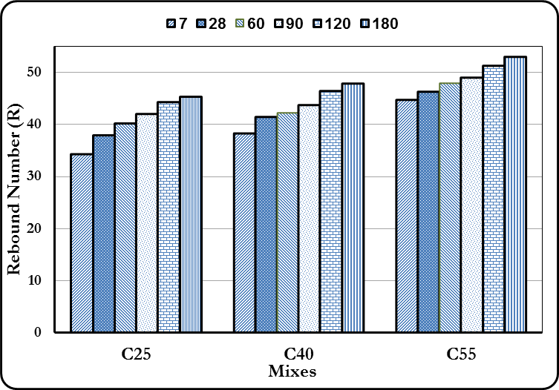

Figure 1: Rebound Number development with age for the laboratory testing

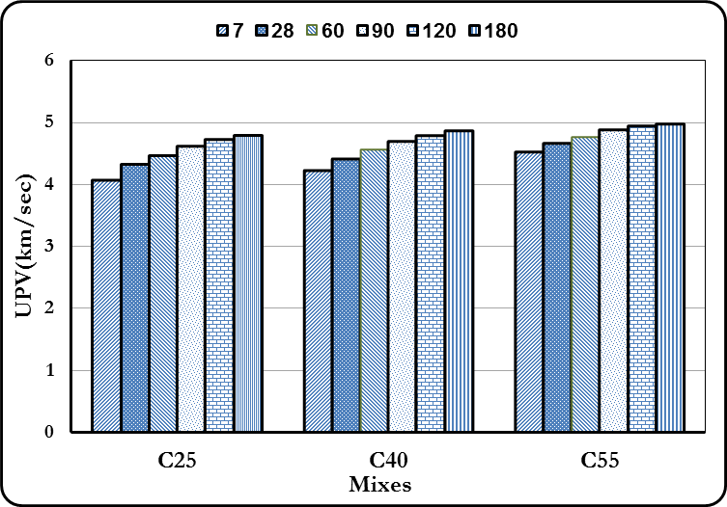

Figure 2: Ultrasonic pulse velocity development with age for the laboratory testing.

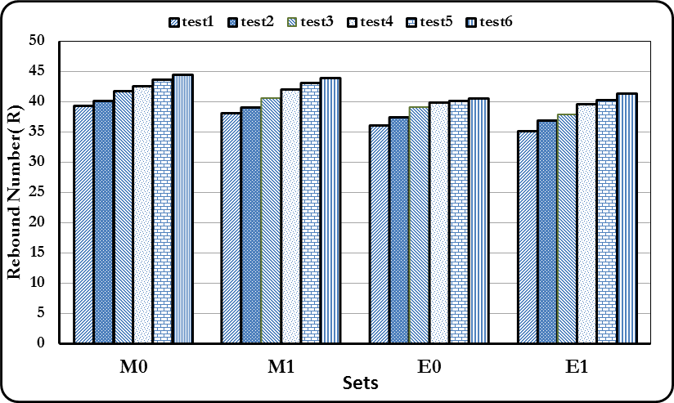

Figure 3: Rebound Number development with age for the feild testing.
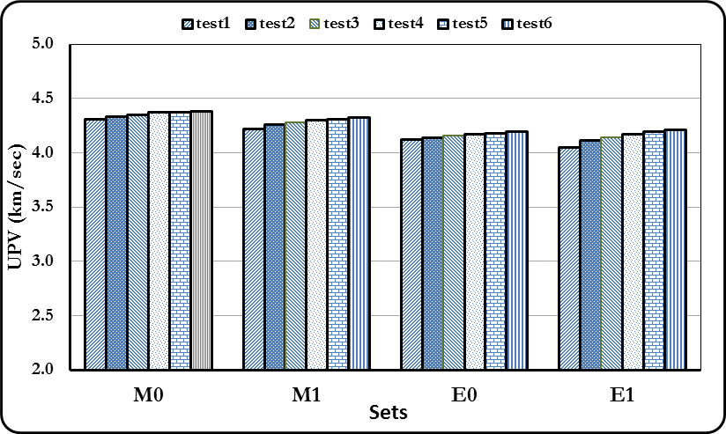
Figure 4: Ultrasonic Pulse Velocity development with age for the feild testing.

Figure 4: Ultrasonic Pulse Velocity development with age for the field testing.
8. References
- Abo-Qudais, S. A. (2005): “Effect of Concrete Mixing Parameters on Propagation of Ultrasonic Waves,” Construction and Building Materials,Vol. 19 ,pp. 257-263.
- ACI 228.2R-98(2004): “Nondestructive Test Methods for Evaluation of Concrete in Structures,” Reported by ACI Committee 228, ACI Manual of Concrete Practice, American Concrete Institute.
- ASTM C 597-02(2006): “Standard Test Method for Pulse Velocity Through Concrete,” Annual Book of ASTM Standards American Society for Testing and Materials, Vol. 04.02.
- ASTM C 805-02 (2006): “Standard Test Method for Rebound Number of Hardened Concrete,” Annual Book of ASTM Standards American Society for Testing and Materials, Vol. 04.02.
- Aydin, F., and Saribiyik, M. (2006): “Compressive Strength of Various Ages Concretes by Nondestructive Test Methods,” 4th Faculty of Architecture and Engineering International Symposium, European University of Lefke, Turkey, pp.183-188.
- Aydin, F., and Saribiyik, M. (2010):“Correlation Between Schmidt Hammer and Destructive Compressions Testing for Concretes in Existing buildings,” Scientific Research and Essays Vol. 5, No. 13, pp. 1644-1648.
- BS1881: part 6089:1981(1999): “Guide to Assessment of Concrete Strength in Existing Structures,” British Standards Institution.
- BS1881:part202:1986 (1991):“Recommendations for surface hardness testing by rebound hammer,” British Standards Institution.
- BS1881:part203:1986 (1991): “Recommendations for Measurement of Velocity of Ultrasonic Pulses in Concrete,” British Standards Institution.
- Bungey, J. H., Millard, S. G., Grantham, M. G. (2006): “Testing of Concrete in Structures,” Taylor and Francis, 4th edition, pp.35-139.
- Grantham, M. (2003): “Diagnosis, Inspection, Testing and Repair of Reinforced Concrete Structures,” in Newman,J., and Choo, B.S., Advanced Concrete Technology ,Testing and Quality, Elsevier, ch.6.
- Gupta, A.K. (2005): “Non-destructive Testing of Bridges,” Indian Railways Institute of Civil Engineering, pp. 1- 23.
- Lin, Y., Kuo, S-F., Hsiao, C., and Lia, C-P. (2007):“Investigation of Pulse Velocity-Strength Relationship of Hardened Concrete”, ACI Material Journal Vol. 104, pp. 344- 380.
- Malhotra, V. M.(2004):“Surface Hardness Methods,” In Malhotra, V.M., and Carino, N. J., Handbook on Nondestructive Testing of Concrete,2nd edition ,Ch. 1, CRC Press.
- Malhotra, V. M.(2006): “Nondestructive Tests,” in Newman,J., and Choo, B.S., Significance of Tests and Properties of Concrete and Concrete-Making Materials, ASTM International, pp.314.
- Naik, T. R., Malhotra, V. M., and Popovics, J. S. ( 2004): “The Ultrasonic Pulse Velocity Method,” In Malhotra, V.M., and Carino, N. J., Handbook on Nondestructive Testing of Concrete,2nd edition ,Ch. 8, CRC Press.
- Nash't , I. H. , A'bour , S. H., Sadoon A. A.(2005): “Finding an Unified Relationship between Crushing Strength of Concrete and Non-destructive Tests,” 3rd MENDT - Middle East Nondestructive Testing Conference & Exhibition ,Bahrain, Manama.
- Neville, A. M. (2005): “Properties of concrete,” Fourth and Final Edition Standards updated to 2002, Pearson, pp. 302.
- Neville, A. M., and Brooks, J. J. (2010): “Concrete Technology,” Pearson, 2nd edition, pp. 306-318.
- Poole, R. W., and Farmer, I. W. (1981):“Technical Note: Consistency and Repeatability of Schmidt Hammer Rebound Data During Field Testing,” J. Rock Mech. Min. Sci. & Geomech. Abstr. Vol. 17,pp. 167 to 171.
- Rehman, H.A.(2008): “Nondestructive Tests for Self-Compacting Concrete with Compressive Strength in Range (20-80) MPa,” M.Sc. Thesis, Al-Mustansiriya University, 2008.
- Samarin, A.( 2004): “Combined Methods,” In Malhotra, V.M., and Carino, N. J., Handbook on Nondestructive Testing of Concrete,2nd edition ,Ch. 9, CRC Press..
- Shetty, M.S. (2009):“Concrete Technology, Theory and Practice,” 6th multicolour edition, pp.438-443.
- Soshiroda,T., Voraputhaporn,K., Nozaki,Y.(2006): “Early-Stage Inspection of Concrete Quality in Structures by Combined Nondestructive Method,” Materials and Structures, Vol. 39, 2006, pp.149-160.
- Wood, S. L. (1992): “Evaluation of the Long-Term Properties of Concrete,” Research and Development Bulletin RD102T, Portland Cement Association, Skokie, Illinois.

