تم دراسة توزيع الاجهادات في حالة تثبيت ستة براغي أو مسامير فوق وتحت موقع الكسر لكلا طريقتي التثبيت.
إن قيم الاجهادات عند استخدام سبيكة الكوبلت كروم في طريقة التثبيت الداخلي تكون اقل من قيم الاجهادات عند استخدام الفولاذ المقاوم للصدأ لكل وزن من الأوزان المدروسة. تكون قيم الاجهادات في البراغي المثبتة خارجيا أعلى من قيم الاجهادات في البراغي المثبتة داخليا.
عند تقليل عدد البراغي المستخدمة فان قيم الاجهادات سوف تزداد، لذلك فعند استخدام ثمانية براغي فان قيم الاجهادات ستكون اقل مما لو استخدمنا ستة براغي لكلا طريقتي التثبيت(الداخلي و الخارجي).
Introduction
Fractures can be treated conservatively or with external and internal fixation. Conservative fracture treatment consists of closed reduction to restore the bone alignment. Subsequent stabilization is then achieved with traction or external splinting by slings, splints, or casts. Braces are used to limit range of motion of a joint. External fixators provide fracture fixation based on the principle of splinting [1].

The external fixation method is the best method for many situations such as open fractures especially with high contaminated field wounds, also in fractures with (burns, infections, non union) fractures, also fractures associated with nerve injuries. The principle of this method is simple: the bone is transfixed above and below the fracture by transfixing screws and the proximal and distal transfixing screws is then connected to each other by rigid bars as shown in(Fig.2).There are numerous techniques and fixation devices: transfixion by pins, screws connecting bars on both sides of the bone or on one side only; triangular and circular configuration fixed connections or adjustable connections; bars and pins of varying rigidity and stability which, together with the specific geometry of the system, provide varying degrees of fracture 'immobilization'.The bone fragments may be fixed by internal fixation by using screws transfixing pins or nails, a metal plate held by screws, along intramedullary (with or without locking screws), or a combination of these methods as shown in (Fig.1). Properly applied, internal fixation holds a fracture securely so that movements can be at once; with early movement the 'fracture disease' (stiffness and oedema) is abolished. As far as speed is concerned, the patient can leave hospital as soon as the wound is healed [2].
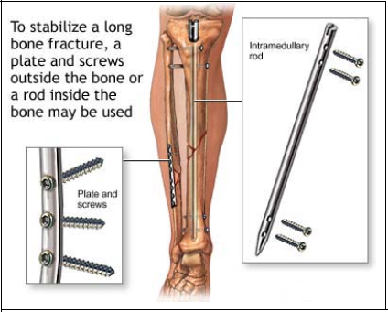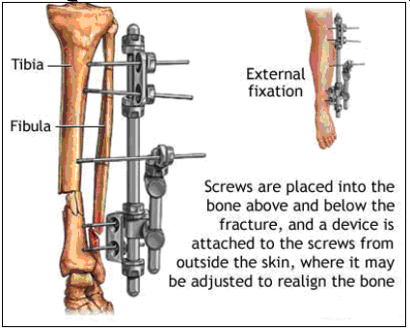
Figure (1) Internal fixation [3]. Figure (2) External fixation [4].
Viceconti M. et al. (1996) [5], developed three dimensional models of the femur from CT data. The resurfacing FE model was developed, meshed and combined with the bone models using Pro Engineer CAD software. All materials of cortical bone were modelled as isotropic elastic materials and cancellous bone was modelled as an isotropic elastic-perfect plastic material. These results, got in a previous study, demonstrate the improved physiological loading of the proximal femur obtained with a polymer-on-polymer resurfacing. Since one of the most time consuming steps in finite element (FE) studies is the generation of the model geometry from CT scans, the potential time savings due to the availability of a public domain model is significant. The applied force was set along to the mechanical axis of the femur that is passing through the centre of the coxo-femoral joint and the centre of knee articulation. The model consists of 27012 2nd-order tetrahedral elements and 13510 nodes. Final step is to load these IGES files into ANSYS and Pro Engineer for mesh generation and solving. The results clearly indicate that the FE model is capable of reasonably predicting the stress-distribution in the proximal region of the composite femur. By adjusting the maximum cortical density and elastic constants, the distribution of the material properties of the FE model were determined for this specific bone, the result was an accurate distribution of material properties of the femur including density and elastic constants.
In (2000), Vallejo B. et al. [6] determined the failure characteristics of remodelled bone with various densities following two types of femur fixation using modal analysis. A high- resolution fully orthopaedic three- dimensional model was created with only the distal portion of the idealized femur to simulate a comminuted fracture. The model was developed in pro-engineering and meshed using the FE package. The idealized distal femur with variable density- strength functions was fixed with two types of common clinical fixations:
(1) Titanium plates with two screws, (2) Two titanium flexible intramedullary nails. All failures were noted to occur in the area of the remodelled fracture site. The plate fixation demonstrated a tensile failure mode at 215HZ and bending failure mode at 1038 HZ. The nail fixation technique showed a compression failure mode at 262 HZ and bending failure mode at 949 HZ. The nail fixation showed uniform stress tensor distributed through the model while the plate fixation demonstrated asymmetrical stress distribution with smaller transitions on the plate side. Tensile and bending failure modes for the plate fixation occur going toward the side of plate placement.
Fracture happening
Bone is relatively brittle, yet it has sufficient strength and resilience to withstand considerable stress. Fractures result from:
1. A single traumatic incident.
2. Repetitive stress.
3. Abnormal weakening of the bone (a pathological fracture).
Fractures due to a traumatic incident most fractures are caused by sudden and excessive force, which may be tapping, crushing, bending, twisting, or pulling [7].
With a direct force
The bone break at the point of impact; the soft tissues also must be damaged. Taping (a momentary blow) usually causes a transverse fracture and damage to the overlying skin; crushing is more likely to cause a comminuted fracture wit extensive soft–tissue damage [7].
With an indirect force
The bone breaks at a distance from where the force is applied; soft tissue damage at the fracture site is not inevitable.
The force may be:
1. Twisting, this causes a spiral fracture.
2. Bending which causes a transverse fracture.
3. Bending and compressing, which results in a fractures that is partly transverse but with a separate triangular" butterfly” fragment.
4. A combination of twisting, bending and compressing, which causes a short oblique fracture.
5. Pulling, in which a tendon or ligament literally pulls the bone apart [7].
Fatigue or stress fracture
Cracks can occur in bone as in metal and other materials as shown in (Fig.3), due to epetitive stress [7].
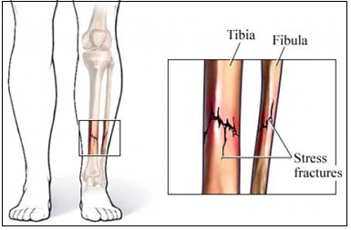
Figure (3) stress fractures [8].
Pathological fractures
Fractures may occur even with normal stresses if the bone has been weakened (e.g. by a tumor) or if it is excessively brittle. [7].
Experimental Methods
The ANSYS V.(10) program has many finite element analysis capabilities, ranging from a simple, linear, static analysis, to a complex, nonlinear, transient dynamic analysis [9]; [10].The CT scan slices which are of the femur bone of a 30-Year-old patient, these slices of 0.2 mm thickness, The slices were transmitted to graph paper and then manually the keypoints were founded, The lines and the arcs between the keypoionts were drawn and the areas and volumes were created (3-Dimenssion femur geometry was founded), Descritized the models by using the element (solid 95) as shown in (Fig.4) because of the complicated volumes in the model. In this analysis it is assumed that each individual constituting element of the system is made of isotropic material.The femur was modelled as homogeneous isotropic materials with Ε=9 Gpa, the "υ" =0.3 [11]. The Fracture of the bone was presented in the shaft of the femur as a transverse mid shaft non comminuted fracture and then the two types of fixation was studied (the external fixation which consists of the pins and the external frame) as shown in (Fig.5).
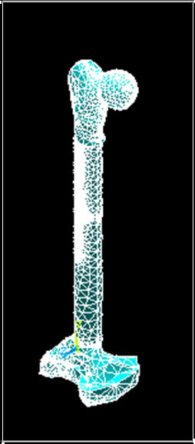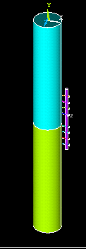

Figure (4) ANSYS screen shows
the femur model meshing.
Figure (5) ANSYS screen shows the fracture femur fixed externally by pins and the external frame.

The pins are drawn as a cylinders overlapping with the shaft of femur, This pins with an inner diameter of 3.5 mm, the material of the pins which used in the external fixation was stainless steel material which has Ε =200 GPa and "υ" =0.3 [11].
The mesh was applied to the shaft of the fracture femur which is fixed externally by pins as shown in (Fig.6).
Also the other type of fixation (internal fixation which consists of the screws and the plate). These screw also overlapping with the shaft of femur to get the stresses transitions from the bone to these screws as shown in (Fig.7).

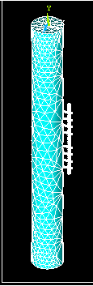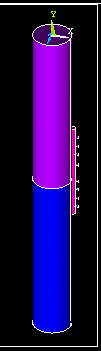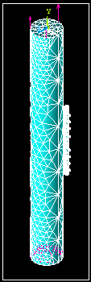

Figure (6) ANSYS screen shows the mesh of the fracture femur fixed externally by pins and the external frame

Figure (7) ANSYS screen shows the fracture femur fixed internally by pins and the plate.

Figure (8) ANSYS screen shows the mesh of the fracture femur fixed internally by pins and the plate.

The material of the screws was changed firstly used stainless steel material which is of E= 200 GPa and"υ"= 0.3 [11]. Then the second material which is cobalt chromium materials with E =210 GPa and "ν" =0.3 was used [12]. The mesh was applied to the shaft of the fracture femur which is fixed internally by pins as shown in (Fig.8).
Forces applied to the head of femur model
Forces transmitted across the femur bone are as shown in (Fig.9 and Fig. 10) [13]:
- 1/3 body weight.
- Abductor muscles.
- Ground reaction.

Table (1) Calculated forces applied to the femur (which represents the effected forces at this region):
Body weight (kg) | 1/3 of B.W(N) | Abductor muscles(N)
70 | 228.6 | 22.86
90 | 294 | 29.4
110 | 359.3 | 35.93

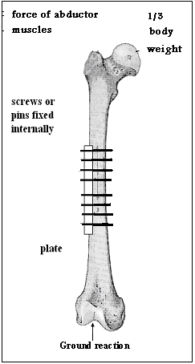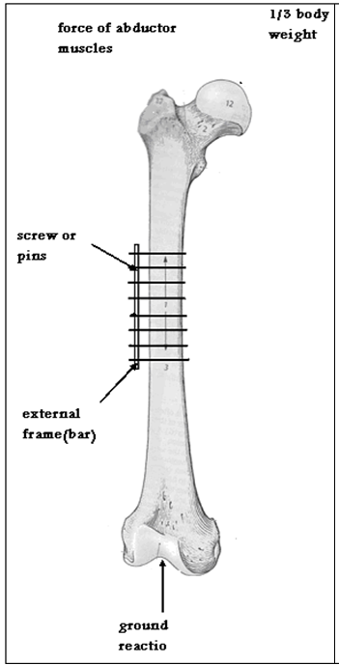

Figure (9) free body diagram of the femur bone fixed internally by plate and screws.
Figure (10) free body diagram of the femur bone fixed externally by pins and external frame.

Because of the complexity of the femur bone model to be analysed totally, the model divided into two parts, the head of the femur and the shaft of the femur. The loads applied to the head of femur, and then by using Query method, the von mises stresses of the femur head were obtained. These obtained stresses must be applied to the shaft of femur to study the stresses on the screws or pins in both internal and external fixations.
Models Analysis:
The models build were analyzed using the Ansys program, for each model the applied forces were in three body weights; for 70Kg body weight, 90Kg body weight and 110Kg body weight. The results of the Analysis were represented as a contour in the Figures (11-28). Stresses were represented as a von mises stresses.
The results of the external fixation are as shown in (Fig.11-13):

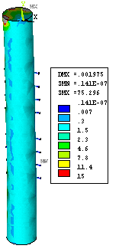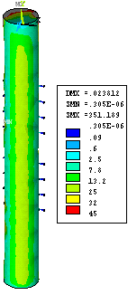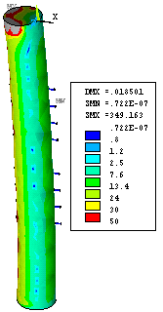

Figure (11) Von mises stresses for 70kg body weight of the shaft of the femur.
Figure (12) Von mises stresses for 90kg body weight of the shaft of the femur
Figure (13) Von mises stresses for 110kg of the shaft of the femur.

The results of the internal fixation are as shown in (Fig.14-19):
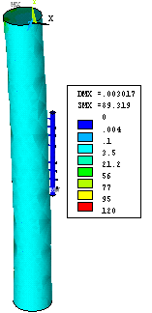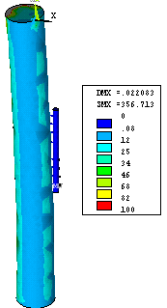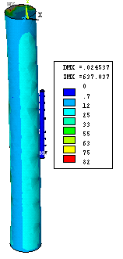

Figure (16) Von mises stresses for110 kg body weight of the shaft of femur for stainless steel screws
Figure (15) Von mises stresses for90 kg body weight of the shaft of femur for stainless steel screws.
Figure (14) Von mises stresses for70 kg body weight of the shaft of femur for stainless steel screws.

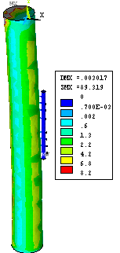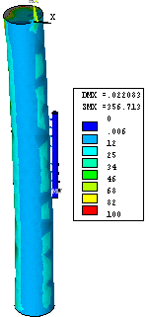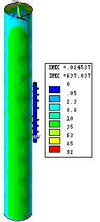

Figure (17) Von mises stresses for 70kg body weight of the shaft of the femur for the cobalt chromium screws
Figure (18) Von mises stresses for 90kg body weight of the shaft of femur for cobalt-chromium screws
Figure (19) Von mises stresses for 110kg body weight of the shaft of femur for cobalt-chromium screws

The results of 6 screws fixations are as shown in (Fig.20-25):
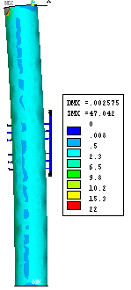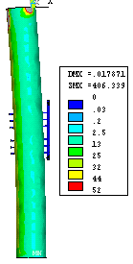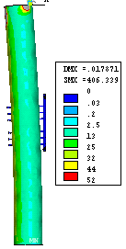

Figure (20) Von mises stresses for 70 kg body weight with decreased screw's numbers of the shaft of the femur for the cobalt chromium screws
Figure (21) Von mises stresses for 90 kg body weight with decreased screw's numbers of the shaft of the femur for the cobalt chromium screws
Figure (22) Von mises stresses for 110kg body weight with decreased screw's numbers of the shaft of femur for the cobalt chromium screws

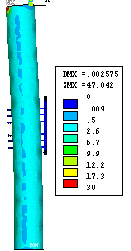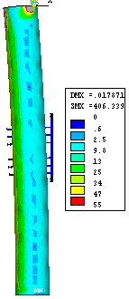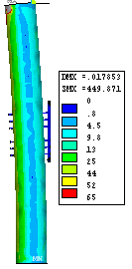

Figure(23) Von mises stresses for 70 kg body weight with decreased screw's numbers of the shaft of the femur for the stainless steel screw
Figure (24) Von mises stresses for 90 kg body weight with decreased screw's numbers of the shaft of the femur for the stainless steel screw
Figure(25)Von mises stresses for 110 kg body weight with decreased screw's numbers of the shaft of the femur for the stainless steel screw

The results of the external fixation are as shown in (Fig.26-28)

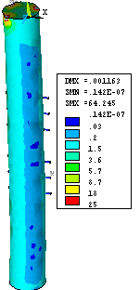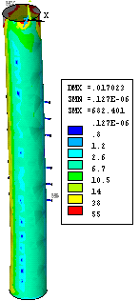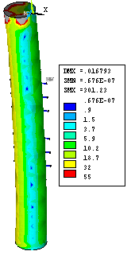

Figure (26)Von mises stresses for 70kg body weight of the shaft of femur.

Figure (27)Von mises stresses for 90kg body weight of the shaft of femur.

Figure (28) Von mises stresses for 110kgbody weight of the shaft of femur

Table (2): Summary of von mises stresses of fractured femur fixed externally by 8 pins or screws inner diameter (3.5mm), made of stainless steel material, to compare between (70,90,110)kg body weights:

Region | Von Mises stresses (N/mm²)
Region | 70kg | 90kg | 110kg
Terminal part of the 1st pin above fracture side (right side). | 0.000354 | 0.00724 | 0.00845
Terminal part of the 2nd pin above fracture side (right side). | 0.000103 | 0.00211 | 0.0063
Terminal part of the 3rd pin above fracture side (right side). | 0.000349 | 0.00712 | 0.00883
Terminal part of the 4th pin above fracture side (right side). | 0.000347 | 0.00707 | 0.00777
Terminal part of the 5th pin below fracture side (right side). | 0.000347 | 0.00708 | 0.00836
Terminal part of the 6th pin below fracture side (right side). | 0.000352 | 0.00720 | 0.00856
Terminal part of the 7th pin below fracture side (right side). | 0.000351 | 0.00716 | 0.00834
Terminal part of the 8th pin below fracture side (right side). | 0.000347 | 0.00709 | 0.00865
Left side of the fracture side | 0.01038 | 0.15862 | 0.00313
Superior part of the femur shaft | 0.00789 | 0.05981 | 0.0139
Inferior part of the femur shaft | 0.00525 | 0.08505 | 0.01515

Table (3): Summary of von mises stresses of fractured femur fixed internally by plate and 8 screws with inner diameter (3.5mm), made of stainless steel material, to compare between (70,90,110)kg body weights:

Region | Von Mises stresses (N/mm²)
Region | 70kg | 90kg | 110kg
Terminal part of the1st screw above fracture side (right side). | 0.00000313 | 0.0000303 | 0.0000452
Terminal part of the2nd screw above fracture side (right side). | 0.00000335 | 0.0000325 | 0.0000483
Terminal part of the 3rd screw above fracture side (right side). | 0.00000325 | 0.0000316 | 0.0000468
Terminal part of the 4th screw above fracture side (right side). | 0.0000127 | 0.000122 | 0.000183
Terminal part of the 5th screw below fracture side (right side). | 0.0000190 | 0.000184 | 0.000274
Terminal part of the 6th screw below fracture side (right side). | 0.0000172 | 0.000167 | 0.00025
Terminal part of the 7th screw below fracture side (right side). | 0.0000157 | 0.000152 | 0.000225
Terminal part of the 8th screw below fracture side (right side). | 0.0000169 | 0.000165 | 0.00025
Superior part of the plate | 0.0067 | 0.08395 | 0.1498
Plate above fracture side immediately | 0.0088 | 0.09969 | 0.16796
Plate below fracture side immediately | 0.0099 | 0.1074 | 0.17706
Inferior part of the plate | 0.0131 | 0.13952 | 0.2025
Left side of the fracture site | 0.01556 | 0.05999 | 0.1583
Superior part of the femur shaft | 0.00822 | 0.0325 | 0.04913
Inferior part of the femur shaft | 0.00762 | 0.0501 | 0.0680

Table(4): Summary of von mises stresses of fractured femur fixed internally by plate and 8 screws with inner diameter (3.5mm), made of cobalt chromium material, to compare between (70,90,110)kg body weights:

Region | Von Mises stresses (N/mm²)
Region | 70kg | 90kg | 110kg
Terminal part of the 1stscrew above the fracture side (right side). | 0.00000313 | 0.0000303 | 0.0000451
Terminal part of the2nd screw above fracture side (right side). | 0.00000335 | 0.0000325 | 0.0000482
Terminal part of the 3rd screw above fracture side (right side). | 0.0000325 | 0.0000316 | 0.0000468
Terminal part of the 4th screw above fracture side (right side). | 0.0000127 | 0.000123 | 0.000182
Terminal part of the 5th screw below fracture side (right side). | 0.0000190 | 0.000184 | 0.000273
Terminal part of the 6th screw below fracture side (right side). | 0.0000172 | 0.000166 | 0.000245
Terminal part of the 7th screw below fracture side (right side). | 0.0000157 | 0.000153 | 0.000225
Terminal part of the 8th screw below fracture side (right side). | 0.0000169 | 0.000164 | 0.000247
Superior part of the plate | 0.006 | 0.08390 | 0.1499
Plate above fracture side immediately | 0.0088 | 0.09960 | 0.16796
Plate below fracture side immediately | 0.0098 | 0.107 | 0.1771
Inferior part of the plate | 0.0130 | 0.131766 | 0.2026
Left side of the fracture site | 0.0150 | 0.05992 | 0.1584
Superior part of the femur shaft | 0.008 | 0.032422 | 0.0497
Inferior part of the femur shaft | 0.0076 | 0.0500414 | 0.0688
Table (5): Summary of von mises stresses of fractured femur fixed internally by 6 pins or screws inner diameter (3.5mm), made of cobalt chromium material, to compare between (70,90,110)kg body weights:

Region | Von Mises stresses (N/mm²)
Region | 70kg | 90kg | 110kg
Terminal part of the 1st pin above fracture side (right side). | 0.00001646 | 0.000127 | 0.000187
Terminal part of the 2nd pin above fracture side (right side). | 0.0000753 | 0.00057 | 0.00038
Terminal part of the 3rd pin above fracture side (right side). | 0.000070 | 0.00053 | 0.000615
Terminal part of the 4th pin above fracture side (right side). | 0.000080 | 0.000620 | 0.002050
Terminal part of the 5th pin below fracture side (right side). | 0.0000613 | 0.000469 | 0.00186
Terminal part of the 6th pin below fracture side (right side). | 0.0000651 | 0.000498 | 0.000599

Table (6): Summary of von mises stresses of fractured femur fixed internally by 6 screws with inner diameter (3.5mm), made of stainless steel material, to compare between (70,90,110)kg body weights:
Region | Von Mises stresses (N/mm²)
Region | 70kg | 90kg | 110kg
Terminal part of the 1st pin above fracture side (right side). | 0.00001646 | 0.000127 | 0.000187
Terminal part of the 2nd pin above fracture side (right side). | 0.0000753 | 0.00057 | 0.00038
Terminal part of the 3rd pin above fracture side (right side). | 0.000070 | 0.00053 | 0.000615
Terminal part of the 4th pin above fracture side (right side). | 0.000080 | 0.000620 | 0.002050
Terminal part of the 5th pin below fracture side (right side). | 0.0000613 | 0.000469 | 0.00186
Terminal part of the 6th pin below fracture side (right side). | 0.0000651 | 0.000498 | 0.000599
Table(7) Summary of von mises stresses of fractured femur fixed externally by 6 screws with inner diameter (3.5mm), made of stainless steel material, to compare between (70,90,110)kg body weights:
Region | Von Mises stresses (N/mm²)
Region | 70kg | 90kg | 110kg
Terminal part of the 1st pin above fracture side (right side). | 0.00632 | 0.06127 | 0.07156
Terminal part of the 2nd pin above fracture side (right side). | 0.00628 | 0.0607 | 0.0734
Terminal part of the 3rd pin above fracture sidte (right side). | 0.00597 | 0.05790 | 0.07242
Terminal part of the 4th pin above fracture side (right side). | 0.00630 | 0.06103 | 0.0667
Terminal part of the 5th pin below fracture side (right side). | 0.00601 | 0.05821 | 0.06973
Terminal part of the 6th pin below fracture side (right side). | 0.00605 | 0.05862 | 0.07342
Discussion:
Finite element analysis is one of the modern methods of prosthetic implant analysis. The aim of the finite element analysis is to develop a three dimensional model of the bones that can be used as a computational tool to prosthetic implant analysis. One of the problems which were faced in the finite element analysis is the model building. Finding the applied load was also difficult. There was no complete information about the complete loads on each method of fixation. So a calculation was applied on each method of fixation for different weights of the human body to find the forces of muscles using the free body diagram. Results obtained from the ANSYS were important in understanding the areas of stress concentrations.
Because of the high length of femur bone, the increasing in the number of the pins or the screws in the fractured femur bone to make it more stable and to decreases the stresses on each pin or screw. For the external fixation method four pins or screws fixed above the fracture site and another four pins or screws fixed below the fracture site, the greatest compressions stress concentrations in the pins which are fixed above and below the fracture site, these stresses were increased with increasing the weight of the body. Also stresses distributed in the shaft of the bone.
The external frames which used as an external bar used to fix these pins to provide varying degrees of fracture immobilization. When the external frame put near the skin, this represents the best position because the force arm is small and the torque is small and then the fixation become more stable. Also, from the results of the ANSYS program the stress in the pins increased by increasing the body weights, 110kg body weight has compression stresses in the pins greater than compression stresses in the pins of (90kg body weight) which has a compression stresses greater than the pins of (70kg body weight).
As a result for both cases (8 screws and 6 screws) in the external fixation the stresses are greater than the stresses in the internal fixation because the external fixation is far from the bone. Therefore the torque is greater than that obtained in the internal fixation because the internal fixation is attached to the bone immediately. Thus the distance is less than the distance of the external fixation, then the torque of the internal fixation is less. Also the screws and plates used in the internal fixation are stronger than the bar and pins used in the external fixation.
From the results of the internal fixation method the most compression stress in the screws which are of diameter (3.5mm) and plate. These stresses increased with increasing body weight.
The stress values in the screws made of stainless steel (E=200 GPa), are equal or greater than the stresses on the screws made of cobalt chromium (E=210 GPa), this gives an indication that the cobalt chromium is more strong than stainless steel because it's stresses are equal to the stresses of stainless steel inspite of the Young’s modulus of stainless steel is less than Young’s modulus of cobalt chromium, while in the surgical operations the cobalt chromium is more strong than the stainless steel. However stainless steel is more favorable material than the cobalt chromium because the stainless steel can be cold worked, but cobalt chromium not cold worked.
When the fractured bone was fixed by 6 pins or screws (3 pins above the fracture site and 3 pins below the fracture site) for each method of fixation (internal and external),using two types of materials in the internal method of stainless steel and cobalt chromium, the cobalt chromium material was stronger than stainless steel material. The compression stresses inside the screws when compared with the compression stress inside the screws used to fix the fractured femur by 8 screws (4 pins above the fracture site and 4 pins below the fracture site) were greater. Also the stresses of the external fixation of 6 pins if compared with the stresses of the external fixation of 8 pins were greater.
Conclusions:
- The fixation is one of the most important methods of treating fractures because the goal of fracture fixation is to stabilize the fractured bone, to enable fast healing of the injured bone, and to return early mobility and full function of the injured extremity.
- There are many causes that caused the failure in the implants of fixation mainly the stress fracture followed by: In proper implant,Thin plate, Small head of screw, In proper material, Bad technique, Non union of the fracture, post operation:
- Theoretically the stress increasing for each pin in external fixation if compared with the stress for same screw in the internal fixation are greater the more compression stress in the fractured femur located at the pin or screw
- There are many kinds of material used in fixation like stainless steel, cobalt chromium& titanium, the cobalt chromium material is better than stainless steel material under same boundary conditions because the young’s modulus of stainless steel =200Gpa while the young’s modulus of cobalt chromium =210Gpa, but the failure index of the stainless steel is equal or greater than the failure index of cobalt chromium material
References
[1] Taljanovic Mihra S., Jones Marci D., Ruth John T., Benjamin James B., Sheppard Joseph E., and Hunter Tim B.: Fracture Fixation1. 2003. Vol 23: P.1569–1590.
[2] APLEY A., Grahman, and Solomon Louis: Apley’s system of orthopaedics and fractures. Seventh Ed., Lendon Boston Durban Singapore Sydney Toronto Wellington. 1993. P.515-537.
[3] Roye Bengman D., D.M. and H. M. P.: Department of orthopaedics, 2001.
[4] Bracero Xiomara, Perez Jackxander, Rodriguez Yarielaine, and Ruiz Rebeca: Biomechanics of orthopaedic fixation. Applications of Engineering Mechanics in Medicine, 2003.
[5] M. Viceconti, M. Casali, and B. massari: The stress values numerical computing in the proximal femur under physiological load conditions. J. Biomechanics, 1996.
[6] Vallejo B., Selgas C., Mahar, A., and Impelluso T.: Using modal analysis to determine failure characteristics of remodelled bone in a fractured femur model. J Biomechanics, 2000.
[7] Hall Susan J.: Basic Biomechanics. 1995, 2nd Ed., McGraw-Hill Companies. p. 87- 108.
[8] healthygate. Partners. Org/ browsing/ browse Conten.
[9] Rao S. S.: The Finite Element Method in Engineering. 1989, 2nd ed., Pergamon Press, p.1-6.
[10] Ansys ® 5.4 Package (1997) Help.
[11] Gefen A.: Computational simulations of stress shielding and bone resorption around existing and computer-designed orthopaedic screws. J Medical & Biological Engineering & Computing, 2002. 40:P.311-321.
[12] Lewis Jack L., Lew William D.: Bioengineering of total joint replacement.
[13] Ismaeel Mustafa Q.: Biomechanical Aspects of Shoulder Hip Articulations a Comparison of two Ball and Socket Joints, 2005, p 68.

