INTRODUCTION
Thin oxide film have found application in many areas ranging from electronic circuits to wear and corrosion protection like cutting tool ,D.NGUYENM(1986)study amorphous Al₂O₃ and Al₂O₃₋ZrO₂ films prepared by spray pyrolysis with XRD and SEM, and FREDERICK J.(2006) prepared Al₂O₃ films by PVD and CVD technique and he found that the thickness was (1-10 µm) and grain size was(100 nm).Alumina is one of the most import thin oxide film materials because of their favorable dielectric properties, low thermal conductance and high wear and corrosion resistances., Internet S.L (2008), K. CHOPRA, S. (1983). Oxide wear resistant coatings used in industrial application can be prepared by many techniques JOHN D. (2008), he made a review on the methods used to prepare ceramic films like TiN ,TiC and Al₂O₃. BJORN L.(2001) used mainly CVD, PVD technology to prepare Al₂O₃ and studded five different types of wear for TiN, Al₂O₃ and TiAlN .Spray pyrolysis is attractive because it is a low cost technique references to thin coatings of Al₂O₃deposited by spray pyrolysis, have been relatively rare D.Nguyen (1984), L. MAISSEL (1970). The aim of this work is to produce a thin ceramic film from Al₂O₃ by spray pyrolysis method and doping the films with some elements then study some of their mechanical properties.

EXPERIMENTAL WORK
In this work an aqueous solution of Aluminum nitrate [Al(NO₃)₂.9H₂O] has been used in this study to prepare Al₂O₃films. The concentrations was used (0.3 M). The acidity was maintained to be 3-4 pH during spraying .Three salts [2Fe(NO₃)₂.9H₂O, NiCl₂ , and CuCl₂) were used to dope Al₂O₃film with three elements (Fe , Ni and Cu) respectively at( 1,2,3,4 and 5wt.%) for each dopant. The choice of these dopants is done to cover group (VII) and transition elements of the periodic table. The deposition of the films is made by spray pyrolysis technique. The spraying apparatus used in this study was manufactured locally in the university laboratories with inexpensive equipment. In this technique, the previously prepared aqueous solutions were atomized by a special nozzle glass sprayer at heated glass and stainless steel 304 substrates fixed on thermostatic controlled hot plate heater, the chemical composition is listed in table 1. Air was used as a carrier gas and to atomize the spray with the help of an air blower. The substrate temperature was maintained to be 450 °C during spraying with ±10 ºC. To avoid excessive cooling of the substrate, spraying was achieved in periods of about 5 s followed by 2 min wait. Deposition rate was about 2-4 nm/s with 2.5 ml/min of flow rate. To deposit films of uniform thickness the distance between the substrate and spray nozzle was kept at ( 28±1 cm.) The spray of the aqueous solution yields the following chemical reaction R.WEAST (1985):

2Al(NO₃)₃.9H₂O $\vec{\text{450}C}$ Al₂O₃ ↓ + 6NO₂ ↑ + 9H₂↑ (1)

Each one of the doping elements is precipitated according to the reaction below:
2Fe(NO₃)₂.9H₂O $\vec{\text{450}C}$ 2 Fe ↓ + 6NO₂ ↑ + 9H₂O↑ (2)

NiCl₂ $\vec{\text{450}C}$ Ni ↓ + Cl₂↑ (3)

CuCl₂ $\vec{\text{450}C}$ Cu ↓ + Cl₂↑ (4)

Thickness of Al₂O₃ was 1µm, to determine the nature of the growth and the structural characteristics of Al₂O₃ films. The properties of X-ray diffraction was used from diffractometer type CuKα with( λ = 1.54056 Å ), the scanning speed was 3%. The data was compared with that ASTM (46-1212) card. The topography of the Al₂O₃ surface was inspected with optical reflected-microscope type (Nicon 73346) under magnification of X 108. The vicker's microhardness was performed with (5g load) by using the following reaction:

H.v =1854.4p/d2 (5)

Where p is the load and d is the average diameter of the trace.
Wear test was done by using pin on disk method with 0.5Kg load as in ASTM (G65-91) by using following reaction:

R.W = (m1-m2)/2π*V*S*t (6)

Where m1 is the sample mass before test and m2 is the mass after test ,V is the velocity of the disk, S is the diameter of the length and t is test time( minuet), apparent density was calculated from films mass and volume ,open pores was measured by used prop point method, Internet RES 2008.

RESULTS AND DISCUSSION
Figure 1 shows the XRD chart of the Al₂O₃ film ,and observed that the films was crystalline Al₂O₃ with α- Phase agree with ASTM cart (46-1212) the grain size was (60 nm) for pure Al₂O₃ and ( 2θ=35.19 ) as listed in table 2. FREDERICK find grain size was 100 nm for Al₂O₃ film prepared by PVD. Figure 2 illustrates the topography of pure Al₂O₃ film were the surface is white and little mite with some pit on surface of the film as show in Figure 2-1. In Figure 2-2 illustrates the type of circles that happen in the surface of the films because of the drupe that fill on the surface and this result is agree with lettrucare CHOPRA, MAISSEL. Figure 2-3 shows the interface between area coated with Al₂O₃ and beside area which does not coated, some times a little crack can be happen because of heat change in the lattice during spray time. The topography of doped Al₂O₃ films shows in figures below, the surfaces were also white and little mite without any colors (another metal oxides) agree with MITCHELL C.(1998). Figure 2-5 shows Al₂O₃:Fe films in a: (1wt%) doping of iron and in b( 3wt%) and in c: (5%wt) assume in the Figure. In Figure 2-6 shows Al₂O₃ : Ni films at a :(1wt%) of Ni and in b:(3wt%) and in c: (5wt%) .While in figure 2-7 shows Al₂O₃ : Cu and in a: (1wt%) of cu , b: (3wt%) and in c: (5wt%). Figure 2-8 shows the Al₂O₃ film deposited on stainless steel 304 a- pure Al₂O₃ ,b- AL₂O₃:Fe(1wt%) films on steel substrate, in- c AL₂O₃:Ni(1wt%) films on stainless steel substrate, in -d AL₂O₃:Cu (1wt%)films on steel substrate H.K(2005). Figure 3 show apparent density which is change with doping percentage while open porosity in figure 4 show little effected with doping change. Figure 5 show the vicars microhardness of the films on glass the H.V because of doping percentage in areas in Fe doping the effect is more than Cu, in figure 6 show the vicker's microhardness of the films on steel304 which is more than in glass because of structure effect of the film on stainless steel 304K Christova (1991), D.F(1999).Figure 7 show the wear of stainless steel 304 and in Figure 8 the films wear on stainless steel 304.Rate of wear change with doping percentage of the metals Internet DOI (2005).
CONCULUSION
The main conclusion of this research are:
1-Al₂O₃ films was prepared by spray pyrolysis technique.
2-Chosing the right deposition distains and temperature help by reducing the internal stress ratio.
3- No oxides has been deposited with Al₂O₃ films, and this give use perfect percentage of doping.
4-Increasing thin films density after doping.
5-Redusing open porosity after doping.
6-Increasing microhardness and reducing wear rate resistance after doping.

REFERENCES

BJORN L. "Modern Machine Shop"(2001).

D.F."Cutting tool engineering",February 1999/vol.51/*no.1.

D.Nguyen ,J.Can. Ceram. Soc.,53(1984),34-38.

D.NGUYENM."THIN Solid Films"135(1986)L19-L21

FREDERICK J."CUTTING TOOL ENGINEERING" ,October, (2006), www.ctemag.com.

H.K."COATING MATERIALS NEWS",Volume15Issue2June, 2005.

Internet :www.crystran.co.uk, S.L., Registered in England No. 2863378, (2008).

Internet" www. Prior art Database" ,RES ,November 02, 2008.

Internet ,DOI"JOURNAL OF MATERIALS ON LINE",September,2005.

JOHN D.WACHTMAN "CERAMIC FILMS AND COATINGS",WILLIAM ANDREW, (2008).

K. CHOPRA, S. MAJOR AND D. PANDYA, "Transparent Conductors" Thin Solid Films, 102 (1983) 1.

K Christova et al " Semicond. Sci. Technol." 1991( 6 )748-751.

L. MAISSEL , “Handbook of Thin Film Technology”, McGraw-Hill, New York, 1970, ch. 18.

MITCHELL C.,”TECHNICAL PUBLICATIONS”,Vol.(8)Issue1(1998).

R.WEAST ,"CRC Handbook of Chemistry and Physics" ,CRC press 1985.

List of symbol
Symbols | Description
A.D | Apparent density
ASTM | American Standard for Testing Materials
g.s | Average grain size
hkl | Miller indices
H.v | Microhardness of vicker's
I_{m} | Measured intensity
I_{ASTM} | ASTM standard intensity
M | Molary
R.W | Rate of wear
XRD | X-ray diffraction
(δ) | Internal strains
Table 1 Chemical composition of stainless steel 304.

Austenitic stainless steel -304 | Element
0.08 | Carbon
2.00 | Manganese
0.045 | Phosphorus
0.03 | Sulfur
1.00 | Silicon
18.00-20.00 | Chromium
8.00-10.50 | Nickel
Balance | Iron

Table 2 Result of XRD of Al₂O₃ film.

g.s | δ | Int._{M} | Int._{ASTM} | hkl | 2θ_{M} | 2θ_{ASTM}
60nm | 0.027% | 91.19 | 100 | 104 | 35.19 | 35.182

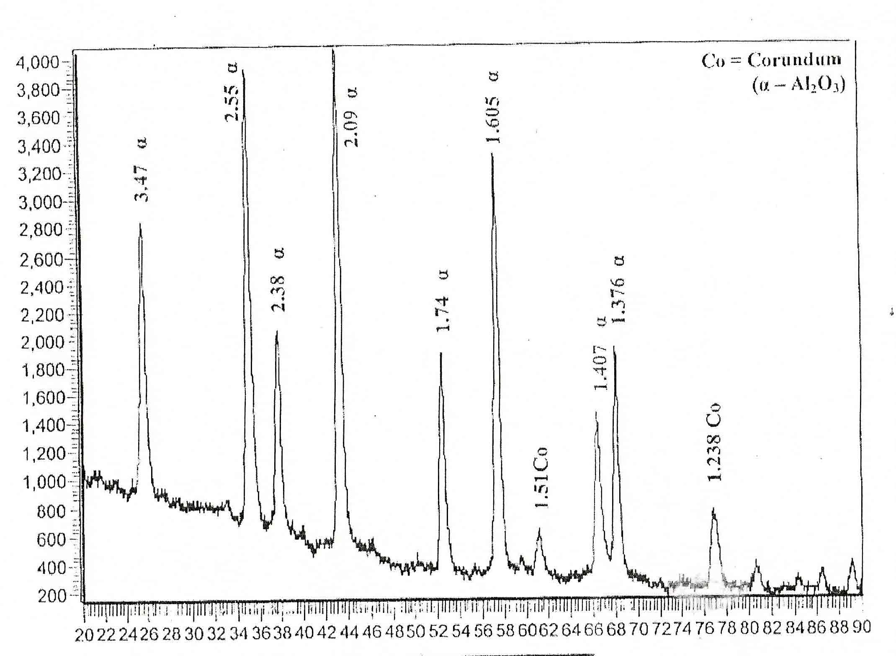

Figure 1 XRD of Al₂O₃ film.

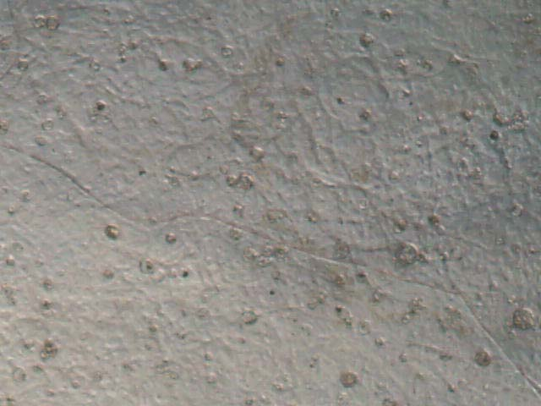 | 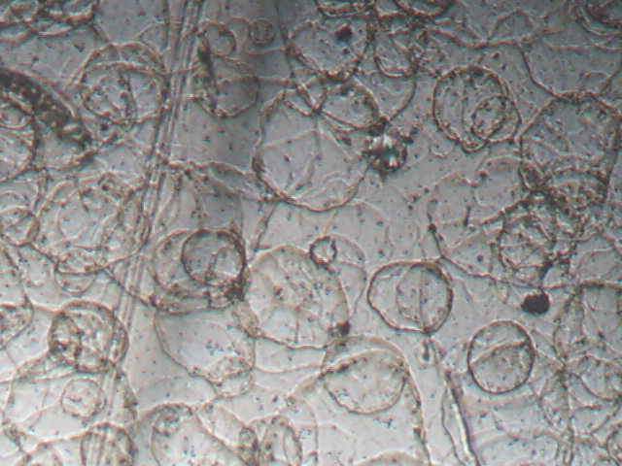
Figure 2-1 Pure Al₂O₃ film on glass substrate. | Figure 2-2 Circle type of deposited Al₂O₃ film on glass substrate.
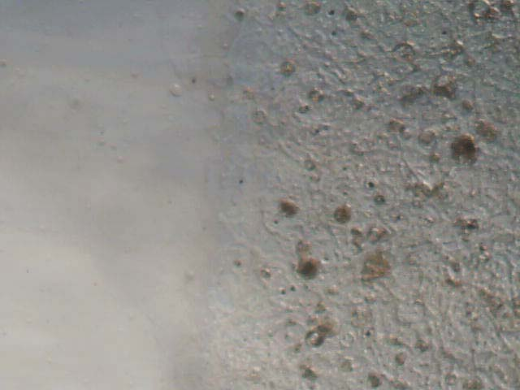 | 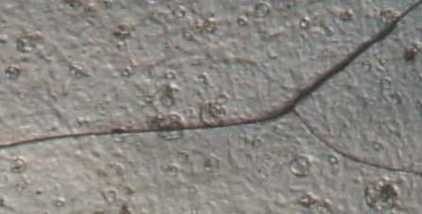
Figure 2-3 Interface of Al₂O₃ film on glass substrate | Figure 2-4 Some crake in Al₂O₃ film on glass substrate.
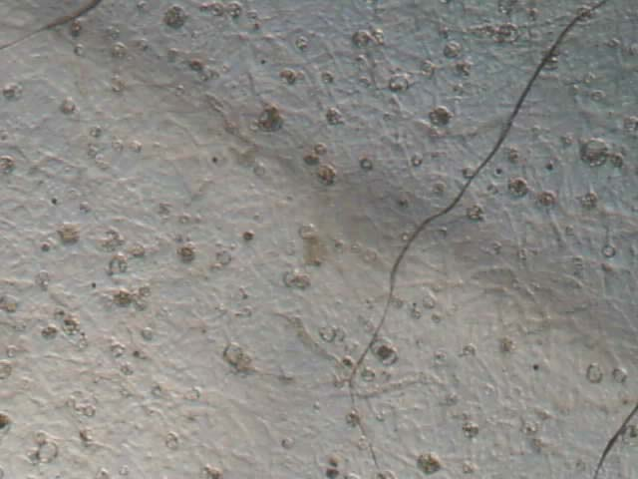 | 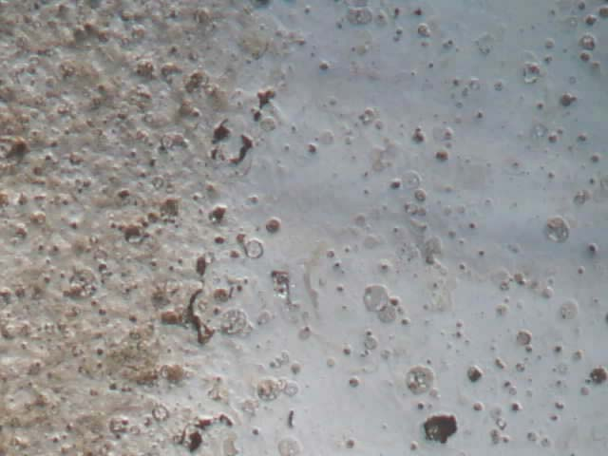
(b) 3 wt% Fe | (a) 1 wt% Fe
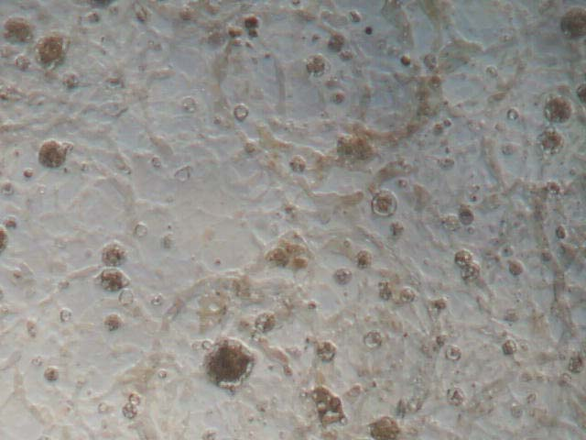
(c) 5 wt% Fe

Figure 2-5 Al₂O₃:Fe film on glass substrate.

 | 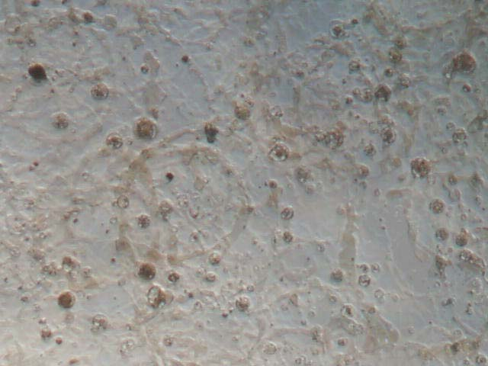
(a) 1wt% Ni | (b) 3wt% Ni
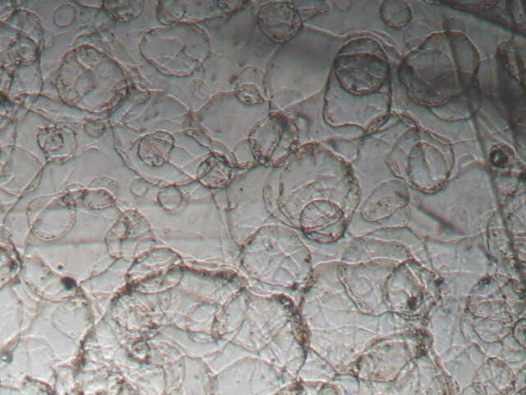

(c) 5wt%Ni

Figure 2-6 Al₂O₃:Ni films on glass substrate.

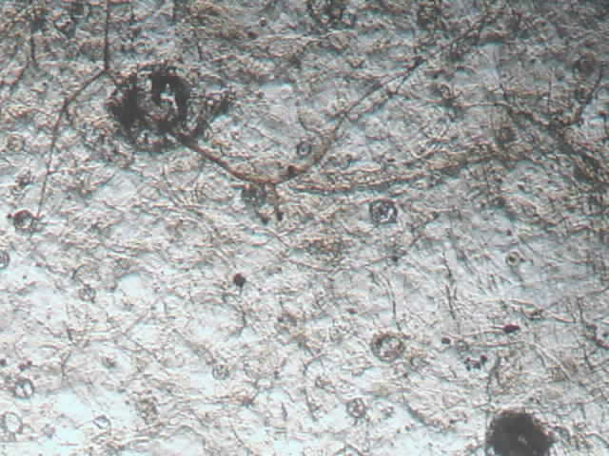 | 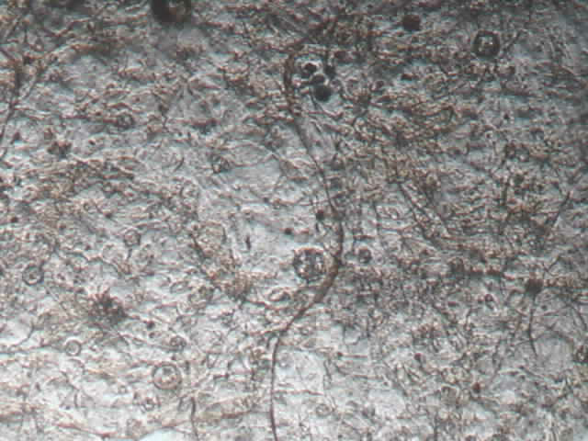
(a) 1wt%Cu | (b)3wt%Cu
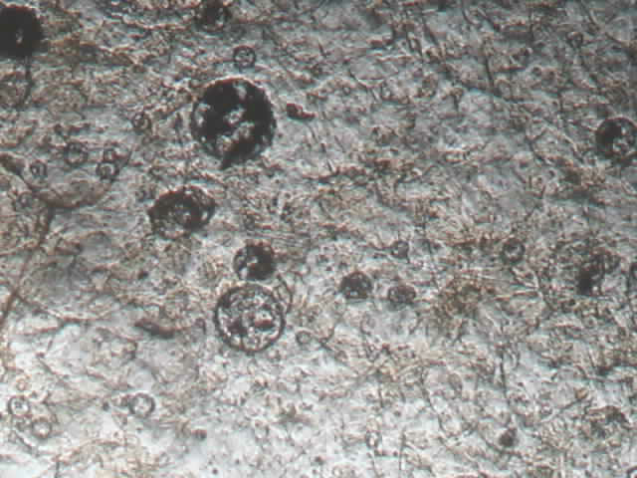
(c) 5wt%Cu
Figure 2-7 Al₂O₃:Cu films on glass substrate.

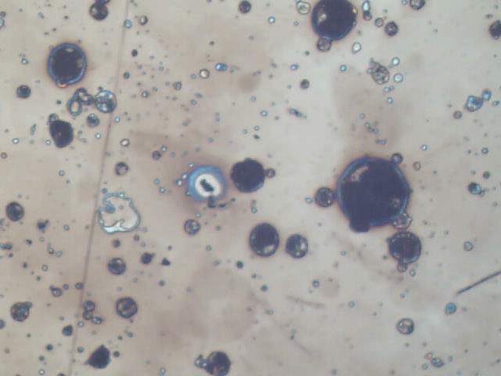  (a) | 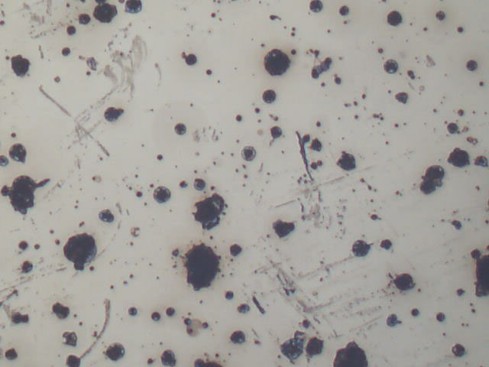  (b)
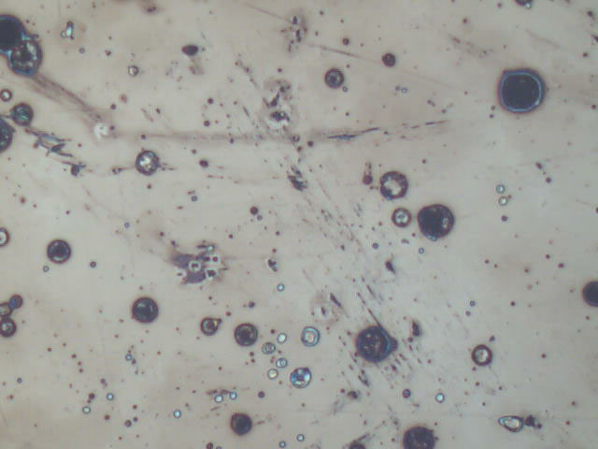  (c) | 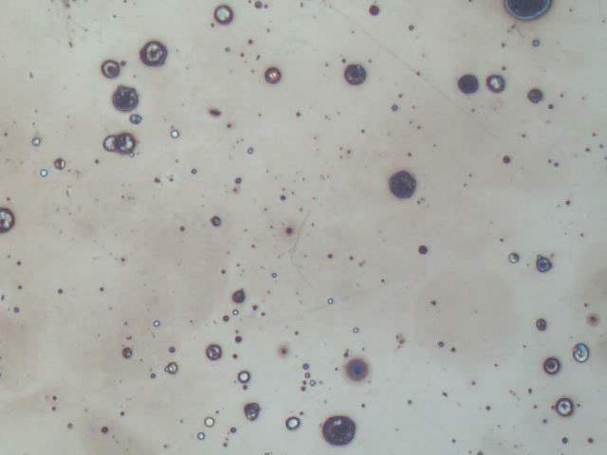  (d)

Figure 2-8 (a) Al₂O₃ films on stainless steel-304 substrate (b) Al₂O₃:Fe(1wt%)
(c) Al₂O₃: Ni(1wt%) (d) Al₂O₃:Cu (1wt%).

Figure 3 Apparent density of Al₂O₃ film.

Figure 4 Open pores in Al₂O₃ film on stainless steel-304.

Figure 5 Microhardness of vicker's Al₂O₃ films on glass.

Figure 6 Microhardness of vicker's Al₂O₃ films on stainless steel-304.

Figure 7 Wear result of stainless steel-304.
Figure 8 Wear result of Al₂O₃:Fe films.

Figure 9 Wear result of Al₂O₃:Ni films.

Figure 10 Wear result of Al₂O₃:Cu films.

