Exploring Students Comprehension of Speaker Intention In Part A of The TOEFL Listening Section
May Ali Abdul – Ameer
University of Al- Qadissiyah / College of Arts

Abstract
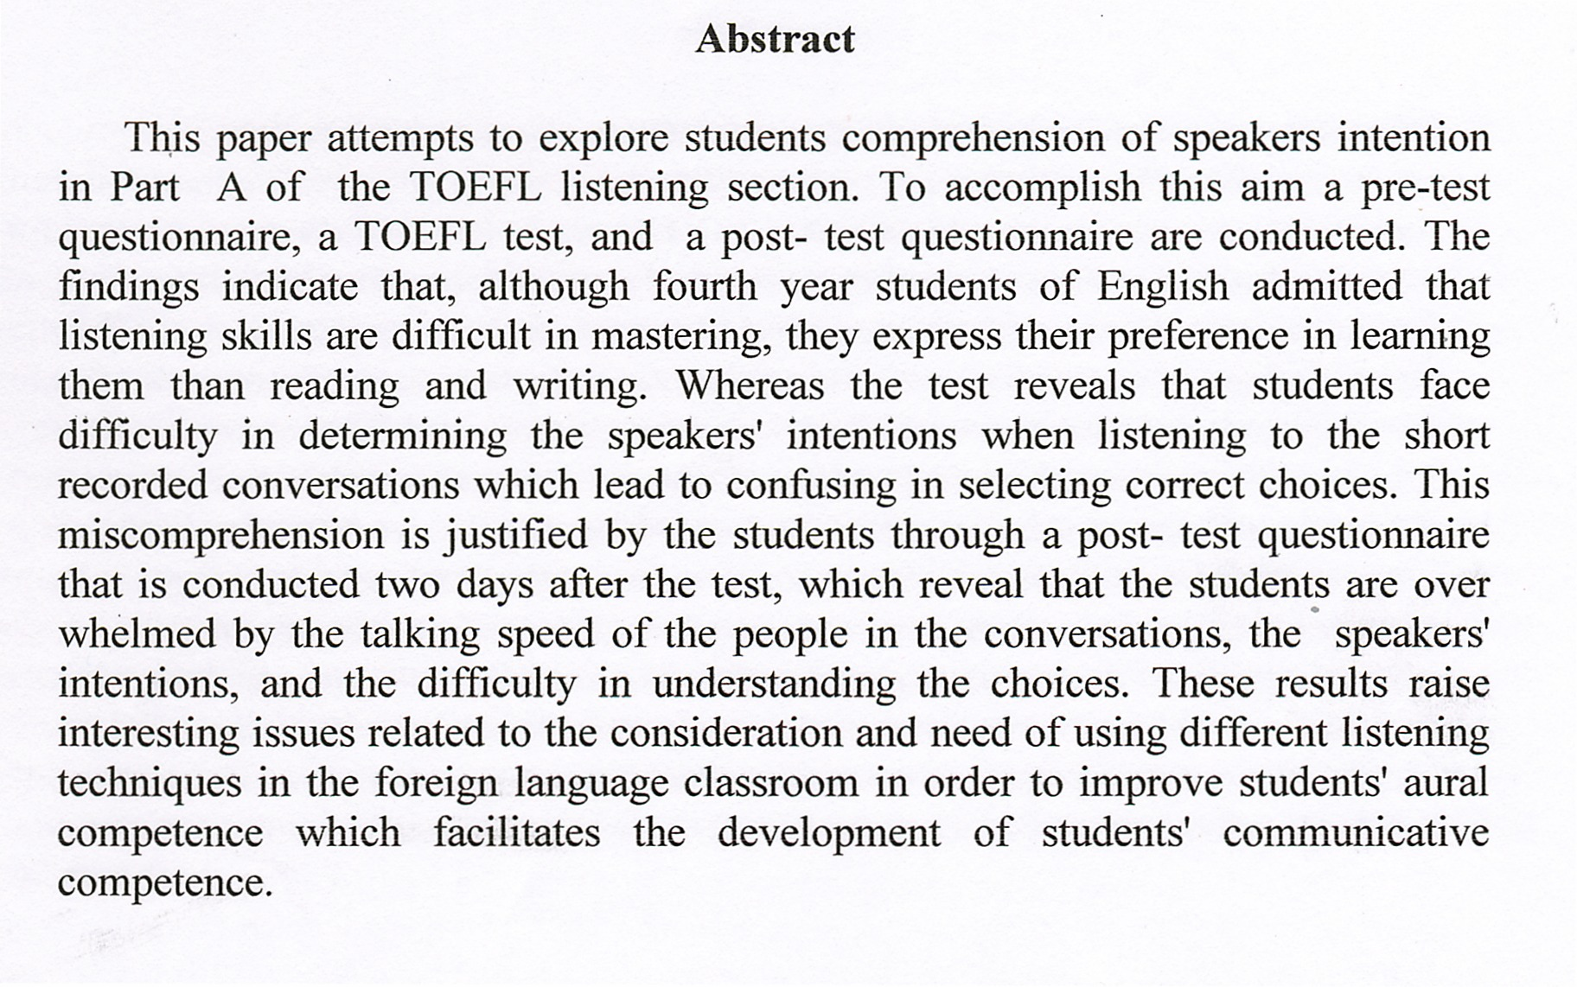
الخلاصة
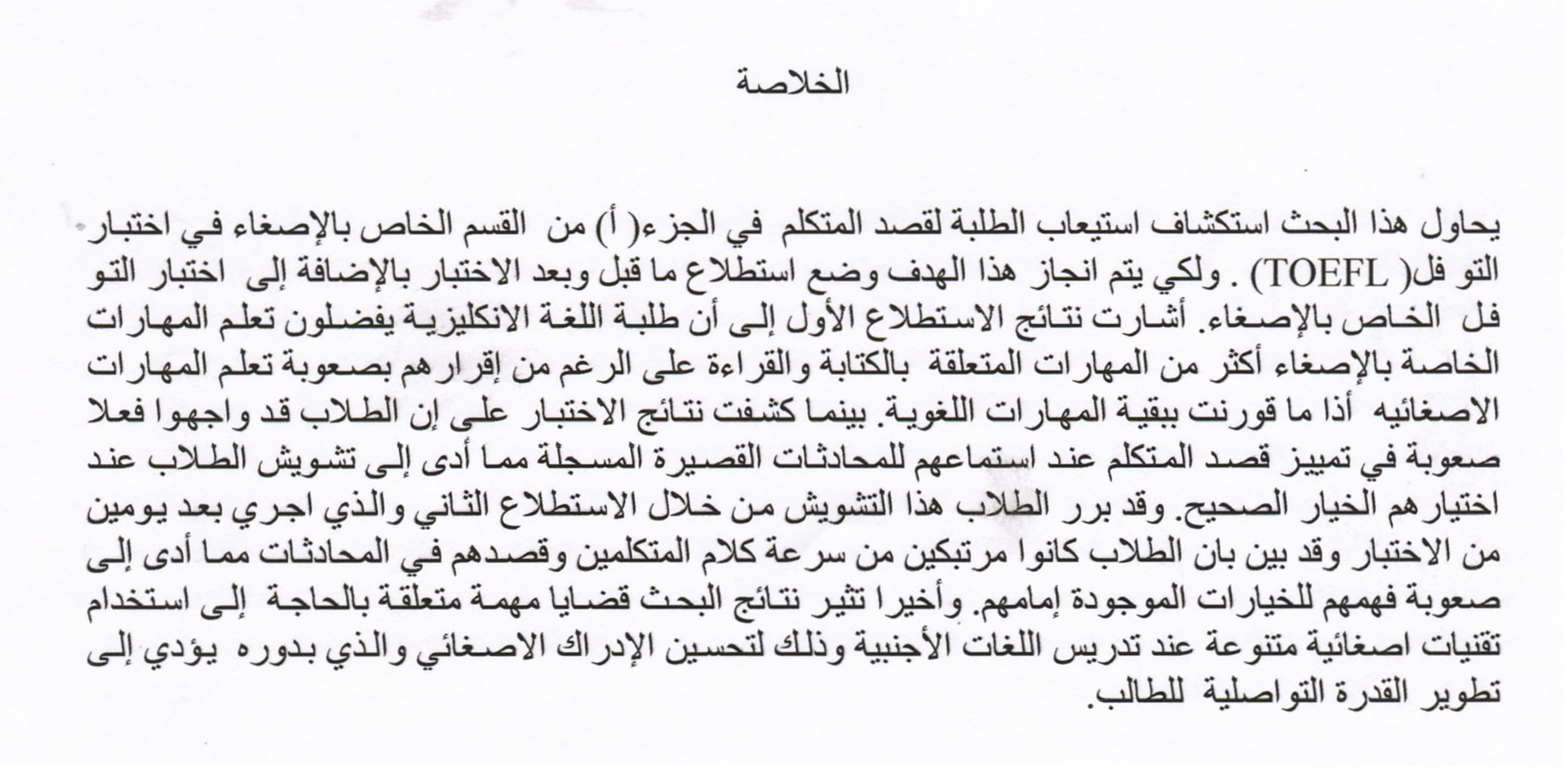
1. Introduction:
For almost five years, the Ministry of Higher Education in Iraq has encouraged Universities to improve students' communicative competence in foreign language education through tests such as TOEFL (Test of English as a Foreign Language). Students who intend to be more competent in English language and who plan to continue their higher studies inside Iraq or abroad are obliged to take such a test. Having studied English for four years, students of English throughout Iraq who attempt to take such a test must get a pre-determined score in order to pass. But most students of English, who had experienced the TOEFL test, always have a negative reaction against it.
Putting in mind this fact, this paper tries to explore English students' comprehension of speakers intention in the TOEFL listening section. The reason behind giving priority to study listening comprehension compared with the structure and reading in TOEFL is the hypothesis this paper works under which is: students of English face difficulty in the listening comprehension skill and, although this skill is important in the process of acquiring communicative competence it rarely takes place in the Iraqi English departments. Besides a pre-test questionnaire which has been conducted by the researcher has shown that most students who had participated in the test are eager to improve their overall English ability, especially listening and speaking and some of them are planning to continue their higher studies in the near future. Furthermore, according to the questionnaire many of the students expressed their preference of improving listening capabilities to reading and writing, though they acknowledged that listening is the most difficult skill to master.
Rivers (1994:11) points out that, teaching language as communication has become an accepted aim of the foreign language teacher throughout the world, which means we must teach our students to speak the language with some fluency and authentic style. However, what has been less emphasized is that communication is a process involving at least two people. Speaking by itself does not constitute communication unless what is said is comprehended by another person (Cook, 1990:29).Rivers (1994:12 ) states that, the greatest difficulty for a traveler in a foreign country is not that he can not make himself understood; this simply can be done by gesture, by writing or by pointing to something written in a bilingual book of phrases. His first difficulty, and one that leads to considerable emotional tension and embarrassment, is that he cannot understand what is being said to him and around him. Even if the native speaker pronounces his words slowly, elements of stress, intonation and word-grouping, often appear in an attempt at clarity, add to the confusion of the inexperienced foreigner. As a result there is no effective communication and the traveler's speaking skills cannot be exercised to such a great advantage. His participation in community life is limited by his inability to comprehend announcements, broadcasts, lectures, plays and films (ibid).
In this study the researcher will focus on part A of the TOEFL listening comprehension because the part contains several short conversations which expose students to a variety of authentic spoken English conversations. Also this part serves the aims of the study which are:
- exploring the fourth-year students of English comprehension of part A in the TOEFL listening section.
- identifying the factors that made the listening section of the test difficult through a post-test questionnaire.
2. Review of literature
2.1 Listening Comprehension as a skill :
Although listening comprehension plays a key role in foreign language teaching, it still remains one of the least understood processes. It has long been regarded as a passive skill and researchers considered it an ability that would develop without assistance (Anderson and Lynch, 1988; Brewster, 1994; Brown, 2001).
Richards (1998:55) points out that, it was not until 1970s that listening comprehension began to attract much attention and started to be explored. During the 1980s special attention to listening was incorporated into new instructional frameworks focused on functional language and communicative approaches. Then throughout the 1990s, attention to listening in language instruction increased dramatically, new theoretical models of comprehension in the field of cognitive psychology emerged.
Listening is the most common communicative activity in daily life: "we can expect to listen twice as much as we speak, four times more than we read, and five times more than we write"(Morley,1991:82). Unfortunately, as Brown (2001:247) states, the importance of listening in language learning can hardly be"overestimated", through reception we internalize linguistic information without which we could not produce language. He(ibid) adds that, in classrooms, students always do more listening than speaking, listening competence is universally "larger" than speaking competence. Despite this important fact, Wills(2002:10) points out that careful observation of college English teaching practice has shown that listening skills are still the weak link in the Language Teaching process. Having mastered the basic elements of English grammar and vocabulary, students listening comprehension is often weak. He adds that while students integrate skills in reading, writing and translation, their listening and speaking capabilities have been left behind. Thus, Morley (2001:84) suggests that , skill building in listening comprehension needs to be of central focus in language teaching- all day, every day, it is not something that can be accomplished in a half-hour lesson, nor limited to language laboratory tapes. Today there are many text and tape programs to choose from and, in general, materials are becoming more carefully principled. Coming to the fact that material developers should pay attention to principles of design, communicative outcomes, language functions, language processes, and affective considerations(ibid).
2.2 Listening Comprehension as a Process:
In the process of listening comprehension, listeners do not simply extract meaning from the input, but construct it based on their knowledge of the language system , their prior knowledge and the context of interaction (Vander and Goh, 2003:395). Listeners must discriminate between sounds, understand vocabulary and grammatical structures, interpret stress and intonation, then interpret this within the immediate as well as the larger socio-cultural context of the utterance (Wilph,1994:4). Leading to the fact that listening comprehension is a complex active process of interpretations in which "listeners mach what they hear with what they already know"(ibid).Richards (2003:443) points out that when the distinction between bottom-up processing and top-down processing was derived in the 1980s, listening came to be viewed as an interpretive process. And, at the same time, fields of conversation analysis and discourse analysis were revealing a great deal about the organization of spoken discourse and led to the realization that written texts read aloud could not provide suitable basis for developing the abilities needed to process real-time authentic discourse .Both bottom-up and top-down processing have directed the attention of many researchers and educationalists. Top-down processing makes use of "higher level", non-sensory information (e.g., learners knowledge of the world) to predict or interpret "lower level" information (e.g., words and sentences), while bottom-up processing makes use of the information present in the input to achieve higher levels of meaning(Cook,1990:79).
According to Matsuoka (2009:32) listening comprehension is the ability to understand the spoken language of a native speaker, it is concerned with decoding of speech, which involves continual mental processing, concentrated attention, and memory. He states that listening comprehension as a process has seven levels:
- Isolation of sounds;
- Identification of meaning;
- Integration of meaning with the past experience;
- Noting of relationships;
- Interpretation to discover implications;
- Interpretation of responses;
- Introspection concerning the effect of what is heard upon the listener.
But,these levels are also influenced by many linguistic, paralinguistic and psychological factors: the physical environment, the mental and physical condition of the listener,the listener's attitude and the ability to "tune out" distractions, the interest of the communication, the speaker's sincerity and the complement of the group.. etc (ibid).
To sum up, it is widely admitted that successful listening is not something that happens because of what a speaker says; the listener has a crucial part to play in the process, by "activating various types of knowledge, and applying what he knows to what he hears" in order to understand what the speaker means (Anderson and Lynch,1988:88). It is not only the process of an "unidirectional receiving of audible symbols, but an interactive process"(Brown,2001:249).
3. Methodology
3.1. The Participants and Setting:
The sample of the study was the fourth year students/ Department of English/ College of Education/ University of Al-Qadisiya. It should be noted that the students who have chosen to participate in the test have never experienced this kind of test before and were willing to take it after their graduation. So, out of 114 only 20 participated in the test 8 boys and 12 girls. It should also be mentioned that the test was taken from the TOEFL Actual Test book (2004), a book composed of previously administrated TOEFL test. The test focused on part A of TOEFL listening comprehension because, as mentioned previously in the introduction, this part includes several short conversations which expose students to a variety of authentic spoken English language. Description and analysis for other sections in the TOEFL are not included in this paper. Also a pre-test questionnaire was conducted the day before the test to investigate the aims and background of the participants. Then a post-test questionnaire was also conducted two days after the test to identify the factors that made the TOEFL listening comprehension part A difficult .
3.2. The Pre-test questionnaire:
In order to verify the hypotheses of the study and to investigate the aims and background of the participants, a pre-test questionnaire was conducted. The questions asked were:
- Which of the following four skills of English do you feel difficult to learn: listening , reading, writing and speaking? Choose one skill
- Which of the following four skills of English do you want mostly to learn? Choose one skill.
- Why do you want to take the TOEFL test after graduation? Check up two reasons of the following:
a. because it is required in the Iraqi Universities for M.A. studies.
b. to prepare for studying abroad in the future.
c. to challenge for a test that I have never taken.
d. to test my English ability.
e. because I am interested in TOEFL.
f. other reasons.
The two tables below show the results of the three questions in the pre-test questionnaire:
Table(1):Results of Question (1) and (2) of the Pre-Test Questionnaire: Students' Preference in Studying English Skills in Percentages
questions | listening |  | speaking |  | reading |  | writing |  | Total
questions | N | % | N | % | N | % | N | % | N | %
1. skill that students feel difficult to learn | 8 | 40% | 8 | 40% | 1 | 5% | 3 | 15% | 20 | 100%
2. skills that students want mostly to learn. | 8 | 40% | 10 | 50% | 1 | 5% | 1 | 5% | 20 | 100%

Table (2):Results of question (3) of the pre-test questionnaire: reasons behind students taking the TOEFLin the future
Reasons behind students taking the TOEFL test in the future | Students choices
Reasons behind students taking the TOEFL test in the future | N | %
a. because it is required in the Iraqi Universities for M.A. studies. | 17 | 85%
b. to prepare for studying abroad in the future | 8 | 40%
c. to challenge for a test that I have never taken | 6 | 30%
d. to test my English ability. | 6 | 30%
e. because I am interested in TOEFL. | 3 | 15%
f. other reasons. | no entry | %
3.3 The test:
The test was taken from the TOFEL Actual textbook (2004), and test (1) in the book was chosen. It is required from the students in part A of the test to hear 30 short conversations between two people. After each conversation they will hear a question about it, putting in mind that the conversations and the questions will not be repeated again. After hearing the questions the students should read then choose a best answer out of four possible ones written in a test paper in front of them.
Although the test is not conducted in a formal setting of any TOEFL test, but it did provide essential data for the analysis. Moreover it served in verifying the first aim of the study that is: exploring fourth year students of English comprehension of speakers intention in the TOEFL listening section. Also, it should be noted that the researcher has categorized the answers given by the students into three categories, from (1 to 10, 11 to 20, 21 to 30), this was done for analyzing purposes only, since mentioning 20 answers for 30 items will take a table of two pages making it distracting and boring to cope with.
Table (3) shows the score parentages of students performance in part A of the TOEFL listening section.
Table (3):Score percentages of students' performance in part A of the TOEFL listening comprehension
Test answer | right |  | wrong |  | total
Test answer | N | % | N | % | N | %
1 to 10 | 6 | 30% | 14 | 70% | 20 | 100%
11 to 20 | 8 | 40% | 12 | 60% | 20 | 100%
21 to 30 | 8 | 40% | 12 | 60% | 20 | 100%
3.4 Post- test questionnaire :
In order to explore the factors that made the TOEFL listening section difficult,(the second aim of the study), a post–test questionnaire was conducted. In the questionnaire the students were asked to choose two factors that they think made TOEFL listening difficult.
The factors were as followed:
- Difficulty in understanding the choices.
- Difficulty in determining the speakers' intention.
- The talking speed of people.
- Unknown vocabulary.
- Lack of time in reading choices.
- Perplexity in deciding correct answers.
Table (4) below shows the results of the post-test questionnaire:

Table(4):Results of the post-test questionnaire: factors that students think made theTOEFL listening section difficult
Factors | percentages of choosing two factors  N %
1.Difficulty in determining speakers' intention. | 16 | 80%
2.Difficulty in understanding the choices. | 5 | 25%
3.The talking speed of people. | 8 | 40%
4. Unknown vocabulary. | 8 | 40%
5.Lack of time in reading choices. | 1 | 5%
6.Perplexity in deciding correct answers. | 1 | 5%
3.5 Data Analysis:
Data for this research were collected through a pre-test questionnaire, part A of a TOEFL test and a post-test questionnaire. Table (1) shows the results of question 1 and 2 of the pre- test questionnaire which indicate that 30% of the students selected speaking and listening as the skills most difficult to master although 40% of them expressed their preference of learning the two skills than reading and writing. This contradictory, but noteworthy, result makes it clear for the need and importance of teaching listening comprehension in the English Departments in Iraq. Table (2) shows the results of question 3 of the same questionnaire which asks about the reasons why they want to take the TOEFL test after graduation. The students were requested to checkup two reasons out of six presented in the questionnaire. It appeared that 85% of the students wants to take the test because it is required in the Iraqi Universities for M.A studies. Reason number 2, to prepare to study abroad in the near future was selected by about 40% which seemed to be the second most important reason. It was found that 30% of the students wanted to take the test both to challenge for a test that they have never taken and to test their English ability. Only 15% wanted to take the test because they were interested in TOEFL. No entry was written in the last open-ended space.
Table (3) shows the score percentages of students performance in part A of the TOEFL listening section. In the first ten conversations only 30% of the students managed to choose the correct answer, while in the second and third ten conversations only 40% chose the right ones. This suggests that fourth year students of English face difficulty in comprehending such recorded conversations spoken by native speakers of English which lead to miscomprehension of the choices given in the test sheet. In order to examine the results and to observe the reflections of the students on the test, a post- test questionnaire was conducted. Table (4) shows the results of the questionnaire, which asked the students to identify two factors out of six presented in front of them that they think made the TOEFL listening comprehension section difficult. According to the table 80% of the students selected "difficulty in determining speakers' intention" as the most significant factor. Both "unknown vocabulary" and "talking speed of the people in the recorded conversations" follows, selected by 40%. The factor concerning "difficulty in understanding the choices" was selected by 25%, and 5% chose the factor "lack of time in reading the choices" and "perplexity in deciding correct answers."
4. Conclusion
The output of this study proves the researchers' initial believe regarding the fact that Iraqi students of English faced difficulty with dialogues in part A in the TOEFL listening section. In particular, They expressed their difficulty in determining the speakers' intention which is hidden under the surface meaning and showed confusion in selecting correct choices. In fact, even though the students have more difficulty in mastering listening skills than in reading and writing, they expressed their eagerness to achieve a rather good degree of learning in listening. However, teaching listening comprehension rarely (if never) takes place in the Iraqi universities, despite the fact that it is important in the process of acquiring communicative competence. Thus, in order to obtain better results concerning students' listening comprehension, it is urgent to develop new materials and resources suitable to all ages beginning from the primary stages in Iraq up to the University stage. And if the new materials are to be used in the foreign language classrooms, they need to include higher quality sound systems and slower speed talking. Strategies concerning conversational analysis and listening instructions that is needed in order to comprehend listening skills should be taught to offer support for learning experiences and help student discover and rehearse listening processes. In this respect, Vander and Goh (2009:396) argue that students should be taught how to listen, otherwise listening activities become nothing "more than disguised forms of testing learners' existing listening abilities, which serves to increase anxiety about listening"
In sum, it is necessary to conduct further studies concerning listening comprehension as a skill and a process in foreign language teaching and learning. Besides, the importance of Multimedia applications in the classroom, internet-based content and computer-based technology, in improving learners' listening skills should also be studied and analyzed in order to design a coherent syllabus which may respond to the learners' needs. Putting in mind that improving listening comprehension as a skill and a process might facilitate and improve the other skills in language learning.
Bibliography
Anderson, A. & Lynch, T. (1988). Listening. New York: Oxford University Press
Brewster, J.(1994). Listening and the young learner. In C. Brumfit, J. Moon, and R. Tongue (Eds.), Teaching English to children. London: Nelson, pp158-177. first published by Collins ELT in 1991.
Brown, G. (1989). Making sense: The interaction of linguistic expressions and contextual information. Applied Linguistics 1, pp. 97-108.
Brown, H. D. (2001). Teaching by Principles: An interactive approach to language pedagogy. Second edition. New York: Longman.
Cook G. (1990). Discourse. Oxford: Oxford University Press.
Matsuoka, Y. (2009). Possible strategies for listening comprehension: Applying the Concepts of conversational implicature and Adjacency pairs to understand speaker intention. Accent Asia [online], (2), 27-56
Morley, J. (1991). Listening comprehension in second/ foreign language instruction. In Celce-Murcia 1991.
………, …. . (2001). Aural comprehension instruction: principles and practices. Boston: Heinle and Heinle publishes.
Richards, J.C. (1998). Listening Comprehension. NewYork:Cambridge University press.
…………, .. . (2003). What Do I See? What Do I Think? What Do I Wonder?: A visual strategy to help emergent readers focus on storybook illustrations. The Reading Teacher, pp442-448.
Vander, L. & Goh, C. (2009). Teaching and Testing listening Comprehension. In M. H. Long and C. J. Doughty (Eds.), The Handbook of Language Teaching. Blackwell, pp 395-408.
Wills, R. (2002). An investigation of factors influencing English Listening comprehension and possible measures for improvement. Harlow: Longman.

Wilph,J.(1994). Strategies for teaching second language listening comprehension. Foreign language Annals 17: 345-48

Appendix
Directions: In this test you will hear short conversations between two people. After each conversation you will hear a question about it. The conversations and the questions will not be repeated. After hearing the question, read the four possible answers in your test sheets and choose the best one.
Note: Do not take notes or write in your test sheets at any time. Do not turn the sheet until you are told to do so.
The test
- (A) She reads more slowly than the man does.
(B) She has a lot of material to read before she has coffee.
(C) The man does more work than necessary.
(D) The man seems to be taking a long time preparing for philosophy class.
- A)The woman should have shown him the newspaper.
(B) He thinks the woman will win the contest.
(C) The woman's pictures are on top of the newspaper.
(D)The new photograph does not look anything like her others.
- (A) Return his literature books to the bookstore.
(B) Keep his books from the literature class.
(C) Sell his literature books to the woman.
(D) Visit the reference section of the library.
- (A) Give the secretary Janet's new address and phone number.
(B) Ask Janet a question about his health.
(C) Get information about Janet from the secretary.
(D) Visit Janet at her new school.
- (A) She will help the man find the exhibit.
(B) She has already seen the exhibit.
(C) She will help the man read the map.
(D) She Knows where to get a map.
- (A) She is also planning to travel.
(B) She already picked up money from the trip.
(C) She has to study instead of traveling.
(D) She thinks the man should take more money.
- (A) The woman should not get involved in the situation.
(B) The woman should not be angry with her friends.
(C) He wants to talk to Sally and Mark.
(D) He will explain to the woman what happened.
- (A) What travel plans Philip is making.
(B) How Philip's parents are going to travel.
(C) What Philip said.
(D) Where Philip heard the news.
- (A) She will have to postpone her trip.
(B) She has already gotten her passport office application.
(C) The passport office is closed.
(D) She was late in applying for her passport.
- (A) He has not played tennis in a while.
(B) He does not know how to play tennis.
(C) His tennis racket is broken.
(D) He needs to rest before he plays.
(A) No one was interested in the discussion.
(B) Politics is a sensitive topic.
(C) The woman is not being serious.
(D) People avoided discussing politics.
- (A) She already read the book.
(B) She will not lend her book to the man.
(C) The man can use her book whenever he likes.
(D) The man does not need the book.
12. (A) It is about to start raining.
(B) The rain will stop soon.
(C) It has been raining all day.
(D) It just stopped raining.
13. (A) She is not permitted to live off-campus this year.
(B) She has been living off-campus for a year.
(C) She is happy with her living arrangements.
(D) She is required to move next year.
14. (A) She misses her old roommate.
(B) She changes roommates often.
(C) She does not know Julie very well.
(D) She did not really enjoy living with Julie.
15 (A) Take a shorter route.
(B) Buy new sunglasses
(C) Drive on a different road.
(D) Consider using Route 27.
16. (A) Give her ticket to the man.
(B) Borrow some jazz music from someone else.
(C) Go to the concert without the man.
(D) Help the man to complete his paper.
17. (A) Sullivan's has never been able to keep its chef.
(B) The service at Sullivan's is dependable.
(C) The quality of the cooking at Sullivan's is inconsistent.
(D) Customers get a lot of personal attention at Sullivan's.
18. (A) She thinks the weather is pleasant.
(B) She has been working hard in the lab.
(C) She is not feeling very well today.
(D) She has been staying up quite late recently.
19. (A) The woman can wear it all winter.
(B) The woman may have trouble paying for it.
(C) It may not be warm enough.
(D) It will not fit if the woman loses weight.
20. (A) Introduce Michelle to the other reporters.
(B) Take Michelle home.
(C) Take a tour of the office.
(D) Start working at his desk.
21. (A) They should turn left when they see a stop sign.
(B) He does not have the directions with him.
(C) He does not see the stop sign yet.
(D) He does not know which way to turn.
22. (A) He has not been to the new restaurant yet.
(B) He would like to go to the new restaurant with the woman.
(C) The food at the new restaurant is not very good.
(D) A restaurant's atmosphere is very important to him.
23. (A) She is planning to drop the class.
(B) She thinks the man wants to take the class.
(C) She only has one class on Tuesdays and Thursday.
(D) She has to leave for class.
24. (A) He does not feel very well.
(B) He had several teeth filled.
(C) The dentist gave some medication.
(D) The woman is mistaken.
25. (A) Business courses have become popular.
(B) The school only offers business courses.
(C) The business school has a new program.
(D) The school has just started to offer business courses.
- (A) His alarm clock is broken.
(B) He has been late before.
(C) He prefers to study early in the morning.
(D) He worked in the lab last night.
27. (A) He will lend the woman money to buy a computer.
(B) The woman should wait a while before buying a computer.
(C) The woman should find a better way to invest her savings.
(D) The woman should buy a computer.
- (A) There are none left.
(B) They are too expensive.
(C) They might be available at the concert.
(D) They need to be purchased in advanced.
- (A) She will go to the restaurant with the man.
(B) She will meet the man and his friends later in the evening.
(C) She has already had dinner.
(D) She will not change her original plans

