Beyond the Law of Transitivity:A Functional Stylistic Study of Maya Angelou's
I Know Why the Caged Bird Sings
Muthanna Makki Muhammed
College of Education for Humanities/University of Kerbala
muthannamakki@yahoo.com

Abstract
The dominant critical focus on Maya Angelou’s writings has been on the thematic features of her texts. Linguistic and stylistic appraisals on her works are generally sparse. This paper is a stylistic study of Maya Angelou’s autobiographical novel
I Know Why the Caged Bird Sings. It aims at examining the stylistic features of the text vis-à-vis the semantic Law of Transitivity so as to investigate the features that contribute in the discourse’s trespassing the sphere of informing to the sphere of interaction and influence.
The paper starts with brief notes on stylistics in relation to semantics. This is followed by a discussion of the Law of Transitivity, frequent references are made to John R. Searle’s patterns of metaphor. The varied forms of the relations between the signified or the source (the vehicle) and the signifier or the target (the tenor) in relation to the sign (the common ground) are discussed in the light of the figurative devices employed by the author and the functions achieved in revealing the ideological issues of race and gender in the book. The study attempts also at positioning the formal and psychological elements within a sociocultural context in order to promote the reader’s understanding of the purposes and functions to which certain linguistic choices are made.
Keywords: Stylistics, the Law of Transitivity, race, autobiography, metaphor, figuration.
الملخص
ان جلَّ ما كُتِب من نقد عن كتابات مايا أنجيلو قد ركّز على الملامح الموضوعية لنصوصها. فقلما نجد دراسات لغوية أو اسلوبية تتناول أعمالها بشكل عام. هذا البحث دراسة اسلوبية لرواية السيرة الذاتية (أعرف لِمَ يُغرِّد الطائر الحبيس) لمايا أنجيلو. تهدف الدراسة الى تفحص السمات الاسلوبية للنص ازاء ما يعرف في علم الدلالة بـ (قانون التعدية) من أجل تحري السمات التي تسهم بتعدي الخطاب نطاقي الاعلام والاخبار الى حيِّزي التفاعل والتأثير.
يُستهل البحث بملاحظات موجزة عن الاسلوبية وعلاقتها بعلم الدلالة. يتبع ذلك نقاش حول ماهية قانون التعدية بالإشارة الى أنماط الاستعارة التي ذكرها جون سيرل . كما يتم مناقشة الاشكال المتعددة للعلاقة ما بين الدال والمدلول من ناحية والعلامة من ناحية اخرى، وذلك في ضوء الوسائل البلاغية التي وظفتها المؤلفة في كتابها والغايات المتحققة من وراء طرح مواضيع فكرية كالعِرق والجنوسية.
كما تسعى الدراسة لوضع العناصر الشكلانية والنفسية في سياق ثقافي – اجتماعي لتعزيز فهم القارئ للأغراض والوظائف التي من أجلها انتُخِبَت خيارات لغوية معيّنة في النص.
الكلمات الدلالية: الاسلوبية، قانون التعدية، العِرق، الجنوسية، رواية السيرة الذاتية، الاستعارة، الوسائل البلاغية.

A modern trend among stylisticians (like Fairclough, 1989; Kress, 1989; Mills, 1995; and Haynes, 1992) is to focus on the way in which the decoding of a discourse is influenced by the ideological structures it carries.
In this way the study of the issues of segregation, gender, and the relation between the centre and the margin (to use the terminology of cultural criticism) is carried on within a framework of Critical Discourse Analysis.¹
Sociology also has offered a perspective for investigating style; classifying stylistic features by social standards as civil, popular, vulgar, rustic, …etc. The same can be said about psychology, semantics, …etc.² This interdisciplinarity and the availability of varied frameworks by which style can be studied is a feature of postmodernism which indicates the complexity of literary writing.³
Functional stylistics works interdisciplinarily in undertaking the task of justifying the use of certain stylistic features by a certain author, in a certain text, on a specific occasion; i.e. to specify the reasons for the author’s conscious or unconscious linguistic choices.⁴ Investigating the stylistic functions and the semantic implications of a discourse can be carried on within the framework of the logical Law of Transitivity and by looking for patterns in which transitive relations are stretched beyond the relation between the signifier, the signified, and the sign. For the apprehension of such relations a stylistician should determine who or what “A” and “B” are, what conception they have of themselves, and the relationships “A” and “B” have with the idea or object, on one hand, and with the form, on the other.⁵ The following points should be considered when applying a functional stylistic study:
1. The meaning of a lexical item is associated with the context and situation and the nature of the subject of the discourse, all these elements regulate the general current of the writer’s linguistic choices (the Synchronic axis);⁶ as the writer uses words which are different in describing, say, a child-rape accident from those employed in giving an account of a religious sermon.
2. To arrive at a certain author’s stylistic features we should isolate the features that belong to the age and the adopted genre so that only those related to the author remain.
3. The author’s intention behind using specific features in a specific discourse and situation determines his linguistic choices.⁷
These steps require the functional stylistician to work interdisciplinarily and to include the semantic level to explain how the parts make up the whole picture and the function these parts play in serving the meaning. These elemental parts are the discoursal features that include relations like compare and contrast, and cause and effect in which the semantic Law of Transitivity often plays a basic role as in simile and metonymy, while in other cases these relations provide interplay as in the case of extended metaphor, hyperbole and irony.⁸
Figuration is a crucial means of examining the transactional nature of discourse.⁹ For the purpose of understanding the relations between the components of certain expressions the semantic relations should be investigated as well.
Transitive relations include the concepts of similarity, equality, and comparison.¹⁰ The logical Law of Transitivity holds that:
If A=B, B=C,
Then A=C
i.e. if “A” bears a certain relation to “B” and “B” bears the same relation to “C”, then “A” bears it to “C”.¹¹ Roland Barthes, in his book Mythologies, states that the semiological relation between a signifier and a signified that belong to different categories is one of equivalence rather than of equality.¹² The applicability of a general term (like simile, metaphor, metonymy,…etc.) on a set of objects is to index a certain common property. The Law of Transitivity indicates that the relation between the sentence literal meaning and the metaphorical utterance meaning is systematic, unlike the relation between words and meaning which is random.¹³ These rules of transference or mechanisms for deriving one meaning from another make figurative interpretation systematic.¹⁴
The property of inequality follows the same principle:
If A is greater than B (i.e. A > B), B > C, then A > C; and if A is less than B (i.e. A < B) and B < C, then A < C.¹⁵
The system of transitivity is the grammatical means by which experience can be captured in literary language. It is the way meanings are encoded in the text. To investigate this process of encoding from a functional stylistic view point three key components should be selected:
1. The verb phrase in which grammar is realized.
2. The noun phrase in which the participants associated with the process are realized.
3. The prepositional and adverbial phrases that constitute the adjunct element in the discourse.¹⁶
Relations within the system of transitivity are used in I Know Why the Caged Bird Sings to symbolize ideologies and to reveal identities. The author’s stylistic choices reveal various semantic functions that arouse the reader’s sympathy and apathy towards a certain character, in a certain situation, at a certain time.¹⁷ However, there are kinds of associations, as in certain types of metaphor, which are psychologically based, that hold no literal similarities as in the break between the speaker’s utterance meaning and literal sentence meaning in irony in which what the speaker says contradicts what is said.¹⁸
Maya Angelou in her autobiographical novel recreates the self in the character of Marguerite, who relates her early experiences of gender and racial discrimination from an African-American female perspective and, faced with experiences the protagonist does not fully comprehend, resorts to transitive relations to figure out some kind of explanation. This results in shifting identifications by the substitution of one relationship for another to highlight the ideological issues of feminism and segregation.¹⁹
The writer establishes a relation of equivalence in assimilating Marguerite to “sweet little white girls”, “movie stars” as well as associating her with “what was right with the world” once she puts “ruffles on the hem and cute little tucks around the waist”.²⁰ This conditional relation of equivalence, indicated by the lexical item “once” reveals the inferiority the White-American culture has infused into the character’s mind: black is ugly and wrong, white is magic and right.²¹ Critic Barry Stampfl indicates that “as if” statements in a linguistic discourse denote a departure from a real to an unreal assumption;²² see (Appendix: Figure 4). Yet, this association of the lexical item “black” shifts as the protagonist grows more conscious of the African-American identity to allude to positive values through the recurrent angel imageries associated with her brother Bailey who is presented as the physical foil of Marguerite’s unattractiveness “He smelled like a vinegar barrel or a sour angel” (p. 23); the simile here serves as a thematic clue.
The shift from the real to the unreal noticed in the early pages of the book depicts an innocent, childish, and fantastic way of perceiving the world “The giggles hung in the air like melting clouds that were waiting to rain on me.”(p. 3) .²³ It must be stressed here that the function played by a process of transitivity is not always absolute as meaning is not stable but depends on the receiver’s response or interpretation as much as it depends on the linguistic choices made by the writer.²⁴
The writer resorts to transitivity to provide explanation for the character’s self-chosen silence after the rape incidence. It is achieved through a number of devices including foreshadowing; like for example, when Mr. Freeman’s lawyer interrogates the young raped Marguerite in the court and the narrator comments “I used silence as a retreat” (p. 85).
Transitivity is employed by Angelou to reveal Social identity and discourse roles via the use of forms of address arriving at situational irony. In the court scene Grandmother Henderson (Momma) is unwittingly called “Mrs. Henderson” by a judge who did not know she was colored; it was a blunder calling a black woman “Mrs.”; the whites laughed, yet, the blacks thought it proved the worth of the old black woman.” (p. 48). This mishap helps change and at the same time reaffirm the character’s social standing. The discourse here depends on what Halliday calls the interpersonal metafunction of the language.²⁵ The law of transitivity here functions depending on the sender’s and receiver’s shared background information;²⁶ see (Appendix: Figure 4).
Employing certain lexical items and establishing relations of opposition between them in the form of metaphoric relations within the framework of transitivity is used by the writer to exemplify cases of racism in the southern city of Stamps, Arkansas :
People in Stamps used to say that a Negro couldn’t
buy vanilla ice cream except on July Fourth. Other
days he had to be satisfied with chocolate.
(underlines added. p. 49)
The comic tone is enhanced by the use of the lexical items “Negro” vs. “vanilla”; and “ice cream” vs. “chocolate”.²⁷ Similarly, the word “white” is used to say something while meaning something else in “of course, I knew that God was white too, but no one could have made me believe he was prejudiced.” (p. 50); see (Appendix: Figure 2).
Angelou often uses euphemistic expressions and imagery while presenting a traumatic or grotesque scene, in which case transitivity has the function of restoring the humanity and highlighting the innocence of the marginalized victim; as when Momma suggests that Uncle Willie hides under layers of onions and potatoes to avoid being spotted by the attacking Klan members:
I pictured his mouth pulling down on the right side
and his saliva flowing into the eyes of new
potatoes and waiting there like dew drops for the
warmth of morning. (p. 19)
It is the novelty of expression and newness of imagery in comparing the crippled old man’s saliva to dew drops that makes this piece worthy of stylistic examination. Associating the character here with vegetables is in sharp contrast with metaphors that depict the white world from black children’s view point as a “man-eating animal’s territory” (p. 25). This process of dehumanization can be seen elsewhere in the book like when Marguerite (the narrator) foreshadows the murder of her rapper comparing him to “helpless pigs which are fattened all year long for the slaughter, the joy of eating them comes only with their death.” (p. 72). Figure 1 in the Appendix clarifies the relationships of the elements of this metaphor.
The rape incident, which represents the climax in the book, provides a fertile ground for the law of transitivity to shift identities, highlight situations, and unravel a state of physical and psychological transformation. The writer describes the act of rape on an eight-year-old as “a matter of the needle giving” (p. 78). The needle image is clearly symbolic of the male sexual organ, while the physical pain inflicted on the child’s tender body is also suggested.²⁸ Angelou manipulates color symbolism and imagery to transfer the meaning onto other layers of meaning as in evoking the image of blood, the vagina, and physical passion when describing how the women whispered “out of blood-red mouths that I knew as much as they did. I was eight and grown.” (p. 84) “Knowing” here signifies sexual knowledge.
A major function of the law of transitivity is, then, to multiply the layers of meaning to enrich the significance of the discourse. This is achieved also by intertexuality and literary and Biblical allusions; here is an example of the latter:
Baily and I decided to memorize a scene from the
Merchant of Venice, but we realized that Momma
would question us about the author and that we’d
have to tell her that Shakespeare was white [….]
so we chose “The Creation” by James Weldon
Johnson instead. (p. 14).
James Johnson is here a substitute to Shakespeare;²⁹ a relationship of equivalence exists between The Merchant of the Venice and The Creation that reveals racial tension and that symbolically represents the call for ethnic equality. Marguerite and Baily’s subversion from the European to the African, from the white to the black is an act that reflects Momma’s prejudice and the two characters’ ethnic consciousness. There exists here tension between the transitive and the intransitive that highlights the racial rigidity in the novel. The law of transitivity here does not function on the bases of any metaphoric relation, rather it relies on ideological considerations and is enhanced by the writer’s choice of linguistic structure.
A similar tension between the transitive and intransitive can be detected when the author juxtaposes Mr. McElroy’s religiously revolting image with Momma’s obstinately religious one, as he “never went to church, which Baily and I thought also proved he was a very courageous person [….] to be able to stare religion down, especially living next door to a woman like Momma.” (p. 21). McElroy and Momma are each other’s foil regarding religion (intransitive relationship), yet, they are similar to each other in moral courage and strength (transitive relationship of equivalence).
Intertexuality with the Bible provides semantic features that enhance characterization “And all those people in the court would have stoned me as they had stoned the harlot in the Bible.” (p.85) (underlines added), the religious austerity of Margruite’s grandmother Henderson (Momma) is highlighted by the lexical archaism “Thou” and the Biblical structure of the Ten Commandements: “Thou shall not be dirty” and “Thou shall not be impudent” (p. 27). Note also a similar use in presenting the detestable character of Reverened Thomas in an ironic comparison to Christ receiving children “he opened his awful arms and groaned, “suffer little children to come unto me, for such is the Kingdom of Heaven”” (p. 35). Such style is used for purposes similar to those for which the mock-heroic is used in poetry: to satirize a character by describing the trivial by using a heroic style.³⁰
Angelou makes subjective claims that can be verified only by the receiver’s identification with the persona as in her use of hyperbole when she calls the black city of Stamps “metropolis” and the villages “towns” (p. 21).This deliberate and obvious exaggeration reveals the young Maragurit’s view point towards her world regarding her sense of its size. This also signifies an ironic tone with which the character-narrator presents the underprevillaged city of Stamps. This relation is clarified in (Appendix: Figure 4).
8

Conclusion:
The particularity and aesthetics of the range of stylistic features employed by Angelou in her narrative interact and cooperate to emphasize and highlight identity and ideology, that stimulates emotional, imaginative, and intellectual responses in the reader towards the plight of margenalized individuals in the Black American society. The semantic Law of Transitivity often plays a basic role in that process as in simile and metonymy, these relations, in other cases, provide interplay as in the case of extended metaphor, hyperbole and irony.
These multiple roles provide the writer with mechanisims for infusing additional meanings into existing ones in which the figurative sense replaces the literal resulting in polysemy or transfer of senses a thing that enriches the significance of the discourse. This is achieved also by intertexuality and literary and Biblical allusions.The writer resorts to transitivity to provide description or explanation for vague experiences and unravel a state of physical and psychological transformation.³¹
Certain stylistic patterns can be detected in the narrative; such as, the recurrent use of black and white imagery; vegetable imagery, mechanic imagery, and animal imagery, there is also the use of size adjectives, and metaphors of dehumanization exemplified by the use of the pronoun “it”, and the noun “thing” when refering to genetals; which is motivated by the narrator’s need to maintain her “face” and self-worth.³² Likewise, transitivity has the function of restoring the humanity and highlighting the innocence of the marginalized victim by associating him\her with images of vegetation, freshness and life.
The study also exposes the writer’s use of certain narrative techniques that feature feminine writing style; these techniques present the protagnist\narrator as a mouthpiece of the black American victimized woman. The discourse addresses the American society, exposing its injustices as well as the waste of feminine dignity and rights. This anti-racist, feminist collective discourse makes this prosaic work a linguistic expression of resistance and call for change that is rich with poeticalness.
The law of transitivity in I Know Why the Caged Bird Sings does not always function on the bases of metaphoric relation, but sometimes it relies on ideological considerations and is enhanced by the writer’s choice of linguistic structure. Searle’s metaphoric patterns 1, 2, and 4 can be detected in the book while patterns 3, 5, and 6 cannot be found.
Appendix:
Figures that clarify patterns of meaning and transitive and intransitive relations (adopted, with slight modifications from John R. Searle’s Expression and Meaning.
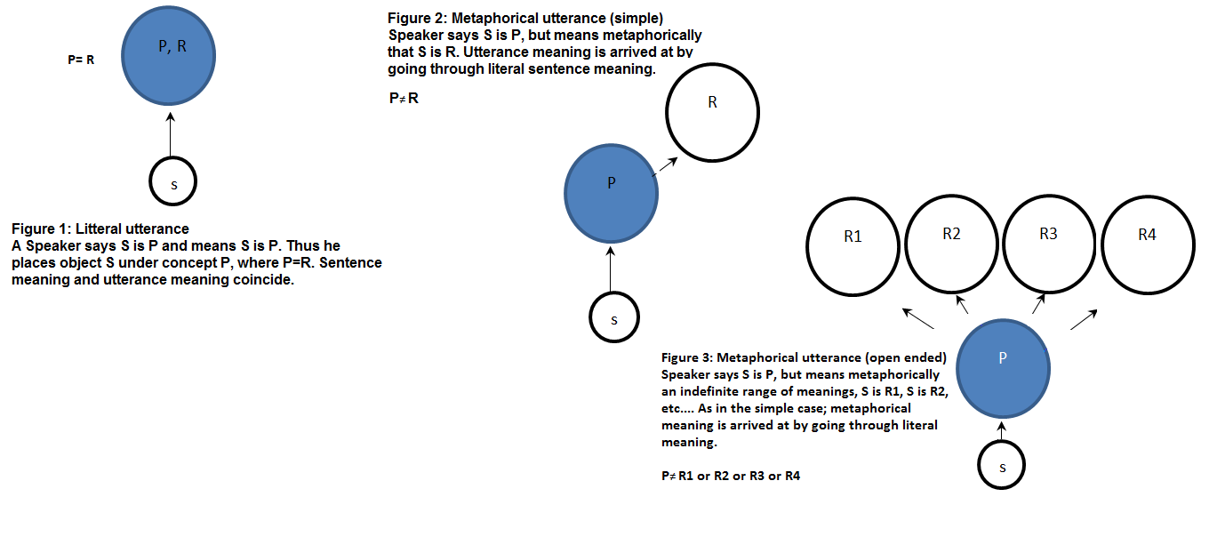

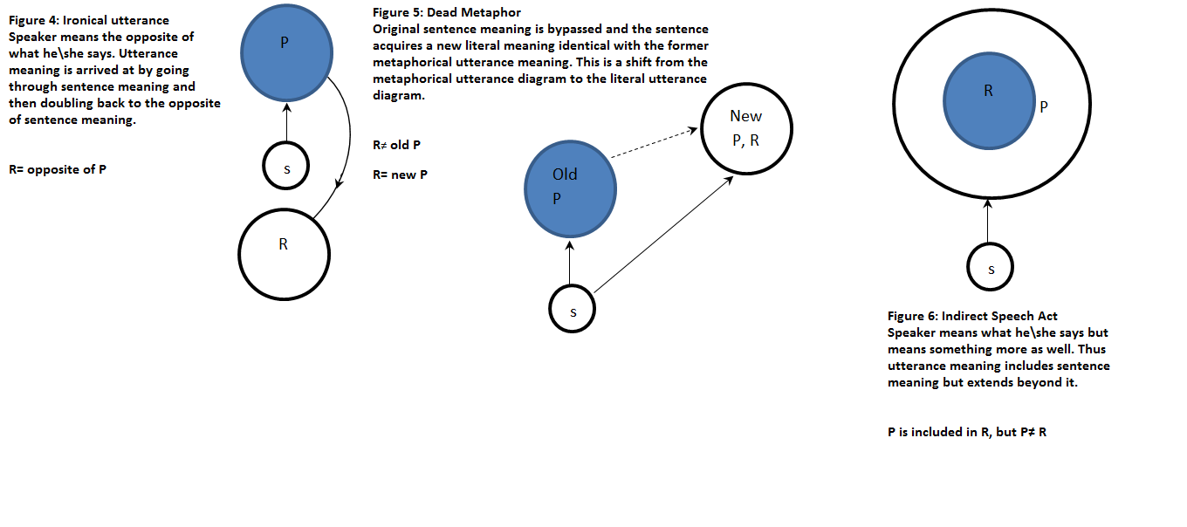

Notes
1. Alan Davies et al, ed., The Handbook of Applied Linguistics. (Oxford: Blackwell Publishing Ltd, 2004). p. 332.
2. Elizabeth Black, Pragmatic Stylistics.( Edinburgh: Edinburgh University Press, 2006). p.143.
3. Richard Bradford, Stylistics. (New York: Routledge,1997).p.11.
4. Ibid, p. 143.
5. Elizabeth Black, Pragmatic Stylistics. ( Edinburgh: Edinburgh University Press, 2006). p. 287.
6. Safa Elnaili, “A stylistic Analysis of Libyan Short Stories: The Connotation of Adjectives”. An M. A. Thesis submitted to the Graduate Faculty of the Louisiana State University and the Humanities and Social Science College. 2013. P. 17.
7. Alan Davies et al, The Handbook of Applied Linguistics. (Oxford: Blackwell Publishing Ltd, 2004). p. 334.
8. Jan Chloupek and Jiří Nekvapil, eds., Studies in Functional Stylistics. (Amesterdam: John Benjamins Publishing Company, 1993). P. 275.
9. Unlike in the Expressionistic Stylistics of Charles Bally (1865-1947) who held that the artistic methods of expression which are concerned with aesthetic values should be eliminated from the study of stylistics, as such elements are forms of communication and they reveal the author’s intention to attract and amuse the reader. (See: Majeed Mtashar Amer, “On Modern Linguistics: The Expressionistic Stylistics of Charles Bally”. Al-Basrah Journal of Arts. Issue No. 56, 2011. pp. 114-115.
10. “Transitivity”, Microsoft Student 2009 DVD. Microsoft Corporation.
11."Transitivity Law", Encyclopedia Brittanica Ultimate Reference Suite. Chicago: Encyclopedia Britannica, 2009.
12. “Language”, Microsoft Student 2009 DVD. Microsoft Corporation. 13. John R. Searle, Expression and Meaning Studies in the Theory of Speech Acts. (Cambridge: Cambridge University Press, 1981). P. 81.
14. Geoffrey N. Leech, A Linguistic Guide to English Poetry. (London: Longman Group Limited, 1974). P. 149.
15. Searle, p. 78.
16. Paul Simpson, Stylistics: A Resource Book for Students.(New York: Routledge, 2004). P. 22.
17. Safa Elnaili, p. 16.
18. As in indirect speech acts where the hearer perceives more than what the speaker actually says by virtue of: their mutually shared factual (linguistic and nonlinguistic) background information, the hearer’s rationality and ability to make inferences, and some general principles of cooperative conversation. John R. Searle, p. x, p. 32 and p. 77.
19. Barry Stampfl, “Similes as Thematic Clues in Hemingway’s Short Stories”.. The Hemingway Review, San Diego State. Spring, 1991. P. 31
20. Maya Angelou, I Know Why the Caged Bird Sings. (New York: Bantam Book, 1997). P. 2. All references to the novel are taken from this edition, therefore, all subsequent references shall be henceforth referred to only by page numbers parenthetically indicated.
21. Maya Angelou, pp. 2-3.
22. Barry Stampfl, p. 31.
23. Within the system of transitivity function features like the morphological and phonetic ones; notice the onomatopoeic effect in the repetition of the /g/ and /ŋ/ sounds in the cited example. Notice also the effect of using fricatives to convey the image of swiftness and uncontrollable danger in the next quotation.
24. Alan Davies et. al., pp. 333-334.
25. Michael Burke, ed., The Routledge Handbook of Stylistics, (New York: Routledge, 2014). P.
26. Barbara Johnstone, The Linguistic Individual: Self-Expression in Language and Linguistics. (Oxford: Oxford University Press,1996). P. 140.
A written text says what it says, but it does not necessarily mean what it appears to mean. (See Andrew Clark, “The Death of the Other: On Derrida’s Conceptualization of Autobiography”, Journal for Cultural Research, Taylor & Francis.2013.Vol.17,No.3,279–294, http://dx.doi.org/10.1080/14797585.2012.752162 p. 280. Retrieved on (7th July, 2015).
27. Lesley Jeffries, Opposition in Discourse: The Construction of Oppositional Meaning. (London: Bloomsbury Academic, 2014). P. 124.
28. This metaphor could have other possible implications. Derrida's deconstructive style of reading challenges the idea that a text has an unchanging, unified meaning. He showed that there were many possible interpretations that depended on the reader and the reader’s context as much as on the author. Derrida’s Deconstruction multiplies the number of legitimate readings of a process of transitivity. See (Index: Figure 3). The metaphor is reminiscent of medication especially when viewed in the light of Marguerite’s carving for love and caring. See pp. 84-86 of the text.
“Jacques Derrida”, Microsoft Encarta DVD. 2009. Microsoft Corporation.
29. James Weldon Johnson (1871-1938) an African-American author, lawyer and diplomat who reflected deep understanding of African-American life in the U.S. in his writings. Ibid., “James Weldon Johnson”.
30. Intertexuality is the relationship that exists between different texts, especially literary texts, or the reference in one text to others.
31. Elizabeth Black, Pragmatic Stylistics. ( Edinburgh: Edinburgh University Press, 2006). P. 72.
32. Greg Watson and Sonia Zyngier, ed., Literature and Stylistics for Language Learners: Theory and Practice. (New York: Palgrave Macmillan, 2007). P. 37.
Bibliography
Angelou, Maya. I Know Why the Caged Bird Sings, New York: Bantam Book, 1997.
Argamon, Shlomo, et al. “Stylistic Text Classification Using Functional Lexical Features”; Journal of the American Society for Information Science and Technology, 2007, Wiley Periodicals, Inc.
Black, Elizabeth. Pragmatic Stylistics, Edinburgh: Edinburgh University Press, 2006.
Bradford, Richard. Stylistics, New York: Routledge,1997.
Burke, Michael, ed. The Routledge Handbook of Stylistics, New York: Routledge, 2014.
Clark, Andrew. “The Death of the Other: On Derrida’s Conceptualization of Autobiography”, Journal for Cultural Research, 2013, Taylor & Francis. Vol. 17, No. 3. http://dx.doi.org/10.1080/14797585.2012.752162.
Chloupek, Jan and Nekvapil, Jiří, eds. Studies in Functional Stylistics, Amesterdam: John Benjamins Publishing Company, 1993.
Davies, Alan, et al. The Handbook of Applied Linguistics, Oxford: Blackwell Publishing Ltd., 2004.
Elnaili, Safa. A Stylistic Analysis of Libyan Short Stories: The Connotation of Adjectives, An M. A. Thesis submitted to the Graduate Faculty of the Louisiana State University and the Humanities and Social Science College. 2013.
Encyclopædia Britannica Ultimate Reference Suite, DVD, 2014.
Lesley Jeffries, Opposition in Discourse: The Construction of Oppositional Meaning, London: Bloomsbury Academic, 2014.
Barbara Johnstone, The Linguistic Individual: Self-Expression in Language and Linguistics. Oxford: Oxford University Press, 1996.
Geoffrey N. Leech, A Linguistic Guide to English Poetry. London: Longman Group Limited, 1974.
Majeed Mutashar A’mer, Trans. “On Modern Linguistics: Charles Bally and His Expressionistic Stylistics”, Al-Basrah Journal of Arts, 2011, Issue 56.
Microsoft Premium Encarta, DVD. 2009. Microsoft Corporation.
John R. Searle, Expression and Meaning: Studies in the Theory of Speech Acts, Cambridge: Cambridge University Press, 1981.
Paul Simpson, Stylistics: A Resource Book for Students, New York: Routledge, 2004.
Barry Stampfl, “Similes as Thematic Clues in Hemingway’s Short Stories”. The Hemingway Review: San Diego State. Spring, 1991.
Greg Watson and Sonia Zyngier, ed., Literature and Stylistics for Language Learners: Theory and Practice, New York: Palgrave Macmillan, 2007.
Andrew Clark, “The Death of the Other: On Derrida’s Conceptualization of Autobiography”, Journal for Cultural Research, Taylor & Francis. Vol.17,No.3. http://dx.doi.org/10.1080/14797585.2012.752162 p. 280. Retrieved on (7th July, 2015).

