Physiological study for extracted surface layer from Aeromonas hydrophila isolated from diarrhea

Lobna Adil Al-Noori¹ Wejdan R. Taj Aldeen¹ Frial Gemeel Abd¹

1Department of Biology, College of Science, University of Babylon,Iraq.
Corresponding author: loubna_adil@yahoo.com.
To cite this article:
Al-Noori ,L.A.; Taj Aldeen ,W.R.;Abd, F. G. Physiological study for extracted surface layer from Aeromonas hydrophila isolated from diarrhea. Mesop. environ. j., 2016, Vol. 2, No.3, pp. 11-26.
Received Date: 2/2/2016, Accepted Date: 15/3/2016, Publishing Date: 15/5/2016
This work is licensed under a Creative Commons Attribution-NonCommercial-NoDerivatives 4.0 International License.


Abstract:

A total of 349 stool samples were collected from the patients with diarrhea during the period from December 2014 to May 2015,the results show that there were 11(3.15%) positive isolates of Aeromonas hydrophila, these isolates were identified by cultural method ,biochemical tests and confirmed by API 20E and Vitek 2 system.Tryptose soy agar that contained Congo red stain was used to detect A.hydrophila isolates that produced surface layer protein (S-layer) ,eight (8) isolates was given positive result on this media. The S-layer protein was extracted by two methods, Sodium Dodecyl Sulphate (SDS 0.05%) solution was given significantly higher protein concentration in compared with LiCl 5M solution. Then it was precipitated by two methods also, ammonium per sulfate 80% was given significantly higher protein concentration in compared with acetone Con.95%. The molecular weight of S-layer protein was determined by SDS-PAGE and the result reveal that it was 52 KDa. The physiological factors that affecting on the production of S-layer protein from A.hydrophila was investigated by incubate the inoculated production media at different degree of temperature, pH, incubation period ,at the ordinary and shacking incubator, and by add (Glycine, Tyrosine ,Lysine ,Alanine) in two Con. 0.5mg/L and 1mg/L. The result show that all these factor affecting on the production of S-layer protein and the highest protein concentration was obtained at temperature 37 ºc, pH 7, after incubation period 24 hrs., at shacking incubator, by add1mg/L of glycine.
Keywords: Aeromonas hydrophila ,Surface layer protein, Physiological factors.
Introduction
Aeromonas spp. are Gram negative ,short rod shape ,facultative anaerobes resistance to O/129 vibrio static and non-spore forming They are generally motile by polar flagella recently assigned family Aeromonadaceae, [1,2,3].Aeromonas spp. are pathogenic to fish, amphibians and also humans [4].They are ubiquitous microorganisms found in both aquatic and environmental habitats such as estuary sediment ,sea water , sea grass, sea food, and drinking water[5,6].Aeromonas infections are typically acquired through two routes, ingestion of contaminated water or food with this bacteria, or through contact of the organisms with a break in the skin [7].Aeromonas hydrophila is one species of the genus Aeromonas that received increasing attention as opportunistic pathogens and enterotoxigenic pathogens ,because of its association with human diseases , aquatic and terrestrial animals infections [8,9]. Isolation of A. hydrophila from water and food sources like fish, and the increasing resistance of this organism to antibiotics and chlorination in water, presents a significant threat to public health [10].Pathogenicity of A. hydrophila infection is complex and multi-factorial [11]and it's attributed to a multiple virulence factors, including cell structural : lipopolysaccharide (LPS), outer membrane proteins (OMPs), pili and flagella, type III secretion system(T3SS) acts as adhesion structures and extracellular factors such as exo-toxin, aerolysins, heamolysins, enterotoxin and sidro-phore that seem to play an important role in pathogenesis [12,13].Surface array protein or S-layer are monomolecular arrays made up of a single protein species and represent the simplest biology membrane developed during evaluation. S-layer composed the outer most layer of the cell envelope of prokaryotic (archea and bacteria) [14].
A. hydrophila and A .salmonicida can cause disease in salmonids in freshwater and marine environments. Typical strains of both species are responsible for furunculosis, a fatal disease of these fishes, the S-layer is essential for virulence of both organisms, a crude acid-extract of an S-layer of A. hydrophila strain has been used for immunizing channel catfish. When immunization was performed with the S-layer protein-containing extract emulsified in Freund's incomplete adjuvant (FIA) ,catfish were protected against this bacteria by subsequent experimental challenge with the homologous virulent bacteria was considered a good vaccine candidate because of its surface location and its immunological properties[15,16]S-Layer protein of A. hydrophila used as a vaccine in Nile tilapia (Oreochromis niloticus) fish against the pathogenic A. hydrophila ,the vaccine reduced the probability of death of the vaccinated fish when compared to unvaccinated [17].
Materials and Methods
Collect of stool samples
A total of (348) stool samples were collected between December 2014 and May 2015 from patient whom suffering from diarrhea. before starting their antibiotic therapy, samples were collected from Babylon hospital for maternity and pediatrics.
Isolation and identification of A. hydrophila
One gram of each sample was briefly emulsified in 3ml of sterile 0.85%(w/v) saline and vortexes for 30sec.Organ debris was allowed to settle down for 5 min .the samples were put it in alkaline peptone water ( pH9 )and sub cultured after incubation at 37C for 6 h. onto to macConkey agar ,Aeromonas agar at 37C for 24hrs.[18;19].The strains first identified as Aeromonas spp. According to colony morphology on MacConkey agar, Blood agar, Thio sulphate citrate bile salt sucrose agar (TCBS) agar and Aeromonas agar(AIA) , and by microscopic morphology(Gram stain)and by chemical tests (Oxidase ,Catalase, Indole, Methyl red, Vogas- Proskure , Citrate utilization, Gelatin liquefaction, kligler iron and Urease test)and by String test ,Lysine decarboxylase ,Arginine decarboxylase, Ornithine decarboxylation for differentiated from Vibrio cholera and the diagnostic of these strains confirmed by Api 20E and Vitic 2 system ( Biomerieux, france).

Detection the presence of S-layer in A.hydrophila isolates
This test was performed by inoculating tryptose soy agar that contained Congo red stain with A. hydrophila isolates by streaking method, and then it was incubated at 37°C for 24 hours[20,21].
Extraction of S-layer protein
In this study S-layer protein was extracted from A. hydrophila isolates by two methods, and then it was compared between methods according to protein concentration that was measured by Bradford method [17,22].
First method: extracted of S-layer protein by SDS 0.05%
In this method S-layer protein was extracted according to the modified method of [23,24,25].A.hydrophila was reactivated, then 1ml of bacterial suspension was added to tryptose soy broth and incubated at37ºc for 24hrs.The bacterial cells was collected by centrifuge at 6000 rpm for 10 min. The pellet of cells was suspended by phosphate buffer solution pH7 and washed 3 times by centrifuge at 6000 rpm for 15 min. Then the pellet was suspended by 5 ml SDS 0.05% solution and incubated for 10 min at 37ºc .Then the bacterial suspension was centrifuged at 12000 rpm for 15 min at 4ºc ,the supernatant represent the crude extraction(CE) was used and kept in refrigerator at 4ºc .
Second method: extracted of S-layer protein by lithium chloride 5M
In this method S-layer protein was extracted according to the modified method of[26].The same steps of the first method was performed but in the second method the cell pellet was suspended by lithium chloride 5M after washed the bacterial cells, then the bacterial suspension was incubated at shacking incubator at 200 rpm for 1 hr.at37ºc.after that it was centrifuged at 12000 rpm for15 min at 4ºc, the supernatant was used and kept in refrigerator at 4ºc .
Precipitation of S-layer protein
In this study two methods has been used to precipitate S-layer protein from crud extraction (CE) and it has been compared between methods. the S-layer protein Con. was measured by Bradford method [17,22].
First method: Precipitation by ammonium per sulfate with Saturation ratio 80%
This method was done according to method of [27]Ammonium per sulfate (51.6 g) was gradually added to (100 mL) of crud extraction (CE) of S-layer protein with continuous mixing by magnetic stirrer at 150 rpm for 10 min at 4°C.The solution was centrifuged at 10000 rpm for 15 min. the supernatant was removed and the sediment (S-layer protein) was used. Phosphate buffer saline (5ml) was added to the sediment (S-layer protein),then it was kept in refrigerator at 4°C .
Second method: Precipitation by absolute acetone with Con.95%
This method was performed according to [28]Acetone (95%) was cooled to -20°C.The crud extract (CE) was putted into sterile test tube. Cooled acetone (95%) was added to the crud extract (CE) in percentage (2:1), 2 ml of Cooled acetone (95%) to 2 ml of the crud extract (CE).The solution was centrifuged at 10000 rpm for 15 min at 4°C, the supernatant was removed and the sediment (S-layer protein) was used. Phosphate buffer saline (5ml) was added to the sediment (S-layer protein), then it was kept in refrigerator at 4°C .
SDS- Poly acrylamide gel electrophoresis (SDS-PAGE) of S-layer protein
This assay was performed according to the method[29]to determine the molecular weight of S-layer protein. The proteins were visualized in 15% polyacrylamide gel with denaturing conditions (SDS-PAGE) .After preparation of the gel, the protein extracts 50 μL were added to a mix containing 50μL of sample buffer and heated in a water bath at 100°C for 5 min before being applied in the gels. After electrophoresis, the gels were stained with Coomassie Blue [30] and the protein standards were registered in an image-capturing system.
Effect of the physiological factors on the production of S-layer protein
Three isolates of A. hydrophila bacteria (second , fifth, and eighth isolates) has been chosen to study the effect of five physiological factors on the production of S-layer protein. In this experiment S-layer protein has been extracted by first method (0.05% SDS solution) [23,24,25] and it was also precipitated by the first method (Ammonium sulfate 80%) [27].
The physiological factors were investigated by inoculate the production media(tryptose soy broth) with A. hydrophila isolate and incubated at different degree of temperature (5, 10, 15, 20, 25, 30, 37, 40, 45 and 50)ºc, pH(1,4,7,10), incubation period (4,8,12,16,20,24,28 and 30) hrs., at the ordinary and shacking incubator, and by add four type of amino acid (Glycine, Tyrosine ,Lysine ,Alanine) in two Con. 0.5mg/L and 1mg/L.
Statically analysis
Data were processed and analyzed by using Anova one way, and the Least Significant Difference (LSD) to determine the significant difference between the different factor in the tests by using the using statistical program SPSS 19 and the results were expressed as(Mean±S.D).P-Values below 0.05 were considered to be statistically significant.
Results and Discussion
Isolation of A. hydrophila
Out of three hundred forty nine (349) stool samples analyzed,11(3.15%) samples were positive for A. hydrophila bacteria as show in the Table1. This result is similar to the result that obtained from the local study[21]that reported 2.7% (13 isolates) of A. hydrophila from 479 stool samples in Babylon province .
Table 1. Percentage of A. hydrophila isolates from stool samples.
Bacterial type | NO. of samples | Percentage
A. hydrophila | 11 | 3.15%
Other type of bacteria | 338 | 96.84%
Total | 349 | 100%

However ,the result of this study revealed that A. hydrophila infected children from 1-6 years old more than other agesin this study and having 3.84%(6 isolates) from 156 stool samples as show in the Table 2., this result is similar to the finding of the local study [31] that reported 4.08% (12 isolates) from 294 stool samples from 1 month to 6 years old in AL-Samawa province.

Table 2. Percentage of A. hydrophila isolates according to the age group.
Categories of patient | NO. of stool samples | N0. A. hydrophila isolates | Percentage
1-6 years | 156 | 6 | 3.84%
7-12 years | 109 | 3 | 2.75%
13-18 years | 84 | 2 | 2.38%
Total | 349 | 11 | 3.15%

Identification of A.hydrophila
The colonies of A. hydrophila that was grown on culture media appeared 1-3mm in diameter as with[32]The positive isolates for A. hydrophila revealed pale ,non -lactose fermenters, small colonies on the MacConkey agar because it is un capable to ferment lactose sugar and it was showed smooth ,rounded, convex, β-hemolysis colonies on blood agar .and yellow- shine color on TCBS agar due to their ability to ferment sucrose sugar ,the results agreed with other studies [13,33]Aeromonas agar with ampicillin supplement was also used, it was appeared in dark green color, opaque with dark center this is agree with [3].The microscopically examination was exhibited Gram negative rod bacteria, that was appeared singly, in pairs, or even as short chains on glass slide this agreed with [32].The biochemical tests used to confirmed the initial diagnosis of A.hydrophila as show Table 3. the positive isolates of A. hydrophila were given appositive result of each oxidase, catalase, indole, methyl red, vogues –proskauer, citrate utilization and gelatin liquefaction tests . It had the ability to ferment glucose on kligler iron agar (Alk/Acid). In the top of the slant agar, the red color (Alkaline) was appeared while in the bottom of the slant agar, the yellow color (acidic) was appeared with no H2S production . It was given a negative result for urease test ,this is agreed with [34].
Table 3. Biochemical tests of A. hydrophila isolates
No. | Type of test | Result
1 | oxidase test | +
2 | Catalase test | +
3 | Indole test | +
4 | Methyl red test | +
5 | Vogues –Proskauer test | +
6 | Citrate Utilization test | +
7 | gelatin liquefaction test | +
8 | kligler iron agar test | Alk/Acid
9 | Urease test | -
String test was done to distinguished A. hydrophila which was negative to this test from V. cholera which was positive to this test. amino acid utilization test was also performed, In this test A. hydrophila was given a positive result to lysine decarboxylase and arginine decarboxylase and a negative result to ornithine decarboxylase, this result was agreed with[35]as show in the Table 4. API 20E and Vitek 2 System was also used to confirm the identification of A. hydrophila isolates.
Table 4. Differentiate between A. hydrophila and V. cholera via string test and amino acid utilization test
No. | Type of test | A. hydrophila | V. cholera
1 | String test | - | +
2 | Lysine decarboxylase | + | +
3 | Arginine decarboxylase | + | -
4 | Ornithine decarboxylase | - | +

Detection the presence of S-layers in A. hydrophila isolates
Out of eleven(11) isolates of A. hydrophila, eight(8)isolates was revealed a positive result in this test. the isolates that produce S-layers protein was given a dark red colonies or the same color of the medium as in the Figure 1 ,while the isolates that was not produce S-layers was given colorless or light orange colonies, This is agree with other study that also used Congo red agar (CRA) as a differential media for the fish pathogen A. salmonicida and it had improved that the S-layers protein absorb Congo red stain therefor the isolates that have S-layers appear in dark red colonies on the medium[20,36].
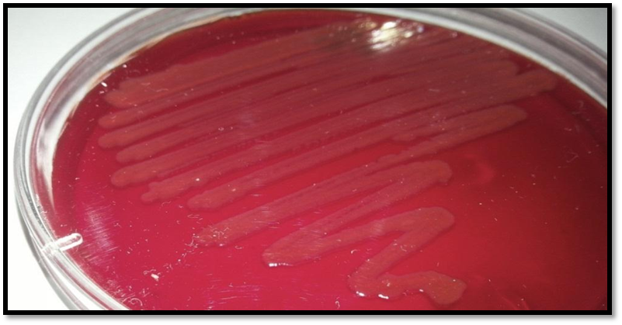
Fig.1: S-layers in A. hydrophila appeared as dark red isolates on tryptose soy agar that contains Congo red
Extraction of S-layer protein from A.hydrophila
The first method (SDS 0.05%) was given high protein concentration for all A. hydrophila isolates with mean value 769.07±41.43µg/ml in compare with the second method (lithium chloride,5M) that was given protein concentration with mean value 498.53±40.48 µg/ml. Based on determined protein concentration and statically analysis there’s a significant difference at(P˂0.05) between these two methods. Isolates of A. hydrophila was produce different amount of protein concentration ,the fifth (5) isolate was given the highest protein concentration, it was given 828 µg/ml and 549.42 µg/ml. while the seventh(7) isolate was given the lowest protein concentration ,it was given 713.71 µg/ml and 442.28 µg/ml. in The first method (SDS 0.05%) and the second method (lithium chloride,5M) respectively as show in the Figure 2.
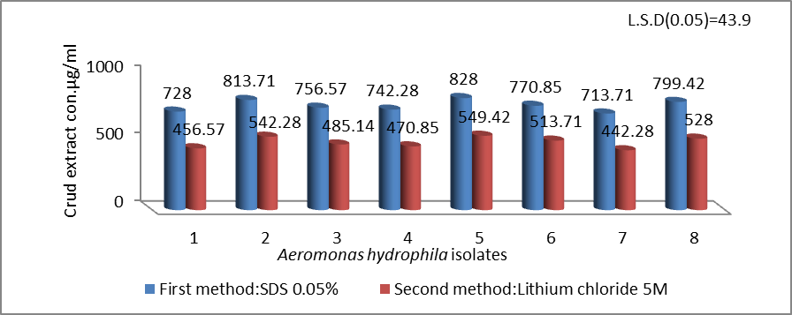
Fig.2:Concentration of crud extract for S-Layer protein of A. hydrophila isolates in two methods
The S-layer protein in A. hydrophila bacteria is composed of protein subunits that are bound to the underlying cell wall through the hydrogen bonds that are important in stabilizing the layer with other cell wall components , S-layer protein can be extracted from the cell surface by different chemicals at a concentration capable of disrupting H-bonds [37]. Both of Sodium Dodecyl Sulphate (SDS 0.05%) solution and lithium chloride (LiCl,5M) solution that used in our study considered as a hydrogen –bond breaking agent [24,38]that break the hydrogen bonds and affecting the stability of S-layer protein by wreaking the hydrophobic interaction.

Precipitation of S-Layer protein
The first method(ammonium per sulfate 80%) was given a high protein concentration for all A.hydrophila isolates with mean value 625.5±39.83µg/ml in compare with the second method (acetone 95%) that was given protein concentration with mean value 371.23±58.93µg/ml. Based on determined protein concentration and statically analysis there’s a significant difference at(P˂0.05) between these two methods. Isolates of A. hydrophila was different in their production of s-layer proteins .The second ,fifth and eighth isolates was given a high level of protein concentration in compare with other isolates ,in the first method(ammonium per sulfate (0.05%) it was given 670.85 , 678 and 656.57µg/ml respectively. hile in the second method(acetone 95%) it was given 428.1, 435.14and 413.72µg/ml respectively as show in the Figure 3.
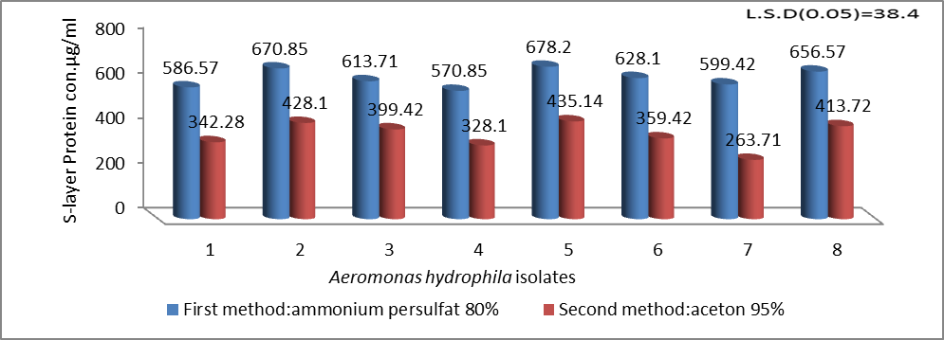
Fig.3:S-layer protein concentration of A. hydrophila isolates in two methods.
According to the result that the S-layer protein concentration that obtained by the first method were higher than the second method, therefore ammonium per sulfate (0.05%) was preferred in the precipitation of S-layer protein in this study.In addition other study precipitated S-layer protein from the crude extraction by ammonium per sulfate [17].

SDS-Polyacrylamide Gel Electrophoresis of S-layer protein
The result revealed that the molecular weight of S-layer protein was 52KD as show in the Figure 4 .It was detected in comparison with the molecular weight of standard proteins in rang 10-180KD ,this result agree with the finding of other studies that reported the molecular weight of S-layer protein A. hydrophila was 52KD which also determined by SDS-PAGE technique [17,39].
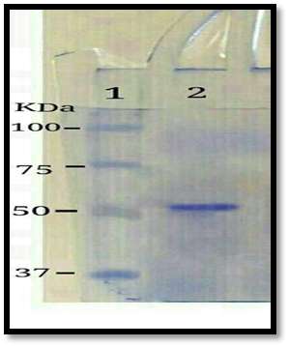
Fig.4:SDS- PAGA gel(15%poly acrylamide)analysis of S-layer protein Lane 1:lader protein ,Lane 2:sample.
Effect of the physiological factors on the production of S-layer protein
Temperature
The result revealed as show in the Figure 5 that the highest S-layer protein concentration was obtained at 37ºc with mean value 679.42±3.79 µg/ml. While the lowest protein S-layer concentration was obtained at 45ºc with mean value 52.76±3.57 µg/ml .Statically analysis show that the incubation temperature has significantly effect on the production of S-layer protein. The production of S-layer protein has a direct relationship with the growth of bacteria that greatly affected by the temperature degree of incubation. A. hydrophila isolates that considered as a human pathogen and caused diarrhea illness in human classified as a mesophilic bacteria [13].
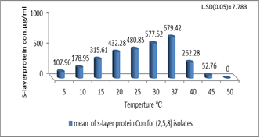
Fig.5: Effect of incubation temperature on the production of S-layer protein by A. hydrophila isolates.
The optimum rang of temperatures for the growth of. A. hydrophila was (20-37)ºc [40,41] this rang of temperature was appropriate for the enzymatic and metabolic activities of mesophilic bacteria and any increase or decrease from the optimum temperatures will effected on the growth of bacteria .Other study mention that the isolates was able to grow well at 37 ºc [42], as this result revealed that the optimum rang for the production of S-layer was rang between (20-37)ºc and the highest S-layer protein concentration was obtained at 37ºc.But the lowest S-layer protein concentration was obtained at 45ºc,and there was no significant production at 50ºc,because the A. hydrophila isolates was not able to grow at 50ºc and the thermal point of A. hydrophila isolates from 40 to 50 ºc [42].Other study mention that the high temperature cause loss of virulence factor including S-layer protein[20].

pH Value
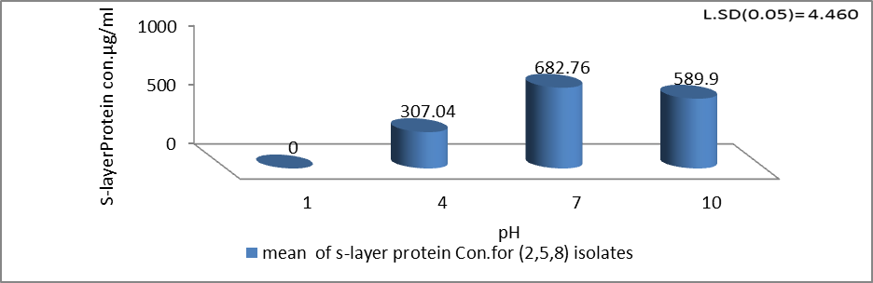
The result revealed as show in the Figure 6 that the highest protein concentration was obtained at pH7 with mean value 682.76±2.19 µg/ml. while pH 10 with mean value 589.90±3.62 µg/ml ,while the lowest protein Con. was obtained at pH4 with mean value 307.04±2.19µg/ml .and there was no significant production at pH1.

Fig.6:Effect of pH level of production media on the production of S-layer protein by A. hydrophila isolates.
The maximum growth of A. hydrophila occurred between pH 5.2 and 9.8 [43],and all A. hydrophila isolates show more or less similar growth at pH 7, 8, 9,while the log number of cells at pH 5, 6, 10 was found lesser than pH 7, 8, 9 [44]in the present study the that the highest S-layer protein Con. was obtained at pH7 flowed by S-layer protein Con.at pH 10.On the other hand the least level of pH for the growth of A. hydrophila isolates at the pH 4.5[45].Therefore the lowest S-layer protein Con .was obtained at pH 4,and there is no significant production of at pH1.
Incubation period

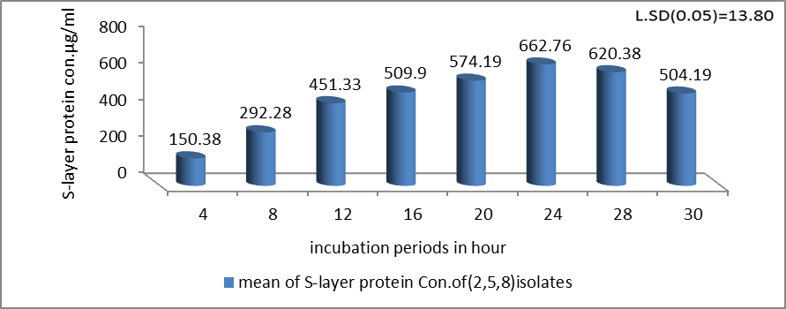
Fig.7:Effect of incubation periods on the production of S-layer protein by A. hydrophila isolates.
Other study mention that the bacteria produce the S-layer protein in the mid of the log phase and the end of the log phase, and the concentration of S-layer protein in the mid of the log phase was lower than in the end of the log phase [46].In addition that there was some studies extracted the S-layer protein from A.hydrophila at different incubation period at 18 hrs.[39]and at 24 hrs. [47]and at 48hrs[17].
Aeration
The result revealed as show in the Figure 8 that the S-layer protein concentration with mean value 863.71±7.14µg/ml that obtained after incubation at shacking incubator was higher than S-layer protein concentration with mean value 656.57±14.28 µg/ml after incubation at ordinary incubator. A. hydrophila are gram-negative, facultative anaerobic [1]. That grow under aerobic and un aerobic condition ,other study recorded that the maximal cell yield of A. hydrophila bacteria and it is enzymatic activities increased under aerobic condition after incubation the production media at shaking incubator [48].
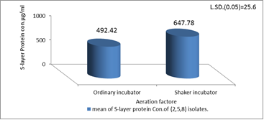
Fig.8:Effect of Aeration on the production of S-layer protein by A. hydrophila isolates.
The component of the production media
In the present study four type of amino acid (Glycine, Tyrosine ,Lysine ,Alanine) was added to the production media as a nitrogen source in two concentration 0.5mg/L and 1mg/L, in two experiments. In the first experiment, 0.5mg/L of the amino acid was added, the result revealed that the high protein concentration was obtained after adding glycine with mean value 1158.95±10.90µg/ml flowed by(Tyrosine ,Lysine ,Alanine) with mean value (1138.95±12.48, 931.33±7.05 ,700.71±9.94) µg/ml, as show in the Figure 9.
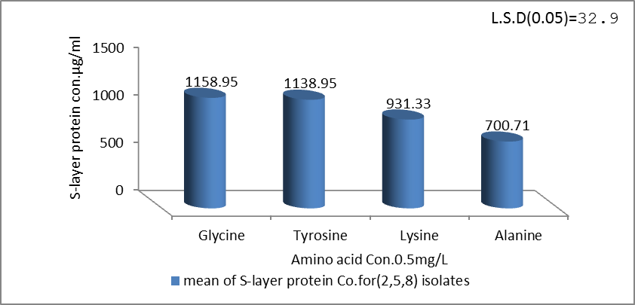
Fig.9:Effect of different amino acid with Con.0.5mg/L on the production of S-layer protein by A. hydrophila isolates.
At the second experiment,1mg/L of the amino acid was added, the result revealed that the high protein Con. Was also obtained after adding glycine with mean value1318±8.72 µg/ml flowed by(Tyrosine ,Lysine ,Alanine) with mean value (1229.90 ±4.59,1100.85±5.14,774.19±9.73) µg/ml, as show in the Figure 10.
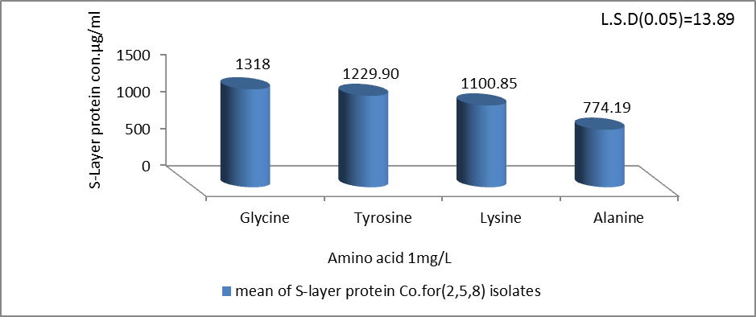
Fig.10: Effect of different amino acid with Con.0.5mg/L on the production of S-layer protein by A. hydrophila isolates.
In the tow experiments glycine was given the highest protein concentration followed by Tyrosine ,Lysine ,Alanine. and the concentration of S-layer protein was increase after increase the concentration of amino acid from 0.5mg/L to 1mg/L. Amino acid as a nitrogen source caused increase in the growth of bacteria in the production media and the result showed significant increase in the concentration of S-layer protein after adding amino acid. The result also showed that the S-layer protein Con. was different according to the type and concentration of amino acid, and the type of amino acid has significantly effect on the production of S-layer protein , because the nitrogen source have different effect on the growth stimulation of A. hydrophila and so their production [48]. Schar-Zammaretti [49] suggested that S-layer protein is preferentially expressed under different fermentation media. Furthermore, it has been shown that the S-layer production is changed with the change in medium (such as bile salt, penicillin G)[50].
Conclusions
(1)A.hydrophila bacteria one of the causative agent of diarrhea
(2)Extraction of Surface layer (S-layer)protein from A.hydrophila by Sodium Dodecyl Sulphate (SDS 0.05%) solution and precipitated by ammonium per sulfate with saturation ratio 80% was given high concentration of S-layer protein.
(3)The S-layer protein profile by SDS-PAGE analysis show that the molecular weight of S-layer protein was 52KDa.
(4)The physiological factor like Temperature ,pH, incubation period, aeration and the component of the production media affecting on the production of S-layer protein by A.hydrophila.
Acknowledgment
All material of this study was supported by department of Biology ,College of Science ,University of Babylon.
Refrences
[1] Meiyanti, S.; Salim, O. C.; Surjawidjaja, J. E. and Lesmana, M. Isolation and antibiotic sensitivity of Aeromonas from children with diarrhea. Universa Medicina ,Vol.29,No.1,pp14-20. 2010.
[2]Uche,O.A. and Johnkennedy,N. Prevalence of Aeromonas Species among patients attending general hospital Owerri. Advanced medical sciences: An International Journal(AMS),Vol.1,No.4,pp.1:10.2014.
[3] Samal, S. K. ; Das, B. K. and Pal, B.B. Isolation, biochemical characterization, antibiotic susceptibility study of Aeromonas hydrophila isolated from freshwater fish. International journal of current of microbiology and applied sciences ,Vol. 3,No.12,pp. 259-267. 2014.
[4] Kamble, S.R.; Meshram, S.U. and Shanware, A.S. Characterization of Aeromonas species isolated from diseased fish using ERICRAPD markers .AsPac Journal of Microbiology Biotechnology, Vol. 20,No.3,pp.99-106.2012.
[5] Matyer, F.; Kaya, A. and Dincer, S. Distribution and antibacterial drug resistance of Aeromonas spp. from fish and brackish waters in southern Turkey. Annals of Microbiology,Vol.57,pp.443-447. 2007.
[6] Ottaviani, D.; Parlani, C.; Citterio,B.; Masini, L.; Leoni, F.;Canonico, C.; Sabatini, L.; Bruscolini, F. and Pianetti, A. Putative virulence properties of Aeromonas strains isolated from food, environmental and clinical sources in Italy: A comparative study. International Journal of Food Microbiology ,Vol.144,pp.538-545.2011.
[7] Jawetz, Melnick, and Adelberg’s. Medical Microbiology. In: Geo, F. B., Karen, C. C., Janet, S. B. and Stephen, A. M. 23th [Eds].Int, 2004.
[8]Pavanelli, G.C.; Eiras, J.C. and Takemoto, R.M. Doenças de Peixes: profilaxia, diagnóstico e tratamento.3rd[Eds]. Eduem, pp. 311. 2008.
[9] Naharro, G.; Riano, J.; de Castro, L.; Alvarez, S. and Luengo, J.M. Aeromonas: Molecular Detection of Foodborne Patho-gens. CRC Press. North Ryde, pp.273-289. .2009.
[10] Thayumanavan, T.; Vivekanandhan, G.; Savithamani, K.; Subashkumar, R. and Lakshmanaperumalsamy, P. Incidencem of haemolysin-positive and drugresistant Aeromonas hydrophila in freshly caught finfish and prawn collected from major commercial fishes of coastal South India. FEMS Immunological Medical Microbiology, Vol.36,No.1-2,pp.41-5. 2003.
[11] Chopra, A.K.; Xu ,X.J.;Ribardo, D.; Gonzalez, M.; Kuhl, K.; Peter-son J.W. and Houston C.W. The cytotoxic enterotoxin of Aeromonas hydrophila induces proinflammatory cytokine production and activates arachidonic acid metabolism in macrophages .Infection and Immunity, Vol.68, pp.2808-2818. 2000.
[12] Pablos, M; Rodríguez-Calleja, J.M.; Santos, J.A.; Otero, A. and García-López, M.L. Occurrence of motile Aeromonas in municipal drinking water and distribution of genes encoding virulence factors. Int. Journal of Food Microbiology, Vol. 135,pp.158-164. 2009.
[13]Janda ,J.M. and Abbott, S.L. The genus Aeromonas: Taxonomy, pathogenicity, and Infection. Clinical microbiology reviews,Vol.23,No.1,pp.35-73.2010.
[14] Sleytr, U.B.; Sara, M.; Pum, D. and Schuster, B. Characterization and use of crystalline bacterial cell surface layers .Progress in Surface Science, Vol.68,pp. 231-278. 2001.
[15]Ford, L.A. and Thune ,R.L. Immunization of channel catfish with a crude, acid-extracted preparation of motile Aeromonas S-layer protein. Biomed Lw,Vol.47,pp.355-62. 1992.
[16] Figueiredo, H. C. P. and Leal, C.A.G .Tecnologias aplicadas em sanidade de peixes. R. Bras. Zootec,Vol.37,pp.8-14. 2008.
[17] de Santana Lacerda, I.P.; Gonçalves, Y.S; Leal de Oliveira, S.T. ;Demarqui, F.N.; Krewer, C.C.; Gouveia, G.V.; Félix ,W.P. and Costa, M.M. Efficacy of Aeromonas hydrophila S-layer bacterins with different protein profiles as a vaccine in Nile tilapia (Oreochromis niloticus). African Journal of Microbiology Research.Vol.9,No.29,pp.1770-1777.2015.
[18] Nzeako, B.C.; Okafor, N. and Azikiwe, N. Prevalence of Aeromonas hydrophila in seasonal episodes of gastroenteritis in Nsukka Nigeria. Kuwait Medical Journal,Vol.34,No.1,pp.16-19. 2002.
[19] Jatau, E.D. and Yakubu, S.E. Incidence of Aeromonas hydrophila in tilapia obtained from Ahmadu Bello University Dam Zaria. Nigeria Journal of Scientific Research, Vol. 4,pp. 86-91. 2004.
[20] Ishiguro, E.; Ainsworth, T.; Trust, T.J. and Kay, W. Congo red agar, differential medium of Aeromonas salmonicida detect the presence of the cell surface protein array involved in virulence .Journal of Bacteriology,Vol.164,No.3,pp.1233-1237.1985.
[21] Obaid ,A .J.Effect of some Physiological Factor on S-layer synthesis of Aeromonas hydrophila in Babylon Province .M.Sc. thesis submitted to Babylon University, Collage of science,pp.41.2013 .(Arabic).
[22] Brad ford, M.M. A rapid and Sensitive Method for the Quantification of Microgram Quantities of Protein Utilizing The Principle of Dye Binding. Analytical biochemistry,Vol.72,No. 1-2,pp.248-254.1976.
[23] Ray, B., and Johnson, M.C. Freeze-drying injury of surface layer protein and protection in Lactobacillus acidophilus. Cry letters, Vol. 7, pp.210-217.1986.
[24] AL-Amin, B. Identification and characterization of S-layer protein in Aeromonas hydrophila and Lactobacillus acidophilus. Iraqi Journal of Biotechnology, Vol.41,pp151-169.2005.
[25] AL-Rawi, A. M. ; Al- Taee, G.A. and Al- Taee M.A. Study of the S-Layer Protein in Legionella pneumophila and Listeria monocytogenes. Al Rafidian Journal of science, Vol. 19 ,No.3,pp.87-96. 2008. (Arabic).
[26] Lortal, S.; Heijenoort, J.V.; Gruber, K. and Sleyter, U.B.S-layer of lactobacillus helveticus ATCC 12046: isolation, chemical characterization and re-formation after extraction with lithium chloride. Journal of Microbiology ,Vol. 138,pp.611-618.1992.
[27] Harris, E. Concentration of Extract.in Protein purification methods E.L.V. Harris and S. Angal .Oxford Uni.Press,pp.154.1989.
[28] Golowezye , M. A.; Mobili, p. ; Garrote ,G.L. ;Abraham, A.G. and De Anton, G. L. Protective action of Lactobacillus kefir carrying S-layer protein against Sallmonella entrica serovar Enteridis. International Journal of food and microbiology,Vol.118,pp.264-273. 2007.
[29] Laemmli, U .k. Cleavage of structural proteins during the assembly of the head of bacteriophage T4. Nature ,Vol.227,pp.680 - 690.1970.
[30] Blum ,H.;Beier, H. and Gross, H.J. Improved silver staining of plant proteins, RNA and DNA in polyacrylamide gels .Eletrophoresis, Vol. 8,pp.93- 99.1987.
[31]Naji, N.Q. Bacteriological and Immunological Study of Aeromonas hydrophila in AL-Samawa city. M.Sc. thesis submitted to Al-Muthana University. Collage of science,pp.61-63.2014.
[32] Brenner, D. J.; Krieg, N. R. and Staley, J. S. Bergey’s Manual of Systematic Bacteriology.2nd [Eds]. New York: Springer. Part B, Vol .2, pp. 556–578. 2005.
[33] Abbood, A.S.;Gali, A.H. andJassim, K.A. The histological effect of Aeromonas hydrophila on liver of male albino mice. Baghdad science journal,Vol.2,No.1,pp.260-268. 2013. (Arabic).
[34] Winn, W.C.; Allen, S.D.; Janda , W.M.; koneman , E.W.; Procop , G.W., Schreckenberger, P.C. and Woods,G.L. koneman’s Color Atlas andText book of Diagnostic Microbiology.6 th ed. Lippincott Williams and Wilkins, USA, 2006.
[35] Taj Aldeen,W.R.;AL-rubaiae,A.F.;Al-bermani,O.k.H. and Naj,S.N. PCR detection of putative hemolysin and erolysin Genes in An Aeromonas hydrophila isolates from diarrhea in Babylon Province. Journal of Natural Sciences Research,Vol.4,No.11,pp.41-47.2014.
[36] El Gizawy, S.; Refae, R.A. ;Abd El kareem H.; Gomaa,O.M. and Hamed, H. Decolorization of Congo Red by Aeromonas hydrophila Under Microaerophilic Conditions. Journal of Radiation Research and Applied Sciences,Vol.2;No.5,pp1027-1038.2009.
[37] Bhowmik, T.; Johnson, M.C. and Ray, B. Isolation and partial characterization of the surface protein of Lactobacillus acidophilus strains. Journal of food and microbiology ,Vol. 2,pp. 211-321.1985.
[38]Frece ,J.; Kos, B.; Svetec, I.K.;Zgaga, Z.;Mrša, V. and Šušković ,J. Importance of S-layer proteins in probiotic activity of Lactobacillus acidophilus M92. Journal of Applied Microbiology,Vol.98,pp.285-293.2005.
[39] Kokka, P.M. ;Vedros, N.A. and Janda, J.M. Immunochemical analysis and possible biology role of an Aeromonas hydrophila surface array protein in septicaemia. Journal of general microbiology,Vol.138,pp.1229-1236.92.1992.
[40] Rouf ,M.A. and Rigney, M.M. Growth Temperatures and Temperature Characteristics of Aeromonas. Applied microbiology,Vol.22,No,4,pp.503-507.1971.
[41] Sautour ,M.; Mary, P. ;Chihib, N.E. and Hornez ,J.P. The effects of temperature, water activity and pH on the growth of Aeromonas hydrophila and on its subsequent survival in microcosm water. Journal of Applied Microbiology,Vol.95,pp.807-813. 2003.
[42] Jayavignesh ,V. ; Sendesh, K. and Bhat, A. Biochemical characterization and cytotoxicity of the Aeromonas hydrophila isolated from Catfish. Archives of Applied Science Research,Vol.3,No.3,pp.85-93.2011.
[43] Popoff, M. and Lallier, R. Biochemical and serological characteristics of Aeromonas. Methods in Microbiology ,Vol.16,pp.127.1984.
[44] Vivekanandhan, G.; Savithamani, K. and Lakshmanaperumalsamy, P. Influence of pH, salt concentration and temperature on the growth of Aeromonas hydrophila. Journal of Environmental Biology,Vol.24,No.4,pp.373-9. 2003.
[45]Kirov, S.M.; Hudson. J; Hayward,L. and Mott, S. Distribution of Aeromonas hydrophila group and their virulence properties in Australasian clinical and environment isolated. App. Microbiology,Vol.18,pp.63-71.1994.
[46] Petre, M. Advance in Application Biotechnology. Khaleghi, M. and kermanshahi, R .k. chapter 11.Effect of Environmental Stresses on S-layer Production in Lactobacillus acidophilus ATCC 4356,pp.209-224.2012.
[47] Dooley, J. S. G., and Trust ,T. J. Surface protein composition of Aeromonas hydrophila virulent for fish: identification of an S-layer protein. Journal of Bacteriology, Vol. 170,pp.499-506. 1988.
[48] O'reilly ,T. and Day, D.F .Effect of cultural condition on protease production by Aeromonas hydrophila .Application and Environmental Microbiology,Vol.45,No. 3,pp.1132-1135.1983.
[49] Schar-Zammaretti, P.; Dillmann, M-L.; D'Amico, N.; Affolter, M. and Ubbink, J. Influence of fermentation medium composition on physicochemical surface properties of Lactobacillus acidophilus. Applied and Environmental Microbiology,Vol.71,No.12,pp8165-8173.2005.
[50] Khaleghi, M.; Kasra Kermanshahi, R. and Zarkesh-Esfahani, S. H. Effects of penicillin G on morphology and some physiological parameters of Lactobacillus acidophilus ATCC 4356. Journal of Microbiology and Biotechnology, Vol. 21,No.8,pp.822-829.2011.

