Mycoremedation of total and hexavlent chromium from tannery wastewater using fungus Trichoderma harizianum
Nida'a S.Hamad¹ Mayson M. Al-Taee² Enas R.Al-kidsawey³
1,3 Department of Biology ,College of Science for Women ,University of Babylon /Iraq.
2 Department of Biology ,College of Science ,University of Babylon/Iraq.

Corresponding author: dr.maysoon@yahoo.com
To cite this article:
Hamad,N.S.; Al-Taee,M.M.; Al-kidsawey,E.R. Mycoremedatiom of total and hexavalent chromium from tannery wastewater using fungus Trichoderma harizianum. Mesop. environ. j., 2016, Vol. 2, No.3, pp.34-41.

Received Date: 20/2/2016, Accepted Date: 26/3/2016, Publishing Date: 15/5/2016


This work is licensed under a Creative Commons Attribution-Non Commercial-No Derivatives 4.0 International License.


Abstract

The current study was conducted to study the ability of Trichoderma harizianum for removing total and hexavalent chromium from tannary wastewater in laboratory .The experiment continue for thirteen days ,chemical and physical characteristics total and hexavalent chromium concentration were tested in the days (1,4,7,10and 13) and biomass in the end of experimental is weighted. Results shows that pH value change from( 8.6-3.2) and removal percent for Total dissolved solids ,Total alkalinity, total hardness, calcium and magnesium hardness ,nitrite ,nitrate and ,sulphate, total chromium ,hexavalent chromium and biomass (97.54%,90%,97.77%,87.97%,99%,95%,84.66%,90%).While the removal percent for total and hexavalent chromium were 70.18% and 99.67% respectively . The experiment show increasing in fungus biomass in the end of experiment period .
Keywords; Mycoremedation ,tannary wastewater, hexavalent chromium
Introduction
Tannary industry wastewater effluent contain many pollutant , chromium is one of important of them because, this element used as a salt in this process .The toxic Cr(VI) transforming to trivalent chromium Cr(III) which is almost non-toxic and even an essential element for growth [1,2,3].This industry is a major source of chromium pollution and release Cr(VI)ranging from 40-25000 mg/l of hexavalent chromium in wastewater is carcinogenic ,even with a little quantity ,10 mg/l can cause nausea, vomiting ,skin irritation and problems related with respiratory tract can cause lung carcinoma due to chromium toxicity[4] so this element must be removed from wastewater prior of disposal ,many methods used for this purpose but, bioremediation processes is the best choice due to they are less expensive and highly efficient even at low heavy metal concentration from those methods ,The fungus used to remove this ion [5,6].Some researcher used Trichoderma harizianum for bioremediation heavy metals from industry wastewater by absorption such as hexavalent chromium (VI). As a result Trichoderma harizianum consider an important fungi for cleaning environment from pollutants [7,8].
The present study aimed to reduce pollutants from tannery wastewater by using an isolate of Trichoderma harizianum
Materials and Methods
Trichoderma harizianum isolate provided from college of science /Kufa university .It was purified and cultivated at ( 28) ºC and incubated for seven days on potato dextrose agar (PDA) . Wastewater from tannery industry was sterilized then in (1) litter flask pour (570) ml from it and calculated with (30) ml from fungus vaccine in three replicates with control treatment using distilled water with fungi for biomass measuring and industrial wastewater with fungi [9]and incubate for thirteen day ,chemical and physical ,total and hexavalent chromium were tested each (1,4,7,10,13) days [ 10].pH measured by pH meter ,while total dissolved solids (TDS) , total alkalinity (T.A), total hardness (T.H),calcium and magnesium hardness ,Nitrite ,Nitrate , sulfate, measured according to [11]. While total chromium measuring according to [12] have also been measuring hexavalent chromium according to [13].biomass was measured in the end at experiment after filtering the water and drying and then weighting at 85 ºC.
Results and Discussion
The result show that the PH value is change from alkaline value (8.6)to acidic value (3.2) therefore, the large quantities of organic acids produced reduce the pH value after lap thirteen days period chemicals changes caused by the act of enzymatic microbial .This is agree with the study of treatment the wastewater of Najaf refinery by fungi ,which reduced pH from (8.5-4.1) by the fungus Pencillium sp.[14] figure1 this may due to decrease pH value during period experiment .
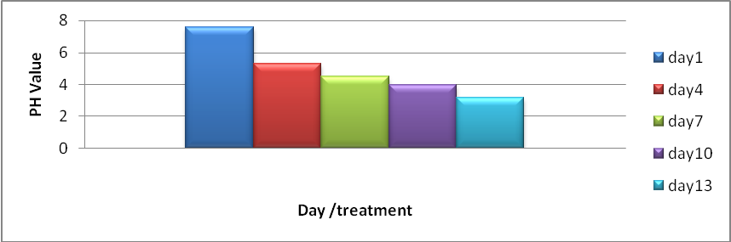
Fig. 1: pH value decreaing during experiment thirteen days
-Total Dissolved Solids
Which is about organic materials and inorganic molecules and particles accumulate with each other to be what is known as solids and be small in size ,When the presence the salts with and resulting from the presence of ions called total solids [15]. (TDS) percent removal was (97.54%)this may be due to it is important for growth and reproduction of fungi [16].(TDS) reduced from( 660-256.3) mg/l by removal percent (62.15%)by Penicillium sp. from oil refinery wastewater in Najaf [14].
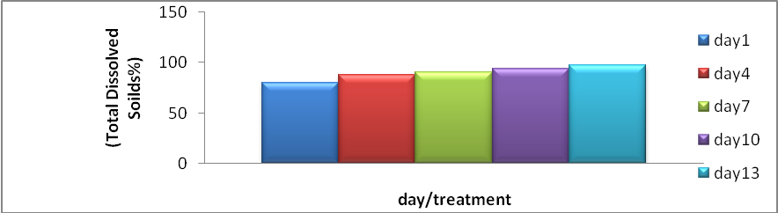
Fig. 2: percent removal of total dissolved solids during thirteen days
-Total Alkalinity (T.A)
The alkalinity of the water is the content of carbonate and bicarbonate and hydroxides [17].Alkalinity percent removal was (93.33%)Figure3, this may due to the use of ion bicarbonates as source of carbon ,carbon act an nutrient for fungi and it is important for growth ,multiplying and sporulation [18].This is agreed with high percent removal for total alkalinity for wastewater of the public Euphrates company that was(88.6%,86.66%) by Aspergillus niger,Aspergillus terreus respectively [19] .
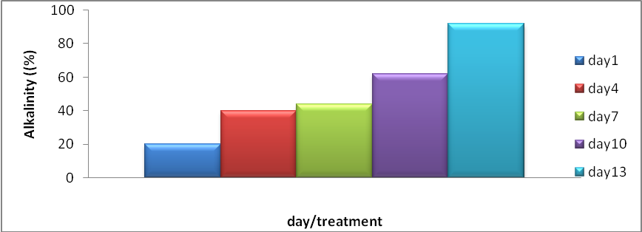
Fig. 3: removal percent of total alkalinity during thirteen days
-Total hardness ,Calcium and Magnesium hardness
Total hardness acts the total of many ions such calcium ,magnesium ions [20] . Total hardness ,calcium and magnesium hardness percent removal was (97.77%,87.97%,99%) respectively Figure (4,5,6).This due to that the fact the calcium nutrients that is needing by fungi for growth purpose [21]. Total hardness and magnesium hardness were reduced by Aspergillus niger and the removal percent was (77.77%,83.39%) respectively [19].
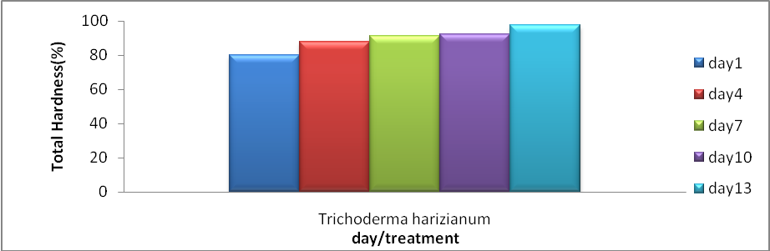 Fig. 4: removal percent of total hardness during thirteen days
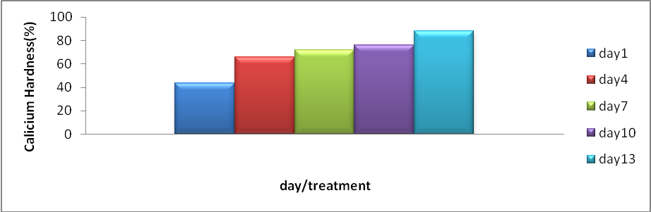
Fig. 5: removal percent of calcium hardness during thirteen days
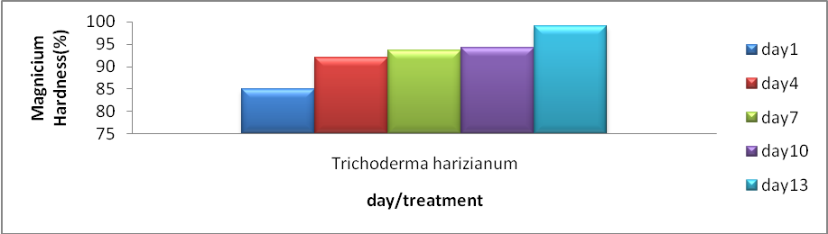
Fig. 6: removal percent of magnesium hardness during thirteen days
-Sulfate
Tanning processes that includes utilizing chromium sulfate of the leather , many of mechanical and chemical processes of tanning include organic materials and inorganic with collagen protein in the leather and used material chrome sulfate as tanning of the leather ,percent removal for sulfate was (90%) during period experiment because , fungi used sulfur as an energy source [22], sulfate was reduced from (700.2-243.3)mg/l in wastewater for najaf refinery when treatment by using Penicillium sp.[14].
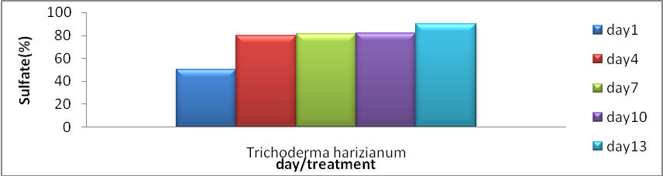
Fig. 7: removal percent of sulfate during thirteen days
-Nutrient(Nitrite and Nitrate )
The nutrients are bio stimulation and important elements in formation of enzymes and proteins for living microorganisms [23].percent removal for nitrite and nitrate was (84.66%,95%) respectively Figure(8,9)during the study period was due to the nutrients that stimulate growth for fungi [24,25]. Nutrients reduced from (40-20)mg/l for nitrite when treatment wastewater oil refinery in Najaf by two fungi Aspergillus terrus ,Pencillium sp.[14].
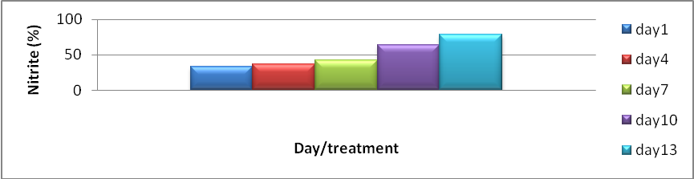
Fig. 8: removal percent of nitrite during thirteen days
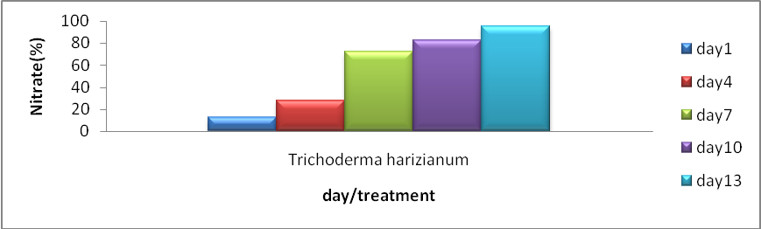
Fig. 9: removal percent of nitrate during thirteen days
-Total chromium
Chromium is toxic heavy metals resulting from industries such as leather tanning industry as well as other pollutants dispose to the environment ,Total chromium includes Cr(III) ,Cr(VI) [26],percent removal percent was (70.18%) by using the fungus Trichoderma harizianum Figure (10) because of the chromium one of important structural element of the surface of fungal cells founded that is as a structural element for chitin ,chitosan for fungus cell wall that is altered when active uptake for chromium [27].
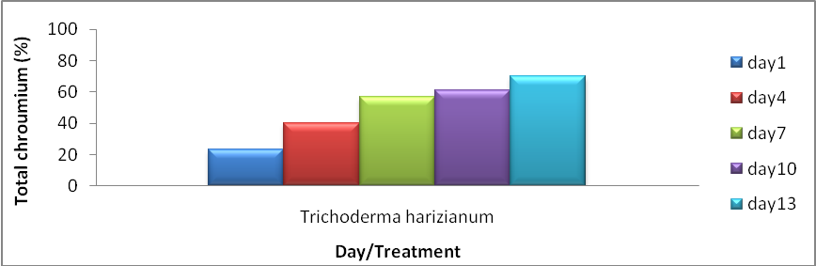
Fig. 10: removal percent of total chromium during thirteen days

-Hexavalent chromium
The hexavalent chromium compounds in industry has led to environmental contaminants are widespread ,The leather tanning processes is characterized by chromium compounds hexavalent [28].In present study chromium concentration from (30.8-0.1) ppm by percent removal was (99.67%) by filamentous fungus Trichoderma harizianum .
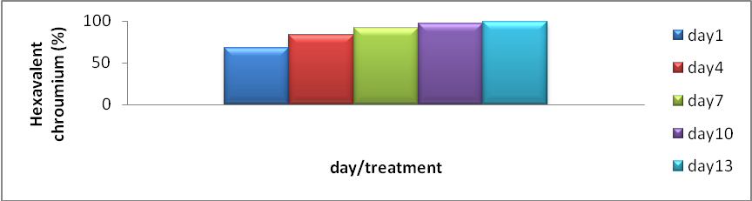
Fig. 11: removal percent of hexavalent chromium during thirteen days
-Biomass Estimation
Biomass was measured in the end of experiment after filtering the water and drying then weighting in control (Distilled water ) was 0.613g as compared with( industrial wastewater) was 1.422 g , The percent increasing was (56.89%).This due to that the fungus Trichoderma harizianum was using all of elements in wastewater for building its biomass during thirteen days from incubation .This increase in the biomass culture explained by the fact this an additional nitrogen and carbon contribution which allows the synthesis of new secondary metabolites for the production microbial biomass[29].
Conclusions
1-T.harizianum is a good candidate for bioremediation of total and hexavalent chromium from tannary waste water
2- T. harizianum isolates was observed increasing of biomass as a result consuming elements and nutrient that founding in tannery wastewater.
References
[1] Vierira ,R. and Volesky ,B .Biosorption :A solution to pollution International Microbiology Vol.3, pp.17-24.2000.
[2] Wang,J. and Chen C.Biosorbent for heavy metal removal and their future. Biotechnology Advances pp. 27-226.2009 .
[3] Ahmad ,W.A.; Zakaria , Z.A.; Khaasim , A.R.; Alias, M.A.; Shaik Ismail S.M.H. Pilot –scaleremoval of chroumium from industrial wastewater using the Chrome Bac system .Bioresource Technology, Vol. 101, pp.4371-4378.2010.
[4] Palmar, D and Puis, W. Natural attenutation of hexavalent chroumium in ground water and soils .EPA Ground water Issue ,pp.87-90.1994.
[5] Cheung, K.H. and Gu,J.D.Mechanism of hexavalent chroumium detoxification by microrgansim and bioremediation application potential :A review .International Biodeterioration and Biodegradation Vol.59,No.18.pp.64-78.2007.
[6] Chojnacka,K. Bio sorption and Bioaccumulation prospects for practical applications . Enviroment International, Vol.36, pp. 299-307.2010.
[7] Nurliana,L. ; NurAinIzzati ,M.Z and Fan ,S.G. Tolerance and biosorption of copper (Cu) and Lead (Pb) by filamentousefumgi isolated from a fresh water ecosystem .Journal Enviroment Science ,Vol. 23,pp.824-830.2011.
[8] Zafer , S., Aqil, F .and Ahmad ,I .Metal Tolerance and bio sorption potential of filamentous fungi isolated from metal contaminated agricultural soil . Bioresourcecans G20 :Assessment of its toxicity and correlation with those of zinc and lead .Environmental Microbial. Vol.13, No.l ,67,pp.4765-4772.2007.
[9] Gopi ,V ;U Padage , A; and soundara Jan D .Bioremediation Potential of individual and consordum Non – adapted strains on azodexes containing textile effluent advances applied science Research, Vol. 3, No.1:pp.303-311.2012.
[10] Syed ,A; Tharanum,S.;and Krishnamurthy, V. Study of chromium tolerance remediation and accumulation by an indigenous bacterium isolated from electroplating industrial effluent .International journal of pure and applied research in engineering and technology .Research, Vol.1, No.8 :pp.133-140.2013.
[11] APHA .Standard Method for the Examination of Water and Wastewater ,APHA, AWWA and WEF ,21 ST Edition ,2005
[12]APHA .Standard methods for the examination of water and wastewater . A mer pub Health Assoc ,Washington ,Dc.59-60.1976.
[13] ManakBhavan; Bahadur shah;Zafer mark.Indian standard methods of sampling (physical and chemical) for water and waste water part 52 chromium , first revision , part 52.2003 .
[14] Al-bakri, Joolan Jabar S . Possibility study of petroleum hydrocarbons removal and some water pollutants from najaf refinery wastewater by fungus. M.Sc. thesis , College of Science for Women ,University of Babylon,Iraq,2015.
[15]Merrin ,J.S.;Sheela ,R.; Saswathi ,N.;Prakasham ,R.S., and Rama Krishna ,S.V. Bio sorption of chroumium using Rhizopusarrhizus . 1nd .J. Exp .Biol. Vol.36: pp.1052-1055.1998.
[16] Dezuane,Jhon. Handbook of Drinking Water Quality (2nd ed) Jhon Wiley and Sons .ISBN 0-471-28789-X.1997.
[17]Murphy ,S.General information in solids . U S G S , Water Quality Monitoring .USA.2002 .
[18]Geo ,F.B;Karen ,C ;Janet ,S.P . and Stephen ,A.M. Medical Microbiology 24 thed .Mcgrow Hill Processional B , p.832,2007 .
[19] Khalaf,A. R. H. Mycoremedation for some disposal pollutants to general company for chemical industry . M.Sc. thesis, College of Science for Women, University of Babylon, Iraq,2014.

[20] Smith ,R. Current methods in aquatic science .University of water ,Canada .2004.
[21] Walker ,G.M. . Metal in yeasts Fermentation Processes ains removal of the direct textile by fungi strains in vivo Micronucleus and RAPD-PCR technique on metal rate .Journal of applied Toxicology ;Vol.29, No.4 :pp.484-490. 2004.
[22] US-EPA. Mannual of nitrogen controll, office of research development center for Enviromental Research information risk and reduction Engineering Labrotary ,Cincinate ,625/R-93/010.1993.
[23] Atlas ,R.M.Two bacteria of hydrocarbon degradation . petroleum microbiology .Masmillan publishing company ,3 ed.Newyork.1984.
[24] Potin ,O.; Rafin , C .and Veignie ,E. Bioremedation of an aged polycyclic aromatic hydrocarbons (PAHs) –contaminated soil by filamentouse fungi isolated from the soil .International Biodeterioration and Biodegradation, Vol.54, pp.45-52.2004.
[25] Mollea ,C.; Bosco ,F .and Ruggeri ,B.Fungal biodegradation of naphthalene :microcosms studies .Chemospher, Vol.60,pp.636-643.2005.
[26] Potin ,O.; Rafin , C .and Veignie ,E. Bioremediation of an aged polycyclic aromatic hydrocarbons (PAHs) –contaminated soil by filamentous fungi isolated from the soil .International Bio deterioration and Biodegradation, Vol.54, pp.45-52.2004.
[27] Padma,S.Vankar and Dhara Bajpai, Phytoremediation of chrome (VI) of tannary effluent by Trichodermaspecies. Conference on Dasilination and the Environment .Sponsored by the European Desalination Society and center for Research and Technology Hellas (CERATH) ,Sani Resort ,Halkidiki ,Greece ,April 22-25.2007.
[28] Jacob,S.J.; Hardison ,R.L.,and Rouse, J.V. In situ remediation of heavy metals using sulphar base treatment technologies .Hydrovisions ,Vol .10, pp1-4.2001 .
[29] Wottom, MA ; Kremer RJ ; Keaster,AJ.Effect of carbofuran and the corn rhizpsphere on growth of soil microorganisms .Bull Environ Contam Toxicol Chem. Vol.12: pp.1059-1056.1993.

