Ecophysiological study of silver nanoparticles effect on the liver and regulatory cytokine in rabbit
Frial Gemeel Abd

Department of Biology, Faculty of Science, Babylon University, Babylon/Iraq
Corresponding author: frialabd@yahoo.com

To cite this article:
Abd, F. G. Ecophysiological study of silver nanoparticles effect on the liver and regulatory cytokine in Rabbit. Mesop. environ. j., 2016, Vol. 2, No.3, pp.27-33.

Received Date: 5/2/2016, Accepted Date: 10/3/2016, Publishing Date: 15/5/2016

This work is licensed under a Creative Commons Attribution-NonCommercial-NoDerivatives 4.0 International License.



Abstract
Silver naoparticles are widely used in treatments and as products using by human ,There is likelihood of release into the enivrements .That affect on health and environnemental concerns so their effect on liver must be studied.In this study silver nanoparticles were extracted from Morganella morganii and the rabbits were immunized with the extract to study the immunization capacity of Silver naoparticles. The liver function were studied by determine GPT and GOT and the serum level were increased (6.66,5.33) for test when compared with control(4.666, 4.667) respectively. The regulatory interleukines (IL-10 and IL-12)were determined By enzyme linked immunosorbent assay. The concentrations IL-10 were increased in test group(13.27) than in cotrol (10.25)while IL-12 concentrations were decreased in test group than control (14.20).The conclusion that Silver nanoparticles effect on function of rabbit liver and increase TH2 by increasing IL-10 and decrease IL-12 .
.
Keywords; Silver ,nanoparticles ,interleukin ,immune-regulatory.
Introduction
The relationship between nano materials and biology has led to the development of diagnostic devices, analytical tools, physical therapy and drug delivery vehicles [1]. The nano materials with antibacterial properties, metallic nanoparticles are the best ,because nanoparticles increase chemical activity due to crystallographic surface structure with their large surface to volume ratio [2] .Silver nano-particles:can be synthesis by bacteria, fungi, and plant extracts ,many bacteria have ability to synthesis silver nanoparticles and the most widely accepted mechanism of silver biosynthesis is the presence of the nitrate reductase enzyme[3] . It is estimated that tones of silver are released into the environment from industrial wastes, and it is believed that the toxicity of silver in the environment is majorly due to free silver ions in the aqueous phase. Toxicity of nanoparticles depends on many factors such as size, shape, chemical composition, surface area, surface charge, and others .
The adverse effects of these free silver ions on humans and all living beings include permanent bluish-gray discoloration of the skin or the eyes and exposure to soluble silver compounds may produce toxic effects like liver and kidney damage; eye, skin, respiratory, and intestinal tract irritations; and unto ward changes in blood cells[4] . The environmental transformation of AgNPs, the behavior of AgNPs should be thoroughly monitored in complex environmental relevant conditions, additional in vivo toxicity studies should be carried out to understand the exact toxicity mechanism of AgNPs, and to predict the health effects to human [1] .The aim of this study to investigate the effect of silver nanoparticles on liver and cellular immunity.
Materials and methods
Silver nanoparticles were extracted from Morganella morganii were achieved from previous work [5].
Immunization
Forty mg/Kg of silver nanoparticles was injected subcutaneously and intramuscular by using rabbits(Rabbits of 1-1.5Kg body weight),these rabbits were selected as test experimental animals .They were brought from local market and of local breed (Orcyctalagus cuninculus) among which 6 were checked and found to be free of pathogenic agents then grouped into two groups each of three and kept at libitum.
Liver from control and test group were removed and fixed in a 10 % formalin solution containing normal saline .The organs were embedded in paraffin ,and stained with hematoxylin and eosin and examined under light microscopy .
GOT and GPT enzyme

The liver enzymes in serum determination of GPT, GOT by specialized Kits from Linner company.

Test principle
Blood after separation to the erythrocytes and the plasma. In the presence of GOT, α-ketoglutarate and alanine sulfinate are converted to pyruvate and glutamate . In a second reaction step, catalyzed by pyruvate oxidase, the resulting pyruvate is cleaved into acetyl phosphate , carbon dioxide and hydrogen peroxide . In the presence of POD the hydrogen peroxide converts an indicator into its oxidized blue form. The dye is measured kinetically at 567 nm as measure of the enzyme activity of GOT and the result displayed after 124 second ]6[. Test for quantitative determination of GPT (ALT) in blood , serum or plasma with Reflotron.
In the presence of GPT , α-ketoglutarate and alanine are converted to pyruvate and glutamate . In a second reaction step , catalyzed by pyruvate oxidase , the resulting pyruvate is cleaved into acetyl phosphate, carbon dioxide and hydrogen peroxide. In the presence of POD the hydrogen peroxide converts an indicator into its oxidized blue form. The dye is measured kinetically at 567 nm as measure of the enzyme activity of GOT and the result displayed after 140 second. Testing procedure , as like as ALP measurement, the same procedure is used for GPT measurement by Reflotron instrument ]6[.

Cytok-ine concentration

IL-12 and IL-10 concentrations were determined according the company instructions (BioSource).-Principle of test .The BioSource IL-12 EASIA is a solid phase enzyme amplified sensitivity immunoassay performed on microtiter plate. The assay uses monoclonal antibodies (M. Abs.)directed against distinct epitopes of IL-2. Calibrators and samples react with the capture monoclonal antibody (Mab 1) coated on microtiter well and with a monoclonal antibody (Mab 2) labeled with horseradish peroxidase ( HRP). After an incubation period allowing the formation of a sand witch : coated Mab 1–human IL-12- Mab 2 –HRP, the microtiter plate is washed to remove unbound enzyme labeled antibody. Bound enzyme labeled antibody is measured through a chromogenic reaction, chromogenic solution (TMB) is added and incubated. The reaction is stopped with addition of stop solution and the microtiter plate is then read at the appropriate wave length. The amount of substrate turnover is determined colori metrically by measuring the absorbance, which is proportional to the IL-12 concentration. A calibration curve is plotted and IL-12 concentration in sample is determined by interpolation from the calibration curve [7[.
Assay procedure
- The required number of strips were selected for the run. The unused strips should be resealed in the bag with a desiccant and stored at 2-8⁰C.
- Securing the strips into holding frame .
- 100 µl of incubation buffer adding into the wells .
- 100 µl of each calibrator, control and sample adding into the appropriate wells .
- Adding 50 µl of anti –IL-12 HRP conjugate into all the wells .
- Incubation for 2 hours at room temperature on a horizontal shaker set at 700 rpm ± 100 rpm.
- Aspiration the liquid from each wells .
- Washing the plate 3 times by dispensing 0.4 ml of wash solution into each well, and aspiration the content of each well.
- 100 µl of the chromogenic solution adding into each well within 15 minutes following the washing step.
- Incubation the microtiterplate for 15 minutes at room temp. on a horizontal shaker set at 700 rpm ± 100 rpm.
- 200 µl of stop solution should be added into each well .
- Reading the absorbance at 450 nm and 490 nm ( reference filter 630 nm or 650 nm) within 3 hours and calculation the result .

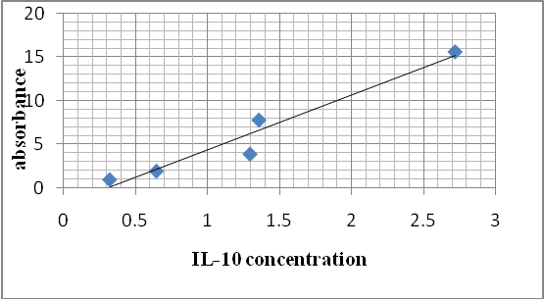
Fig.1:standard curve for IL-10
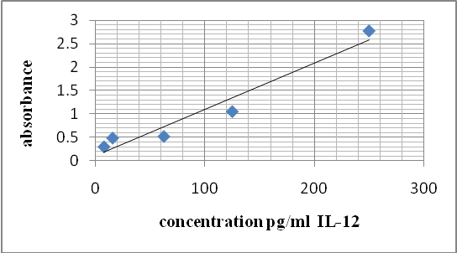
Fig. 2:standard curve of IL-12
Results and Discussion
Silver nano particules (AgNps) That was entracte frome clinicat isolats of M .morgani [5] .AgNp effect on liver function by increasing the enzyme GPT and GOT in rabbits that immunized with it as that showed in (table1) .There is non-significant increase in test group compare with control ,while[8]found that liver ALT was increase while AST was decrease in mice treated with AgNP ,this mean that AgNps effect on the liver cells and it causes blood congestion in liver (figure3). Other studies on silver nanoparticles that mice were given AgNP orally ,It found that AgNPas mitogenic response in splenocytes[10]. In table (2)the AgNps increase the IL-10 concentration in serum of rabbit immunized with AgNps this mean that Silver nanoparticles increase Th2 cells ,other studies also showed silver nanoparticles increase the anti-inflammatory cytokine IL-10 [9,11].IL-12 concentrations were decreased in test group compare control this due to the Silver nanoparticles increase TH2 by increasing IL-10 , IL-12 act as a key factor for activation TH1 and consider one member of immune-regulatory cytokine group that include IL-12,IL-23,27andIL-35 [11] but this disagreement with[9,11] that found Silver nanoparticles increaseIL-12 in mice when repeated doses were used. This may be the method for extract nanoparticles ,dose and route of administration .

Table 1: GPT and GOT in rabbit serum immunized with silver nanoparticles of Morganella morganii

p-value ≥0.05 | M ±SD | group | Enzyme
0.031 | 6.666 ± 2.081 | Test | GPT
 | 4.666 ± 0.577 | control | GPT
0.047 | 5.333 ± 2.081 | Test | GOT
 | 4.667± 0.577 | control | GOT

Table 2: Regulatory interleukin in serum of rabbit immunized with silver nanoparticles
p-value ≥0.05 | M ±SD | group | Interleukin
0.9 | 14.20 | Test | IL-12
0. 6 | 18.29 | control | IL-12
0.004 | 13.27 | Test | IL-10
0.077 | 10.25 | control | IL-10

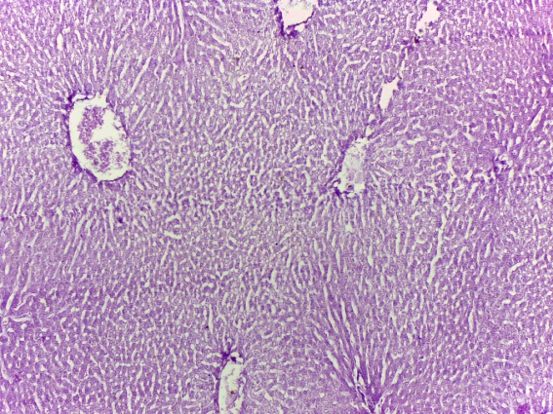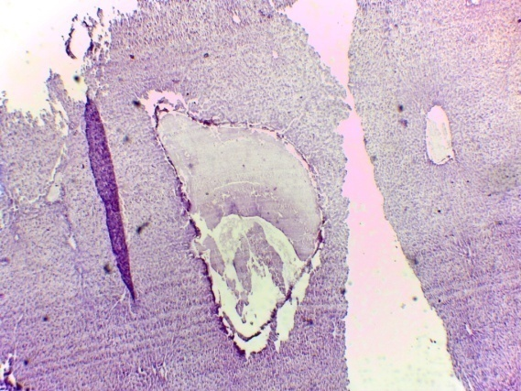
A
B
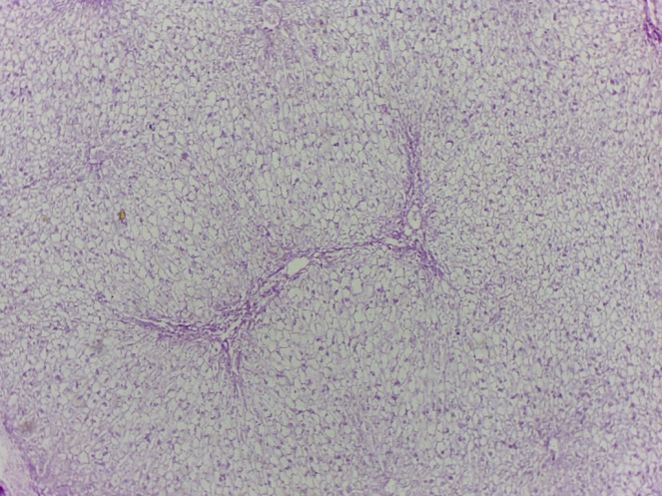
C
Fig.3: (A) and (B)-liver of rabbit immunized with silver nanoparticle ,show congested blood vessel .(C) liver from control rabbit immunized with normal saline(power 10X)
A

References
]1[ Yu,S.;Yin, Y .and Liu,J.Silver nanoparticles in the environment . Environ. Sci.: Processes Impacts,Vol.15, pp. 78- 92. 2013.

[2] Singh, M.; Singh, S.;Parasad,S.andGambhir, I.S. Nanotechnology in medicine and antibacterial effect of silver nanoparticles. Digest Journal of Nanomaterials and Biostructures .Vol.3, No.3, pp. 115 – 122. 2008.

]3 [Prabhu,S.andKpoulose,E.Silver nanoparticles: mechanism of antimicrobial action, synthesis, medical applications, and toxicity effects , Prabhu and Poulose International Nano Letters, VOl.2:pp.32.2012.
]4[Panyala, NR, Pena-Mendez, EM, Havel, J. Silver or silver nanoparticles: a hazardous threat to the environment and human health? J. Appl. Biomed.Vol.6, pp.117–129 .2008.
]5[Abd, F.G; Al-Kawaz, A.,H and Al-Dahamoshi, H.O.Phenotypingand genotypinic investigation on silver nanoparticales of Morganella morganii recovered from(cauti),Iraq .I.J.M.PS , Vol.3, No.3: pp.29-38. 2013.
]6[Rosche Diagnostic .Tests for quantitative determination of AST , EC ( 2.6.1.1), ALT ( 2.6.1.2) and
ALP (3.1.3.1) in blood serum or plasma by reflotron. Charless Avenue , Burgess Hill. UK. 2012 .
]7[BioSource, C.E. Manual of ELISA principles and methods for interleukins, IL-1B EASIA , KAP 1211, IL-2 EASIA KAP 1241 , IL-10 EASIA KAP 1321, IL-12 EASIA KAP 1561. BioSource Europe S.A.-Rue de I`Industrie , 8, B-1400. Nevelles – Belgium.2011.
]8[AL-Harbi, M.S.;El-Deeb,B.A.; Mostafa, N. and Amer, S.A. Extracellular biosynthesis of AgNPs by the bacterium Proteus mirabilis and its toxic effect on some aspects of animal physiology.Advances in nanoparticles, Vol. 3,pp.83-91. 2014.
]9[Malaczewska, J.The effect of silver nanoparticles on splenocyte activity and selected cytokine
levels in the mouse serum at early stage of experimental endotoxemia. Pol J Vet Sci. ; Vol.14, No.4: pp.597-604.2011.
[10] Hamza,T. ;Barnett, J.B. and Li, B.Interleukin IL-12 a key immunoregulatory cytokine in infection application. Int. J. Mol. Sci., Vol.11, pp.789-806.2010.
]11[Park,E.J;Bae,E.;YiJ.;Kim,Y.;Choi,K.;Lee, B.C. and Park, K . Repeated –dose toxicity and inflammatory responses in mice by oral administration of silver nanoparticles. Environ Toxicol Pharmacol. ;Vol.30, No.2:pp.162-168.2010.

