Removal of methylene blue dye from aqueous solution by using commercial granular activated carbon with different types of adsorbers

Jabbar H. Al-Baidhany¹ Simaa T. Al-Salihy²

1Department of Environmental Eng.,, College of Engineering, University of Babylon, Iraq
2Department of Civil, College of Engineering, University of Babylon, Iraq

Corresponding author: Simaa.alsalihy@yahoo.com

To cite this article:

Al-Baidhany, J. H. and Al-Salihy, S. T Removal of Methylene BlueDyefrom aqueous solution by using Commercial Granular Activated Carbonwith different types of adsorbers.Mesop. environ. j., 2016, Vol. 2, No.2, pp. 1-11.

This work is licensed under a Creative Commons Attribution-NonCommercial-NoDerivatives 4.0 International License.



Abstract

This study is to compare the removal efficiency of methylene blue dye from synthetic solutions by using commercial granular activated carbon with different operational conditions and with different types of adsorbers in a continuous system for bothfixed-bed and fluidized-bed. Twenty experiments and different column systems were carried out at various initial concentrations, flow rate and bed depth. Activated carbon in fluidized bed achieved higher removal efficiencies than activated carbon in fixed bed. Column experiments (continuous system) showed that the use of fluidized bed instead of fixed bed reduces the contact time by about (11-21) % under the same operating conditions. It was showed that fluidized bed makes the process of adsorption faster due to increasing the adsorption surface area of the adsorbent which leads to reduce dead zones between the particles.
Keywords; methylene blue, adsorption, activated carbon, fluidized bed, fixed bed.
Introduction
Dyes are widely used in textile, paper, plastic, food and cosmetic industries. The wastes coming from these industries can affect our atmosphere causing pollution. The level of pollutants even at a very low concentration is highly visible and it affects aquatic life. Hence, contaminations due to dyes pose not only a severe public health concern, but also many serious environmental problems because of their persistence in nature and non-biodegradable characteristics [1].
In a continuous system, there are types of adsorbers that are generally used in wastewater application, down flow fixed-bed, packed moving-bed and up-flow expanded-bed [2]. The fluidized-beds offer a high available surface area, since there is no contact between particles, intimate contact of the entire surface with the waste stream is assured, and making the process faster by the increasing of the adsorption surface area of the adsorbentthrough the reduction of dead zones between the particles. Based upon basic principles of adsorption process, it is reasonable to expect that fluidized bed with activated carbon showed increasing the removal efficiency of some pollutants of wastewater as compared with fixed bed under the same operating conditions.
Santhi, et al.[3] Investigate the potential use of activated carbon prepared from the AnnonaSquamosa seed for the removal of methylene blue (MB), methyl red (MR) and malachite green (MG) dyes from simulated wastewater. Adsorption of MB, MR and MG dyes on the AnnonaSquamosa seed showed highest values at around pH 7. Activated carbon developed from the AnnonaSquamosa seed can be an attractive option for dyes removal from diluted industrial effluents.
Materials and methods
Adsorbate Material
Methylene blue which is the most commonly used material for dying cotton, wood, and silk is a heterocyclic aromatic chemical compound with (C₁₆H₁₈ClN₃S, 3H₂O) as molecular formula and a molecular weight of 373.9 x 10⁻³ kg mol⁻¹ [4]. A stock solution of 100 mg/l of methylene blue (MB) was prepared for calibration purposes. From the stock, different concentrations of methylene blue were prepared by diluting with water. A spectrophotometer was used for the determination of absorbance at the predetermined maximum absorbance wavelength (λ_{max}=664nm) of the MB dye for different concentrations of MB subsequently.
Adsorbent Material
Activated carbon has a large volume of very small pores which creates a large surface area [5]. The activated carbon firstly was washed with distilled water to remove the impurities and then dried in an electric oven at 110-120 Cº for (3600 sec.) [6]. It was then placed in desiccators for cooling. The commercial activated carbon (GAC) with the physical properties listed in Table (1) was supplied by the scientific bureaus in Iraqi commercial markets.
Table (1): Physical Properties of Activated Carbon Utilized in the Present Study (Commercial Markets).
Item Name | Granular Activated Carbon
Base | Coconut Shell
Bulk Density | 0.3 x 10³ Kg/m³
Particle Density | 1.5 x 10³ Kg/m³
Surface Area | 650 m²/g
Internal Porosity | 0.2
pH | 10.2-10.6

Column Experiments and Breakthrough Curves
Continuous flow adsorption studies were conducted in two glass columns made of Pyrex glass tube each of (0.8m) height and (0.05m) inner diameter. One of the glass columns used as a fixed bed and the other one was used as a fluidized bed. In the glass column which is used as a fixed bed, a very fine stainless steel screen was attached at the bottom followed by a layer of glass beads. A known quantity of the adsorbent was packed in the column to yield the desired bed heights of the adsorbent, the influent solution was introduced to the column through a perforated plate, fixed at the top of the column to ensure a good distribution of the solution over the bed. In the glass column which was used as a fluidized bed, a layer of glass beads was placed in the bottom of the column to ensure a uniform distribution of influent through the bed and the adsorbent bed was placed above it. The influent solution was introduced to the column through a perforated plate or fine stainless steel screens, fixed at the bottom of the column. A very fine stainless steel screen was attached at the top of the column.A schematic diagram of the treatment system and process flow used in the study is shown in Figure (1).

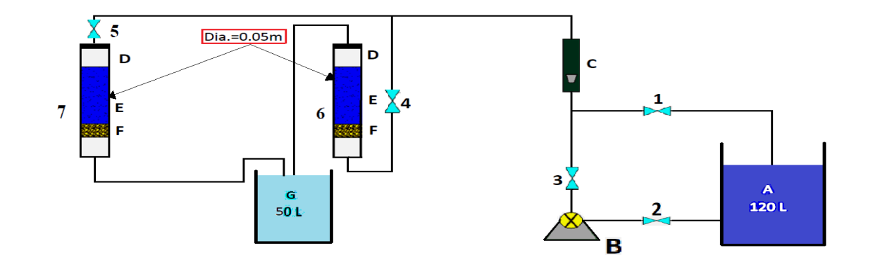

Figure (1): Schematic Representation of Experimental Equipments. (A) Feed Tank, (B) Pump, (C) Rotameter, (D) Perforated Plate in Fixed Bed and Stainless Sieve in Fluidized Bed, (E) Packed Bed Adsorber, (F) Class Beads & Stainless Sieve, (G) Effluent Tank, (1,2,3,4&5) Valves, (6) Expanded Bed Adsorber and (7) Packed Bed Adsorber.

In all these experiments, the room temperature and solutions pH of 5 were kept constantwith the particle size of (0.6-1.2) mm. Every (15) minutes at the beginning and then every (0.5) hour, a (25 ml) sample was taken from the outlet of the column and analyzed for MB concentration using UV Spectrophotometer until equilibrium state was reached. The effects of various initial dye concentrations, bed height, and flow rate for methylene blue adsorption on commercial activated carbon bed studied and the removal efficiency in fluidized and fixed bed systems are investigated. The performance of fixed bed system of removal efficiency of methylene blue dye was studied for the same operating conditions of experiments conducted in fluidized bed system. Finally comparison between the results of fluidized and fixed bed systems was conducted.

Continuous Experiments (Fixed Bed)
1-Effect of Initial Concentration
The effect of influent MB concentration on the shape of the breakthrough curves was investigated by varying the initial MB concentration between (15, 30 and 50) mg/l with constant bed depth of 0.1 m, flow rate of 12 l/hr and solution pH of 5 is shown by the breakthrough curves presented in Figure (2).
Figure (2): The Experimental Breakthrough Data for Adsorption of MB onto Commercial Activated Carbon at Different Initial Concentrations, Q=12 l/hr, L=0.1m, pH=5.
At the highest MB concentration of 50 mg/l, the activated carbon bed was exhausted in the shortest time of 14.5 hours leading to the earliest breakthrough. The breakpoint time decreased with the increasing the initial concentration as the binding sites became more quickly saturated in the column. The decreasing of MB concentration gives an extended breakthrough curve indicating that a higher volume of the solution could be treated. This was due to the fact that at lower concentration, sufficient sites are available for the adsorption of the MB dye. However, at higher concentrations of the dye, the number of MB cations is relatively higher compared to the availability of adsorption sites. Hence, the percentage removal of MB depends on the initial concentration and decreases with the increasing in the initial concentration as in the case of adsorption of dyes onto activated carbon. The equilibrium uptake capacities of the activated carbon increased with the increasing initial of MB concentration because the initial MB concentration provides an important driving force to overcome all mass transfer resistance. This result was agreed with [6].

2-Effect of Adsorbent Bed Height
Figure (3) shows the breakthrough curves obtained for MB adsorption on the commercial activated carbon for three different bed heights of (0.05 m, 0.10 m, and 0.15 m), at a constant flow rate of 12 l/hr, MB initial concentration of 50 mg/l, and solution pH of 5.
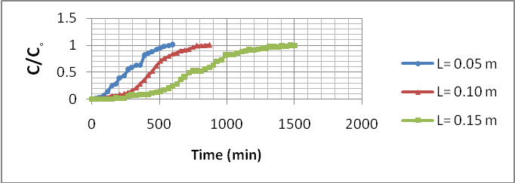
Figure (3): The Experimental Breakthrough Data for Adsorption of MB onto Commercial Activated Carbon at Different Bed Depths, Q=12 l/hr, C_{o}=50 mg/l, pH=5.
It can be observed from this figure that the total quantity of solute removed from solution at any period of time increases with the increasing the bed depth. Both the breakthrough and exhaustion time increased with the increasing the bed height. A higher MB uptake was also expected at a higher bed height due to the increasing in the specific surface of the activated carbon which provides more fixation binding sites for the dye to adsorb. The increasing in the adsorbent mass in a higher bed provided a greater service area which would lead to the increasing in the volume of the solution treated. [7]reported in their works that as the bed height increases, the residence time of the fluid inside the column increases, allowing the adsorbate molecules to diffuse deeper inside the adsorbent. Thus, the bed capacity is likely to change with service time. Also, as the bed height (adsorbent mass) increases, MB had more time to contact AC that resulted in higher removal efficiency of MB molecules in column. Therefore, the higher bed column resulted in a decrease in the effluent concentration at the same service time.
3-Effect of the Solution Flow Rate
The effect of the flow rate on the adsorption of MB using commercial activated carbon was investigated by varying the flow rate (10, 12, 18and 24 l/hr) with a constant carbon bed height of 0.1 m, initial dye concentration of 50 mg/l, and solution pH of 5 as shown by the breakthrough curves in Figure (4).

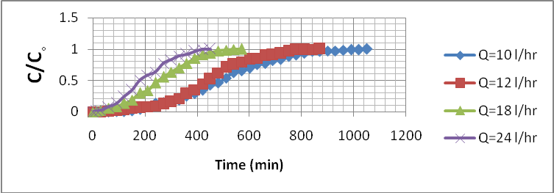
Figure (4): The Experimental Breakthrough Data for Adsorption of MB onto Commercial Activated Carbon at Different Flow Rates, L=0.1 m, C_{o}=50 mg/l, pH=5.

It can be seen that the breakthrough generally occurred faster with a higher flow rate. When the flow rate increases, the residence time between the dye and the adsorbent in the bed decreases which results in lower bed utilization. Therefore, the breakthrough time and the bed capacity will decrease. Breakthrough time to achieve saturation was increased significantly with the decreasing in the flow rate. At a low rate of influent, MB had more time to be in contact with adsorbent which resulted in a greater removal of MB molecules in column. It is expected that the change of flow rate will affect the film diffusion, but not the intraparticle diffusion. Similar effects of flow rate on breakthrough curves obtained in dye and metal adsorption on packed bed of other adsorbents were observed by many authors [7].At a higher flow rate, the adsorption capacity was lower due to insufficient residence time of the solute in the column and diffusion of the solute into the pores of the adsorbent, therefore, the solute left the column before equilibrium occurred. This result was agreed with [6].

Continuous Experiments (Fluidized Bed)
1-Estimation of the Minimum Fluidization Velocity
Minimum fluidized velocity in continuous experiments can be determined theoretically and experimentally. The calculation of theoretical value was obtained using Equation (1). The minimum fluidized velocity is equal to 1.3887×10⁻³ m/sec which corresponds to a minimum flow rate =9.8161 l/hr. Experimentally, the minimum fluidized velocity can be determined by visual observation as the lower velocity that lifts the particles and making them suspended. The experimental minimum fluidized velocity was approximately equal to the theoretical velocity. The minimum flow rate used in continuous experiments was equal to 10 l/hr. Different flow rates of higher than the minimum were used to increase the mixing and to show its effect on the removal efficiency of MB.
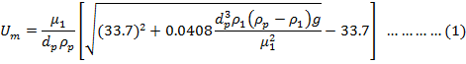
2- Effect of Initial Concentration
The effect of different initial concentrations of the solute (15, 30 and 50 mg/l) were investigated at constant flow rate and bed height (Q=12 l/hr and L= 0.1m). The experimental breakthrough curves are presented in Figure (5) for MB adsorption in terms of C/C_{o} versus time.
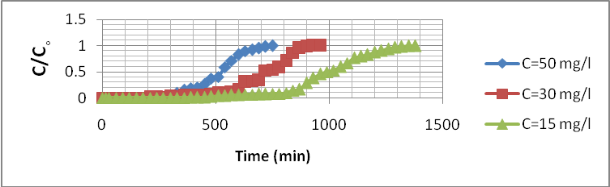
Figure (5): The Experimental Breakthrough Data for Adsorption of MB onto Commercial Activated Carbon at Different Initial Concentrations, Q=12 l/hr, L=0.1m, pH=5.
From the above figure, it is clear that the breakpoint was inversely related to the initial concentrations and the time required reaching saturation decreases with the increasing of the inlet solute concentration. In the case of low initial solute concentration, the diffusion rate will take a longer time to reach saturation. It is also clear that when the influent concentration increases, the adsorption capacity increases. This is due to a high concentration difference between the bulk solution and the concentration of the solute on the solid phase. This will increase the rate of mass transfer of solute to attach a free site (s) on the solid phase of the activated carbon. The driving force for adsorption is the concentrations difference between the solute on the adsorbent and in the solution. If the initial concentration is high, the saturation of the bed is faster and the slope of the breakthrough curve is higher.This result was agreed with [8, 9].
3-Effect of Adsorbent Bed Height
The bed height is a major design parameter on adsorption process. The effect of bed height (0.05, 0.10 and 0.15 m) at constant flow rate and initial concentration (Q=12 l/hr and C_{o}=50mg/l) was investigated. The experimental breakthrough curves are present in Figure (6).
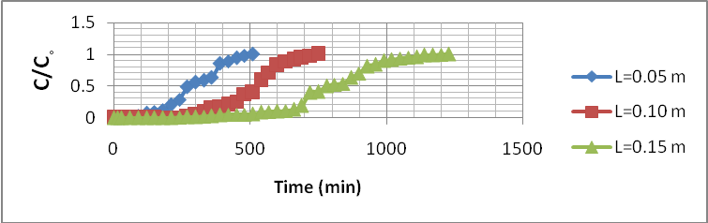
Figure (6): The Experimental Breakthrough Data for Adsorption of MB onto Commercial Activated Carbon at Different Bed Depths, Q=12 l/hr, C_{o}=50 mg/l, pH=5.
Examining this figure, it can be seen that the increasing of bed height will provide an extra surface area for the adsorption process with the increasing of the activated carbon bed depth. The increasing of the bed height will increase the adsorption capacity, because additional space will be available for the MB molecules to be adsorbed on these unoccupied areas, furthermore, the increasing of the bed height will give a sufficient contact time for these molecules to be adsorbed on the activated carbon surfaces. This shows that at low bed height the effluent adsorbate concentration ratio increases more rapidly than for a higher bed height. Furthermore, in a low bed height, the bed is saturated in less time. The lower bed height corresponds to lesser amount of adsorbent and weak capacity for the bed to adsorb adsorbate from solution. When the flow rate kept constant, the increasing of the bed height will increase the contact time of the solute in the bed, and these improving the solute removal efficiency. These results agree with those obtained by [9 , 10].
4-Effect of the Solution Flow Rate
The solution flow rate is a major parameter in the design of adsorption fluidized bed column. The effects of flow rate at (10, 12, 18, and 24 l/hr) on the adsorption were studied. The breakthrough curves are plotted for a bed height of 0.1m with pH 5 and an initial concentration of 50 mg/l. Figure (7) presents the results in term of C/C_{o} verses time.
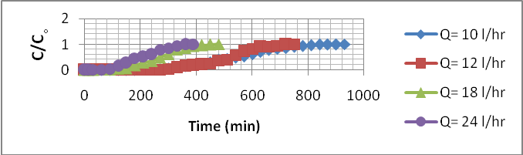
Figure (7): The Experimental Breakthrough Data for Adsorption of MB onto Commercial Activated Carbon at Different Flow Rates, L=0.1 m, C_{o}=50 mg/l, pH=5.
When the flow rate increases, the breakthrough curves become steeper. The breakpoint decreases due to the residence time in the column. At a high flow rate, the adsorbate solution leaves the column before the complete equilibrium occurs due to the reduction in the contact time. The increasing of the flow rate will cause a reduction in thickness of the surface film which considered the resistance for the mass transfer. As a result of that the increase in flow rate will increase the mass transfer rate. The increasing of flow rate leads to an additional disturbances (mixing) which makes the penetration and the passage of the adsorbate molecules through the particles and occupy a site (s) on the adsorbent easier. This was due to a good available contact time which will affect the amount of the capacity and this is for a low flow rate the aqueous solution molecules which would have a sufficient contact time to occupy the space within the particles. This result agrees with this obtained by [9, 10].
Comparison of the Results of Fluidized and Fixed Bed Columns

Experiments were conducted in fixed bed columns for the comparison purpose with fluidized bed columns, and to understand how each of the three operating parameters (for three initial concentrations of 50, 30, 15mg/l, and using three bed depths of 0.05, 0.10, 0.15 m with four flow rates of 10, 12, 18, 24 l/hr) studied can affect the MB adsorption capacity in each column. Figures (8) to (17) show the comparison between fixed and fluidized bed columns.

The Comparison at Different Initial Concentrations
Figures (8) to (10), show the comparison between fixed and fluidized bed columns for three different initial concentrations of 50, 30, 15 mg/l.
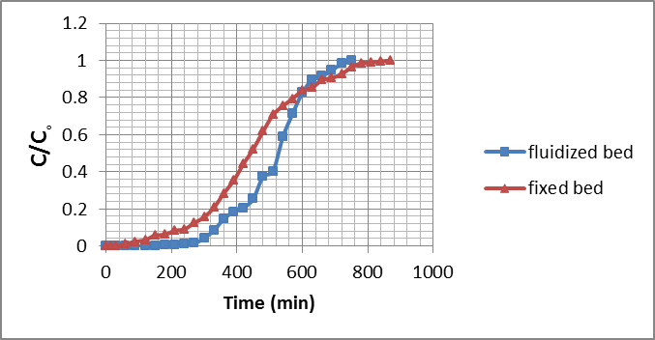
Figure (8): The Experimental Breakthrough Data for Adsorption of MB onto Commercial Activated Carbon at C_{o}=50 mg/l, Q=12 l/hr, L=0.1m, pH=5.
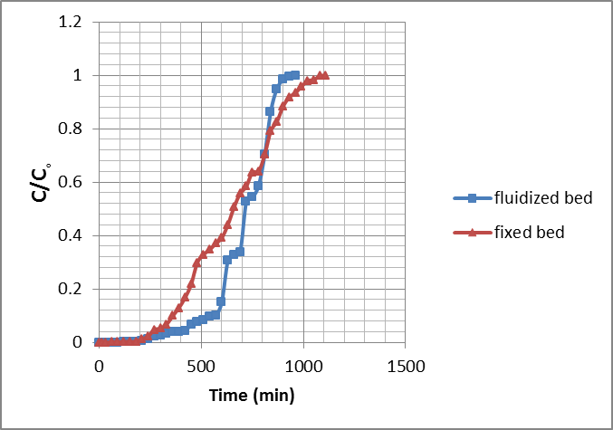
Figure (9): The Experimental Breakthrough Data for Adsorption of MB onto Commercial Activated Carbon at C_{o}=30 mg/l, Q=12 l/hr, L=0.1m, pH=5.
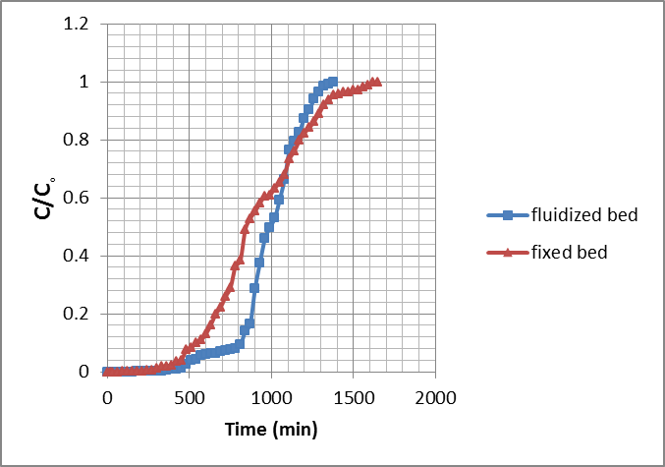
Figure (10): The Experimental Breakthrough Data for Adsorption of MB onto Commercial Activated Carbon at C_{o}=15 mg/l, Q=12 L/hr, L=0.1m, pH=5.

The Comparison at Different Bed Depths
Figures (11) to (13), show the comparison between fixed and fluidized bed columns for three different bed depths of 0.05, 0.10, 0.15 m.
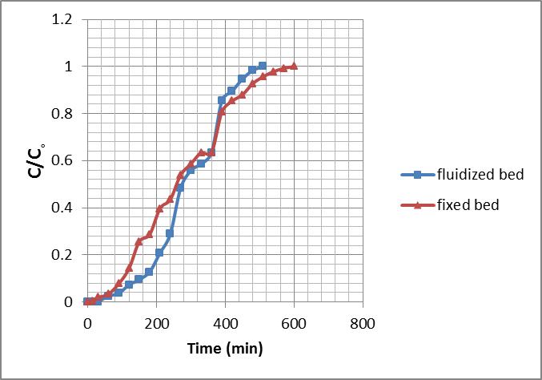
Figure (11): The Experimental Breakthrough Data for Adsorption of MB onto Commercial Activated Carbon at L=0.05 m, Q=12 l/hr, C_{o}=50 mg/l, pH=5.
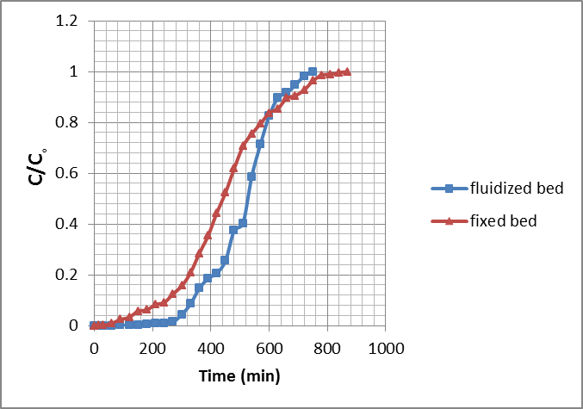
Figure (12): The Experimental Breakthrough Data for Adsorption of MB onto Commercial Activated Carbon at L=0.10 m, Q=12 l/hr, C_{o}=50 mg/l, pH=5.
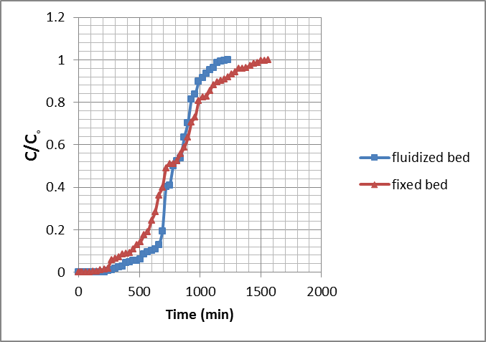
Figure (13): The Experimental Breakthrough Data for Adsorption of MB onto Commercial Activated Carbon at L=0.15 m, Q=12 l/hr, C_{o}=50 mg/l, pH=5.

The Comparison at Different Flow Rates

Figures (14) to (17), show the comparison between fixed and fluidized bed columns for four different flow rates of 10, 12, 18, 24 l/hr.
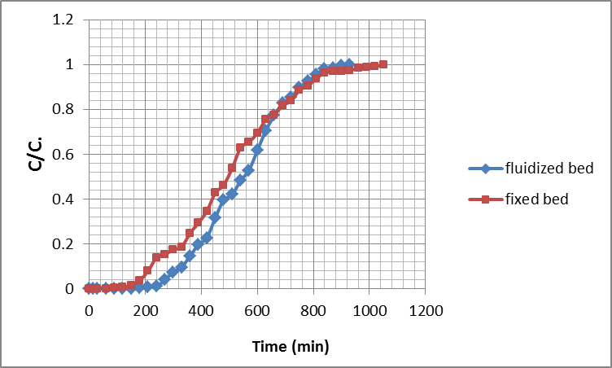
Figure (14): The Experimental Breakthrough Data for Adsorption of MB onto Commercial Activated Carbon at Q=10 l/hr, L=0.1 m, C_{o}=50 mg/l, pH=5.
Figure (15): The Experimental Breakthrough Data for Adsorption of MB onto Commercial Activated Carbon at Q=12 l/hr, L=0.1 m, C_{o}=50 mg/l, pH=5.
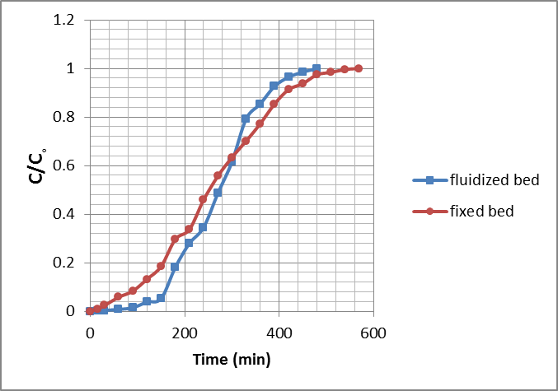
Figure (16): The Experimental Breakthrough Data for Adsorption of MB onto Commercial Activated Carbon at Q=18 l/hr, L=0.1 m, C_{o}=50 mg/l, pH=5.
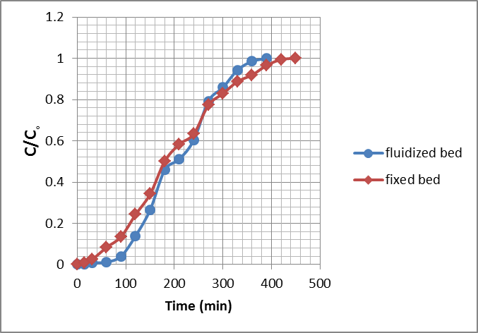
Figure (17): The Experimental Breakthrough Data for Adsorption of MB onto Commercial Activated Carbon at Q=24 l/hr, L=0.1 m, C_{o}=50 mg/l, pH=5.

The fluidized bed mode of carbon contacting system can be given low effluent concentration at short times because the particles have a free mean distance between particles and they are supported by the drag force of the fluid [11]. Fluidized bed makes the process faster by the increasing of the adsorption surface area of the adsorbent through the reduction of dead zones between the particles. With the further increasing in fluid velocity, the solid beds increase in height to provide more interstitial space for the moving fluid, until a single particle is suspended in infinite volume of fluid [12]and the adsorption efficiencies are relatively high.The breakthrough time in a fluidized-bed adsorber is, however considerably shorter than that in an adsorber operating at comparable conditions whose bed is prevented from expanding. This is probably due to axial mixing occurring in both the solid and liquid phases of the fluidized-beds. These results agree with those obtained by [13]. In the case of fixed-beds, axial mixing is comparatively unimportant because it is relatively small [14].

Conclusions
The using of continuous fluidized bed makes the process of adsorption faster and more efficient due to the increasing of the adsorption surface area of the adsorbent which leads to reduce the dead zones between the particles. The breakthrough time in a fluidized-bed adsorber is considered to be shorter than that of fixed beds adsorber under the same operating conditions. Activated carbon in fluidized bed achieves higher removal efficiencies than activated carbon in fixed bed at short time. The results of continuous flow experiments show that, as the flow rate increases, the time required reaching saturation of adsorbent decreases. For smaller bed height, (C/C_{o}) ratio increases more rapidly than for a higher bed height. For a higher adsorbate initial concentration, steeper breakthrough curves are obtained and break point is achieved sooner.

References
[1] Hajira, T., Mohammed, S. and Qazi, J. Removal of Basic Dye Methylene Blue by Using BioabsorbentsUlvaLactuca and Sargassum. African J. Biotechnol., Vol. 7, No.15, pp. 2649-2655, 2008.
[2] Cavaseno V. Industrial Wastewater and Solid Waste Engineering. McGraw-Hill, New York, pp. 178-182, 1980.
[3] Santhi T., Manonmani S. and Smitha T. Kinetics and Isotherm Studies on Cationic Dyes Adsorption onto AnnonaSqumosa Seed Activated Carbon. International Journal of Engineering Science and Technology, Vol. 2, No.3, pp. 287-295, 2010.
[4] Hameed, B. H., Din, A. T. M., and Ahmad, A. L. Adsorption of Methylene Blue onto Bamboo-Based Activated Carbon: Kinetics and Equilibrium Studies. Sch. Chem. Eng., University Science Malaysia, Eng. Campus, 14300 NibongTebal, Penang, Malaysia, 2006.
[5] Snider, E. and Porter, J. Design Overview-Carbon Adsorption. www.Arcesystems.com, 2002.
[6] Al-Taliby W. H. A. Evaluation of Methylene Blue Removal from Wastewater by Adsorption onto Different Types of Adsorbent Beds. M.Sc. Thesis, University of Babylon, College of Engineering, Dept. of Civil Engineering, 2009.
[7] Hassan, A. A. Removal of Blue Dye from Wastewater by Adsorption on Activated Carbon. M.Sc. Thesis, University of Babylon, College of Engineering, Dept. of Civil Engineering, 2005.
[8] Wang, R. C., Kuo, C. C. and Shyu, C. C. Adsorption of Phenols onto Granular Activated Carbon in a Liquid-Solid Fluidized Bed. J. Chem. Tech. Biotechnol., Vol. 68, pp. 187-194, 1997.
[9] Al-Sultani K. F. The Removal of Water Pollutants in Fluidized Bed Column by Adsorption. M.Sc. Thesis, University of Technology, College of Engineering, the Department of Chemical Engineering, 1999.
[10] Mohammed, S. A. M., Faisal, I. and Alwan, M. M. Oil Wastewater Treatment Using Expanded Bed of Activated Carbon and Zeolite Chemical. Journal of Engineering,Vol. 17, No. 1, pp. 103-115. 2011.
[11] Bierau H. Process Integration of Cell Disruption and Fluidized Bed Adsorption of Microbial Enzymes: Application to the Retro-Design of the Purification of L-Asparaginase. Ph. D. Thesis, the University of Birmingham, 2000.
[12] Mohammed, S. Y. Removal of Cadmium from Simulated Wastewater Using Biosorption M.Sc. Thesis, University of Baghdad, College of Engineering, Environmental Engineering Department, 2012.
[13] Mathews A. P., and Fan L. T.Chemical Engineering Symposium Series. No. 230, pp. 79, 1983.
[14] Mckay, G., The Chemical Engineering J., Vol. 39, pp. 87, 1988.

