Photocatlytic oxidation of congo red dye by using Co₂O₃–Cr₂O₃ as a Photocatalyst

Alaa R. Amrin

Environmental research center/University of Babylon , Hilla, Iraq.

Corresponding author: alaa_rashed30@yahoo.com.

To cite this article:

Amrin, A. R. Photocatlytic Oxidation of Congo Red Dye by Using Co₂O₃–Cr₂O₃ as a Photocatalyst.. Mesop. environ. j., 2016, Vol. 2, No.2, pp.66-74.

This work is licensed under a Creative Commons Attribution-NonCommercial-NoDerivatives 4.0 International License.



Abstract

Homogeneous crystalline chromium and cobalt oxides (Cr₂O₃- Co₂O₃) was prepared by co-precipitation method by mixing metals nitrate in the basic medium and the precipitate was calcinated at 700 ºC for 6 hrs. The crystalline structure of the synthesized products were analyzed by X-ray diffraction (XRD). The obtained XRD patterns of specimens revealed formation of a well-crystallized structure of double oxides after calcination at 700 ºC. The photocatalytic activity of double prepared oxides was investigated via following removal of congo red dye from the aqueous solution upon irradiation of reaction suspension under irradiation with UV light. .

Keywords; co-precipitation method, XRD-diffraction, Congo red, chromium and cobalt oxides photocatalytic oxidation.
Introduction
There are many industrial applications for Dyes and pigments such as, their usage as colorant material for artificial fibers, paper, and textiles, as well as their applications as plasticizers in the plastics manufactures[1]. There are many classes of synthetic organic pigments which have wide uses in the different fields of industry. Theses classes of dyes are Azo dyes, which are one of the important classes of synthetic organic pigments utilize in manufactured coloured productions Worldwide. now the Organic dyes appear in many industrial effluents[2] because use of these dyes along with lots of water in textile industries has resulted in the production of polluted and coloured waters being discharged into the environment ( nearby land or rivers) without any treatment because the conventional treatment methods are not Effective[2,3]. These coloured compounds are aesthetically objectionable and inhibiting sunlight penetration into these waters (e.g. streams, rivers etc)[4].
Ground-water are also affected by these pollutants because of leaching from the soil. Congo red one of important dye that can be found in wastewater have higher solubility in the water about 1 g/30 mL[5]. There are many Various physical and chemical techniques have been employed to eliminate dyes from wastewaters, like adsorption[4,5], reverse osmosis[6], coagulation[7], flocculation[8], membrane technology[7,8,9], biological treatments, and photo catalytic oxidation but in developing countries, these methods are still too expensive to be used widely. but photo catalytic oxidation Among these methods Various is the utilize most in the wastewater treatment (purification, decolorization and the removal of toxic organics)[10], because efficient, economical, safety and achieve the reaction with ambient temperature and atmospheric pressure[11].
The photocatalyst that is used in these fields, have two bands, valance band filled by electrons in lower orbitals and conduction band which is impute from electrons in higher orbitals, separation between these two bands gape called gape energy. When the particle of photo catalyst irradiation with light have energy equal or more the band gape. The electron in the valance band is transferred from valance band to the conduction band leaves its location positive hole. Generally, the pairs (electron-hole) enter in many reactions as shown in the following mechanism[12]:

The super oxide anion and hydroxide radicals which are generated in equation reaction 2 and 4 are important in the oxidation process because haves more activity compare with generated others radicals. In the present work, we tried the synthesis of (nickel Oxide - cobalt oxide) as couple photo catalyst by co-precipitation method, and evaluate the prepared material, characterization, and examination of its activity in photooxidation of the Congo red dye.

Experimental Design :
Preparation of photocatalyst by using co-precipitation method

Mixing nickel nitrate and cobalt nitrate and adjusting Ph at 10 Stirrer the mixture with heated of the solution at 70 ºC for 2 hours

filtration the precipitate dried at 50 ºC for 24 hours
Precipitate wear calcined at different temperatures (300-700 ◦ C) for 6 h.

calcinated at 500 ºC

calcinated at 300 ºC

calcinated at 100 ºC
calcinated at 700 ºC

Characterized speciment by X-ray diffraction XRD with (Cu- Kα radiation, λ=1.5406 ºA) Shimadzu,1800, Japan.

Photocatalytic decolorization 100ml of 10 ppm Congo red dye 1g of powder calcinated with 300 ºC .

Photocatalytic decolorization 100ml of 10 ppm Congo red dye 1g of powder calcinated with500 ºC .

Photocatalytic decolorization 100ml of 10 ppm Congo red dye 0.5g of powder calcinated with100 ºC .

Photocatalytic decolorization 100ml of 10 ppm Congo red dye 1g of powder calcinated with700 ºC .

Preparation Congo red dye Solution

Congo red dye (Chemical formula=C₂₃H₂₂N₆O₆S₂Na₂, Formula weight=696.65g.mol⁻¹) supplied by BHD Chemicals. The solution of Congo red were prepared by dissolving appropriate amounts (accurate weighed) of dry powdered dye in double distilled water to prepare Stock solution (100 mg L⁻¹ ). The experimental solution was obtained by dilutions were made to obtain the working solution at desired concentrations[13].

Photocatalytic studies

Photocatalytic decolorization of Congo red dye was carried out in glass reactor with an outer jacket for water circulating. A sample of 0.2 g of prepared catalyst was suspended by stirring magnetically in 100ml of 10ppm aqueous CR solution. The solution was stirred in drake for 30 minutes to attain adsorption desorption equilibrium, and it was irradiated using 125 watt middle pressure mercury lamp. The irradiation was carried out in the unit show in the picture.1, for 90 minutes. Then these samples were centrifuged at 15,000 rpm to remove suspended catalyst particles, and then analyzed using a UV-VIS spectrophotometer (UV/VIS-JENWAY,1600, Jerman), was used for measuring absorbance at different time intervals. The efficiency of dye removal was calculated from following equation:
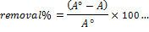
Aº and A is the absorption of concentration of dye before and after irradiation respectively[14]. A graph of photocatalytic decolorization Congo read percentage versus time (hour) was plotted for Congo red.
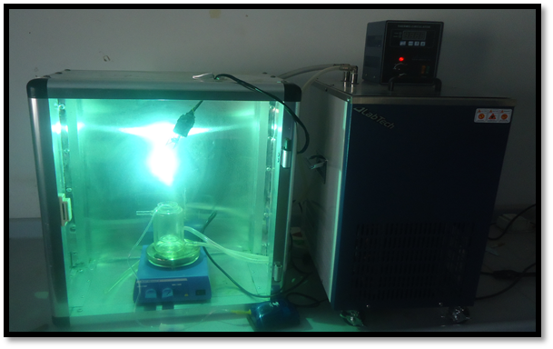

Plate1: the unit that used in the photo decolonization of Congo red dye by use the new prepared couple semiconductor.

Results and discussion

The XRD patterns of the prepared coupled oxides powders that were calcinated at different temperatures are shown in Fig. 1.

There are many peaks broad and sharp with different intensities were observed in the diffractograms, which indicating formation of fine single phase of coupled oxides structure, A few characteristic peaks of cobalt and cromium oxides[15] were also observed in the diffractograms. The XRD results revealed that an increase in calcination temperature leads to a considerable increase in peak intensity. Meanwhile, the widths of the diffraction peaks become narrower (The diffraction peaks are continuously getting sharper) with the increase of calcination temperature, indicating that the grain size become larger when calcination temperature was increased from 100 ºC to 700 ºC . Scherrer formula [15], and the phases and the mean size are listed in Table 1

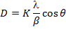

Where the K is Sharpe factor, λ is λ is the wavelength of X-ray radiation (λ = 0.154 nm), β is the line broadening at the half maximum intensity (FMWH) in the radian, and is Bragg angle. generally the practical size at maximum intensity was found 40.8nm.

Table. 1. shows that the mean size of prepared coupled oxides.

Temperature ºC | Peak position | Intensity | grain size (nm)
100 | ………….. | ………… | …………..
300 | 59.04 | 0.282 | 53.5
500 | 59.44 | 0.306 | 79.5
700 | 59.1 | 0.353 | 83.7

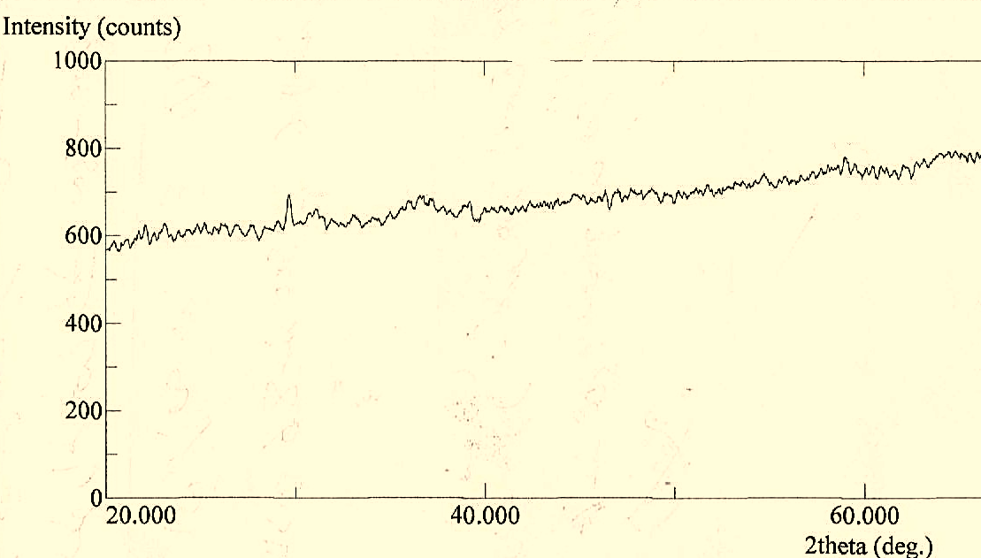
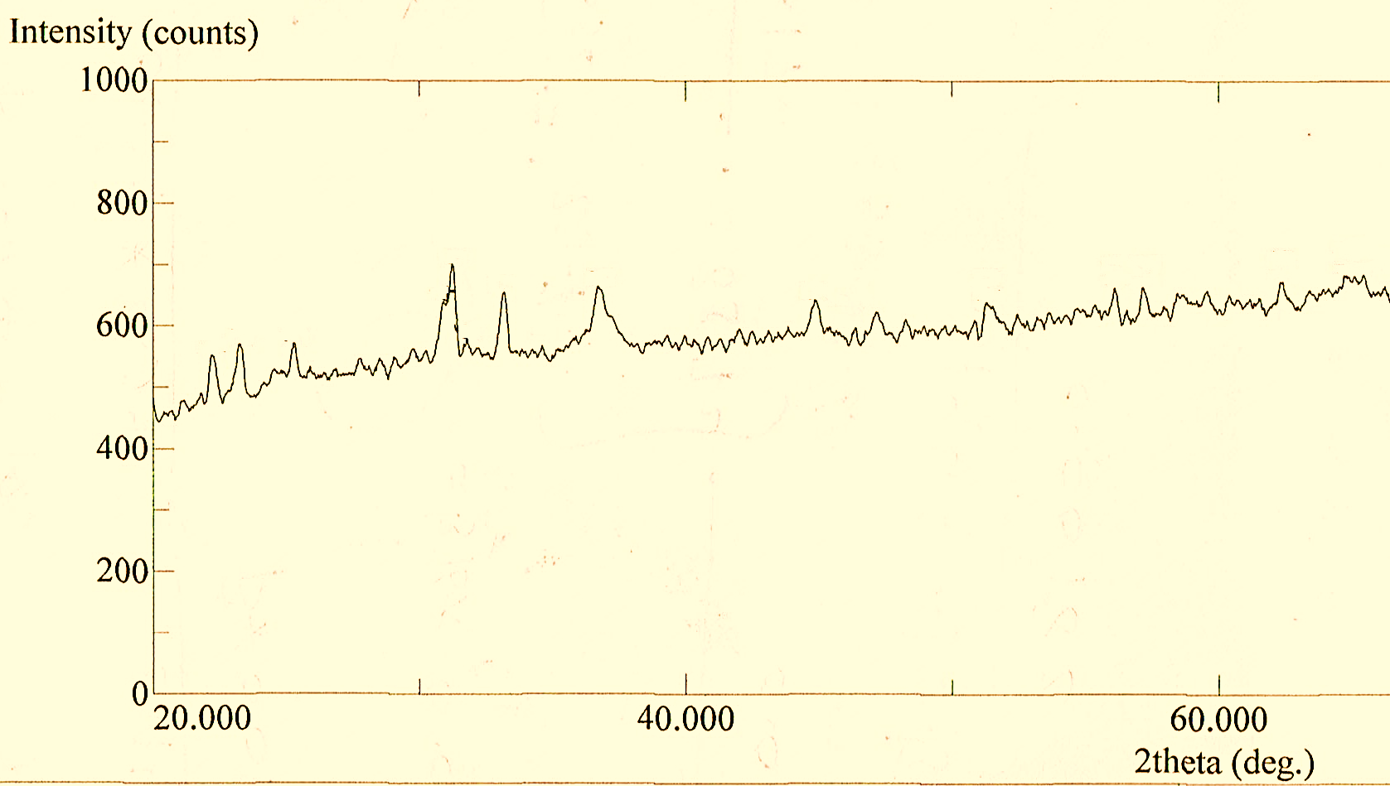
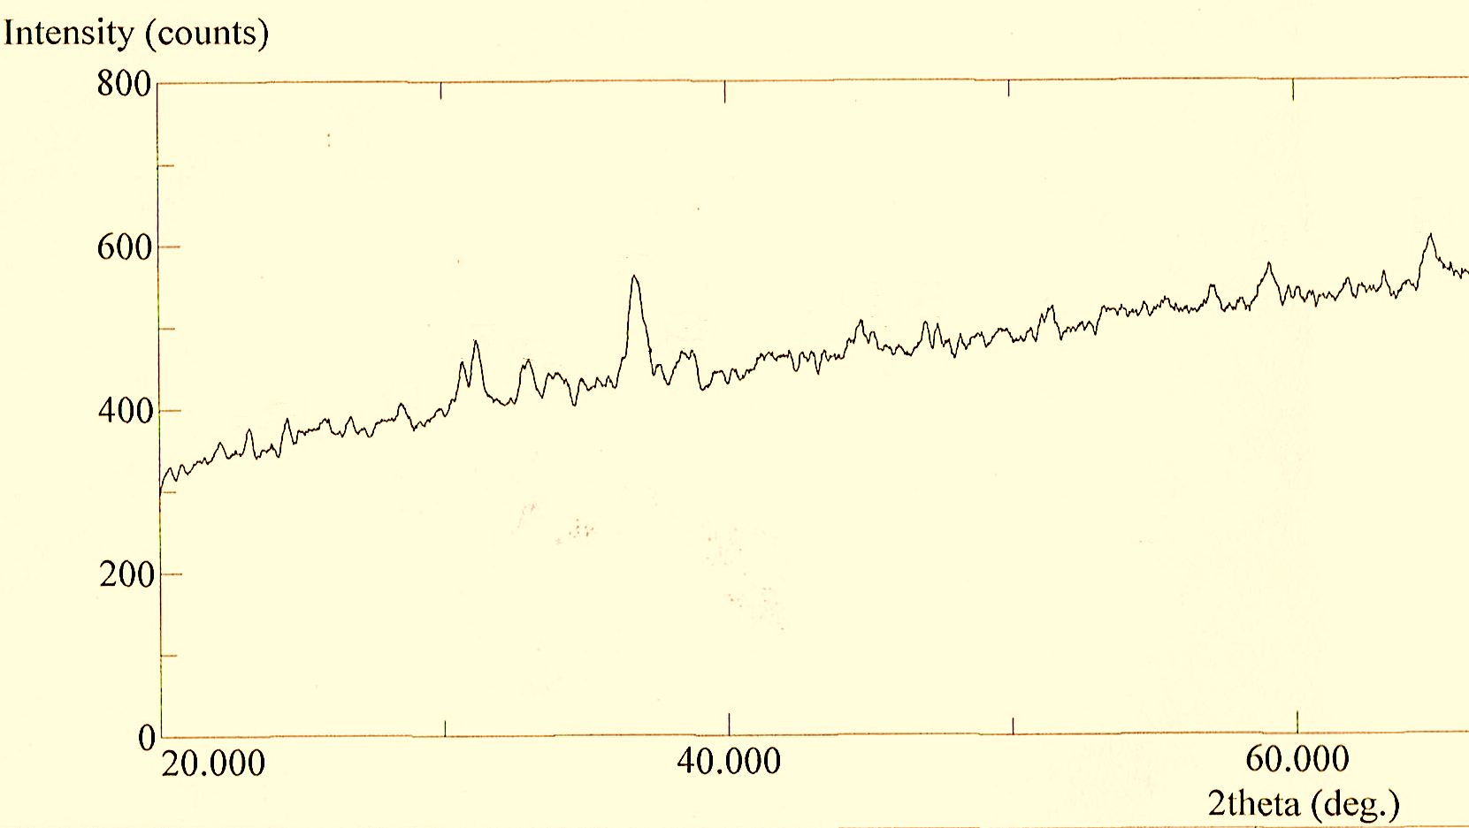

a

b

c

Fig.1. XRD patterns of the prepared coupled oxides powders calcinated at different temperatures 300 ºC Fig.a, 500 ºC Fig.b, and 700 ºC Fig.c .
Photocatalytic activity

The photocatalytic removal of Congo read dye in presence of prepared coupled oxides (nickel Oxide - cobalt oxide) at different time intervals was observed at λmax 497 nm. The results revealed that absorbance of Congo red dye solution was decreased with the increase in the irradiation time for all the prepared coupled oxides , and thus Congo red dye can be photocatalytically degraded. The activity of coupled photocatalyst can be explained through inter- particle electron transfer pathway of the couple semiconductor[16]. The higher activity of (Cr₂O₃-Co₂O₃) show the roles of the electrons and holes of the catalyst which can be possess through different redox energy levels for their corresponding conduction and valence bands[17].

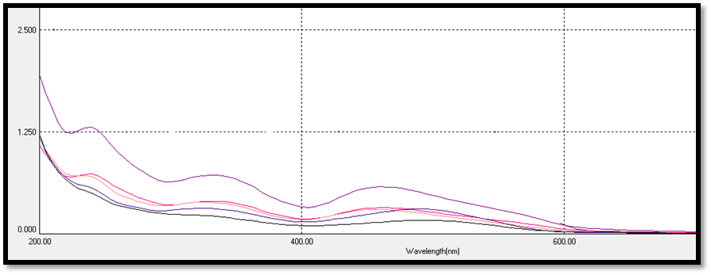
Fig.2. Photocatalytic declorization of congo red dye using 0.15g of (Cr₂O₃-Co₂O₃) calcienated at 700ºC.

Fig. 3 shows the ln(A_{o}/A) versus time curves of the Congo red dye photocatalytic decolorization using prepared coupled oxides photocatalyst, where A_{o} and A were the Absorbance's of the Congo red dye before and after irradiation, respectively. Curve shown in Fig. 4 was linear, revealing that the kinetic data of the azo dye photocatalytic decolorization fit well to the first-order reaction kinetic model. Assuming first-order reaction kinetics for thephotocatalytic oxidation process, the decolorization rate constant was determined from the equation

ln(A_{o}/A_{t})=−kt

where A_{o} and A_{t} are the dye Absorptions at times 0 and t , respectively, and k is the first-order rate constant.

Table.2. show the rate constant, R² values and, decolorization percentage for prepared coupled oxides at different calcination temperatures .

Sample | Temperature/^{O}C | R² | Rate constant | Decolorization%
1 | 300 | 0.984 | 0.0044 | 53.8%
2 | 500 | 0.861 | 0.0073 | 79.2%
3 | 700 | 0.9907 | 0.0127 | 88.5%

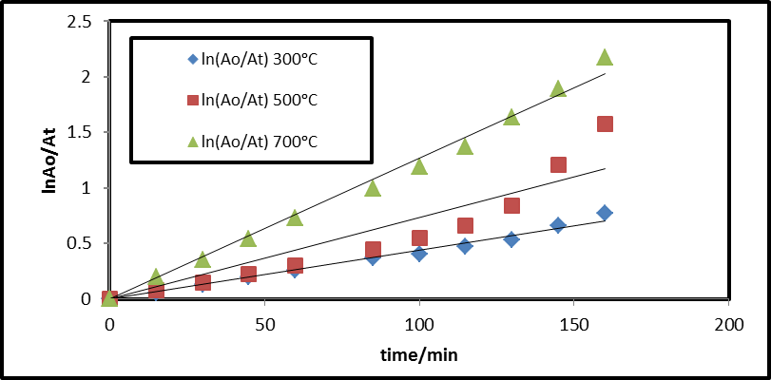
Fig.3. A plot of Ln(Aº/A_{t}) versus time was linear and follows pseudo first order kinetics.

Conclusions

In this study, photocatalytic oxidation of Congo Red dyes in aqueous solutions had been carried out using prepared coupled chromium and cobalt oxides powder as photocatalyst. This prepared coupled oxides may be viewed as useful photocatalyst for wastewater treatment. The obtained results can be summarized as follows
- The gran size was increased with increase of calcination temperature.
- The optimum calcination temperature was 700ºC.
- The photocatalytic activity was increasinged with increase of calcination temperature.
References

[1] Alzaydien. A.S. Adsorption of methylene blue from aqueous solution onto a Low-cost Natural Jordanian Tripoli, Am.J. of Environ. Sci. vol 5. pp197-208. 2009.

[2] Rys .P. and Zollinger .H. Fundamentals of Chemistry and Applications of Dyes, John Wiley
& Sons Inc. USA 1972.

[3] .Alau. K.K. Archives of Applied Science Research,Vol. l2, No. 5. pp. 456-461. 2010.

[4] Ray P. K. "Environmental pollution and cancer" J Sci. Ind. Res. India, vol. 45, pp 370-371, 1986.

[5] Dawood .S.; Sen T.K. Removal of anionic dye Congo red from aqueous solution by raw pine and acid-treated pine cone powder as adsorbent: Equilibrium, thermodynamic, kinetics mechanism and process design, Water Res. Vol. 46. pp 1933-1946. 2012.

[6] Somasekhara .R.; Sivarama K. L.; and Varada .R. A, The use of an agricultural waste material, Jujuba seeds for the removal of anionic dye (Congo red) from aqueous medium J Haz. Mats. Vol. 203. pp 118-127. 2012.

[7] Gupta .V.K.; Mittal .A. R.; Jain .M.; Mathur Sikarwar.S, Photochemical degradation of hazardous dye- Safaranin-T using TiO2 catalyst, J. Colloid. Interface Sci. vol. 309. pp 460-465. 2007.

[8] Fan .L.; Zhou .Y.; Yang .W.; Chen .G.; Yang .F. Electrochemical degradation of aqueous solution of Amaranth azo dye on ACF under potentiostatic model, Dyes Pigments, vol. 76. pp 440-446. 2008.

[9] Zonoozi .M.H.; Moghaddam .M.R.; Arami .M. Coagulation/Flocculation of dye containing solutions using Polyaluminium chloride and alum, Water Sci. Technol. Vol. 59. pp 1343-1351. 2009.

[10] Sachdeva S.; Kumar .A. Preparation of nonporous composite carbon membrane for separation of Rhodamine B dye, J. Membr. Sci. vol. 329. pp 2-10. 2009.

[11] Nada. Y. Fairooz.; Alaa. R.; Imran. Wet Commixing Synthesis, Physical properties and Photocatalytic activity of Nickel oxide chromite spinel Journal of Applicable Chemistry, Vol. 2. No. 2. pp 129-136. 2013.

[12] Malik P.K.; Saha S.K, Oxidation of direct dyes with hydrogen peroxide using ferrous ion as catalyst, Sep. Purif. Technol. Vol. 31 . pp 241-250. 2003.

[13] Jasim M. Salman.; Alaa R. Amrin.; Falah M. Hassan. Sarab. A. Jouda.;Removal of congo red dye from aqueous solution by using natural materials. Mesop. environ. j. Vol . 1, No. 3: pp. 82-89 . 2015.

[14] Noraidura.A.;Rusmidah.A.; Wan.A.; Mohd.N.; Mohd.Y.; TiO₂ and ZnOon different supports for photodegredation of Paraquat, Teknologi.J. Vol. 47. pp.1-8. Pp.2007.

[15] Tandon.S.P.; Gupeta.J.P.; Physical Statues Solidi. Vol.38. pp363. 1970.

[16] Serpone. N.P., Maruthamuthu. P., Pelizezetti. E. and Hidaka. H. exploiting the interparticle electron transfer process in the photocatalyzed oxidation of phenol 2-clorophenol and pentachlorophenol : chemical evidence for electron and hole transfer between coupled semiconductorsJ. photochem. Photobiol. A: Chem. Vol.85. pp 247-255. 1995.
[17] Liao. D. L.; Badour . C. A.; and Liao. B.Q.; Preparation of nanosize TiO2/ZnO composite catalyst and its photocatalytic activity for degradation of methyl orange. J. photochem. Photobiol. A: Chem. Vol.194. pp 11-19. 2008.

