Isolation and characterization of virulence-related properties of pathogenic Vibrio Parahaemolyticus isolated from aquatic environments

Thankamani Kumaran Thavasimuthu Citarasu

Centre for Marine Science and Technology, Manonmaniamsundaranar University, Rajakkamangalam, Kanyakumari District 629502

Corresponding author: kumaranaqua@yahoo.com

To cite this article:

Kumaran, T. and Citarasu, T. Isolation and Characterization of Virulence-related properties of Pathogenic Vibrio Parahaemolyticus isolated from aquatic environments. Mesop. environ. j., 2016, Vol. 2, No.2, pp. 57-65.

This work is licensed under a Creative Commons Attribution-NonCommercial-NoDerivatives 4.0 International License.



Abstract

Vibrio parahaemolyticus is a pathogenic Gram-negative halophilic bacterium, a natural inhabitant of the marine environment and can be found in crabs, shrimps, fish, oysters, mussels and other seafoods. We areisolate and study the hemolytic activity of the pathogenic V. parahaemolyticus by different blood samples (human, rabbit and rat). Visualization of hemolysis of red blood cells in agar plates facilitates the categorization of some pathogenic bacteria such as vibrio sp. Haemolysins are one of the pathogenic determinants of several vibrio sp strains isolated from a variety of hosts and geographic origin.SDS – PAGE had been used to characterize and identify the virulent protein profiles on whole cell and extra cellular products (WC,ECP) of several species. The molecular weight was determined to be48.4kDaand 25.6kDa by sodium dodecyl sulfate-polyacrylamide gel electrophoresis. Based on the results Hemolytic activity has been considered as important virulence factors contributing to the pathogenicity of the infection for the pathogens.
Keywords; Marine environment; V. parahaemolyticus; Extra cellular products; Pathogenicity.
Introduction
Vibrio species are very common in marine and estuarine habitats and on the surface and in the intestinal contents of marine animals. They are responsible for diseases in many wild and reared aquatic organisms including shrimp, mollusks, fish and other vertebrates.[1] Many Vibrio species are pathogenic for human and/or marine vertebrates and invertebrates with the virulence mechanisms reflecting the presence of enterotoxin, haemolysin, cytotoxin, protease, lipase, phospholipase, siderophore, adhesive factors and/or haemagglutilnins[2].
Vibrio parahaemolyticus is a marine bacterium, responsible for gastroenteritis in humans.Haemolysins are produced by many different species of bacteria including Escherichia coli, pseudomonas aeruginosa and Vibrios.Haemolysis which results from the lysis of erythrocytes membranes with the liberation of haemoglobin consists of β-hemolysis such that the complete degradation of hemoglobin and α-haemolysis such that the incomplete degradation of hemoglobin. In most cases epidemiological and experimental evidence suggests that haemolysins are involved in disease pathogenesis [3].
The majority of V. parahaemolyticus strains isolated from cases of gastroenteritis in humans produced a β-haemolysin on Wagatsuma agar, which is a type of blood agar [4]. Extracellular products of these pathogens contain the enterotoxin, hemolysin. Hemolytic activity of hemolysin toxin is identified by the different blood samples (Human, rat, rabbit). The aim of the present work was to examine the reaction between the hemolytic pathogen and the blood cells, hemeagglutination test is done. SDS PAGE is done for the characterization and identification hemolysin in ECP. It is used to know the significance of hemolysin cause haemolytic activity.
Material and Methods
Source of sample and collection
Disease affected shrimps are collected from the shrimp farms as well as shrimp hatcheries, fish markets and aquatic environments. The collected shrimps were kept in ice box and transported to the laboratory condition in CMST campus, and stored at -20˚C. The collected samples include both adult and young ones. The isolated Vibriosp. was identiﬁed as V. parahaemolyticus by morphological, physiological and biochemical confirmations [5] as well as based on the characteristics described in Bergey’s Manual of Systematic Bacteriology.
Preparation of V. parahaemolyticus extracellular products
Bacterial ECPs were produced by the cellophane overlay method as described by Liu 1957. Tubes containing 5-mL of marine broth were inoculated with one bacterial colony from a 24-h Zobell marine Agar culture of V. parahaemolyticus and incubated at 20⁰C for 18-h. A volume of 2-mL of this culture was transferred onto a sterile cellophane ﬁlm placed on the surface of each Zobell marine Agar plate. After incubation at 20⁰C for 48-h, the cellophane overlay was transferred to an empty Petri dish. Cells were washed off the cellophane ﬁlm using 4-mL of cold D.H₂O and removed by centrifugation at 10,000g and 4 ⁰C for 30-min. The supernatant containing the ECPs was sterilized by ﬁltration (0.22-mm) and stored at -80 ⁰C until use. The protein concentration of the ECPs was measured by the method of Bradford [6], with bovine serum albumin (Sigma) as the standard.
Screening of haemolytic activity (plate assay)
Haemolytic activity was determined as a zone of haemolysis around the colonies on Blood agar plates containing 2% (V/v) human blood, rabbit blood and rat blood after 24 h incubation at 37°C.Haemolytic activity of V. parahaemolyticus isolated was tested on nutrient agar supplemented with 2% human erythrocytes with incubation at 37°C for 48 h. For haemolysin quantififation, bacterium was cultured in TSB (Tryptic soy broth) at 37°C for 24 h. After incubation the culture was pelleted by centrifugation at 10,000×g for 10 min supernatant (500 μl) was added to 1mL of 1% suspension of sheep erythrocytes in phosphate-buffered saline and incubated at 37°C for 1 h and centrifuged at 5,000 × g for 5 min to remove unlysed erythrocytes. Lysis of erythrocytes was determined by measuring the absorbance of the supernatant at 545nm.
Quantitative and qualitative protein analysis of V. parahaemolyticus
The whole cell and extracellular product supernatants obtained were re-suspended in PBS at pH 7.2, and protein was estimated according to the Bradford assay[6]. Further, the above proteins were resolved in 12% SDS-PAGE [7] to generate profiles.
Challenge against Penaeusmonodon
Healthy shrimp (Penaeusmonodon) weighing approximately 3±1 g were purchased from a commercial shrimp pond. They were acclimatized and kept in quarantine tanks for the period of 5 days to assess their disease-free health status. After acclimatizing, ten triplicate (10 X 3 = 30)experimental groups were stocked in 100 l capacity, flow-through aquaria with a water flow rate of 1 l/min. The fishes were challenged with a lethal dose of virulent V. parahaemolyticus(1X10⁷)injected with intramuscularly, and observed cumulative mortality and other for pathologicalsigns for 7 days.
Results
Identification of pathogenicV. parahaemolyticus
Among the various isolates from the shrimp hatcheries and aquatic environments, the effective pathogenic bacteria was confirmed as V. parahaemolyticus by morphological, physiological and biochemical confirmation. The phenotypic confirmation revealed that, the V. parahaemolyticus. They are gram negative, motile and able to ferment carbohydrate such as glucose and fructose(Table 1).

Table 1. Morphological and biochemical confirmative test of the Vibrioparahaemolyticus micro flora isolates from the diseased Shrimp

S. No | Biochemical Tests | V.parahaemolyticus
1. | Gram staining | -Ve
2. | Motility | +Ve
3. | Oxidase | +Ve
4. | Catalase | +Ve
5. | Indole | -Ve
6. | Methyl red | -Ve
7. | Vogesproskauer | -Ve
8. | Citrate | +Ve
9. | Starch | -Ve
10. | Arginine decarboxylase | +Ve
11. | Lysine decarboxylase | +Ve
12. | Ornithine decarboxylase | +Ve
14. | Glucose | +Ve
15 | Fructose | +Ve
16 | Lactose | -Ve

Hemolytic activity of Vibrioparahaemolyticusagainst human, rat, rabbit blood groups
The haemolytic activity of the pathogenic Vibrio parahaemolyticus were given in the figure 1. The isolate produced clear zone around the streak of inoculums in blood agar indicating β-haemolysis. In O^{+ive} blood group V. para showed maximum haemolytic activity at the range 3.7mm., AB ^{+ive} blood group showed the highest lysis of blood cells(2.33mm). In B ^{+ve} blood group V. para reflected the best haemolytic activity in the range of 2.3mm. Greatest activity was observed in V. para against rat blood sample (3.6mm). In rabbit blood sample V. para shows moderate haemolytic activity.
Characterization of Virulence factors
The protein profile indicate major virulence factor of the isolated bacteria. The total protein was estimated all isolates were given in the (Table 2). The optimum proteins obtained by the isolate V. parahaemolyticusin 100µg/ml 96.69 respectively. The details of the whole cell and extra cellular protein (WC,ECP) profile were given in the (Fig 2.) Prominent protein band was separated in the SDSPAGE around 35 kDa, 58 kDa and 78 kDa in the V. parahaemolyticus isolate and faint band had the molecular weight of around 48.4kDa,and25.6kDa in the isolated vibrio ECP.

Table 2. Total protein estimation for ECP (µg/ml) of pathogenic V.parahaemolyticusby Bradford’s assay.

S.No | Concentration | Total protein forECP (µg/ml)
1 | 10 | 9.867  ±  0.001
2 | 20 | 19.83  ±  0.005
4 | 40 | 38.992  ±  0.0008
6 | 60 | 58.030  ±  0.006
8 | 80 | 78.25  ±  0.016
10 | 100 | 96.699  ±  0.0816

Fig 1. Haemolyitc activity against pathogenic V. parahaemolyticususing O ^{+ve}blood group.
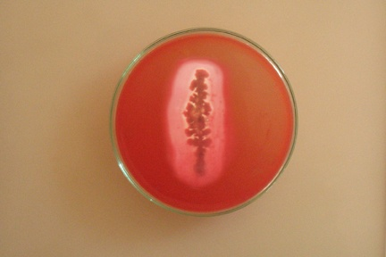

Fig 2. SDSPAGE analysis for the ECP protein profile of pathogenic V.parahaemolyticus (M- Mol. Wt. Marker, 1- Whole cell (W), 2- Extra cellular Products (ECP)
M 1 2
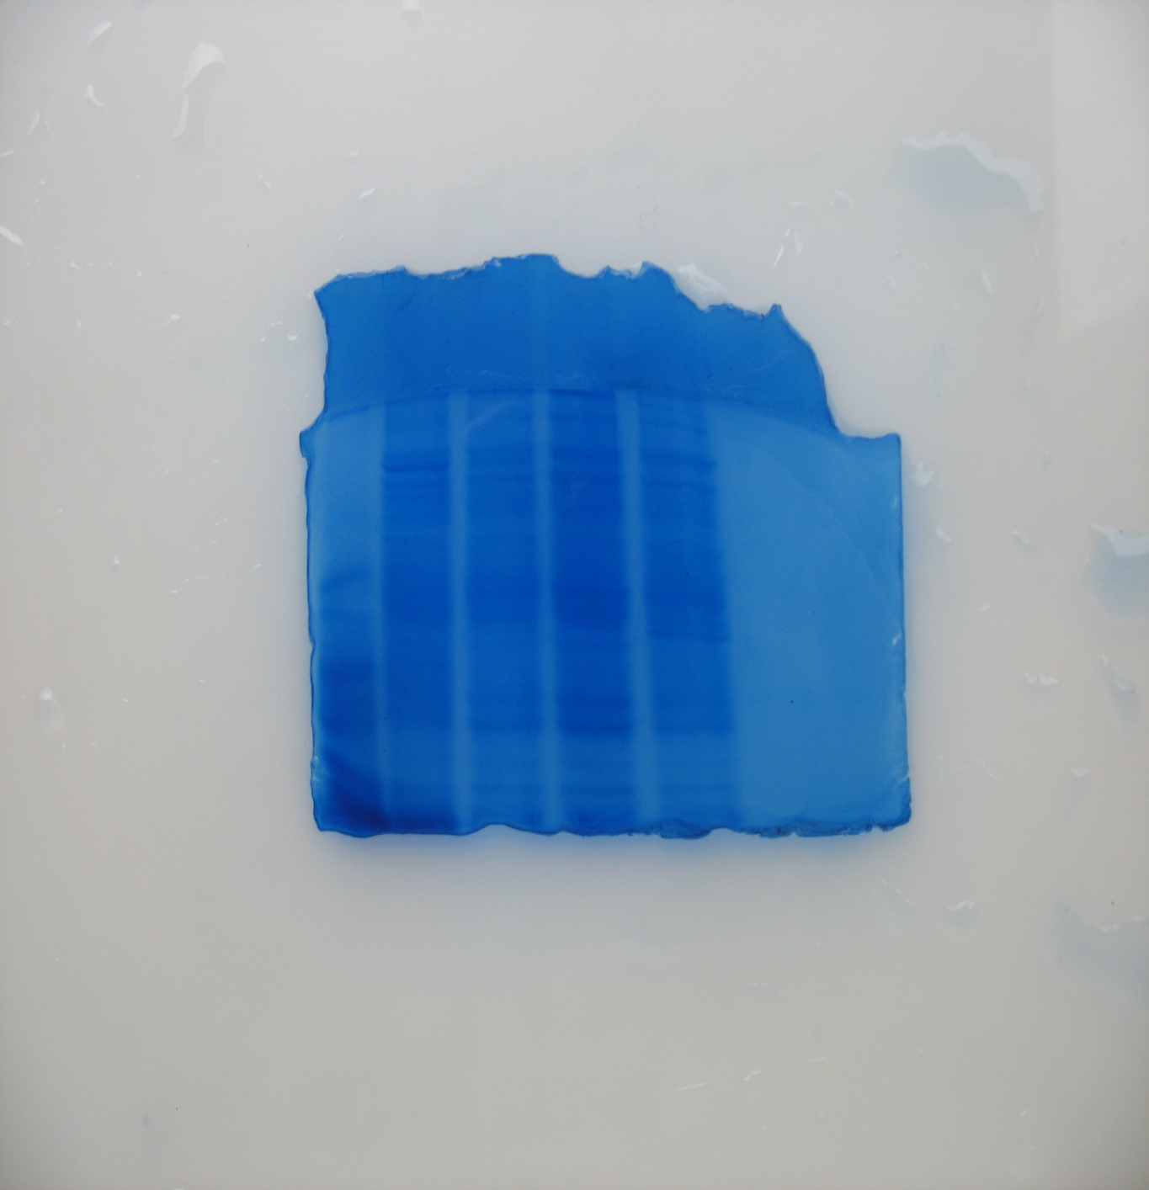

97.4 k Da

66 k Da

43 k Da
29 k Da
20 k Da
14 k Da

48.4 k Da

25.6 k Da

Determination of virulence by challenge test

The percentage of cumulative mortality of Penaeusmonodon after 7 days of V. parahaemolyticus was given in the (Fig 3). The shrimp challenged with whole cell of V. parahaemolyticus had low cumulative mortality of 35 % within seven days due to less virulence. The and extra cellular protein of V. parahaemolyticus responsible for high virulence and the cumulative mortality of 75 and 100 % respectively within seven days. The ECP responsible for higher virulence and all shrimp succumbed to death within five days.
Fig. 3. Cumulative mortality of P. monodon challenged with ECP of V. parahaemolyticus
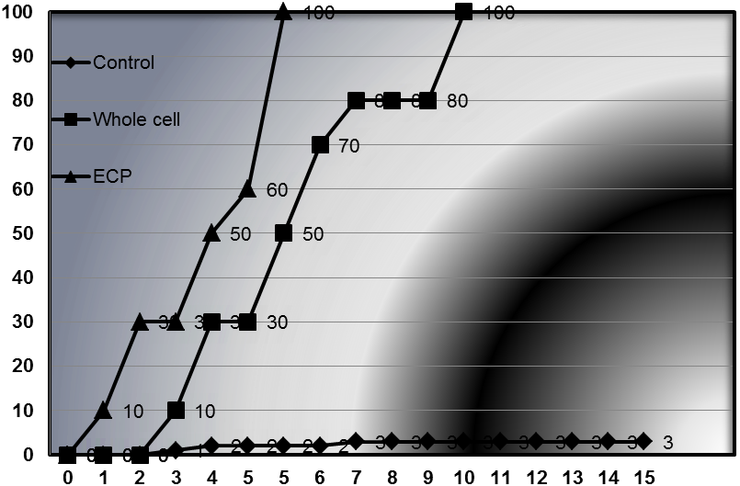
Discussion
In recent years, Vibriosis has become one of the most important bacterial diseases in maricultured organisms, affecting a large number of species of fish and shellfish [8]. Considering the importance and immediate need for the country research works on the bacterial disease of shrimp, especially vibriosis, we have been commenced systematically and developed step by step. In the first attempt, Vibriosis was taken for the study.
The present studies, among the fifteen colonies from the Shrimp samples, dominant colonies were selected based on morphological and biochemical confirmative tests. The pathogenic strain V. parahaemolyticus was isolated from the infected shrimp hatchery. V. Parahaemolyticus is a marine bacteria causing gastroenteritis after ingestion of contaminated sea food [9]. It also causes wound infections and septicemia in humans. In P. monodon, the V. parahaemolyticus has been implicated as a cause of red disease in India [10]. Pathogenicity has been established in tiger prawns with the LD₅₀ dose of 1 x 10⁵ CFU (colony forming units) shrimp [11].
The ECPs from cellophane overlays showed negligible haemolytic activity. This observation is at odds with the reported haemolytic activity observed in ECPs from cellophane overlays of Vibrio sp. [12].. However, recently the virulence of this species has been recognized in a small but growing list of marine animals including tiger prawn, P. monodon[13].Hemolytic and cytotoxic activities of ECPs have also been considered as important virulence factors contributing to the pathogenicity of the infection process [14]. Analysis of haemolytic activity revealed that the strongest reactions with all types of red blood cells occurred with the concentrated ECP. The greatest activity was recorded towards sheep erythrocytes, with 50% haemolysis noted following incubation with 176 mg of crude ECPs. Sodium Dodecyl Sulphate Poly Acrylamide Gel Electrophoresis (SDS – PAGE) of total proteins has been used to characterize and identify the protein profiles (PP) of several bacterial species with the potential to virulence factor[15].
The present study revealed that, the virulence of the pathogenic Vibrios isolated from the infected shrimps, extra cellular protein and haemolytic activity. The results of our study also indicate that, even if in low percentages, potentially pathogenic Vibrio sp. can be present in seafood products from marine environments and that, as a consequence, these foods can play a signiﬁcant role in the transmission of these micro-organisms to humans. Moreover, an efﬁcient monitoring strategy should include health educationprograms aimed at eliminating the errors and omissions which are often at the root of toxin infections.
References
[1]. Austin B and X.H. Zhang, X. H. Vibrio harveyi: a significant pathogen of marine vertebrates and invertebrates. LettApplMicrobiol, Vol.43:pp. 119-124. 2006.
[2]. Shinoda, S. Protein toxins produced by pathogenic vibrios. J Nat Toxins, Vol. 8: pp. 259–269.1999.
[3]. Ludwig, A and Goebel, M. Haemolysins of Escherichia coli. In Escherichia coli: Mechanisms of Virulence ed. Sussman, M. pp. 281– 329. Cambridge: Cambridge University Press. Microbio, vol. l38:pp. 406–411.1997.
[4].Wagatsuma, S. On the medium for hemolytic reaction. Media Circle, Vol. 13: pp. 159–162.1968.
[5]. Farmer, J .J., and Hickman-Brenner, F. W. The genera Vibrio and Photobacterium. In: The prokaryotes. 2nd ed. III. New York, N.Y: Springer-Verlagpp. pp. 2990–2991.1992.
[6]. Bradford, M.M. A rapid and sensitive method for the quantitation of microgram quantities of protein utilizing the principle of protein-dye binding. Analytical Biochemistry, Vol.72: pp.248-254. 1976.
[7] Laemmli, U.K. Cleavage of structural proteins during the assembly of the head of bacteriophage T4.Nature, Vol.227: pp.680-683.1970.
[8] Wu, H.B and Pan, J. P. Studies on the pathogenic bacteria of the Vibriosis of Serioladumeriliin marine cage culture. J. Fish. China, Vol. 21: pp.171-174.1997.
[9] Raimondi, F., Kao, J. F. ; Fiorentini,C. ; Fabbri, A.; Donelli, G.; Gasparini, N.; Rubino, A. and Fasano, A. Enterotoxicity and cytotoxicity of Vibrio parahaemolyticusthermostable direct hemolysin in in vitro systems. Infect Immun, Vol. 68: pp.3180–3185.2000.
[10]. Jayasree, L., Janakiram, P., Madhavi, R. Characterization of Vibrio spp. associated with diseased shrimp from culture ponds of Andhra Pradesh (India). J. World Aquacult. Soc. Vol.37, pp.523–532.2006.

[11]. Sudheesh, P. S., Xu, H. S. Pathogenicity of Vibrio parahaemolyticus in tiger prawn PenaeusmonodonFabricius: possible role of extracellular proteases. Aquaculture Vol.196, pp.37–46.2001.
[12].Liu, P. C. ; Lee, K.K. and Chen, S. N. Pathogenicity of different isolates of Vibrio harveyiin tiger prawn, Penaeusmonodon. Lett. Appl. Microbio. Vol. l22:pp.413–416.1996.
[13].Karunasagar, I., R. Pai, Malathi, G. R. and Karunasagar, I. 1994. Mass mortality of Penaeusmonodonlarvae due to antibiotic-resistant Vibrio harveyiinfection. Aquaculture Vol. 128: pp.203-209.1994.
[14].Zhang X.H., Meaden, P.G. and Austin, B. Duplication of hemolysin genes in a virulent isolate of Vibrio harveyi. Appl Environ Microbiol, Vol. 67: pp.3161-3167.2001.
[15].Takeda, Y., Taga, S. and Miwatani, T. Evidence that the thermostable direct hemolysin of Vibrio parahaemolyticus is composed of two subunits. FEMS MicrobiolLett, Vol. 4:pp. 271–274. 1978.

