Effect of phosphorus concentration and light intensity on protein content of microalga Chlorella vulgaris

Maysam Alaa Baiee Jasim M. Salman

Department of Biology, College of Science, University of Babylon, Iraq.

Corresponding author: maysam.baiee@yahoo.com

To cite this article:

Baiee, M. A. and Salman J. M. Effect of phosphorus concentration and light intensity on protein content of microalga Chlorella vulgaris. Mesop. environ. j., 2016, Vol. 2, No.2, pp. 75-86.

This work is licensed under a Creative Commons Attribution-NonCommercial-NoDerivatives 4.0 International License.



Abstract

The exploitation of microalgae as a protein source has led to increased interest in the use of microalgae in health food production and source of animal feed. Three light intensities (125, 268 and 300 µE\m²\sec) and four phosphorous concentrations (0, 2, 4, 6, g\l) were used to study their effect on the growth and amount of protein content in Chlorella vulgaris alga. The growth curve of the studied alga was different among the treatments. The stationary phase began at the days 13, 12 and 9 for treatments 125, 268 and 300 (µE\m²\sec) respectively, while it was identified as day 14, 12, 10 and 6 in treatments 6, 4, 2 and 0 g\l of phosphorous respectively. The highest K value was 0.15 at the 268 µE\m²\sec (control), while the lowest K value was 0.08 at 125 µE\m²\sec. The shortest doubling time (G) was 2 days at control (268 µE\m²\sec) treatment.
When used different phosphorous concentrations, The highest K value was 0.16 at 0 g\l treatment, while the lower K value was 0.1 at 6 g\l treatment. The shortest doubling time (G) was 1.8 day in treatment 0 g\l.
Protein content of C. vulgaris increased from 39.46% to 57.51% at 125 µE\m²\sec to 300 µE\m²\sec light intensity. When used different phosphorus concentrations, protein content increased from 51.17% at control treatment (4 g\l) to 75.56% at 6 g\l treatment.
Keywords; Protein, Chlorella vulgaris, light intensity, phosphorous concentration
Introduction
Algae have been used in animal and human diets since very early times. The lipids and starch fraction in algae can be used for bio- oil production, the residual algae cake, which is rich in proteins, is important for producing valuable co-products. Protein (and starch) content can constitute up to 60% of dry weight of algae [1]. This residual protein from the biomass can be used for livestock, poultry, and fish feed additives [2]. It has been reported that algae can replace about5%–10% of conventional protein sources in poultry feed [3]. Recently residual algae cake after lipid extraction has been used in large animal feeding trials [4]. However high concentrations of nucleic acids in algae can pose challenges for the utilization in animal feed applications [5].
The biochemical composition of algae varies with species, light, temperature, and growth stage. Variation in biochemical composition due to growth stage is frequently related to culture age and nutrient depletion, particularly if an organism is grown in batch culture [6 , 7].
Light is the energy source during photoautotrophic growth phase and organisms use light energy to convert carbon dioxide to organic compounds especially, sugars. Light intensity affects the cellular composition of algae, for example Dunaliella tertiolecta exhibits decrease in protein content and an increase in the lipid fraction with increasing light intensities up to saturation [8]. Low light intensity has been observed to result in higher protein content while high photon flux density (PFD) results in increased extracellular polysaccharide content [9].
Considerable variation in the biochemical composition under conditions of nutrient limitation can be observed in algae depending upon which nutrient is limited and to what degree. In general, the growth rate of algae is proportional to the uptake rate of the most limiting nutrient under optimal conditions of temperature and pH and is generally described by Michaelis- Menten equation [10].Phosphorus is an important component required for normal growth and development of algal cells [11]. It has been shown that phosphorus, rather than nitrogen, is the primary limiting nutrient for microalgae in many natural environments [12]. Phosphorus typically constitutes 1% of dry weight of algae [13], but it may be required in significant excess since not all added phosphate is bioavailable due to formation of complexes with metal ions [14]. Immediate effects of phosphorus limitation include a reduction in the synthesis and regeneration of substrates in the Calvin- Benson cycle and a consequential reduction in the rate of light utilization required for carbon fixation [15].phosphorus starvation reduces chlorophyll a and protein content thereby increasing the relative carbohydrate content in algal cells [16 , 17 , 18].
Therefore, this study was conducted to increase the protein content of green alga (Chlorella vulgaris) under different light intensities and phosphorous concentrations.
Materials and Methods
Alga Isolation, Purification and Cultivation
Microalgal species of the research (Chlorella vulgaris) was isolated from artificial canal around University of Babylon campus near Al-Hilla city. The alga cultured in Chu-10 modified from Kassim 1999 [19] (Table 1).
For algae isolation and purification, two techniques were used, these were serial dilution and streaking on plate agar methods.10 ml of isolated alga was added to 100 ml of Chu-10 media and incubated for 14 days for alga cultivation and then transported to a glass container (five liter) [20]. Optical density (OD 540 nm) was determined daily to measure growth cells. The following two equations were used to calculate growth rate (K) and doubling time (G):

(log OD_{t}– log OD₀)
* 3.322 [21]ـــــــــــــــــــــــــــــــــــــــK =
t
G= 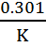 [21]
t: time (day)
OD_{t}: Optical density after (t) day
OD₀: Optical density at zero time

Table 1The components of modified Chu-10
Concentration  g\l | Chemical formula of each salt | Number of stock solution
10 | MgSo₄.7H₂O | 1
4 | K₂HPO₄ | 2
8  16 | NaNo₃  CaCl₂ | 3
0.32 | FeCl₃ | 4
4 | EDTA-Na | 5
30 | NaCl | 6
8 | Na₂Co₃ | 7
0.02  0.028  0.224  0.08  0.004  0.288 | MnCl₂.4H₂O  (NH₄) ₆Mo₇O₂₄.4H₂O  ZnSo₄.7H₂O  CuSo₄.5H₂O  CoCl₂.6H₂O  H₃BO₃ | 8
Experimental Planning
Three light intensities were used, the light intensity 268 µE\m²\sec was used for cultivation of studied isolated alga. This intensity was treated as control in the study experiments and measured by lux meter [22]. The other two levels of light were used 125 and 300 µE\m²\sec as treatments [23].
Phosphate represented as phosphor source in this study that was used in the media for isolated alga C. vulgaris. The phosphate compound is K2HPO4, and its concentration is 4 g\l (as a stock solution salt) that considered to be the control for the experiments according to their concentration in modified Chu-10 media (Table 1).
Three concentrations of phosphate were used 0, 2, 6 g\l (stock solution salt) as treatments, in each treatment the Phosphate in used media were taken off.
Determination of Protein
After centrifugation of alga samples by cooling centrifuge for 5000 r/min for 30 min, 4C° in the stationary phase, the supernatant was collected and the protein determined according to Bradford [24].
Statistical Analysis
General Treatment Structure was used as an experimental design. Data were analyzed by using gene stat discovery (2012) programme to study the effect of different light intensities and phosphorous concentrations on growth curve and protein content. Least significant difference (LSD) was used to compare the significant difference between means at p ˂ 0.05.
Results and Dissection
Effect of Light Intensity on the Growth Curve and Protein Content
Different growth curve and growth rate (K) were observed for isolated alga in the treatments. Figure (1) illustrates the effect of different levels of light intensity on C. vulgaris biomass growth. The stationary phase began at the days 13, 12 and 9 for treatments 125, 268 and 300 (µE\m²\sec) respectively.
The highest K value was 0.15 at the 268 µE\m²\sec (control), while the lowest K value was 0.08 at 125 µE\m²\sec, but the K value at 300 µE\m²\sec was 0.09.
Significant differences were recorded in K value (p<0.05) between all treatments (Figure 2). The growth rate of algae is maximal at saturation intensity and decreases with both increase or decrease in light intensity [25]. Light intensity increases above saturating limits causes photo inhibition or photo oxidation (viz. irreversible damage to the photosynthetic machinery) [26]. This is due to the disruption of the chloroplast lamellae caused by high light intensity and inactivation of enzymes involved in carbon dioxide fixation [9].
The shortest doubling time (G) was 2 days at control treatment, while the longest was 3.4 days at 125µE\m²\sec and at 300 µE\m²\sec G was 3.1 days. Significant differences were recorded in G value (p<0.05) between control and all treatments as shown in (Figure 3).
The doubling time (G) increased when the light intensity below or above the control, because the decreasing of growth rate led to slow of cell division so doubling cells took more time [27].
This study is in agreement with a study by [28] reported that the growth rate of Microcystis aeruginosa was increased from 0.42 at 20 µE\m²\sec to 0.48 at 40 µE\m²\sec. [29] observed a marked decrease in productivity of Spirulina platensis during scale-up to outdoor cultivations even in favorable conditions. Thus they attributed to photo-inhibition because of high light intensity which resulted in the reduction of biomass yield.
Protein content of C. vulgaris increased from 39.46% to 57.51% at 125 µE\m²\sec to 300 µE\m²\sec, and it was 51.17% at control treatment, and statistically there are significant differences among treatments (Figure 4).
A study by [30] on the marine diatom ,Phaeodactylum tricornutum showed the low light (400 lux at the culture surface) led to an increase in the rate of protein synthesis. In the study by [31] on C. vulgaris reported the rapidly growing cells of natural day light at 25-30°C showed higher amount of protein i.e. 52.6%.
Effect of Phosphorous Concentrations on Growth Curve and Protein Content
The biomass growth of C. vulgaris entered a stationary phase in different days among treatments (Figure 5). The stationary phase was identified as day 14, 12, 10 and 6 in treatments 6, 4, 2 and 0 g\l respectively.
The highest K value was 0.16 at 0 g\l treatment, while the lower K value was 0.1 at 6 g\l treatment, but at 4 and 2 g\l treatments the K value was 0.14 and 0.15. Significant differences were recorded in K value (p<0.05) between control all treatments except treatment 4 g\l as shown in (Figure 6).
The shortest doubling time (G) was 1.8 day in treatment 0 g\l, while the longest was 2.8 in 6 g\l, and at control treatment (4 g\l) and 2 g\l the G was 2.1 and 1.9 days respectively. Significant differences were recorded in G value (p<0.05) between control and all treatments except treatment 4 g\l (Figure 7).
The explanation for these results was that when phosphorus concentration decreased cause increase in dry weight and reduction of essential photosynthetic pigments and photosynthetic activity was observed [32]. Reduced utilization of the light energy for photosynthesis will increase membrane damage caused by excessive photo oxidation, this may be compensated for by a reduction of thylakoid membranes [33]. A study on the green alga C. kessleri agrees with this study, and shows an increasing in growth under phosphate starvation [34].
Protein content of C. vulgaris decreased from 51.17% at control treatment (4 g\l) to 13.85% at 0 g\l treatment, and it was 31.90% at 2 g\l treatment, while the highest protein content was 75.56% at 6 g\l treatment. Significant differences were recorded between all treatments (Figure 8). A study on Green Alga Selenastrum minutum by [35] reported that soluble protein content decreased under phosphorus limitation. They suggested that the decreasing because the synthesis of nonessential proteins may be repressed during phosphorus limitation because the enzymes that are responsible for protein synthesis affected by phosphorus concentration [35]. The study of [36] noted that in C. vulgaris the protein level decreased from 50.8% to 38.16% during phosphate starvation.

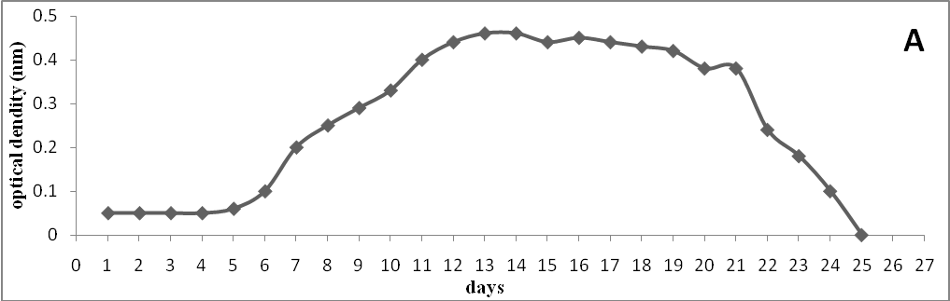
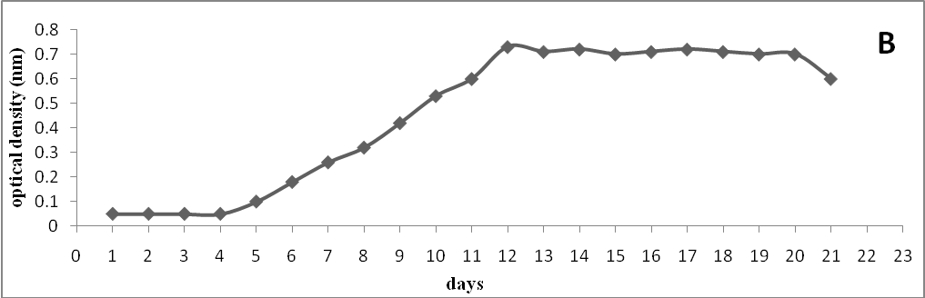
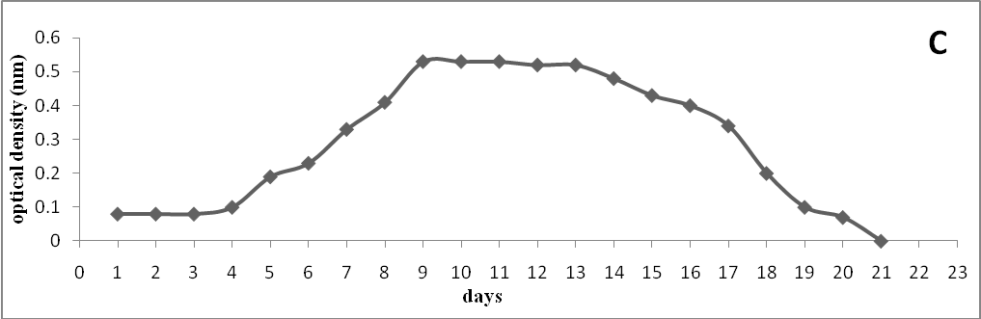
Figure 1:Growth curve of C. vulgaris at different levels of light intensities (µE\m²\sec) A= 125; B= 268(control); C= 300.
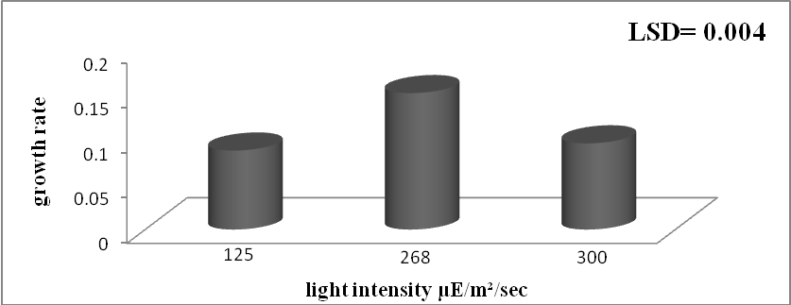
Figure 2: Growth rate of C. vulgaris at different light intensities (µE\m²\sec).

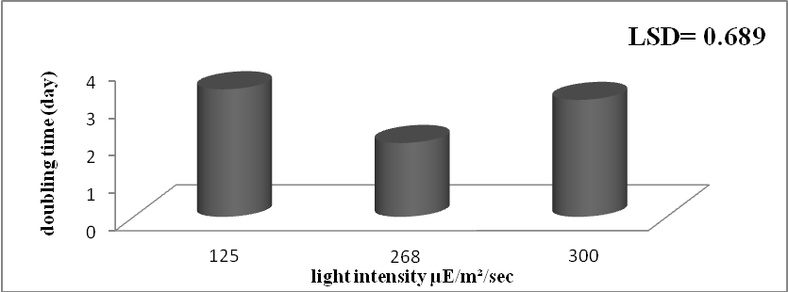
Figure 3: Doubling time of C. vulgaris at different light intensities (µE\m²\sec).

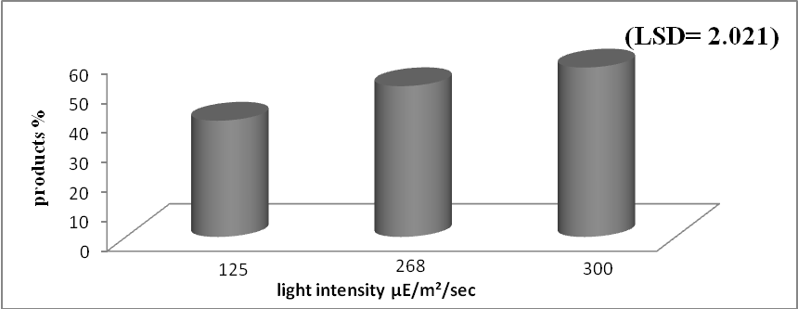
Figure 4: Protein content of C. vulgaris at different light intensities (µE\m²\sec).

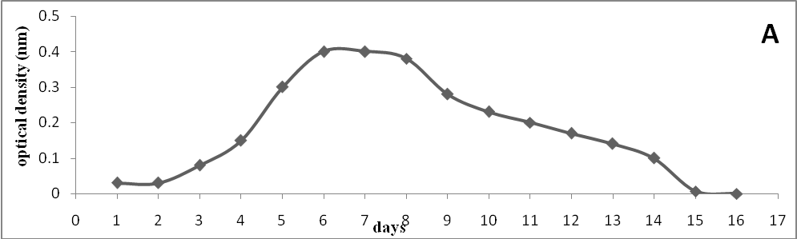
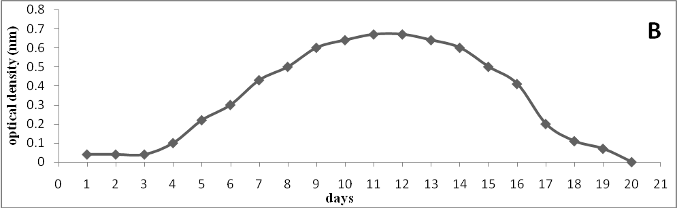
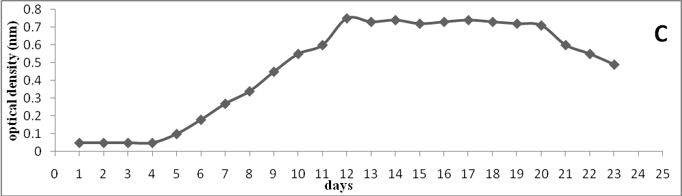
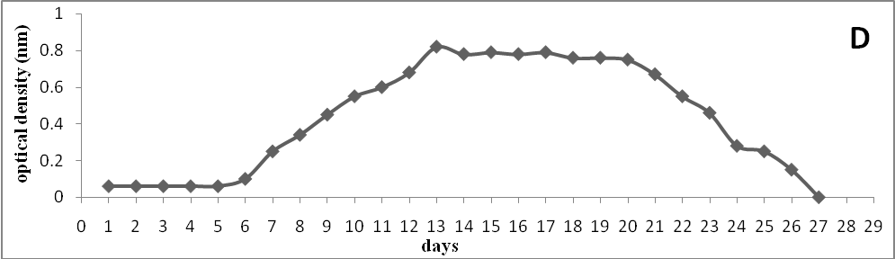
Figure 5: Growth curve od C. vulgaris at different phosphate concentrations (g\l) A=0; B=2; C= 4(control); D= 6.
Figure 6: growth rate of C. vulgaris at different phosphate concentrations (g\l).

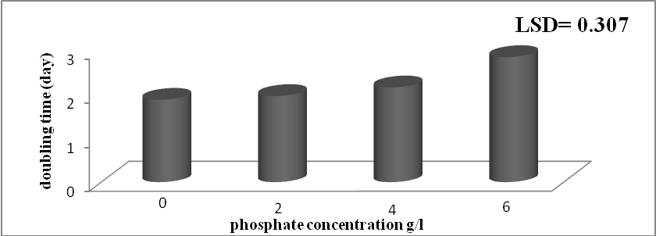
Figure 7: Doubling time of C. vulgaris at different phosphate concentrations (g\l).

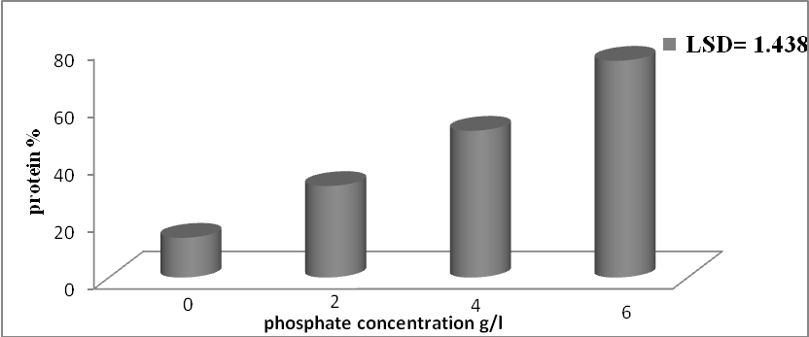
Figure 8: Protein content of C. vulgaris at different phosphate concentrations (g\l).

Conclusions
1-High light intensity and phosphorus limitation affect the biomass production and growth rate of studied microalga.
2- Highest growth rate and shortest doubling time for studied isolated microalga were recorded at 268µE\m²\sec light intensity and zero g\l phosphate.
3. The best light intensity that leads to increase protein content is 300 µE\m²\sec.
4. The best phosphorus concentration that leads to increase the protein content is 6 g\l.
Acknowledgment
We are grateful to Department of Biology, College of Science, and University of Babylon for their support to this research.
References
[1] Becker, E.W. Micro-algae as a source of protein. Biotechnol. Adv. Vol.25, pp: 207–210. 2014.
[2] Singh, J. and Gu, S. Commercialization potential of microalgae for biofuels production. Renew. Sustain. Energy Rev. Vol.14, pp: 2596–2610. 2010.
[3] Spolaore, P.; Joannis-Cassan, C.; Duran, E. and Isambert, A. Commercial applications of microalgae. J. Biosci. Bioeng. Vol. 101, pp: 87–96. 2006.
[4] Hasan, M.R. and Chakrabarti, R. Use of Algae and Aquatic Macrophytes as Feed in Small-Scale Aquaculture: A Review; Food and Agriculture Organization of the United Nations (FAO): Rome, Italy, 2009.
[5] Zepka, L.Q.; Jacob-Lopes, E.; Goldbeck, R.; Souza-Soares, L.A. and Queiroz, M.I. Nutritional evaluation of single-cell protein produced by Aphanothece microscopica Nägeli. Bioresour. Technol. Vol.101, pp: 7107–7111. 2010.
[6] Harrison, P.J.; Conway, H.L.; Holmes, R.W. and Davis, C.O. Marine diatoms grown in chemostats under silicate or ammonium limitation. III. Cellular chemical composition and morphology of Chaetoceros debilis, Skeletonema costatum and Thalassiosira gravida. Mar. Biol. Vol.43: pp:19–31. 1977.
[7] Morris, R.J.; McCartney, M.J. and Robinson, G.A. Studies ofa spring phytoplankton bloom in an enclosed experimental ecosystem. I. Biochemical changes in relation to the nutrient chemistry of water. J. Exp. Mar. Biol. Ecol. Vol.70: pp: 249–262.1983.
[8] Cuhel, R.L.; Ortner, P.B. and Lean, D.R. Night synthesis of protein by algae. Limnol. Oceanogr. Vol. 29, pp: 731–744. 1984.
[9] Iqbal, M. and Zafar, S. Effects of photon flux density, CO2, aeration rate, and inoculum density on growth and extracellular polysaccharide production by Porphyridium cruentum. Folia Microbiol. Vol.38, pp: 509–514. 1993.
[10] Titman, D. Ecological competition between algae: Experimental confirmation of resource-based competition theory. Science . Vol. 192, pp: 463–465. 1976.
[11] Hu, Q. Environmental Effects on Cell Composition. In Handbook of Microalgal Culture: Biotechnology and Applied Phycology; Richmond, A., Ed.; Blackwell: Oxford, UK, pp 83–93. 2004.
[12] Larned, S. Nitrogen-versus phosphorus-limited growth and sources of nutrients for coral reef macroalgae. Mar. Biol. Vol. 132, pp: 409–421. 1998.
[13] Borchardt, J.A. and Azad, H.S. Biological extraction of nutrients. J. Water Pollut. Control Fed. Vol.40, pp:1739–1754. 1968.
[14] Chisti, Y. Biodiesel from microalgae. Biotechnol. Adv. Vo.25, pp: 294–306. 2007.
[15] Barsanti, L. and Gualtieri, P. Algae: Anatomy, Biochemistry, and Biotechnology, 1st ed.; CRC Press:Boca Raton, FL, USA, 2005.
[16] Kilham, S.; Kreeger, D.; Goulden, C. and Lynn, S. Effects of nutrient limitation on biochemical constituents of Ankistro desmusfalcatus. Fresh w. Biol. Vol.38, pp: 591–596. 1997.
[17] Healey, F.P. Phosphate. Biol. Cyanobacteria . Vol.19, pp: 105–124. 1982.
[18] Healey, F.P. and Hendzel, L.L. Indicators of phosphorus and nitrogen deficiency in five algae in culture. J. Fish. Board Can. Vol. 36, pp: 1364–1369. 1979.
[19] Kassim, T.I.; Al-Saadi, H. and Salman, N.A. Production of some phyto-and zooplankton and their use as live food for fish larva. Iraq.J. Agric. Proc. Of 2ndSci.Confer., Vol.4, No.5: pp: 188-201. 1999.
[20] Tredici, M.R. Mass production of microalgae: photobioreactors. In: Richmond A, eds. Handbook of Microalgal Culture: Biotechnology and Applied Phycology. Oxford: Blackwell Science. 2004.
[21] Fogg, G.E. Algae Culture and Phytoplankton Ecology- 175 pp. 2nd ed. University of Wisconsin Press, Wisconsin, U.S.A. 1975.
[22] Al-Juboori, I.F. Lipid production from some local algae at different cultivation conditions. M.Sc. Thesis, College of Science for Women, University of Baghdad, Iraq. 2012.
[23] Jiminez, C.; Cossio, B.R. and Niell, F.X. Relationship Between Physiochemical variables and productivity in open ponds for the production of Spirulina: A predictive model of algal yield. J. Aquaculture, Vol. 221, No. 4: pp: 331-345. 2003.
[24] Bradford, M. A. rapid and sensitive method for the quantitation of microgram quantities of protein using the principle of protein dye binding. Anal. Biochem, Vol.72, pp:248-254. 1976.
[25] Juneja, A.; Ceballos, R.M. and Murthy, G.S. Effects of Environmental Factors and Nutrient Availability on the Biochemical Composition of Algae for Biofuels Production: A Review. Energies, Vol.6, pp: 4607-4638. 2013.
[26] You, T. and Barnett, S.M. Effect of light quality on production of extracellular polysaccharides and growth rate of Porphyridium cruentum. Biochem. Eng. J., Vol.19, pp: 251–258. 2004.
[27] Al-Saadi, H.A.; Al-Lami, A.A. and Kassim. T.I. Algal ecology and composition in Garmat Ali River. Iraq Reg Riv., Vol.12, No.1, pp: 27-38. 1996.
[28] Hassan, F.M.; Yaseen, A.A. and Abed, R.K. Effect of different temperature and light intensity on growth of algae Microcystis aeruginosa. J. Babylon Univ., Vol.9, No.3, pp: 609-620. 2004.(In Arabic)
[29] Soni, S.K.; Agrawal, K.; Srivastava, S.K.; Gupta, S. and Pankaj, C.K. Growth performance and biochemical analysis of Spirulina platensis under different culture conditions. J. Algal Biomass Utln., Vol.3, No.1, pp: 55- 58. 2012.
[30] Morris, I.; Glover, H. and Yentsch, C. Products of photosynthesis by marine phytoplankton: The effect of environmental factors on the relative rates of protein synthesis. Mar. Biol., Vol.27, pp: 1–9. 1974.
[31] Sharma, R.; Singh, G.P. and Sharma, V.K. Effects of culture conditions on growth and biochemical profile of Chlorella vulgaris. Plant Pathology and Microbiology, Vol.3, No.5, pp: 131. 2012.
[32] White, S.; Anandraj, A. and Bux, F. Pam Fluorometry as a Tool to Assess Microalgal Nutrient Stress and Monitor Cellular Neutral Lipids. Bioresour. Technol., Vol.102, No.2, pp: 1675-1682. 2011.
[33] Wanner, G.; Henkelmann, C.; Schmidt, A. and kost, H.P. Nitrogen and sulfur starvation of the cyanobacteriumSynechococcus6301. An ultrastructure, morphological, and biochemical comparison. Z. Naturforsch., Vol.41 c, pp: 741-750. 1986.
[34] El-Sheek, M.M. and Rady, A.A. Effect of phosphorus starvation on growth, photosynthesis and some metabolic processes in the unicellular green alga Chlorella kessleri. Phyton, Vol.35, pp: 139–151. 1995.
[35] Theodorou, M.E.; Elrifi, I.R.; Turpin D, H. and Plaxton, W.C. Effects of phosphorus limitation on respiratory metabolism in the green alga Selenastrum minutum. Plant Physiol., Vol.95, pp: 1089-1095. 1991.
[36] Mutlu, Y.B.; Isik, O.; Uslu, L.; Koc, K. and Durmaz, Y. The effect of nitrogen and phosphorus deficiencies and nitrite addition on the lipid content of Chlorella vulgaris (Chlorophyceae). Afr. J. Biotechnol.,Vol.10, No.3, pp: 453-456. 2011.

