Comparison of flow pattern in a 60° sharp bend by using FLUENT software and artificial neural network , support Vector Machine Methods

Salma Ajeel¹ Azadeh Gholami ² Hossein Bonakdari ³ Negar Bagheri ⁴
Ali Akbar Akhtari ⁵

1 General Directorate for Dams and Reservoirs , Ministry of Water Resources, Iraq.
2,3,4,5 Department of Civil Engineering, Razi University, Kermanshah, Iran.

Corresponding author: salma.civil66@gmail.com

To cite this article:

Ajeel, S., Gholami, A., Bonakdari, H., Bagheri, N. and Akhtari, A. A. Comparison of flow pattern in a 60° sharp bend by Using FLUENT Software and Artificial Neural Network , Support Vector Machine Methods. Mesop. environ. j., 2016, Vol. 2, No.2, pp.27-39.

This work is licensed under a Creative Commons Attribution-NonCommercial-NoDerivatives 4.0 International License.
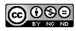


Abstract

This paper presents an experimental and numerical study of the flow patterns in a strongly-curved 60º open channel bend. Corresponding numerical model is based on the Fluent software and ANN,SVM methods. The use of artificial intelligence methods and Support vector Machine in different hydraulic sciences has become conventional in recent years. In this study the turbulence model is used to simulate turbulent flow parameters and Compared of flow pattern in a 60° sharp bend by Using FLUENT software and ANN, SVM Methods. The results show that , enjoying low error values, the FLUENT model has an acceptable level of consistency with the available experimental results. ANN model can predict velocity pattern fairy accurately. The error values of FLUENT and ANN models are smaller in the outer wall (contraction zones) in comparison with the inner wall (separation zone). It could therefore be said that the error value is greater in high- velocity areas (erosion- prone areas) than in low- velocity areas (sedimentation- prone areas). Careful examination of these models will make it clear that both FLUENT and SVM model underestimate and the ANN model overestimates. The error value is very small in the cross sections after the bend in all three models.
Keywords; sharp bends, numerical model, velocity distribution, FLUENT ,ANN,SVM.
Introduction
Rivers have fascinated scientists and engineers. It is the main source of providing water supply for domestic, irrigation, industrial consumption or transportation and recreation uses. River channels do not remain straight for any appreciable distance, the major problems encountered in many hydraulic structures it is the flow separation. Rivers have always been subject to changes and variations through time, and erosion in walls and beds, and scour at other parts are instances of such changes which were not favored by people settling at riverbanks, and caused irreparable damage to people and the facilities [14]. Thus, considering the importance of such issue, taking some critical measures in order to control and direct rivers so as to minimize the above mentioned damages and to make the best use of these resources is deemed indispensable. River bend routes are one of the areas in which complex flow patterns exist. Such complexity is due to not only the turbulence and the 3D nature of the flow, but also bed topography and depth variations which are generally under the influence of erosion, sediment transport and sedimentation processes. Various factors in the flow pattern change of the bend, Distribution of velocities component and water surface profiles are involved that their study for a comprehensive understanding of the behavior of the flow in channels and natural rivers with bend will support. Therefore, the first step taken towards the goal is investigating flow pattern and measuring the velocities in river routes. The radius of curvature of the channel and hydraulic conditions governing the flow are some of these conditions. Flow characteristics in channel bends are much more complicated than those in straight channels. Investigation of velocity profile and water surface change have an important role in environmental engineering. Designing of height of channel wall is so vital for arranging rivers. there have been extensive researches undertaken into flow and scour pattern in river bend routes and they are addressed as follows.
Rozovskii in 1957, offered a relation for the determination of a specific length for when the secondary flow has the maximum strength. Based on this relation, he concluded that in order to develop secondary flow, there needs to be a bend with a central angle of at least 100 degrees for shallow flumes, and a 180 degree central angle of 180 degrees for deep ones. He also observed that logarithmic distribution probability for velocity profile leads to favorable results [13]. Leschziner and Rodi in 1979, numerically simulated the flow in a 180 degree sharp bend in turbulence by using k-ε model. They assumed absence of hydraulic jump and flow separation. They observed that closer to the end of the bend, maximum velocity tends to be found towards the external bend [1]. De Vriend and Geoldof in 1983, carried out a field investigation, and numerical simulation of flow in the Dommel, a river in the Netherlands, within a short period of time. The section included two 90 degree bends located sequentially, and in the same direction, and there was a short, straight reach in between. The results indicated that maximum velocity is found at the entrance of the bend, close to the inner wall, and when close to the end of the bend, it is oriented towards the external bend [2]. Blanckaert and Graf (2001) investigated channel bed level changes at a 120º sharp bend with a movable bed using an experimental setup. They reported a minor secondary rotating flow cell at the outer wall of the bend. As numerical hydraulic models can significantly reduce costs associated with the experimental models, their use has been rapidly expanded in recent decades [3]. Bodnar and Prihoda (2006) presented a numerical simulation of the turbulent free-surface flow by using the k-ω turbulence model and analysed the nature of non-linearity of water surface slope at a sharp bend [4]. Sui et al. in 2006, conducted an experimental study on local scour in a flume with a 90 degree bend, and analyzed the effect of some parameters such as Froude number, the slope and width of the protective wall, and bed particle size on the amount of scour near the bed [5]. Naji Abhari et al. (2010) studied the flow pattern in a 90° mild bend numerically and experimentally. In this study, they only focused on the velocity distributions, the streamlines at different water levels and the distribution of shear stresses and they did not study water surface profiles. The results showed that the flow pattern in a channel bend is heavily influenced by the secondary flow and centrifugal force. However, the numerical model used in this study did not perform well in predicting the minor secondary flow in the outer wall. Presenting the CFD two-dimensional model[6]. Bonakdari et al. (2011) investigated the flow pattern at a 90º mild bend using numerical model, artificial neural network and genetic algorithm. But they only focused on the velocity components [7]. Uddin and Rahman in 2012, conducted an experimental study of 3D flow pattern and erosion by using ADCP velocity meter in the bend of the Jamuna River. They measured 3D velocity of the flow and shear stress near the river bed, and presented a model in order to predict erosion on the bend, based on the processes of the flow. Finally, they compared the model with the real data recorded through their observations of the mentioned river [8]. Liaghat et al. in 2014, carried out a numerical study of the hydraulic of the flow in a U-shaped flume with changing width by using SSIIM software. They studied 3D flow velocity components, shear stress, the strength of the secondary and spiral flows [9]. Vaghefi et al. in 2014, used Depth-Averaged Method to study and analyze shear stress distribution near the bed in a 180 degree sharp bend. The results suggested that the maximum dimensionless shear stress near the bed occurs at the beginning of the bend, near the inner wall and in the 40 degree cross section [10]. Gholami et al., (2014) using experimental and numerical models to study flow patterns in 90 ° sharp open channel bend. The results showed that in a sharp bend, the maximum velocity till the final sections remains in the inner wall of the channel and in the sections located after the bend is transmitted to the outer wall of the channel. In relation to bathymetry and studying water level in this research report does not exist [11].
In this paper, the flow pattern was studied at a strongly-curved 60º open channel bend, by using Fluent software and ANN,SVM method and comperes with experimental data. In this study, the transversal and longitudinal distribution of velocity, longitudinal distribution of flow depth under the subcritical flow have been analysed.
2. Experimental model
Experimental tests were conducted at Mashahd Ferdowsi University Hydraulic Laboratory (Figs. 1 and 2). The channel section used has dimensions of 40.3×40.3 cm and the channel bed and walls are made of Plexiglas. The central angle of the bend is 60° and the central radius of the channel (Rc) is 60.45 cm which is equal to 40.3 cm with regard to the value of the channel width (B), the ratio of the radius of the central bend to the channel width is 1.5 (𝑅𝑐𝐵) and since this ratio is smaller than 3, the under- study bend is considered a sharp bend. The original reservoir is divided into two parts through a sharp edge triangle-shaped weir used to measure the discharge. In the second part of the original reservoir the flow is conveyed to the entrance reservoir by a centrifuge pump.
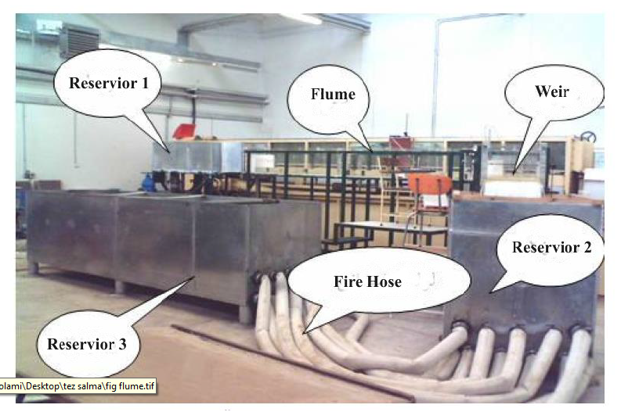
Fig.1:the experimental flue of the 60° bend related to Akhtari (2009) [12]
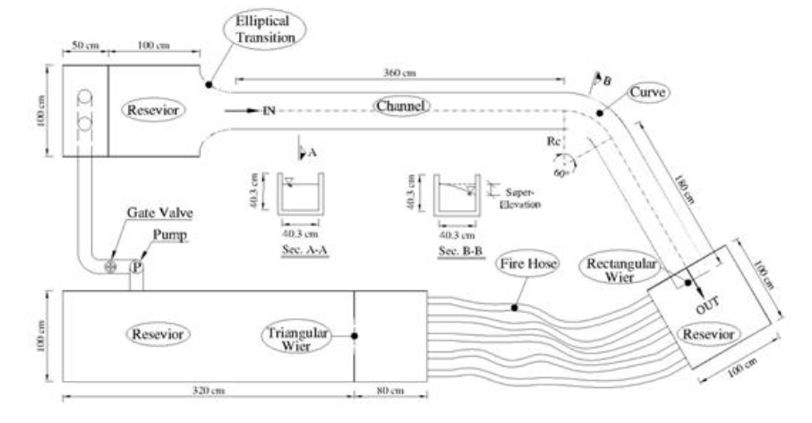
Fig.2:The plan of the experimental flume related to the 60° bend used by Akhtari (2009) [12]

2-1 The hydraulic conditions of the experiments
The hydraulic properties of the flow have been shown in Table (1) in the 60° bend channel.
Table 1: The hydraulic properties of experiments
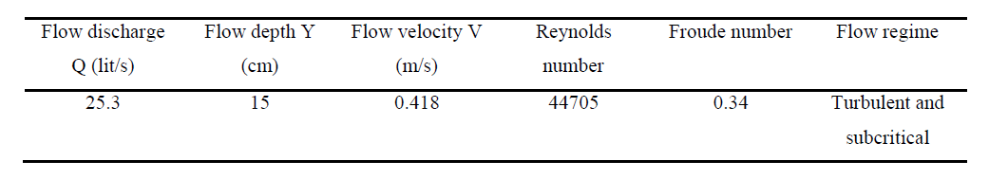

3. Numerical methods
The numerical model FLUENT has been used in the present thesis to numerically simulate the flow in the 60° sharp bend. The results obtained from the numerical simulation have also been verified with the experimental results obtained by Akhtari (2009). The artificial neural network method has also been used to examine the efficiency of these methods in predicting the flow pattern.
3-1 Governing equations
The equations governing the motion of a viscous in compressible fluid in a turbulent state are laid down by averaged Navier- Stokes equations known as Reynolds (RANS). The continuity equations (conservation of mass) and motion (momentum conservation) are as follows:
In Reynolds averaging:
(1)
Where and are the mean and fluctuating velocity components respectively. Substituting expressions of this form for the flow variables into the instantaneous continuity and momentum equations and simplifying (and dropping the over bar on the mean velocity, ), we have:
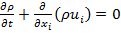 (2)
(3)
Eqs.2 and 3 are known as Reynolds-averaged Navier-Stokes (RANS) equations. is called Reynolds stresses and obtained as (Hinze1975):
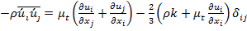 (4)
In the RANS equations, the number of unknowns is more than equations. Therefore, these equations are not closed. The objective of the turbulence models for the RANS equations is to close the RANS equations and to compute the Reynolds stresses. In this numerical model, the RNG k-ɛ turbulence model was used.
4. Verification Model
In this study, various flow variables were studied in a strongly-curved 60º open channel bend, which are discussed separately below.
4-1 Transverse distribution of the flow’s longitudinal velocity
The maximum level of inconsistency between the results of the experimental and numerical models could be seen in the graphs of transverse distribution of longitudinal velocities in the cross sections at the entrance of the bend (0°and 60° degree) cross sections (figures 3 and 4), especially in the layers near the channel bed which indicates that the numerical model is unable to suddenly increase the velocity and the flow undergoes separation in these cross sections.
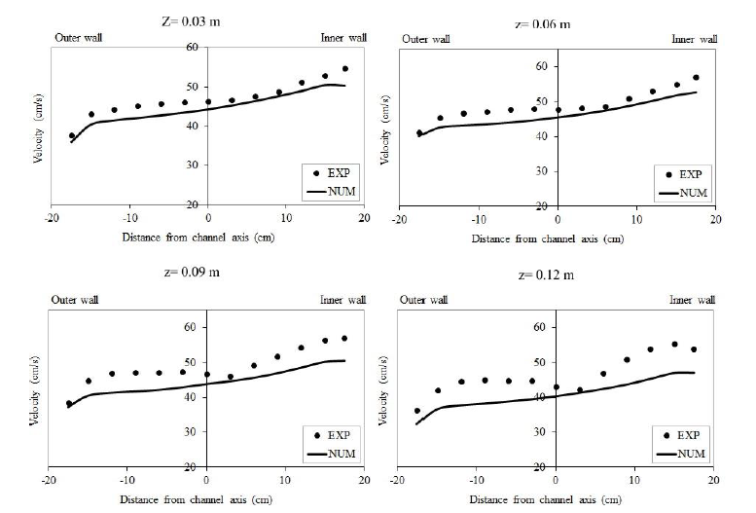
Fig.3: comparing the experimental and numerical models of the transverse distribution of velocity in the 0° cross section at the different distance from the channel bed (z= 0.03, 0.06, 0.09 , and 0.12 m)
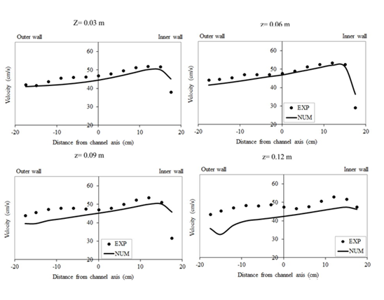
Fig.4: The transverse distribution of velocity in the 60° cross section at the different distance from the channel bed (z= 0.03, 0.06, 0.09, and 0.12 m)
Table 2: the RMSE and MAPE error values for cross sections 40 cm before the bend, 0°, 50°, 60°, at different distance from the channel bed and averaged level.
Cross sections | Z= 0.03 m |  | Z= 0.06 m |  | Z= 0.09 m |  | Z= 0.12 m |  | Average velocity
 | RMSE | MAPE | RMSE | MAPE | RMSE | MAPE | RMSE | MAPE | RMSE | MAPE
40cm before | 2.34 | 4.73 | 3.08 | 6.00 | 4.27 | 8.22 | 6.24 | 12.69 | 3.96 | 7.88
0° | 2.52 | 9.54 | 2.90 | 5.56 | 4.65 | 8.78 | 6.03 | 11.94 | 3.97 | 7.81
50° | 3.19 | 6.11 | 2.57 | 5.08 | 4.43 | 8.76 | 6.81 | 13.78 | 4.03 | 8.29
60° | 3.04 | 5.78 | 2.78 | 5.50 | 5.56 | 10.64 | 6.97 | 13.27 | 4.13 | 8.52

the maximum velocity occurs in the inner wall of the channel and as the flow moves forward along the bend, it remains in this same wall also as the secondary flows become stronger in the distance between the 50° to 60° cross sections.

4-2 longitudinal distribution of flow depth
The results of the flow depth’s longitudinal distribution along the inner wall, the axis, and the outer wall of the channel have been compared with the experimental values in Figure (5). The RMSE and MAPE values between these results have been presented in Table (3). The figure and the values make it clear that the fairly consistent results along with 0.12 and 0.61% for RMSE and MAPE mean values along the bend are acceptable.
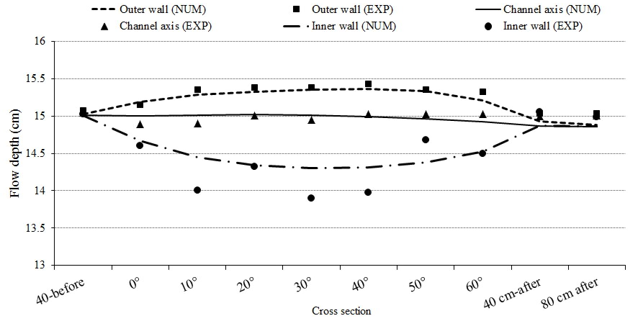
Fig.5: Comparing the longitudinal distribution of the flow depth in the inner wall, the channel axis, and the outer wall in experimental and numerical models.
Table 3: RMSE values between the flow depth values in the experimental and the numerical models along the channel
Channel length | RMSE | MAPE
Outer wall | 0.22 | 1.03
Channel axis | 0.081 | 0.42
Outer wall | 0.07 | 0.37
Mean RMSE | 0.12 | 0.61

5. the process of flow pattern prediction by artificial neural network (train and test)
In velocity-prediction model, 130 experimental data were used for each discharge, making it a total of 780 experimental data for all 6 discharges. These data were divided into two groups: testing and training. Out of 780 data, 546 (70%) were randomly selected for training and 234 (30%) for testing. The data utilized were related to 10 different cross sections of the 60° bend (40 cm before the bend, 0°, 10°, 20°, 30°, 40°, 50°, 60°, 40 and 80 cm after the bend). Each cross-section has 13 transverse points. The value of each velocity data is the depth-averaged velocity of that location. See Figure 6.

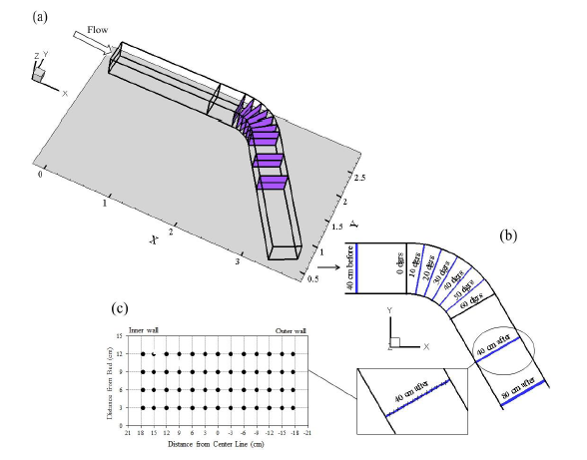
Fig.6: 10 different cross sections, 13 points in the cross section’s width, and the distances and coordinates of the studied points.
5-1 performance evaluation of model in predicting velocity
Figure (7) show the scatter plot diagrams of predicted velocity values by ANN model comparison with experimental data in test and train datasets. The R2 value in two datasets (test and train) shows the high accuracy of model. Model in the test and train dataset shows almost the same R2 values that indicate the data used to train the model present considerable flexibility. This figure indicates that ANN model in both datasets have experienced under estimation. The ANN model under estimation in the test is more. Table (4) shows the ANN model performance to predict the flow velocity in test, train and whole of datasets which is evaluated by using different statistical indexes. BIAS index shows the model underestimation and overestimation.

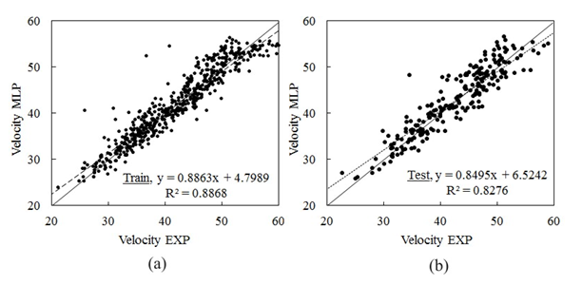
Fig.7: Scatter plots of the ANN model in predicting velocity in the (a): train and (b) test datasets.
Table 4: Performance evaluation of ANN model in predicting velocity with the training, testing and whole of datasets.
Index | Train datasets |  | Test datasets |  | Whole of datasets
RMSE | 4.13 |  | 3.27 |  | 2.96
MAE | 4.07 |  | 2.38 |  | 2.15
R² | 0.87 |  | 0.56 |  | 0.85
BIAS | 0.024 |  | -0.047 |  | 0.0028

5-2 velocity prediction models
Figure (8) show the scatter plot graphs between the velocity values predicted by FLUENT, SVM, and ANN models in comparison with the experimental values. Careful examination of these figures will make it clear that the results of all three models have an acceptable level of consistency with the experimental values. All the data are within ±20% range of the error line in all three models. Studying this figure carefully however will make it clear that most of the data are around the exact line in the ANN model and they are not widely scattered. The data are more scattered in FLUENT and SVM models. Most of the data are not concentrated around the exact line in the FLUENT model and they are located farther. Therefore the FLUENT model is less precise than the other models.

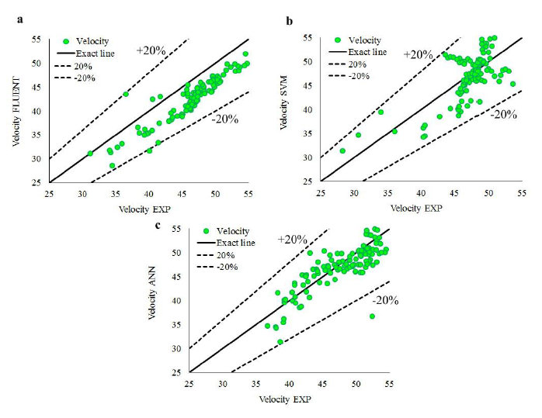
Fig.8:The scatter plots graphs for the velocity values which have been predicted by (a) FLUENT, (b) SVM, and (c) ANN models in comparison with the experimental values.

5-3 water surface depth prediction models
The scatter plot graphs of the water depth predicted by these models have been shown in Figure (9). Careful examination of these figures will make it clear that the water surface depth values which have been predicted by all three models have an acceptable level of consistency with the experimental values. The data are concentrated around the exact line in all three models but careful examination of the images will clarify that all the data are within ±5% error line range in the ANN model. After that and in the FLUENT model, a few data fall outside +5% error line and then in the SVM model, more data exceed than error line.
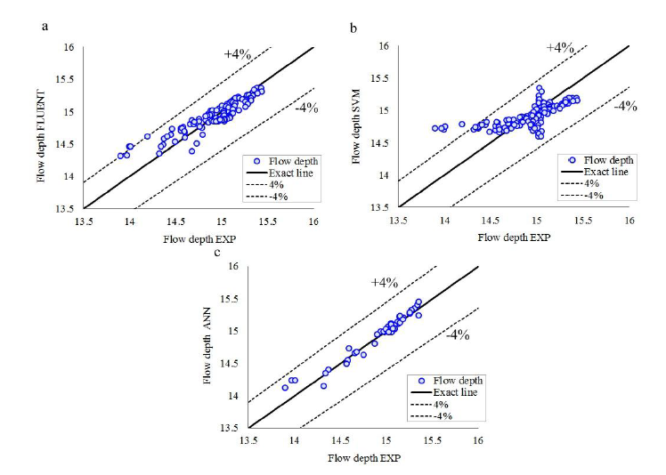
Fig. 9:The scatter plots graphs for the water- depth values which have been predicted by (a) FLUENT, (b) SVM, and (c) ANN models in comparison with the experimental values

5-4 performance evaluation of models in predicting velocity and water surface depth
All the different statistical indexes for predicting the water depth and velocity parameters and for comparing the FLUENT, ANN, and SVM models have been shown in Table (4-8). Note that all these indexes are related to the whole datasets (train + test dataset) for SVM and ANN models. Careful examination of the table regarding the velocity- predicting models, will make it clear that the MARE relative error index of the ANN model which is equal to 0.055 is smaller than that of the rest of the models. SVM is after that with a relative error of 0.089 and then there is the FLUENT model with a relative error of 0.069. Careful examination of these models will make it clear that both FLUENT and SVM model underestimate and the ANN model overestimates.

Table 5: Assessing the performance of FLUENT, SVM, and ANN models when predicting the velocity and water depth in comparison with the experimental values through using different statistical indexes.
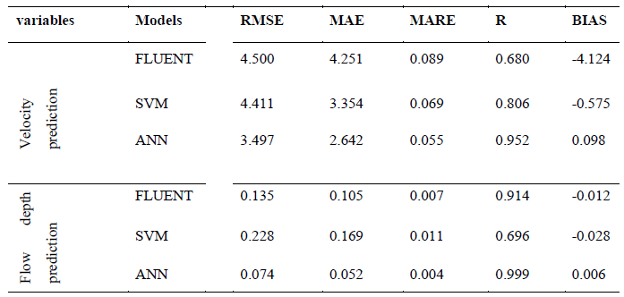
Conclusions
The three- dimensional flow pattern within the 60° sharp bend will be thoroughly examined by using the FLUENT model. SVM and ANN models will also be used to assess the performance of these models. The results indicate that, enjoying low error values, the FLUENT model has an acceptable level of consistency with the available experimental results. Both the ANN and the SVM models can predict water surface and velocity pattern fairy accurately. The ANN model has smaller error values in comparison with the two other models when predicting both water surface and velocity variables. However, the SVM and FLUENT models have smaller error values respectively when predicting the velocity and the FLUENT and SVM models have smaller error values when predicting the water surface. Some of the most important results of this research are mentioned below:
- Examining the transverse velocity profiles in the sharp bends showed that the maximum velocity occurs near the inner wall up to almost the end of the bend. The maximum velocity is transferred to the channel axis between 50° and 60° cross sections and then it occurs in the outer wall of the channel in the cross sections after the bend. Based on that erosion may take place in the channel bed, near the inner wall within the bend, and near the outer wall after the bend.
- Velocity decrease starts from the upper layers (near the water surface) in the present 60° bend and it reaches the bottom layers. In other words, the secondary flows have a greater and quicker effect on the layers neat the water surface.
- Examining the transverse profiles of the water surface in sharp bends showed that transverse gradient occurs in the water surface as the flow enters the bend in such a manner that the water surface increases in the outer wall of the channel and decreases in the inner wall.
- The error values of FLUENT, ANN, and SVM models are smaller in the outer wall (contraction zones) in comparison with the inner wall (separation zone). It could therefore be said that the error value is greater in high- velocity areas (erosion- prone areas) than in low- velocity areas (sedimentation- prone areas). The error value is very small in the cross sections after the bend in all three models. The error value becomes zero in the cross sections close to the exit. The error value is almost zero in the inlet cross sections of the channel.
References
[1] Leschziner, M. A., and Rodi, W. Calculation of strongly curved open channel flow. Journal of the Hydraulics Division, Vol.105, No. 10, pp.1297-1314.1979.
[2] De Vriend, H. J., and Geldof, H. J. Main flow velocity in short river bends. Journal of Hydraulic Engineering, Vol. 109, No.7: pp. 991-1011.198.
[3] Blanckaert, K. and Graf, W.H. Mean flow and turbulence in open channel bend. Journal of Hydraulic Engineering- ASCE, Vol.127, No.10: pp. 835-847.200.
[4] Bodnar, T. and Prihoda, J.: Numerical simulation of turbulent free-surface flow in curved channel. Journal of Flow Turbulent Combust, Vol. 76: pp. 429-442 .2006.
[5] Sui, J., Fang, D., and Karney, B. W. An experimental study into local scour in a channel caused by a 90 bend. Canadian Journal of Civil Engineering, Vol. 33, No.7: pp. 902-911.2006.
[6] Naji Abhari, M., Ghodsian, M., Vaghefi, M. and Panahpur, N. Experimental and numerical simulation of flow in a 90° bend. Flow Measurement and Instrumentation, Vol.21, No. 3: pp. 292-298.2010.
[7] Bonakdari, H., Baghalian, S., Nazari, F., and Fazli, M. Numerical Analysis And Prediction of the Velocity Field in Curved Open Channel Using Artificial Neural Network and Genetic Algorithm. Engineering Applications of Computational Fluid Mechanics Vol. 5, No. 3, PP. 384-396.2011.
[8] Uddin, M. N., and Rahman, M. M. Flow and erosion at a bend in the braided Jamuna River. International Journal of Sediment Research, Vo.27, No.4: pp. 498-509.2012.
[9] Liaghat, A., Mohammadi, K., and Rahmanshahi, M. 3D Investigation of Flow Hydraulic in U Shape Meander Bendswith Constant, Decreasing and Increasing Width. Journal of river engineering, Vol. 2, No.3: pp. 12-23.2014.
[10] Vaghefi, M., Akbari, M., and Fiouz, A.R. Experimental investigation on bed shear stress distribution in a 180 degree sharp bend by using Depth- Averaged method. International Journal of Scientific Engineering and Technology, Vol.3, No.7: pp. 962-965.2014 .
[11] Gholami A, Akhtari AA, Minatour Y, Bonakdari H, Javadi AA. Experimental and numerical study on velocity fields and water surface profile in a strongly-curved 90° open channel bend. Engineering Applications of Computational Fluid Mechanics, Vol. 8, No.3: pp.447-461.2014.
[12] Akhtari, A.A. Surveying flow in strongly-curved open channel and evaluation of the effect of internal non submerged vanes on flow pattern through the bends. Ph.D Thesis, Ferdowsi University of Mashhad, Iran. (In Persian).2010.
[13] Rozovskiĭ, I. L. Flow of water in bends of open channels. Academy of Sciences of the Ukrainian SSR.1957.
[14] Mohanta, A,. Patra, K. C., Khatua, K. K. CFD Simulation And Two-Phase Modeling Of A Non-Prismatic Converging Compound Channel. International Journal of Engineering Research and Applications (IJERA) ISSN: 2248-9622. National Conference on Advances in Engineering and Technology, 29th March.2014.

