Assessment of a lotic ecosystem by using diatomic indices
(Epipelic Algae), Iraq

Fikrat M. Hassan¹ Ali O. Shaawiat²

1*Department of Biology, College of Science for Women, University of Baghdad,. Iraq
2 Department of Biology, College of Education, University of Al-Qadisiyah, Iraq.

Corresponding author: fikrat@csw.uobaghdad.edu.iq

To cite this article:

Hassan, F M. and Shaawiat, A O. Assessment of a lotic ecosystem by using diatomic indices (Epipelic Algae), Iraq. Mesop. environ. j., 2016, Vol. 2, No.2, pp. 87-100 .

This work is licensed under a Creative Commons Attribution-NonCommercial-NoDerivatives 4.0 International License.



Abstract

Benthic diatoms are considered as bio-indicators in lotic ecosystems. The present study is conducted to assess the environmental status of Al-Shamiya river by applying of diatomic indices (epipelic diatom). Fifteen diatomic indices were used in this study. Saprobic index, Pollution Tolerance Index, Palmer Pollution Index, Percent Sensitive Species and Index of Pollution Sensitivity were used as pollution indices. While trophies indices were trophic State Index, Trophic Diatom Index, Diatomic Index, Generic Diatomic Index and Biological water Quality. Furthermore, the study included the diversity indices such as Simpson index, Richness Index, Shannon-Weaver Index, Evenness Index and McIntoch Diversity Index. According to these indices the quality of the river is ranged from less polluted to moderate pollutes., as well as, they indicate the trophic status of the river.

Keywords; Lotic Ecosytems, Biological Indices, Water Quality, Water Pollution, Diatoms, Epipelic.
Introduction
It is very important for evaluating or monitoring an aquatic ecosystem to use more than metric such as physicochemical properties and aquatic organisms. In the case of running water, it prefers to use benthos such as epipelic algae [1;2]. Lavoie et al. [3] has used benthic algae in the stream and in the river as a bio-indicator of pollution. Maznah and Omar [4] revealed that the use of algae as bio-indicators are important to identify the alteration of water quality in the freshwater ecosystems. In addition, Cosgrovea et al. [5] has used periphyton as bio-indicators for water quality.
Benthic algae are considered as primary producers in lotic ecosystems and also have a role in the cycling of nutrients in an aquatic system. They act as an energy source for many benthic fauna. Moreover, their roles in nutrients recycle. (Through the water column and sediment), and the transformation of inorganic materials into organic matrials via photosynthesis in sediment were also known [6]. In addition, they were considered as oxygen sources for the water and sediment [7; 8]. Bellinger and Sigee [9] have mentioned that the freshwater algae gives two types of water quality information (long and short terms). Also, Scheffer [10] revealed that benthic algae are used as an assessment tool for pollution levels. Using of some organisms which are well known as bio-indicators or bio-monitors will give some explanations of the interaction between ecosystem components [11; 12].
The importance of benthic algae in Iraqi aquatic ecosystems was recently investigated [13; 14; 15]. Many authors have previously recognized benthic algae as bio-indicators in different aquatic ecosystems [16; 17; 18]. The benthos algae was considered to be resistant to the alterations of the environment and the pollution, which due to their ability to attach to the benthic substrates [6].
Diatoms are the most predominant algae in different aquatic systems. This peridominancy might be due to their ability to tolerate the alteration in the environment. Diatoms were defferntially response to pollution, some of these algae are sensitive and other are tolerant [19; 20; 21].
The abundance of diatomic algae was also observed in different studies. The abundance of some diatomic species may reflect the status of the aquatic ecosystem such as the trophic status or organic pollution and water quality [22; 23; 24]. Many authors have pointed out the abundance of diatoms and explained that the diatomic algae had the ability to alter the conditions of their environment, but their community structure is responded, according to the alteration of physicochemical and biological variables in the ecosystem [25; 26; 27] observed the high diversity of epipelic algae in four aquatic systems, that having a gradient of salinity in the central of Iraq. Essa [28] used diatoms as bioindicators in some aquatic systems in the Basra region, Iraq, and here the author has stated that the status of these sites is ranged between oligo-mesotrophic and mesotrophic, in exception of only one site which was trophic.
The relation between diatoms and environmental variables are robust and quantifiable, making diatoms sutible quantitative indicators of ecological conditions in the lotic systems [29; 30]. The relationship has been found to be even stronger than those from lentic environments [31]. Each particular species are related very closely to other species and requires different structural, physical and chemical characteristics that intrinsically to its habitat. Whenever these characteristics are subjected to variations, the composition of the niche is affected; species vary in their sensitivity, and thus be more resistant to environmental changes, which caused either by natural fluctuations or by human activities may be favored by selection [32].
Understanding the relationship of geography and the ecological factors to diatom distribution is important to the process of developing diatom-based water quality indicators. Differences in diatom species composition among geographical areas, are caused not only by environmental variation, but also by historical processes of species dispersal and colonization, which in turns add the difficulties in applying of a uniform methods for water quality assessment using diatoms [33]. Reliable diatom metrics development requires a careful investigation of data sets in terms of the major environmental gradients underlying species composition. Martin and Fernandez [34] mentioned that benthic diatom indices are important and suitable to use in the lotic ecosytems.
The present study selected epipelic diatoms because these diatoms reflected the environmental status of the study area. The present study is aimed to apply the fifteen indices in the lotic ecosystems (Al-Shamiyah River) to evaluate their water quality and to use these indices tool for monitoring in Iraqi aquatic systems.

Material and Methods
Sample collection and identification
Al-Shamiyah River was selected as lotic ecosystems to apply the diatomic indices. Four sites were selected, site 1 represents upstream and site 4 refers to the downstream, whereas, the rest of the sites are within the city of Al-Shamiyah (Fig. 1).

Figure 1: Location of sites on Al-Shamiyah River (Followed Hassan and Shawaait [21].
The study was performed within the period from March, 2013 to Febrary, 2014. All physicochemical parameters were determined according to APHA [35], Parsons et al. [36] and Gaudette et al. [37]. The Physicochemical, qualitative and quantitative studies of diatoms were already published by the authors (Hassan and Shawaait [15; 21]).

Table1. The biological indices used in this study.
Item | Index(Symbol) | Type of index and its reference
Item | Index(Symbol) | Pollution | Trophic | Diversity
1 | Saprobic (S) | Pantle and Buck [38] | - | -
2 | Pollution Tolerance Index (P.T.I) | Lang-Bertalot [39] | - | -
3 | Palmer Pollution Index(PPI) | Palmer [40]) | - | -
4 | Index of Pollution Sensitivity (IPS) | Prygiel and Coste [41] | - | -
5 | Biological Water Quality Index (BWQI) | Wegl [42] | - | -
6 | Percent Sensitive Species (SS%) | - | Metzmeier [43] | -
7 | Trophic diatom index (TDI) | - | Kelly and Whitton [44] | -
8 | Diatomic Index (DI) | - | Descy [45] | -
9 | Generic Diatom Index (GDI) | - | Lecointe et al. [46] | -
10 | Trophic State Index(TSI) | - | Nygaard [47]) | -
11 | Simpson Index (SI) | - | - | Simpson [48]
12 | Richness index (D) | - | - | Stiling [49]
13 | Shannon-Weaver index (H') | - | - | Shannon and Weaver [50]
14 | Evenness index (E) | - | - | Neves et al. [51]
15 | McIntoch Diversity Index (Mc) | - | - | McIntoch [52]

Statistical Analysis
Statistical Package for the Social Science (SPSS) is used for statistical analysis and canonical correspondence analysis (CCA) were used for statistical analysis via the computer program version 4.5 [53].

Results and Discussion

The physicochemical parameter was already discussed by authors [21]. Al-Shamiya river was alkaline, oligohaline, very hard water, oxygenated water and less permissible concentration of biochemical oxygen demand (BOD₅). According to Chlorophyll-a concentration the river was oligotrophic.
The average of the total number of diatoms is ranged from 15.51 to 35.22 cells × 10⁴/cm². The dominance of diatoms in the lotic ecosystems was well known in Iraq [13; 24].
Authors [15] studied the composition of epipelic diatoms in Al-Shamiyah River and a total of 173 diatoms taxa were recorded. The epipelic were predominated with pennate diatoms. Generally, it is very known that in the freshwater ecosystems the pinnate diatoms are predominant, while the centric diatoms are predominate in the marine ecosystems [54].

Different Saprobic index (S) was recorded among the study sites. The mean values were ranged from 1.64 in site 2 to 1.72 in site 1 and 4. While its values in site 3 and 1 were 1.51 and 1.87, respectively (Table 2 and fig. 2). These values indicated that Al-Shamiyah River is slightly oligosaprobic to moderate (Beta-mesosaprobic) according to Lowe [55]. In oligosaprobic pollution all material and biodegradable compounds will be fully oxidative while in the mesosaprobic pollution the organic load will be continuously oxidative [16]. This result might be due to leak organic material and sewage from nearby farmland and domestic into the river this load will be less effective during increased water discharge [16; 56]. The quality and quantity of diatoms will be affected by this index so some of the diatoms are existed as a common or predominant according to their tolerance to pollution [57].

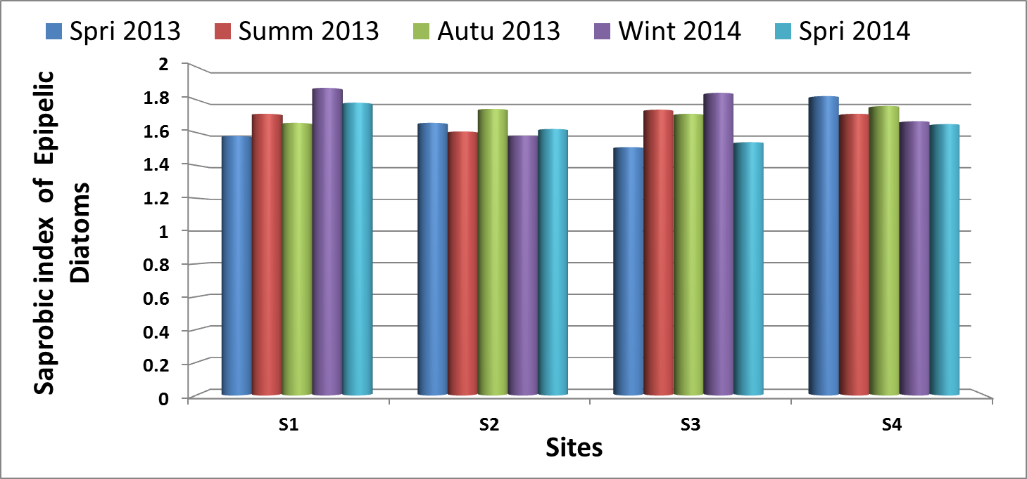

Figure 2: seasonal variations in the Saprobic Index (S); in Al-Shamiyah River during the study period.

Pollution Tolerance Index (PTI) determines the pollution by using diatoms to assess the health of aquatic ecosystems such as rivers [58]. This index is value ranged from 1.61 at site 3 in Spring 2014 to 2.74 at site 1 in Autumn 2013 ( Table 2 and Fig. 3). These results indicated that the river was least polluted to moderately polluted water according to the classification of water pollution by Lange-Bertalot [39]. This classification revealed that the values of PTI were ranged from 1 to 4, since the 1 indicated themost polluted water while the 2, 3 and 4 numbers indicated the moderately polluted water and least polluted water, respectively. Hence PTI results of the Al - Shamyiah river are in agreement with Saprobic index.

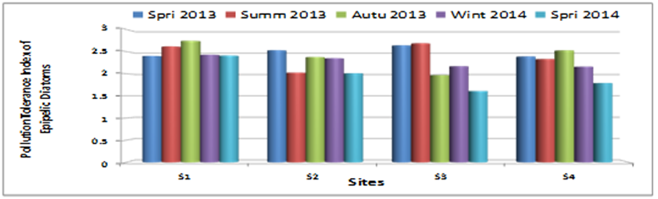
Figure 3: Seasonal variations in the Pollution Tolerance Index (PTI), in Al-Shamiyah River during the study period.

Palmer Pollution Index (PPI) values for epipelic diatoms are ranged from 4.25 at site 2 in Summer 2013 to 11 at site 1 and 4 in Spring 2014, (Table 2 and Fig. 4). The values of the Palmer index were less than 15 and considered as drift in slowly eutrophic status [40; 59]. Similar results were also observed in the two water bodies in India [60]. The palmer index values are confirmed the (PTI) and (S) index results.

(Ramakrishnan, 2003). The palmer index values confirmed the (PTI) and (S) index results.

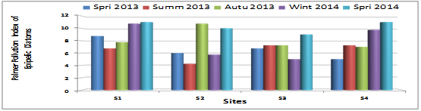
Figure 4: Seasonal variations in the Palmer Pollution Index (PPI); in Al-Shamiyah River during the study period.

The results of the index of Pollution Sensitivity (IPS) of epipelic diatoms showed that Al-Shamiyah river was moderate to good according to IPS values. These mean values ranged from 11.81 at site 4 to 13.85 at site 2 (Table 2 and Fig. 5). Both the low and the high values were recorded in the cold months (in winter 2013).

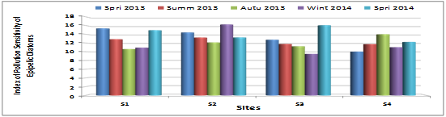
Figure 5: Seasonal variations in the Index of Pollution Sensitivity (IPS), in Al-Shamiyah River during the study period.

Results of Biological Water Quality Index (BWQI) showed that the studied river was moderate to heavily polluted and mostly moderate polluted according to Lobo et al. [61] scale. This scale has varied from 1 to 4 as follows: 0.0-0.9 (pollution absent), 1.0-1.4 (low pollution), 1.5-2.0 (moderate pollution), 2.1-2.7 (heavy pollution) and 2.8-40 (very pollution). The mean values of BWQI have ranged from 1.96 at site 4 to 2.00 at site 1. The lowest values are recorded in Winter 2013 and the highest value were in Spring 2014 (Table 2 and Fig. 6).

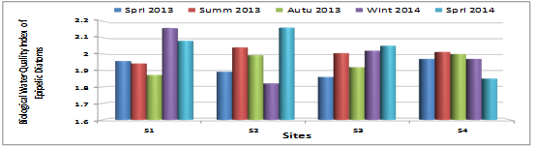
Figure 6: Seasonal variations in the Biological Water Quality Index (BWQI), in Al-Shamiyah River during the study period.

The following changes in the diatoms composition and its ratio in aquatic system might be used to evaluate the water quality by Percent sensitive Species (SS%) (diatoms) index This index has ranged from 25.78% in spring 2014 at Site 4 to 87.15% in winter 2013 at site 1 (Table 2 and Fig. 7). The low results of this index indicated that the pollution is might be due to the waste disposal into the river and leads to reduce the Percent Sensitive Species of diatoms. The percent more than 50 %, indicates to moderately polluted or b- mesosabropic and less than 50% was critically polluted (b-a- mesosabropic. The results of this index indicated that the Al-Shamiyah river has ranged from good to moderately polluted according to Lange-Bertalot [39], and the spatial and temporal variation in this index is related to different load of pollution, predators and the availability of nutrients [7; 62].

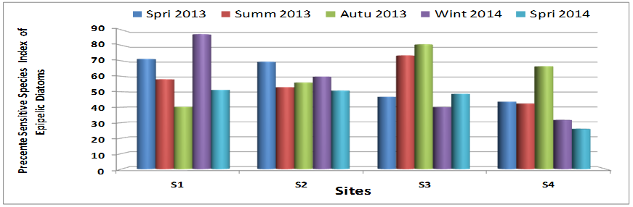
Figure 7: Seasonal variations in the Percent Sensitive Species (SS%), in Al-Shamiyah River during the study period.

Trophic Diatom Index (TDI) is a good tool for monitoring river. The diatom community are liable to the alteration of factors that are not related to nutrients [44]. The present study results of TDI mean values have ranged from 38.52 at site 2 to 54.79 at site 1 (Table 2 and Fig. 8). The lowest value was recorded in spring 2014 while the highest value was in the Winter 2013. According to this index the Al-Shamiyah river was tend to be oligotrophic to mesotrophic, this might be confirmed by existence of A. minutissima at all study sites. This species is found in oligo-mesotrophic river [63].

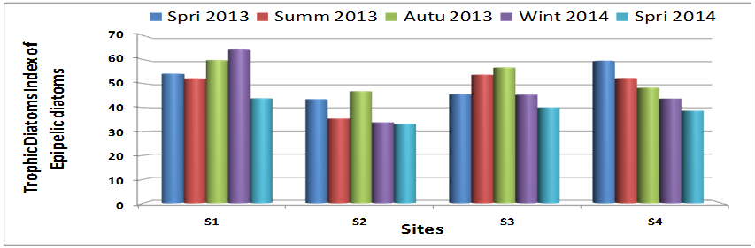
Figure 8: Seasonal variations in the Trophic Diatom Index (TDI), in Al-Shamiyah River during the study period.

The Diatomic index (DI) showed temporal variations. The lowest value is recorded in Winter 2013 was 2.91 in Site 1 and the highest value was in Spring 2013 was 4.08 at Site 3. Its mean values have ranged from 3.50 at sites 4 to 3.66 at site 2 and 3 (Table 2 and Fig. 9). According to Id values that mentioned in Descy [45], the present water quality data are ranged between moderate to good. This may be emphasized by the slight change in diatoms (Epipelic ) communities noted by Hassan and Shawaait [15] study during the same period.

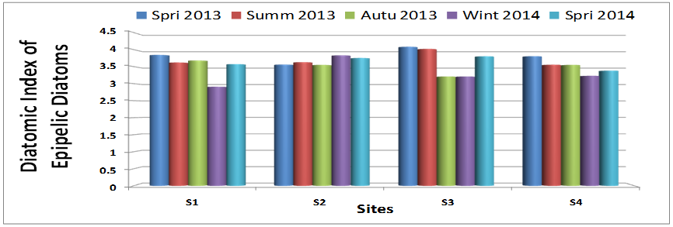
Figure 9: Seasonal variations in Diatomic Index (DI), in Al-Shamiyah River during the study period.

The mean values of the Generic Diatoms Index (GDI) are ranged from 13.11 at site 4 to 14.82 at site 2 (Table 2 and Fig. 10). Both the low and the high values of GDI were recorded in the cold months (in Winter 2013). The highest values of GDI were indicated a good water quality with low or absent pollution [64]. The lowest values of GDI were indicated a deterioration in water quality of an aquatic system. The study area is ranged from moderate to good. Some genera or species of diatoms were sensitive and others were tolerant to pollution, and these diatoms were considered as bioindicatiors [65]. The balance between the existing of sensitive species and tolerant species is depend on alteration in water quality, that is due to different pollutant disposal into an aquatic ecosystem which effect physicochemical and biological features [66; 67; 68]. For example A. minutissima and Nitzchia spp were found predominantly in polluted water, both species are considered as tolerant to different pollution [69].

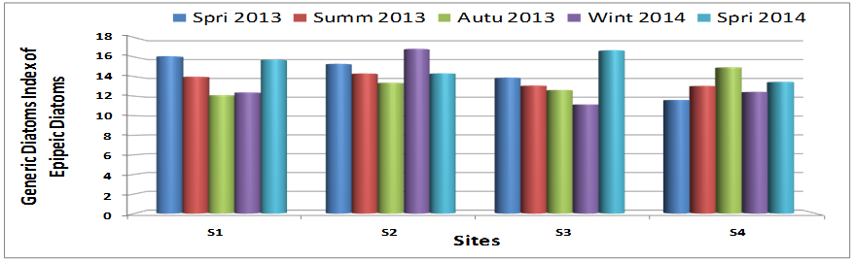

Figure 10:Seasonal variations in the Generic Diatoms Index (GDI), in Al-Shamiyah River during the study period.

Diatoms were considered as sensitive organisms to the environmental alteration in water bodies such as nutrient availability, in which that is related to the trophic status of an aquatic system [70]. The mean value for Trophic State Index (TSI) in this study is ranged from 0.04 at site 4 and 0.09 at site 3. Low value was recorded in Spring 2013 and high value was in Summer 2013 (Table 2 and Fig. 11). Nygaard [47] revealed that the value of this index is ranged from 0.00 to 0.30, and thus indicated as an oligotrophic, while if an aquatic system is ranged from 0.00-1.75, it will be considered as an Eutrophic.

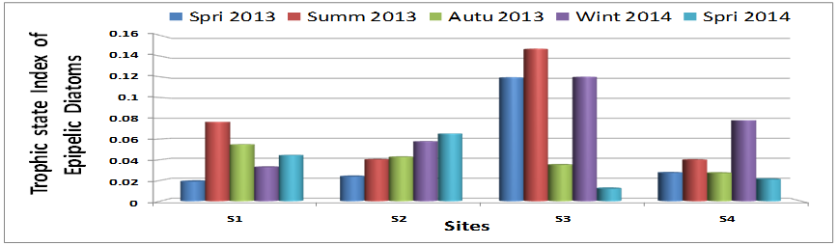

Figure 11: Seasonal variations in Trophic State Index (TSI), in Al-Shamiyah River during the study period.

The lowest value of the Simpson index (SI) for diatoms was 0.08 at site 2 in Autumn 2013, and the highest value was 0.30 at site 1 in Spring 2013 (Table 2 and Fig. 12). The mean values of the Simpson index were ranged from 0.13 to 0.21 in the same above sites, respectively. These results indicate that Al-Shamiyah river is tending to be of the highest diversity and the low or moderate polluted water. This result has evidence that polluted materials are released into the river, varied spatially and temporally which affects the dominancy of some species against another. This finding was also observed by Kassim et al. [71] on the polluted Diyala and Tigris rivers. In general, the highly polluted water body is usually characterized by low diversity and also, the alteration in algal diversity was an indication of changes in water quality [72; 73]. The high values of diversity in Al-Shamiyah river was emphasized by its water quality.

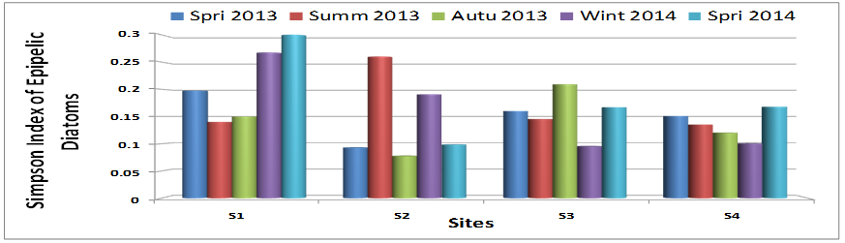
Figure 12: Seasonal variations in the Simpson Index(SI) , in Al-Shamiyah River during the study period.

Mean values of the Richness index (D) for diatoms in this study have ranged from 11.24 at site 4 to 15.24 at site 2 (Table 2 and Fig. 13). The lowest value was recorded in Spring 2014(The warm months) and the highest value was in September 2013 (The cold months). The recorded D values in Al-Shamiya river indicate its high diversity of diatoms that is may be due to the less pollution and less grazing activities by zooplankton [74]. The high values of D were remarkable to healthy diatom communities and this index will cover any alteration in the communities of the aquatic systems [58].

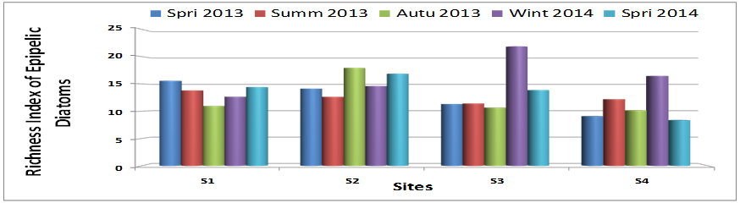
Figure 13: Seasonal variations in the Richness Index(D), in Al-Shamiyah River during the study period.

In the present study the Shannon-Weaver index (H') has recorded values above 1 in the study period. The means values of H were ranged from 2.17 at site 1 to 2.65 at site 2 (Table 2 and Fig. 14). Both low and high values were recorded in spring 2014 (for low value) and Autumn 2013 (for high value), respectively . These findings were confirmed the D index results which emphasize that the Al-Shamiyah river has high biodiversity (diatoms), and also meant that no dominancy for certain species of diatoms in the study river. High values of H index were recorded in the blooming period (spring and autumn). This result agrees with other studies on Iraqi rivers [27; 75]. The high values of the H ' index are an indicator of good water quality of Al-Shamiyah river [70].

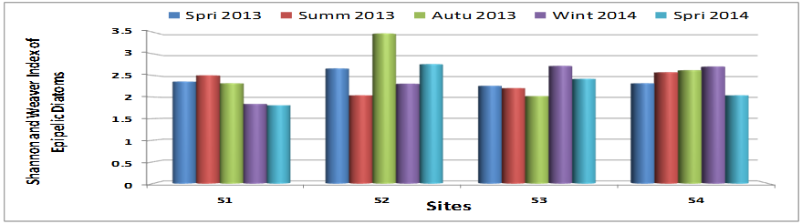
Figure 14: Seasonal variations in the Shannon and Weaver Index (H), in Al-Shamiyah River during the study period.

The results of Evenness index (E) values confirm the homogenization of species in the present studied river where more than 0.5 values were recorded in the study period [76]. Green [76] revealed that the lower values of Evenness index indicate the emergence of few species with high densities and an indication of environmental stress. The mean values of E index were ranged from 0.61 at site 1 to 0.73 at site 2 (Table 2 and Fig. 15). The low and high values were recorded in Spring 2014 and Winter 2013, respectively.

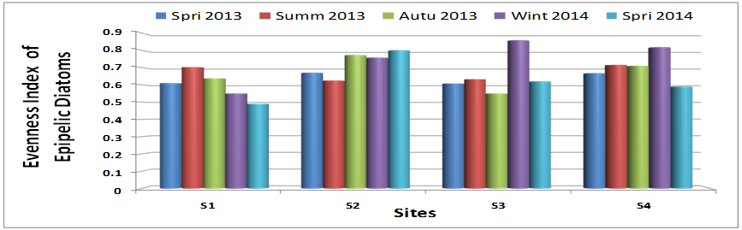
Figure 15: Seasonal variations in the Evenness Index (E), in Al-Shamiyah River during the study period.

The McIntosh Diversity Index (Mc) for diatoms mean values were ranged from 0.74 at site 1 to 0.87 at site 2 (Table 2 and Fig. 16). All recorded values were tended to be close to 1 and this refers that the river was characterized by high biodiversity of diatoms, that is due to a suitable condition diatom growth, and less of a pollution effect. It may be difficult to explain the lowest values because of the environmental factors that organize diatom community in lotic ecosystems were overlapping [77; 78].

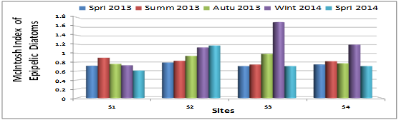
Figure 16: Seasonal variations in the McIntosh Index (Mc), in Al-Shamiyah River during the study period.

Authors in the same period of this study have published the qualitative and quantitative studies of epipelic in Al-Shamiyah river [15]. They explained that some species such as Aulacoseria granulate, Cocconeis placentula, Cymbella spp., Fragilaria capucina, Gomphonies olivaceum, Diatoma elongatum, Navicula radiosa and Syndra ulna were indicative of the trophic status of aquatic ecosystems between oligotrophic to eutrophic [79]. This is in agreement with other results of indices presented in this study (TDI, S, Palmer index and Simpson Index). In the upstream Cocconeis placentula, Cyclotella meneghiniana, Cymatopleura solea, Amphora veneta, Amphora pediculus, Gomphonema parvulum, Gomphonema angustatum and Navicula cryptocephala are the dominant species found in the benthic diatom communities. In downstream Nitzschia palea is dominant species presents in the benthic diatom communities.
CCA analysis (Fig. 17) revealed a positive correlation among some epipelic algae (C. lacustris, C. affinis, N. romana and S. ulna) and DO, Na, N: P, NO3, TSS, and Turbidity. While a negative correlation has been observed among these species and EC, BOD5, PO4, NO2, Ca, SO4, TOC and C:SiO3. C. menenghiana, C. placentula var. euglypta, N. viridula, A. affinis, and A. veneta showed a positive correlation with the following factors (EC, BOD5, TH, light pentertion (LP), CA, SO4, CO2, PO4, NO2, TOC and C:SiO3). While the negative correlation with other factors (DO, Na, N:P, NO3, TSS and Turbidity). The studied physicochemical parameters confirmed that the dominant species of epipelic algae in this investigation can be used as bioindicator for water quality. These factors reflect the clean to moderate water quality of the study sites [80; 81].

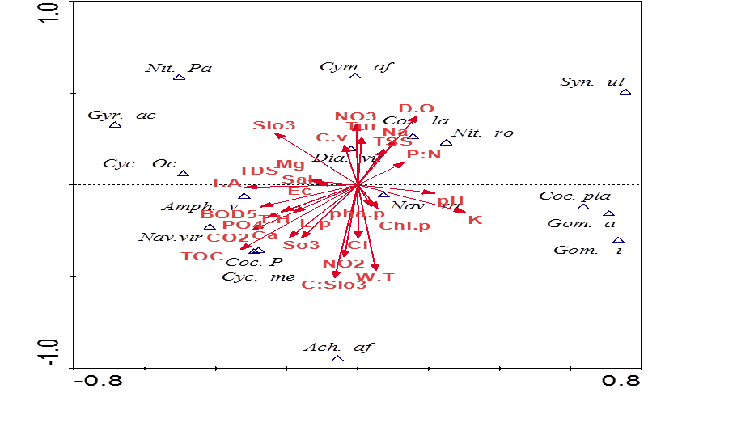
Figure 17: CCA analysis of species Epipelic diatoms—environment correlations.

Table 2. Range (mean ±SD) of indices in Al-Shamiyah River during the study period.
Indicators | Sites
Indicators | 1 |  | 2 |  | 3 |  | 4
Saprobic index(S) | 1.58 – 1.87(1.72 ± 0.11) |  | 1.58 – 1.74 (1.64± 0.06) |  | 1.51 – 1.84 ( 1.67 ±0.14) |  | 1.65 – 1.82 (1.72± 0.07)
Pollution Tolerance Index (PTI) | 2.4 – 2.74 ( 2.52 ±0.15) |  | 2.01 – 2.53 ( 2.29± 0.23) |  | 1.61 – 2.69 ( 2.22±0.46) |  | 1.79 – 2.53 (2.24±0.28)
Palmer Pollution Index | 6.75 – 11 ( 9±1.85) |  | 4.25 – 10.75 (7.35±2.85) |  | 5-9 (7.05 ±1.43) |  | 5 -11(8±2.38)
Precente Sensitive spscies (SS%) | 40.18 – 87.15 (61.55 ±18.20) |  | 50.76- 69.40 (57.76±7.34) |  | 39.99 – 0.61 (57.88±17.95) |  | 25.78 – 66.45(41.95±15.59)
Simpson Index | 0.14 – 0.3( 0.21 ±0.07) |  | 0.08- 0.26(0.14 ±0.08) |  | 0.10 – 0.21(0.16 ±0.04) |  | 0.10 – 0.17 ( 0.13 ±0.03)
Trophic State index | 0.02 – 0.08 (0.05 ±0.02) |  | 0.02 – 0.07 (0.06±0.02) |  | 0.01- 0.15 (0.09±0.06) |  | 0.02- 0.08(0.04 ±0.02)
Trophic diatom index (TDI) | 43.80 -64.19(54.79±7.76) |  | 33.18-46.79 (38.52±6.19) |  | 40.03-56.66(48.24±6.77 |  | 38.63 – 59.48(48.46 ±7.99
Diatomic Index (Id) | 2.91 – 3.84(3.52±0.36) |  | 3.55 – 3.83(3.66±0.12) |  | 3.21- 4.08(3.66±0.43) |  | 3.23 – 3.80(3.50±0.22)
Generic Diatom Index (GDI) | 12.10 – 16.07(14.05±1.83) |  | 13.37- 16.82(14.82±1.31) |  | 11.15 – 16.68(13.48±2.05) |  | 11.61 – 14.94(13.10±1.25)
Index of Pollution Sensitivity(IPS) | 10.61 - 15.33 ( 12.9±2.18) |  | 12.12 - 6.23 (13.85±1.55) |  | 9.49 – 16.05 (12.26± 2.43) |  | 10.03 – 13.99 (11.81 ±1.47)
Biological Water Quality Index (BWQI ) | 1.87 – 2.16 (2.00±0.11) |  | 1.82 – 2.16 (1.98 ±0.13) |  | 1.86 – 2.05 (1.97±0.08) |  | 1.85 – 2.01 ( 1.96±0.06)
Richness Index(D) | 10.95 – 15.57 (13.48±1.76) |  | 12.64 – 7.94(15.24±2.14 |  | 10.64 – 21.85(13.81±4.66) |  | 8.32 – 16.46 (11.24 ±3.27)
Shannon and Weaver Index (H) | 1.81 – 2.50 (2.17 ±0.32) |  | 2.04 – 3.47 (2.65 ±0.54) |  | 2.02 – 2.72 (2.33 ±0.26 ) |  | 2.04 – 2.71(2.45±0.27)
Evenness Index (E) | 0.49 – 0.70 (0.60 ±0.08) |  | 0.63 – 0.8 (0.73 ±0.07 ) |  | 0.55 – 0.86 (0.65±0.12) |  | 0.59 – 0.82 ( 0.70 ±0.08 )
McIntosh Index (Mc) | 0.61 – 0.89 (0.74 ±0.10) |  | 0.79 – 0.95 (0.87±0.17 ) |  | 0.71 – 0.99(0.83 ±0.42) |  | 0.71 – 0.85 (0.78±0.20)

Conclusions
It can be concluded that most of the studied indices reflected the status of the water quality of Al-Shamiyah river which was low to moderately polluted. The results showed an alteration of water quality from upstream (Site 1) to downstream ( site 4) which may be due to discharge of organic and other pollutant being dumped into the river during river passing in Al-Shamiya city and other small villages located on river banks.The results of diatoms indices and physic-chemical analysis indicated that the upstream was moderately polluted and the downstream was excessively polluted. Diatoms have an important role in the biological monitoring of the lotic ecosystems. Building on the existing data from past studies, especially in the southern part of Iraq, there is a promising future for using diatoms for characterizing and monitoring of ecological conditions in other parts of Iraq.

Acknowledgment
The current work is supported by Department of biology, College of Education, University of Al-Qadisiyah. Author expressed their thanks to Dr. Hala Al-Haideri, Department of Biology, College of Science for Women, University of Baghdad for her revising article.
References
[1] Almeida, C.A. Influence of Urbanization and Tourist Activities on the Water Quality of the Potrero De Los Funes River (San Luis – Argentina). Environmental Monitoring and Assessment, Vol.133 (1-3), pp: 459- 465.2007.
[2] Atulegwu, P.U. & Njoku, J.D. The impact of biocides on the water quality. Int. Res. J. Eng. Sci. Tech, (IREJEST), Vol. 1, No. 2, pp: 47-52. 2004.
[3] CCME: Canadian Council of Ministers of the Environment .Canadian water quality guidelines for the protection of aquatic life: CCME Water Quality Index 1.0, User’s Manual. In: Canadian environmental quality guidelines, 1999, Canadian Council of Ministers of the Environment, Winnipeg. Manitoba, Canada. pp: 1-5.2001a.
[4] CCME: Canadian Council of Ministers of the Environment .Canadian water quality guidelines for the protection of aquatic life: CCME Water Quality Index 1.0, Technical Report. In: Canadian environmental quality guidelines, 1999, Canadian Council of Ministers of the Environment, Winnipeg. Canada. pp: 1-13.2001b.
[5] Sharma, D. & Kansal, A. Water quality analysis of River Yamuna using water quality index in the national capital territory, India (2000–2009). Appl. Water Sci., Vol. 1, pp: 147–157.2011.
[6] Udayashankara, T.H; Anitha, K.G.; Rao, S.; Shifa, A. & Shuheb, M. Study of Water Quality and Dynamic analysis of phytoplanktons in four fresh water lake of Mysore India. International Journal of Innovative Research in Science, Engineering and Technology Vol. 2, No. 7, pp: 2600 – 2609.2013.
[7] Edwin, A.I. & Murtala, A.I. Determination of water quality index of river Asa, Ilorin, Nigeria .Pelagia Research Library, Advances in Applied Science Research, Vol.4, No.6, pp: 277-284.2013.
[8] Gyamfi, C.; Boakye, R.; Awuah, E. & Anyemedu, F. Application of the Ccme-Wqi Model in Assessing the Water Quality of the Aboabo River, Kumasi-Ghana. Journal of Sustainable Development; Vol. 6 , No.10, pp.:1 -7.2013.
[9] Abd, I.M. Ecological Assessment of Chebaish marsh by Adoping Environmental and Biological Indices. Thesis, University of Basrah, College of Agriculture. 2010.
[10] Moyel, M.S.Assessment of Water quality of the northern part of Shatt Al-Arab river, using Water Quality Index (Canadian version). Thesis, University of Basrah-College of Science. 2010.
[11] Al-Saboonchi, A.; Mohamed, A.R.M.; Alobaidy, A.H.M.J.; Abid, H.S. & Maulood, B.K. On the Current and Restoration Conditions of the Southern Iraqi Marshes: Application of the CCME WQI on East Hammar Marsh. Journal of Environmental Protection, Vol. 2, pp: 316-322. 2011.
[12] Al-Janabi, Z.Z. Indices Application of Water Quality and Biological Integrity for Tigris River with in Baghdad City. Thesis, University of Baghdad-College of Science for Women. 2011.
[13] A L- Heety, E.A.M. ; Turki , A.M. & Al – Othman, E.M.A. Assessment of the Water Quality Index of Euphrates River Between Heet and Ramadi cities, Iraq. International Journal of Basic & Applied Sciences (IJBAS-IJENS), Vol, 11, No.3, pp: 38 – 47.2011.
[14] Sammen, S. S.Evaluation of Water Quality of Hemren Lake. Diyala Journal of Engineering Sciences, Vol. 06, No. 2, pp: 57 – 76.2013.
[15] Manii, J.K. & Al- Zubaidi, A.A. Assessment of Hydrochemical Water Quality on Al Delmaj Marsh Application of the CCME WQI. Journal of Babylon University/Pure and Applied Sciences/, Vol. 21, No.1, pp: 270 – 280.2013.
[16] Buhlool, M.A. Seasonal Study by use Water Quality Index (Canadian Model) in Euphrates River at Al-Nassiryia city/ Iraq. Thesis, University of Thi-Qar- College of Sciences. 2013.
[17] Rabee, A.M.; Hassoon, H.A. & Mohammed, A.J. Application of CCME Water Quality Index to Assess the Suitability of Water for Protection of Aquatic Life in Al- Radwaniyah-2 Drainage in Baghdad Region. Journal of Al-Nahrain University Vol.17, No. 2, pp: 137-146.2014.
[18] Abbass, R.H.; Abdul-Hussan, J.K.h. & Resen, A.K. Assessment of Water Quality of Shatt al Arab River in north of Basra. Iraqi J. Aquacult. Vol. 11, No. 1, pp: 37-56.2014.
[19] Al-Shammary, A.O.S. A study of Aquatic plants Biodiversity and applications 0f water quality indices in Hilla River, IRAQ. Thesis, University of Babylon- College of Science. 2014.
[20] AL-Shammary, A. C.; AL-Ali, M. F. & Yonuis, K. H. Assessment of Al-Hammar marsh water by uses Canadian water quality index (WQI). Mesop. Environ. J, Vol. 1, No. 2, pp. 26-34. 2015.
[21] Abd Al-Hussein, N.A. Evaluation of Raw and Treated water Quality of Hilla River within Babylon Province by Index Analysis. Mesop. Environ. j. Vol.1, No.3, pp.16-15.2015.
[22] APHA - American public Health Association .Standard methods for the examination of water and waste water.20th ed .Washington DC. USA. 2003.
[23] Parsons, T. R.; Maite, Y. & Laui, C. M. A manual of chemical and biological methods for sea water Analysis pergamon press oxford.1984.
[24] Lind, O.T. Hand book of common method in limnology. C. V. mosby co., st.louis.199 pp.1979.
[25] Mackereth, J. H.; Heron, J. &Talliny, J. F.Water analysis. Some revised method for limnologists, Sci., pub. fresh water Biol. Ass (England).Vol.36, pp.:1-120.1978.
[26] WHO: World Health Organization.Guidelines for Drinking-Water Quality – 2nd Edition - Volume 1– Recommendations, Drinking water - standards.Geneva.1993.
[27] WHO: World Health Organization.Guidelines for Drinking-Water Quality. Vol. 1: 3rd Ed., Recommendations, Geneva.2004.
[28] WHO: World Health Organization. Guidelines for Drinking-Water Quality, Microbial Fact Sheet, Third Addition, Vol. 1. Geneva. 2008.
[29] Iraqi standard for drinking water. Drinking Water, Iraq. First modernization, no. 417, the Council Of Ministers, Central Apparatus for Assessment and Quality Control.1986.(in Arabic)
[30] AL-Thamiry, H.A.K.; Haider, F.A. & Al-Saadi, A.J.J. Salinity Variation of Euphrates River between Ashshinnafiyah and Assamawa Cities. Journal of Engineering, Vol 19, No.11, pp: 1442- 1466.2013.
[31] Alsaqqar, A.S.; Khudair, B.H. & Hasan, A.A. Application of Water Quality Index and Water Suitability for Drinking of the Euphrates River within Al-Anbar Province, Iraq. Journal of Engineering, Vol 19, No. 12, pp: 1619 – 1633.2013.

