Qualitative and quantitative study of phytoplankton in lotic ecosystems, Iraq
Fikrat M Hassan^{1*} Ibrahim M Alslman² Hadeel M. T. Abdulameer³

1Department of Biology, College of Science for Women, Univentersity of Baghdad.
2 College of Ibn- Haithim Education, Univentersity of Baghdad.
3 College of Education for pure Science, University of Karabal.

Corresponding author: fikrat@csw.uobaghdad.edu.iq

To cite this article:

Hassan, F. M., Alslman, I. M., and Abdulameer, H. M. T. Qualitative and Quantitative study of phytoplankton in lotic ecosystems, Iraq. Mesop. Environ. J.,Vol. 2, No. 1, 2015, pp. 46-63.

This work is licensed under a Creative Commons Attribution-NonCommercial-NoDerivatives 4.0 International License.



Abstract

Phytoplankton is the key factor of primary production in streams and other lotic systems. This study focused on phytoplankton in bani- Hassan stream in Karabala province. Five sites were selected along the stream where monthly sampling was carried for 12 months. The physicochemical parameters were studied in addition to diversity, spatial and temporal variation of phytoplankton and biological diversity indices. A total of 136 taxa of phytoplankton were identified which belonged to 65 genera . Where 65, 34, 17, 3 and 1 taxa belonged to Baciallriophyceae, Charophyceae, Cyanophyceae, Dinophyceae and both Euglenophyceae and Cryptophyceae, respectively. Temporal and spatial variations in total number of phytoplankton were noticed in this study. Highest total number was (2.42 cell x 10³ /l) recorded at site 2 in May 2013 and the lowest was (0.18 cell x 10³ /l) recorded at site 4 in January 2013. Cyclotell, Aulacoseria, Cocconeis, Cymatoplerura, Nitzschia, Cymbella and Oscillatoria were all recorded over study time.

Keywords; Phytoplankton, Lotic Systems, Stream, Temporal Variation, Spatial Variation.
Introduction
Phytoplankton is widely used in freshwater systems as bioindictors [1]. These algae have a notable response to environmental change and water quality alteration [2, 3, 4]. Phytoplankton have a main role as the main base of an aquatic food chain, the estimation of quality and quantity of these algae important criteria for determining primary production as the main sources of different kinds of aquatic organisms [5].
Many studies have been published on the phytoplankton ecology in the main Euphrates river in its middle region in Iraq. Salman et al. [6] recorded 105 takes of phytoplankton with Bacillariophyceae dominancy in the Euphrates river between two cities (Al-Musayyab and Hindiya). Hassan et al. [7] identified 145 taxa of phytoplankton in the Euphrates river belonged to Bacillariophyceae, Chlorophyceae, Cyanophyceae and other groups. Some other studies concerning phytoplankton compositions in other branches of Euphrates river (In Hilla River [8,9], in Al- Shamiyah river [10], in Al-Hussainya river [11]). The present study aimed to study the diversity of phytoplankton in bani- Hassan stream in Karabala province and to evaluate the water quality.
Materials and methods
Bani- Hassan stream is one of the main branches of the Euphrates river. Its length is 65 km and irrigates an area 114,000 thousand acres within Karabal province[12]. Five sites were selected along the stream[Figure 1). All physical and chemical parameters were measured according to APHA[13), while nitrite, nitrate, phosphate and silicate were determined according to the methods described by Parson et al.[14]. Volenweider[15] method was used to determine chlorophyll-a. For the phytoplankton quantitative study, the sedimention method used with lougle’s solution to preserve. Haemeosytometer method was used for phytoplankton total number counting[16]. Phytoplankton was identified following references 17; 18, 19;20]. Two biological biodiversity indices were calculated in this study. Shannon –Weaver Index[21] and Chandler scores[22]. The statistical analysis was used by applying CANOCO program[CAA) to clarify the relationship between the physicochemical parameters and phytoplankton.
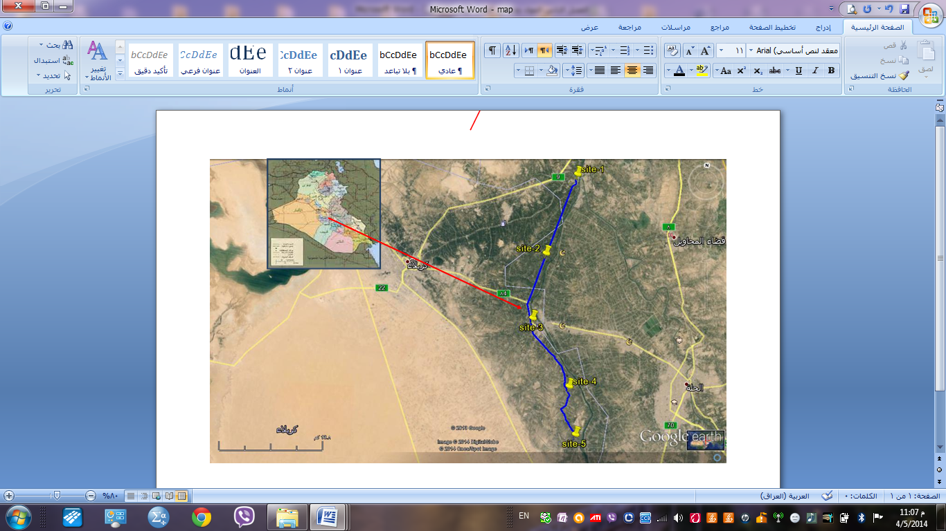

Figure 1. Map of the studied area
Results and discussions
Results of physicochemical parameters were summarized in table 1. The Air and water temperature ranged between 4ºC and 40ºC for air, while 9.5 to 29.8 ºC for water. pH results indicated that the stream was characterized as slightly alkaline as other Iraqi aquatic ecosystems[23, 24]. The stream was oligohaline according to Reid classification in which the present results of the electric conductivity (EC) and salinity (S‰) ranged 989-1440 µS /cm and 0.62-0.88‰, respectively. The statistical analysis showed a positive correlation between EC, S‰ and total dissolved solids and this agreed with another study[25]. The values of both total dissolved solids and total suspend solids ranged as follows 480-703 mg/l and 0.28-81.03 mg/l, respectively. Both values were increased in December 2013 that may be due to eroding the large amount of mud from the surrounding lands. Light penetration and water flow ranged between 30 - 215m and 0.1-1 m/Sec. No anoxia recorded in this study, the stream has a good aeration and oxygen concentration levels were above 5mg/l and up to 12 mg/l during the study period. Biochemical oxygen demand (BOD5) ranged 0.56-4.80 mg/l. Total alkalinity values (95-137 mg CaCO3/l) indicated that the stream was slightly alkaline and belonged to bicarbonate ions and this results noticed in Iraqi aquatic ecosystems[23;26;27]. According to Lind[28) the stream considered as hard water. Hardness concentrations ranged 138-493 mg CaCO3/l. calcium and magnesium values ranged 41-182 mg/l and 9-86 mg/l, respectively.. Only one time the magnesium concentration over calcium concretion, may be due to the consumption of calcium ion by phytoplankton also combined with other ions to produce dissolved compounds in water[26; 29] and this result agrees with another Study[30].
The surface water nutrient levels ranged as follows: 0.03-17.03 µg/l, ND-5.05 µg/l, 2.6-97.90 µg/l for phosphate, nitrite and nitrate respectively, while the silicate ranged 0.01-5.03 mg/l. The highest value of N: P recorded in April 2013, while the lowest value recorded in November 2013.The highest concentration of nutrients might be due to discharge of agro-industrial and municipal discharge[31].
Table 1. Range (Mean±SD) of physicochemial and biological parameters of Bani-Hssan stream during the study period.
Parameters | Sites
Parameters | 1 | 2 | 3 | 4 | 5
Air temperature (°C) | 4-29 (20.16±1.12) | 11-34 (23.25±1.12) | 12-34 (23.97±1.26) | 12-37 (26.83±(1.21) | 13 -40 (29.22±(1.47)
Water temperature (°C) | 9.5 -29.4(12.28±1.05) | 9.7 -29.1 (21.09±1.02) | 10.4 -29.2 (21.86±1.04) | 10.5 -29.7( 21.79±1.02) | 10.7 -29.8 (22.19± 1)
pH | 7.3-8.3 (7.75±0.05) | 8.4- 7.4(7.8±0.05) | 8.5 -7.5 (7.89±0.05) | 8.6 – 7.5 (8.03±0.06) | 8.6 – 7.4 (8.06±0.06)
ElectricConductivity (μS/cm) | 990 – 1386 (1173.61±18.4) | 990 -1440 (1178.06± 19.8 ) | 996 - 1380 (1115.2±18.23) | 1040 -1350 (1169.17±16.02) | 1003 – 1380 (1163.8±19.04)
Salinity ‰ | 0.63 – 0.88 (0.73±0.01) | 0.63 – 0.9 (0.73±0.13) | 0.63 - 0.8 (0.72 ±0.01) | 0.88 - 0.7 (0.73±0.01) | 0.88 - 0.6 (0.71± 0.02)
Total dissolved solid TDS(mg/l) | 480 - 670 (574.5±8.7) | 480-700 (577.5±9.73) | 490 -680 (568±9.04 | 510 - 690 ( 579.2±8.65) | 510 -680 (573.8±9.17)
Total suspended solids TSS(mg/l) | 7.14 - 50.4 (20.55±2.6) | 1.9 - 50.0 (23.05±2.69) | 0.28-70.9 (22.64±3.35) | 0.56 -68.6 (29.02±10.3) | 0.57-81.03 (19.02±3.9)
Light transmittance (cm) | 60- 80 (69.11±0.92) | 37- 215 (86.66±7.71) | 38 -190 (107.13±9.78) | 30-170 (102.43±7.45) | 30 -120 (86.03±4.79)
Water flow (m/sec.) | 0.4-1.0 (0.66±0.03) | 0.2-0.7 (0.93±0.02) | 0.1-0.7 (0.83±0.38) | 0.1-0.7 (0.35±0.14) | 0.3 -0.6 (0.63±0.02)
Dissolved oxygen (mg/l) | 6.0-12.7 (8.35±0.35) | 5.4 -12.6 (8.32±0.37) | 5.8-12.3 (8.44±0.36) | 5.6 -11.9 (8.12±0.34) | 5.8-12.8 (8.86±0.29)
BOD₅mg/l | 0.7–4.5 (2.730.71) | 0.6–4.8(3.25±0.37) | 1–4.2 (2.99±0.35) | 1.2 –3.5(2.50±0.24) | 0.8–4.6 (2.86±0.29)
Total alkalinity (mg CaCo3/L) | 97.3 -135.6 (122.58±2.02) | 95.6-132.3 (120.11±2.19) | 97.0-136.0 (121.3±2.19) | 99.6-137.0 (119.27±1.97) | 99.0-133.3 (119.3±2.18)
Total Hardness (mg CaCo3/L) | 172-460 (342.7±10.22) | 182-466.6 (344.03±11.26) | 162.6 -453.3 (384.7±11.89) | 138.6-493.3 (347.03±14.31) | 143.3-418.6 (336.97±10.45)
Calcium (mg3/L) | 41.9-180.0 (117.5±5.17) | 59.03-165.3 (115.5±4.26) | 63.5-165.3 (116.14±5.02) | 71.5-182.6 (111.28±5.09) | 70.4-166.6 (111.71±4.91)
Magnesium (mg /L) | 16.574.4 (56.11±1.75) | 9.4 -82.5 (57.43±1.90) | 9.4 -76.4 (60.16±1.99) | 29.8-86.4 (60.27±2.47) | 28.2-75.7 (56.3±1.94)
Phosphate (μg/L) | 0.15-16.46 ( 5.89±1.12) | 0.05-17.03 (4.87±1.12) | N.D-15.26 (5.27±1.0) | N.D -15.96 (5.54±1.07) | N.D-16.46 (4.94±1.07)
Nitrite (μg/l) | 0.46-5.06 (1.90±0.25) | 0.22-4.6 (1.32±0.21) | N.D -3.9 (0.98±0.19) | N.D-3.9 (1.19±0.18) | N.D-205 (0.76±0.12)
Nitrate (μg/L) | 9.13- 97.4 (37.07±4.29) | 2.62 -86.6 (32.43± 6.6) | 3.53 -95.5 (33.38±4.65) | 5.63 -76.93 (28.64±3.66) | 5.23-97.93 (28.60±4.37)
Silicate (μg/L) | 0.23-1.83 (0.23±0.09) | 0.09-3.56 (1.29±0.17) | 0.4 -3.13 (1.37±0.15) | 0.01 -3.56 (1.29±0.16) | 0.02-5.03 (1.37±0.25)
Chlorophyll –a ((μg/L) | 0.01-3.7(1.82±0.33) | 0.18-7.3 (1.69±0.34) | N.D -4.0 (1.40±0.25) | N.D-7.7 (1.17±0.39) | N.D-1. (0.71±0.12)
Phyophyten ((μg/L) | N.D-3.7 (1.41±0.27) | N.D-3.5 (1.48±0.29) | 0.26--4.2 (1.92±0.03) | 0.33-4.13 (1.83±0.29) | N.D-3.6 (1.07±0.24)
Total No. Phytoplankton  cell.103/ L) | 1512.4- 253.4(750.89±65.90) | 2420.6- 252.06 (749.18±155.66) | 905.2- 200.8 (507.99±39.18 | 975.9- 181.2 (543.11±38.27) | 673.53-185.9 (350.35±24.43)

A total of 136 species of phytoplankton belonged to 65 genera were identified throughout the sampling period. Six classes of phytoplankton noticed in this study, where the Bacillariophyceae was the dominant class among the other classes (Table 2). The Bacillariophyceae was represented as 79 species belonged to 29 genera, 9 species of centric diatoms and the rest was to pennate diatoms. Other classes were represented as follows: 34, 17, 2, 3,1 and 1 for Chlorophyceae, Cyanophyceae, Euglenophyceae, Dinophyceae and Cryptophyaceae, respectively (Figure 2).
Table 2. Number of species (S) and genus (G) of identifying phytoplankton in each studied sites.
5 |  | 4 |  | 3 |  | 2 |  | 1 |  | Sites  Classes
G | S | G | S | G | S | G | S | G | S | Sites  Classes
17 | 30 | 22 | 46 | 23 | 66 | 24 | 65 | 24 | 55 | Bacillariophyceae
2 | 4 | 3 | 5 | 3 | 7 | 3 | 7 | 3 | 8 | Centrales
15 | 26 | 19 | 41 | 20 | 59 | 21 | 58 | 18 | 47 | Pennales
18 | 25 | 15 | 19 | 15 | 21 | 18 | 26 | 15 | 25 | Chlorophyceae
8 | 10 | 8 | 9 | 8 | 10 | 10 | 15 | 8 | 12 | Cyanophyceae
0 | 0 | 2 | 2 | 0 | 0 | 0 | 0 | 2 | 2 | Euglenophyceae
2 | 2 | 2 | 2 | 1 | 1 | 3 | 3 | 3 | 3 | Dinophyceae
1 | 1 | 0 | 0 | 1 | 1 | 1 | 1 | 1 | 1 | Cryptophyceae
46 | 68 | 49 | 78 | 48 | 99 | 56 | 110 | 50 | 98 | Total

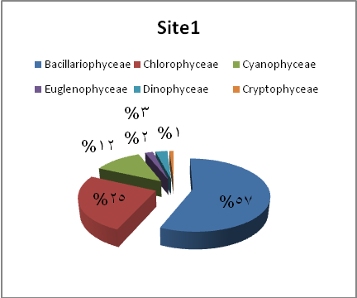
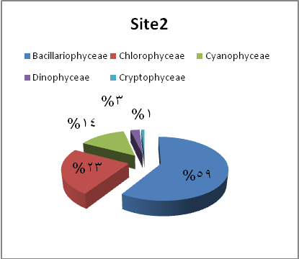

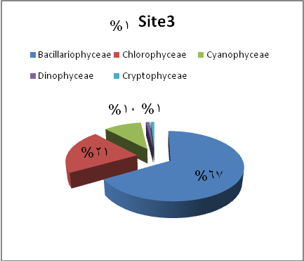
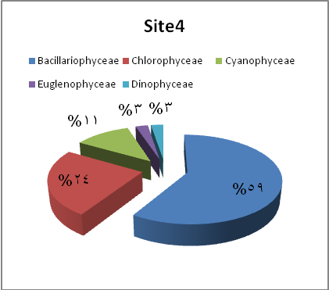
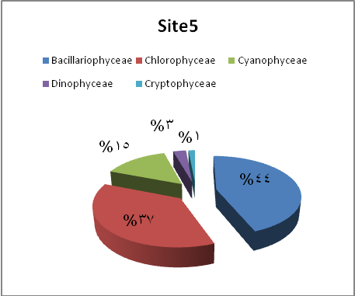
Figure 2. Percent of phytoplankton classes in the studied sites.

Some genera were predominating throughout the study period, such as: Cyclotella, Aulacoseira, Cocconeis, Cymatopleura, Nitzschia, Cymbella,and Oscillatoria.
Spatial and temporal variation of total number of phytoplankton noticed during the present study (Figure 3). The total number of phytoplankton recorded the lowest and highest values (0.18 x 10³ and 2.42 x 10³ individual/l) at sites4 and 2in January 2012 and May 2013, respectively (Figure 3). Two peaks of total number of phytoplankton noticed during the spring and autumn months of the study period. These results might be due to an increased nutrient concentrations in consistent with agricultural activities in spring in Iraq[32]. Chlorophyll-a, and phaeophytin ranged 0.02-7.70 µg/l and 0.01-4.20 µg/l, respectively. The chlorophyll-a concentration result indicated that the stream was considered as oligo-mesotrophic according to Felfὃldy[33]. In this study noticed an incompatibility of chlorophyll-a with the total number of phytoplankton and perhaps the reason was the dominance of Bacillariophyceae[34]. Spatial variation in identifying phytoplankton (table 2 and 3) where different species (genera) recorded in the studied sites as follows: 98 species (50 genera), 110 species (56 genera), 99 species (48 genera), 78 species (49 genera) and 68 species (48 genera) in sites 1, 2, 3, 4 and 5, respectively (Table 3).
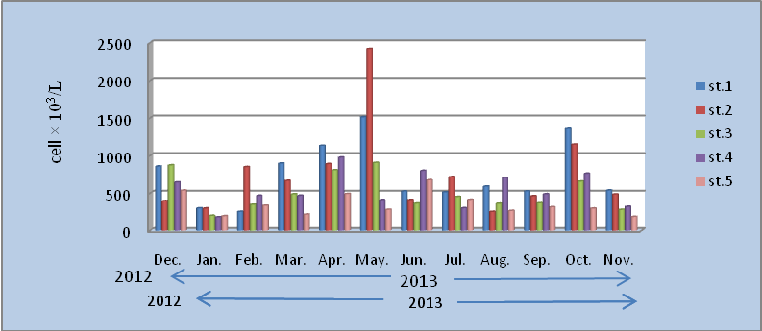
A

.

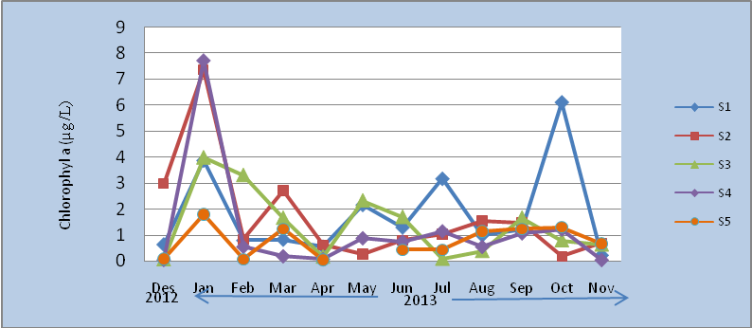
B

Figure 3. Monthly variation of total number of phytoplankton (A) and its Chlorophyll-a (B) in the studied sites.

Table 3. Identified phytoplankton with Chandler’s signsin Bani-Hasssann stream during the study period. Present: P, Frequent: F, Common: C, Abundant: A, very abundant: V (followed Chandler, 1970).
Sites | 1 | 2 | 3 | 4 | 5
Taxa
CYANOPHYCEAE
Anabaena sp. | P | P | P | P | P
Aphanocapsa sp. | F | P | P | - | -
Chroococcus limnaticus var. elegans G.M.Smith | F | F | P | F | P
C. turgidus (Ktz.)Naegeli | - | F | - | - | -
Lyngbya Perelegans | - | P | P | p | P
Gomphosphaeria aponina ((Kutzing) | P | P | P | p | P
Merismopedia elegans | - | P | - | p | -
M. glauca(Ehr.) Naegeli | F |  | P |  | P
M.tenuissima lemmermannn | P | P | - | - | -
Microcystis aeruginosa Kützing | P | P | P | F | P
Nostok sp.
Oscillatoria amoena (Ktz.) Gomont | - | F | - | P | P
O. limnetica Lemmermann | - | C | F | C | F
O.limosa Roth Agardh | F | F | - | - | -
O.miuima (Gicklhorn) | C | F |  | - | -
Oscillatoria sp. | F | - | - | - | F
Spirulina Laxa G.M.Smith | P | P | P | - | -
Chlorophyceae
Actinastrum hantzschii Lagerhein | P | F | p | F | P
A.falcatus (Corda) Ralfs | C | - | - | F | F
A.sp | P | - | P | P | P
Botryococcus protuberans | C | F | F | P | F
Chlamydomonas sp. | F | F | - | - | P
Chlorella vulgaris Bejerinck | C | F | F | C | F
Chlorococcum humicola Naeg. | - | P | p | - | P
Coelastrum microporum (Nageli) | F | F | F | - | P
C. reticulum (Dang.) Senn | P | F | p | P | P
Coelastrum sp | F | F | - | F | -
Cosmarium granutum | P | P | F | F | P
C. leave Rabenhorst | P | P | - | - | -
Cosmarium sp | F | p | - | P | -
Crucigenia tetrapedia(Kirchner) | F | P | F | F | P
Dictosphaerium pulchulum | F | P | p | F | -
Micractinium pusillum (Fresenius) | P | - | - | - | P
Mogeotia sp. | F | F | p | F | F
Kirchnersella obesa | F | F | - | - | -
Large hemiacitiata | F | P | P | P | P
Oocystis sp | F | F | P | P | P
Pandorina morum (Muell)Bory | - | - | P | F | P
Pediastrum simplex Meyen | - | - | P | - | F
Scenedesmus acuminatus (Lag.) Chodat | F | F | P | F | -
S. acuminatusvar.tetradesmoides | P | - | P | - | -
S. arcuatus Lemm | P | p | - | - | P
S.bijuga (Turb.)Lagher | C | F | F | - | F
S.dimorphus (Turb.)Ktz. | F | P | - | - | P
S. intermedius Chodat | - | - | - | P | -
S. quadricauda (Chodat) | C | C | C | - | F
Scenedesmus sp. | - | F | - | - | P
Selanastrum sp. | - | P | P | - | -
Spirogyra subsalsa | - | P | - | P | P
Staurastrum sp. | - | P | - | - | P
Tetraedron minimum Hansgirg | - | - | P | P | P
Euglenophyceae
Euglena sp. | P | - | - | p | -
Trachelomonas sp. | P | - | - | p | -
Dinophyceae
Dinobryon sertularia(Ehrenberg) | P | p | - | F | p
Glenodinium quadriden | P | p | - | - | p
Peridinium sp. | F | F | P | F | -
Cryptophyceae
Chroomonas sp | C | C | F | - | -
Bacillariophyceae
Centrales
Aulacoseira granulate (Ehrenb.) Simonsen | A | A | C | A | C
Melosira. varians Agardh | C | P | F | - | P
Cosinodiscus sp. | - | - | - | F | -
Cyclotella atomus Hustedt | F | F | P | - | -
C. comta(Ehrenb.) Kütz. | P | - | - | P | -
C. kuetzingiana Thwaites | C | F | F | - | -
C. meneghiniana Kütz | A | C | C | C | C
C.ocellata Pant | V | V | A | C | C
Stephanodiscus dubius (Fricke) Hustedt | F | F | F | - | -
Pennales
Acanthoceras zachariasi Brun.Simonsen | - | - | - | P | P
Achananthes affinis Grunow | P | F | F | P | -
A. hungarica (Grunow) Grunow | P | P | P | - | F
Amphora ovalis (Kütz) Kütz | - | P | P | F | -
Amphora veneta Kütz. | - | F | - | P | -
Amphora sp. | - | P | F | F | P
Anomoeoneis exilis Kütz. | - | P | - | - | -
Asterionella Formosa Hass. | F | P | P | - | F
Bacillaria paradoxa Gmelin | P | - | P | P | P
Caloneis ventricosa (Ehr.) Meister | - | P | P | - | -
Cocconema cistula Hempr. | P | F | F | F | -
Cocconeis pediculus Ehernb. | C | C | P | A | F
C. placentula var. euglypta (Ehr.) Grunow | C | C | C | C | C
Cymbella caespitosa (Kützing) Brun | - | P | P | P | -
C. gracilis (Rabenh.) Cleve | F | P | F | P | -
C. leptoceros (Ehrenb.) Kütz. | F | F | P | C | -
C. prostrata (berk.) Cleve | F | F | F | - | -
C. parva (W.Sm) Wolle | P | F | F | P | F
C. stomatophora Grunow | F | F | P | F | F
Cocconema fusidium Ehrenb. | P | C | P | C | -
Diatoma hiemale (Roth)Heib. | - | - | P | - | -
D. vulgare Bory | C | C | C | C | F
Diploneis ovalis(Hilse)Cleve | P | F | P | - | -
Eunotia curvata (Kütz.) Largerst. | - | F | - | F | -
Eunoia sp. | - | P | P | - | -
Fragilaria crotonensis Kitton | - | F | F | P | -
Fragilaria sp. | P | - | P | - | -
Gomphonema olivaceum (Hornemann) Brébisson | F | F | C | P | -
G. angustatum var. productum Grunow | - | F | F | F | F
G.gracile Ehernberg | P | - | F | p | -
G.intricatum Kuetzing | P | - | P | - | -
G. constrictum Ehrenberg | - | P | P | - | P
Gomphonema sp | P | - | P | F | P
Gyrosigma acuminatum (Kütz.) Rabenh. | P | P | F | F | -
G. scalproides (Rabenhorst) Cleve | F | P | P | - | -
Gyrosigma sp. | - |  | P | P | -
Hantzschia amphioxys(Ehr.) Grunow | P | - | P | - | -
Mastogloia elliptica (Ag.) Cleve | P | - | - | - | P
Navicula gracilis Ehrenb. | P | F | P | p | -
N. gibbula Cleve | F | P | F | P | -
N.cuspidata (Kütz) Kütz | - | P | P | - | -
Navicula sp. | F | F | P | F | -
N. halophila (Grun.) Cleve | P | P | F | P | P
N. parva Ralfs | - | P | - | - | -
N. radiosa Kütz. | - | - | P | P | -
N.tuscula Ehrenb. | - | F | - | p | P
Neidium affine (Ehr.)Pfitz | - | P | F | - | -
Nitzschia acicularis (ktz.)W.Sm. | F | P | - | - | -
N amphibia Grunow | F | F | P | P | P
N. gracilis Hantzsch | F | P | P | C | F
N.hungarica Grunow | - | P | F | F | -
N.intermedia Hantzsch | F | P | P | - | -
N. longissima (Berb.)Ralfs | F | F | F | F | C
N. obtusa W. Sm. | - | P | P | - | -
N. palea ( Kütz) W. Sm | F | F | C | - | -
N. romana Grunow | P | P | F | F | -
N. sigma (Kütz) W.Sm. | F | F | F | p | -
N. sigmoidea (nitzsch)W.Sm. | P | F | F | - | P
Nitzschia sp . | F | - | F | C | C
Pinnularia sp. | P | P | P | - | -
Rhoicosphenia curvata (kütz.) Grunow | P | F | - | - | -
Rhopalodia gibba (Ehrenb.) O. Müll. | - | - | P | P | -
Sphinctocystis librilis (Ehrenb.) Hassal | C | C | F | C | F
Surirella ovalis Bréb. | P | C | P | F | F
Synedra affinis Kütz. | P | P | - | - | F
S. acus Kütz. | F | F | F | F | F
S. capitata Ehrenb. | P | - | - | - | -
S. ulna (Nitz.) Ehrenb. | C | C | C | F | F
S. pulchella Ralfs | F | P | P | - | -
Syandra sp. | F | - | P | - | -

Cyclotella ocellata and C. meneghiniana predominate species during the study period . C. ocellata found in alkaline aquatic ecosystems and considered as bio-indictors for olighotrophic aquatic ecosystems [35, 36]. The presence of some genera such as Oscillatoria , Lyngbya and Euglena might be indication of organic pollution[1).
Four biological diversity indices were used in this study and ranged as follows:(3.4 -3.90),)2.90 -3.80), (61% - 36%)for richness, Shannon and Jaccard similarity indices, also the Chandler score was used.
The CCA analysis showed the effect of environmental parameters on phytoplankton diversity. This study will discuss only the main phytoplankton group (Baciallariohyceae). In figure 4 explain that Cyclotella kuetzingiana (Cycl.K) was affected highly significantly by temperature and water flow. Aulacoseira granulate,Cyclotella.ocellata, Nitzschia.hungarica,Diatoma vulgar and Gyrosigma scalpriodehave positive correlation with calcium while C. meneghiniana showed a positive correlation with total hardness, total alkalinity and pH. The following species Cymbella cistula, Cymbella affinis, Diatoma hiemale, Navicula gracilis و Nitzschia sp have a positive correlation with nitrate and temperature and a negative correlation with total hardness. Other species (Asterionella Formosa, Surirella ovalis,Fragilaria affinis,Gymphoneis olivaceum) showed a positive correlation with nitrate, phosphate, silicate and temperature. While the following species; Diatoma vulgare, Gyrosigmascalpriodes and Nitzschia.hungarica were correlated positively with water temperature and water flow while a negative correlation with total alkalinity and total dissolved solids. Light penetration, dissolved oxygen, BOD5 and total dissolved solids with Navicula sp and Bacillaria faxillifer, while a negative correlation noticed with water flow. Nitzschia longissima, Navicula gracilis,Achnanthes hungarica, Cymatopleura solea, and Gyrosigma sp have a positive correlation with total dissolved solids, salinity (S‰) and total hardness while a negative correlation noticed with nitrate, chlorophyll-a and total suspended solids. Synedra sp showed a positive correlation with total hardness.

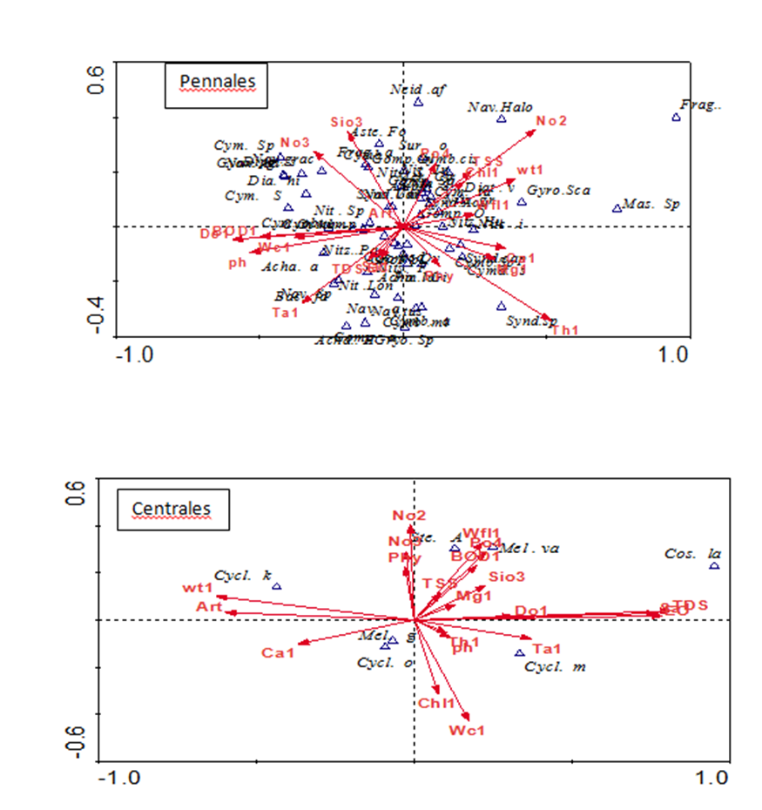
Figure 4: CAA analysis of effect of environmental parameters and Bacillariophyceae. Ph: pH, EC : Electric Conductivity, TDS: Total Dissolved Solids , TSS: Total Suspended Solids, Art: Air Temperature, wt1 :Water Temperature , Do1: Dissolved Oxygen, BOD1 : Biochemical Oxygen Demand, Ta1 : Total Alkalinity, Th1: Total Hardness, Ca1: Calcium, Mg1: Magnesium, Sa1 : Salinity, Wfl1 : Water Flow, Wc1: Light penetration, Po4: Phosphate, No2: Nitrite , No3 : Nitrate , Sio3: Silicate ,Chl1 : Chlorophyll-a, Phy: Phytoplankton Total Number. Other abbreviations are the initials of algae species.

References
- Bellinger, E. G., and Sigee, D. C. Freshwater algae: Identification and use as bioindicators. Chichester, West Sussex, UK: Wiley-Blackwell., pp 100-136, 2010
- Burford, M.A. Phytoplankton dynamics in shrimp ponds, Aquatic Research .Vol.28, pp. 351–360, 1997
- Hassan , F. M., Salah , M.M. and Salman , J.M. Study of physicochemical properties and heavy metals in Euphrates river , Iraq. E.J of chemistry .Vol. 7, No..3,pp 685-692, 2010.
- Gulecal, Y. and Temel, M. Water Quality and Phytoplankton Diversity in Büyükçekmece Watershed, Turkey 16 (1) journal of Water resource and protection, Vol. 6, pp55-61,2014.
- Lowe , R.L. And Pan, Y. Benthic algae communities as biological monitors. in stevenson , R. J., Both wel, ML; lowe , RJ .(Eds) , Algal ecology : Fresh water benthic ecosystemes , San Diego : Academic Press . pp.705-739,1996.
- Salman,J.M., Kalifa,T.A., Hassan , F.M. Qualitativeand Quantitative Study of Epipelic Algae and related environmental parameters in AL-Hindyia river, Iraq .International Journal of Current Research,Vol. 5,No. 11,:pp 3318-3327, 2013.
- Hassan, F. H., Al-Taee, M. M. S. and Mohammed, A. B. A limnlogical study in Euphrates River from Al- Hindiya Barrage To Al- Kifil city – Iraq. BasrahJ.Sci. Vol. 28 No. 2,pp 273-288, 2010.
- Hassan , F.M. and Al- Saadi , H.A. On the seasonal variation of phytoplankton population in Hilla river , Iraq . J.coll. Educ. For women Univ. Baghdad., Vol.6, No.2, pp 55-61, 1995.
- Hassan, F. M.,Kathim, N. F. and Hussin, F. H. Effect of Chemical and Physical Propertiesof River Water in Shatt Al-Hilla on Phytoplankton Communities. E-Journal of Chemistry, Vol.2, No.5,pp 323-330, 2008.
- Hassan, F. M.and Shaawiat, A.O. .A Contribution to the Epipelic Algal Ecology in Lotic Ecosystem of Iraq. Journal of Environmental Protection, Vol. 6,pp 85-95, 2015.
- Hassan, F. H., Salman, J. M., and Abdulameer, S. H. Seasonal variation of environmental properties and phytoplankton community in Al-Hussainya river, Holly Karabal-Iraq.Mesop.Environ.J., Vol. 1, No. 1,pp 56-82, 2014.
- Abdulameer, H.M. T. An ecological study of phytoplankton on Bany- Hassan stream –Holy Karabal Province-Iraq. M.Sc thesis, Colleege of Eduction for Pure Science, University of Karabala, 110p, 2014.
- American Public Health Association(APHA). Standard Method for the Examination of Water and Wastwater.21st. ed. American Public Health Association,2005.
- Parsons, T.R.; Mait, Y. and Laulli, C.M. Amanual of chemical and biological methods for seawater analysis pergamone press Oxford., 1987.
- Vollenweider , R.A. A. manual on methods for measuring primary production in aquatic environment . Int. Biol. Program hand book 12. Blackwell scientific publications Ltd. Oxford , 225 pp, 1974.
- Furet, J.E. and Benson. Evans, K. An evaluation of the time required to obtain complet sedimentation of fixed algal particles prior to enumeration. Br. Phycol. J., Vo1.7, pp 253-258, 1982.
- Desikachary, F.R. Cyanophyta, London, Acad. Press, 1959.
- Germain , H. flora des diatomees . Diatomophyceae eau doucesetsaumatres du Massif Armoricion et des contreesvoisinesd'europeoccindental. Sciete Nouvelle des EditimBoubee Paris, 1981.
- Hassan, F.M., Toma, J .J., Ismall, A.M. Alhassny, J. S., Hadir.A.M. andMaulood, B.K. A contribution to algal flora in baghdad area, Iraq. J. Adv. Lab. Res. Bio., Vol. 3,No. 2, pp 90-100, 2012..
- Perscott , G.W. Algae of the western Great lake Area .William ,C.Brow , Co., publishers, Dubuque , Lowa. M 977 p, 1973.
- Shannon , C.E and Weaver , W. The mathematical theory of communication.Univ Illinois press, Varbana, 117 pp, 1949.
- Chandler ,J.RA. biological approach to water quality management. Wat. Pollution Control ,Vol. 4, pp 415-422, 1970.
- Hassan, F.M. Limnological features of Diwanyia river , Iraq . J. of Um- Salama for science , Vol. 1,No.1,pp 119 – 124, 2004.
- Talib, A. H. Hassan, F. M. and Sadoon, W. A. An Environmental Study on Phytoplankton (Diatoms) in Al- Yusifiya River, Iraq.Baghdad Sci.J. Vol. 11, No.3,pp 1301-1309, 2014.
- Abowei, J.F.N., Davies O.A. and Eli, A. Physico-chemistry, morphology and abundance of fin fish of Nkoro River, Niger Delta, Nigeria. Int. J. Pharm. Bios ci, Vo.6, No.2,pp 1-11, 2010.
- Al-Saadi , H.A; Al-Tamimi , A.N. and Al-Ghafily , A.A. on the limnological features of Razzazah lake , Iraq . Mutah . J. for research and studies.Vl. 1, No.1, pp 41-48,1998.
- Aziz, F. H., Hassan, F. M.and Rasul, B. H. An Ecological Observation on Inland water Ecosystem in Erbil –Iraq Kurdistan with particular reference to blue green algae Glaucospira. Baghdad Sci.J. Vol. 11, No. 3,pp 1387-1396, 2014.
- Lind, G.T. Handbook of common methods in Limnology.2nd ed., London. 1979.
- Wetzel,R.G. Limnology, Lake and river ecosystem. 3rd. Acadimicpres, AQn Elsevier imprint , Sanfrancisco, New York, London. 2001.
- Alkam, F. M. and Al-Nashi, N. H. Some physic-chemical properties of east Euphrates drainage with effect of epipelic algae/ Al-Dawaniya/ Iraq. Journal of Al-Qadisiyah for pure Science, Vol. 18, No.1, pp 1-18, 2013.
- Hussein , S.A. , Al-Shawi , I.J. and Abdullah , A.M. Impact of Al- Najebiya thermal energy power plant on aquatic ecosystem of Garmat Ali canal .Monthly differences in nutrient budget and TDS. J. Thi-Qar Sci., Vol. 1, No.4 :pp 51-59.l-Mousawi, A.H., H. A. Al-Saadi and F.M. Hassan (1994).Spatial and seasonal variation of phytoplankton and related environment in Al-Hammar marsh. Iraq. Bas. J. Sci. Vol. 12,No.1,pp 9-20, 2009.
- Ariyadej, C. Tansakul, R.;Tansakul, P. and Angsupanich, S. Phytoplankton diversity and its relationship to the physico-chemical environment in the BanglangResevoir, Yala province.Songklanakarin J. Sci. Tech Nol., Vol. 26, No.5, pp 595-607. 2004.
- Felfoldy, L. A. biologiaivizminosites (Biological water quality evaluation).VizugyiHidrobiologia 16. VGI, Budapest. 1987.
- Al-Mousawi, A. H., Al-Saadi, H. A. and Hassan, F. M. Spatial and seasonal variations of phytoplankton population and related environments in Al-Hammar marsh, Iraq. Bas.J. Sci. Vol.12, No. 1,pp 9-20, 1994.
- Stoermer, E.F. and Julius, M.L. Centric diatoms.In:Freshwater algae ofNorth America Ecology and classification (Eds.: J.D. Wehr and R.G.Sheath). Academic Press, USA. pp. 559-594, 2003.
- Tas, B.I., Gonulol, A. andTas, E. A study of the seasonal variation of the phytoplankton of lakeCernek (Samsun- Turkey). Turkish J. Fish.Aquat. Sci., 2, pp 121-128, 2002 .

