Evaluation of Transboundary Impact on Air Pollution in a Rural Area Shyamnagar, Bangladesh
M. Sarkar¹ J. B. Islam¹ K. S. Ahmed¹ A. K. M. L. Rahman¹ B. A. Begum²

¹Department of Chemistry, Jagannath University, Dhaka-1100, Bangladesh
²Chemistry Division, Atomic Energy Centre, P.O. Box 164, Dhaka-1000, Bangladesh

Corresponding author: akash.mamon@gmail.com
To cite this article:

Sarkar, M., Islam, J. B., Ahmed, K. S., Rahman, A. K. M. L. and Begum, B. A. Evaluation of Transboundary Impact on Air Pollution in a Rural Area Shyamnagar, Bangladesh. Mesop. environ. j., 2015, Vol. 2, No 1, pp. 64-70.

This work is licensed under a Creative Commons Attribution-NonCommercial-NoDerivatives 4.0 International License.


Abstract:
Traditional biomass burning is a threatening air pollutant causing public health concern mostly seen in developing countries. Long-range transport of pollutant tremendously enhances this threatening on air pollution. To evaluate the air pollution, particulate matter (PM) samples (PM_{2.5}) were collected from Male Declaration air quality monitoring station (MDAQMS) at Shyamnagar under Shatkhira district from December 01, 2012 to March 07, 2013 using Air Metrics MiniVol sampler. The samples were analyzed for particulate matter (PM_{2.5}) mass and black carbon (BC) concentrations. The observed average PM_{2.5} concentration during December, February and March were 92.4, 94.3 and 63.4 μg/m³, respectively whereas the BC concentrations in PM_{2.5} were 20.1, 18.1 and 13.1 μg/m³, respectively. The average BC concentration in PM_{2.5} is almost same in December and February but lower in March. It was observed that concentration of PM and BC was higher with lower value of relative humidity and wind speed. The average BC/PM_{2.5} ration during December, February and March were 0.22, 0.19 and 0.21, respectively. The largest contribution of fine particulate matter and BC is the cooking (Indoor) and agricultural biomass burning. Other sources are traditional brick kilns, motor vehicles, human haulers emission and long-range transport.

Keywords: Biomass burning; BC; PM_{2.5}; Traditional brick kiln; Transboundary impact

Introduction
Bangladesh is a densly populated south Asian plain country on the bank of Bay of Bangle. Shyamnagar under Satkhira (22° 19′ N, 89° 6′ E) district is the coastal district located in the remort corner. But in recent couple of decates due to increasing population and their luxerious demand, air quality in this reasion detorieorated day by day. Traditional biomass such as wood, dung and crop residue burning (for cooking and agriculture) is a common scenario in Shyamnagar like other parts of Bangladesh. Incomplete biomass burning is a threatening source of Black carbon (BC) and particulate matter (PM). BC has received increasing attention in recent years because of its potential to contribute to global warming, carries carcinogenic compounds, and causes serious health risks [1,2,3]. Beside this, BC has an impact on changing the albedo (surface reflectivity) of ice and snow leading to additional warming of the earth surface and melting of ice [4]. Diesel or petrol powered vehicle is the largest source of air pollution in this reason. Another high concentration of smoke, fogs and sulfur dioxide emitting source is the combustion of sulfur containing fossil fuel such as coal that is used in brick kiln. Air Pollution from these sources may not only create hazardous problems near to these sources but also can cause problems far away. Air pollutants can travel long distances [5], chemically react in the atmosphere to produce secondary pollutants such as acid rain or ozone [6]. Among the all pollutants PM₁₀ and PM_{2.5} shows the highest percentage of existence in atmosphere [7,8,9,10,11] and thus transported hundred or thousand miles across the wind direction. During wintertime, wind blows from northwest direction over Bangladesh and carries lots of polluted air mass, which may increase the local air pollution [12]. China, United States, Russia, India, Mexico and Japan are the world leaders in air pollution emissions [6]. Due to the long range transport of pollutant, as a neighbor country of India, Bangladesh facing lot of pollution problems with its own during winter seasons. Most of the air quality management efforts in Bangladesh have focused mainly on Dhaka centric. No vast work has been performed in the rural area outside of the Dhaka yet. But the air quality evaluation is very much necessary for safe and sound health and clean environment for the next generation. This study depicts the quantitative assessment of the particulate matter and black carbon in downstream air trajectory of Bangladesh. After assessing the concentration of particulate matter and black carbon we have tried to observe the relationship between the BC in PM_{2.5}. Finally, we have tried to predict the transboundary impact on the enhancement of local pollution. Therefore, it could be a fruitful attempt to understand the air quality and the intimate relation between local pollution and Transboundary impact.

Material and Methods

Preparation of filter
The filters were equilibrated for 24 hours and weighed in an air-conditioned room on a microbalance (METTLER Model MT5) at temperature near 22 ºC with relative humidity of 50%. After weighed the filter is stored at petri slides in air-conditioned room.

Sampling

The PM_{2.5} samples were collected from Male Declaration air quality monitoring station (Fig. 1) at Nurnagar, Shyamnagar under Shatkhira district using Air Metrics MiniVol sampler from December 01, 2012 to March 07, 2013 for measuring the local impact. The sampler was setup on the flat roof of the building at a height of 8 m upper from ground. The selected site (rural area) was 12 Km away from main road and situated near Indian border. The sampler was placed so that the air flow around it was unhindered. The air flow of the sampler was maintained at 5 l/m. Twenty four hours (8 am to 8 am to the next day) representative sampling were collected for fine PM (< 2.5 µm aerodynamic diameter) using Teflon filter paper. After sample collection filter samples and samples on impaction substrates were placed in petri dishes and then frozen immediately until subsequent analysis. The collected filter samples were taken to the laboratory using a ice carrier.

PM and BC determination

The masses of the PM samples were determined using a microbalance (METTLER Model MT5) in the Chemistry Laboratory of the Atomic Energy Centre, Dhaka (AECD). The loaded filters were weighing after the exposure of the filter and by subtracting the blank filter paper mass, the PM mass on the filters were determined. A ²¹⁰Po (alpha emitter) electrostatic charge eliminator (STATICMASTER) was used to eliminate the static charge accumulated on the filters before each weighing. The humidity and temperature of the balance room is about 50% and 22 ºC respectively.

The concentration of BC in the PM_{2.5} samples was determined by reflectance measurement in AECD laboratory using an Evans Electroselenium Limited (EEL) type Smoke Stain Reflectometer M3D. Known black carbon concentrations were used to calibrate the reflectometer as secondary standard [13].
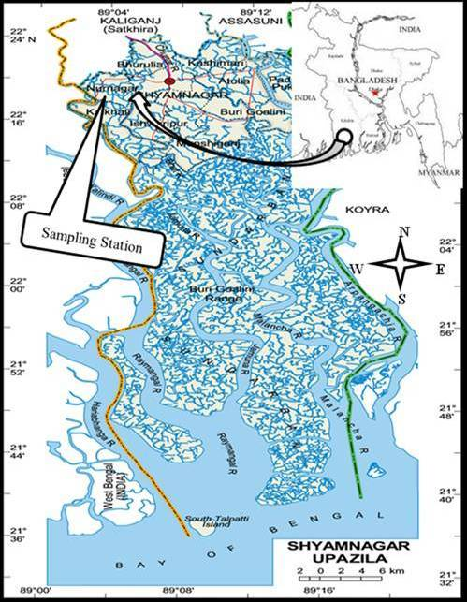

Fig. 1: Sampling stations in the Map.

Result and Discussions
Meterological condition
The climate character of Bangladesh is high temperature, high humidity most of the year and distinctly marked seasonal variation of precipitation. On the basis of meteorological circumstance, the year of Bangladesh is divided into four seasons, pre-monsoon (March-May), monsoon (June-September), post-monsoon (October-November) and winter (December-February) [14]. The winter seasons is characterized by dry soil conditions, low relative humidity, scanty rainfall and low northwesterly prevailing winds. Rainfall and wind speed become southwesterly (marine). During the monsoon season, the wind speed further increases and the air mass is highly marine in nature. In the post-monsoon season, the rainfall and relative humidity decreases, as does the wind speed. The direction starts to shift back to northeasterly [15]. In the dry winter and part of the post-monsoon season, the strength of north and northwesterly winds coming from India, Nepal and Southeastern China to the Bay of Bengal through Bangladesh can transport pollutants. Moreover, during this season, wind speeds are low so that locally emitted pollutants are not well dispersed into the downwind area. Mixing heights of the boundary layer are important factors influencing the dispersion of pollutants [16].

PM and BC concentration

Shyamnagar under Satkhira district is a remote area of Bangladesh near Indian West Bangal border situated 16ʹ upper from see level. It is a less densely (135/km²) populated area (1,968.23 km²) without big industries. In recent times, with economic development the diesel/petrol powered privet and public vehicle is increased in the road. In most cases the engine design and maintenance are poor. Thus the PM and BC emissions are increased. On the other hand, in diesel powered engines using higher sulfur content fuel emits the higher PM contents [17]. Beside these the biomass burning for cooking/brick kiln and agricultural sector is another source of PM and BC. To evaluate air pollution, samples were collected for PM_{2.5} and BC analysis. In this analysis the 24 h average values of PM_{2.5} were higher than the 2005 Bangladesh National Ambient Air Quality Standard (BNAAQS) as well as 1997 USEPA standard (65 μg/m³) during December and February (Fig. 2).

The day-to-day variation of 24 h average PM_{2.5} and BC in PM_{2.5} mass fractions are shown in Fig. 2 and 3. The average 24 h daily concentrations of PM_{2.5} ranged from 43.15 to 182.56 μg/m³ whereas concentration of BC in PM_{2.5} ranged from 9.54 to 30.32 μg/m³. Figure 2 shows the higher value of PM_{2.5} durigh January 2, 2013 and lower value shows at December 11, 2012 both the effects are fitted by the meteorological data. During January 2, 2013, the lower humidity and wind speed were recorded thereby high concentrations of PM_{2.5} were observed whereas in December 11, 2012 those parameters was higher and inversely lower PM_{2.5} concentrations were recorded. The variation of PM_{2.5} and BC fraction is due to meteorological condition like wind speed and wind direction drive this variability. The sources of high value of PM and BC are motor vehicle (including diesel and petrol powered passenger bus, heavy duty truck, human hauler, diesel engine for irrigation), biomass burning for cooking and industrial purpose, agricultural incineration, soil and agricultural dust. Beside these during winter season, northwesterly wind blows over Bangladesh which carries fine PM mass including BC. Figure 2 and 3 depict that during winter season the mass fraction of PM_{2.5} and BC both the values show high value but during post monsoon show relatively lower values. The meteorology is responsible for dispersion and dilution of PM and BC in atmosphere [18]. Since PM_{2.5} fraction have relatively high residential time (seven days), thus this fraction could travel long-range and could have regional contribution apart from local source contribution during winter time [19].
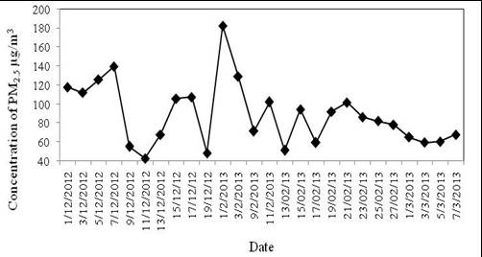

Fig. 2: PM_{2.5} fraction as a function of time during December, 2012 to March, 2013.

Due to its unambiguous characteristics BC has focused our concern in recent years. BC is tracer of primary anthropogenic emissions and its variability reflects changes in source strengths, long-range transport and atmospheric mixing characteristics. The small particle size, large specific surface and consequent adsorbing properties of BC particles permits it to be potential transporters of toxic compounds into human and animal respiratory system [20]. After banning tow stock engine in Dhaka city these have been spreaded in the rural are of the country. Old and fitness expired vehicle run in the road out of Dhaka and diesel/petrol is their main fuel which is the major source of BC. Beside these around the sampling area there are a number of brick kiln which is also the giant source of BC. In the study area people burn brick in traditional brick kiln for non-commercial purpose and they use wood as their main fuel.

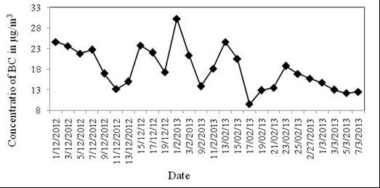

Fig. 3: BC mass fraction as a function of time during December, 2012 to March, 2013.

Ratio of BC/PM_{2.5}
The average BC/PM_{2.5} ration during December, 2012, February, 2013 and March, 2013 were 0.22, 0.19 and 0.21, respectively. It was found that the high distribution of the BC/PM_{2.5} mass rations during December, 2012 and February, 2013 (winter season) which is shown in Fig. 4. The reason of high concentration of BC/PM_{2.5} mass ratio is not only for seasonal variation, but also by meteorological influence. The potential source of the high concentration of BC is the biomass burning for cooking. Besides this some brick kiln operated in the northwest direction of the sampling point which is the notable source of BC. A national high way running 12 km northwest direction of the sampling point over which transport different type of diesel vehicle and intensify the concentration of BC. Long-range transportation of pollutants from fossil fuel related sources and biomass burning could be another source of BC [21].
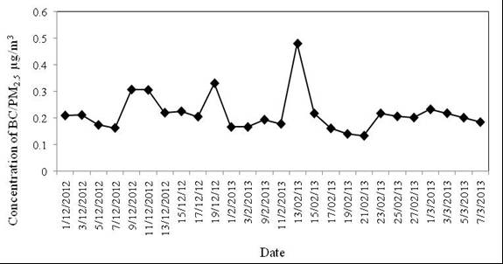

Fig. 4: BC/PM_{2.5} mass ratio as a function of time during December, 2012 to March, 2013.

Transboundary effects
Shyamnagar is less densely populated area in other part of Bangladesh with less industrial and communication development. But the PM_{2.5} mass fraction during the observed period was higher than the BNAAQS projected values. Long-range transport of pollutants can significantly result in air quality degradation [22]. Pollutants emitted from its source cross geopolitical boundaries or migrate across several geographic zones, the pollution is designed as transboundary even if the physical distance of the boundary from the emitting pollutant source is quit short [23]. Consequently, with local source the high mass fraction of PM_{2.5} is attributed to long range transport. India is the only country in the South Asian region heavily dependents on coal based energy (307 MT in 97/98 Vs. 84 MT of oil and 21.5 MT of natural gas). Beside these large scale biofuel consumption is a common scenario in India [12]. Across north to south Bangladesh is a plain land without any large mount obstacle. As a consequence, during winter season northwest wind transport huge amount of PM including BC and enrich the local pollution.

Conclusion
The PM concentration was higher during the winter seasons. The sources of PM were local and also predicted transbounday effect exists. The total estimation of transboundary contribution could not be determined. As a conscience, Government should take necessary steps for developing the cooking fuel and incinerator condition. The authority should prohibit the traditional brick burning. The human hauler and expired heavy duty vehicles should be banned for transportation.

References
[1] Ramanathan, V. and Carmichael, G. Global and regional climate changes due to black carbon. Nature Geosci. Vol. 1, pp. 221-227. 2008.
[2] Koelmans, A. A.; Jonker, M. T. O.; Cornelissen, G.; Bucheli, T. D.; Van Noorrt, P. C.M. and Gustafsson, O. Black carbon: The reverse of its dark side. Chemosphere. Vol. 63, pp. 365-377. 2006.
[3] Hansen, J. and Nazarenko, L. Soot climate forcing via snow and ice albedos. Proceedings of the National Academy of Sciences. Vol. 101, pp. 423-428. 2004.
[4] Hansen, J.; Sato, M.; Ruedy, R.; Lacis, A. and Oinas, V. Global worming in the Twenty-first century: an alternative scenario. Proc. Nat. Acad. Sci. U.S.A. Vol. 97, pp. 9875-9880. 2000.
[5] Islam, J. B.; Rahman, A. K. M. L.; Sarkar, M.; Ahmed, K. S. and Begum, B. A. Partuculate matter and black carbon concentration in ambient air of an urban-trafic influenced site at Farmgate, Dhaka, Bangladesh. Jagannath University Journal of Science, Vol. 3, No.1, pp.87-96. 2014.
[6] Yadav, S. K. Environmental pollution problem associated with energy production for high demand. International Journal of Engineering Research and Technology. Vol. 6, pp. 823-830. 2013.
[7] Hai, C. D. and Oanh, N. T. K. Effects of local, regional meteorology and emission sources on mass and compositions of particulate matter in Hani. Atmos. Environ. Vol.78, pp. 105-112. 2013.
[8] Hopke, P. K.; Cohen, D. D.; Begum, B. A.; Biswas, S. K.; Ni, B. F.; Pandit, G. G.; Santoso, M.; Chung, Y. S.; Davy, P.; Markwitz, A.; Waheed, S.; Siddique, N.; Santos, F. L.; Pabroa, P. C. B.; Seneviratne, M. C. S.; Wimolwattanapun, W.; Bunprapob, S.; Vuong, T. B.; Hien, P. D. and Markowicz, A. Urban air quality in the Asian region. Sci. Total Environ. Vol. 404, pp. 103-112. 2008.
[9] Gupta, P.; Christopher, S. A.; Wang, J.; Gehrig, R.; Lee, Y. and Kumar, N. Satellite remote sensing of particulate matter and air quality assessment over global cities. Atmos. Environ. Vol. 40, pp. 5880-5892. 2006.
[10] Oanh, N. T. K.; Upadhyaya, N.; Zhuang, Y. H.; Hao, Z. P.; Murthy, D. V. S.; Lestari, P.; Villarin, J. T.; Chengchua, K.; Co, H. X.; Dung, N. T. and Lindgren, E. S. Particulate air pollution in six Asian cities: spatial and temporal distributions and associated sources. Atmos. Environ. Vol. 40, pp. 3367-3380. 2006.
[11] Tasi, Y. I. and Chen, C. L. Atmospheric aerosol composition and source apportionments to aerosol in southern Taiwan. Atmos. Environ. Vol. 40, pp. 4751-4763. 2006.
[12] Begum, B. A.; Hopke, P. K. and Markwitz, A. Air pollution by fine particulate matter in Bangladesh. Atmos. Pollut. Res. Vol. 4, pp. 75‐86. 2013.
[13] Biswas, S. K.; Tarafder, S. A.; Islam, A.; Khaliquzzaman, M.; Tervahattu, H. and Kupiainen, K. Impact of unleaded gasoline introduction on the concentration of lead in the air of Dhaka, Bangladesh. J. Air Waste Manag. Assoc. Vol. 53, pp. 1355. 2003.
[14] Salam, A.; Bauer, H.; Kassin, K.; Ullah, S. M. and Puxbaum, H. Aerosol chemical characteristics of a megacity in Southeast Asia (Dhaka, Bangladesh). Atmos. Environ. Vol. 37, pp. 2517-2528. 2003.
[15] Begum, B. A.; Biswas, S. K.; Markwitz, A. and Hopke, P. K. Identification of sources of fine and coarse particulate matter in Dhaka, Bangladesh. Aerosol Air Qual. Res. Vol. 10, pp. 345-353. 2010a.
[16] Begum, B. A.; Hossain, A.; Saroar, G.; Biswas, S. K.; Nasiruddin, M.; Nahar, N.; Chowdury, Z. and Hopke, P. K. Sources of carbonaceous materials in the airborne particulate matter of Dhaka. Asian Journal of Atmospheric Environment. Vol. 4-5, pp. 237-246. 2011a.
[17] Begum, B. A.; Salahuddin, K. M.; Hossain, A.; Saroar, G.; Nasiruddin, M.; Biswas, S. K.; Nahar, N. and Hopke, P. K. Impact of vehicle fleet characteristic on ambient PM_{2.5}, PM₁₀ and gas concentrations in Dhaka at the Farmgate (CAMS-2). Bangladesh Journal of Physics. Vol. 11, pp. 89-102. 2012.
[18] Begum, B. A.; Iswas, S. K. B.; Pandit, G. G.; Saradhi, I. V.; Waheed, S.; Siddique, N.; Seneviratne, M. C. S.; Cohen, D. D.; Markwitz, A. and Hopke, P. k. Long-range transport of soil dust and smoke pollution in the south Asian region. Atmos. Pollut. Res. Vol. 2, pp. 151-157. 2011b.
[19] Begum, B. A.; Biswas, S. K. and Hopke, P. K. Temporal variations and spatial distribution of ambient PM_{2.2} and PM₁₀ concentrations in Dhaka, Bangladesh. Sci.Total Environ., Vol. 36, pp. 358. 2006.
[20] Nunes, T. V. and Pio, C. A. Carbonaceous aerosols in industrial and coastal atmospheres. Atmos. Environ. Vol. 27A, pp. 1339-1346. 1993.
[21] Viidanoja, J.; Sillanpaa, M.; Laakia, J.; Kerminen, V. M.; Hillamo, R.; Aarnio, P. and Koskentalo, T. Organic and black carbon in PM_{2.5} and PM₁₀: 1 year of data from an urban site. Atmos. Environ. Vol. 36, pp. 3183. 2002.
[22] Kallos, G.; Astitha, M.; Katsafados, P. and Spyrou, C. Long-range transport of anthropogenically and naturally produced particulate matter in the Mediterranean and North Atlantic: current state of knowledge. J. Appl. Meteor. Climatol. Vol. 46, pp. 1230-1251. 2007.
[23] DiGiovanni, F. and Fellin, P. Transboundary air pollution, Environmental monitoring, Encylopedia of life support systems, EOLSS Publishers Co., UK, pp. 12. 2013.

