Determine the validity of the Euphrates River (Middle Euphrates) for drinking purpose using a water quality index (CCME WQI)
HussainYousif Al-Rekabi¹ Dunia Bahel Gada'an Al-Ghanimy²

¹ Department of Community Health, Technical Institute, South technical university, Al-Nassiriah, Thi- Qar, Iraq
² Department of Biology, College of Education, University of Al- Qadisiyah, Al- Diwaniyah, Iraq Corresponding author: duniaalghanimy@yahoo.com

To cite this article:

Al-Rekabi, H.Y. and Al-Ghanimy, D.B.G. Determine the validity of the Euphrates River (Middle Euphrates) for drinking purpose using a water quality index (CCME WQI). Mesop. environ. j., 2015, Vol. 2, No.1, pp. 1-11.

This work is licensed under a Creative Commons Attribution-NonCommercial-NoDerivatives 4.0 International License.



Abstract

The current study conducted to assess the Euphrates river (mid Euphrates) for drinking purpose adoption of water quality Index-Canadian model-as an effective means to identify the water validity of various purpose, as has been selected four sites and samples were collected from these locations for the period between May 2013 to April 2014 and its conducted some physical and chemical tests, which included: pH, turbidity, electrical conductivity, total alkalinity, dissolved oxygen, Biochemical oxygen demand, calcium, magnesium, chloride, total hardness, sodium, nitrates, nitrites, sulfates, boron, total coliform, lead, copper, zinc, cadmium, manganese and chromium. As used Principal Component Analysis (PCA) to determine the greatest physical, chemical and biological factors that influence in the Index and causing the deviation of it from normal values. The result of PCA confirmed that physical, chemical and biological variables have different effect in all sites of study area on the Index values whose ranges between71.83-36.4 that ​​indicates Euphrates in the study area has the Fair-Poor quality.
Keywords; Iraq, PCA, Euphrates River, CCME WQI, potable water supply Index
Introduction
Potable safe water is absolutely essential for healthy living; it is a basic need of all human being to get the adequate supply of safe and fresh drinking water. Quality of water is defined in terms of its physical, chemical, and biological parameters. However, the quality is difficult to evaluate from a large number of samples, each containing concentrations for many parameters. An effective way to reach the safety of water use evidence of water quality Index (WQI), where the water quality is assessed on the basis of calculated water quality indices.[1]And it is the most effective tools to communicate information on the quality of water to the concerned citizens and policy makers. It, thus, becomes an important parameter for the assessment and management of surface water. WQI is defined as a rating reflecting the composite influence of different water quality parameters. WQI is calculated from the point of view of the suitability of surface water for human consumption [2].
Canadian Water quality Index an upgraded version of the Canadian Council of the Ministry of Environment and is an effective model in the evaluation of water quality for its ability to summarize a large number of water quality data and convert it to a single number between (0-100) [3].
The Canadian water quality Index (CCME) has been applied in a lot of places in Canada, such as Ontario, Newfoundland, Saskatchewan and Alberta using a lot of variables [4]
To estimate the quality for the River Yamuna, India, CCME used for this purpose [5] And it also applied in four freshwater lakes of Mysore, India, with National Sanitation Foundation (NSF) [6]. In Nigeria [7] used water quality Index-Canadian model to estimate the water quality of Asa River. CCME- WQI also applied on Aboabo River in Ghana. [8]
In Iraq CCME-WQI also used in many Studies and Research that included the study of water quality of Inland Aquatic bodies such as the study of [9] on chebaish Marsh and [10] on the northern part of Shatt Al-Arab river. [11] Also used CCME- WQI to assess the water in Al Hammar Marsh While [12] applied the same Index on Tigris River. [13] Use Canadian model to find the quality of Euphrates River between two cities Heet and Ramadi.
Water Quality Index (WQI) was applied in Hemren Lake, Diyala province, by using Weighted Arithmetic Index method (WAM) and the Canadian water quality Index (CWQI model) [14]. To evaluate water quality for Al-delmaj marsh [15] using water quality index (CCME WQI). Also [16] use (CWQI model) to assess the water quality of Euphrates River near Al-Nasiriya city to determine its suitability for drinking water, aquatic organisms life and for Irrigation.[17] Applied CCME WQI on Al-Radwaniyah-2 Drainage in Baghdad Region to assess the Suitability of Water for Protection of Aquatic Life. [18] Also used CCME WQI on the north part of Shatt Al Arab River.
CWQI model also applied to assessment the water of Al-Hilla River for general, drinking and irrigation purpose [19]. [20] also use the CCME WQI to assess the water quality of East Al-Hammar marsh after restoration. While [21] Use MNE WQI to evaluate water quality of raw and treated water of Hilla River within Babylon province.
Materials and methods
The Euphrates is the longest river in western Asia. It originates in Turkey, runs through Syria entering Iraq from the western border and discharge in Shatt Al-Arab. Monthly sampling was taken for the study period of May 2013-April 2014 in present study from four sites along the main river basin. The GPS readings are us following: S1 [N= 32°13'10.20"E= 44°21'45.00"], S2 [N= 32°02'15.10" E= 44°24'38.80"], S3 [N= 31°45'33.01"E= 44°31'09.04"], S4 [N= 31°34'49.05"E= 44°38'47.01"]. (Figure 1).
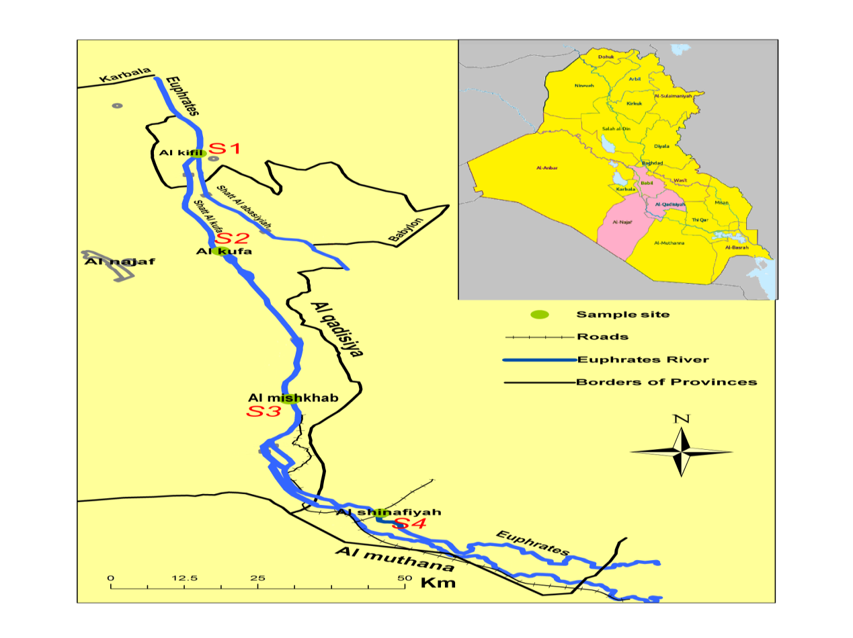
Fig.1: Map of the studies area
Physicochemical parameters were measured according to the methods of [22] for Total Alkalinity, Dissolved Oxygen, Biochemical Oxygen Demand, Calcium Ion, Magnesium Ion, Chloride Ion, Sulfate Ion, Boron Ion, Total Coliform. Nitrite and Nitrate measured according [23].While Total Hardness followed [24]. Electrical Conductivity measured by [25] while pH and Turbidity measured in situ by pH meter and Turbidity meter respectively.
Cadmium, Lead, Zinc, Copper, Manganese and Chromium evaluated by using Flame Atomic Absorption Spectrophotometer according to [22].
The CWQI calculated by selecting a set of twenty two parameters based on both importance and availability of data using sets of standard values [26, 27, 28, 29] were applied to categorize the water primarily for use as drinking water.
The detailed formulation of the WQI is described in the Canadian WQI 0.1Technical Report [3] While Ranking of water quality based on this index is as in Table (1)

Table 1: CCME WQI categorization schema [3]
Rank | WQI Value | Description
Excellent | 95-100 | Water quality is protected with a virtual absence of threat or impairment; conditions very close to natural or pristine levels.
Good | 80-94 | Water quality is protected with only a minor degree of threat or impairment; conditions rarely depart from natural or desirable levels.
Fair | 65-79 | Water quality is usually protected but occasionally threatened or impaired; conditions sometimes depart from natural or desirable levels.
Marginal  Poor | 45-64  0-44 | Water quality is frequently threatened or impaired; conditions often depart from natural or desirable levels.  Water quality is almost always threatened or impaired; conditions usually depart from natural or desirable levels.
Results and discussions
Results indicated that water quality Index for drinking purposes values ranging from the highest value (71.83) in the second site in May, less the value of 36.4 in the fourth site in November, which means that the Euphrates River waterfall between the two categories (Fair-Poor) (figure2). The results of the statistical analysis indicate of significant differences between different months, as well as between sites.
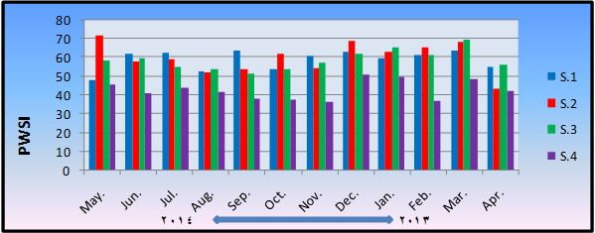
Fig.2: monthly and in situ changes to the values of potable water supply Index
The results illustrated that the water quality Index values ​​for drinking purposes in the study area ranged between (fair-poor) as evidence depreciated in the hot months especially in August, and this goes back to some of the variables that have high value compare with global and Iraqi standard determinants for drinking purposes, particularly pH, turbidity, electrical conductivity, TDS, biochemical oxygen demand, Total Alkalinity, calcium ion, magnesium ion, sodium ion, chloride ion, total hardness, sulphates, boron ion, the total number of coliform, lead and cadmium (Table 2). This is due to the large stresses in Iraqi and International standard values for drinking purpose because of linked directly to community public health. While nitrate and nitrite, chromium, manganese, zinc, copper and dissolved oxygen was within the permissible limits. This result agrees with [16] and [19] which they found high values of water quality Index for drinking purpose in the cold months because of the positively impact of the decline on temperatures on most of the variables from the standard values.
Table 2: The range and standard deviation and mean of water quality parameters of the study sites
parameter | S1 | S2 | S3 | S4 Iraqi and global standard
Electrical Conductivity (µs/cm) | 1018 – 1952  1198.33 ± 9.0 | 1048 – 2562  1407.5 ± 11.88 | 1123 – 1922  1398.75± 21.59 | 2654 – 5402 <2500***  3993.3 ± 17.3
Turbidity (NTU) | 5.11 – 69  18.08 ± 2.36 | 1.76-29.18  11.403± 1.75 | 0.06-36.2  15.29±1.86 | 8.54-130 5**  60.56±3.19
pH | 7.21-8.9  8.37±0.37 | 6.03-9.04  7.85±0.46 | 7.6-8.69  8.15±0.28 | 7.49-8.9 6.5-8.5**  8.08±0.42
Dissolved Oxygen (mg/l) | 6.6-10.7  8.17±0.63 | 5.5-9.5  8.09±0.59 | 7.2-11.9  9.09±0.68 | 56.7-11.1 >5**  8.78±0.62
Biochemical Oxygen demand (mg/l) | 0.1-7  3.29±0.73 | 0.1-6.9  2.94±0.78 | 0.9-5  2.51±0.66 | 1-6.8 <3**  3.28±0.75
Total Alkalinity (mg/l) | 75-139  118.08±2.27 | 53-161  124.25±2.95 | 28-147  115.75±3.15 | 33-202 100#  155.5±3.71
Total Hardness (mg/l) | 384-732  490±5.54 | 420-792  533±5.83 | 424-800  552.67±6.09 | 716-1176 <500**  929.67±7.05
Calcium Ion (mg/l) | 80.16-291.78  141.48±4.33 | 84.97-205.21  132.26±3.29 | 81.76-256.51  138.68±3.88 | 96.19-219.64 <150**  155.51±3.49
Magnesium Ion (mg/l) | 0.79-60.205  33.28±2.53 | 1.84-81.56  49.24±2.71 | 3.78-124.32  50.13±3.04 | 66.95-176.78 <100**  131.51±3.
Sodium Ion (mg/l) | 90-328  139.25±4.53 | 102.5-366  151.23±4.78 | 107.5-393  157.54±5 | 188.5-714 <200**  304.46±6.6
Chloride (mg/l) | 93.97-349.89  146.79±4.64 | 97.97-275.91  159.28±4.04 | 111.97-291.91  173.61±4.02 | 407.87-865.73 <350**  611±6.7
Sulfate (mg/l) | 427-1022  809.83±7.55 | 327-1031  821.83±8.71 | 568-1032  880.92±7.45 | 543-1041 4000#  924.83±7.06
Boron Ion (mg/l) | 0.05-2.5  0.95±0.5 | 0.01-4.26  1.18±0.68 | 0.015-2.49  0.8±0.48 | 0.02-4.25 0.3##  1.65±0.74
Nitrite (µg/l) | 0.01-0.13  0.057±0.037 | 0.024-1.35  0.442±0.37 | 0.006-0.39  0.134±0.130 | 0.01-0.45 3**  0.16±0.150
Nitrate (µg/l) | 2.15-33.98  15.10±1.97 | 12.3-44.78  25.99±2.05 | 5.19-43.64  22.11±2.31 | 8.69-44.73 50**  23.4±2.05
Dissolved Cadmium (mg/l) | 0.001-0.077  0.014±0.008 | 0.002-0.02  0.01±0.005 | 0.001-0.013  0.007±0.004 | *N.D.- 0.014 0.003**  0.006±0.004
Dissolved Lead (mg/l) | 0.001-0.013  0.007±0.004 | N.D.-0.023  0.008±0.006 | 0.01-0.020  0.007±0.006 | 0.001-0.019 0.01**  0.010±0.006
Dissolved Zinc (mg/l) | 0.002-0.015  0.008±0.004 | N.D.- 0.019  0.008±0.006 | 0.001-0.017  0.008±0.005 | 0.001-0.01 3**  0.006±0.003
Dissolved Cupper (mg/l) | 0.002-0.017  0.009±0.005 | N.D.-0.022  0.009±0.006 | 0.001-0.018  0.009±0.005 | 0.004-0.028 1**  0.01±0.006
Dissolved Chromium (mg/l) | N.D.-0.011  0.004±0.003 | 0.001-0.019  0.007±0.005 | N.D.-0.01  0.005±0.003 | N.D.-0.009 0.05**  0.004±0.003
Dissolved Manganese (mg/l) | 0.002-0.016  0.009±0.005 | 0.002-0.02  0.009±0.006 | N.D.-0.026  0.011±0.007 | N.D.-0.018 0.1**  0.01±0.004
Total Coliform (cell/ml) | 3-250×103  27141.5±146.28 | 4-265×103  26218.83±143.9 | 3-300×103  44411.25±178.68 | 8-372×103 0**  47406.08±188.2
## [26] # [27] *** [28] ** [29] * = Not Detection (Impalpable)
The spatial different in the Index values ​​attributable to the increase of pollutants that received in the river as it passes in cities and increase a lot of variables such as chlorides, total hardness, electrical conductivity and turbidity in the fourth site, in particular resulting from directly water discharge into the river at this site and this was confirmed by [30], which caused a lack of Index and the value of this means that the Euphrates River water is unsuitable for drinking purposes and this agreed with [16 , 19, 31].
It was evident from the results of the Principles components analysis (PCA) that calcium, chloride, electrical conductivity, total hardness, magnesium, sulfates, chromium, biochemical oxygen demand, sodium, copper are the most influential on the Index value in Site (1) and came after nitrates, total coliform, dissolved oxygen, zinc, Total Alkalinity, pH, manganese, turbidity, lead, cadmium, boron and nitrite respectively. (figure 3) While the most variables impact on Index values in Site (2) are nitrates, chloride, electrical conductivity, total hardness, manganese, total coliform, magnesium, total alkalinity, dissolved oxygen, biochemical oxygen demand and lead, other variables have less effect. (figure 4)

Fig. 3: Water quality variables responsible for changes in potable water Index values in Site 1, according to the Principles Components Analysis (PCA)
Fig. 4: Water quality variables responsible for changes in potable water Index values in Site 2, according to the Principles Components Analysis (PCA)
It seen from (figure 5) that Boron, cadmium, nitrites, turbidity, sulfate, magnesium, dissolved oxygen are the most influential on Index value in Site (3) While total hardness, electrical conductivity, total alkalinity, magnesium, copper, calcium, total coliform, nitrate, chromium, manganese, pH, dissolved oxygen and sodium are the most effect variables on the Index value in Site (4) (figure 6).
Fig. 5: Water quality variables responsible for changes in potable water Index values in Site 3, according to the Principles Components Analysis (PCA)
Fig. 6: Water quality variables responsible for changes in potable water Index values in Site 4, according to the Principles Components Analysis (PCA)

References
[1] Almeida, C.A. Influence of Urbanization and Tourist Activities on the Water Quality of the Potrero De Los Funes River (San Luis – Argentina). Environmental Monitoring and Assessment, Vol.133 (1-3), pp: 459- 465.2007.
[2] Atulegwu, P.U. & Njoku, J.D. The impact of biocides on the water quality. Int. Res. J. Eng. Sci. Tech, (IREJEST), Vol. 1, No. 2, pp: 47-52. 2004.
[3] CCME: Canadian Council of Ministers of the Environment .Canadian water quality guidelines for the protection of aquatic life: CCME Water Quality Index 1.0, User’s Manual. In: Canadian environmental quality guidelines, 1999, Canadian Council of Ministers of the Environment, Winnipeg. Manitoba, Canada. pp: 1-5.2001a.
[4] CCME: Canadian Council of Ministers of the Environment .Canadian water quality guidelines for the protection of aquatic life: CCME Water Quality Index 1.0, Technical Report. In: Canadian environmental quality guidelines, 1999, Canadian Council of Ministers of the Environment, Winnipeg. Canada. pp: 1-13.2001b.
[5] Sharma, D. & Kansal, A. Water quality analysis of River Yamuna using water quality index in the national capital territory, India (2000–2009). Appl. Water Sci., Vol. 1, pp: 147–157.2011.
[6] Udayashankara, T.H; Anitha, K.G.; Rao, S.; Shifa, A. & Shuheb, M. Study of Water Quality and Dynamic analysis of phytoplanktons in four fresh water lake of Mysore India. International Journal of Innovative Research in Science, Engineering and Technology Vol. 2, No. 7, pp: 2600 – 2609.2013.
[7] Edwin, A.I. & Murtala, A.I. Determination of water quality index of river Asa, Ilorin, Nigeria .Pelagia Research Library, Advances in Applied Science Research, Vol.4, No.6, pp: 277-284.2013.
[8] Gyamfi, C.; Boakye, R.; Awuah, E. & Anyemedu, F. Application of the Ccme-Wqi Model in Assessing the Water Quality of the Aboabo River, Kumasi-Ghana. Journal of Sustainable Development; Vol. 6 , No.10, pp.:1 -7.2013.
[9] Abd, I.M. Ecological Assessment of Chebaish marsh by Adoping Environmental and Biological Indices. Thesis, University of Basrah, College of Agriculture. 2010.
[10] Moyel, M.S.Assessment of Water quality of the northern part of Shatt Al-Arab river, using Water Quality Index (Canadian version). Thesis, University of Basrah-College of Science. 2010.
[11] Al-Saboonchi, A.; Mohamed, A.R.M.; Alobaidy, A.H.M.J.; Abid, H.S. & Maulood, B.K. On the Current and Restoration Conditions of the Southern Iraqi Marshes: Application of the CCME WQI on East Hammar Marsh. Journal of Environmental Protection, Vol. 2, pp: 316-322. 2011.
[12] Al-Janabi, Z.Z. Indices Application of Water Quality and Biological Integrity for Tigris River with in Baghdad City. Thesis, University of Baghdad-College of Science for Women. 2011.
[13] A L- Heety, E.A.M. ; Turki , A.M. & Al – Othman, E.M.A. Assessment of the Water Quality Index of Euphrates River Between Heet and Ramadi cities, Iraq. International Journal of Basic & Applied Sciences (IJBAS-IJENS), Vol, 11, No.3, pp: 38 – 47.2011.
[14] Sammen, S. S.Evaluation of Water Quality of Hemren Lake. Diyala Journal of Engineering Sciences, Vol. 06, No. 2, pp: 57 – 76.2013.
[15] Manii, J.K. & Al- Zubaidi, A.A. Assessment of Hydrochemical Water Quality on Al Delmaj Marsh Application of the CCME WQI. Journal of Babylon University/Pure and Applied Sciences/, Vol. 21, No.1, pp: 270 – 280.2013.
[16] Buhlool, M.A. Seasonal Study by use Water Quality Index (Canadian Model) in Euphrates River at Al-Nassiryia city/ Iraq. Thesis, University of Thi-Qar- College of Sciences. 2013.
[17] Rabee, A.M.; Hassoon, H.A. & Mohammed, A.J. Application of CCME Water Quality Index to Assess the Suitability of Water for Protection of Aquatic Life in Al- Radwaniyah-2 Drainage in Baghdad Region. Journal of Al-Nahrain University Vol.17, No. 2, pp: 137-146.2014.
[18] Abbass, R.H.; Abdul-Hussan, J.K.h. & Resen, A.K. Assessment of Water Quality of Shatt al Arab River in north of Basra. Iraqi J. Aquacult. Vol. 11, No. 1, pp: 37-56.2014.
[19] Al-Shammary, A.O.S. A study of Aquatic plants Biodiversity and applications 0f water quality indices in Hilla River, IRAQ. Thesis, University of Babylon- College of Science. 2014.
[20] AL-Shammary, A. C.; AL-Ali, M. F. & Yonuis, K. H. Assessment of Al-Hammar marsh water by uses Canadian water quality index (WQI). Mesop. Environ. J, Vol. 1, No. 2, pp. 26-34. 2015.
[21] Abd Al-Hussein, N.A. Evaluation of Raw and Treated water Quality of Hilla River within Babylon Province by Index Analysis. Mesop. Environ. j. Vol., No.3, pp.16-15.2015.
[22] APHA - American public Health Association .Standard methods for the examination of water and waste water.20th ed .Washington DC. USA. 2003.
[23] Parsons, T. R.; Maite, Y. & Laui, C. M. A manual of chemical and biological methods for sea water Analysis pergamon press oxford.1984.
[24] Lind, O.T. Hand book of common method in limnology. C. V. mosby co., st.louis.199 pp.1979.
[25] Mackereth, J. H.; Heron, J. &Talliny, J. F.Water analysis. Some revised method for limnologists, Sci., pub. fresh water Biol. Ass (England).Vol.36, pp.:1-120.1978.
[26] WHO: World Health Organization.Guidelines for Drinking-Water Quality – 2nd Edition - Volume 1– Recommendations, Drinking water - standards.Geneva.1993.
[27] WHO: World Health Organization.Guidelines for Drinking-Water Quality. Vol. 1: 3rd Ed., Recommendations, Geneva.2004.
[28] WHO: World Health Organization. Guidelines for Drinking-Water Quality, Microbial Fact Sheet, Third Addition, Vol. 1. Geneva. 2008.
[29] Iraqi standard for drinking water. Drinking Water, Iraq. First modernization, no. 417, the Council Of Ministers, Central Apparatus for Assessment and Quality Control. [ in Arabic].1986.
[30] AL-Thamiry, H.A.K.; Haider, F.A. & Al-Saadi, A.J.J. Salinity Variation of Euphrates River between Ashshinnafiyah and Assamawa Cities. Journal of Engineering, Vol 19, No.11, pp: 1442- 1466.2013.
[31] Alsaqqar, A.S.; Khudair, B.H. & Hasan, A.A. Application of Water Quality Index and Water Suitability for Drinking of the Euphrates River within Al-Anbar Province, Iraq. Journal of Engineering, Vol 19, No. 12, pp: 1619 – 1633.2013.

