Cockroach-associated food-borne bacterial pathogens from some hospitals and restaurants in hosur, Tamilnadu: distribution and antibiograms
Suresh K. Narayanan Mathiyazhagan Selvam R.

PG & Research Centre in Biotechnology, M.G.R. College, Hosur 635 109, Tamil Nadu, India
Corresponding author: sureshbioteck@yahoo.com

To cite this article:

Suresh, K.; Mathiyazhagan, N. and Selvam, R Cockroach-associated food-borne bacterial pathogens from some hospitals and restaurants in Hosur, Tamilnadu: Distribution and antibiograms. Mesop. environ. j., 2015, Vol. 2, No.1, pp. 87-99.

This work is licensed under a Creative Commons Attribution-NonCommercial-NoDerivatives 4.0 International License.



Abstract

The association of cockroaches with various pathogens is well documented and this study assessed the role of cockroaches as potential vectors of food-borne bacterial pathogens in Hosur, Tamilnadu, India. A total of 160 adult cockroaches, captured aseptically from four hospitals and two restaurants, were identified as Blattela germanica. Culturing external surface wash and gut homogenates by pooling cockroaches in batches of ten resulted in the isolation of 12 Salmonella spp., two Shigella flexneri, two Escherichia coli, 17 Staphylococcus aureus, and 25 Bacillus cereus. The analysis of isolates for antimicrobial susceptibility demonstrated that most of the isolates, belonging to the various genera, developed multiple drug resistance to up to 12 antimicrobials. To evaluate survival in and shedding of pathogens by B. germanica, Salmonella Group B, S. flexneri and S. aureus were separately fed to B. germanica at a level of 106 cfu/g of contaminated food. Cultural examination of faecal pellets from B. germanica showed that Salmonella and Staphylococcus aureus could be excreted for 35 and 14 days, respectively. Shigella flexneri was not shed by cockroaches during the experiment. The results indicated that B. germanica is a possible reservoir and potential vector of some food-borne pathogens and may spread multiple drug resistance in hospitals and food catering establishments.
Keywords; Blattela germanica, food-borne bacterial pathogens, antibiograms, antibiotics.
Introduction
Food consumers in developing countries suffer from food-borne bacterial illnesses, especially from those of Salmonella spp., Shigella spp., Staphylococcus aureus and Bacillus cereus. Unhygienic food handling results in food contaminated by pathogens. One possible source of food contaminations could be dissemination of the pathogens to foods and/or utensils of catering centres through small animals such as cockroaches that live closely with humans in urban environments. Various investigations around the world revealed that cockroaches living close to human dwellings were important carriers of etiologic agents belonging to all groups of potential pathogens: viral, bacterial, protozoan and helminthes [1].
Over 4% of cockroaches collected from hospitals, houses, animal sheds, grocery stores, and restaurants in India harboured multiple drug resistant Salmonella [2]. According to the studies of [3] almost all cockroaches isolated from hospital and residential areas carried medically important microorganisms. In a recent study, 70% of cockroaches collected from hospitals in Iran yielded Salmonella spp. and some of the isolates were resistant to antimicrobial drugs [4]. Various food-borne pathogens were isolated from cockroaches collected from kitchens in Ghana [5, 6].
The number of immuno-compromised people and bacterial drug resistance is on the increase in India. The role of cockroaches as mechanical vectors and/or reservoir hosts to pathogens and their drug resistance is unknown. The aim of this study is, therefore, to identify the major cockroach species in hospital and restaurant environments in Addis Ababa, to isolate the common food-borne pathogens from the cockroaches, to assess the drug susceptibility pattern of the isolates and to determine survival and shedding of the pathogens in experimentally infected cockroaches.

Materials and methods
Collection and identification of cockroaches
Four hospitals and four food catering centres in Hosur, Tamilnadu were considered in this study. The hospitals were among the largest public health institutions in the city. The food catering centres represented medium level eating centres which served about 50 customers per day. Samples of cockroaches were collected from all study sites once a week for twelve weeks. Cockroaches were collected using sterile screw-capped 250 ml jars and sterile hand-gloves [7]. Each time 10 cockroaches were caught from each of the eight sampling areas, they were pooled as one sample. Only cockroaches caught whole and alive were considered in the study. Identification of cockroaches was performed in accordance with [1].

Processing of cockroaches for isolation of pathogens
The collected cockroaches were brought to the laboratory and killed in a sterile jar using chloroform soaked cotton. The external body surface was washed by vortexing in 5 ml sterile physiological saline for two minutes, and the wash was taken as external body homogenate sample. After external body washing, the cockroaches were soaked in 90% ethanol for five minutes to decontaminate their external surfaces and were dried. They were then re-washed with sterile saline to remove traces of ethanol, and the alimentary tract was aseptically dissected out using autoclave-sterilized entomological dissecting needles under a dissecting microscope. The instruments were dipped in ethanol and flamed between dissections. The excised gut was then homogenized in 5 ml of sterile normal saline water. A total of 320 specimens consisting of 160 external body surface and 160 gut homogenates of the cockroaches were analyzed. For primary enrichment, 1 ml of each homogenate was inoculated separately into 9 ml of buffered peptone water and incubated at 37°C for 18-24 h.
Isolation and identification of pathogens
For the isolation of Salmonella and Shigella, a volume of 0.1 ml of growth from buffered peptone water was inoculated in to 10 ml of Rappaport-Vassilidias (RV) broth and incubated at 42°C for 24-48 h for secondary enrichment. This was streaked on Xylose Lysine Deoxycholate agar. After 18-24 h of incubation at 37°C, Salmonella and Shigella were distinguished by their characteristic appearance on the Xylose Lysine Deoxycholate Agar [8] . Colonies typical of Salmonella and Shigella were picked from each plate, characterized biochemically following standard methods [9] and confirmed by serogrouping with slide agglutination using BBL antisera.
Escherichia coli was isolated by streaking a loopful of overnight growth from buffered peptone water on Sorbitol MacConkey Agar. This was incubated at 37°C for 18-24 h. After 18-24 h incubation, non-sorbitol fermenting presumptive E. coli colonies were characterized biochemically and confirmed by Dry spot E. coli latex agglutination test and E.coli H7 antiserum. Positive controls were included during diagnostic testing.
For the isolation of S. aureus, growth from buffered peptone water was heavily plated on Mannitol Salt Agar and incubated at 37°C for 48 h. Mannitol fermenting colonies were further characterized by microscopic examinations and biochemical tests. Further confirmation of S. aureus was done using DNAase and coagulase tests .
Bacillus cereus was isolated after heat-treating BPW culture for 10 min at 80°C in a water bath. A loopful was streaked on Bacillus cereus Selective Medium and incubated at 37°C for 18-24 h. Lecithinase positive pink colonies were picked and further characterized by morphology, Gram reaction, and catalase production and presence of spore.
Survival and excretion of pathogenic bacteria from experimentally infected cockroaches
The cockroaches used for the challenge experiment were those collected from the same study sites considered in this work. Each cockroach was transferred to a sterile test tube containing sterile food. Faecal pellets were collected and checked for pathogens to rule out previous contamination with Salmonella, Shigella or S. aureus. Each cockroach was checked three times at three-day intervals for the presence or absence of the bacterium in question. Cockroaches free of Salmonella, Shigella or S. aureus were selected for the challenge study and were starved for 5 days at room temperature as described in ³. Salmonella group B, Shigella flexneri and S. aureus, previously isolated from cockroaches in this study, were used as test pathogens. Each test strain was separately grown in Tryptose Soy Broth at 37°C for 36 h. Four uncontaminated and starved cockroaches were transferred aseptically to a 100 ml test tube containing 1 g of food (a mixture of milk, wheat powder and sucrose) contaminated with 0.1 ml of test bacterial culture containing 10⁶ cfu/ml and allowed to feed on it for one hour.
Another group of four uncontaminated cockroaches was transferred to a similar test tube containing only sterile food and allowed to feed for an hour as a negative control. Each group of cockroaches was transferred aseptically to a sterile wire mesh vessel plugged with wet cotton wool, hung over in a sterile 250 ml jar and kept at room temperature for 24 h.
The exposed portion of the mesh was wrapped with sterile aluminium foil to prevent contamination from an external source. The set up allowed faecal pellets to be collected from the bottom of the jar passed through the mesh without contamination from external body of cockroaches. During this period, no further food was given to prevent regurgitation ³.The next day, each group of cockroaches (test and control) was transferred aseptically to a new sterile container of the same set up but with sterile semisolid food composed of milk, wheat powder, sucrose and water coated on the cotton wool plug of the mesh. The cockroaches were transferred to new sterile containers containing sterile food at three-day intervals. The experiments continued until excretion of test strains ceased or, if excretion continued, until all test cockroaches were dead. Excreted faecal pellets were processed for isolation of the respective test strains. The faecal pellets were aseptically picked at intervals of 72 h and placed in 2 ml of nutrient broth. The broth was incubated overnight at 37°C. For isolation of S. aureus, broth culture was streaked on MSA. For isolation and identification of Salmonella and Shigella flexneri, direct plating of growth was made on Xylose Lysine Deoxycholate agar, and a volume of 0.1 ml of growth was dispensed into RV broth. After 48 h incubation at 42°C, enriched culture was streaked on Xylose Lysine Deoxycholate agar. The faeces of control insects not exposed to the test pathogens were analysed in the same way. All confirmatory biochemical and serological tests were done as indicated previously.

In-vitro drug susceptibility testing
Susceptibility testing was done on Mueller-Hinton agar plates following the standardized disk diffusion technique [10] with drug discs: ampicillin (Amp), (30μg); sulfamethoxazole (SXT), (25 μg); polymyxin B (Pol), (30 μg); carbenicillin (Car), (10μg); cephalothin (Cep), (30 μg); chloramphenicol (Chl), (30 μg); gentamicin (Gen), (10 μg); kanamycin (Kan), (30 μg); streptomycin, (Str) (10 μg); tetracycline (Tet), (30 μg) augmentin (Aug), (30 μg); clindamycin (Cli),(2 μg); oxacillin (Oxa), (5 μg); erythromycin, (15 μg); penicillin-G, (Pen), (10 μg); vancomycin (Van), (30 μg); and mupirocin (Mup), (5 μg). The reference strains, S. aureus (ATCC 6538) and E. coli (ATCC 25922), sensitive to all the drugs used in this study, were routinely tested. Interpretation of readings as sensitive, intermediate or resistant was made according to a chart [11] Intermediate readings were few and therefore considered as sensitive for the purpose of assessing the data.
Results and discussions
A total of 160 cockroaches were collected in this study. A batch of ten cockroaches was separately collected from each source for 20 consecutive weeks. All cockroaches were identified as Blattella germanica. A total of 12 Salmonella, two each of Shigella and E. coli, 17 Staphylococcus aureus and 24 Bacillus cereus were isolated from cockroaches in this study (Table 1). Thirty-four isolates were obtained from hospital and 23 from restaurant environments. Gut and external surface samples yielded 34 and 23 isolates, respectively. There was no significant difference in the distribution of potential pathogens between source locations or body parts. Based on serological tests by group antisera, the Salmonella isolates consisted of four each of Salmonella B, Salmonella D, and Salmonella E. Both Shigella isolates were Shigella flexneri. Of the 13 non-sorbitol-fermenting isolates from SMAC, which were identified as E. coli using biochemical tests, two belonged to E. coli but failed to react with the H7 antiserum.
The isolation of Salmonella spp., S. aureus, Shigella, E. coli and B. cereus from this cockroach species indicated that domestic pests could pose health problem to humans. Based on the available literature, E. coli was isolated from B. germanica for the first time, which may indicate the potential role of cockroaches to spread rare and emerging pathogens into the community.
Table 1: Distribution of pathogens isolated from Blattela germanica
Hospital |  |  | Restaurant
Isolate | External | Gut | External | Gut | Total
Salmonella B | 2 | 2 | - | - | 4
Salmonella D | - | 3 | - | 1 | 4
Salmonella E | - | 4 | - | - | 4
Shigella flexneri | - | - | 1 | 1 | 2
E. coli | - | 2 | - | - | 2
S. aureus | 3 | 8 | 4 | 2 | 17
B. cereus | 5 | 5 | 8 | 6 | 24
Total | 10 | 24 | 13 | 10 | 57
Six individual batches of cockroaches (two from restaurant, one from hospital) yielded B. cereus from gut and external surface samples Figure 1 . One individual batch from a hospital contained Salmonella group E in gut and external surface samples. Multiple carriage of pathogens was also noted for B. cereus and Staphylococcus aureus. One individual batch of an external surface sample from a restaurant harboured both pathogens. Similarly, both pathogens were isolated from two individual batches (one each of gut and external surface sample) from hospital samples. This, however, would not mean that a single insect was infected with two different pathogens or carried the same pathogen in the gut and the external parts at the same time.
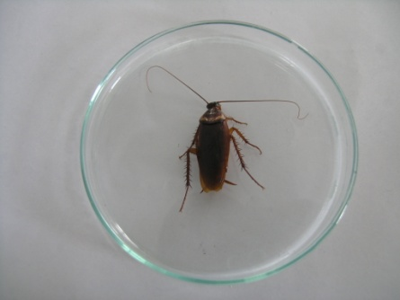 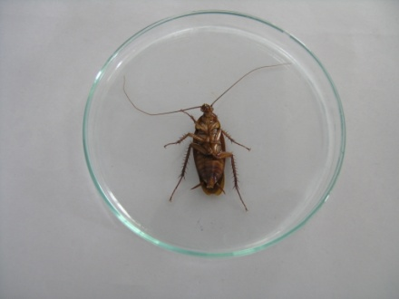 a b 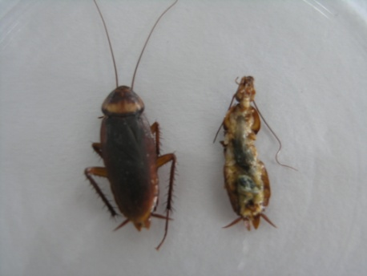 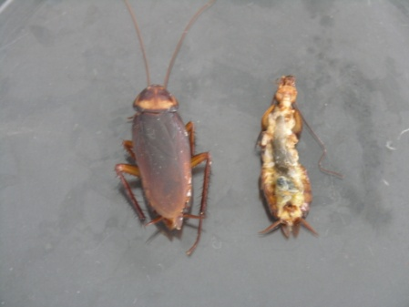 C d
Figure 1. a & b, Collected cockroaches were killed in a sterile petridish using chloroform c& d ,the external body surface was washed by vortexing in 5 ml sterile physiological saline
Salmonella has been isolated from different species of cockroaches found in hospitals, restaurants, residents, schools, animal shelters etc. throughout the world [11] [12 [13] [14] [15]. The fact that 10 of the 12 Salmonella isolates were from the gut suggested that cockroach intestine served as a major reservoir of Salmonella. Moreover, 11 of the isolates were from hospital cockroaches and were found to be resistant to 3 or more drugs, suggesting the possible role of cockroaches as reservoir and vectors of drug resistant Salmonella in health facilities that may contribute to nosocomial infections.
Salmonella isolates were sensitive to polymyxin B, gentamicin and kanamycin. Over a third of the isolates were, however, resistant to the other drugs used in this study (Table 2) Figure 2 . Similarly, Shigella and E. coli isolates were sensitive to polymyxin B, cephalothin, gentamicin, and kanamycin. E. coli isolates were, in addition, sensitive to tetracycline. Less than half of the Staphylococcus aureus isolates were sensitive to cephalotin, chloramphenicol, gentamicin, and tetracycline. Resistance to vancomycin was observed in 16 of the 17 isolates. Most of the Bacillus cereus isolates were sensitive to nine of the 13 drugs tested except to augmentin, oxacillin, penicillin, and mupirocin. The number of Staphylococcus aureus isolates resistant to the various antimicrobials used in this study was significantly higher in restaurant isolates than in the hospital ones. On the other hand, a significantly higher number of resistant B. cereus isolates were obtained from hospitals than from restaurants. There was only one Salmonella isolate from a restaurant to make a comparison.
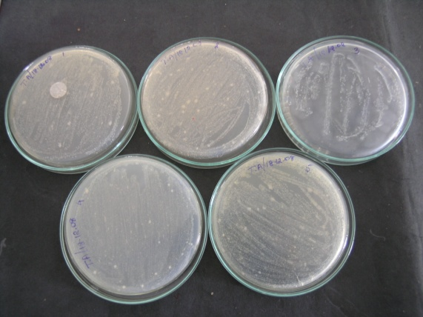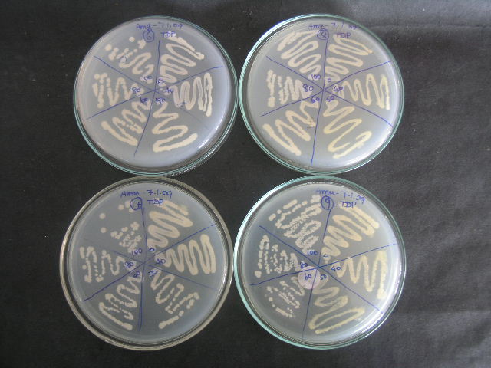
a b
Figure 2 a & b This was streaked on Xylose Lysine Deoxycholate agar. After 18-24 h of incubation at 37°C, Salmonella and Shigella were distinguished by their characteristic appearance on the Xylose Lysine Deoxycholate Agar

The antimicrobial susceptibility analysis of all Salmonella isolates showed four patterns of multiple resistance to the antimicrobial drugs used in this study (Table 3). The commonest resistance pattern (Amp, Sxt, Car, Cep, Chl, Str, Tet, Aug) was noted in six of the 04 hospital isolates and the single restaurant isolate, and one hospital isolate was resistant to nine drugs. A single resistance pattern to 7 drugs (Amp, Sxt, Car, Chl, Str, Tet, Aug) was seen in the two Shigella isolates. The two E. coli isolates also had a resistance pattern to six drugs (Amp, Sxt, Cep, Chl, Str, Aug). All S. aureus isolates obtained from both sources were multiply resistant to various drugs. Fifteen different multiple resistance patterns were seen ranging from resistance to three drugs to resistance to 12 drugs. No particular pattern was dominant. Nine different patterns of multiple resistance were detected among the Bacillus cereus isolates ranging from resistance to 4 drugs to resistance to 12 drugs. The commonest pattern was Oxa, Pen, Aug, Mup and this was seen in 16 of the 24 isolates. This pattern was evenly distributed among hospital and restaurant isolates.
In survival and shedding experiments, all excreta samples of cockroaches fed with Salmonella were shed Salmonella for 35 days, after which all cockroaches were dead. Salmonella B was also isolated from the gut content of dead cockroaches. All Salmonella isolates were obtained from samples enriched in RV and later streaked on XLD plates. All direct streaks on XLD from an overnight broth failed to yield Salmonella throughout the study period (Table 4). All excreta samples from negative control group were found to be negative both with and without RV enrichment throughout the study period. Culture examinations of faecal samples on MSA shed S. aureus for 14 days, after which three of the four cockroaches were dead in the test group. None of the cockroaches in the negative control excreted S. aureus (Table 4). Gut contents of dead cockroaches yielded S. aureus within a day of their death Our isolation of S. aureus from B. germanica collected from hospitals and restaurants is in agreement with other findings elsewhere [16, 18, 20] .
Although the mechanical transmission of pathogens has received considerable attention among researchers, few attempts have been made to determine whether cockroaches sustain internal infections after ingesting them for an extended period of time.. In our study, cockroaches fed with Salmonella could shed the pathogen for 35 days after which all the test cockroaches were dead. It is evident from this result that B. germanica is capable of ingesting Salmonella contaminated food and excreting viable bacteria in its faeces. When compared with other results, this is probably the longest Salmonella excretion time, and we assume that the cockroaches could have continued to excrete the pathogen for an extended period of time if they had lived longer. Since our Salmonella test strains were recovered only after enrichment, the number of cells shed by the infected cockroaches must have been very low. Our S. aureus test strain could also survive in cockroach gut for two weeks. However, the increasing difficulty to isolate Salmonella and S. aureus from the faecal pellets with time indicated that the pathogens were not multiplying in the gut of cockroach. The observed survival and shedding rate of our test strains in cockroach gut may not hold true for other strains because the phenomena seem to be associated with bacterial strain, species of cockroaches and antagonism effects of endogenous gut bacteria as observed in other studies [17][19] . This may also explain the inability of our Shigella test strain to survive in cockroach gut even for a day.
Culture examination of faecal pellets of B. germanica after exposure to Shigella flexneri contaminated food failed to yield the bacterium on XLD agar plates both with and without RV enrichment for 30 days. All challenged cockroaches were found dead after 30 days. However, it was possible to recover Shigella flexneri on XLD agar plates, after direct and RV enrichment, from the contaminated feed. The gut contents of dead cockroaches were negative for Shigella flexneri both after primary and RV enrichment. The negative control group was treated similarly and found negative for the bacterium.
Table 2: Susceptibility/resistance of pathogens isolated from Blattela germanica
Isolate | No. of Isolates | A | S | P | Ca | C | Ch | Ge | K | Str | Tet | Aug | Cli | Oxa | Ery | Pen | Van | Mup
Salmonella | 12 | 10 | 9 | 0 | 8 | 10 | 8 | 0 | 1 | 8 | 8 | 10 | ND | ND | ND | ND | ND | ND
Shigella | 2 | 2 | 2 | 2 | 0 | 2 | 0 | 2 | 0 | 0 | 2 | 2 | ND | ND | ND | ND | ND | ND
E. coli | 2 | 2 | 2 | 2 | 0 | 2 | 0 | 2 | 0 | 2 | 0 | 2 | ND | ND | ND | ND | ND | ND
Staphylococcus | 17 | ND | ND | ND | ND | 8 | 5 | 0 | 5 | 10 | 8 | 17 | 15 | 16 | 14 | 17 | 16 | 17
Bacillus cereus | 24 | ND | ND | ND | ND | 1 | 1 | 0 | 0 | 1 | 4 | 17 | 6 | 22 | 4 | 23 | 5 | 17

ND, not determined; A, ampicillin; S, sulfamethoxazole; P, polymyxin B; Ca, carbenicillin; C, cephalothin; Ch, chloramphenicol; Ge, gentamicin; K, kanamycin; Str, streptomycin; Tet, tetracycline; Aug, augmentin; Cli, clindamycin; Oxa, oxacillin; Ery, erythromycin; Pen, penicillin-G; Van, vancomycin; Mup, mupirocin.

Table 3: Frequency of multiple resistance pattern among various pathogens isolated from Blattela germanica

Isolate | No. | Pattern
Salmonella B | 3
Salmonella D | 3 | Amp, Sxt, Car, Cep, Chl, Str, Tet, Aug
Salmonella E | 1
Salmonella B | 1 | Amp, Cep, Aug
Salmonella D | 1 | Amp, Sxt, Car, Cep, Chl, Kan, Str, Tet, Aug
Salmonella E | 1 | Amp, Sxt, Cep, Aug
Shigella B | 1 | Amp, Sxt, Car, Chl, Str, Tet, Aug
E. coli | 2 | Amp, Sxt, Cep, Chl, Str, Aug
Staph. aureus | 2 | Cli, Oxa, Pen, Van, Aug, Mup
 | 2 | Cep, Chl, Kan, Str, Tet, Cli, Oxa, Ery, Pen, Van, Aug, Mup
 | 2 | Kan, Tet, Cli, Oxa, Ery, Pen, Van, Aug, Mup
 | 2 | Cep, Cli, Oxa, Ery, Pen, Van, Aug, Mup
 | 1 | Pen, Aug, Mup
 | 1 | Chl, Str, Cli, Oxa, Ery, Pen, Van, Aug, Mup
 | 1 | Kan, Str, Tet, Cli, Oxa, Ery, Pen, Van, Aug, Mup
 | 1 | Cep, Chl, Str, Cli, Oxa, Ery, Pen, Van, Aug, Mup
 | 1 | Cep, Chl, Str, Tet, Cli, Oxa, Ery, Pen, Van, Aug, Mup
 | 1 | Cep, Chl, Kan, Str, Cli, Oxa, Ery, Pen, Van, Aug, Mup
Bacillus cereus | 16 | Oxa, Pen, Aug, Mup
 | 1 | Cli, Pen, Aug, Mup
 | 1 | Clin, Oxa, Pen, Aug, Mup
 | 1 | Tet, Oxa, Pen, Aug, Mup
 | 1 | Cli, Oxa, Ery, Pen, Van, Aug, Mup
 | 1 | Cep, Tet, Cli, Oxa, Ery, Van, Aug, Mup
 | 1 | Gen, Cli, Oxa, Ery, Pen, Van, Aug, Mup
 | 1 | Chl, Str, Tet, Cli, Oxa, Ery, Pen, Van, Aug, Mup

Amp, ampicillin; SXT, sulfamethoxazole; Pol, polymyxin B; Car, carbenicillin; Cep, cephalothin; Chl, chloramphenicol; Gen, gentamicin; Kan, kanamycin; Str, streptomycin; Tet, tetracycline; Aug, augmentin; Cli, clindamycin; Oxa, oxacillin; Ery, erythromycin; Pen, penicillin-G; Van, vancomycin; Mup, mupirocin.
Table 4. Excretion of Salmonella B and S. aureus by Blattela germanica
Salmonella B |  |  | S. aureus
Time (days) | Primary enrichment | Secondary enrichment
2 | ++ | ++++ | +++
5 | - | ++++ | +++
8 | - | ++++ | ++
11 | - | ++++ | ++
14 | - | +++ | ++
17 | - | +++ | CD
20 | - | +++ | --
23 | - | ++ | --
26 | - | ++ | --
29 | - | + | --
32 | - | + | --
35 | - | + | --
38 | CD | CD | --

Key: ++++, 250-300 colonies; +++, 100-250 colonies; ++, 50-100 colonies; +, <50 colonies; -, no colonies; CD, cockroaches dead
Conclusion
All cockroaches collected in this study were identified as Blattella germanica. This species was commonly found in out-patient rooms, wards and staff resting rooms, cafeteria, and food handling establishment of the hospitals. Tea/coffee machines, food and drink service cabinet, feeding and processing units, drawers and even the ceilings of the restaurants were found to be infested with cockroaches. Blattella germanica is the most abundant and closely associated with humans worldwide. Since there was no prior work done on the identification, prevalence, and vector potential of cockroach species in India, it was not possible to compare our data with local works .
The pathogens considered in this study were reported to be isolated in India from various kinds of raw foods and ready-to-eat cooked foods. High levels of drug resistance were observed in Salmonella and Shigella, isolated from diarrhoeal patients in various parts of India .Use of antibiotics for empirical treatment of bacterial food-borne infections in humans and indiscriminate and continuous use of sub-therapeutic doses of antibiotics in animals in India are possible factors for the dissemination of drug resistant pathogens in the environment. This study has demonstrated that cockroaches can contribute to the dissemination and spread of food-borne pathogens and multiple drug resistance in human environments for an extended period of time. The observations made in this study indicate the need to use molecular epidemiology to categorically establish the link between isolates from cockroaches and those from humans.
References
- Burgess, N.R.H. McDermott, S.N, Whiting, J. Laboratory transmission of Enterobacteriaceae by the oriental cockroach, Blatta orientalis. Journal of Hygiene., Vol. 71: pp. 9-14. 1973.

- Devi, S.J.N Murray, C.J. Cockroaches (Blattella and Periplaneta species) as reservoirs of drug-resistant Salmonella. Epidemiology and Infecttion, Vol.107: pp.357-361. 1991.

- Fotedar, R. Shriniwas, U.B, Samantray, J.C. Nayar, E. Verman, A. Nosocomial infections: cockroaches as possible vectors of drug-resistant Klebsiella. Journal of Hospital Infection. Vol.18: pp.155-159.1991.

- Fathpour, H. Emtiazi, G. Ghasemi, E. Cockroaches as reservoirs and vectors of drug resistant Salmonella spp. Iranian Biomedical Journa. Vol. .l 7: pp. 35-38. 2003.

- Agbodaze, D. Owusu, S.B. Cockroaches (Periplanetta americana) as carriers of bacterial diarrhoea in Accra, Ghana. Central African Journal of Medicine. Vol. 35: pp. 484–486. 1989.

- Umunnabuike, A.C, Irokamulo, E.A. Isolation of Campylobacter subspecies jejuni from oriental and American cockroaches caught in kitchens and poultry houses in Vom, Nigeria. International Journal of Zoonoses. Vol. 13:pp. 180–186. 1986.

- Paul,S. Kham,A.M, Muhibullah, M. Evaluation of the common cockroach Periplaneta americana as carrier of medically important bacteria. Journal of communicable Diseases.Vol. 24: pp. 206–210.1992.

- Collins, C.H. Lyne, P.M, Grange J.M. Microbiological methods, 6th ed. 450pp.Butter worth-Heinemann Halley Court, Jordan Hill, Oxford. 1991.

- Farmer, J.J. Enterobacteriaceae: Introduction and identification. In: Murray, P. R., Baron. E. J., Pfaller, M. A., Tenover, F,C.,and Yolken,R. H.,(eds) Manual of Clinical Microbiology 7thed,PP 442-474, American Society for Microbiology, Washington, DC. 1999.
- Bauer, A.W. Kirby, W.M, Sherris ,J.C. Tuck, M. Antibiotic susceptibility testing by a standardized single disk method. American Journal of Clinical Pathology Vol. 45: pp. 493-496. 1966.
[11] Jorgenson, J.H. Turnidge, J.D. Washington, J.A. Dilution and disc diffusion method. In: Murray, P.R., Baron, E.J., Pfaller, M.A., Tenover, F.C., Yolken, R.H., (eds), Manual of Clinical Microbiology 7thed, pp. 1526-1543, American Society for Microbiology, Washington, DC. 1999.

[12] Rivault, C. Cloarec, A. Guyader, A. Bacterial load of cockroaches in relation to urban environment. Epidemiology and Infection. Vol. 110: pp. 317-325. 1993.

[13] Cloarec, A. Rivault, C. Fontaine, F.Le Guyader, A. Cockroaches as carriers of bacteria in multifamily dwellings. Epidemiology and Infection.Vol. 109: pp. 483-490. 1992.

[14] Dillon, R.J. Dillon,V.M. The gut bacteria of insects: Non-pathogenic interaction. Annual Review Entomology. Vol. 49: pp. 71-92. 2004.

[15] Gedebou, M. Staphylococcus aureus strains from a Teaching Hospital: Clinical sources and antibiograms. East African Medical Journal. Vol. 59: pp. 810-815.1982.

[16] Lindtjorn, B. Setegn, D. Niemi, M. Sensitivity Pattern of Bacteria isolated from patients at Sidamo regional hospital. Ethiopian Medical Journal. Vol. 27: pp. 27-31.1989.

[17] Imamura, S. Kita, M. Yamaoka, Y. Vector potential of Cockroaches for Helicobacter pylori Infection. American Journal of Gastroenterology. Vol. 98: pp. 1500-1503. 2003.

[18] Pai, H.H. Chen, W.C. Peng, C.F. Isolation of non-tuberculous mycobacteria from Hospital cockroaches (Periplaneta americana). Journal of Hospital Infection. Vol. 53: pp. 224- 228.2003.

[19] Aseffa, A. Gedlu, E, Asmelash T. Antibiotic resistance of prevalent Salmonella and Shigella strains in northwest Ethiopia. East African Medical Journal. Vol. 74:pp. 708-713. 1997.

[20] Wolday, D. Erge, W. Increased incidence of resistance to antimicrobials by urinary pathogens isolated at Tikur Anbesa Hospital, Ethiopian Medical Journal. Vol. 35: pp. 127-135. 1997.

