Bioaccumulation of heavy metals concentration in mullet fish (Palaniza abu), waters and sediments from al-hammar marsh, Iraq
Noori Abdul-Nabi Nasir Ghassan Adnan Al- Najare

Aquaculture and Marine Fisheries, Marine Science Center, Basra University, Iraq.
Corresponding author: nornasir2@yahoo.co.uk

To cite this article:

Nasir, N. A. and Al-Najare, G. A. Bioaccumulation of heavy metals concentration in mullet fish (Palaniza abu), waters and sediments from al-hammar marsh, Iraq. Mesop. environ. j., 2015, Vol. 2, No.1, pp. 24-32.

This work is licensed under a Creative Commons Attribution-NonCommercial-NoDerivatives 4.0 International License.



Abstract

The present study was carried out to assess the concentrations of some heavy metals in waters, sediments and mullet fish from al-Hammar marsh southern Iraq, which is potentially polluted from industrial, domestic and sewage effluents during the period between September 2010 to August 2011. Concentrations of six heavy metals (copper, cadmium, lead, nickel, magnesium and cobalt were determined on temporal basis in gills, muscles , ovaries, intestine and skin of Palaniza abu species using atomic absorption spectrophotometer. The order of heavy metal concentrations in fish tissues was arranged as follows: intestine > gills > skin > gonads > muscles. The order of heavy metals concentrations in fish tissues on descending trend were found to be Fe > Ni > Cu > Co > Mn > Cd. The heavy metal concentrations in the edible parts of mullet fish were within the acceptable level for human health. The order of heavy metal accumulation in waters was arranged from higher to lower as follow Ni > Fe > Cd > Cu> Co> Mn. However, in sediment was in the rank follow Fe > Mn > Cu > Cd > Co>Ni. The transfer factors of all metals to the fish tissues from water were larger than those from sediments. This led to the conclusion that fish bioaccumulation with these metals came from the water.
Keywords; heavy metals, bioaccumulation, Palaniza abu, Al-Hammar marsh.
Introduction
Heavy metals in aquatic ecosystem are in an increasing pattern up to levels globally being of great important [1]. The growth population, urbanization, industrialization and agriculture practices have significant impact [2,3]. Heavy metals can be bioaccumulated and biomagnified via the food chain and consumed by human causing health problem [4].However, fishes are often used as indicators of heavy metals pollution in the aquatic ecosystem due to their importance as food source [4,5].
The toxic metals reaches the aquatic environment and then dissolves in the aqueous phase and stay as such in the water column. Such metal might be adsorbed on some suspended solids of organic or inorganic matter or settle down into the benthic environment [3,6].
The aim of the present study is to assess the seasonal variations of copper, cadmium, lead, nickel, managinsum and coblet in mullet fish Palaniza abu (Previously known as Liza abu), waters and sediments of al-Hammar marsh.
Materials and methods
Water, sediments and 840 specimen of L. abu were monthly collected during the period between September 2010 to August 2011 from Al-Hammar Marsh, Southern Iraq (Figure 1). The study area is adjacent to an agricultural drainage area. Moreover, the industrial effluents as well as domestic sewage/wastes are disposed in this area.
The samples were preserved by packed in an icebox and transported to Marine science center laboratory, Basra University for analysis.
Heavy metals in fish tissues
The fish samples of length class 12 cm were dissected and different organs (muscles, gills, ovary, intestine and skin) were removed and cleaned with distilled water to remove any contaminated particles. Then samples were cut to small pieces with clean knife and dried in an oven at 100 °C. then samples were grained into a fine powder by a ceramic mortar and kept in polyethylene bags until used for acid digestion [7]. The samples were digested by adding acid mixture (10 mL, 70% high purity HNO3 and 65% HClO4, 4:1 v/v) to the beaker containing 2 g dry sample [8]. The mixture was then digested at 80 °C till the transparent solution was completed. Following cooling, the digested samples were filtered with Whatman no. 42 filter paper and the filtrate was diluted to 50 mL with deionised water. The levels of copper, cadmium, lead, nickel, magnesium and cobalt in digests were determined by Shimadzu atomic absorption spectrophotometer using different cathode lamps with air acetylene flame method. The cathode lamps adjusted to wave length range from 190 to 900 nm.
Heavy metals in Water samples
Water samples were collected at the depth of 10 cm from surface water with 500mL plastic bottles and preserved by adding few drops of nitric acid and stored at 4°C. Water samples were then digested by standard methods following [9].
Sediment samples
Sediments were collected using core which pushed down into 30 cm . Depth. The sediment samples were preserved in pre-cleaned plastic bags, and sent to the laboratory. Sediments were digested after drying following [10].

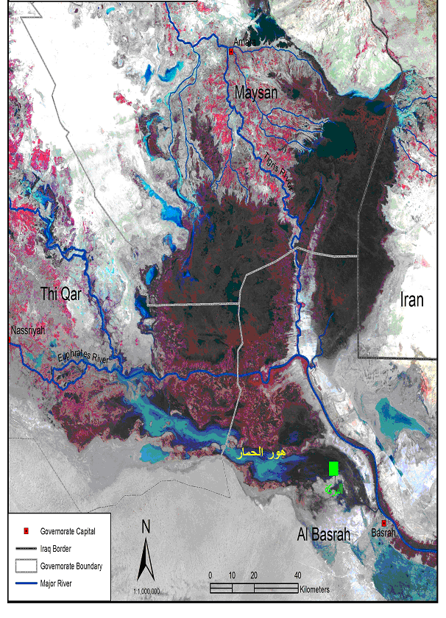 Figure 1. Local map showing Al-Hammar Marsh , Southern Iraq.
Transfer factor (TF)
The transfer factor in fish tissues from the fish water and sediments, was estimated as:
TF= M tissue/ M sediment or water [11,12].
Where, M tissue is the metal concentration in fish tissue; M sediment or water is metal concentration in sediment or water.

Results and discussions
Heavy metals in water samples
The average concentrations of heavy metals in the water samples were 15.32, 8.06, 7.79, 3.39, 2.73 and 2.42 μg/g for Ni, Fe, Cd, Cu, Co and Mn, respectively. Ni and Cd represented the highest and lowest level of the metal investigated respectively. On temporal basis, the highest concentration were recorded for Ni (28.87 μg/g) and Fe (14.93 μg /g) in January and the lowest were Ni (1.87 μg/g) and Mn (1.33 μg/g) in July and June respectively. The highest concentrations of Cu, Cd and Co were recorded in June. Highest levels of Mn were observed during August. In general, Co showed very lowest level during the study period (Figure 2).
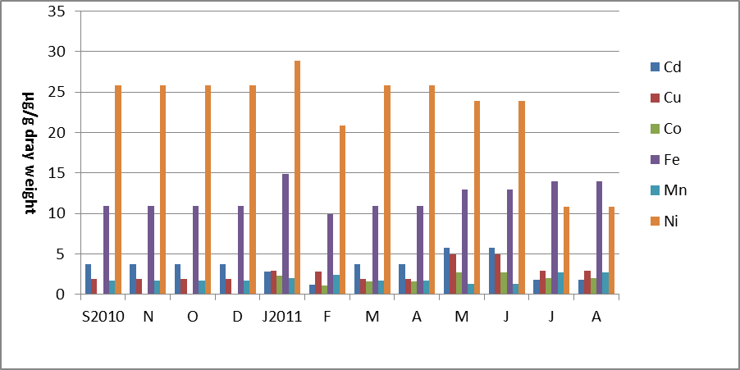
Figure 2. Heavy metals (µg) concentration in the water samples from Al-Hammar Marsh.
Heavy metals in sediment samples
The average concentrations of heavy metals in sediment were 171.86, 185.86, 3418.4, 211.2, 140.18 and 203.55 μg/g for Cu, Cd, Fe, Ni, Mn and Co respectively. The Fe observed at higher levels in comparison with other metals particularly during January-July, 2011. The second highest level represented by Mn with similar levels at all months. The highest concentrations of the Cu, Cd, Fe, Mn and Co were recorded during Mach, June, February, April, and June, 2011 (Figure 3). The lowest concentrations for these metals were noticed during July, September, January, June, and January respectively (Figure 3).

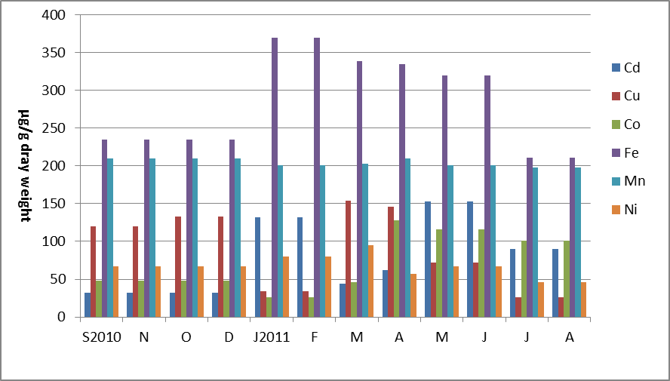
Figure 3. Heavy metals in the sediment samples from Al-Hammar Marsh.

Heavy metals in Fish tissues.
Concentration levels of six heavy metals ( Cu, Cd, Fe, Ni , Mg and Co) in the tissues of P. abu collected monthly (September 2010 – August 2011) from Al-Hammar marsh are shown in Figures 4 to 8. The total concentrations of heavy metals in different fish tissues were 1219.72, 992.36, 805.07 and 716.36 μg/g for intestine, gills, muscles and ovaries respectively. Generally, the heavy metals investigated showed high accumulation in the intestine followed by gills, skin, ovaries and muscles. The Fe found to be the most metal accumulated in fish tissue. However, the Cd was the lowest.

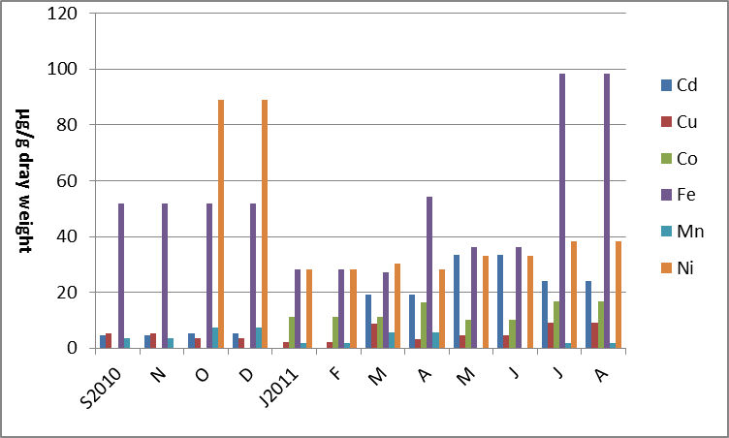

Figure 4. Heavy metals in the muscle of Palaniza abu from Al-Hammar marsh.

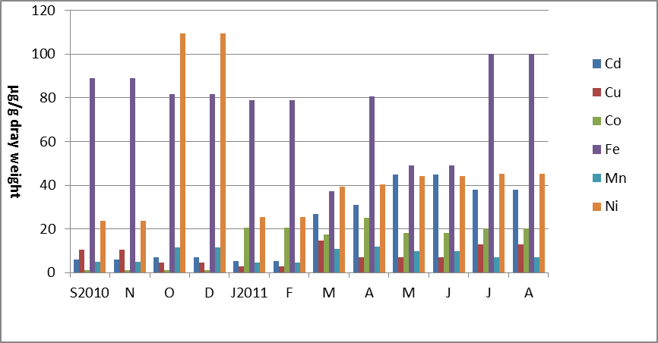
Figure 5. Heavy metals in the intestine of Palaniza abu from Al-Hammar marsh.
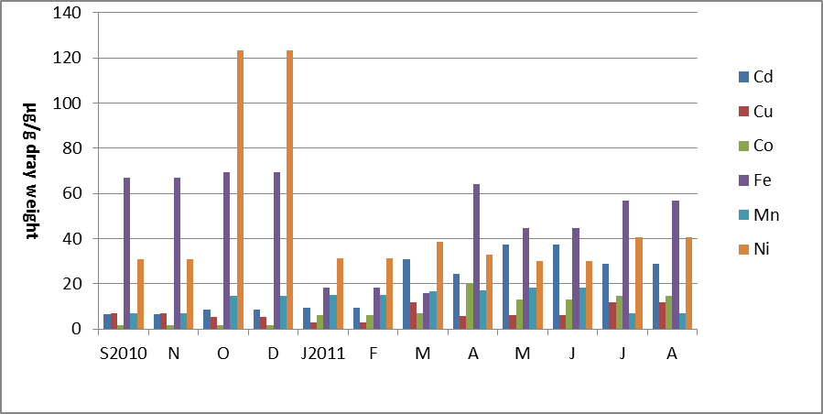
Figure 6. Heavy metals in the gills of Palaniza abu from Al-Hammar marsh .
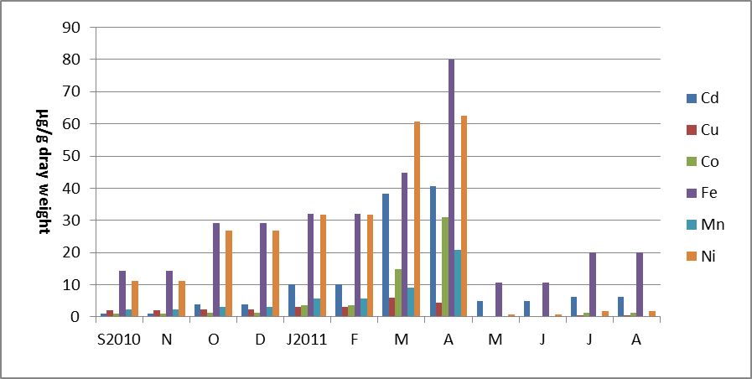
Figure 7. Heavy metals in the ovaries of Palaniza abu from Al-Hammar marsh .
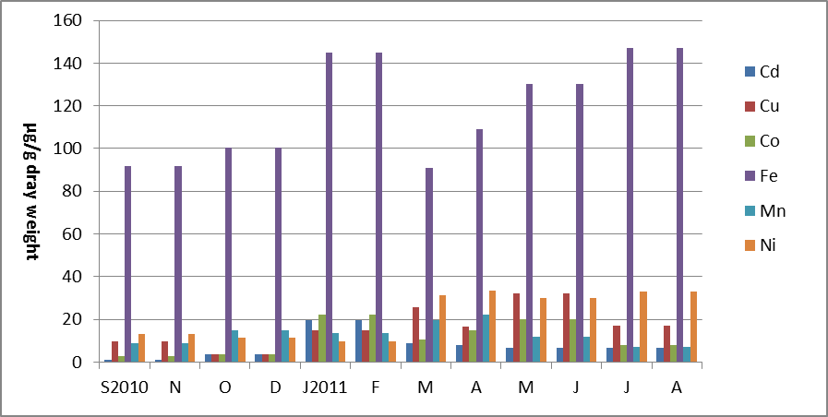
Figure 8. Heavy metals in the skin of Palaniza abu from Al-Hammar marsh .
The average of concentrations fish tissues for Fe, Ni, Cu, Co, Mn and Cd were 1431.72, 1109.57, 521.68, 286.80, 224.20 and 159.52 μg /g respectively.
Transfer factor (TF)
The transfer factors in different organs from water and sediments are given in Table 1 and 2. The results revealed that the transfer factor of sediment were greater than those of water. The results also indicated that all the values of the transfer factors of the water were greater than 1, while all of the sediment was less than 1 (Table 1 and 2). The water transfer factors of metals Cd, Cu, Co, Fe with lesser extent Ni are higher in Intestine in comparison with other fish organs.
Table 1. Water transfer factor (TF) of heavy metals (µg) in different
Tissues of Palaniza abu from the Al-Hammar Marsh ecosystem.
TF | Cd | Cu | Co | Fe | Mn | Ni
Water/Muscles | 4.63 | 1.93 | 6.73 | 4.11 | 1.93 | 1.53
Water /Intestine | 6.97 | 3.12 | 10.7 | 6.12 | 4.44 | 2.02
Water /Gills | 6.4 | 2.69 | 6.68 | 3.99 | 7.04 | 2.02
Water / Ovaries | 4.63 | 0.96 | 5.46 | 2.73 | 3.05 | 1.21
Water /Skin | 2.44 | 6.27 | 8.53 | 9.64 | 7.25 | 1.0

Table 2. Transfer factor (TF) of heavy metals (µg) in different tissues of Palaniza abu from the Al-Hammar marsh ecosystem (sediment).
TF | Cd | Cu | Co | Fe | Mn | Ni
Sediment/Muscles | 0.19 | 0.05 | 0.13 | 0.17 | 0.02 | 0.52
Sediment/Intestine | 0.29 | 0.09 | 0.2 | 0.25 | 0.04 | 0.69
Sediment/Gills | 0.27 | 0.07 | 0.13 | 0.16 | 0.07 | 0.69
Sediment/ Ovaries | 0.19 | 0.03 | 0.1 | 0.11 | 0.03 | 0.41
Sediment/Skin | 0.11 | 0.17 | 0.16 | 0.5 | 0.07 | 0.34

References
[1] Malik, N., Biswas, A. K., Qureshi, T. A., Borana, K. and Virha R. Bioaccumulation of heavy metals in fish tissues of a freshwater lake of Bhopal. Environ. Monit. Assess. Vol.160: pp.267-267.2010.
[2] Giguere, A., Campbell, P.G. C., Hare, L., McDonald, D.G. and Rasmussen, J.B . Influence of lake chemistry and fish age on cadmium, copper and zinc concentrations in various organs of indigenous yellow perch (Perca flavescens). Cand. J. Fish. Aquat. Sci. Vol. pp. 61: 702-716.2004.
[3] Gupta, A., Rai, D.K., Pandey, R.S. and Sharma, B. Analysis of some heavy metals in the riverine water, sediments and fish from river Ganges at Allahabad. Environ Monit Assess. Vol.157, No.1-4: pp. 449-58.2009.
[4] Agah, H., Leermakers, M., Elskens, M., Fatemi, S.M.R., Baeyens, W. Accumulation of trace metals in the muscles and liver tissues of five fish species from the Persian Gulf. Environmental Monitoring and Assessment.Vol. 157: 499- 514.2009.
[5] Blasco, J., Rubio, J. A., Forja, J., Gomez-Parra, A. and Establier, R. Heavy metals in some fishes of the muglidae family from salt-pounds of Codiz Bay SW Spain. Ecotox. Environ. Res. Vol.1: pp. 71-77. 1998.
[6] Fernandes, C., Fontainhas-Fernandes, A. Peixoto, F. and Salgado, M.A. Bioaccumulation of heavy metals in Liza saliens from the Esomriz- Paramos coastal lagoon, Portugal. Ecotox. Environ. Saf. Vol. 66: pp. 426-431.2007.
[7] ROPME. Manual of Oceanographic Observation and Pollution Analyses Methods ROPME/ P.O Box 16388. Blzusafa, Kuwait.2010.
[8] AOAC. Official Methods of Analysis of AOAC International. 16th ed., Vol. 1 (Cunnif, P. Ed.), AOAC Int. Arlington, Virginia, USA.1995.
[9] APHA. Standard Methods For The Examination of Water and Waste Water. American Public Health Association, 18th ed., Academic Press. Washington D.C. pp. 214-218.1992.
[10] Kouadia, L. and Trefry, J.H. Saline trace metal contamination in the Ivory Coast West Africa. Air, Water Soil Pollut. Vol. 32: pp.145-154.1987.
[11] Kalfakakour, V. and Akrida-Demertzi K. Transfer factors of heavy metals in aquatic organisms of different trophic levels. In: HTML publications. Vol.1: pp.768-786.2000.
[12] Rashed, M.N. Monitoring of environmental heavy metals in fish from Nasser Lake. Environ. Int. Vol. 27: pp.27-33.2001.
[13] WHO. Guidelines for Drinking Water Quality (Recommendations). WHO, Geneva.1985.
[14] Uysal, H. and Tuncer, S. Levels of heavy metals in some commercial food species in the Bay of Izmir. VI^{es} Journées Etud. Pollut. Cannes, CIESM, 323.1984.
[15] Alliot, A. and Frenet-Piron, M. Relationship between metals in sea-water and metal accumulation in shrimps. Marine Pollution Bulletion, Vol. pp. 21: 30-33.1990.
[16] Kargin, F. Seasonal changes in levels of heavy metals in tissues of Mullus barbatus and Sparus aurata collected from Iskenderun Gulf (Turkey). Water, Air and Soil Pollut., Vol. 90: pp. 557-562. 1996.
[17] Kalay, M. and Ayo Canli, M. Heavy metal concentrations in fish tissues from the Northeast Mediterranean Sea. Bull. Environ. Contam. Toxicol., Vol. 63: PP. 673-681.1999.
[18] Karadede, H. and Unlu, E. Concentrations of some heavy metals in water,sediment and fish species from the Ataturk Dam Lake (Euphrates), Turkey. Chemosphere, Vol. 41: PP.1371-1376. 2000.
[19] Forstner, U. and Wittmann, G.T.W. Metal pollution in the aquatic environment. Springer-Verlag, Berlin, pp. 30-61.1983.
[20] Dalzell, D. J. B., and MacFarlane, N. A. A. The toxicity of iron to brown trout and effects on the gills: a comparison of two grades of iron sulphate. Journal of Fish Biology. Vol. 55: pp. 301−315. 1999.
[21] Khaled, A. Heavy metals concentrations in certain tissues of five commercially important fishes from El-Mex Bay, Alexandria,Egypt. Egypt. J. Aquat. Biol. Fish., Vol. 8, No. 1 : pp. 51–64.2004.
[22] Moore, J.W. and Ramamoorthy, S. Heavy metals in naturals. Springer-verlag, New york.1981.
[23] Khan, A.T. Weis, J.S. and D'andrea, L. Bioaccumulation of four heavy metals in two populations of grass shrimp, Palaemonotes pugio. Bull. Environ. Contam. Toxicol., Vol. 42: pp. 339-343.1989.
[24] Kargin, F. and Erdem, C. Accumulation of copper in liver, spleen, stomach, intestine, gill and muscle of Cyprinus carpio, Doga. Tr. J. Zoology, Vol. 15: pp. 306-314.1991.
[25] USEPA. Quality Criteria for Water. EPA-440/5-86-001, Office of Water Regulations.1986.

