Assessment of water quality in main branches of
Shatt Al Arab River

Kifah M. Khudhair
Dept. of Civil Eng., College of Eng., Univ. of Basra, Basra-Iraq
Corresponding author: kifahmk@yahoo.co.uk

To cite this article:
Khudhair, K. M.Assessment of Water Quality in Main Branches of Shatt Al Arab River. Mesop. environ. j., 2015, Vol. 2, No.1, pp. 71-86.

This work is licensed under a Creative Commons Attribution-NonCommercial-NoDerivatives 4.0 International License.



Abstract
Shatt Arab River is characterized by its large number of lateral branches. Some of these branches extend into the center of Basra province, Southern of Iraq. These branches include; Saraji, Khora, Ashar, Khandek, Robat, Jubyla, and Shatt Al Turk. The extension of these branches into the center of Basra province transforms them to locations for the disposal of sanitary sewage and solid waste. This causes their pollution and high lights the necessity of evaluating their water quality. The aim of this study is to assess the present status of water quality in main branches of Shatt Al Arab River using Canadian Water Quality Index. The assessment considers the water quality for three uses; domestic, recreation, and aquatic life support. To achieve this aim, water samples were taken from the considered branches during high and low tide times. The samples were tested for determining the values of ten quality parameters; dissolved oxygen, biochemical oxygen demand, turbidity, total dissolved solids, pH, ammonia, total coliform bacteria, fecal coliform bacteria, nitrate, lead, and sulfate. The obtained values of Canadian Water Quality Index for the main branches of Shatt Al Arab River vary over the ranges (13.3-25.8), (19.3-32.1), and (13.0-27.8) for domestic, recreation, and aquatic life support uses. These results indicated that the water quality in main branches of Shatt Al Arab River is poor and their water cannot be used for domestic, recreation, or aquatic life support.
Keywords; Shatt Al Arab branches, Canadian Water Quality Index, Water use.
Introduction
Shatt Arab River is formed by confluence of twin rivers Tigris and Euphrates at Qurna town northern the Basra province and extends for 120 km within Iraqi lands [1]. It is characterized by its large number of lateral branches. Some of these branches extend into the center of Basra province. These branches include; Saraji, Khora, Ashar, Khandek, Robat, Jubyla, and Shatt Al Turk. The extension of these branches into the center of Basra province transforms them to locations for the disposal of sanitary sewage and solid waste which leads to their pollution. The water quality of the main body of Shatt Al Arab River has been studied extensively by many researchers. Examples of these studies include those conducted by Hantoush et al. [2], Mohammad et al. [3], Farid et al. [4], Saad et al. [5, 6], Jorany et al. [7], and Mohammed [8]. In contract, very few researchers considered the water quality of Shatt Al Arab branches and all of them studied the presence of heavy metals in their water such as the studies of; Hejuje [9] who investigated the distribution of heavy elements in water and sediments of Ashar and Khandek branches, Khafaji, [10] who investigated the pollution of Jubyla branch by selected heavy metals, and Imarah et al. [11] whom considered the levels of trace metals (Co, Cu, Ni and Zn) in both dissolved and particulate phases in water of Khora, Ashar, Khandek, Rubat, Jubylah and Shatt Turekbranchs during two seasons, spring and summer 2006. Thus, a need has been highlighted for studying the water quality of Shatt Al Arab main branches.
The aim of this study is to assess the present status of water quality in main branches of Shatt Al Arab River (Saraji, Khora, Ashar, Khandek, Robat, Jubyla, and Shatt Al Turk) for three uses; domestic, recreation, and aquatic life support. The quality of water used for different purposes has an important effect on living beings health. Water of poor quality can be the reason behind the spread of disease and the growth of undesirable aquatic life. The outcomes of this study can be used for setting of pollution control plan for each branch. The water quality of Shatt Al Arab main branches shall be assessed using the Canadian Council of Ministers of the Environment Water Quality Index (CCME WQI) (also referred to as Canadian Water Quality Index, CWQI, in the text).
CWQI was put in 2001 to assess the water quality of surface waters across Canada and it was considered to be the most stringent water quality index [12]. The most important benefits of CWQI include [13]; It's using as a tool to transform complex water quality data into clear descriptions (e.g., good, fair, poor) and applicability to all beneficial water uses; drinking, recreation, agriculture (livestock and irrigation), aquatic life, and industrial uses. After the presentation of CWQI, it was used widely by many researchers. Lumb et al. [14] applied it to monitor the changes in water quality at five sites in the Mackenzie-Great Bear sub-basin which is the largest of the six sub-basins within the Mackenzie River basin, NT, Canada. Janabi et al. [15] used it for three stations located along the Tigris River in Baghdad city, Iraq. Munna et al. [16] used it to assess the water quality of Surma River in Sylhet city, in the north eastern region of Bangladesh. Jakovljević [17] assessed the water quality of Danube River in Serbia for 2010 using CWQI and compared the obtained results with those of applying Serbian Water Quality Index (SWQI). Finally, Buhlool et al. [18] applied this index for assessing the water quality for irrigation uses of four stations located along the Euphrates River in Nassiryia city, Iraq.
Materials and Methods
Formulation of CWQI
Canadian Water Quality Index (CWQI) has been developed by Canadian Council of Ministers of the Environment. It is defined by the following equation [19]:

where F1 is the scope which assesses the degree by which the water quality objective is not satisfied, F2 is the percentage of failed tests, and F3 is the amplitude that represents the magnitude by which the failed test values do not satisfy their objectives. These factors are calculated using the following equations [19]:

In Eq.(2), the variables indicate the water quality parameters considered in CWQI determination. In Eq.(3), nse represents the normalized sum of excursions and it is obtained as;
An excursion is the number of times by which a value of water quality parameter is larger than (or less than, when the objective is a minimum) the objective. When the test value must not exceed the objective:
while, when the test value must not drop below the objective:
The above formulation gives CWQI value varies over the range (0-100), i.e, a numerical value to the status of water quality in the water body. The CWQI value is then used to find the rank of water quality by adopting the classification scheme shown in Table 1.
Table 1. CWQI classification schema, [20]
Rank | CWQI value | Description
Excellent | 95-100 | Water quality is completely secured with no pollution.
Good | 80-94 | Water quality is secured with only a slight degree of pollution.
Fair | 65-79 | Water quality is generally secured, but, it is sometimes polluted.
Marginal | 45-64 | Water quality is commonly polluted.
Poor | 0-44 | Water quality is polluted all the time.
Water Quality Criteria
Water quality criteria have been set based on CCME regulatory values applied on various water uses [cited in 14], regulatory values of the Central Pollution Control Board in India [20], and the guidelines for Canadian Recreational Water Quality [21]. These criteria are presented in Table 2.

Table 2. Water quality criteria for various uses
Water use | Criteria | Ref. No.
Domestic water source after application of conventional treatment. | - TC (MPN/ 100ml) ≤5000  - pH range = 6 - 9  - DO ≥ 4 mg/l  - BOD ≤ 3 mg/l | [20]
 | - Sulfate ≤ 500 mg/l  - Lead ≤ 0.01mg/l  - Nitrate ≤ 48.2 mg/l  - Turbidity ≤ 5NTU  - TDS ≤ 500mg/l  - Ammonia ≤ 1.37 mg/l | [14]
Recreation | - TC (MPN/100ml) ≤500 pH range= 6.5 - 8.5  - DO ≥ 5 mg/l | [20]
Recreation | - Turbidity ≤ 50NTU | [21]
Aquatic life support | - pH range= 6.5 - 8.5  - DO ≥ 4 mg/l  - Ammonia ≤ 1.2 mg/l | [20]
Aquatic life support | - Sulfate ≤ 500 mg/l  - Lead ≤ 0.01mg/l  - Turbidity ≤ 5NTU  - TDS ≤ 500mg/l | [14]
Field Work Program
A field work program has been conducted on 17-June to 16-July/2013 to gather the data required for assessing the water quality of main branches of Shatt Al Arab for the different uses. The work was carried in Saraji, Khora, Ashar, Khandek, Robat, Jubyla, and Shatt Turk branches. The followings sections illustrate the details of this work program.

Measured Parameters
The field work includes collection of water samples for measuring the values of; (1) dissolved oxygen (DO), (2) biochemical oxygen demand (BOD), (3) turbidity, (4) total dissolved solids (TDS), (5) pH, (6) ammonia, (7) total coliform bacteria (TC), (8) fecal coliform bacteria (FC), (9) nitrate, (10) lead, and (10) sulfate. The samples were analyzed in Al Fusul Company lab, the environmental lab of Art College/ Basra Univ., and the bacteriological lab of Marine Science Centre/ Basra Univ.

Locations of Water Sampling Stations
Number of stations has been specified for collecting water samples from each of the seven branches. Fig.1 shows water sampling locations along each branch. From this figure, it can be shown that water samples were taken from five stations in each branch, excluding Khora and Khandek branches, where water samples were taken from six stations and stations of No.6 are located in the links of Saraji and Khora branches and Ashar and Khandek branches.
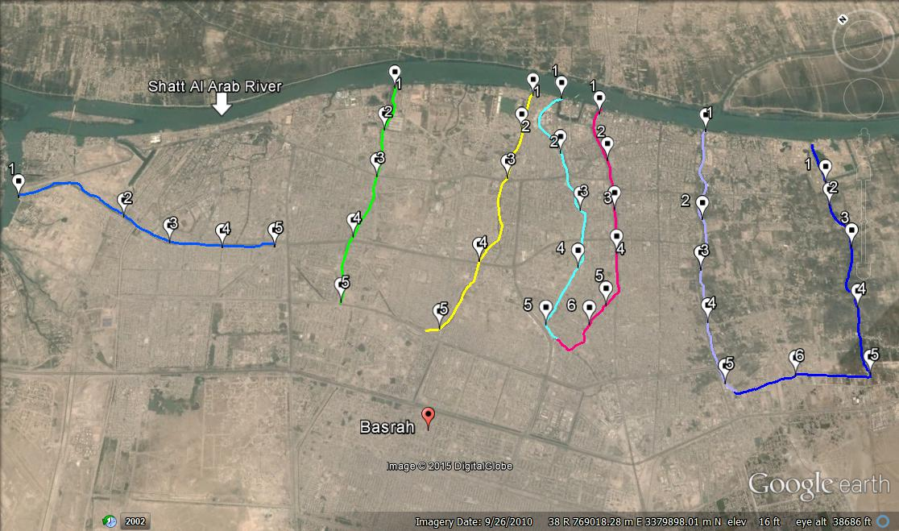
Saraji branch
Khora branch
Ashar branch
Khandek branch
Robat branch
Jubyla branch
Shatt Al Turk branch

Fig.1: Locations of water sampling stations in main branches of Shatt Al Arab River
Timing of Water Sampling
The main branches of Shatt Al Arab River are affected by flood and ebb phenomenon occurs in this river, which is of mixed tide type, dominant semi-diurnal [22]. Thus, to study the status of their water quality, it is necessary to collect water samples during flood and ebb periods.
In this study, water sampling was performed at times of high tide (maximum flood level) and low tide (minimum ebb level). The times of high tide (HT) and low tide (LT) were specified based on tide tables for the year 2013. These tables are published by the General Company of the Iraqi Ports. The tide data of Al Maqal port were used. All water samples were collected at HT and LT times except those collected from Ashar branch. That is because the connection between Shatt Al Arab and Ashar branch was closed by a regulator and the branch is filled with water by pumping water from Shatt Arab with closing the gates and emptied by opening the regulator gates. The water samples were collected from Ashar branch at times of maximum water level (at the end of pumping period) and minimum water level (when the gates are opened).
Results and Discussion
The results of water quality analysis of Shatt Al Arab main branches are shown in the figures and tables indicated in Table 3. From these figures and tables, it can be shown that;
•The levels of dissolved oxygen (DO) in Khora, Ashar, Khandek, Robat, Jubyla, and Shatt Al Turk branches are very low, excluding the values measured in stations of No.1. These stations are located at the heads of these branches. This can be attributed to the high BOD values caused by the discharges of untreated sanitary sewage into these branches. The discharge of raw sanitary sewage is mainly from the illegal residences along their banks or/and the illegal connections of sanitary sewers with storm sewer network. Where in center of Basra province, storm water pumping stations discharge their water into these branches. However, the DO values measured in Saraji branch can be acceptable for some water use figures.
•The levels of total and fecal coliform bacteria are very high in all the considered Shatt Al Arab branches which indicate their pollution by raw sanitary sewage.
•The concentrations of sulfate and TDS in all of the considered branches exceed the permissible limit and this can be attributed to the high salinity of Shatt Al Arab River water which is caused by the lower discharges of Tigris, Euphrates, Carun Rivers. These rivers are the sources of fresh water flowing into Shatt Al Arab River.
•The results of water quality analysis of all the considered branches during flood period are not better than those obtained during ebb period.
Although it is clear from the above points that the water quality of Shatt Al Arab main branches is very bad, but, the suitability of the branches water for use has been studied. That was done by calculating CWQI for each branch and for domestic, recreation, and aquatic life support uses. The results of CWQI calculations are presented in Table 11. From this table, it can be shown that the CWQI values vary over the ranges (13.3-25.8), (19.3-32.1), and (13.0-27.8) for domestic, recreation, and aquatic life support uses, respectively. With referring to Table 1, it can be shown that the rank of water quality in the main branches of Shatt Al Arab River is poor. That means the water quality of these branches is polluted all the time.
Table 3. Figure and table numbers of water quality analysis results

Branch | Water Quality Parameters | Results on Fig. or Table
Saraji | DO, BOD, turbidity, TDS, and pH | Fig.2
Saraji | Ammonia, Nitrate, Sulfate, Lead, FC, and TC | Table 4
Khora | DO, BOD, turbidity, TDS, and pH | Fig.3
Khora | Ammonia, Nitrate, Sulfate, Lead, FC, and TC | Table 5
Ashar | DO, BOD, turbidity, TDS, and pH | Fig.4
Ashar | Ammonia, Nitrate, Sulfate, Lead, FC, and TC | Table 6
Khandek | DO, BOD, turbidity, TDS, and pH | Fig.5
Khandek | Ammonia, Nitrate, Sulfate, Lead, FC, and TC | Table 7
Robat | DO, BOD, turbidity, TDS, and pH | Fig.6
Robat | Ammonia, Nitrate, Sulfate, Lead, FC, and TC | Table 8
Jubyla | DO, BOD, turbidity, TDS, and pH | Fig.7
Jubyla | Ammonia, Nitrate, Sulfate, Lead, FC, and TC | Table 9
Shatt Al Turk | DO, BOD, turbidity, TDS, and pH | Fig.8
Shatt Al Turk | Ammonia, Nitrate, Sulfate, Lead, FC, and TC | Table 10

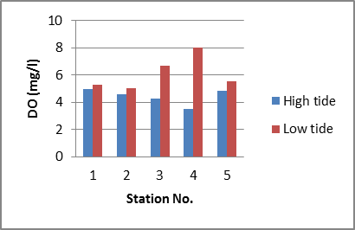 | 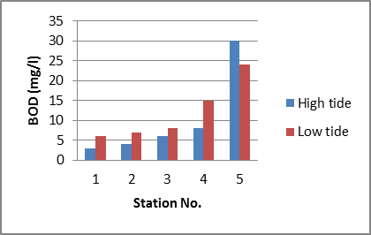
- DO | - BOD
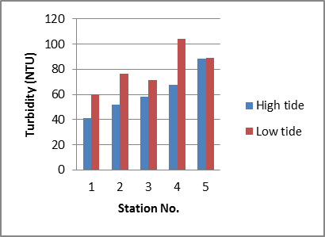 | 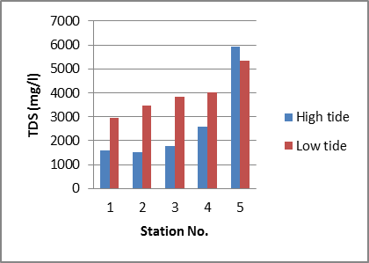
- Turbidity | - TDS
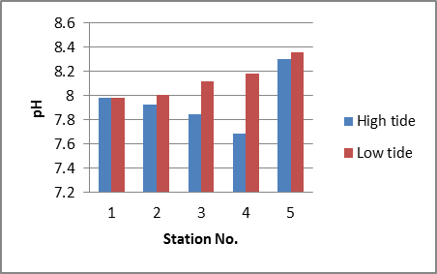
(e) PH
Fig.2: Distribution of some water quality parameters in Saraji branch during high and low tide times

Table 4. Values of some chemical parameters and bacteria count
in water of Saraji branch during high tide time

Sta.  No. | Parameter Concentration (mg/l) |  |  |  | Bacteria Count (MPN/100ml)
Sta.  No. | Ammonia | Nitrate | Sulfate | Lead | FC (×10⁴) | TC (×10⁴)
1 | 0.19 | 1.0 | 351.5 | 0.18 | 10 | 12
2 | 0.07 | 1.5 | 399.5 | 0.97 | 12 | 39
3 | 0.85 | 1.0 | 367 | 0.45 | 17 | 50
4 | 1.30 | 1.0 | 460 | 1.05 | 17 | 72
5 | 0.63 | 1.0 | 818 | 0.59 | 7 | 45

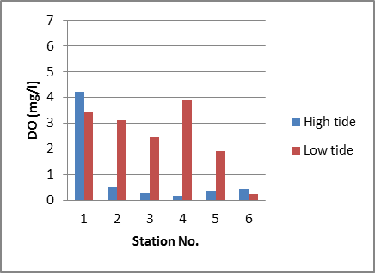 | 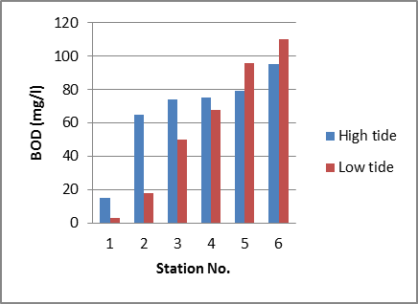
- DO | - BOD
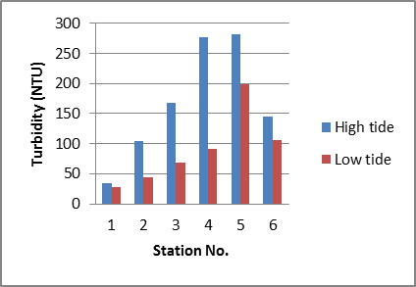 | 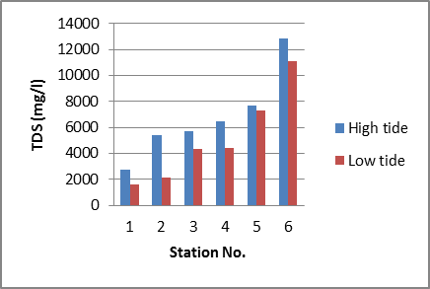
- Turbidity | - TDS
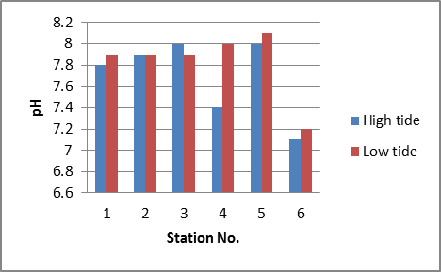
(e) PH
Fig.3: Distribution of some water quality parameters in Khora branch during high and low tide times

Table 5. Values of some chemical parameters and bacteria count
in water of Khora branch during high tide time

Sta.  No. | Parameter Concentration (mg/l) |  |  |  | Bacteria Count (MPN/100ml)
Sta.  No. | Ammonia | Nitrate | Sulfate | Lead | FC (×10⁴) | TC (×10⁴)
1 | 1.9 | ≤1 | 195.0 | 0.38 | 4 | UC*
2 | 5.6 | ≤1 | 364.5 | 0.33 | 42 | UC
3 | 10.9 | ≤1 | 358.0 | 0.34 | 65 | UC
4 | 15.3 | 8.4 | 504.0 | 0.28 | 3 | UC
5 | ≥50 | 17.8 | 896.5 | 2.16 | 9 | UC
* UC : Uncountable

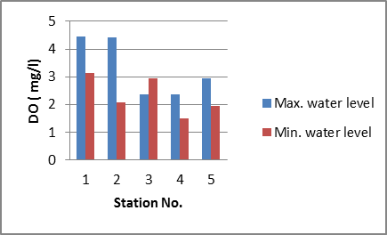 | 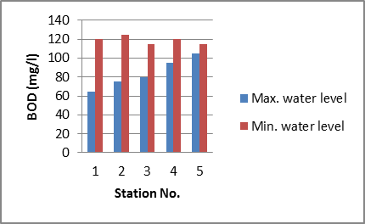
- DO | - BOD
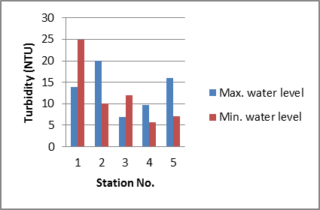 | 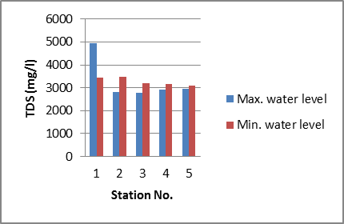
- Turbidity | - TDS
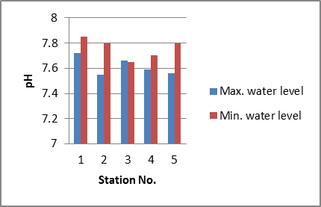
(e) PH
Fig.4: Distribution of some water quality parameters in Ashar branch during max and min water level times
Table 6. Values of some chemical parameters and bacteria count
in water of Ashar branch during max water level period

Sta.  No. | Parameter Concentration (mg/l) |  |  |  | Bacteria Count (MPN/100ml)
Sta.  No. | Ammonia | Nitrate | Sulfate | Lead | FC (×10⁴) | TC (×10⁴)
1 | 2.9 | ≤1 | 726 | 0.48 | 11 | 20
2 | 0.8 | ≤1 | 814 | 0.99 | 17 | 26
3 | 0.9 | 1.9 | 818 | 0.9 | 10 | 30
4 | 0.8 | 1.4 | 831 | 0.97 | 25 | 30
5 | 0.5 | 1.8 | 904 | 1.88 | 30 | 225

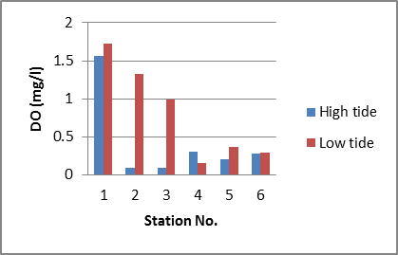 | 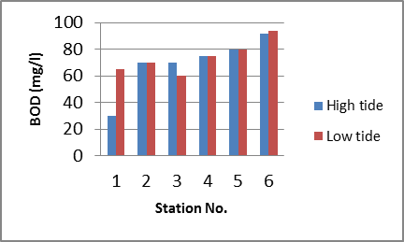
- DO | - BOD
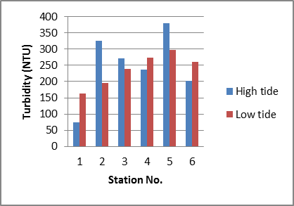 | 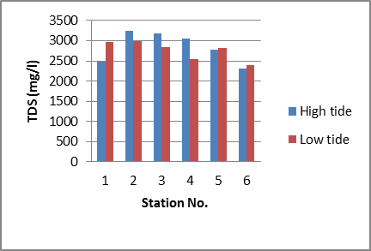
- Turbidity | - TDS
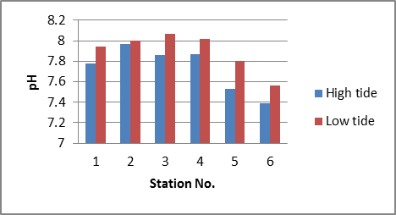
(e) PH
Fig.5: Distribution of some water quality parameters in Khandek branch during high and low tide times
Table 7. Values of some chemical parameters and bacteria count
in water of Khandek branch during high tide time

Sta.No. | Parameter Concentration (mg/l) |  |  |  | Bacteria Count (MPN/100ml)
Sta.No. | Ammonia | Nitrate | Sulfate | Lead | FC (×10⁴) | TC (×10⁴)
1 | 7.4 | ≤1 | 432 | 0.54 | 94 | UC
2 | 14.5 | 1.2 | 477 | 0.26 | 21 | UC
3 | 20.8 | 1.8 | 415 | ≤0.1 | 102 | UC
4 | 20.5 | 1.1 | 556 | 0.3 | 37 | UC
5 | 18.1 | ≤1 | 709 | 0.24 | 151 | UC
* UC : Uncountable
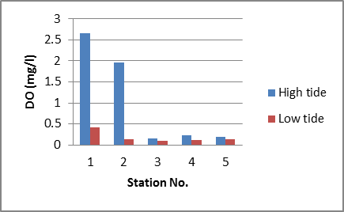 | 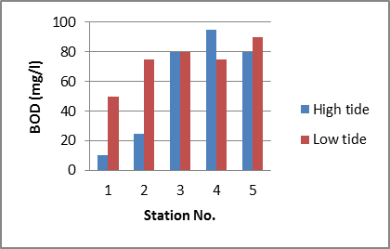
- DO | - BOD
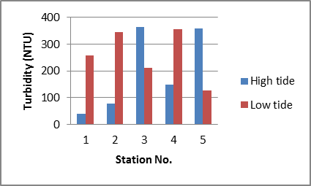 | 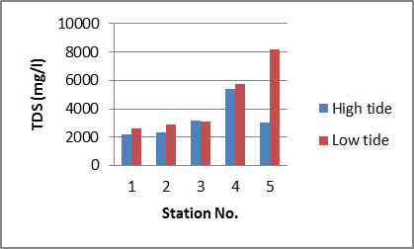
- Turbidity | - TDS
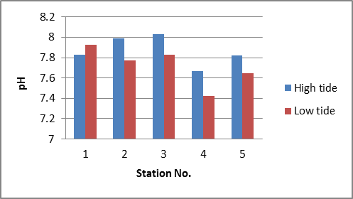
(e) PH
Fig.6: Distribution of some water quality parameters in Robat branch during high and low tide times
Table 8. Values of some chemical parameters and bacteria count
in water of Robat branch during high tide time

Sta.No. | Parameter Concentration (mg/l) |  |  |  | Bacteria Count (MPN/100ml)
Sta.No. | Ammonia | Nitrate | Sulfate | Lead | FC (×10⁴) | TC (×10⁶)
1 | 0.63 | ≤1 | 675 | 0.56 | Nil | Nil
2 | 18.1 | ≤1 | 434 | 0.33 | Nil | 3
3 | 20.5 | ≤1 | 418 | ≤.1 | 29 | 27
4 | 10.2 | 1.65 | 2385 | 0.79 | 7 | UC
5 | 20.2 | ≤1 | 381 | 0.26 | 97 | 3

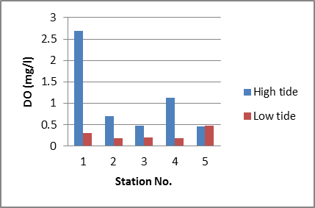 | 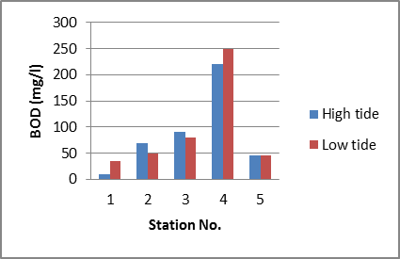
- DO | - BOD
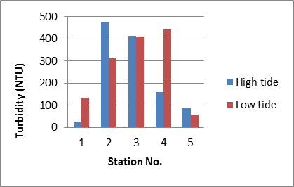 | 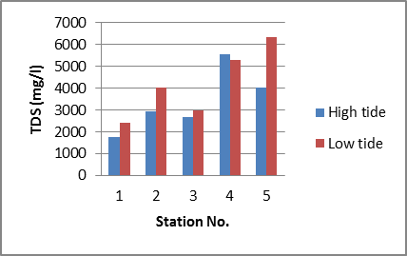
- Turbidity | - TDS
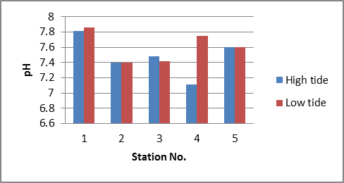
(e) PH
Fig.7: Distribution of some water quality parameters in Jubyla branch during high and low tide times
Table 9. Values of some chemical parameters and bacteria count
in water of Jubaila branch during high tide time

Sta.No. | Parameter Concentration (mg/l) |  |  |  | Bacteria Count (MPN/100ml)
Sta.No. | Ammonia | Nitrate | Sulfate | Lead | FC (×10⁴) | TC (×10⁶)
1 | 1.95 | 1.1 | 703 | 0.11 | 4 | 48
2 | 3.83 | ≤1 | 819 | 0.5 | 39 | 200
3 | 5.39 | 1.2 | 621 | 1.22 | 225 | 80
4 | 7.81 | ≤1 | 964 | 0.19 | 20 | 116
5 | 3.1 | 2.4 | 468 | 0.34 | 43 | 8

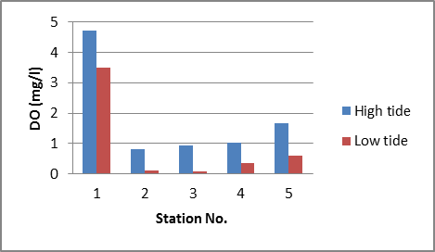 | 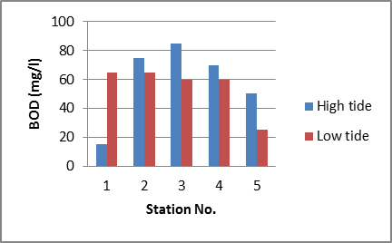
- DO | - BOD
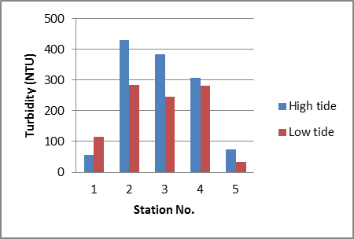 | 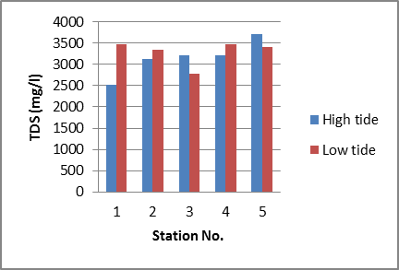
- Turbidity | - TDS
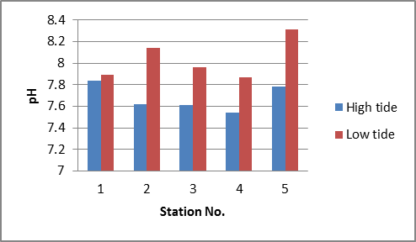
(e) PH
Fig.8: Distribution of some water quality parameters in Shatt Al Turk branch during high and low tide times
Table 10. Values of some chemical parameters and bacteria count
in water of Shatt Al Turk branch during high tide time

Sta.No. | Parameter Concentration (mg/l) |  |  |  | Bacteria Count (MPN/100ml)
Sta.No. | Ammonia | Nitrate | Sulfate | Lead | FC (×10⁴) | TC (×10⁶)
1 | 2.8 | 6.4 | 370 | 0.23 | 174 | 27
2 | 7.1 | 3.5 | 674 | 0.17 | 224 | 3
3 | 8 | 1.2 | 650 | 0.20 | 65 | 1
4 | 9.4 | 2.2 | 817 | 0.15 | 42 | 108
5 | 8.5 | ≤1 | 702 | 0.19 | 57 | 70

Table 11. CWQI values of Shatt Arab main branches for different uses

Branch | CWQI for indicated water use |  |  | Assessment result
Branch | Domestic | Recreation | Aquatic life support | Assessment result
Saraji | 25.8 | 20.8 | 27.8 | Poor for the three uses
Khora | 16 | 20.9 | 15 | Poor for the three uses
Ashar | 16.9 | 32.1 | 16.8 | Poor for the three uses
Khandek | 15.6 | 19.3 | 14.8 | Poor for the three uses
Robat | 15.2 | 20.6 | 14.5 | Poor for the three uses
Jubyla | 13.3 | 19.9 | 13 | Poor for the three uses
Shatt Al Turk | 13.7 | 19.5 | 14.1 | Poor for the three uses

Conclusions
Based on results of this study, the following conclusions were obtained:
- The levels of DO in waters of Khora, Ashar, Khandek, Robat, Jubyla, and Shatt Al Turk branches are below the permissible limit and associated with high levels of BOD, excluding the values measured in stations of No.1. These stations are located at the heads of these branches. However, the DO values measured in Saraji branch are acceptable for some water use figures.
- The levels of total and fecal coliform bacteria are very high in the considered branches.
- The concentrations of sulfate and TDS in all the considered branches exceed the permissible limit.
- The obtained values of CWQI for the main branches of Shatt Al Arab River vary over the ranges (13.3-25.8), (19.3-32.1), and (13.0-27.8) for domestic, recreation, and aquatic life support uses.
- The CWQI values indicate poor water quality for domestic, recreation, and aquatic life support uses of Shatt Al Arab main branches.
Acknowledgment
The author wishes to thank the manager of Fusul Company for Consulting and Engineering Designs for providing the financial support and all the requirements of the field work.
References
- Mayahi, D. S. B. A quantitative Analysis of Transverse River Profiles and its Applications for Morphotectonics: A Case Studying Shatt Arab River, Southern Iraq. Mesopot. J. Mar. Sci., Vol. 26, No.1, pp. 15 – 24. 2011.
- Hantoush, A.; Adhub, A. Y. and Hussain, N. A. Levels of Dissolved and Particulate Petroleum Hydrocarbons in Shatt Arab River, Basrah, Southern Iraq. Mesop. J. Mar. Sci., Vol. 23, No.1, pp.77-96. 2008.
- Mohammad, M. H.; Imarah, F. J. M. and Mezher, A. A. Determination of Nickel in Water of Shatt Arab River by Atomic Absorption and Spectrophotometery. Mesop. J. Mar. Sci., Vol.23, No.1, pp. 167-179. 2008.
- Farid, W. A.; Saad, H. T.; Adhub, A. Y. Monitoring of Hydrocarbons in Shatt Al Arab River by Using Some Species of Molluscs. Mesop. J. Mar. Sci., Vol. 23, No.1, pp. 305-319. 2008.
- Saad, H. T.; Hantoush, A. A.; Mahdi,E. A. and Saleh, S. M. Distribution and Sources of Dissolved Fatty Acids in Water of Shatt Arab Estuary and Northwest Arabian Gulf. Mesop. J. Mar. Sci., Vol. 24, No.1, pp. 25 – 34. 2009.
- Saad, H. T.; Hantoush, A. A.; Hello, M. A. and Zukhair, M.K. Seasonal Variations of Particulate Fatty Acids in Waters of Shatt Arab River and Northwest Arabian Gulf. Mesopot. J. Mar. Sci., Vol.25, No.1, pp. 41 – 52. 2010.
- Jorany, Y. S. J.;Sowdani ,K. H. andMizhir, A. A. Bulid-up a Flow Injection Analysis Unit for Ammonium Determination in the Shatt Arab Water.Mesopot. J. Mar. Sci., Vol. 26, No.1, pp. 47 – 58, 2011.
- Mohammed, M. H. Modified Method for the Determination of Cobalt (II) and Copper (II) ions by Adopting Schiff Base Complexes in Water of Shatt Arab River. Mesopot. J. Mar. Sci., Vol.26, No.2, PP. 170 -181, 2011.
- Hejuje, M. M. Distribution of heavy elements in water and sediments from Ashar and Khandek canals connected with Shatt Arab River and their effects on algae. M. Sc. Thesis, Basrah Univ.,104 p., 1997.
- Khafaji, B. Y. Preliminary Survey of Selected Heavy Metals in Jubyla Branch Connected with Shatt Arab River. Mesop. J. Mar. Sci., Vol.15, No.1, pp. 69-80. 2000.
- Imarah, J. M.;Mahmood, A. A. andHumadi, M. S. Levels of Trace Metals in Shatt Arab Branches during Spring and Summer Seasons, 2006. Mesop. J. Mar. Sci., Vol.23, No.1, pp. 9-17.2008.
- Lumb, A.; Sharma, T. C.; Bibeault , J. F. and Klawunn, P. A. Comparative Study of USA and Canadian Water Quality Index Models. J. of Water Quality, Exposure and Health, Vol.3, Issue 3-4, pp. 203-216.2011.
- Kent, R. National Water Quality Indicator for Canada. UN International Work Session on Water Statistics Vienna, Austria, June 20-22. 2005.
- Lumb, A.; Halliwell , D. and Sharma, T. Application of CCME Water Quality Index to Monitor Water Quality: A Case of the Mackenzie River Basin, Canada. Environmental Monitoring and Assessment 113, pp. 411–429.2006.
- Janabi, Z. Z.; Kubaisi, A. and Obaidy A. M. J. Assessment of Water Quality of Tigris River by using Water Quality Index (CCME WQI). J. of Nahrain University, Vol.15, No.1, pp.119-126, 2012.
- Munna, M.; Chowdhury, M. M. I.; Ahmed, A. A.; Chowdhury, S. and Alom, M. M. A Canadian Water Quality Guideline-Water Quality Index (CCME-WQI) Based Assessment Study of Water Quality in Surma Riverˮ, J. of Civil Engineering and Construction Technology, Vol. 4, No.3, pp. 81-89, 2013.
- Jakovljević, D. Serbian and Canadian Water Quality Index of Danube River in Serbia in 2010. J. Geogr. Inst. Cvijic., Vol.62, No.3, pp.1-18. 2013.
- Buhlool, M. A; Rekabi, H. Y. and khafaji, B. Y. Applied of CCME Water Quality Index for Evaluation of Water Quality of Euphrates river For Irrigation Purposes in Nassiryiacity. J.Thi-Qar Sci., Vol.4, No.3.2014.
- Canadian Council of Ministers of the Environment (CCME). Canadian Water Quality Guidelines for the Protection of Aquatic Life: CCME Water Quality Index 1.0. Technical Report, Canadian Council of Ministers of the environment winnipeg, MB, Canada. Available at: http://www.ccme.ca/sourcetotap/wqi.html, 2001.
- Bhardwaj, R. M. Water Quality Monitoring in India- Achievements and Constraints. IWG-Env., International Work Session on Water Statistics. Vienna, pp. 1-12, June 20-22.2005.
- Health Canada. Guidelines for Canadian Recreational Water Quality. Third Edition. Water, Air and Climate Change Bureau, Healthy Environments and Consumer Safety Branch, Health Canada, Ottawa, Ontario, Catalogue No H129-15/2012E, Available at: http://www.healthcanada.gc.ca, 2012.
- Mahdi, A. A.; Abdullah, S. S. and Hussian, N. A. Some Features of the Physical Oceanography in Iraqi Marine Waters. Mesop. J. Mar. Sci., Vol.22, No.2, pp. 209-222. 2007.

