Abundance and ecological indices of mammals at east hammar marsh, Basrah ,southern Iraq
Adil F. Abbas Najah A. Hussain

1Dept. of Ecology, College of Science , Basrah University

Corresponding Author: dr.najah.h@gmail.com

To cite this article:
A.F.,Abbas ; N.A.Hussain .Abundance and Ecological Indices of Mammals at East Hammar Marsh, Basra ,Southern Iraq. Mesop. environ. j. 2015, Vol 2, No.1, pp. 12-23.

This work is licensed under a Creative Commons Attribution-NonCommercial-NoDerivatives 4.0 International License.



Abstract

Abundance and ecological indices were evaluated for the terrestrial mammals at East Hammar marsh. Sixteen species were recognized and 236 individuals were recorded during the period from May 2012 to May 2013. The most abundant species were Canis aureus followed by Herpestes javanicus. C. aureus consider as the only resident species and scored the highest dominance value ( 23%).The highest Species diversity by Shannon and Wiener and Simpson indices were in October (1.72 and 0.79), the lowest value were in September,( 0.93 and 0.55 ) respectively. The highest richness values by Margalef and Menhinick indices were in August( 2.17 and 1.89), the lowest values were in September (0.66 and 0.67 ) respectively. The highest values of similarity by Jaccard and Sørensen indices were between March – April (85.71% and 83.3%), the lowest values were between June – July and July – August 20% and 33.3% respectively. Four monthly groups appeared to match with cold ,spring ,warm and hot season. Strong correlation existed between H. javanicus,C. aureus and Hemichinus auritus with moderate temperature at spring season.
Keywords; Hammar marsh ,wild mammal, diversity ,ecological indices. southern Iraq.
Introduction
Previous studies about mammals in Iraqi marshes were limited mainly dealt with their occurrence and geographical distribution. Most comprehensive study was that of Hatt (1959) mentioned the occurrence of 13 species in two types of the southern marshes ( the riparian and openness marshes)[1].
During the nineties of last century the habitats of southern marshes suffered from a planned desiccation for more than thirteen years .After inundation in 2003, few survey were conducted about mammals[2,3,4,5] and recently survey on Al- Dalmaj marsh[6].
The aim of the present study to measure the relative abundance and ecological indices of the mammals assemblage at East Hammar marsh ,Basrah ,southern Iraq .during the study period .
Materials and methods
Study area:
The study area was situated at south east of East Hammar marsh with following co-ordinations (N: 30° 39' 1.3" , E: 47° 40' 25.6").The area is permanent marsh dominated by macrophytes canopies including Phragmites australis, Typha domingensis, Shoenoplectus litoralis, and Vallisneria spiralis . The eastern part was semi-desert with thick Halophytes plants (Alhage spp. , Suaeda spp. and Tamarix spp.) .The sampling area includes several mosaic habitats include marshland , semi-desert terrain ,agriculture fields and presence few agriculture activities like fish ,chicken farms and few herds of sheep's ,cows and buffalos , beside several artisanal fishermen were active at the marsh.[7,8,9].
Several methods were used to record the mammal species and counted their individuals to obtained the monthly data was described .[10]
Ecological Indices
The following indices were used to calculated the relative abundance and other biological indices.

Relative abundance Index:
[11]
ni=Number of individuals of species i
N= Total Number of individuals of all collected species

Shannon and Wiener Index:
[12]
ni=Number of individuals of species i
N= Total Number of individuals of all collected species.

Simpson index:
[13]
ni= Number of individuals of species i
N= Total Number of individuals of all collected species
Margalef Richness Index:
[14]
S = Number of species collected
N = Number of individuals collected

Menhinick richness index:
[15,16]
S = Number of species collected
N= Number of individuals collected

Berger-Parker Dominance index:
[17]
n_{max}=highest number of individual of species
N = total number of individuals collected

Jaccard Similarity Index:
[18]
a = Number of common in two samples species
b = Number of unique species in sample A
c = Number of unique species in sample B

Sorensen similarity index:
[19]
c = Number of common species in two samples
a = Number of species existed in sample A
b = Number of species existed in sample B
Results and discussions
Sixteen species were collected and 236 individuals were recorded during the study period from May 2012 to May 2013 on monthly basis, by using different methods as illustrated in table (1).

Table 1: Number of species and individuals of mammals recorded at East Hammar marsh during the period from May 2012 to May 2013.
Total | Apr | Mar | Feb | Jan | Dec | Nov | Oct | Sep | Aug | July | Jun | May | Species
54 | 5 | 5 | 3 | 5 | 3 | 6 | 4 | 5 | 4 | 3 | 7 | 4 | Canis aureus
3 | 1 |  | 1 |  |  |  | 1 |  |  |  |  |  | Canis lupus
2 |  |  |  |  |  |  | 1 |  | 1 |  |  |  | Vulpes vulpes
11 | 1 | 1 |  | 1 | 1 | 1 | 3 |  |  | 3 |  |  | Felis chaus
53 | 7 | 4 | 3 |  | 3 |  | 6 | 12 | 2 |  | 6 | 10 | Herpestes javanicus
7 |  |  |  |  |  | 7 |  |  |  |  |  |  | Hyaena hyaena
3 |  |  |  |  |  | 2 |  |  |  | 1 |  |  | Lutra lutra
3 |  |  | 1 | 1 |  |  |  |  |  | 1 |  |  | Mellivora capensis
26 | 4 | 6 |  | 6 |  |  |  |  |  |  | 2 | 8 | Mus musculus
1 |  |  |  | 1 |  |  |  |  |  |  |  |  | Nisokia indica
26 | 3 | 2 | 5 | 9 | 2 |  |  |  |  |  | 4 | 1 | Rattus norvegicus
1 |  |  | 1 |  |  |  |  |  |  |  |  |  | Suncus etruscus
5 |  |  |  |  |  |  | 1 | 3 | 1 |  |  |  | Suncus murinus
16 | 2 | 3 |  | 2 |  | 4 |  |  | 1 | 2 | 1 |  | Sus scrofa
14 |  |  |  |  | 1 | 1 |  |  | 1 |  | 7 | 4 | Hemichinus auritus
11 |  |  |  | 1 |  | 1 | 2 |  |  | 3 |  | 4 | Lepus capensis
16 | 7 | 6 | 6 | 8 | 5 | 7 | 7 | 3 | 6 | 6 | 6 | 6 | Total No. species
236 | 23 | 21 | 14 | 26 | 10 | 22 | 18 | 20 | 10 | 13 | 27 | 31 | Total No. individuals

Categorization of species frequency:
Monthly frequency of species was divided during the study period ( 12 months) as showed in table(2) [20].

1-Resident:Appeared at sampling area for 10-12 months.
2-Fluctuated : Appeared at sampling area for 7-9 months.
3-Occasional : Appeared at sampling area for 4-6 months.
4-Rare: Appeared at sampling area for 1-3 months.

Only Canis aureus consider as resident species appeared for 12 months along the sampling period. Fluctuated category consisted of four species (Herpestes javanicus, Felis chaus, Rattus norvegicus and Sus scrofa). Three species were placed as occasional and eight species were consider as rare ones (table,2).

Table 2: Categorization of monthly frequency of mammals species at East Hammar marsh during the period from May 2012 to May 2013.
Category | Monthly frequency | Species
Resident | 12 | Canis aureus
Fluctuated | 9 | Herpestes javanicus
Fluctuated | 7 | Felis chaus
Fluctuated | 7 | Rattus norvegicus
Fluctuated | 7 | Sus scrofa
Occasional | 5 | Hemiechinus auritus
Occasional | 5 | Lepus capensis
Occasional | 5 | Mus musculus
Rare | 3 | Canis lupus
Rare | 3 | Suncus murinus
Rare | 3 | Mellivora capensis
Rare | 2 | Lutra lutra
Rare | 2 | Vulpes vulpes
Rare | 1 | Suncus etruscus
Rare | 1 | Hyaena hyaena
Rare | 1 | Nesokia indica

Relative abundance :
Relative abundance were calculated for the sixteen species. The most abundant species was C. aureus ( golden jackel)23% followed in the second rank H. javanicus (Small asian mongoose) 22.5% .The lowest abundant species was S. etruscus (White-Toothed Pygmy Shrew) 0.42% (table,3).
Table 3:The relative abundance of wild mammals assemblage at East Hammar marsh during the period from May 2012 to May 2013.
Relative abundance % | No. of individuals | Species
23.0 | 54 | Canis aureus
22.5 | 53 | Herpestes javanicus
11.0 | 26 | Mus musculus
11.0 | 26 | Rattus norvegicus
6.00 | 15 | Sus scrofa
5.95 | 14 | Hemiechinus auritus
4.68 | 11 | Felis chaus
4.68 | 11 | Lepus capensis
2.97 | 7 | Hyaena hyaena
2.12 | 5 | Suncus murinus
1.27 | 3 | Canis lupus
1.27 | 3 | Lutra lutra
1.27 | 3 | Mellivora capensis
0.85 | 2 | Vulpes vulpes
0.42 | 1 | Nesokia indica
0.42 | 1 | Suncus etruscus
Biodiversity indices:
Diversity indices
Diversity values were calculated by applying Shannon and wiener index and Simpson index.The highest value for diversity for both indices were in October 1.72 and 0.79 respectively (seven species recorded ) .The lowest value was in September 0.93 and 0.55 respectively ( three species recorded) (fig.1).
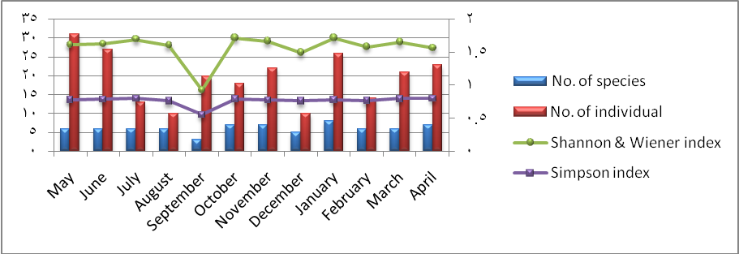
Fig.1:Values of Shannon and wiener index and Simpson index at East Hammar marsh during the period from May 2012 to May 2013.
Richness indices
Richness values were calculated by two indices Margalef and Menhinick.The highest values for both indices were in August 2.17 and 1.89 respectively (six species and ten individuals) , lowest values were in September for both indices 0.66 and 0.67 respectively (three species and 20 individuals) (fig.2).
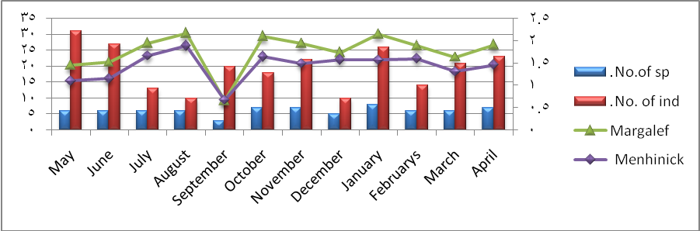
Fig.2:Values of richness by Margalef and Menhinick indices at East Hammar marsh during the period from May 2012 to May 2013.

Dominance Indices
Dominance index was calculated by Burger and Parker index .The highest value for index was during the study period (twelve months) was scored by C. aureus 23%,followedby H. javanicus .Monthly dominance were varied between species as exhibited in table (4).

Table 4: Monthly species dominance values by Berger-Parker index at East Hammar marsh during the period from May 2012 to May 2013.

Monthly dominant species | Berger-Barker  index | No.  species | No. individual | Months
H. javanicus | 32.26 | 6 | 31 | May
C.aureus + H. auritus | 25.93 | 6 | 27 | June
C.aureus + F.chaus + L. capensis | 23.08 | 6 | 13 | July
C.aureus | 40.00 | 6 | 10 | August
H. javanicus | 60.00 | 3 | 20 | September
H. javanicus | 33.33 | 7 | 18 | October
H. hyaena | 31.82 | 7 | 22 | November
C.aureus + H. javanicus | 30.00 | 5 | 10 | December
R.norvegicus | 34.62 | 8 | 26 | January
R.norvegicus | 35.71 | 6 | 14 | February
M. musculus | 28.57 | 6 | 21 | March
H.javanicus | 30.43 | 7 | 23 | April

Similarity Indices
Similarity Indices for wild mammals assemblages were calculated at East Hammar marsh by using Jaccard (1908) and compare with Sorensen(1948) .The highest value was between March and April 85.7% and 92.3 % respectively .The lowest values 10% were between September and January by Jaccard index and 18.1% by Sorensen index (Table,5).

Table 5:Values of similarity indices by Jaccard (1908) index at East Hammar marsh during the period from May 2012 to May 2013.
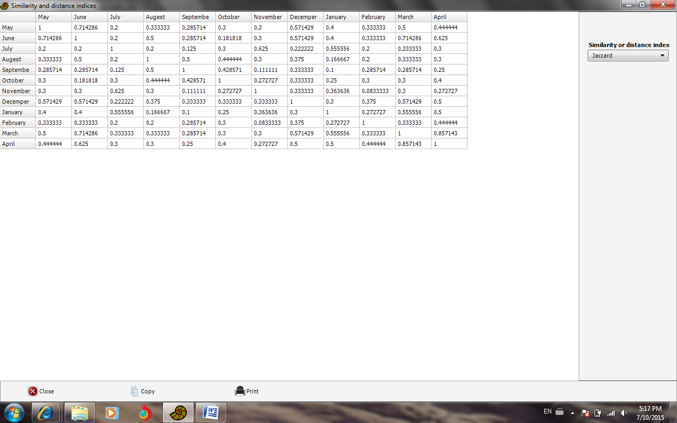

The cluster analysis of similarity reveal the appearance of four monthly groups. The biggest was the spring or moderate temperature group included five months January, March, April, May and June. The second group was winter or cold temperature group consisted of February and December The third group formed of Summer or hot temperature group consisted of August, September and October..The fourth was loosely associated with other groups included July and November as demonstrated in fig.(3). Four monthly groups appeared matched with cold ,spring ,warm and hot season.

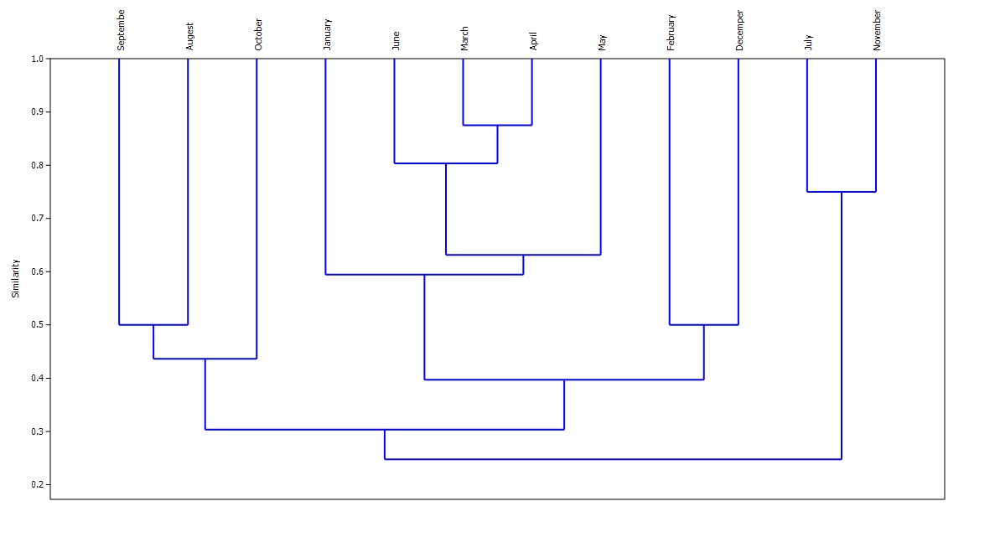

Fig. 3 : Cluster analysis of monthly similarities in East Hammar marsh during the period from May 2012 to May 2013.
PCA analysis indicated that strong correlation existed between H. javanicus,C. aureus, H. auritus with moderate temperature at spring season in March and June. The same was true for M. musculus. On the contrary R. norvegicus showed moderate correlation with cold temperature at winter season in December, January and February (Fig,4).
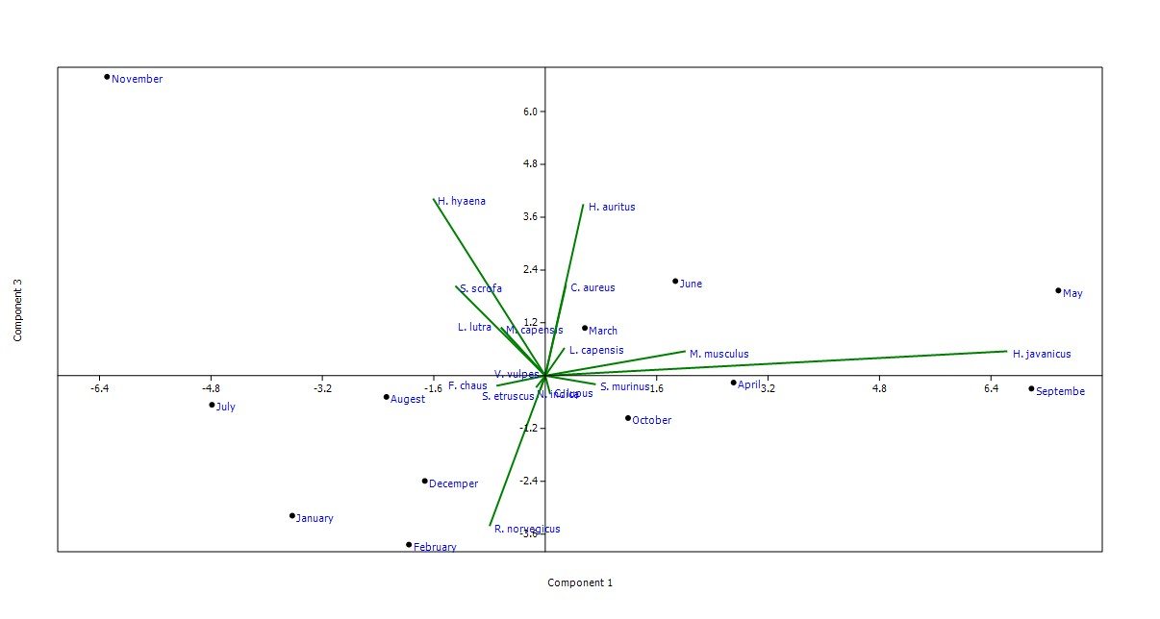
Fig.4: PCA diagram demonstrate the relationship between mammals species and sampling months.
Most previous and recent studies recorded sixteen species as an average in the middle and southern Iraqi marshes habitats was summarized [10].The differences between these studies in the number of the species could be related to the duration of the study period or the designated sampling area to include several habitats or expansion of the original sampling area to include other neighboring habitats ,than confined to the proper marsh itself [1,7,8,3,6,21,22] .
Noticeable seasonal increase in number of species and individuals synchronized with periods of moderate temperature at the end of spring and early winter ,this mode was noticed in other Iraqi marshes and similar to other temperate regions which conceded with noticeable increase in spring and autumn productivity in the marshes also followed by increase of macro- invertebrates[23,24,25] ,fish and aquatic birds abundance [26].
Availability of trash food from fish and chicken farms beside the lift over of artisanal fishing, attracted carnivores species to the study area , consequently represented more than 50 % of number of species and individuals recorded .
The tool of decay of desiccation on the marshes was devastated on number of species and number of individuals , especially those species depend on aquatic environment consequently most rare species reported were those depend in their living on the marshes and or near the river banks like L. lutra ,N. bunnii , N. indica and Tetera indica [27,28].The failure of collecting previously recorded species near by the water edge of the marshes or the river banks indicated that these species became very rare or extinct from the East Hammar marsh as proved by the collection of only one specimen of N.indica during twelve months of continuous sampling.
Guard dogs (C. familiaris ) of the fish and chicken farms play a passive role by chasing away many wild species from the study area, prevented them from feeding on trash materials and even bites nearby camera trip .
Numbers of C.arueus and H.javanicus individuals have strong effect on ecological indices calculated especially on diversity values of East Hammar marsh, these two species were the dominant ones since their relative abundance were about to be even. Diversity indices of Shannon and wiener (1948) showed good value for the marshes (1.72) such value was comparable to other values recorded for marshes. Richness values (2.17) were low in comparison with other groups for Iraqi marshes was showed [26]. C.arueus and H.javanicus were considered as occasional species and not obligatory even they were the most abundant ones, since they dash to marsh edge (riparian marsh) searching for food .
PCA analysis showed a close relation between certain species with moderate months or season indicated the direct effect of seasonal temperature on their abundance. Sever air temperature as that of the summer in East Hammar marsh had negative effect on their abundance in comparison with that of the winter- spring period .Again PCA exhibited the correlation existed between the most abundant or dominant species (C.arueus H.javanicus and H. auritus) with moderate temperature the same is true to Rattus norvegicus in cold months.
Grazer animal have tremendous effect on other species in the study area especially the small ones since buffalo herds move around the area during the night and with cows during the day, disturbed surrounding habitats .
The grazing of domestic livestock on rangelands has probably had a greater adverse impact on wildlife populations than any other single factor and grazing depresses all species of wildlife especially the problem of overgrazing[29]. Inevitably grazing led to severe soil erosion reduces the quality of the habitat for even kangaroo rats and jackrabbits. A study in southern Idaho/USA found rodent burrows significantly higher on ungrazed pastures than on grazed ones [30].
In a study on the impact of burrows on a desert region in the Grand Canyon found both a greater diversity of small mammals as well as higher total numbers on an area devoid of burros compared to an adjacent one heavily grazed by domestic livestock[31]. Almost without exception the data indicate that excessive grazing or overgrazing has adverse effects on most forms of wildlife[29]. the presence of livestock and other human activities in the wilderness areas of Ethiopia negatively affected habitat availability and quality for Nyala (Tragelaphus buxtoni) [32].
Number of small Asian mongoose (H.javanicus) as a predator was double of that of rodents( M. musculus) existed in the sampling area, could be as result of predation pressure . Weasels as natural predators may have contributed to the localized extinction of the field vole population on the experimental area in British Columba /Canada[33]. weasel could remove 26% of adult population of field voles in Scotland[34] .
Weasel Mustela nivalis able to decreased the population density of forest rodents (bank vole Cleothrionomys glareolus and yellow-necked mouse Apodemus flavicollis) from exceeded 300 individuals /ha of rodents numbers during the autumn outbreak and dropped to 8 individuals/ha in the following autumn[35]. as result of predation by weasels in deciduous forests of Bialowieza National Park, eastern Poland .There was independent spatial and temporal variation in numbers of species and individuals of mammals in East Hammar marsh.
References
[1] Hatt, R. T. The mammals of Iraq. Museum of Zoolgy, University of Michigan, No.106. 1959.
[2]Nature Iraq organization.Key Biodiversity Survey of Southern Iraq: Site Review. Dalmaj (ME10)(IBA023)draft report,6pp. Sulaimani, Iraq: Nature Iraq . 2011-2005.
[3] Haba, M.K. Mesopotamian marshland mammals. Marsh Bulletin. Vol.4, No.2: pp. 179-189. 2009.
[4] Al-Sheikhly, O.F. and Nader, I.A. The Status of Iraq Smooth-Coated Otter Lutrogale perspicillata maxwelli Hayman 1956 and Eurasian Otter Lutra lutra Linnaeus 1758 in Iraq IUCN Otter Spec.Vol.30, No.1: pp.18 – 30.2013.
[5] Al-Sheikhl O.F. & D. Mallon.The Small Asian Mongoose Herpestes javanicus and the Indian Grey Mongoose Herpestes edwardsii in Iraq . Zoology in the Middle East. 2013.
[6] Mahammed,K.M. The current status of vertebrates diversity in al-Dalamj marsh Al-Diwaniya province.Bull.Iraq nat.Mus.Vol.13, No.1: pp.5-14. 2014.
[7] Harrison D.L. The Mammals of Arabian Gulf. George Allen & Unwin, London. 1981.
[8] Harrison D.L.& Bates P.J.J. The Mammals of Arabia .Harrison Zoological Museum, Sevenoaks. 1991.
[9] Aulagnier, Haffner, Mitchell-Jones, Moutou& Zema Mammals of Europe, North Africa and Middle East. English edition published by A&C Black Publisher Ltd. London . 2009.
[10] Abbas A.F.and Hussain, N.A.Occurrence of wild mammals at the restored East Hammar marsh-Basrah-Iraq.Marsh Bulletin (In press). 2015.
[11] Odum W.E. Insidious alteration of the estuarine environment. Transactions of the American Fisheries Society. vol. 99, pp.836–847. 1970.
[12] Shannon C. E. and Weaver W. The mathematical theory of communication. Urbana, IL: University fo Illinois Press.cited in Magurran, A. E., 2004, Measuring biological diversity, Blackwell Publishing: Oxford, UK.256 p.1949.
[13] Simpson E.H. Measurement of diversity. Nature 163, 688.cited in Magurran, A. E., 2004, Measuring biological diversity, Blackwell Publishing: Oxford, UK.256 p.1949
[14] Margalef, R. Information theory in Ecology. Gen. Systems .Vol.3, pp.36-71. 1958.
[15] Menhinick, E.F. A comparison of some species diversity indices. 1964.
[16] Whittaker, R. H. Evolution of species diversity In land communities. In Evolutionary biology eds Heeht M. K., W. C. Steee and B Wallace Plenum, NY. 1977.
[17] Berger, W. H.; Parker, F. L. Diversity of planktonic Foramenifera in deep sea sediments. Science .Vol.168, pp.1345-1347. 1970.
[18] Jaccard, P. Application of numerical classification in ecological investigation of water pollution. Nouvelles recherches sur la distribution florale. Bull. Soc. Vaudoise Sci. Nat. 44:223-270.(Cited in Boesch,D.F.,1974 . EPA/USA,ECO.Vol.600, pp.13-77. 1908.
[19] Sorensen, T. A Method of establishing groups of equal amplitude in plant sociology based on similarity of species and its application to analyses of the vegetation on Danish commons". Kongelige Danske Videnskabernes Selskab .Vol.5, No.4: pp.1–34. 1948.
[20] Tyler A.V. Periodic and resident components in communities of Atlantic ishes. J. Fish. Res. Bd. Canada. Vol. 28, No.7: pp.935-946. 1971.
[21] Garstecki, T. and Amr Z. Biodiversity and Ecosystem Management in the Iraqi Marshlands – Screening Study on Potential World Heritage Nomination. Amman, Jordan: IUCN.2011.
[22] Abbas,A.F. Study of the relative abundance and biodiversity for terrestrial mammals of East Hammar marsh. MSc thesis ,Basrah University .80 pp. 2013.
[23] Hammadi,N.S.; Jasim,A.Q. and Al-Sodani H.M. Occurrence and seasonal variations of phytoplankton in the restored marshes of southern Iraq. Marsh Bulletin. Vol.2, No.2: pp.96-109.2007.
[24] Al-Sodani, H.M., Abed, J.M., Al-Essa, S.A.K. and Hammadi, N.S. Quantitive and qualitative study on zooplankton in restored southern Iraqi marshes. Marsh Bulletin. Vol.2, No.1: pp.43-63. 2007.
[25] Hamdan M. A.; Asada, T.; Hassan, F. M.; Warner, B. G.; Douable, A.; Al-Hilli, M. R. and Alwan,A.A.Vegetation response to re-flooding in the Mesopotamian wetlands, Southern Iraq. Wetlands .Vol.30,pp.177-188. 2010.
[26] Hussain,N.A.Ali,A.H. and Lazim, L.F.Ecological indices of key biological groups in southern Iraqi marshlands during 2005-2007 .Mesopot.J.Mar.sci.Vol.27, No.2: pp.112-125. 2012.
[27] Al Robaae, K. Distribution of Nesokia indica (Gray& Harwicke,1830) in Basrah Liwa, south Iraq; with some biological notes. Saugetiekundliche Mitt.,Vol. 25: pp. 194-197. 1977.
[28] Kadhim, A. H. Geographical distribution of Nesokia indica Gray & Hardwicke (Muridae: Rodentia) and Tatera indica Hardwicke (Cricetidae: Rodentia) in Iraq and their economical importance. Bulletin Biol.Res. Center.Vol.12, pp.3-8. 1981.
[29] Gallizioli, S. Effects of Livestock Grazing on Wildlife. 10th Annual Joint Meeting of the American Wildlife Society and American Fisheries Society.14pp. 1979.
[30] Anderson, R.D. Curlew Valley Validation Site Report. S.I.B.P. Desert Biome. Utah State University. 1972.
[31] Carothers, S., M.E. Stitt and R. Johnson. On Analysis of Biotic Impact, Legal Considerations and Management Alternatives. Forty-first North American Wildlife Conference, Washington, DC. 1976.
[32] Mamo, Y.and Bekele, A. Human and livestock encroachments into the habitat of Mountain Nyala (Tragelaphus buxtoni) in the Bale Mountains .National Park, Ethiopia. Tropical Ecology. Vol.52, No.3: pp.265-273. 2011.
[33] Sullivan, T. P. and Sullivan, D. S. The Use of Weasels for Natural Control of Mouse and Vole Populations in a Coastal Coniferous Forest. Oecologia. Vol.47, No.1: pp.125-129. 1980.
[34] Islam . G and Lambin,X. The impact of weasel predation on cyclic field-vole survival:the specialist predator hypothesis contradicted. Journal of Animal Ecology .Vol.71: pp.946–956. 2002.
[35] Jedrzejewski, W. ; Jedrzejewska, B. and Szymura L.Weasel . Population Response, Home Range, and Predation on Rodents in a Deciduous Forest in Poland. Ecology. Vol.76, No.1: pp.179-195. 1995.

