Studies on bioefficacy of coal ash to promote plant growth

Aravind C.¹ Ashwindh A. ¹ Ganesh K Babu¹ Arumugam P² Sindhu S ³ Vinoth D. Kumar⁴ Ramesh N.G. Babu⁵

¹Final Year B.Tech,. Department of Biotechnology, Adhiyamaan Engineering College, Hosur, India
² Director, Armats Biotek, Guindy, Chennai, India
³Research Scholar, Armats Biotek, Guindy, Chennai, India
⁴Asst. Prof. Department of Biotechnology, Adhiyamaan Engineering College, Hosur, India
⁵Professor and Head, Adhiyamaan Engineering College, Hosur, India

Corresponding author: vinoth.vinopaul79@gmail.com

To cite this article:

Aravind, C.; Ashwindh A.; Ganesh, K. B.; Arumugam, P.; Sindhu, S.; Vinoth, D.K.; Ramesh, N.G.Babu. Studies on bioefficacy of coal ash to promote plant growth, Mesopotomia Environment Journal, Vol. 1, No. 4, 2015, pp. 27-38.

This work is licensed under a Creative Commons Attribution-NonCommercial-NoDerivatives 4.0 International License.


Abstract
Coal ash, the residue formed after burning of coal, is of two types namely fly ash and bottom ash. Fly ash is the fine particles which are collected from flue gas and bottom ash is the residual solid. The fly ash and bottom ash consists of heavy metals and hence their disposal poses a great challenge. Fly ash and bottom ash are used as soil amendments to improve plant growth due to the presence of nutrients such as N, P, K, Ca, Mg, etc. They are great alternatives to dispose coal ash. Disposal of coal ash in landfills pose the risk of leachate formation and contamination of ground water. The present study explores a way to overcome the accumulation of heavy metals by the use of fungus Trichoderma viride. The bioremediation of fly ash and bottom ash result in the reduction of heavy metal levels and increase the concentration of nutrients such as N, P, K, and Mg. The untreated and treated coal ash was studied for their potential to promote plant growth in Vigna radiata and Vigna mungo. The results of the study proved that 25% blending of treated ash with soil was beneficial. In conclusion, we have developed a process not only to use coal ash as an ecofriendly amendment for bio-fertilizers but also safe disposal of coal ash.

Keywords; Coal ash, soil amendenment, heavy metals, Trichoderma viride,Vigna radiate, Vigna mungo.

Introduction

The global energy need has increased with rapid industrialization, which to a large extent has been met by fossil fuels. Coal plays a crucial role in meeting the ever increasing energy demands of countries around the world. Electricity production from coal produces a variety of residues – fly ash, bottom ash, and the flue gas desulfurization waste. Over 225 million tons of coal is produced annually in India and over 100 thermal power stations generate more than 108 million kilowatts power produced every year [1]. Investigating the use of coal ash is not only economic - technical, but also has a huge social impact (reduced landfill, reduction in environmental destruction).
Coal burns at a high temperature (>1500°C) and the inorganic material melts and agglomerates into spheres. Upon leaving the combustion zone, the ash particles are cooled quickly and solidify. About 90% of the ash formed from the burnt coal is carried out of the furnace, extracted from the flue gas and is known as Fly Ash. The remaining coarser fraction falls to the bottom of the furnace where it sinters together to become Furnace Bottom Ash. Fly ash production depends on the quality of the coal, which contains a relatively high proportion of ash that leads to 10-30% fly ash formation [2]. In India 75% of electricity is generated from by coal based thermal power plants. Nearly 50-60% of fly ash is being stored in plant dump sites. Disposal of such a high quantity of fly ash is one of the major problems in developing countries and it is usually disposed in basins and landfills near the power plant. Fly ash is sometimes used in building constructions such as roads and embankments and in cement industries. Its alkaline character and a high concentration of mineral substances have resulted in attempts at using it as a fertilizer or amendment to enhance the physiochemical properties of soil. Fly ash contains a high concentration of toxic elements such as Cu, Zn, Cd, Pb, Ni, Cr, etc [3,4,5] along with low nitrogen and phosphorous content and pH ranges from 4.5 - 12.0 depending upon the content of parent coal. Fly ash is disposed off either by dry or wet methods. In the dry method, the fly ash is dumped in landfills and fly ash basins. In wet method, the fly ash is washed out with water into artificial lagoons and is called pond ash. Both methods ultimately lead to dumping the fly ash on open land, which degrades the soil and endangers human health and the environment. Therefore, disposal and utilization of fly ash needs careful assessment to prevent conversion of arable land into landfills and accumulation of toxic metals in soil [6].
Bottom ash is part of the non-combustible residue of combustion in a furnace. In an industrial context, it usually refers to coal combustion and comprises traces of combustibles embedded in forming clinkers and sticking to hot side walls of a coal-burning furnace during its operation. The portion of the ash that escapes up the chimney or stack is, however, referred to as fly ash. The clinkers fall by themselves into the bottom hopper of a coal-burning furnace and are cooled. The above portion of the ash is referred to as bottom ash too. The heating was affected to various oxides and some part of 15-25 % coal ash was melted and mixed to be a big one and fall into the burning room called bottom ash or furnace ash. It is reported that the bottom ash may contain some essential elements for plant growth like K, Ca and Mg, etc which would be the form available to plant absorption for their growth [7]. Studies proposed that bottom ash also possessed mineral elements that are necessary for plant growth. Fly ash and bottom ash both possess the characteristic property for use as a fertilizer but only major drawback is the high concentration of heavy metal deposition in the soil. Therefore, reducing the concentration of the heavy metals in fly ash and bottom ash will ensure using the latter as an eco-friendly fertilizer.
Metal remediation through common physico-chemical techniques is expensive and unsuitable in treating large contaminated areas effectively. Bioremediation offers a promising means to reclaim such contaminated soil in an economical and eco-friendly way. Bioremediation employs microorganisms especially fungus (mycoremediation) capable of degrading toxic contaminants or having the ability to accumulate it in their cells.
Earlier studies proposed that fungus has the capability to remove heavy metals like Cr, Zn, As, Pb, and Cd etc. from contaminated soil. Fungi have been used as bioremediation agents [8] and biofertilizers for agricultural, horticultural and silvicultural plant species in polluted areas [9].
The present study aims at the bioremediation of coal ash, bottom ash and studying its effect on plant growth and also evaluating its growth promoting potential.

Materials and Methods

Sample collection and preparation

Fly ash and bottom ash samples were collected from Neyveli Lignite Corporation, Neyveli. 5g of fly ash and bottom ash were taken in two 30ml test tubes. 15 ml of distilled water was added to each of the test tube and it was vortexed for about 2 mins.

Antimicrobial Assay-Media preparation and well diffusion assay

For 5g of peptone, 5g of sodium chloride and 100ml of distilled water was added. 3g of yeast extract was added and the pH of the solution was adjusted to 7±0.2 and 2g of agar was added to the solution and it was sterilized in an autoclave at 121°C. The antimicrobial activity is checked for 4 species of bacteria. Two among them are gram positive (Streptococcus mutans (MTCC 497) and Staphylococcus aureus (MTCC 96)) and the other two are gram negative (Escherichia coli (MTCC 443) and Proteus vulgaris (MTCC 426)). The petri plates were sterilized in an autoclave. The four plates were marked by the culture number of the species which was going to be used. 20ml of nutrient agar is poured into each Petri plate. The media was allowed to solidify. Each bacterial broth is now swabbed on the media using cotton swabs in their appropriate petri plates Then 5 wells were formed in each petri plate. Tetracycline was used as a control. The wells were marked as 25, 50, 75, 100 and T and 25µl, 50µ, 75µl and l00µl of fly ash and bottom ash solution was added and tetracycline was added to T well respectively.

Fungal Treatment (Bioremediation)

Fifty g of Trichoderma viride powder was added to 500g of fly ash and bottom ash respectively and was blended properly. Appropriate moisture content was maintained throughout the process. The tray is covered with a black cover to avoid direct sunlight. The black cover is perforated to provide aeration and the setup was maintained for 30 days.

Viability Test for Fungal Treatment

Three petriplates were taken and they were marked as control, FA, BA respectively. 20ml of PDA (Potato Dextrose Agar) was added to each of the plates in an aseptic condition. The PDA was allowed to solidify. To control petri plate, Trichoderma viride was inoculated at three different places. Similarly for FA and BA marked plates, three small specks of bioremediated fly ash and bottom ash were inoculated, respectively. Viability test was done three times during the course of the bioremediation process.
20 g of potato is taken and it is cut into very small pieces. The potato pieces are taken in a 200ml conical flask and 100 ml of water is added to it. Now it is boiled for 2 minutes in a microwave oven. The solution is filtered in a tea filter to remove the potato pieces. This solution is the potato extract. To this solution 2 g of dextrose is added. The pH of the solution is adjusted to 5.6. Now 2 g of agar is added to the solution and is sterilized in an autoclave at 121° C.

Evaluation of Plant Growth Promoting Effect of Coal Ash- Cup

Seed treatment

The seeds of Vigna radiata and Vigna mungo were washed with distilled water 2-5 times, soaked in fly ash, bottom ash and water for 5 hours. The soaked seeds were then incubated in sterile Petri plates lined with filter papers wetted with appropriate solution for germination. The germinated seeds were used for further study.

Preparation of Coal ash blended soil

Coal ash was blended with soil at different concentrations such as 0%, 5%, 10%, 20% and 25% (W/W).

Evaluation of Plant Growth Promoting Effect of Coal Ash- Cup Assay

The coal ash blended soil, at different concentration, was taken in recyclable cups and sprayed with water. The germinated seeds (7 seeds) were soaked in the cups and maintained under optimal growth conditions for 7 days. Seeds soaked in water served as control and were sowed in red soil (100%).

Estimation of Plant Growth Parameters of Coal Ash- Cup Assay

After 7 days of plant growth, the plantlets were carefully de-rooted for the evaluation of plant parameters. The length of the shoot and root of the plants were measured with the help of a thread and a ruler. The number of hairy roots were calculated and recorded.

Evaluation of Plant Growth Promoting Effect of Coal Ash- Pot Assay

The optimal concentration of blending was selected based on the results of cup assay and taken for pot studies. The seeds were germinated as mentioned earlier, sowed in 1 kg of optimal coal ash blended soil and maintained for 14days.

Estimation of Plant Growth Parameters of Coal Ash- Pot Assay

After 14 days of growth, the shoot length, root length and hairy roots were measured as mentioned earlier. The plant leaves were collected and subjected to the following estimations.

Estimation of Biochemical parameters
100 mg of leaves were taken in a test tube and 2 ml of Dimethyl sulfoxide (DMSO) was added. It was incubated at 60° C in water bath for 20 minutes. Supernatant was decanted and another 3 ml of DMSO was added to the residue. Supernatants were pooled and the volume was made up to 10ml with DMSO. Absorbance was measured at 645 nm and 663 nm [10, 11, 12]. Chlorophyll concentration was measured by using specific absorption coefficients of chlorophyll a and b at 663 nm and 645 nm in DMSO:
- Total chlorophyll (mg/l) = 20.2 A₆₄₅ + 8.02 A₆₆₃
- Chlorophyll a (mg/l) = 12.7 A₆₆₃ – 2.69 A₆₄₅
- Chlorophyll b (mg/l) = 22.9 A₆₄₅ – 4.68 A₆₆₃
Chlorophyll level was also calculated on fresh weight basis using formulae,

Total chlorophyll (mg/g) = (20.2 A₆₄₅ + 8.02 A₆₆₃) x V
Ax 1000 x W
Chlorophyll a (mg/g) = (12.7 A₆₆₃ – 2.69 A₆₄₅) x V
Ax 1000 x W
Chlorophyll b (mg/g) = (22.9 A₆₄₅ – 4.68 A₆₆₃) x V
Ax 1000 x W
Where,
A: length of the light path in the cuvette
V: Volume of the extract in ml
W: Weight of the sample in µg

Estimation of Reducing Sugars by Dinitrosalicylic Acid (DNS) method

Three ml of the extract was mixed with 3 ml of DNS reagent. The mixture was heated for 5 minutes in a boiling water bath. After the colour was developed, 1 ml of 40% Rochelle salt was added. The tubes were cooled and absorbance was measured at 575 nm. The amount of reducing sugar was calculated using a standard graph prepared from glucose [13].

Results
Evaluation of Physiochemical Properties of Coal Ash

The colour of fly ash and bottom ash was light grey and back colour and also the pH was 10.62 and 7.88 respectively (Fig 1).

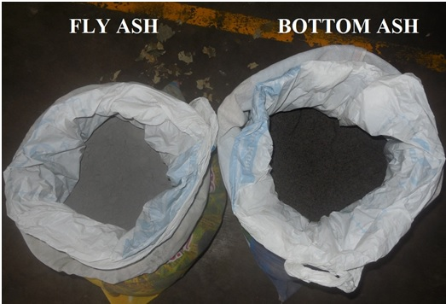
Figure 1. Fly ash and bottom ash samples
Viability Test for Fungal Treatment
Viability test was done to check whether the Trichoderma viride inoculated in the fly ash and bottom ash was viable or not. The inoculation of treated coal ash powder in PDA resulted in the formation of green colour which indicates the growth of Trichoderma viride.

Growth parameters of treated seeds

The growth parameters of Vigna radiata plants were observed after 6 days and the results of fly ash blended soil and bottom ash blended soil were tabulated in Table 1 and 2 respectively also shown in Fig 2.

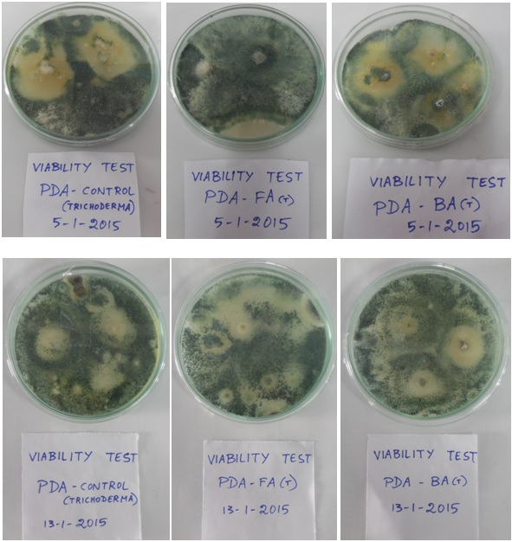
Figure 2. Viability Test for Treated coal ash
Table 1. Growth parameters of Vigna radiate seeds treated with fly ash
Parameters | Control | 5% | 10% | 15% | 20% | 25%
Length of shoot (cm) | 11.48 | 9.23 | 9.86 | 9.81 | 10.74 | 9.77
Length of root (cm) | 4.6 | 4.84 | 5.6 | 5.28 | 4.72 | 4.55
No of hairy roots | 28 | 21 | 23 | 18 | 19 | 17

Table 2. Growth parameters of Vigna radiata seeds treated with bottom ash
Parameters | Control | 5% | 10% | 15% | 20% | 25%
Length of shoot (cm) | 11.21 | 12.11 | 12.54 | 12.35 | 12.76 | 14.54
Length of root (cm) | 3.94 | 6.81 | 7.9 | 7.08 | 11.58 | 9.08
No of hairy roots | 23 | 22 | 20 | 19 | 32 | 30

The growth parameters of Vigna mungo plants were observed after 6 days and the results of fly ash blended soil and bottom ash blended soil were tabulated in Table 3 and 4 respectively also shown in Fig 3
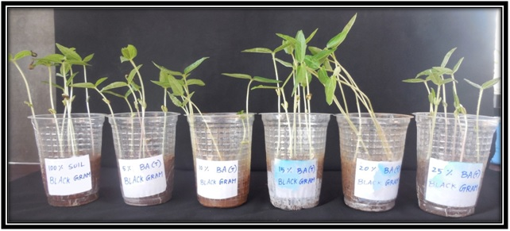
Figure 3. Treated seeds (Vigna radiata) in bottom ash

Table 3. Growth parameters of Vigna mungo seeds treated with fly ash
Parameters | Control | 5% | 10% | 15% | 20% | 25%
Length of shoot (cm) | 10.1 | 7.64 | 8.24 | 5.85 | 3.87 | 4.6
Length of root (cm) | 6.88 | 4.47 | 4.78 | 3.73 | 2.13 | 2.8
No of hairy roots | 12 | 13 | 10 | 11 | 4 | 6

Table 4. Growth parameters of Vigna mungo seeds treated with bottom ash
Parameters | Control | 5% | 10% | 15% | 20% | 25%
Length of shoot (cm) | 10.28 | 6.28 | 5.67 | 4.6 | 6.78 | 6.4
Length of root (cm) | 4.21 | 2.85 | 2.6 | 1.57 | 2.57 | 2.64
No of hairy roots | 9 | 9 | 9 | 6 | 10 | 8

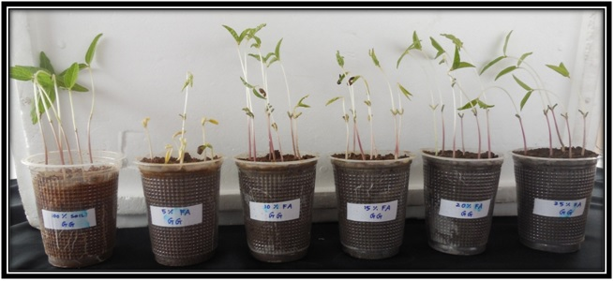
Figure 4. Treated seeds (Vigna mungo) in fly ash
Evaluation of plant growth in untreated coal ash

The growth parameters of plants were observed after 7 days and the results for control, fly ash blended soil and bottom ash blended soil were tabulated in Table 5,6,7 and8.

Table 5. Growth of Vigna radiate untreated fly ash
Parameters | Control | 5% | 10% | 15% | 20% | 25%
Length of shoot (cm) | 9.78 | 6.31 | 9.77 | 9.77 | 9.58 | 7.58
Length of root (cm) | 9.44 | 6.33 | 5.6 | 5.5 | 3.44 | 2.68
No of hairy roots | 25 | 21 | 21 | 19 | 13 | 11

Table 6. Growth of Vigna radiate untreated bottom ash
Parameters | Control | 5% | 10% | 15% | 20% | 25%
Length of shoot (cm) | 9.78 | 8.76 | 8.41 | 9.93 | 10.72 | 10.31
Length of root (cm) | 9.44 | 7.26 | 9.14 | 8.94 | 11.54 | 10.06
No of hairy roots | 25 | 25 | 27 | 25 | 27 | 29

Table 7. Growth of Vigna mungo untreated fly ash
Parameters | Control | 5% | 10% | 15% | 20% | 25%
Length of shoot (cm) | 11.14 | 10.86 | 10.34 | 12.24 | 12.7 | 11.33
Length of root (cm) | 6.82 | 8.04 | 3.76 | 4.71 | 3.95 | 4.14
No of hairy roots | 26 | 22 | 14 | 18 | 14 | 16
Table 8. Growth of Vigna mungo untreated bottom ash
Parameters | Control | 5% | 10% | 15% | 20% | 25%
Length of shoot (cm) | 11.14 | 9.6 | 8.06 | 11.1 | 9.07 | 11.76
Length of root (cm) | 6.82 | 8.08 | 3.11 | 6.87 | 9.68 | 10.31
No of hairy roots | 26 | 24 | 9 | 26 | 25 | 30

Evaluation of plant growth in treated coal ash

Treated coal ash (bioremediated coal ash) is blended with soil in the following concentrations such as 0%, 5%, 10%, 20% and 25% (W/W). Cup assay with treated coal ash was done only with Vigna mungo seeds. The growth parameters of the plants in treated fly ash and treated bottom ash were measured after 7 days and the results were tabulated in Table 9 and 10.

Table 9. Growth of Vigna mungo treated fly ash
Parameters | Control | 5% | 10% | 15% | 20% | 25%
Length of shoot (cm) | 9.83 | 8 | 7.21 | 7.68 | 6.77 | 9.16
Length of root (cm) | 7.80 | 5.03 | 6.15 | 6.84 | 6.01 | 9.65
No of hairy roots | 37 | 28 | 18 | 27 | 22 | 34

Table 10. Growth of Vigna mungo treated bottom ash
Parameters | Control | 5% | 10% | 15% | 20% | 25%
Length of shoot (cm) | 9.83 | 7.1 | 10.37 | 9.67 | 7.45 | 12.77
Length of root (cm) | 7.80 | 5.15 | 7.24 | 7.14 | 7.11 | 9.47
No of hairy roots | 37 | 27 | 25 | 29 | 33 | 38

Table 11. Pot assay for the growth of Vigna mungo
Parameters | Control | 10% FA(UT) | 25% FA(T) | 25% BA(UT) | 25% BA(T)
Length of shoot (cm) | 13.24 | 13.31 | 13.46 | 14.10 | 13.15
Length of root (cm) | 14.46 | 5.4 | 7.185 | 14.335 | 14.63
No of hairy roots | 35 | 31 | 20 | 38 | 35

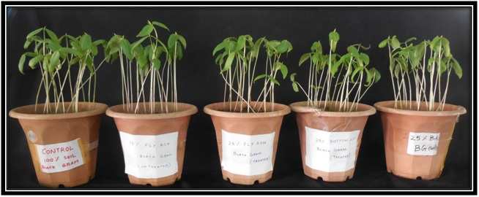
Pot assay for the growth of Vigna mungo
Estimation of Biochemical parameters
Estimation of chlorophyll content by DMSO method

The chlorophyll content of the plants which were grown in pot assay was estimated by using DMSO method. The readings were tabulated in Table 12.

Table 12. Chlorophyll content – DMSO method – Vigna mungo
 | Total Chlorophyll (mg/l) | Chlorophyll a(mg/l) | Chlorophyll b (mg/l)
Control | 12.06 | 7.86 | 4.199
10%FA(UT) | 10.06 | 6.67 | 3.39
25%FA(T) | 7.25 | 4.76 | 2.49
25%BA(UT) | 7.81 | 5.155 | 2.66
25%BA(T) | 8.37 | 5.49 | 2.88

Estimation of reducing sugars by Dinitrosalicylic acid method:
The amount of reducing sugar present in the plants grown via pot assay was estimated by using DNS method. The results were tabulated in Table 13.

Table 13. Reducing sugar estimation – DNS method – Vigna mungo
Sample | Reducing sugar content(mg/ml)
Control | 5.094
10%FA(UT) | 0.933
25%FA(T) | 1.183
25%BA(UT) | 1.688
25%BA(T) | 2.323

Discussion
The composition of fly ash and bottom ash revealed the presence of heavy metals such as arsenic, lead, zinc which affect the growth of plants adversely. The presence of arsenic resulted in symptoms of phytotoxicity and in considerable inhibition of initial growth of young black gram plants [14] and the presence of lead results in the reduction of cholorophyll content on Vigna mungo plants [15]. This is the reason why plant growth begins to retard as the concentration of coal ash is increased. Therefore the concentration of heavy metal coal ash needs to be reduced.
The optimal concentration of untreated fly ash and bottom ash for Vigna radiata seeds were recorded as 10 % and 20 %, respectively, whereas, Vigna mungo seeds showed better results at 10 % and 25 % untreated fly ash and bottom ash. 5-10 % fly ash-soil blending concentration showed better yield and improved the physiochemical characters of the soil [16].
Fungal strains are generally used in the process of bioremediation for significant reduction of heavy metals and toxins while some studies have shown enhanced phytoextraction through the accumulation of heavy metals in plants.
Trichoderma viride was used to treat coal ash and the composition analysis done after treatment showed that the concentration of arsenic, lead and zinc were reduced in fly ash and in case of bottom ash, lead and zinc concentration was reduced. In addition, the concentration of essential nutrients such as N, P, K and Mg were found to be increased by the treatment. The results obtained in the study suggest that coal ash can be used at higher concentration after bioremediation.
Furthermore, the tolerable level of fly and bottom ash has increased from 10% to 25% after treatment with Trichoderma viride. The results of phytochemical analysis of the plants grown in untreated coal ash showed reduction in chlorophyll and reduction in sugar content as compared to plants grown in 100 % soil. Also, the reduction was observed to be dose dependent. The process of bioremediation provides a solution for this problem, as suggested by the increase in phytochemical content of the plants grown in treated coal ash. The results of phytochemical analysis showed the level of chlorophyll and reducing sugar was reduced when 10 % fly ash and 25 % bottom ash were blended with soil. The level of chlorophyll reduced from 12.06 to 10.06 and level of reducing sugar reduced from 5.094 to 0.933. The phytochemical analysis of plants grown in treated coal ash indicated a rise in the level of phytochemicals.

Conclusion
Fly ash and bottom ash has immense potential as a soil-ameliorating agent and is immensely used in agricultural, forestry and waste reclamation because of its heterogeneous nature. The usage of untreated coal ash blended soil resulted in the accumulation of heavy metals in the plants which may cause adverse effect to agricultural land as well as living organism ingesting those plants. Thus it could be deduced that bioremediation of coal ash provides a way to reduce the accumulation of heavy metals, thereby making it much safer for agriculture.

References

[1] Aggarwal, S.; Singh, G.R. and. Yadav, B.R. Utilization of Fly ash for Crop Production: Effect on the Growth of Wheat and Sorghum Crops and Soil Properties. Journal of Agricultural Physics. Vol. 9, p.p. 20-23. 2009.

[2] Singh, L.P. and Siddiqui, Z.A. Effects of fly ash and Helmintho sporiumoryzae on the growth and yield of three cultivars of rice. Bioresource Technology. Vol. 25, p. p.78-86. 2003.

[3] Rautaray, S. K.; Ghosh, B.C. and Mittra, B.N. Effect of fly ash organic wastes and chemical fertilizers on yield, nutrient uptake, heavy metal content and residual fertility in a rice-mustard cropping sequence under acid lateritic soils’, Bioresource Technology. Vol. 90, pp. 275-283. 2003.

[4] Lee, H.; Ha, H.S.; Lee, C.S.; Lee, Y.B. and Kim, P.J. Fly ash effect on improving soil properties and rice productivity in Korean paddy soil’, Bioresource Technology, Vol. 97, pp.1490-1497. 2006.

[5] Tiwari, S.; Kumari, B. and Singh, S.N. Evaluation of metal mobility or immobility in fly ash induced by bacterial strains isolated from the rhizospheric zone of Typhalati folia growing on fly ash dumps. Bioresource Technology. Vol. 99, pp. 1305-1310. 2008.

[6] Petruzzelli, G.; Lubrano, L. and Guidi, G. Uptake by corn and chemical extractability of heavy metals from a four years compost treated soil. Plant and soil. Vol. 16, pp. 23-27. 1989.

[7] Kowapradit, S.; Pongnak, W. and Soytong, K. Biological ash from bottom coal ash mixed with beneficial fungi on the growth of rice varpathumthani. J. o Agricultural Technology. Vol. 3, No. 1, pp. 129-136. 2005.

[8] Leyval, C.; Joner, E.J.; Del Val, C. and Haselwandter, K. Potential of Arbuscular mycorrhizal fungi for bioremediation. Mycorrhizal Technology in Agriculture. Ed .by S.Gianinazzi et al., (Ist edition), Springer Basel AG, Published, Birichausor Verlag, Switzerland. pp, 175-186. 2002.

[9] Lakshman, H.C. Symbiotic association of Arbuscular mycorrhizal fungi in rhizospheric soils of Jatropha curcas. International J. o Plant Sciences (Muzaffarnagar). Vol. 4, No. 1, pp. 120-122. 2009.

[10] Barnes, J.D.; Balaguer, L.; Manrique, E.; Elvira, S. and Davison, A.W. A reappraisal of the use of DMSO for the extraction and determination of chlorophylls a and b in lichens and higher plants. Environmental and Experimental Botany. Vol. 32, No. 85, pp. 8-10. 1992.

[11] Luisa, E.B.; Philippe, L. and Vilma, C.M. Leaf Chlorophyll content estimation in the Monarch Butterfly Biosphere Reserve’, Rev. Fiototec. Mex. Vol. 33 No. 2, pp. 175-181. 2010.

[12] Hiscox, J.D. and Israelstam, G.F. A method for the extraction of chlorophyll leaf tissue without maceration. Canadian J. o Botany. Vol. 57, pp. 1332-1334. 1979.

[13] Miller, G.L.Use of dinitrosalicylic acid reagent for determination of reducing sugar. J. o Analytical Chemistry. Vol. 31, pp. 426. 1959.

[14] Saumya S. and Yogesh K. S. Impact of Arsenic Toxicity on Black Gram and Its Amelioration Using Phosphate. Hindawi Publishing Corporation ISRN Toxicology, Vol. 20, pp. 8. 2013.

[15] Gurpreet, S.; Agnihotri, R.K.; Reshma, R.S. and Ahmad, M. Effect of lead and nickel toxicity on chlorophyll and proline content of Urd (Vigna mungo) seedlings. Indian J. o Plant Physiology and Biochemistry. Vol. 10, No. 10, pp. 30-32. 2012.

[16] Pawan L.; Vidyadhar, V.; Gedam, R.J. and Christian J. Engelsen. A comprehensive physic-chemical, mineralogical and morphological characterization of Indian mineral waste. Environmental Monitoring and Assessment, DOI 10.1007/s10661-012-3029-7. 2013

