Potential use of cyanophyta species Oscillatoria limnetica in bioremediation of organophosphorus herbicide glyphosate

Jasim M. Salman ¹ Esraa Abdul-Adel¹

1Department of Biology, College of Science, University of Babylon,Iraq.

Corresponding author: jasimsalman@uobabylon.edu.iq
To cite this article:

Salman, J.M. and Abdul-Adel, E. Potential use of cyanophyta species Oscillatoria limnetica inbioremediation of organophosphorus herbicide glyphosate. Mesop. environ. j., 2015, Vol. 1, No.4, pp. 15-26 .

This work is licensed under a Creative Commons Attribution-NonCommercial-NoDerivatives 4.0 International License.

Abstract:

One locally microalga species Oscillatoria limnetica was isolated from the artificial canal around University of Babylon in Al-Hilla city. The isolated microalga species was cultivated in BG-11 media for biomass production and to test their ability to degrade glyphosate that is the widely used organophosphorus herbicide by high performance liquid chromotography analysis. HPLC appeared to be an effective technique to follow decrease of glyphosate in biodegradation process.
Removal efficiencies of glyphosate were evaluated and compared. The results confirmed the high efficiencies of O.limnetica for the removal of the target contaminant.
There were significant differences in the rate of glyphosate removal from the medium after 3, 5, 7, 14 and 35 days in all treatments. It was 97.5% after seven days at 5 mg/l treatment, 57.9% and 37.1% after fourteen days at 10 mg/l and 15 mg/l treatments, respectively and 99.9% after thirty five days at 20 mg/l treatment. Maximum removal efficiency percentages of isolated species were increased to reach their maximum in all treatments after thirty five days.

Keywords: Cynophyceae, Oscillatoria limnetica , Herbicide , Gyphosate Bioremediation.

Introduction
As a result of human influence, the amounts of organic compounds found in surface water have increased in the recent decades. Of these organic compounds, pesticides are most commonly detected in all aquatic environments [1]. Although the use of pesticidees increases the productivity of crop and control unwanted organisms, but also increase the contamination of water resources. This pollution can reduce water quality and lead to significant economic effects when pollutant concentrations warrant closure or mandate remediation of a contaminated drinking water source [2 ; 3]. This
contamination stems from the action of rainwater and irrigation water that can take these compounds and carry them to rivers and lakes that are used in cities for water supply [4].
Glyphosate-based herbicides are the world’s leading broad spectrum, post-emergent and non-selective herbicides for the control of annual and perennial weeds in agricultural lands, ornamental and residential gardens and in aquatic systems[4]. In the last decades glyphosate consumption has increased sharply and it has become one of the most used agrochemicals globally [5]. Glyphosate is a competitive inhibitor of the enzyme 5-enolpyruvylshikimate 3-phosphate synthase EPSPS), which is involved in the pathway of synthesis of shikimic acid [6].
A treatment that promises to be efficient, economic and safe is bioremediation. This kind of treatment has been approached from a biotechnological point of view in order to be able to have a methodology that is carried out at lower temperature and pressure and requires less energy than the conventional physical-chemical treatment technology, as well as avoiding additional damages to the environment [7]. Bioremediation may provide a suitable method for treatment of water pollution with pesticides effectively [8].
Microalgae are eukaryotic, as the green algae (Chorophytceae) or prokaryotic photosynthetic microorganisms, as the blue-green algae (cyanophyceae) [9]. They are considered to be the principal agents for the degradation of pesticides in bioremediation processes. Their cell size, morphology, density and activities show an important role in the uptake and removal of pesticides. High surface area to biovolume ratio of algae provides greater potential for sorption and subsequent interaction with pesticides [10].
Therefore, this study wasconducted to investigate the survival and tolerance of cynophyceae species (Oscillatoria limnetica) with different concentrations of glyphosate, as well as evaluating their efficiency for removing and recovering this pesticide from contaminated water by high performance liquid chromatography (HPLC) analysis.
Material and Methods
Sample collection and identification
Samples of freshwater algae were collected from artificial canal around University of Babylon in Al-Hilla city by using phytoplankton net.
Phytoplankton net (mesh size 0.50 μm) which made of silk cloth [11] was swept on surface water and samples were transferred into sterile plastic bottles/containers which marked with data and location of sampling then carried to the laboratory at once to be incubated in suitable and controlled conditions for algae growth [12]. Experimental cultures were incubated at cool white fluorescent lamps (200) μE/m²/s with a light/dark cycle of 16/8 h. and 26± 1°C [13]. Moreover the cultures were mildly shaken by hand on alternate days [14].

Preparation and sterilization of media

Modified BG-11 medium was used for the enhancement of cyanophyta growth [15] quoted from [16]. The stocks were prepared for all macro and micro elements (Table1) and dissolved in one liter of distilled water to prepare BG-11 culture medium. Micronutrient solution was sterilized by filtration through 0.22-mm polycarbonate membrane to avoid interaction and precipitation of heavy metals [17]. BG-11 medium was autoclaved at 121C° for 15min.when cooled, pH was adjusted to approximately 7.4 with 1N NaOH and 1N HCl using pH meter to avoid heavy precipitation [18].

Table 1. BG-11 medium components

Components | Stock solution g.L⁻¹dH₂O |  | Quantity Used | Concentration in Final Medium (M)
NaNO₃ |  |  | 1.5 g | 1.76 X 10⁻²
K₂HPO₄ . 3H2O | 40 |  | 1 ml | 1.75 X 10⁻⁴
MgSO₄ · 7H₂O | 75 |  | 1 ml | 3.04 X 10⁻⁴
CaCl₂ · 2H₂O | 36 |  | 1 ml | 2.45 X 10⁻⁴
Na₂CO₃ | 20 |  | 1 ml | 1.89 X 10⁻⁴
Citric acid | 6 |  | 1 ml | 3.12 X 10⁻⁵
EDTA (disodium salt) | 1 |  | 1 ml | 2.79 X 10⁻⁶
Ferric ammonium citrate | 6 |  | 1 ml | ~3 X 10⁻⁵
Trace metals mix A5 | As shown below |  | 1 ml
Trace metals mix A5 |  | Amount g |  | Concentration in Final Medium (M)
H₃BO₃ |  | 2.86 |  | 4.63 X 10⁻⁵
MnCl₂.4H₂O |  | 1.81 |  | 9.15 X 10⁻⁶
ZnSO₄.7H₂O |  | 0.22 |  | 7.65 X 10⁻⁷
NaMnO₄.2H₂O |  | 0.39 |  | 1.61 X 10⁻⁶
CuSo₄.5H₂O |  | 0.079 |  | 3.16 X 10⁻⁷
Co(NO₃)₂.6H₂O |  | 0.049 |  | 1.70 X 10⁻⁷
Distilled water |  | 1 L

Algae isolation and purification:

Serial dilution culture (SDC) technique

Serial dilutions of the collected samples were prepared starting with 1ml of sample inoculated into 9 ml of BG-11 media. This procedure was repeated with examining of each dilution until one species of algae were obtained. After the target dilution was microscopically examined several times to confirm obtaining unialgal culture, 2 ml of unialgal culture was transferred into 20 ml of fresh BG-11 enhancement solution then incubated under suitable conditions for algal growth till the culture turn into greenish color [19,20]. Obtained algal isolates were identified with the help of classical algal classification references [21, 22].

Agar plating technique

BG-11 nutrient medium solidified by 2% agar-agar and autoclaved, after sterilization, BG-11 media with 45-50 C˚ was poured into petri-dishes and left to solidify. Then the surface of each plate was inoculated with 1 ml of sampled water, the inoculum distributed with a sterile spreader or streaking using a sterile loop. The inoculated plates were kept under suitable and controlled conditions for algae growth in a cooled illuminated incubator with about 200 µE/m²/s light intensity and 16:8 light: dark period for two weeks [13]. Aggregated colonies were noticed on the surface of the plates. Part of these colonies was cultured on other plates. Each subculture was examined intervally, this method was repeated till an unialgal

culture or cultures have been obtained [23]. A small part of unialgal culture (which was microscopically confirmed as unialgal culture) was transferred into BG-11 nutrient solution within a 250 ml sterile flask and incubated for 2-3 weeks according to the method of Jawad [19] to get appropriate growth.

Alga cultivation for biomass.

Prepared 10 ml of isolated alga was grown in 250ml Erlenmeyer flask containing 100 ml of BG-11 medium for two weeks, then transferred to 1000 ml of medium and incubated for 14 days; finally the growth transported to glass pools 5L for mass culture [24 , 25].

Pesticide

The organophosphorus pesticide used in this study is the formulation of the herbicide glyphosate commercially available as Roundup® (containing 480 g active ingredient/L of glyphosate) was obtained from Al-Farah company, Iraq.
Experimental Design

The selected algal isolates were batch-cultured in 500 ml Erlenmeyer flasks. Into each flask 200 ml of liquid culture media, BG11 medium for O.limnetica ,was added. Glyphosate was added to the culture medium to the final concentrations 5 , 10 , 15 , 20 mg/l. The flasks were cultivated under the conditions described above. After 3 , 5 , 7, 14and 35 days, 5 ml of algal cultures was filtrated by Millipore filter 0.45 µm. The algal filtrate was used to determine glyphosate residues in the culture medium by high performance liquid chromatography (HPLC).

HPLC analysis of glyphosate.

Analysis of residual glyphosate was done using HPLC system (shimadzu, japan) with a chromatographic column 80SAX from GMB, Germany (length: 25cm, diameter: 4.6mm, particle size: 5 µl) and UV detector at 195 nm. The isocratic mobile phase consisted of 0.8437 g of KH₂PO₄ dissolved in 960 ml distal water and 40 ml of MeOH, and the pH was adjusted to 2.1 with 85% orthophosphoric acid at a flow rate of 1 ml/min.
The standards and samples (50 µl) were injected into the HPLC system after they were filtered by Millipore filter paper (0.45 µm. pore size) and the time required by a sample to pass through the system is recorded as its retention time. The concentration of residential glyphosate was determined by the following formula:

C sample = C: concentration, A: area
Analysis of glyphosate removal
In agreement with the methodology described by [26]. The percent reductions of glyphosate were calculated by the equation:
Parameter reduction (%) = * 100
A = Initial concentration of glyphosate , B= Concentration after treatment.

Statistical Analysis

The general treatment structure was used as an experimental design. Data were analyzed to study bioremediation capacity of O. limnetica and Least significant difference (LSD) was used to compare the significant difference between means at p<0.05.

Results and Discussion

Data present in Table 2 illustrated that O. limnetica have the ability to biodegrade glyphosate at different concentrations and siginificant differences were recorded between initial and residual concentrations after 3, 5, 7, 14 and 35 days.
Glyphosate was reduced from an initial value of about 5 mg/l to 1.95 mg/l, 0.13 mg/l and 0.12 mg/l which corresponds to 60.89%, 97.33% and 97.55% removal efficiency after three, five and seven days of treatment, respectively.In 10mg/l treatment, glyphosate concentration was reduced to 7.17 mg/l, 6.78mg/l, 6.66mg/l and 4.20, which equating to a removal efficiency of approximately 28.25 %, 32.13 %, 33.90and 57.9% after three, five, seven,and fourteen days of treatment, respectively.In addition, 15mg/l reduced to 12.56 mg/l, 11.30 mg/l, 10.35 mg/l and 9.42 mg/l, which equates to 16.22%, 24.64 %, 30.98 % and 37.18 % removal efficiency after three, five, seven and fourteen days of treatment, respectively.While 20 mg/l reduced to 9.86 mg/l, 4.63 mg/l and 0.02 mg/l which equates to 50.68 %, 76.82 % and 99.9% removal efficiency after seven,fourteen and thirty five days of treatment, respectively. After thirty five days there was no glyphosate in all treatments because the peak of glyphosate disappeared after that time.
In agreement with these results [27]reported that mixed culture of Spirulina spp. showed a remarkable capacity to degrade the widely used organophosphorus herbicide glyphosate, that served as sole source of phosphorus for cyanophytal growth. Also, [28] study the tolerance of six cyanophytal strains to the herbicide up to millimolar concentrations. Four strains (Arthrospira fusiformis, Leptolyngbya boryana, Microcystis aeruginosa and Spirulina platensis) were able to use the phosphonate as the sole phosphorus (P) source for growth while two strains (Anabaena sp. and Nostoc punctiforme) were found to possess a glyphosate-insensitive form of EPSP synthase, which is in line with the findings of [29] who reported that tolerance of Anabaena variabilis ATCC 29413 is related to the presence of a resistant form of the target enzyme EPSP reported that tolerance of Anabaena variabilis ATCC 29413 is related to the presence of a resistant form of the target enzyme EPSP. [30] too stated that the existence of phosphorous-dependent glyphosate transformation with marine cyanophyta species Trichodesmium erythraeum.
In general, data obtained from Foriani et al. [28] suggested that some hydrolytic enzymes inside the cyanophyta cells may be able to distinguish the herbicide molecule as a substrate, even though with low efficiency. The resulting low rate of C–P bond hydrolysis could not be able to destroy high levels of glyphosate, but may be sufficient to provide the cell with lower quantities of phosphate that are required for growth in the absence of extra physiological phosphorus sources. According to them, the initial tolerance up to 20 mM is in line with the previous reports [31 ; 32] on varying resistance of cyanophyta to this herbicide. On the other hand, the low permeability of the cell membrane to the phosphonate seems to represent another mechanism that allows some cyanophyta strains to grow in the presence of the herbicide. At micromolar concentrations, those at which diffusion across the membrane does not work [33], glyphosate incorporation appears to proceed through a low affinity carrier, and low amounts of herbicide are incorporated into the cell.

Table 2. The residual concentration of glyphosate after (3,5,7,14,35) days and O.limnetica removal effenciency(%).

20mg/l |  | 15mg/l |  | 10mg/l |  | 5mg/l |  | Exposure  time (days)
Removal Efficiency  (%) | Residual  Concentration  mg/l | Removal Efficiency  (%) | Residual  Concentration  mg/l | Removal Efficiency  (%) | Residual  Concentration  mg/l | Removal Efficiency  (%) | Residual  Concentration  mg/l | Exposure  time (days)
------ | ------ | 16.22 | 12.56 | 28.25 | 7.17 | 60.89 | 1.95 | 3
------ | ------ | 24.64 | 11.30 | 32.13 | 6.78 | 97.33 | 0.13 | 5
50.68 | 9.86 | 30.98 | 10.35 | 33.90 | 6.66 | 97.55 | 0.12 | 7
76.82 | 4.63 | 37.1 | 9.4 | 57.9 | 4.20 | ------ | ------ | 14
99.9 | 0.02 | ------ | ------ | ------ | ------ | ------ | ------ | 35
 | 0.941* |  | 0.817* |  | 0.813* |  | 0.941* | LSD value
- (p < 0.05)
A significant differences between treatments and residual concentration after all days.

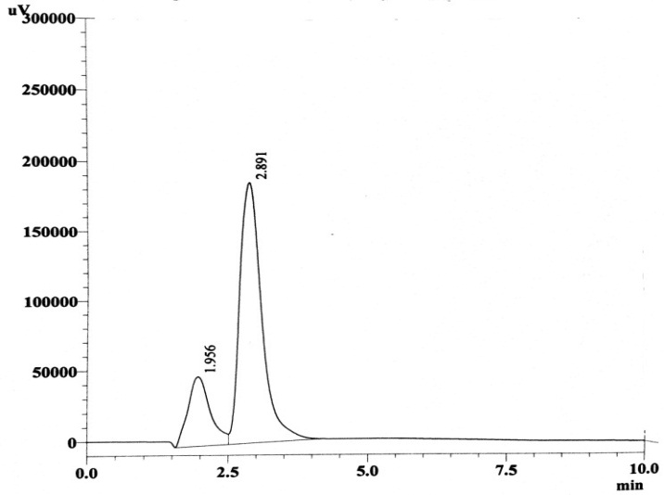
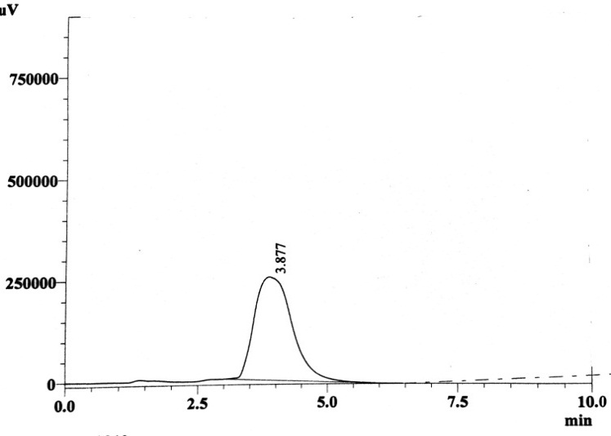
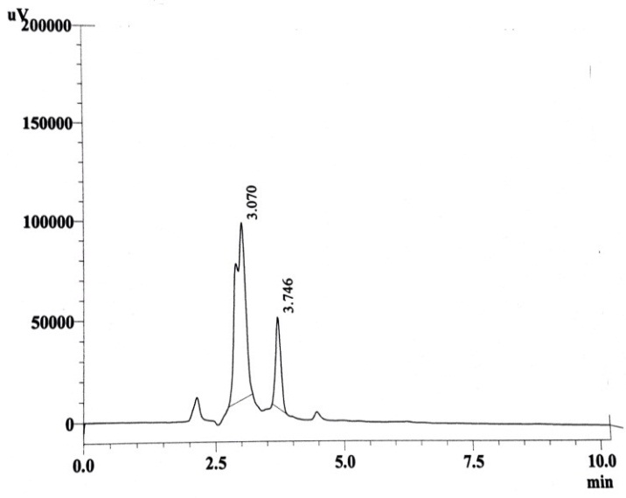
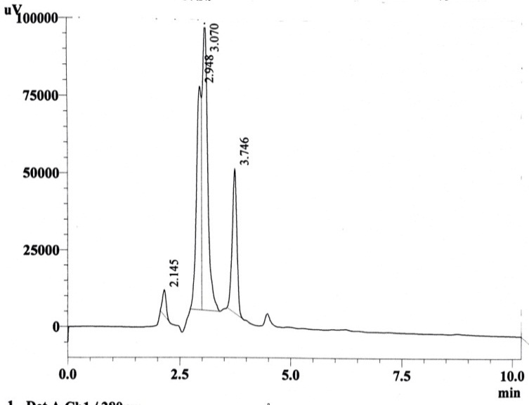
(A) (B)
(C) (D)

Fig. 1:Chromatogram of HPLC forGlyphosate standard solution at 5 mg/l (A) and sample of O.limnetica at 5 mg\l glyphosate concentration after 3 days (B), 5 days (C), 7 days (D).

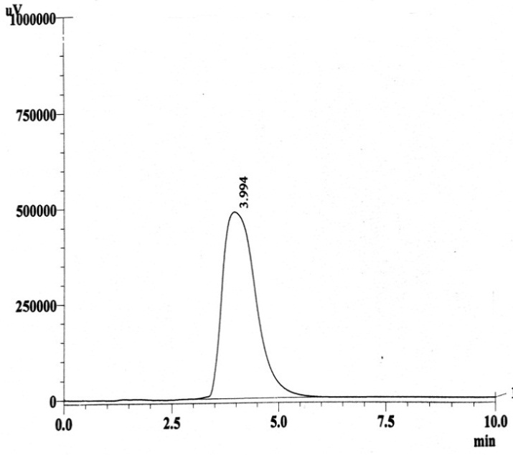
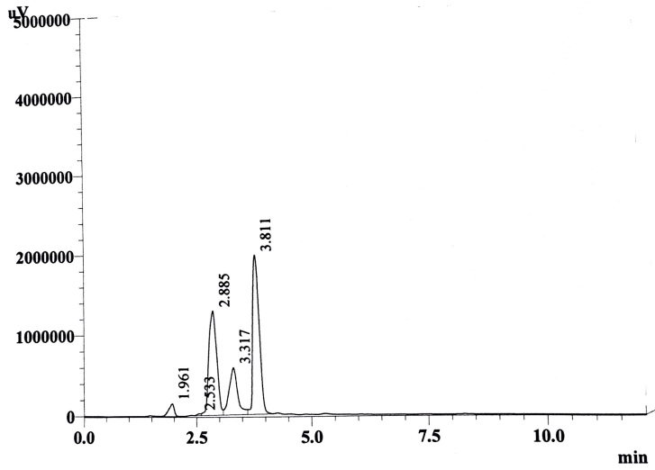
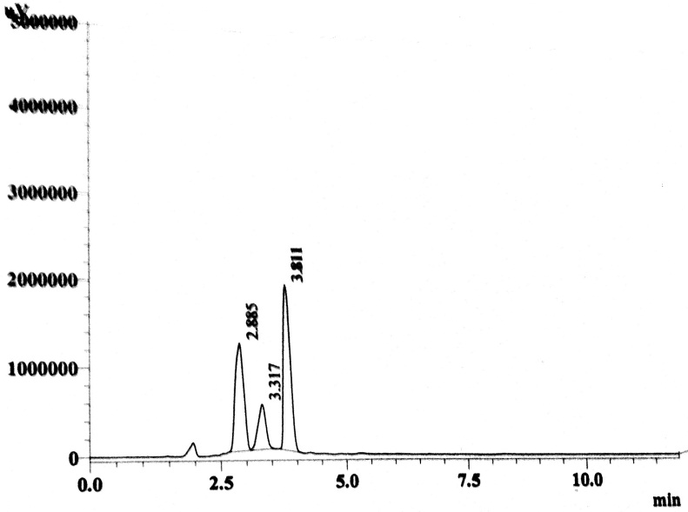
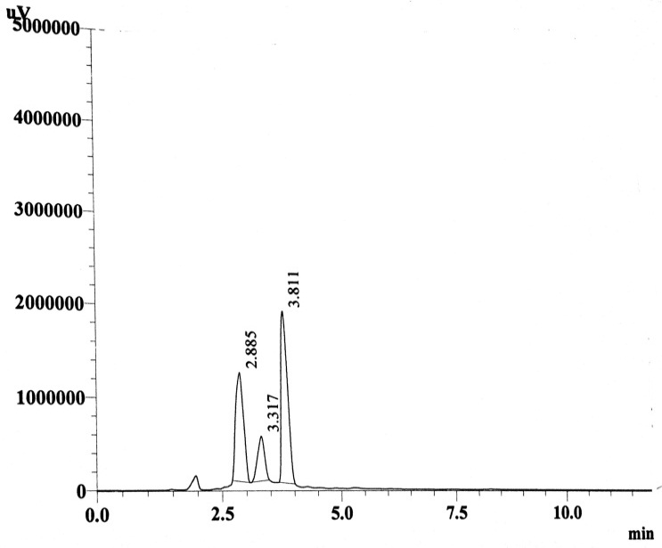
(A) (B)
(C) (D)
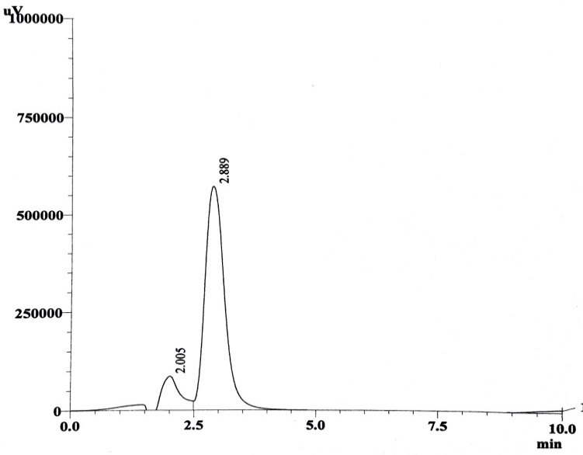

(E)
Fig. 2:Chromatogram of HPLC for glyphosate standard solution at 10 mg/l (A) andsample of O.limnetica at 10 mg\l glyphosate concentration after 3 days (B), 5 days (C), 7 days (D), 14 days (E).

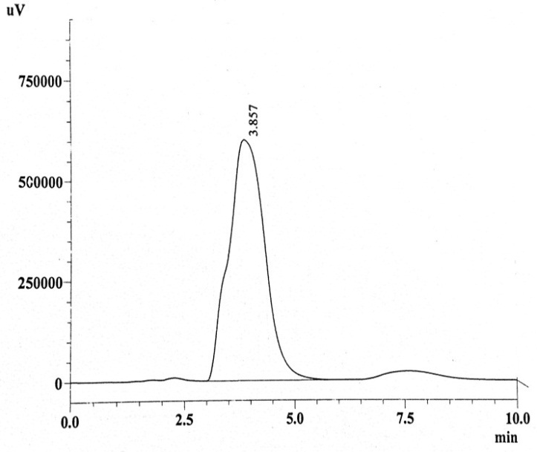
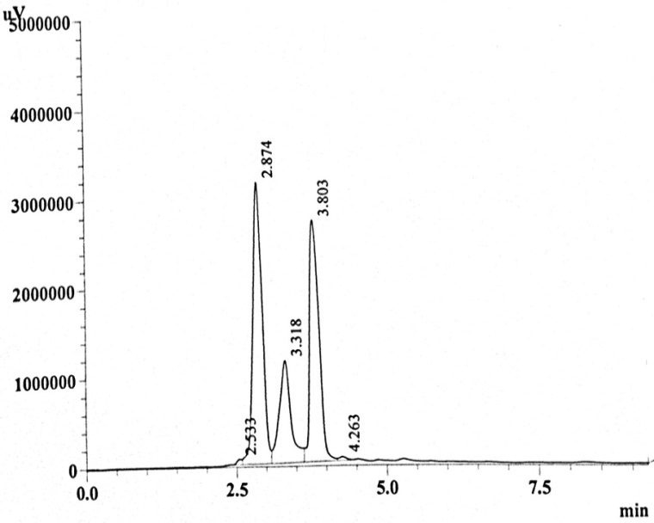
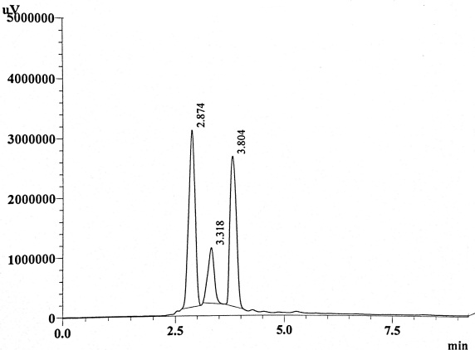
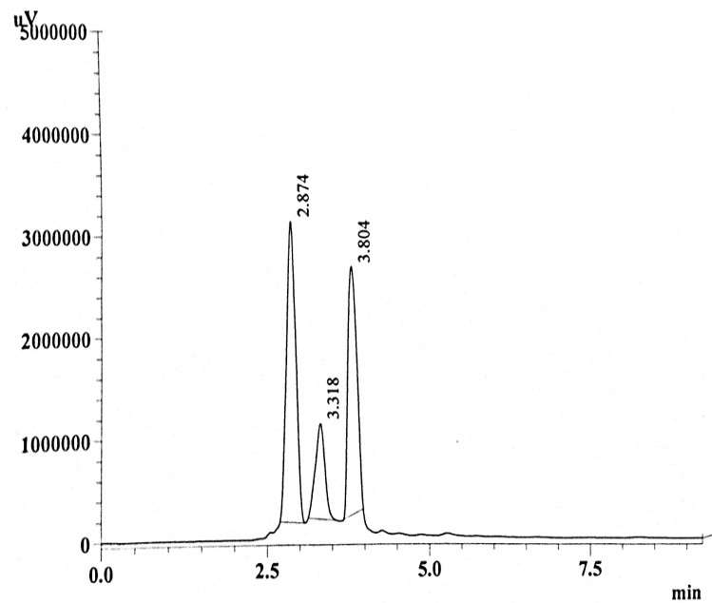
(A) (B)
(C) (D)
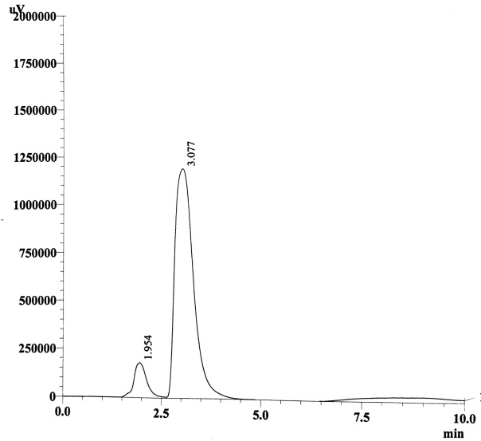

(E)
Fig. 3: Chromatogram of HPLC for glyphosate standard solution at 15 mg/l(A) and sample of O.limnetica at 15 mg\l glyphosate concentration after 3 days (B), 5 days (C), 7 days (D), 14 days (E).

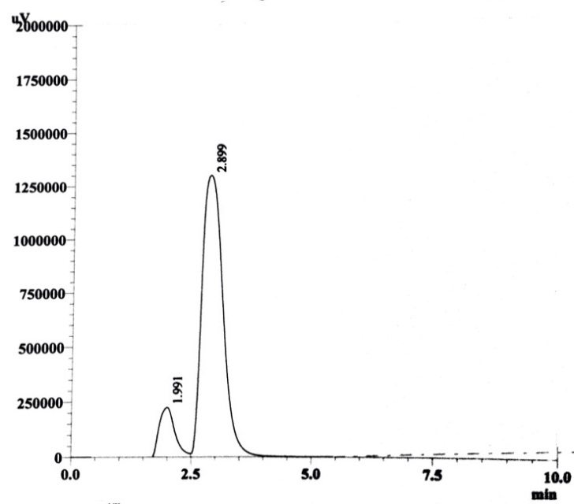
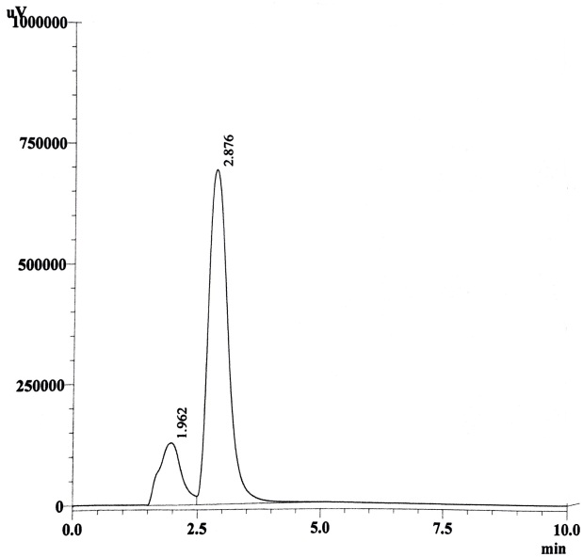
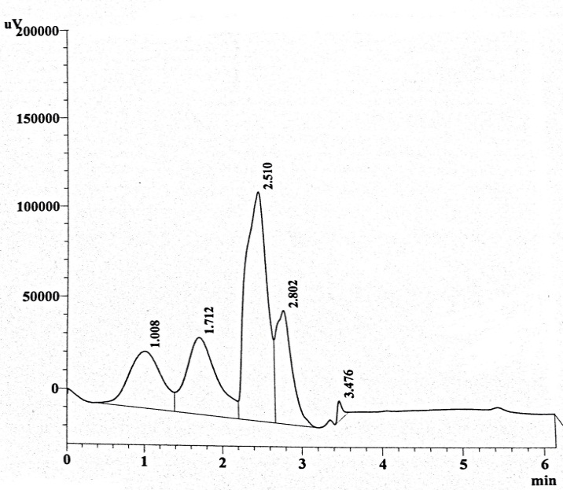
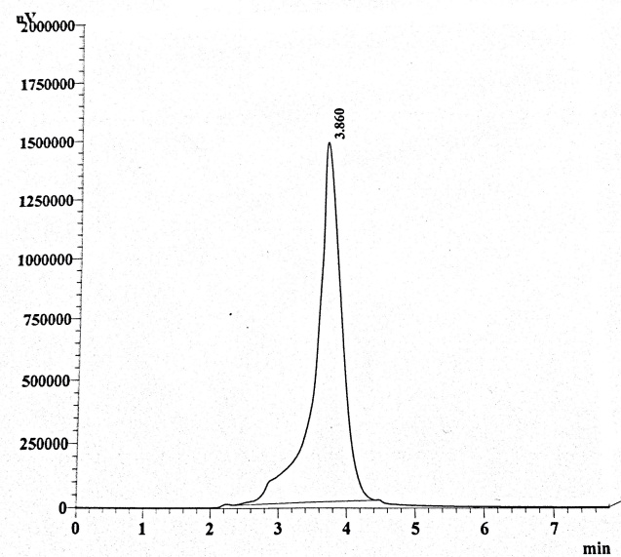
(A) (B)
(C) (D)

Fig. 4:Chromatogram of HPLC for glyphosate standard solution at 20 mg/l (A) and sample of O.limnetica at 20 mg\l glyphosate concentration after 7 days (B), 14 days (C), 35 days (D).

Conclusions

(1) The capacity of Oscillatoria limnetica to survive and grow in the high concentrations level of the herbicide, show that this strain may possess potential to be used in bioremediation of glyphosate-contaminated environments. In addition, this work adds to the list of glyphosate degrading organisms a new degrading species that is O. limnetica
(2) Glyphosate degradation was measured by HPLC. The method’s sensitivity is suitable and reliable to evaluate the presence of glyphosate in water samples.
(3) Glyphosate removal efficiency percentages of O.limneticawere increased to reach their maximum in all treatments after thirty five days.

Acknowledgment

All material of this study was supported by department of Biology,College of Science and Environmental Research Center,University of Babylon.

References

[1] Ali, U.;Syed, J. H.;Malik, R. N.; Katsoyiannis, A.; Li, J.; Zhang, G. and Jones, K.C.Organochlorine pesticides (OCPs) in South Asian region: a review. Science of the Total Environment, Vol.476/477,pp.705–717.2014.

[2] Fenner, K.; Canonica, S.; Wackett, L.P. and Elsner, M. Evaluating pesticide degradation in the environment: blind spots and emerging opportunities. Science, Vol.341,No.6147,pp.752–758.2013.

[3] Simonsen, A.; Badawi, N.; Anskjær G.G.; Albers, C.N.; Sørensen, S.R.; Sø- rensen, J. and Aamand, J.Intermediate accumulation of metabolites results in a bottleneck for mineralisation of the herbicide metabolite 2,6- dichlorobenzamide (BAM) by Aminobacter spp. Applied Microbiology and Biotechnology,Vol.94,No.1,pp.237–245.2012.

[4] Lipok, J.; Studnik, H. and Gruyaert, S.The toxicity of Roundups 360 SL formulation and its main constituents: Glyphosate and isopropylamine towards non-target water photoautotrophs. Ecotoxicology and Environmental Safety, Vol.73,No.1,pp.1681-1688.2010.
[5] Zhang, W.; Jiang, F. and Ou, J. Global pesticide consumption and pollution: with China as a focus. Proceedings of the International Academy of Ecology and Environmental Sciences, Vol.1,No.2,pp.125-144.2011.

[6] Serra, A. A.; Nutten, S. A.; Larvor, V.; Renault, D.; Couée, I.; Sulmon, C. and Gouesbet, G. Low environmentally relevant levels of bioactive xenobiotics and associated degradation products cause cryptic perturbations of metabolism and molecular stress responses in Arabidopsis thaliana. Journal of Experimental Botany, Vol.64,No.10,pp.2753–2766.2013.

[7] Araya, M.and Lakhi, A. Response to consecutive nematicide application using the same product in Musa AAA cv. Grande Naine originated from in vitro propagative material and cultivated on a virgin soil. Nematologia Brasileira,Vol.28,No.1,pp.55-61.2004.

[8]Monteiro, C.; Castro P.and Malcata F.Metal uptake by microalgae: underlying mechanisms and practical applications. Biotechnology Progress,Vol.28,No.2,pp.299-311.2012.

[9] Mata, T.M.; Martins, A.A.and Caetano, N.S. Microalgae for biodiesel production and otherapplications: A review. Renewable and Sustainable Energy Reviews,Vol.14,No.1,pp.217–232.2010.
[10] Subashchandrabose, S. R. ; Ramakrishnan, B. ; Megharaj, M. ; Venkateswarlu, K.and Naidu, R. Mixotrophic cyanobacteria and microalgae as distinctive biological agents for organic pollutant degradation.Environment International, Vol.51,59–72.2013.
[11] Mansor, R. ; Ab Rahman, N. S. ; Mohamad, S. F. ; Kuppusamy, P. ; Yusoff, M. M. and Govindan, N. Isolation and Identification of Marine Algae (Oscillatoria Sp.) From Kuantan Coastal Region Malaysia and Studies on Their Bioactive and Antibacterial Properties. World Applied Sciences Journal, Vol.28,No.2,pp. 200-204.2013.

[12]Priya-Gopinath, T. and Ajit Kumar, K. G. MICRO ALGAL DIVERSITY OF THE FRESH WATER LAKE INTHIRUVANANTHAPURAMDISTRICT, KERALA. International Journal of Plant, Animal and Environmental Sciences, Vol.5, No.1, pp. .2015.

[13]Shoker R. M. H. and Jawad, A. M. Evaluation of Isolated Compounds Activity from Convolvulus Arvensis Against Algae. Iraqi Journal of Science, Vol.54,No.1,pp.62-71.2013.

[14] Selvan, B. K.; Revathi, M.; Piriya, P. S. and Vasan, P. T. Biodiesel production from marine cyanobacteria cultured in plate and tubular photobioreactors. Indian Journal of expermnetal biology, Vol.51,No.3,pp.262-268.2013.

[15] Rippka, R.; Deruelles, J.; Waterbury, J.B.; Herdman, M. and Stanier, R.Y.Generic assignments, strain histories and properties of pure cultures of cyanobacteria.Journal of General Microbiology, Vol.111, No.1, pp.1-61.1979.

[16]Andersen, R. A. and Kawachi, M. Traditional Microalgae Isolation Techniques In: Andersen, R.A. [Ed.] Algal Culturing Techniques. Academic Press, San Diego, pp.578.2005.

[17] Dubey, S. K.; Dubey, J.; Mehra, S.; Tiwari, P. and Bishwas, A. J.Potential use of cyanobacterial species in bioremediation of industrial effluents. African Journal of Biotechnology, Vol.10,No.7,pp. 1125-1132.2011.

[18] Okmen, G.; Bozanta, E.; Ugur A. and Ceyhan, N. Zinc Effect on Chlorophyll a,Total Carbohydrate, Total Protein Contents and Biomass of Cyanobacterial Species. Journal of Applied Biological Sciences, Vol.5,No.2,pp.67-73.2011.

[19] Jawad, A. L. M.Interactions Between Cyanobacteria and Other Microorganisms. Ph.D Thesis submitted to Liverpool University, pp.123-125.1982.

[20] Largeau, C.; Casadevall, E.; Berkaloff, C. and Dhamelincourt, P. Sites of accumulation and composition of hydrocarbons in Botryococcus braunii. Photochemistry,Vol.19,No.6,pp.1043-1051.1980.

[21] Desikachary, T. V. Cyanophyta. Indian Council of Agricultural Research, New Delhi, pp.686.1959.

[22] Prescott, G.W. Algae of the Western Great Lakes Areas.Koenigstien, Germany, Ottokaeltz Science Puplishers, pp.237-488.1982.

[23] Stein, J. R. Handbook of Phycological methods: culture methods and growth measurements. Phyco. Soc. of Am. Inc., pp.788-792.1973.
[24] Kawaguchi, K. Microalgae production systems in Asia. In. Shelef, G., and C. J. Soeder, Eds, Algae Biomass: Production and Use. Biomedical Press, Amsterdam, pp.25-33.1980.
[25] Tredici, M.R. Mass production of microalgae: photobioreactors. In: Richmond A.[Eds.] Handbook of Microalgal Culture: Biotechnology and Applied Phycology. Oxford: Blackwell Science, 2004.
[26] APHA (American Puplic Health Association). Standard Methods for Examination of Water and Wastewater 2nd edition, Washington DC, U.S.A.2000.

[27] Lipok, J.; Owsiak, T.; Młynarz, P.; Forlani, G. and Kafarski, P.Phosphorus NMR as a tool to study mineralization of organophosphonates—The ability of Spirulina spp. to degrade glyphosate. Enzyme and Microbial Technology, Vol.41, PP.286–291.2007.

[28] Forlani, G.; Pavan, M.; Gramek, M.; Kafarski, P. and Lipok, J.Biochemical Bases for a Widespread Tolerance of Cyanobacteria to the Phosphonate Herbicide Glyphosate. Plant Cell Physiology, Vol.49.No.3,pp.443–456.2008.

[29] Powell, H. A.; Kerby, N. W.; Rowell, P.; Mousdale, D. M. and Coggins, J. R. Purification and properties of a glyphosate-tolerant 5-enol pyruvyl shikimate 3-phosphate synthase from the cyanobacterium Anabaena variabilis. Planta, Vol.188,No.4,pp.484-490.1992.

[30] Dyhrman, S. T.; Chapell, P. D.; Haley, S. T.; Moffett, J. W.; Orchard, E. D. and Waterbury, J. B. Phosphonate utilization by the globally important marine diazotroph Trichodesmium. Nature, Vol.439,pp.68-71.2006.

[31] Sikha, D. P.; Singh, S. Influence of glyphosate on photosynthetic properties of wild type and mutant strains of cyanobacterium Anabaena doliolum. Current Science, Vol.86,No.4,pp.571-576.2004.

[32] Singh, S. and Datta, P. Growth and survival potentials of immobilized diazotrophic cyanobacterial isolates exposed to common rice field herbicides. World Journal of Microbiology Biotechnology, Vol.21,No.4,pp.441-446.2005.

[33] Denis, M. H. and Delrot, S. Carrier-mediated uptake of glyphosatein broad bean (Vicia faba) via a phosphate transporter. Physiologia Plantarum,Vol.87,No.4,pp.569–575.1993.

