**Evaluation of raw and treated water quality of Hilla River within Babylon province by index analysis**

**Noor Alaa AbdAL-Hussein1**

Environmental researcher center, Babylon University, Iraq

Email address: [nooralaa21@yahoo.com](mailto:nooralaa21@yahoo.com).

To cite this article:

Abd Al-Hussein,N.A..Evaluation of Raw and Treated water Quality of Hilla River within Babylon Province by Index Analysis. *Mesop. environ. j.* *2015,Vol., No.3, pp.16-15.*

This work is licensed under a [Creative Commons Attribution-NonCommercial-NoDerivatives 4.0 International License](http://creativecommons.org/licenses/by-nc-nd/4.0/).

cc

**Abstract:**

In this paper some water treatment plants spreading in three districts (Al-Sadaa, Al-Hilla Al-Jadeed, Al-Hashimiyia) in Babylon governorate were studied to evaluate water quality. The samples of raw and treated were taken from water treatment plants,eight parameters were considered during a period of one year (pH, turbidity, electric conductivity, total alkalinity, total hardness, Ca, Mg, Cl). starting from September 2013 until September 2014. The results showed that the maximum values of all physical and chemical parameters were within Iraqi standards except turbidity and conductivity.

The results showed that the values of the MNE WQI at all water treatment plants were between (0.8145-1.59) for raw water and the MNE WQI ranged between (0.495-0.87) for treated water and all values of MNE WQI indicated that the (raw and treated) water is clean, few of them can be referred as slightly polluted in raw water of Al-Sadaa WTP (1.59) and treated water of Al-Hashimiya WTP (0.9376).

**Keywords:** Water Quality Index, Shatt Al Hilaa, Drinking Water, Raw water.

**Introduction**

The quality of water is defined in terms of its physical, chemical and biological parameters, and ascertaining its quality is important before use for various intended purposes such as potable, agricultural, recreational and industrial water usages, etc. [1]. It is assessed with the help of various parameters to indicate their pollution level. It is quite likely that any sample of water will exhibit various levels of contamination with respect to the different parameters tested [2].

Many attempts were made to present the water quality data in understandable and acceptable ways using the water quality index (WQI) [3].

WQI is an arithmetical tool used to transform large quantities of water quality data into a single cumulatively derived number. It represents a certain level of water quality while eliminating the subjective assessments of such quality [3-4]. It is intended as a simple, readily understandable tool for managers and decision makers to convey information on the quality and potential uses of a given water body, based on various criteria [5]. Further-more it turns complex water quality data into information that is understandable and usable by the public. It gives the public a general idea of the water quality in a particular region.

To summarize the vast amount of analytical data regarding water quality into useful, easy to understand and convenient management tools for the assessment of water quality, the concept of WQI was developed and pro-posed first by Horten [6]. It is a single number like a grade that expresses the overall water quality at a certain area and time based on several water quality parameters. It is also defined as a rating reflecting a composite influence, on overall quality of water, of a number of water quality parameters

Water quality indices are generally calculated in two steps. The selected water quality characteristics having different units of measurement are transformed into sub index values. These sub indices are then aggregated to give a water quality index value. Various water quality indices were reviewed by many researchers; [3, 4, and 7]. The concept is similar, where a few important parameters are selected and compounded into numerical rating for the evaluation of the water quality. However, in Iraq such studies are in a preliminary stage or not existing, therefore this paper may be regarded as the first attempt to be applied in this country that possibly will lead to several investigations in the future [8].Water quality indices (WQIs) have been developed to integrate water quality variables [9, 10, and 11]. A WQIsummarizes large amounts of water quality data into simple terms (e.g., excellent, good, bad, etc.) for reporting to managers and the public in a consistent manner [12].

In study conducted by [13] on Qaraaoun reservoir in Lebanon ,they showed that the reservoir water was fit for multipurpose uses, domestic, drinking, namely, recreational activities, irrigation, fisheries, livestock and industrial purposes.

A study conducted by [14] indicated that the analysis of the water quality in the Chillan Watershed (Central Chile) by means of a WQI showed a good water quality in most of the watershed, throughout the year. Severely deteriorated conditions were detected during summer in stations downstream of the urban wastewater discharge.

[15] studied the suitability of Oti river(Ghana) for domestic and agricultural water use .They found that the water of Oti river was unsuitable for direct human consumption at the sampled locations, and the WQI for Oti river was calculated to be 39.3 which indicates that water quality of the Oti river was poor.This study aimed to compute water quality indices of raw and treated water of some water treatment plants in Babylon governorate for drinking purpose.

**Materials and Methods**

**Description of the study area**

Babylon governorate located in the middle of Iraq and the main source of its surface water is Euphrates River. All drinking water treatment plants that considered in this research are conventional and it is located in three districts (Al-Hilla, Al-Hashimiyia, Al-sadaa) in the governorate (Fig.1). These water treatment plants included, (Al-Sadaa,Al-Hilla Al-Jadeed, Al-Hashimiyia, Babylon Water Office)**.**

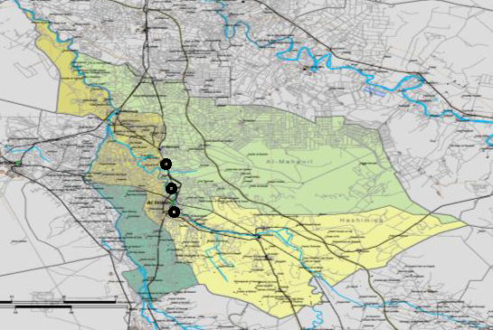



**Fig (1) Map of study station in Babylon province, middle of Iraq.**

**Samples collection and preservations**

Water samples were bimonthly collected for raw and treated,taken from water treatment plants during a period of 12 months starting from September 2013 until September 2014using clean polyethylene bottles. Samples were analyzed immediately after collection.

**Samples analysis**

Samples were analyzed for physco-chemical properties immediately after collection. These parameters are pH value, turbidity; electric conductivity, total alkalinity, total hardness, Ca, Mg, ClConductivity (EC) and pH were directly measured in situ using portable measuring devices (HANNA pH 2011, HI9811, portable pH-EC-TDS meter, Italy). Note that before each measurement, the pH meter was calibrated with reference buffer solution,turbidity measurements are carried out using TurbidirectLovibond . Procedures followed for analysis (total alkalinity, total hardness, Ca, Mg, Cl)have been in accordance with the Standard methods for examination of water and wastewater [16].

**Calculation of WQI [17]**

$WQI=\sum{(Ci/Si)/n}$……. ( 1)

Where:

Ci= concentration of each parameter in each water sample in (mg/L).

Si=Iraqi drinking water standards for each chemical parameter

n= is the number of parameters.

**Efficiency of the Water Treatment Plants calculation**

Efficiency (*E*%) of the Water Treatment Plants was calculated by determining the WQI of the raw water and treated (Tap) water supplied by using the formula given below

$E\%=\frac{WQI of raw water-WQI of treated water}{WQI of raw water}*100$….. (2)

**Rustles and discussion**

The physico-chemical parameters with their WHO and IQS standards are listed in Table (1)Water quality classification based of MIN WQI listed in Table (2) **,** Table (3) illustrates the mean value of the physico-Cemical parameters of raw water and treated water quality in three water treatment plants.

**Table (1): Iraqi Standards and WHO Standardsfor Drinking Water**

|  |  |  |  |  |  |  |  |  |
| --- | --- | --- | --- | --- | --- | --- | --- | --- |
| Parameter | Cl | Mg | Ca | TH | Alk. | Ec | pH | Tur. |
| Units | Mg/L | Mg/L | Mg/L | Mg/L | Mg/l | μs/cm | - | NTU |
| WHO (Stander) | 112..3 | 38.5 | 118 | 452 | 106 | 1111 | 7.96 | 17.26 |
| IQS (Iraqi stander) | 350 | 100 | 150 | 500 | 125-200 | 2000 | 6.5-8.5 | 5 |

**Table (2) Water quality classification based of MIN method**

|  |  |
| --- | --- |
| Water Quality | WQI value |
| Very clean | ≤0.3 |
| clean | 0.31- 0.89 |
| Slightly polluted | 0.9- 2.49 |
| Moderately polluted | 2.5- 3.99 |
| Heavily polluted | 4-5.99 |
| Dirty water | ≥6.0 |

**Table (3) Mean value of eight parameter during one year**

|  |  |  |  |  |  |
| --- | --- | --- | --- | --- | --- |
| **Al-Sadaa** | | **Al Hilla Al-Jadeed** | | **Al-Hashimiyia** | |
| **Parameter(mean value)** | **Raw** | **Treated** | **Raw** | **treated** | **Raw** | **Treated** |
| pH | 7.97 | 7.7 | 7.94 | 7.64 | 7.96 | 7.75 |
| Turp. (NTU) | 20.01 | 3.855 | 12.95 | 1.41 | 14.7 | 7.1 |
| Alka. (Mg/l) | 117.92 | 115.68 | 120.46 | 115.58 | 113.6 | 99.83 |
| Ec(μs/cm) | 1114.7 | 1040.58 | 1082.2 | 1091 | 1068.8 | 1110.6 |
| TH (Mg/l) | 412.84 | 396.7 | 397.7 | 393.7 | 404.58 | 388 |
| Ca+2 (Mg/l) | 105.6 | 104.8 | 97.77 | 85.53 | 109.25 | 95.58 |
| Mg+2 (Mg/l) | 40.07 | 38.53 | 37.46 | 37.3 | 35.16 | 31.08 |
| Cl+2(Mg/l) | 114.23 | 108.7 | 118.92 | 111.3 | 115 | 114.41 |

The results of the mean values from table 3 showed that the mean values of pH, Ec, total alkalinity, total hardness, Mg, Ca, and Cl for samples examined are within the maximum permissible limit of IQS standards while the mean values of turbidity, electric conductivity, are not with the permissible limit of IQ Sstandard. With WHO standard the mean values of Ca and total hardness within the maximum permissible limit While pH, Mg, Cl, turbidity, and total alkalinity are not with the permissible limit.

The pH values at all water treatment plants were between(7.6-8.5) for raw water. For treated water, pH was (7.3-8.15).The pH value of water decreases as the content of CO2 increases, while it increases as the content of bicarbonate alkalinity increases in river water[18].pH is an important factor that determines the suitability of water for various purposes.

Turbidity is widely concerned as an important parameter for drinking water. However, the observed value were higher than the permissible level recommended by the Iraq stander ,The turbidity values at all water treatment plants were between (56-3.95) (NTU) for raw water. For treated water, turbidity was (0.49-22.7) (NTU).The values of the alkalinity at all water treatment plants were between (108-150) (mg/l) for raw water. For treated water, alkalinity concentrations were (104-146) (mg/l). In general, the maximum concentrations of alkalinity were within Iraqi standards.

Conductivity values throughout the period of the study at all water treatment plants were between (758-1400) (µs/cm) for raw water. For treated water, EC values were (756-1355) (µs/cm). The results showed that high values of EC were in the winter season, this due to the increasing concentration of dissolved ions in this season, and depended on the temperature and the total concentration of ionized material [19].

The values of the total hardness at all water treatment plants were between (492-342) mg/l for raw and treated water. The highest concentration of total hardness may be caused by discharge of river or to high precipitation and high soil leaching or high present velocities [20, 21]. All values of total hardness concentrations were within Iraqi standards, the values of calcium concentration for raw water were (130-84) mg/l.

Calcium concentrations for treated water were (70-126) mg/l. All values of calcium concentration were within Iraqi standards. Magnesium concentrations for raw water were ranging (33-50) mg/l. For treated water magnesium, concentrations were (27-46) mg/l. All values of magnesium concentrations were within Iraqi standards. The results of the study refers to high concentrations of calcium more than magnesium in most study period which may due to solubility of CO2 in water and reaction with calcium, in contrast to magnesium tend to precipitate [22].

The values of chloride concentrations for raw water were between (88-140) (mg/l)for treated water, chloride concentrations were (85-137). All values of chloride concentrations were within Iraqi standards. These results agree with [23]she found that chloride concentrations for raw water were between (78.3-144.5) (mg/l), and treated water was (76.6-153).Figures from (1) to (8) showed the raw and treated water for each parameter for three water treatment plant

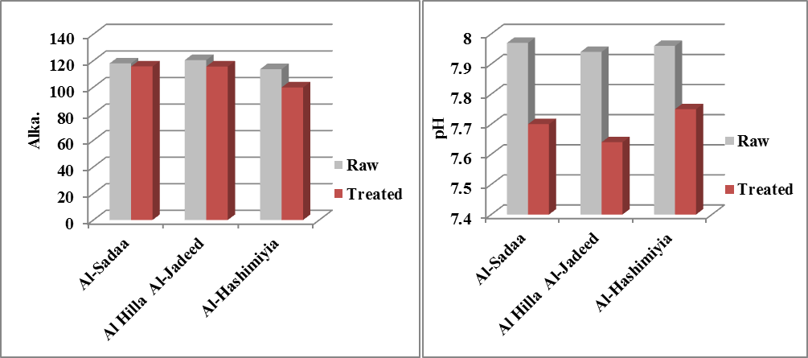

Fig (1) variation of Alkalinity for three water treatment plant for Raw and Treated water

Fig (2) variation of pH for three water treatment plant for Raw and Treated water

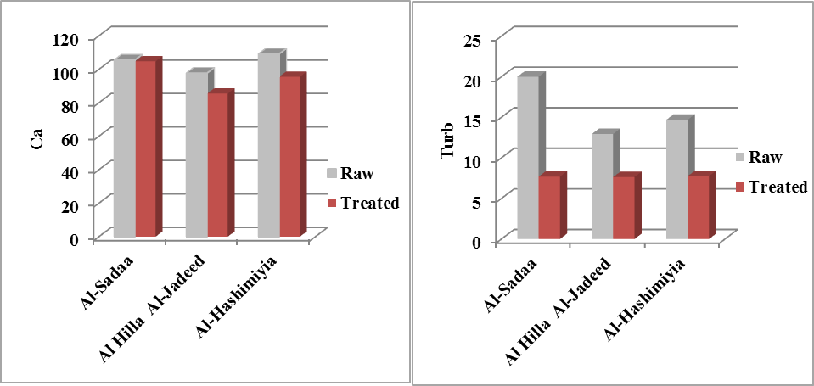

Fig (3) variation of calcium for three water treatment plant for Raw and Treated water

Fig(4) variation of turbidity for three water treatment plant for Raw and Treated water

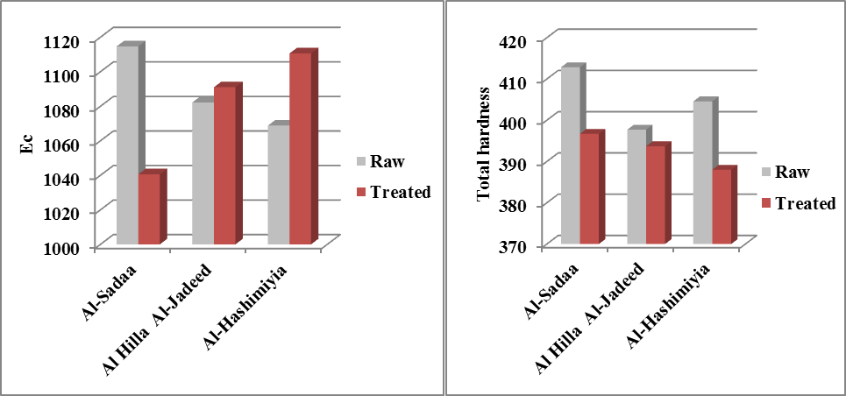

Fig (5) Variation of Electrical conductivity for three water treatment plant for Raw and Treated water

Fig (6) Variation of Total hardness for three water treatment plant for Raw and Treated water

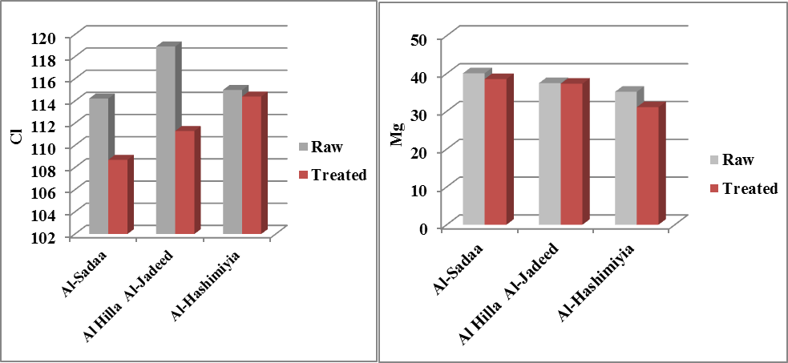

Fig (7) Variation of chloride for three water treatment plant for Raw and Treated water

Fig (8) Variation of manganese for three water treatment plant for Raw and Treated water

The values of the MNE WQI for all water treatment plants were between (0.8145-1.59) for raw water. The highest value found was (1.59) of Al-Sadaa water treatment plant in March has been found to be mainly due to the higher value of turbidity, E.C, alkalinity, total hardness, chlorine, magnesium, sodium, but the lowest value was (0.8145) in May of Al-Hashimiyia water treatment plant, this finding disagree with [23] she illustrate that raw water of hilla river as clean.For treated water the MNE WQI ranged between (0.495-0.937). The highest value found was (0.937) of Al-Hashimiyiawater treatment plant in September due to high concentration of turbidity, E.C, alkalinity , while the lowest value was (0.495) of Al-Sadaa treatment plant in July. Fig. (3) Shows that none of the treated samples are classified as very good (the highest value is 0.937 in Al-Hashimiyia while the lowest value 0.495 occurs for Al-Sadaa). All mentioned values indicated that the water is clean according to MNE WQI classification only the raw water of Al-Sadaa WTP (1.59) and treated water of Al-Hashimiya WTP (0.9376) as slightly polluted.

Figures (9) and (10) show the variation of the MNE WQI during the period of the study for raw and treated water respectively.

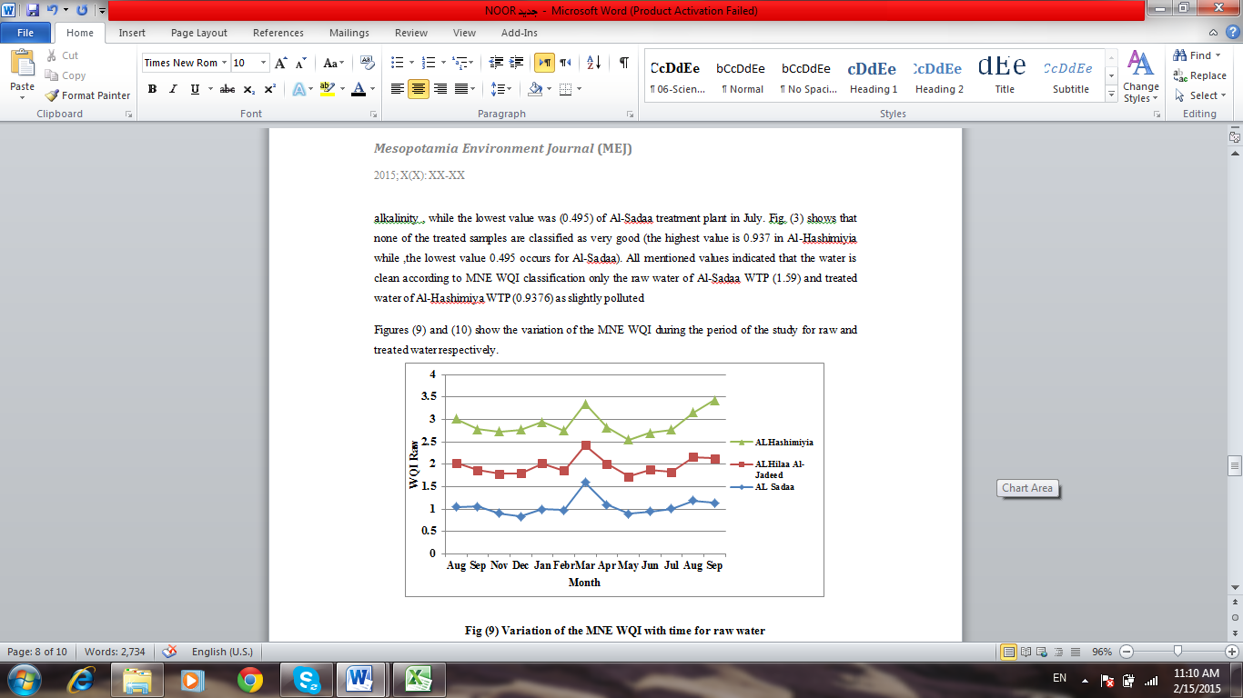

**Fig (9) Variation of the MNE WQI with time for raw water**

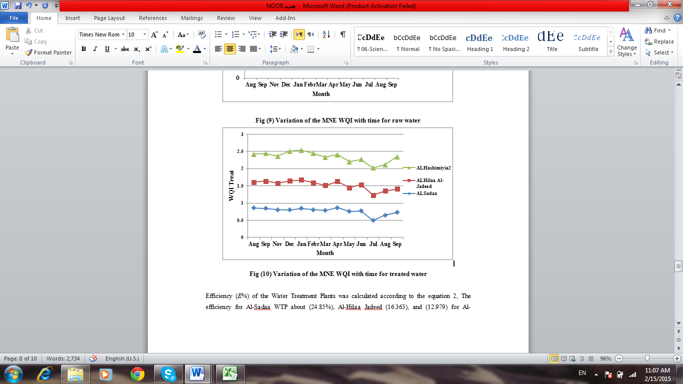

**Fig (10) Variation of the MNE WQI with time for treated water**

Efficiency (*E*%) of the Water Treatment Plants was calculated according to the equation 2, The efficiency for Al-Sadaa WTP about (24.85%), Al-Hilla Al-Jadeed (16.363),and (12.979) for Al-Hashimiyia WTP , it has been concluded that the raw water is poorest in quality throughout the year as the efficiency of WTPs range from 12.979 to 24.85 in the whole period of study. Ultimately, reconsideration of the WTPs system is needed since these stations were designed to provide physical and biological treatment rather than chemical treatment of raw water. This will surely have more consequences if combined with the already high levels of chemical pollution of raw water that we have shown in our results below.

**Conclusions**

The results showed that the worst water quality for raw and treated water according to the values of MNE WQI for raw water slightly polluted for three water treatment plants and clean water for Al-Hilla Al-Jadeed and Al-Sadaa water treatment plants while slightly polluted for Al-Hashimiyia water treatment plant according to MNE method classification.

**Acknowledgment**

The author grateful to Environmental research center, University of Babylon and Babylon water directorate for their support to this research.

**References**

**[1]** **Sargaonkar A. and Deshpande. V.** Development of an overall Index of Pollution for Surface Water Based on a General Classification Scheme in Indian Context Envi-ronmental Monitoring and Assessment, Vol. 89, No. 1, , pp. 43-67. 2003

**[2]** **Abbasi. S. A.** Water Quality Indices: State-of-the-Art, Centre for Pollution Control & Energy Technology, Pondicherry University, Pondicherry.1999.

**[3]** **Štambuk, N. G.**Water Quality Evaluation by Index in Dalmatia, Water Research, Vol. 33, No. 16, pp. 3423-3440. 1999.

**[4]** **Miller. W. W, Joung. H. M., Mahannah. C. N. and Garrett. J. R.** Identification of Water Quality Differences in Nevada through Index Application, Journal of Envi-ronmental Quality, Vol. 15, , pp. 265-272. 1986

**[5]** **Štambuk, N. G.** Comparison of Dalmatian Water Evaluation Indices, Water Environment Research, Vol. 75, No. 5, pp. 388-405. 2003.

**[6]** **Horton R. K.** An Index Number System for Rating Water Quality, Journal of Water Pollution Control Federation, Vol. 37, No. 3, , pp. 300-306. 1965.

**[7]** **Ott, W. R.** Environmental Indices: Theory and Practice Ann Arbor Science Publishers Inc., Ann Arbor, Michigan, USA.1978.

**[8]** **Alobaidy, A.M. , Maulood, B.K. , Abass, J. K**. Evaluating Raw and Treated Water Quality of Tigris River within Baghdad by Index Analysis, Journal of .Water Resource and Protection 2, 629-635.2010.

**[9]** **Oregon, C.C.**Water quality index A tool for evaluating water quality management effectiveness, Journal of the American Water Resources Association, 37, 125–137. 2001.

**[10]** **Liou, S. Lo, S. and Wang. S.A** generalized water quality index for Taiwan, Environmental Monitoring and Assessment, 96, 35–52. 2004

**[11]** **Said, A., Stevens, D., and Selke, G.A.** innovative index for evaluating water quality in streams, Environmental Management, 34, 406–414. 2004.

**[12]** **Hülya, B.**Utilization of the water quality index method as a classification tool. Environmental Monitoring and Assessmen. 2009.

**[13]** **Jurdi, M., Korfali, S. I., Karahagopian, Y. and Davies, B. E,** Evaluation of Water Quality of the Qaraaoun Reservoir, Lebanon: Suitability for Multipurpose Usage, Environmental Monitoring and Assessment Vol.77 page 11–30 .2002.

**[14]** **Debels, P., Figueroa, R., Urrutia, R., Barra, R. and Niell, X.** Evaluation of Water Quality in the Chillan River (Central Chile) Using Physicochemical Parameters And A Modified Water Quality Index", Vol. 110 **.** Springer, page 301–322. 2005.

**[15]** **Abdul-Razak, A. and Asiedu A.B.,** Entsua- Mensah R.E.M. and deGraft- Johnson K.A.A., Assessment of water quality of the Oti river in Ghana, West African J. of Applied Ecology, Vol.15 .2009.

**[16]** **APHA,**WWA & WEF, Standard methods for examination of water and waste water, 21st Edition, American Public Health Association, Washington, D.C. 2005.

**[17]** **Ministry of Nature and Environment (MNE**) of Mongolia .2011.

**[18]** **Chabuk, A.J., Wadi, A.H. and Himod, J.** Evaluation of Selected Trace Elements in ShattAl-Hilla River, Thesis, Department of Environmental College of Engineering, Babylon University.2009.

**[19]APHA** (American Puplic Health Association). Standard Methods for Examination of Water and Wastewater 2nd edition, Washington DC, U.S.A.2000.

**[20]** **Salman, J.M.** Environmental study of some possible pollutants in Euphrates River between Al-Hindia barrage and Al-Kufa, PhD thesis, Collage of Science, University of Babylon, Iraq.2006.

**[21]** **Al-Azawey, A.S.N.** Biogeochemical distribution of some Polycyclic Aromatic Hydrocarbons (PAHs) in AL-Hilla River-Iraq.Ph.D thesis, College of Science, University of Babylon, Iraq.2012.

**[22]** **Goldman, C.R. and Horn, A.J.** Limnology, McGraw Hill int. –B.CO.1983.

**[23]** **MokifL, A** .evaluation the stability and quality of water in Babylon governorate , thesis, College of engineering, University of Babylon, Iraq.2012.