Environmental study of water quality and some heavy metals in water, sediment and aquatic macrophytas in lotic ecosystem, Iraq

Marwa Ali Habeeb¹ Abdul-Karim Kh. Al-Bermani¹ Jasim M.Salman^{2*}

1 Depertment of Biology ,Coll.of Science for women ,University of Babylon,Iraq.
2 Depertment of Biology ,Coll.of Science ,University of Babylon,Iraq

Corresponding author: rflower432@yahoo.com

To cite this article:

Habeeb, M. A.; Al-Bermani, A. K. and Salman, J. M Environmental study of water quality and some heavy metals in water, sediment and aquatic macrophytas in lotic ecosystem, Iraq. Mesop. Environ. J, ,2015, Vol. 1, No. 2 , pp. 66-84.

Abstract

This study was respect to detect possible environmental effects on the eastern Euphrates drainage from the Abo-Garak to south of Kifil city in Babylon province. Five sites were selected along the study area and Omit it during October 2013 to August 2014. Physical and chemical properties are measured (air and water temperature , pH , electrical conductivity , salinity, TDS ,TSS , BOD₅, dissolved oxygen , Alkalinity , Total Hardness , calcium , magnesium ) and nutrients (nitrite , nitrate , reactive phosphate) as well as . The average of the studied heavy metals Fe , Cd , Pb and Cu the dissolved phase of water were 113.89 , 6.35 , 1.5 and 0.8μg /l for Fe , Cd , Pb and Cu , respectively .Heavy metals concentrations in the particulate form were 291.83, 9.39, 3.07 and 12.15 μg/g dry weight for Fe , Cd , Pb and Cu respectively. In the sediments, the concentrations of these heavy metals in the exchangeable phase were 318.66, 12.91, 6.27 and 13.23μg/g for Fe , Cd , Pb and Cu , respectively. While in the residual phase were 461.53, 5.29, 8.62 and 27.07 μg/g for Fe , Cd , Pb and Cu , respectively . The results revealed that the concentrations of heavy metals in water for the particulate phase were higher than in the dissolved phase , while in sediment, their concentrations in the residual phase were higher than their concentrations in the exchangeable phase except for Cd which was in the exchangeable phase higher than in the residual phase. The concentration and distribution of heavy metals in macrophytes Ceratophyllum demersum were (923.63 , 462.34 , 740.45 and 90.59)μg/g dry weight for Fe , Cd , Pb and Cu , respectively . While , (728.57, 162.17 , 244.13 and 118.87) μg/g dry weight for Fe , Cd , Pb and Cu , respectively. for Fe , Cd , Pb and Cu in Hydrilla verticillata .
The study area was very hard water and high BOD₅. The nutrients showed clear seasonal variation in their concentration
Keywords; Water quality, Heavy metals, Sediments, Hydrilla verticillata, lotic ecosystem.

Introduction
Waters pollution with heavy metals have many effects on aquatic organisms, in addition to the bioaccumulation and bioconcentration of these metals in the aquatic food chain put the consumers such as humans in risk [1]. Metals in aquatic system have many origin, distribution and accumulation of metals are influenced by mineralogical composition, sediment texture, adsorption processes and oxidation-reduction state and physical transport [2]. The contamination by heavy metals causes a serious problem may be due to low degradable in nature compared with organic pollutants and they accumulate in different parts of the food chain [3]. The geochemical composition of water body is largely governed by the physiochemical characteristics (pH, EC , DO, ect.) [4]. Various studies have demonstrated that aquatic system are contaminated by heavy metals in different areas of world [5]. Aquatic macrophytes have great potential to accumulate heavy metals inside their tissues. These plants can accumulate heavy metal concentrations 100,000 times greater than in the associated water [6]. Aquatic macrophytes are thought to remove metals by three patterns: metals are restricted from entering the plant and attach to the cell wall; metals are accumulated in the root, but translocation to the shoot is constrained; and hyper accumulation, in which metals are concentrated in the plant parts. The hyper accumulative capacities of aquatic macrophytes are beneficial for the removal of heavy metals [7]. This paper aimed to study the some physical-chemical properties and concentration of some heavy metals in water , sediments and two species of aquatic macrophtes (Ceratophyllum demersum and Hydrilla verticillata )

Materials and methods
Samples were collected monthly from five sites on Eastern Euphrates drain / middle of Iraq, (Fig1) from October 2013 to August 2014. Measure the physio-chemical parameters of water using clean polyethylene bottle (5L) as three replicates and filtered by using filter paper (Millipore filter paper 0.45 µm type fiber class). Air and water temperature were measured by Thermometers , pH by pH meter type WTW, Germany. Salinity examined according to Mackereth et al. [8]. TSS, TDS , DO , BOD₅ , Total Alkalinity measured according to APHA [9] .
In the laboratory nutrients were determined according to standard methods [10]. Nitrates was determined according to [11] and reactive phosphate was determined according to [12] explained by [13]. Aquatic plants collected from the middle of the drainage ,four selected heavy metals (Fe , Cd , Pb , Cu) were determined , the samples are analyzed according to [14], and measure by Flame Atomic Absorption Spectrophotometer type (Shimadze , AA-7000 . Japan) .

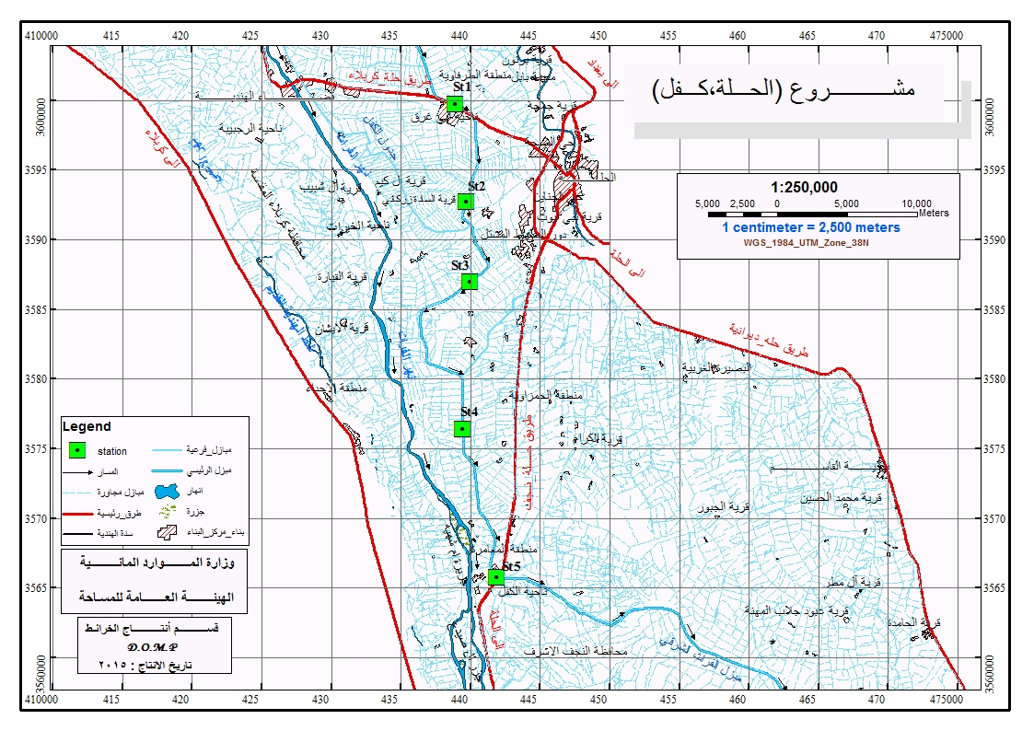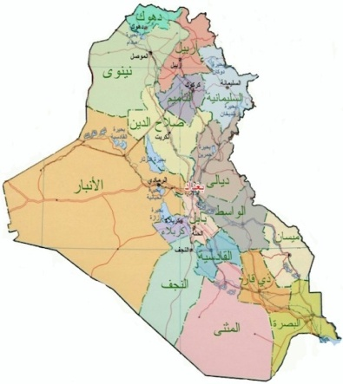

Fig.1: Map of study sites in eastern Euphrates drainage

Result and Dissection:
The physiochemical properties of the study sites are showed in (Table 1). The air and water temperature ranged between (6-46) ºC and (10-35) ºC, respectively it increase during hot months and decrease during cold months these results accepted with other Iraqi studies [15] . Electrical conductivity (EC) values ranged (4360-7400) µs/cm , it increase in winter and spring and in agriculture area because of washing of these area by rain water and increase level of water and dilution factor [16]. Salinity values ranged (2.97-4.73) ‰ according to these values the water of drain is salt because these area affected by agriculture and anthropogenic activities [17] .Total dissolved Solids showed high value ranged (2100-5270) mg/l as a result of washing area by rain water , it is accepted with studies [5, 18]. While Total suspended Solids showed lower values (0.03-0.97) mg/l because increase of level water and affected by dilution factor [16] . The pH of water is a measure of the hydrogen ion (H+) concentration in water, it is an important parameter for describing the state of chemical processes [19] . The pH values are affected by many factors such as temperature [19]. Other factors affect pH values were as the biological activity and CO2 concentration [20], the nature of climate [21], discharge of municipal and industrial wastewaters [22] pH values ranged (6.5-8) . Outside this range organisms exposed to stress as the low pH leads to the liberation of toxic compounds and elements from sediments to the water and then into plants and aquatic organisms [23]. Present study recorded high concentration of dissolved oxygen (5.8-11.5) mg/l . This may be due to good mixing between the surface and bottom layers and high water levels [24]. While lower concentration of DO might be due to low water levels and decomposition processes of organic substance [24]. Biological Oxygen Demand (BOD5) used to determine the amount of oxygen consumer by microbial organism through aerobic oxidation of organic materials processes and convert to inorganic material [25] .The study showed high value through April/2014 in site (4) recorded (5.2) mg/L , it exceeded the international determinants allowed (5) mg/L [26] while lower concentration recorded through February/2014 in site (5) (1.02)mg/L , It is less than the international determinants and perhaps due to the launch of organic waste and ability of drain to self – treatment [27]. Total alkalinity values ranged (200-500) mgCaCO₃/L, the water of drain classified as high alkalinity. The concentrations of total alkalinity were affected by many factors such as organic pollution, rainfall which causes drifting the catchment area [28], and water levels [29] . The water of drain is very hard values ranged (800-2250) mgCaCO3/L , The high values of the hardness in the drain were related to the different factors: the geological nature of the lands that the drainage water passes through it [30] and the effect of agriculture and anthropogenic activities [31]. The concentrations of Calcium ion recorded were higher than Magnesium ion concentrations ; this might be due to the presence of calcium ion in a percentage higher than magnesium ion in the earth crust and soil [7]. The values of calcium ions ranged (160.32-601.2) mgCaCO3/l . While magnesium ion ranged (12.03-339.99) mgCaCO3/l High values of Magnesium ion in the water due to rainfall, while decreasing levels may be due to consumption of this ion by phytoplankton [32]. Nutrients one of the most important factor that affected the abundance and composition of aquatic plants communities [33]. Nitrogen omit it is the most abundant nutrient in fertilizer and enters the water by human and animal waste , as well as , agriculture land [34] . Nitrite values ranged (0.01-0.42) µg/l and the low concentration of nitrite concentration due to good aeration of drain water [35] . Nitrate is a common form of inorganic nitrogen in the aquatic environment [13], the present study recorded high concentration of nitrate in summer and spring due to high temperature that increase the concentration of dissolved salts and decomposition processes [36] . Phosphate one of the most nutrients that influenced on the growth and increase the cellular activity of phytoplankton but it is found in low concentration in aquatic environment [37] . The value recorded (N.D.-1.5) µg/l , it recorded high concentration through March/2014 in site (5) due to drain water influenced by agriculture activates [38] .
Chlorophyll-a one of pigments of photosynthesis present in most plants , algae and phytoplankton [39], the present study recorded (0.12-3.52) µg/L, high concentration of chlorophyll-a during summer and spring belong to algae blooms and phytoplankton and availability of temperature and nutrients and dissolved oxygen [40] while decrease concentration may be to decrease activity of aquatic organisms in cold months so there will be an abundance of oxygen and lack of production in phytoplankton [41] .
The concentration of the dissolved phase ranged between 113.89 µg/l for Fe and 6.35 µg/l for Cd and 1.5 µg/l for Pb and 0.8 µg/l for Cu (Table 2). Heavy metal concentration in dissolved phase were as follows Fe > Cd > Pb > Cu. Heavy metals recorded higher concentrations in summer (May, June, July and August . While they recorded lower concentrations in winter (December, 2013 , January and February 2014) . The increase of their concentrations during summer may be due to high temperature, which increases the solubility of them. This conclusion is confirmed by a positive correlation between them and temperature. Also, might be due to decreasing the pH during summer that also increases their concentrations as confirmed by a negative correlation between them and pH [42]. While the decreasing of their concentration may be due to many factors such as water levels , alkalinity and also, formation complexes with organic matters [43], the amount of particulates and the density of phytoplankton [44]. Anthropogenic activities and throwing of wastes directly to the drainage water may also affect their concentrations [45, 41, 42].
The concentration of heavy metals in the particulate phase ranged (291.83, 9.39, 3.07 , 12.15) μg/g dry weight for each of of Fe ,Cd , Pb and Cu , respectively (Table 2). Their concentrations were as follows: Fe > Cu > Cd > Pb . The concentration of heavy metals in the particulate phase was higher than their concentration in the dissolved phase. This result might be due to the increased particulate matter in the drain, which include living and non - living components. The living components consist of planktons and other microorganisms, while the non – living organisms consist of silts and clay particles, in addition to organic and inorganic particles [46].
Sediments represent the final recipient of pollutants from natural and anthropogenic sources[51]. Thus, they are considered as a good Bioindicator for water pollution. They also, release the pollutants that contaminate them in the water column as a result of the effect of the physicochemical factors [47]. HMs in the sediments during this study were measured in the exchangeable and residual phases. Their concentrations in the exchangeable phase ranged from 318.66 μg/g for Fe and 12.91 μg/g for Cd and 6.27 μg/g for Pb and 13.23 μg/g for Cu . Their concentration's sequences were as follows: Fe > Cu > Cd > Pb . While their concentrations in the residual phase ranged from 461.53 μg/g for Fe and 5.29 μg/g for Cd and 8.62 μg/g for Pb and 27.07 μg/g for Cu and their concentration's sequences appeared as follows: Fe > Cu > Pb > Cd . (Table 2 ) Their concentrations in the residual phase were higher than their concentrations in the exchangeable phase except Cd was in the exchangeable phase higher than in the residual phase. These results might be due to the drainage of wastes directly into the drain Further more, as a result of decomposition and plant residues [14].
The present study recorded high concentration of heavy metals in the tissue of some aquatic plants compared with rates in the water and sediments .Their concentration in C.demersum ranged from 923.63 μg/g dry weight for Fe and 462.34 μg/g dry weight for Cd and 740.45 μg/g dry weight for Pb and 90.59 μg/g dry weight for Cu . Their concentration's sequences were as follows: Fe > Pb > Cd > Cu , while their concentration in H.verticillata ranged from 728.57 μg/g dry weight for Fe and 162.17 μg/g dry weight for Cd and 244.13 μg/g dry weight for Pb and 110.87 μg/g dry weight for Cu (Table 3). Their concentration's sequences were as follows: Fe > Pb > Cd > Cu. The aquatic plants are vary in accumulate heavy metals in their tissue, and many factors are effect on the heavy metals bioaccumulation as water quality , pollution source , growth form of plant [48] . Different accumulation abilities of species more or less depend on individual plants; nevertheless, some studies exist pointing out differences between the groups, e.g. submerged and emergent species [49]. On the other hand, some authors do not confirm these differences [50]. A comparison of total metal uptake by the two plants showed that the greatest uptake of all metals from various concentrations was by the C.demersum excepted Cu is higher concentration in H.verticillata . Mechanisms of accumulation of heavy metals inside aquatic tissues that toxic elements linked to the walls of the cells in the roots or leaves , which prevents transmission through vegetable sap or it's expels to non – sensitive sites in the cell and stored in vacuoles [26] .

Table 1: Some physical - chemical properties of Eastern Euphrates drainage water for period from October 2013 to August 2014 [first line (range ) and second line ( mean ± S.D. )]
Sites |  |  |  |  | Parameters
Site 5 | Site4 | Site3 | Site2 | Site1
7 – 43 | 9 – 45 | 6 – 45 | 8 – 44 | 7 – 46 | Air temp ( C°)
29± 13.27 | 29.1± 14.39 | 29.2± 13.72 | 29.6± 13.54 | 29.5± 14.34
12 - 32 | 11 - 31 | 10 - 32 | 10 - 31 | 10 - 35 | Water temp ( C°)
21.9 ± 7.96 | 21.3 ± 8.2 | 21.2± 8.28 | 21.13 ± 7.48 | 22.1 ±8.38
4360-7400 | 4390-6580 | 4370-6730 | 4900-6650 | 4570-6690 | EC (µs/cm)
5401.1 ±843.36 | 5401.1 ±774.29 | 5752 ±717.98 | 5671 ±668.93 | 5582 ±779.84
2.79 –4.73 | 2.8 – 4.21 | 2.89 – 4.3 | 3.13 – 4.25 | 2.92-4.28 | Salinity ‰
3.65 ±0.65 | 3.57 ±0.48 | 3.73 ±0.45 | 3.65 ±0.42 | 3.60±0.49
2100-5270 | 2230-4640 | 2230-4780 | 2100-4700 | 2200-4690 | TDS (mg/l)
3786 ±805.3 | 3633 ±725.7 | 3859 ±760.8 | 3795 ±749.4 | 3670 ±727.3
0.03-0.97 | 0.04-0.93 | 0.03-0.88 | 0.05-0.93 | 0.04-0.84 | TSS (mg/l)
0.36±0.34 | 0.35 ±0.3 | 0.31 ±0.29 | 0.31±0.3 | 0.31 ±0.28
7.8 – 8.6 | 7.8 – 8.7 | 7.8 – 8.6 | 7.8 – 8.7 | 7.5 – 8.6 | pH
8.2 ±0.29 | 8.5±0.28 | 8.3±0.27 | 8.4± 0.26 | 8.3± 0.31
6.5 – 9.4 | 6.3 – 10.2 | 5.8 – 11.5 | 6.8 – 10.8 | 6.3-11.5 | DO (mg/l)
7.64 ±0.88 | 8.41 ±1.22 | 8.40 ±1.63 | 8.75 ±1.3 | 8.35 ±1.68
1.02 –4.8 | 3.7 – 5.2 | 1.04 – 4 | 1.5 – 4.32 | 2.14 – 4.5 | BOD5 (mg/l)
2.90 ±1.19 | 4.44 ±0.5 | 3.14 ±0.94 | 3.17 ±0.93 | 3.3±0.71
350 - 450 | 200 - 350 | 250 - 500 | 300 - 450 | 300 - 450 | Total Alkalinity (mgCaCO₃/l)
35.35 ±376.60 | 47.14 ±301.53 | 78.88 ±371.27 | 52.96 ±366.37 | 48.3± 366.47
800-2200 | 800-2250 | 800-2200 | 900-2150 | 900-2200 | Total hardness  (mgCaCO₃/l)
449.56±1422.7 | 526.94±1548.6 | 415.96 ±1380.8 | 390.9±1546.9 | 418.46 ±1563.4
200.4-541.08 | 160.3-440.88 | 240.48-480.96 | 240.48-460.92 | 240.48-601.2 | Calcium (mgCaCO₃/l)
325.63 ±103.98 | 287.77 ±96.6 | 326.12 ±87.14 | 338.31 ±80.98 | 389.52±113.04
48.51-339.99 | 12.03-291.47 | 48.56-254.99 | 72.83-266.79 | 48.51-276.39 | Magnesium  (mgCaCO₃/l)
164.48±103.98 | 141.31±96.6 | 179.97±87.14 | 162.61±80.98 | 140.84±113.04
0.02 – 0.36 | 0.03 – 0.35 | 0.01 – 0.42 | 0.02 – 0.39 | 0.01 – 0.36 | Nitrite (µg/l)
0.1±0.1 | 0.14 ±0.12 | 0.16 ±0.14 | 0.14 ±0.11 | 0.14 ±0.12
10.71-20.28 | 11.85-20.85 | 13.14-31.01 | 12.28-22.71 | 14.4-25.14 | Nitrate (µg/l)
15.25 ±3.12 | 16.26 ±3.41 | 22.83±5.97 | 16.9 ±3.78 | 18.97±3.64
0.53 – 1.5 | N.D – 1.53 | N.D – 1.63 | N.D – 1.6 | N.D – 1.52 | ReativePosphate (µg/l)
1.05 ±0.73 | 0.89±0.53 | 0.73 ±0.53 | 0.84 ±0.49 | 0.8±0.49

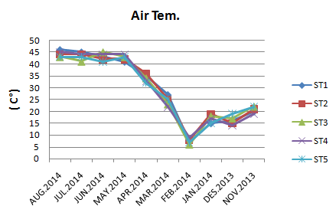
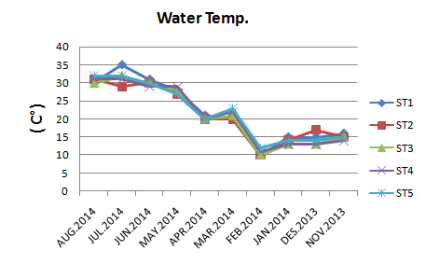

Figure 2 : Monthly variation of Air temperature during study period
Figure 3 : Monthly variation of water temperature during study period

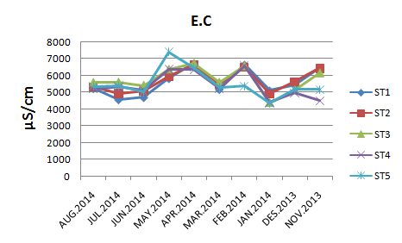
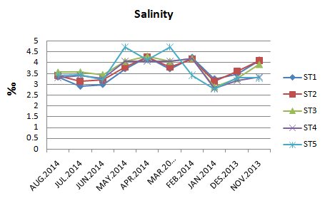

Figure 4: Monthly variation of Electrical conductivity during study period
Figure 5: Monthly variation of Salinity during study period

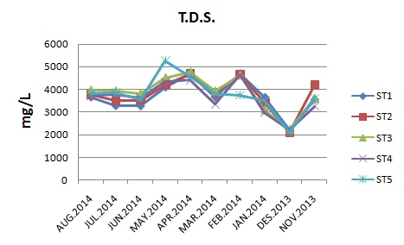
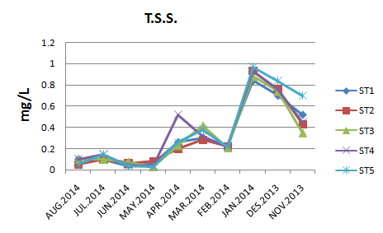

Figure 6: Monthly variation of Total Dissolved Solide during study period
Figure 7: Monthly variation of Total Solid Suspended during study period

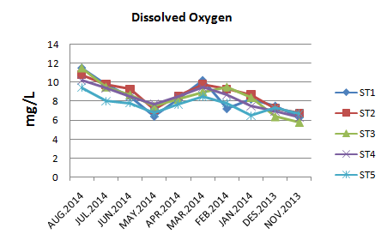
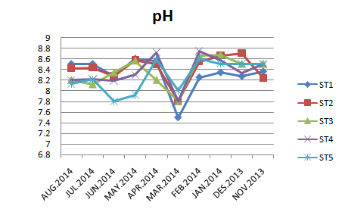

Figure 8: Monthly variation of Dissolved Oxygen during study period
Figure 9: Monthly variation of pH during study period

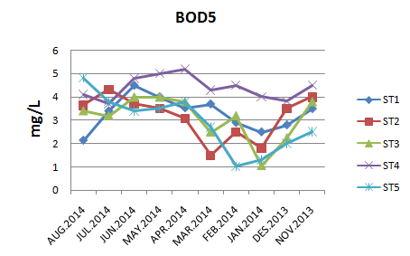
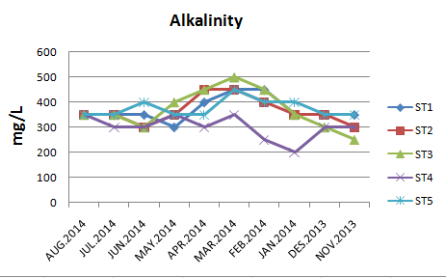

Figure 10: Monthly variation of BOD₅ during study period
Figure 11: Monthly variation of Alkalinity during study period

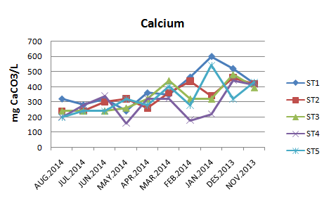
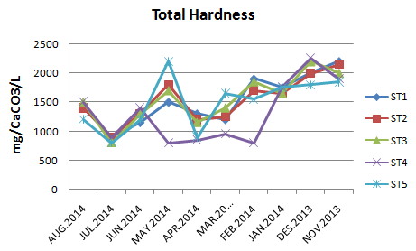

Figure 12: Monthly variation of Total Hardness during study period
Figure 13: Monthly variation of Calcium during study period

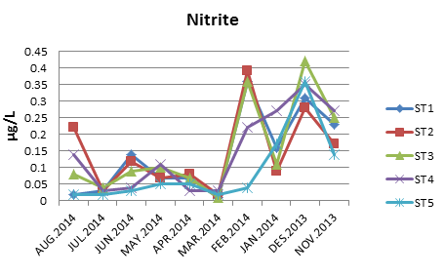

Figure 14: Monthly variation Nitrite during study period

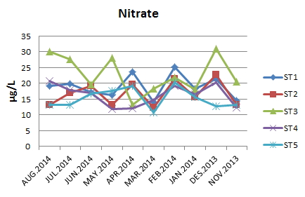
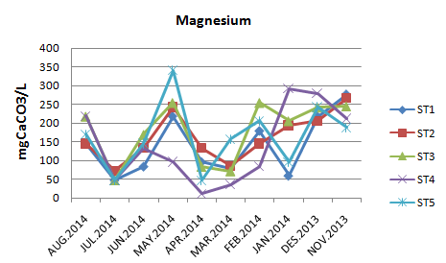

Figure 16: Monthly variation of Magnesium Hardness during study period
Figure 15: Monthly variation of Nitarte during study period

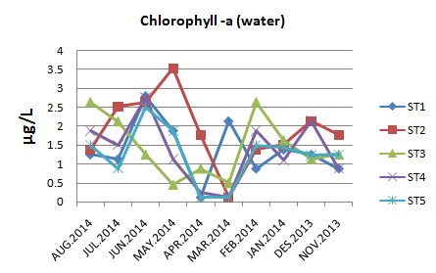
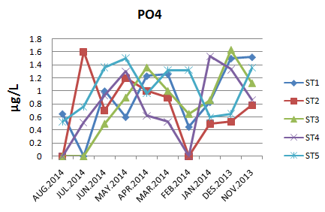

Figure 18: Monthly variation of Chlorophyll-a during study period
Figure 17: Monthly variation of Reactive Phosphate during study period

Table 2: Concentration of some Heavy Metals in Water [Dissolved phase (µg/L) and Particulate phase (µg/g)] and in Sediment [Exchangeable Phase and Residual Phase (µg/g)] in the period from October 2013 to August 2014 first line (range ) and second line ( mean ± S.D. )
Sites |  |  |  |  |  | Elements
Average | 5 | 4 | 3 | 2 | 1
113.89 | 76.88-196.46 | 88.89-180.69 | 70.66 – 140 | 74.38–175.63 | 89.36– 149.13 | D | Fe
 | 115.13±41.14 | 126.6±27.21 | 113.13±21.23 | 109.16±28.04 | 105.4±20.47
291.83 | 172.7-572.08 | 191.8-580.77 | 100.9 -471.09 | 106.56-560.57 | 110.29-361.57 | P
 | 258.26±138.29 | 267.5±136.86 | 303.9±118.34 | 308.92±159.62 | 320.4±73.13
318.66 | 103.08- 497.79 | 100.6-530.33 | 200.8 - 530.38 | 103.64-581.79 | 100.61-531.28 | E
 | 429.9± 123.82 | 316.9± 139.17 | 228± 104.2 | 334.7± 146.38 | 289± 140.79
461.53 | 548.2-334.33 | 619.56-334.3 | 660.98-344.4 | 586.83-327.86 | 669.68-210.87 | R
 | 532.13±84.11 | 481.4±94.23 | 398.1±114.27 | 439.6±81.09 | 446.4±156.82
6.35 | 4.72– 6.72 | 5.13– 7.64 | 6.12– 7.64 | 5.62– 7.64 | 5.13-9.37 | D | Cd
 | 6.3± 0.63 | 6.22± 0.53 | 6.48±0.46 | 6.14± 0.57 | 6.61± 1.52
9.39 | 6.52– 10.52 | 8.03– 12.23 | 8.32– 10.75 | 5.38– 13.42 | 8.15– 13.23 | P
 | 9.24± 1.52 | 9.1± 1.32 | 9.33± 0.85 | 10.01± 2.75 | 9.26± 1.5
12.91 | 9.62– 16.73 | 9.36-13.53 | 12.35–15.71 | 10.26– 14.69 | 11.31– 15.63 | E
 | 12.48±2.48 | 12.72±1.36 | 12.30±1.15 | 13.44± 1.48 | 13.62±1.28
5.29 | 4.53- 5.75 | 3.08-4.83 | 4.92-6.75 | 4.08-6.52 | 5.43-7.53 | R
 | 5.35± 0.48 | 4.85± 0.63 | 5.69± 0.74 | 5.29± 1.55 | 5.31± 0.64
1.5 | 0.62– 3.37 | 0.89– 2.08 | 0.7– 1.52 | 0.62– 1.73 | 1.36– 3.45 | D | Pb
 | 1.63± 0.88 | 1.55± 0.34 | 1.45± 0.29 | 1.48± 0.35 | 1.43± 0.71
3.07 | 1.29 – 3.61 | 1.72– 3.8 | 1.3– 3.74 | 1.72– 3.6 | 4.57 – 5.57 | P
 | 2.48± 0.68 | 2.79± 0.63 | 3.46± 0.81 | 3.32± 0.68 | 3.28± 0.59
6.27 | 4.22 – 7.52 | 5.35 – 8.32 | 5.32 – 8.23 | 5.62 – 7.51 | 4.21– 8.57 | E
 | 6.09± 1.11 | 6.74±0.89 | 6.11± 1.07 | 5.95± 0.67 | 6.49± 1.58
8.62 | 6.51 – 10.31 | 7.26 – 10.45 | 6.32 – 10.52 | 7.41 – 9.54 | 7.52 – 10.43 | R
 | 8.15± 1.21 | 8.64± 1.07 | 8.85± 1.82 | 9.10± 0.7 | 8.4± 0.93
0.8 | N.D - 5.32 | N.D - 11.04 | 1.14 – 6.83 | 1.14 – 6.58 | N.D- 9.7 | D | Cu
 | 4.79±3.05 | 3.18±2.68 | 2.96±2.03 | 2.24±1.92 | 6.37±2.72
12.15 | 7.17 – 16.77 | 6.72 – 14.23 | 7.47 – 14.81 | 7.27 – 15.8 | 7.42 – 18.09 | P
 | 10.27± 2.68 | 11.8± 2.91 | 13.47±2.98 | 12.63± 2.43 | 12.95± 2.98
13.23 | 8.26-16.51 | 9.2-16.35 | 10.36– 19.52 | 9.62– 18.4 | 12.08– 17.37 | E
 | 10.97±2.28 | 13.7±2.81 | 13.57±2.51 | 15.04±3.06 | 14.41±1.73
27.07 | 22.83-35.73 | 15.07-27.58 | 19.62-35.51 | 21.37-37.24 | 23.12-31.02 | R
 | 28.05±4.17 | 23.63±4.5 | 28.72±4.99 | 28.72±5.54 | 27.11±2.76

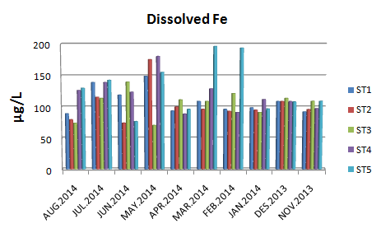
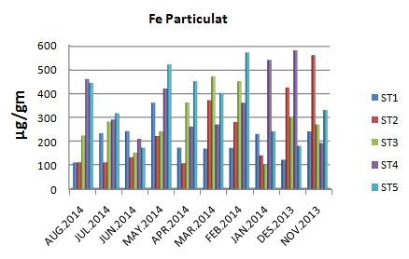

Figure 19: Monthly variation of Dissolved phase Fe during study period
Figure 20: Monthly variation of Particulate phase Fe during study period

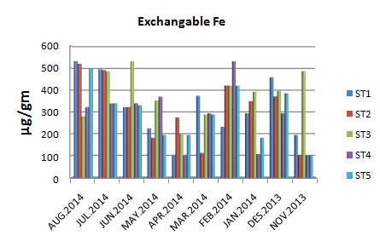
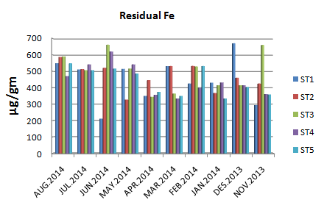

Figure 21: Monthly variation of Exchangable phase Fe during study period
Figure 22: Monthly variation of Residual phase Fe during study period

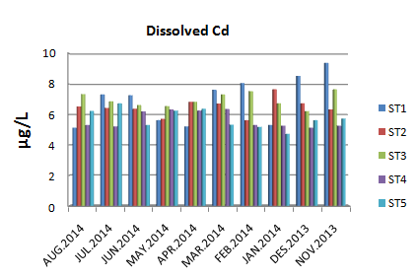
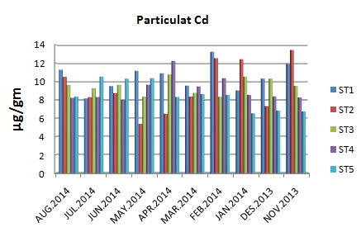

Figure 23: Monthly variation of Dissolved phase Cd during study period
Figure 24: Monthly variation of Particulate phase Cd during study period

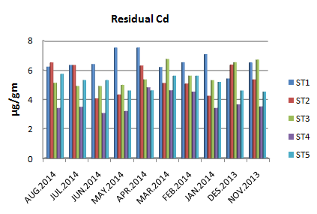
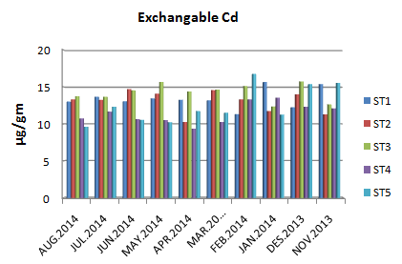

Figure 26: Monthly variation of of Residual phase Cd during study period
Figure 25: Monthly variation of of Exchangable phase Cd during study period

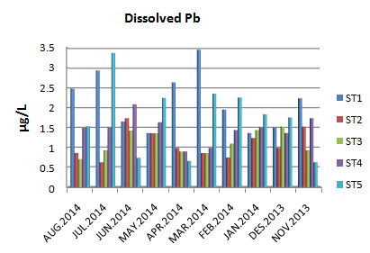
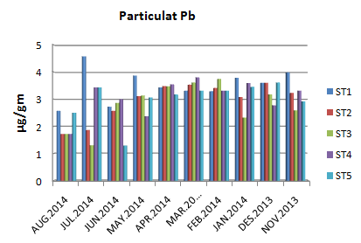

Figure 27: Monthly variation of Dissolved phase Pb during study period
Figure 28: Monthly variation of Particulate phase Pb during study period

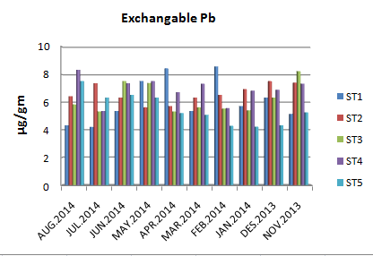
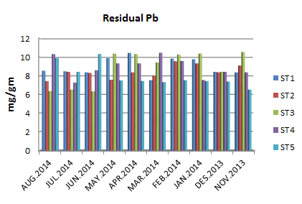

Figure 29: Monthly variation of of Exchangable phase Pb during study period
Figure 30: Monthly variation of of Residual phase Pb during study period

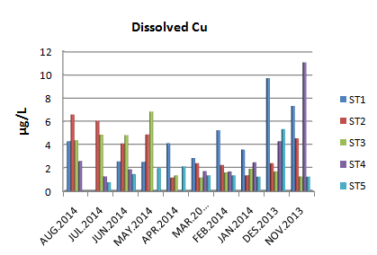
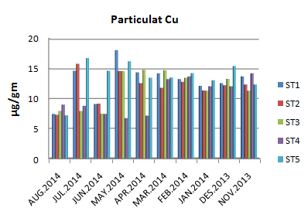

Figure 31: Monthly variation of Dissolved phase Cu during study period
Figure 32: Monthly variation of Particulate phase Cu during study period

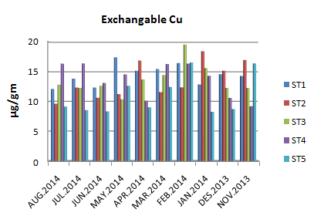
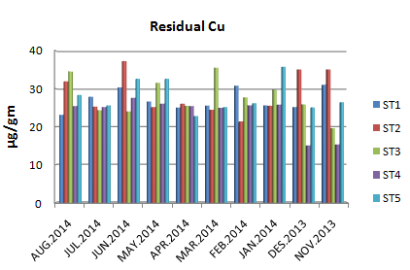

Figure 33: Monthly variation of of Exchangable phase Cu during study period
Figure 34: Monthly variation of of Residual phase Cu during study period

Table 3: Concentration of Heavy Metals in C.demersum and H.verticillata (µg/g) in the period from October 2013 to August 2014 [first line (range ) and second line ( mean ± S.D. )]
Elements | Aquatic  Plants | Sites
 |  | 1 | 2 | 3 | 4 | 5 | Average
Fe | C.demersum | 446.47-1175.75 | 446.47-1276.75 | 563.61-1317.15 | 327.65-1153.53 | 527.65-1340.73 | 923.63
 |  | 918.3±274.44 | 895.16±261.02 | 937.37±238.88 | 931.7±229.59 | 935.61±219.35
 | H.verticillata | 339.67-923.05 | 312.21-1078.24 | 321.04-978.24 | 527.65-1135.35 | 802.94-1246.47 | 728.57
 |  | 620.55±224.86 | 647.59±257.92 | 573.6±255.15 | 753.08±224.84 | 1048.05±131.27
Cd | C.demersum | 165.92-655.74 | 165.92-670.63 | 129.6-678.07 | 171.97-696.68 | 147.7-726.45 | 462.34
 |  | 452.79±156.48 | 480.13±191.66 | 485.91±210.98 | 441.73±182.87 | 461.16±217.32
 | H.verticillata | 98.31-371.35 | 99.63-268.8 | 104.67-254.32 | 99.11-311.53 | 113.37-316.48 | 162.17
 |  | 171.18±100.52 | 137.11±49.77 | 148.36±45.78 | 158.83±77.51 | 195.39±69.03
Pb | C.demersum | 711.36-776.4 | 610.1-785.4 | 559.4-781.9 | 695.56-779.64 | 672.4-784.64 | 740.45
 |  | 746.55±23.89 | 610.0±50.34 | 721.01±64.69 | 741.19±34.73 | 759.93±31.93
 | H.verticillata | 99.31-509.36 | 100.38-602.32 | 121.8-507.14 | 99.11-507.14 | 98.42-507.14 | 244.13
 |  | 255.23±147.89 | 266.74±160.51 | 261.51±142.66 | 224.75±126.94 | 212.43±121.12
Cu | C.demersum | 67.83-125.32 | 68.55-98.1 | 79.82-105.32 | 73.88-129.61 | 80.61-131.04 | 90.59
 |  | 94.10±19.13 | 81.94±9.43 | 90.24±10.48 | 93.05±15.37 | 93.61±15.34
 | H.verticillata | 42.43-171.04 | 41.64-183.42 | 65.1-187.8 | 55.1-171.04 | 122.04-184.29 | 110.87
 |  | 90.17±44.19 | 96.01±44.10 | 108.67±46.38 | 99.35±30.65 | 160.14±25.06

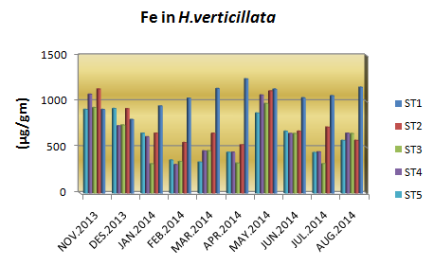
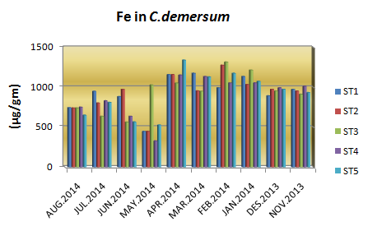

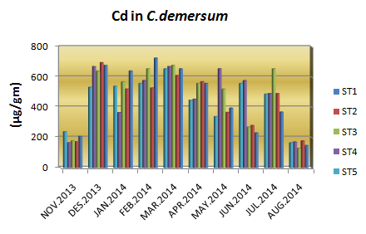
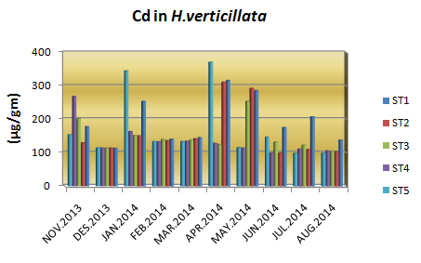

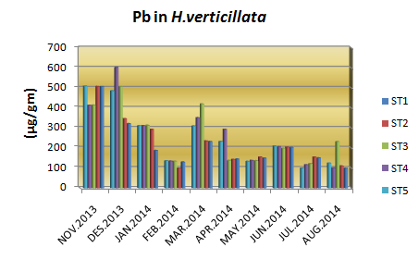
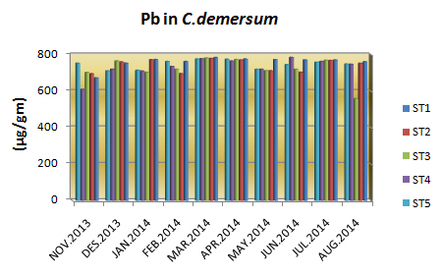

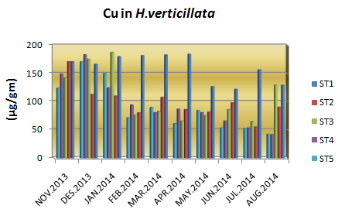
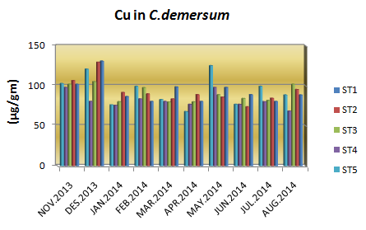

Figure 35: Monthly variation of Heavy Metals in in C.demersum and H.verticillata during study period

Conclusions
- Drainage water was light alkalinity ; hardness ; oligohaline ; high concentrations of suspended solids and high concentrations of nutrients.
- There are differences in the distribution of heavy metals between dissolved and particulate phase of water , concentration in particulate phase recorded higher than concentration in dissolved phase in all months of the study.
- High concentrations of heavy metals in Ceratophyllum demersum and Hydrilla verticillata in the study area. The highest concentrations of heavy metals in water and sediments as a result to impact of agriculture and urban discharge
- From the results of the present study, the aquatic plants under study can be used as a good bioindicator to water pollution by heavy metals.

Acknowledgements
We are grateful to Department of Biology, College of sciences for women and College of Science, University of Babylon for their support to this project.
References
[1] UNEP, Water Quality for Ecosystem and Human Health . United Nations Environment Monitoring System (GEMS) / Water Programme, 2nd edition , Canada ,2008 .
[2] Hejabi, T. A. ; Basavsrajappa, H. T. and Qaid Saeed, A. M. Heavy metal pollution river sediments, Int. J. Environ. Res. Vol. 4, No. 4, pp.:629-636 ,2010.
[3] Šmejkalová1, M. ; Mikanovà², O. and Borůvka³, L. Effects of heavy metal concentrations on biological activity of soil micro-organisms , PLANT SOIL ENVIRON., Vol. 49, No.7, pp.: 321–326 , 2003.
[4] Solai, A. ; Gandhi, S. M. and Sriram, E. Implication of physical parameters and trace elements in surface water off Pondicherry, Bay of Bengal, South East coast of India, Pondicherry, Bay of Bengal, South East coast of India, International Journal of Environmental Science , Vol.1, No.4, pp.529-542 , 2010.
[5] Salman, J.M. Environmental study of some possipal pollutants in Euphrates River between Hindia barrage and Al-kufa, Iraq, Ph.D. Thesis, Babylon University, Iraq , 2006.
[6] Mishra, V. K. ; Upadhyaya , A. R. ; Pandey, S. K. and Tripathi, B. D. Heavy metal pollution induced due to coal mining effluent on surrounding aquatic ecosystem and its management through naturally occurring aquatic macrophytes, Bioresour. Technol, Vol.99, pp.: 936-930, 2008.
[7] Mishra, V. K. and Tripathi , B. D. Concurrent removal and accumulation of heavy metals by the three aquatic macrophytes. Bioresour. Technol. Vol. 99, pp.: 7091–7097, 2008.
[8] Mackereth , F. J. H. ; Heron , J. and Tailing , J. T. Water analysis some revised methods for liminologist . Sci. Publ. Fresh water , Biol. Ass. (England) , Vol.36, pp. : 1 – 120, 1978.
[9] APHA (American Public Health Association) . Standard methods for the examination of water and waste water . 20th ed. Washington DC, U.S.A , 2003.
[10] APHA (American Public Health Association) . Standard methods for the examination of water and wastewater . 21th ed. Washington DC, U.S.A. 2005 .
[11] Wood, E. D.; Armstrong, F.A. & Richards, F.A. Determination of nitrate in sea water by cadmium-copper education to nitrate. J. Mar. Biol. Ass., Vol. 47, pp.: 23-31 , 1967.
[12] Murphy, J. & Riley, J. R. A modificational signal solution method for determination of phosphate in natural water. Chem. Acta., Vol. 27, pp. : 31-36 , 1962.
[13] Smith, R. Current methods in aquatic science. University of Waterloo, Canada, 2004.
[14] ATSDR (Agency For Toxic Substances And Disease Registry ). Toxicological Profile for Copper , Department of Health and Human Services .Public Health services , Atlanta , GA , U.S. 2004.
[15] Addo , M.A. ; Okley, G.M. ; Affum ,H.A. ; Acquah , S.and Gbadago, J. K. Water quality and level of some heavy metals in water and sediment of Kpeshie Lagoon, La-Accra, Ghana,Res. J. Environ. Earth Sci. Vol. 3, No. 5, pp. :487-497 , 2011.
[16] AL-Mousawi, A. H. A.; AL-Saadi, H. A. and Hassan, F. M. Spatial and seasonal variations of phytoplankton population and related environments in AL- Hammar marsh, Iraq. Basrah J. Sci.e, B, Vol.12, No. 1, pp.: 9-20, 1994.
[17] Power, M.; Attrill, M. J. ; and Thomas, R. M. Environmental factors and interactions affecting the temporal abundance of juvenile flat fish in the Thames Estuary Journal of Sea Research, Vol.43, pp.: 135- 149, 2000.
[18] Al-Seedi, S.N.N and Al-Aboody, F.J.F. Ecological study on some physical and chemical properties of Al-Gharaf river water in Thi - Qar governorate. College of Education journal, Vol.4, No. 1, pp.:44-51 , 2011 .
[19] Wetzel, R. G. Limnology, lake and river ecosystems. th ed. Academic press, An Elsevier science imprint, SanFrancisco, New York, London , 2001.
[20] Sharma, A. and Sharma, V. Correlations between Abiotic and Biotic Variables of Stream Ban- Ganga, Katra, Reasi, (J&K) . Journal of Chemical , Biological and Physical Sciences , Vol. 4, No.1 pp.:797 – 83 , 2014.
[21] Varale, Y. and Varale, A. Study of total alkalinity present in the industrial effluent (water sample) of Nipani Town . Journal of Chemical and Pharmaceutical Research , Vol.5, No. 5, pp.:226-229, 2013.
[22] Shekha, Y.A. Multivariate statistical characterization of water quality analysis for Erbil wastewater channel . Journal Of Environmental Science, Toxicology And Food Technology , Vol. 5, No.6, pp.:2319-2402 , 2013.
[23] Salman, J. M. and Hussian, A. H. Water Quality and Seasonal Variations of some Heavy Metals in water and sediments of Euphrates River, Iraq, Journal of Environmental Science and Engineering, Vol.1, pp.:1088-1095, 2012 .
[24] Al-Saadi, H.A.; Al-Tamimi, A.N. & Al-Ghafily, A.A. On the limnological features of Razzazah lake, Iraq. Bas. J. Sci. Vol.13, No.1, pp.: 41-48 , 1998.
[25] Durmishi, B. H. ; Ismaili, M. ; Shabani, A. ; Jusufi, S. ; Fejzuli, X. ; Kostovska, M. and Abduli, S. (2008). The physical, physical-chemical and chemical parameters determination of river water Shkumbini (Pena) (part A). Ohrid, Republic of Macedonia, Vol.27, No.31, pp. :1-11, 2008.
[26] Memon, A. R. ; Aktoprakligil, D. ; Ozdemir, A. & Vertii, A. Heavy metal accumulation and detoxification mechanisms in plants. Turk. J. Bot., Vol. 25, pp. : 111-121 , 2001.
[27] Yasar, A. ; Fawad, A. ; Fateha, A.; Amna, I. and Zainab R. River Ravi potentials, pollution and solutions: an overview. Sustainable Development Study Centre GC University Lahore , 2010.
[28] Al-Noor , M,S. and Kamruzzaman, S.k. Spatial and Temporal Variations in Physical and Chemical Parameters in Water of Rupsha River and Relationship with Edaphic Factors in Khulna South Western Bangladesh. International Journal of Science and Research (IJSR),pp.: 460 – 467 , 2013.
[29] Bagalwa, M.; Zirirane, N.; Pauls, S.U.; Karume, K.; Ngera, M., Bisimwa, M. and Mushagalusa, N.G. Aspects of the physico-chemical characteristics of rivers in Kahuzi-Biega National Park, Democratic Republic of Congo. Journal of Environmental Protection, Vol. 3,pp.: 1590-1595 , 2012.
[30] WHO (World Health Organization). Hardness in Drinking water; Background document for development of WHO guidelines for Drinking – water quality, WHO / HSE / 10.01 / 10 / Rev / 1 , 2011.
[31] Anhwange ,B.A. ; Agbaji, E.B.and Gimba, E.C. (2012) . Impact Assessment of Human Activities and Seasonal Variation on River Benue, within Makurdi Metropolis. International Journal of Science and Technology, Vol.2, No.5, pp. : 248 – 254 , 2012.
[32] Abdulameer , H .M .T . An ecological study of Phytoplankton on Bani – Hassan Stream – Holy Karbala Province – Iraq . M.Sc. thesis . College of education for pure sciences . University of Karbala, 2014 .
[33] Van, T. K. ; Wheeler, G. S. and Center, T. D. (1999).Competition between Hydrilla verticillata and Vallisneria Americana as influenced by soil fertility. Journal of Aquatic Botany, Vol. 62, pp. :225-233 , 1999.
[34] Al –Saffar, M.A.T. (2006). Interaction between the environmental variables and benthic macroinvertebrates community structure in Abu Zirig March, Southern Iraq. M.S.C. Thesis, University of Baghdad, Iraq, 156pp , 2006.
[35] AL-Lami, A. A.; Kassim, T.I. and AL-Dylymei, A. A. ALimnological study on Tigris river, Iraq. The scientific Journal of Iraqi Atomic Energy Commission, Vol.1, 1999.
[36] Appelo C.A.J. and Postma, D. Geochemistry, Ground Water and Pollution. Rotterdam,A.A. Balkama/Australia , 1999.
[37] Turner , B. L. ; Frossard , E. and Baldwin , D. S. Organic phosphrous in the environment . In CAPI publ. , London , U.K. , pp.: 165- 184 , 2005.
[38] Foy, R. H. & Withers, P. J. A. The concentration of agricultural phosphorus to eutrophication. Proc. Fert. Soc., Vol. 365, pp. :32-40 , 1995.
[39] Lutz, D. S. Water quality studies Red Rock and Saylorville reservoirs Desmiones river ,Lowa. Annual Report, Department of The Army, Rock Island, Illionis , 2000.
[40] Lai, P. C. C. and Lam, P. K. S. Major pathways for nitrogen removal in wastewater stabilization ponds. Water Air Soil Pollut., Vol. 94, pp.:125-36 , 1997.
[41] Sarnelle, O. Herbivore effects on phytoplankton succession in a eutrophic lake. Ecol. Monogr. Vol. 63, pp.: 129–149 , 1993.
[42] Li , H. ; Shi , A. ; Li ,M. and Zhang, X. Effect of pH, Temperature, Dissolved Oxygen, and Flow Rate of Overlying Water on Heavy Metals Release from Storm Sewer Sediments. Journal of Chemistry, Article ,2013, ID 434012 , 11pages , 2013.
[43] Power, M.; Attrill, M. J. ; and Thomas, R. M. Environmental factors and interactions affecting the temporal abundance of juvenile flat fish in the Thames Estuary Journal of Sea Research, Vol.43, pp.: 135- 149 , 2000.
[44] Bagalwa, M.; Zirirane, N.; Pauls, S.U.; Karume, K.; Ngera, M., Bisimwa, M. and Mushagalusa, N.G. Aspects of the physico-chemical characteristics of rivers in Kahuzi-Biega National Park, Democratic Republic of Congo. Journal of Environmental Protection, Vol. 3,pp.: 1590-1595, 2012.
[45] Lytle, C. M. & Smith, B. N. Seasonal nutrient cycling in Potomogeton pectinatus of the lower prove river. Great Basin Naturalist, Vol.55, No. 2, pp.: 164-168 , 1995.
[46] Ogoyi , D.O. ; Mwita ,C.J. ; Nguu ,E.K. and Shiundu ,P.M. Determination of Heavy Metal Content in Water, Sediment and Microalgae from Lake Victoria, East Africa. The Open Environmental Engineering Journal ,Vol. 4, pp. :156 – 161 , 2011.
[47] Salman, J. M. Use of Sediment for monitoring of some Heavy metals in Al-Hilla river . Int.J. Environmental science , Vol. 2, pp.:243-248, 2011 .
[48] Saygideger , S. ; Dogan , M. and Keser , G. Effect of Lead and pH on Lead uptake , Chlorophyll and Nitrogen content of Typha latifolia K. and Ceratophyllum demersum L. Int. J. Agri. Biol. ,Vol. 6, No. 1, pp. : 168-172 , 2004.
[49] Cardwell, A. J., Hawker, D. W. & Greenway, M. Metal accumulation in aquatic macrophytes from southeast Queensland, Australia. Chemosphere, Vol. 48, pp.: 653-663, 2002.
[50] Demirezen, D., Aksoy, A. Accumulation of heavy metals in Typha angustifolia (L.) and Potamogeton pectinatus (L.) living in Sultan Marsh (Kayseri Turkey). Chemosphere, Vol. 56, pp.: 685–696 , 2004.
[51] Hassan, F. M. ; Saleh, M. M. and Salman, J. M. A Study of Physicochemical Parameters and Nine Heavy Metals in the Euphrates River, Iraq . E-Journal of Chemistry, Vol. 7, No. 3 ,2010.

