Descriptive Study of Some Epiphytic Algae (Non diatoms) After Restoration of Mesopotamian Marshes, Southern of Iraq

Jinan S. Al-Hassany¹ Fikrat M Hassan²

Department of biology, College of Science for Women, University of Baghdad .

Corresponding author: fikrat@csw.uobaghdad.edu.iq

To cite this article:

Al-Hassany, J. S. and Hassan F.M. Descriptive Study of Some Epiphytic Algae (Non diatoms) After Restoration of Mesopotamian Marshes, Southern of Iraq. Mesop. environ. j., 2015, Vol. 1, No.2, pp.96- 108.

Abstract

The present study conducted on epiphytic algae from four host macrophytes (Phragmites australisTrinex, Typha domengensis Pers, Ceratophyllum demersum L., and Potamogeton pectinatus L.) in restoring marshes of Mesopotamian marshes, southern Iraq. The study was carried in Al- Hawizah marshes. Three classes, nine orders, twenty three genera and thirty-four species of epiphytic algae were described in the studied restoration marshes.

Keywords; Description study, Epiphytic algae, Wetlands, Mesopotamian marshes.
Introduction

The Mesopotamian marshes had been suffered severely drought during the previous period as one of the environmental destroyed by the ex-government’s policy despite being the most [1, 2]. Various projects had been carried out on these marshes after the rehabilitation [3, 4]. Previous studies did not focus on the Al-Hawizah marshes in contrast with other Mesopotamian marshes[5, 6 , 7]. Recently a few works on phytoplankton and primary production were published on these marshes [8 , 9], but had no studies carried out on thebenthic algae in previous studies until the current work finish in these marshes, but only one part of the whole epiphytic study had published by the same authors[10]. Mitsch & Gosselink[11] mentioned the importance of the contributions of epiphytic algae in nontidal freshwater marshes. Other authors were explaining the ecological importance of all types of benthic algae in aquatic systems [12 , 13]. Many environmental factors affected the distribution, diversity and abundance of epiphytic algae on macrophytes in marshes; such as light, temperature, type and growth phase of host plant, depth, nutrients, etc. [14 ,15 ,16] . Some studies focused on the qualitative and quantitative changes in population dynamic of epiphytic algae on different host macrophytesin different aquatic systems [17 , 18 , 19 , 20 , 21 , 22 , 23]. The present work aimed to study the systematic account for epiphytic algae on four species of host macrophytes in Al-Hawizah marshes and to fill the knowledge gap in non-diatomic epiphytic algae in marshes for the first time.
Materials and methods
Epiphytic algal Samples were collected from four host macrophytes (P. australisTrinex,T. domengensis Pers , C. demersum L. and P. pectinatus L). Samples were taken from under water surface due to seasonal abundance and uneven local distribution in Al-Hawizah marshes. The plant parts were placed in polyethylene bags and kept wet for laboratory examination. Separation of epiphytic algal community from their host was carried out by scraping and manual shaking for 30 minutes [23]. The epiphytic algal cells were preserved in 4% formalin and mounted in glycerin as (temporally slides) identification. Several references were used for identification of epiphytic algae [24,25,26,27,28,29,30,31,32,33].
Detailed studies of identifications of algae were made under an Olympus microscope with Camera attachment and microns (µm) used to describe the diameter of each examined taxon. All the identified algae were arranged systematically following Prescott [25]. The identification references were listed beside each taxon.
Results and discussions
In this studya thirty –four species of epiphytic algae were identified and described. These species belonged to twenty three genera, four classes and three divisions. All these epiphytic algae is non diatomic species. The diatomic species were alreadydescribed by authors [10] in the same marshes. The morpho-taxonomic description listedwitheach identified taxon in addition of their photography. These divisions and classes were as follows:

Division (1): Chlorophyta
Class: Zygnematophyceae
Class: Chlorophyceae
Division (2): Chrysophyta
Class: Chrysophyceae
Division (3): Cyanophyta
Class: Cynophyceae

3.1.The following are a description of some identified algae :

Class (1): Zygnematophyceae
Order(1): Zygnematales
Family (1): Desmidiaceae
Genus: Cosmarium
Species: Cosmarium botrytis Meneghinii (pl.1, fig. 1)

[28]882,pl.3 figs.46,47; [31] 94, pl.3, fig.24.
Cell wall warted or granulated, long: 72 μm , wide: 54.6 μm , 15.6 μm wide at isthmus, sinus deep and closed, opening to the isthum; semicell pyramidal with rounded basal and truncate apex; chloroplast with 2-pyrenoids.

Species: Cosmariumleave Rabenhorst (pl. 1, fig.2)

[27] 52, pl.5, figs. 80, 81, 85, 86 ; [28] pl. , figs.; [33] 9, pl.1, fig. 8.
Smooth cell wall, long: 18.2 μm , wide: 15.6μm, 5.2μm wide at isthmus; med deep, sinus deep and closed, opening to the isthmus; semi cell pyramidal with rounded basal and truncate apex; chloroplast with 1-pyrenoid.

Species: Cosmarium meneghinii Breb.ex Ralfs (pl. 1, fig. 3)

[31] 94, pl.3, fig.29; [28] 884, pl.4, figs. 74-75 ;[27] 52, pl.6, fig. 84.
Cell wall smooth, long: 16.5 μm ,wide:12.5 μm, wide at isthmus 2.5 μm .

Genus: Euastrum
Species: Euastrum insulare (Wittr) Roy. (pl. 1 fig. 4)

[28] 882, pl.2, figs. 35-38)
Cell solitary, not very flattened; each semi cell has apical and lateral lobes, median incision not distinct as in E .dubium, cell 30.5 μmlong, 22.5 μm in diameter, isthmus 5.2 μm in diameter.

Genus: Staurastrum MeyenexRalfs (pl. 1, fig. 5)
Species: Staurastrum sp.

[25] 938 , pl. 6 . fig. 16 ; [29] 377 , fig. 87 ).
Apex of the cell extended into 3 or more arms or lobes. The arms usually extended radiating so that the cell appears star- shaped or triangular when seen vertical or end view; extended arms at the apical angles; arms in one plane, with two or more small series of spines or verrucae along the arms and on the apex and body of the central axis of the semi cell , Cell 30 µm in diameter ; 40 µm long .

Class (2) : Chlorophyceae
Order(1) : Microsporales
Family : Microsporaceae
Genus: Microspora
Species: Microspora pachyderma (Wille) Lagerheim (pl. 1, fig. 6 a,b)

[25], 108, pl.8, fig.3).
Plants unbranched; unattached filaments of uniseriately-arranged cylindrical cells 10 μm in diameter; 15 μm long. Cell wall thick and lamellate composed of 2 sections overlapping in the mid region. Chloroplast a folded plate covering most of the cell wall padded parietal plate or net; pyrenoids lacking.

Order (2) : Chaetophorales
Family (1): Chaetophoraceae
Genus: Aphanochaete
Species: Aphanochaete repens A. Braun (pl. 1, fig. 7)

[25] 125 , pl. 17 figs. 2, 3 ; [29] , 322, fig. 2k ).
Filaments are creeping or entwind about larger Filamentous such Cladophora ; uniseriate ; unbranched , cells irregularly , inflatened or sub cylindric, 7-10 µm in diameter , setae without sheathand arising from the upper free walls ; the setae long and very slender , 2-5 µm wide at the base.

Family(2) : Coleochaetaceae
Genus: Coleochaete
Species: Coleochaete scutata deBrébisson (pl. 1 fig. 8)

[25] , 130 , pl. 18,fig.9 ;[29] , 332, fig. 2,I
Thallus discoid , circular or raniform in out line. Consisting of onlya prostrate system or prostrate and erect systems . Filaments compactly adjoined laterally , radiating from a common center. Cells eachcontain a single parietal plate like chloroplast , one or two large pyrenoids . Cells quadrangular 32.5 µm in diameter and 42.5 µm long .

Order(3) : Cladophorales
Family : Cldophoraceae
Genus: Pithophora
Species: Pithophora varia Wille ( pl. 1, fig. 9)

[25], 140, pl. 24, figs. 5, 6).
Filament with branches about the same diameter 60-97 μm; 124-310 μm long.Akinetes variable within in the same filament; ovate, cylindrical or irregularly ovate; 1-3 in a series; 187 μm in diameter, 82.5 μm long.

Order(4) : Chlorococcales
Family(1) : Coelastraceae
Genus: Coelastrum
Species: Coelastrum microporumNügeli ( pl. 2, fig. 10)

[26] , 97 , pl. 5. figs.108-112;[34] 274 , pl. 4 . fig. 107;[35] 23, fig. 56 ;[25] 230 , pl. 53. fig. 3.
Coenobium spherical . composed of 10- sheathed ovoid cells , with the narrow end out wardly direction ;Cells inter connected by very short ,scarcely discerniblegelatinous processes , leaving small intercellular space ; Cells 10.4 µm in diameter including the sheath ; Colony 15 µm in diameter.

Family(2) : Hydrodictyaceae
Genus: Pediastrum
Species: Pediastrum boryanum (Turp.) Meneghinii ( pl. 2, fig. 11)

[25] 222, pl. 47, fig.9 , pl. 48, figs 1, 3)
Colony entire; cells 6-sided with smooth or granular walls, peripheral cells with outer margins extended into 2 blunt- tippped processes; cells 11.24 μm in diameter, 12.5-15.6 μm long; 16-celled colony, 49.4 μm wide, 54.6 μm long.

Species: Pediastrum simplex (Meyen) Lemmermann ( pl. 2, fig. 12)

[25] 227, pl. 50, fig.2; [27] 50, pl.3, figs. 24, 27, 29, 31; [28] 41, pl.4, fig. 29).
Colony 8-16 smooth walled cells; Peripheral cells with the outer free wall extendedto from a single tapering horn like processes; cell 22.5μm long and 12.5-17.5 μm in diameter.

Species: Pediastrum simplex var. Clathratum ( pl. 2, fig. 13)

[35] 261, pl.7, fig. 225, 227; [27] 50, pl.3, figs. 25, 26, 30)
Colony 8-32 cells; cells more deeply emarginated and perforations larger and oval round; Peripheral 20 μm long, 12.5 μm in diameter, inner cells 15 μm long, 10 μm in diameter.

Species: Pediastrumtetras (Ehr.) Ralfs ( pl. 2, fig. 14)

[25] 227, pl. 50, figs. 3, 6)
Colony entire; inner cells with 4 straight sides but with one margin deeply incised; peripheral cells crenate, with a deep incision in the outerfree margin, their lateral marginsadjoined along 2/3 of their length; cells 9.1 μm in diameter, 10.4 μm long.

Species: Pediastrum tetras var. tetraëdron (Cord.) Rabenhorst ( pl. 2, fig. 15)

[26] pl.6, figs. 129; [26], pl.3, fig. 28;[25] 227, pl. 50, fig 7.
Colony8celled, outer margin of peripheral cells with deep incisions; The lobes extend into sharp, horn-like processes; cells 12-15 μm in diameter, 16-18 μm long.

Family(3) : Scenedesmaceae
Genus: Scenedesmus
Species: Scenedesmus quadricauda (Turp.) de Brébisson (pl. 2, fig. 16)

[34] 257, pl.6, figs. 189, 196;[26] pl.1, figs. 15, 16; [24] 280, pl.64, fig.2.
Colony composed of 4-cylindrical-ovate cells arranged in a single series; outer cells with along spine at each pole; inner cells with spineless walls; cells 7.5-7.8 μm in diameter, 13-15 μm long.

Species: Scenedesmus arcuatus var.platydisca G.M. Smith( pl. 2, fig. 17)

[35] pl.5, figs. 140-141; [37] 378, fig. 853 ;[25] 275, pl.62, figs. 10-12) .
Plant composed of 8 cells arranged in a flat, rather than a curved, double series; cells oblong-elliptic, 5 μm in diameter, 10 μm long.

Family(4) : Oocystaceae
Genus: Tetraëdron
Species: Tetraëdron minimum (A. Braun) hansgig ( pl. 2, fig. 18)

[26] 101, pl.5, fig. 124; [25] 267, pl.60, figs. 12-15)
Cells small, flat, tetragonal, the angles rounded and without spines or processes, margins of the cell concave with one frequently incised; cells 7.5 μm in diameter.

Species: Tetraëdron muticum (A. Braun) Hans. ( pl. 2, fig. 19)

[25] 267, pl. 60, figs. 16, 17; [35] 234, pl. 1, figs. 13,14).
Cells small, flat, triangular, the angles without spines or furcations; sides of the cells emarginate or slightly convex; cells 12.5 μm in diameter.

Order(5) : Tetrasporales
Family : Palmellaaceae
Genus: Asterrococcus
Species: Asterrococcus limneticus G.M.Smith ( pl. 2, fig. 20)

[25] 86, pl.4, fig.11)
Cells spherical, arranged at some distance from one another in colonies of 4-16 within a colorless homogeneous investing mucilage; chloroplast stellate shape. Cells 11.25- 17.5 μm in diameter; colonies 50-57.5 μm in diameter.

Division(3) : Chrysophyta
Class : Chrysophyceae
Order: Chrysomonadles
Family : Ochromonadaceae
Genus : Dinobryon
Species: Dinobryon sertulariaEhrenberg ( pl. 3, fig. 21)

[25] 378, pl. 98, fig. 10; [32] 227, pl.1, fig. 80).
Colonies slightly diverging. Lorica as fusiform- campanulate, posterior blunt-pointed; lateral margins smooth, convex, narrowed above the mid region and then slightly flaring to a wide mouth, 10 μm in diameter, 32.5 μm long.

Division(3):- Cyanophyta
Class : Cyanophyceae
Order(1) : Chroococcales
Family: Chroococcaceae
Genus:Gomphosphaeria
Species: Gomphosphaeria aponina var. cordiformis wolle ( pl. 3, fig.22)

[25] 472, pl.106, fig.6; [37] 32, fig.5;[24] 150, pl.28, figs.1-3.
Cell decidedly cordate, compactly arranged within a thick gelatinousenvelope, individual sheaths distinct; cells 12.5 μm in diameter, 18 μm long.

Genus :Aphanothece
Species: Aphanothece castagnei (Bréb.) Rabenhorst ( pl. 3, fig. 23)

[24] 110, pl.21, fig.8; [25] 467, pl. 105, figs. 5, 6).
Cells ellipsoid or ovate to cylindrical 2.5 μm in diameter, 5-7.5 μm long, densely arranged within a gelatinous, amorphous mass which as olive-green or brownish; cell of various shapes and sizes within the same colony, cell contents finely granular.

Genus : Colesphaerium
Species: Colesphaerium dubium Grunow. ( pl. 3, fig. 24)

[25] 470, pl. 106, figs. 1;[24] 147, pl.28, figs. 10, 11, 14, 15.)
Colony a spherical up to 150μ in diameter or sometimes irregularly shaped with 3-4 colonies placed together up to 300 μm in diameter of spherical cells, or an aggregate of colonies in a common gelatinous envelope; not lamellate up to 8 free floating; cells densely arranged in the colonial envelopes; cell contents homogenous light blue-green; cells 2.5-5 μm in diameter.

Genus: Microcystis
Species: Microcystis aeraginosa Kützing ( pl. 3, fig. 25)

[24] pl.17;[38] 141, pl.1, figs. 1-4 and 10; [39] 76, pl.1, figs 1-2;[25] 456, pl.102, fig. 1-4;) .
An ovate, spherical or irregularly lobed and clathrate colony of numerous spherical cells which are much crowded with distinct hyaline colonial mucilage; cell 3.12-3.75 μm in diameter; spherical generally with gas vacuoles and highly granular.

Family (2) : Synechococcaceae
Genus: Johannesbaptistia
Species: Johannesbaptistia pellucida (Dickie) Taylor et Drouet (Pl. 3, Fig.26)

[24] 165, pl.32, figs. 14-19;[40] 329, pl.86, fig.1; [18] 81, pl.1, fig.2;[29] 80, fig.6A).
Filaments straight or curved; 12.5-15 μm in diameter round cell at apices of the filaments; short discoid or sphaerico-discoid that are arranged in uniseriate, cylindrical hyaline mucilage filaments; cells 7.5-10 μm in diameter and 2.5-5 μm long.

Order(2): Hormogonales
Family(1) : Oscillatoriaceae
Genus: Oscillatoria
Species : Oscillatoria limnetica Lemmermann ( pl. 3, fig. 27)

[24]226, pl. 37, fig.3 ; [25] 488, pl. 109, fig. 16)
Trichome solitary, straight, not tapering toward the apex, not capitates; cells 2.5 - 6 as long as broad, cells 1.5 µm in diameter, 5 µm long, end cell rounded, calyptras absent.

Species: Oscillatoria limosa (Roth) Agradh ( pl. 3, fig. 28)

[24] 206, p. 1-42, fig. 11; [25] 489, pl. 109 fig. 17)
Trichome usually a very dark blue-green to brown or olive-green, more or less straight, tapering little or not at all toward the apex, apical cell rotund, the outer membrane thickened but without calyptra. Cells 15 μm in diameter, 5 μm long, not constricted at the cross wall, which are granular. Trichomenot infrequently in closed in a homogonous sheath.

Species: Oscillatoria perornata Skuja ( pl. 3, fig. 29)
[24] 205; pl. 41, figs. 8, 9 , 14;[36] 77, pl. 1, figs. 3-4)
Trichomes erect, apices attenuated and bent or curved, well constricted at the cross-wall, cells 15 μm in diameter and commonly 1/2-1/5 as along as broad, finely granular, end cell depressed.

Species: Oscillatoria tenuis Agardh ( pl. 3, fig. 30)

[24]222 pl. 42, fig. 15;[39] 78, pl. 1, figs. 18-19; [25] 491, pl. 110, figs. 8, 9 , 14)
Trichomes aggregated to form a blue-green mass, sometimes becoming scattered and appearing singly among other algae. Straight or slightly flexuous, especially at the anterior end, which does not taper; homogonous sheath frequently present. Apical cell convex, smooth, and not capitates; outer membrane sometimes slightly thickened cells 7.5-8.7 μm in diameter, 2.5 μm long; constricted at the cross walls (sometimes only slightly so), which are granular.

Family(2) : Nostocaceae
Genus: Nostoc
Species: Nostoc sphaericum Vaucher ( pl. 3, fig. 31)

[24] 390, pl. 7 ;[25] 525, pl. 12, figs. 6-9).
Thallus free, globose, olive-green colony, when youg becoming flattened somewhat membranous and brown in age; trichome densely entangled; cells globose 5.2 μm in diameter; hetercysts spherical 7.5 μm in diameter.

Genus: Calothrix
Species: Calothrix parietana (Naeg.) Thuret ( pl. 3, fig. 32)

[24] 539-540, pl. 108, figs. 6-8 and pl.115, fig.1; [35] 129,pl.3, figs. 10-13;[37[40, fig,.15;[25] 553, pl. 132, fig.6).
Trichomes solitary or gregarious, forming dark brown patches on submerged substrates, tapering from the base much twisted and contorted, with the basal portion of the trichome, appressed on the substrate; vegetative cell very short, 6.5 μm in diameter, 2.5 μm long; heterocysts 10 μm in diameter, usually basal, quadrate- globose to hemispherical; broader than the cells; sheaths firm, relatively thick and close, not lamellated, becoming yellowish-brown with age.

Genus: Scytonema sp. C.A. Agardh. ( pl. 4, fig.33 a,b)

[25] 525, pl. 12, figs. 6-9).
A falsely branched, usually thick-sheathed, filament, the false branches ordinarily developing in pairs between heterocysts; forming wooly mats or tangled clots. Trichomes solitary within the sheath, forming hormogonia in the branches. Cells quadrale 3.75 μm in diameter, 3.7μm long. Heterocysts subglobose or quadrangular-globose. Filaments 12.5 μm in diameter, sheath thick 2.5 μm in diameter.

Family(3) : Rivulariaceae
Genus: Rivularia
Species:Rivulariahansgirgii Schmidle ( pl. 4, fig. 34 a,b)

[24] 549, pl. 112, fig. 7.
Trichome unbranched, long, expanded, flat, gelatinous thin, solid, horizontally expanded, generally intricate and curved; rarely sub parallel, at the end gradually tapering, in the middle 6µm broad, at the apices 2-4 µm ; distinctly torulose; sheath thin, colourless or pale yellow; cells rectangular or subquadrant, at the base than broad; heterocysts basal, single or two together, hyaline, about 7.5 µm diameter.
11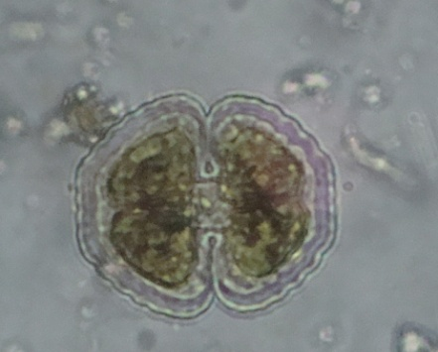  1 | 2 | 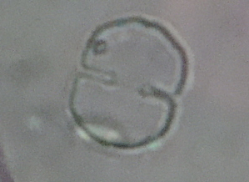  3
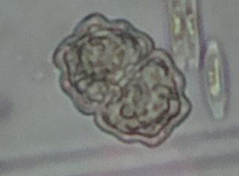  4 | 5 |  | 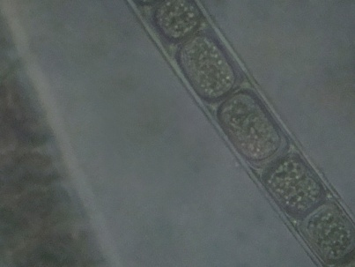  6-a
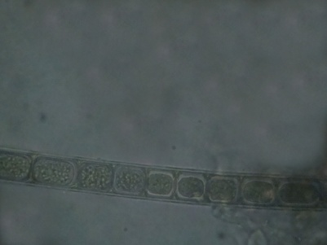  6-b | 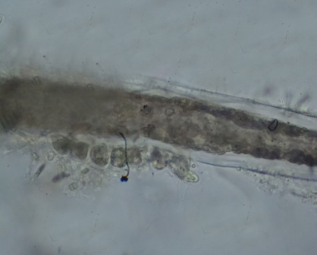  7-a |  | 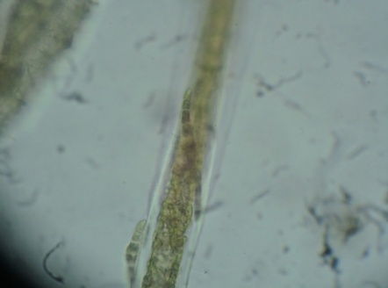  7-b
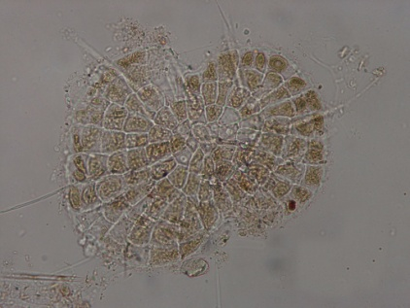  8 | 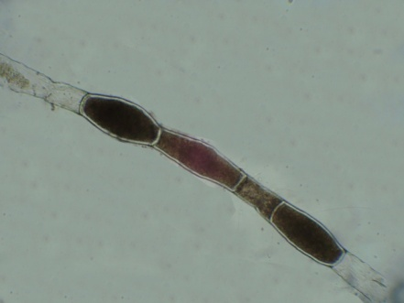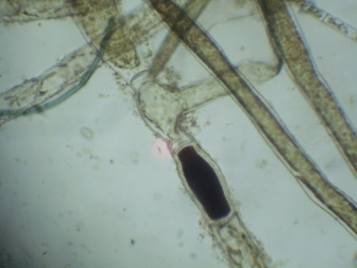  9
Plate (1): Class I:Zygnematophyceae: figs. 1.Cosmarium botrytis, 2.C. leave,3.C. meneghinii, 4.Euastruminsulare, 5.Staurastrumsp, Class II: Chlorophyceae ,6. (a,b )Microsporapachyderma,7. (a,b) Aphanochaeterepens, 8.Coleochaetescutata, 9.Pithophoravaria(each scale 10µm except figs.1, 9)

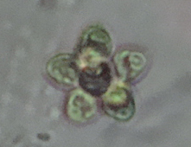  10 | 11 | 12
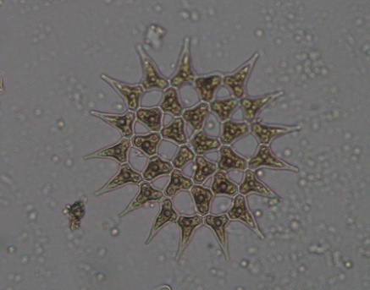  13 | 14 | 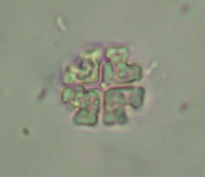  15
16 | 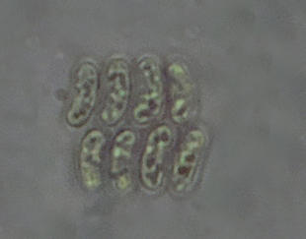  17 | 18
19 | 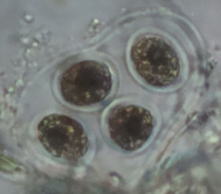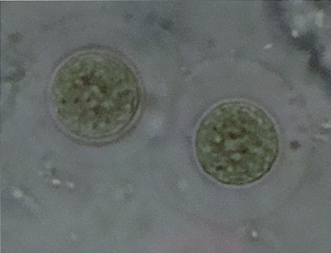  20
Plate (2): ClassII:Chlorophyceae: figs. 10.Coelastrummicroporum, 11.Pediastrumboryanum, 12. P.simplex,13.P.simplex var. Clathratum,14. P.tetras,15.P. tetras var. tetraëdron,16.Scenedesmusquadricauda, 17.S. arcuatusvar.platydisca ,18.Tetraëdron minimum, 19.T .muticum, 20.Asterrococcuslimneticus .

21 | 22 | 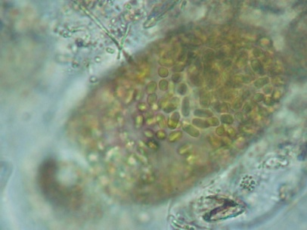  23
24 | 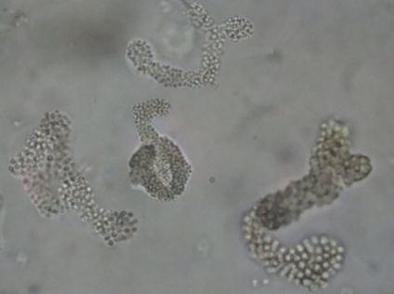  25 | 26
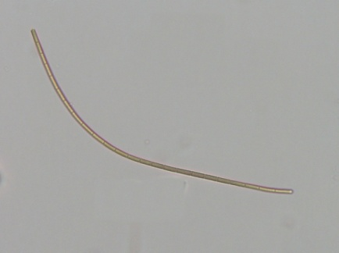  27 | 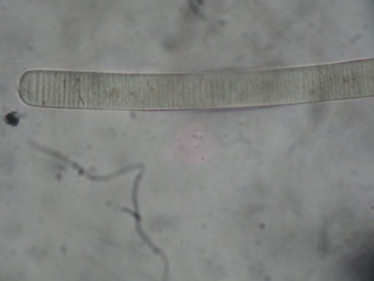  28 | 29
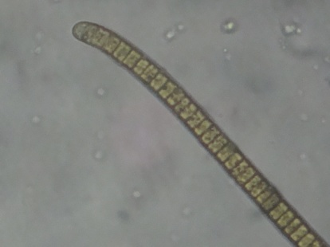  30 | 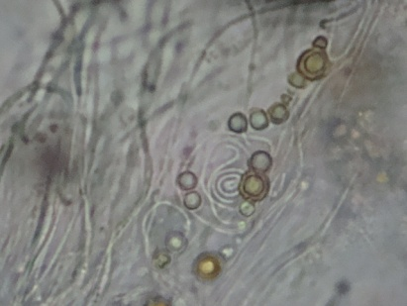  31 | 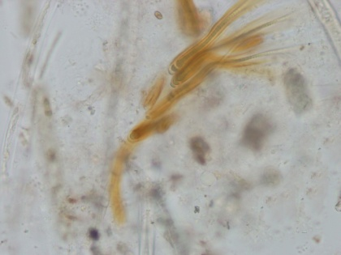  32
Plate (3): Class III:Chrysophyceae: figs. 21.Dinobryonsertularia,Class IV : Cyanophyceae: figs.22.Gomphosphaeriaaponina var. cordiformis, 23.Aphanothececastagnei, 24.Colesphaeriumdubium, 25. Microcystisaeraginosa, 26.Johannesbaptistiapellucida, 27.Oscillatorialimnetica,28.O. limosa, 29.O. perornata,30. O. tenuis , 31. Nostocsphaericum, 32. Calothrixparietana

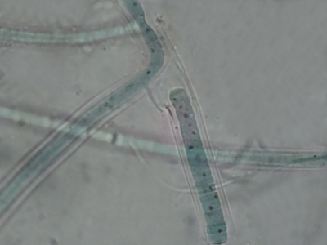  33- a | 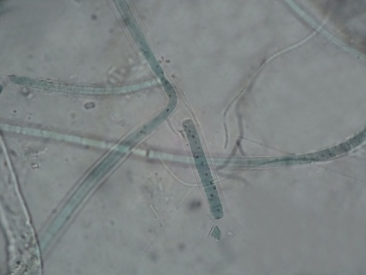  33-b
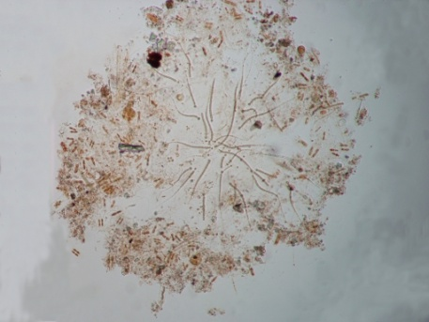  34-a | 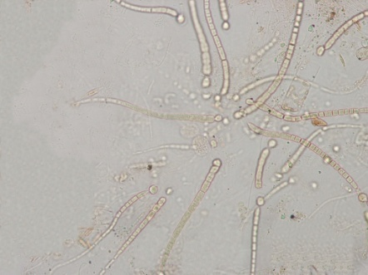  34-b
Plate (4): Class IV :Cyanophyceae: figs.33.(a,b)Scytonemasp., 34. (a,b) Rivulariahansgirgii

References
- Brasington, J. The Iraqi marshlands: a human and environmental study. In: Nicholson E. and Clark, P.(eds). Politics Publishing, London.2002.
- Al-Kwnzawi, M. A. H., Hassan, F. M. and Al- Mayah, A. A. A. The distribution of Ceratophyllum demersum L. in relation to environmental factors in restored Al-Mashb marsh, Hor Al-Hammar, southern Iraq. Marsh Bulletin Vol.7, No.2, pp. 137-149. 2012.
- Hamdan, M. A. H; Asada, T. Hassan, F.M; Warner, B.G; Douabul, A. Al-Hilli, M.R.A. and Alwan, A.A. Vegetation response to re-flooding in the Mesopotamian wetlands, Southern Iraq. J. of. Wetland, Vol.30, pp. 177-188. 2010.
- Al-Haidarey M.J. S., Hassan, F. M., AL-Kubaisey A. R. A.and Douabul A A Z. The geoaccumulation index of some heavy metals in Al- Hawizeh marsh, Iraq. E.J.Chem. Vol. 7, No.S1, pp. S157-S162. 2010.
- Al-Saadi, H.A.;Pankow,H. and Huq, M. F. Algeological investigations in the polluted Ashar canal and Shatt al-Arab jn Basrah Iraq. Int. Revue. Ges Hydrobiol., Vol.64, No.4, pp. 527-540. 1979.
- Maulood, B.K.; Hinton, G.C.F.; Kamees, H.S.; Saleh, F.A.K.; Shaban, A.A. and Al-Shahawani, S.M.H. An ecologyical survey of some aquatic ecosystem in Southern Iraq. Trop. Ecol., Vol. 20, No.1, pp.27-40.1979.
- Al-Mousawi, A. H., Al-saadi, H. A. and Hassan, F. M. Spatial and seasonal variations of phytoplankton populations and related environments in Al-Hammar marsh, Iraq. Bas.J.Sci. Vol.12, No.1, pp.9-20.1994.
- Al-Handal, A.Y.and Abdulla,D.S. Diatoms from the restored Mesopotamian marshes, of the South Iraq. Algological studies, Vol.133,pp. 65-103. 2010.
- Hassan, F.M.; Al-Kubaisi,A.A. and Talib,A.H. phytoplankton primary production in southern Iraqi marshes after restoration. Baghdad Science Journal, Vol.8, No.1,pp. 51-530. 2011.
- Al-Hassany, J. S. and Hassan, F. H. Systematic study of epiphytic algal after restoration of Al-Hawizah marshes, southern of Iraq. 2014.
- Mitsch, W.J. and Gosselink, J.G. Wetlands 3rd. ed. John Wiley and Sons, Inc. 2000.
- Nozaki, K.; Darijav,K.; Akatsuka, T.; Goto,N. and Mitamura.O. Development of filamentous green algae in the benthic algal community in a littoral sand-beach zone of lake Biwa. J. 2003.
- Simkha'ada, B.;Jutter,I. and Chimonides, J. Diatoms in loland ponds of Koshi Tappu, Eastern Nepal- relationships with chemical and habitat characteristics . Int. Rev. ges. Hydrobiologia.., Vol. 91, No.6,pp. 574-593.2006.
- Sheldon, R.B. and Boylen, C.W. Factors affecting the contribution by epiphytic algae to the primary productivity of an oligotrophic freshwater lake. Appl. Microbio., Vol.30, No.4, pp.657-667.1975.
- Limpens, J.; Raymakers,J.T. A.; Baar, J; Berendse,F. and Zÿlstra,J.D. The interaction between epiphytic algae, a parasitic fungus and Sphagnum as affected by N and P. OIKOS, Vol.103, pp. 59-68.2003.
- Michael,T.S.; Shin, H.W.; Hanna, R. and spafford, D.C. A review of epiphytic community development: Surface intractions and settlement on seagrass. J. of Environ. Biol. Vol.29, No.4, pp. 629 – 638. 2008.
- Blindow, I. The composition and density of epiphyton on several species of submerged macrophytes-the neutral substrate hypothesis tested. Aquat. Bot., Vol.29, pp.157-168.1987.
- Kassim, T.I. and Al-Saadi, H.A. Seasonal variation of epiphytic algae in a marsh area (Southern Iraq). Acta Hydrobiol.,Vol. 37, No.3, pp.153-161. 1995.
- Kassim, T.I.; Sabri, A.W. and Al-Lami, A.A. Ecological study on epiphytic algae community in the River Tigris at Sammarra impoundment. The Scientific Journal of Iraqi Atomic Energy Commission, (2000). Vol.2, pp. 33-51, 2000.
- Hadi, R.A.M and Al-Zubaidi, A.J.M. Species composition and seasonal variation of epiphytic diatoms on Typha domtoms, Typha domengensis and Phragmites australis from Southern Iraqi Marshes. J. Coll.Edu. for Women, Univ. Baghdad, Vol. 12, No.1, pp.113-119.2001.
- Hassan, F.M.; Salah, M.M. and Salman, J.M. Quantitative, and qualitative variability of Euphrates River, Iraq, Iraq J. Aqua., Vol. 1, pp.1-16. 2007.
- Hassan, F.M.; Hadi,R.A.;Kassim, T.I.; and Al-Hassany, J.S. Systematic study of epiphytic algal after restoration of Al-Hawizah marshes, southern of Iraq.International journal of Aquatic Science ,Vol.3, No.1, 37-57. 2012.
- Zimba, P.V. and Hopson, M.S. Quantification of epiphyte removal efficiency from submersed aquatic plant. Aquat. Bot., Vol.58, pp.173-179. 1997.
- Desikachary, T.V. Cyanophyta, Indian Council of Agricultural Research. New Delhi, 686 pp. 1959.
- Prescott, G. W. Algae of the western Great Lakes Area. William, C. Brown Co., Publ. Dubuque, Iowa, 977 pp. 1982.
- Nural-Islam, A.K.M. and Khatun, M. Preliminary studies of the phytoplanktons of polluted water. Sci. Res. East Reg. lab., Pakistan, Vol.3, No.2, pp. 94-109. 1966.
- Nural-Islam, A.K.M. and Zaman, K.M. Limnological studies of the River Buriganga III. Biological aspect. J. Asiatic Soc. Bangladesh (Sc.),Vol. 1, No.1, pp. 45-65. 1975.
- Nural-Islam, A.K.M. and Haroon, A.K.Y. Desmids of Iraq. Int. Rev. ges. Hydrobiologia, Vol.70, No.6,pp. 877-889. 1985.
- Wehr, J.D. and Sheath, R.G. Freshwater Algae of North America: Ecology and Classification Academic Press, 918 pp. 2003.
- Hinton, G.C.E. and Maulood, B.K. Some diatoms from brackish water habitats in Southern Iraq. Nova Hedwigia, Vol.33, pp. 487-497.1980.
- Al-Handal, A.Y. Desmids of the Basrah district South Iraq. Int. Revue. Ges Hydrobiol., Vol.80, No.1,pp. 89-102. 1995.
- Delazari- Barroso, A.; Anna, S. and Senna, P. Phytoplankton from Duas Bocas reservoir, Espirito Santo. State, Brazil, Hoehnea Vol.34, No.2, pp. 211-229.2007.
- Skinner, S. and Entwisle, T.J. Non-marine algae of Australia: 6. Cladophoraceae (Chlorophyta). Telopea, (2004). Vol. 10, No.3, pp. 731-748. 2004.
- Felisberto, S.A. and Rodrigues, L. Periphytic desmids in Corumba', Goia's, Brazil: genero Cosmarium corda. Braz. J. Biol., Vol.64, No.1, pp.1-2.2004.
- Nurul-Islam, A.K.M and Begum, Z.T. Studies on the phytoplankton of Dacca District order: Chlorococcales J. Asiatic Soc. Pakistan. Vol. 15, No.3, pp. 227- 271. 1970.
- Belcher,H.and Swale, E. An Illustrated guide to river phytoplankton.Her Majesty Stationary Office ,64pp. 1979.
- Pankow, H. Algenflora der Ostsee I. Benthos. (Blau-, Grun-, Braun- und Rotalgen). Gusta Fischer Veglag. Stuttgart. 419 pp. 1971.
- Nurul- Islam, A. K. M. and Nahar, L. Preliminary studies on the phytoplanktonof polluted water. (Part II.- Blue-green algae) Sci. Res. IV. Vol.2, No.3, pp. 141-149. 1967.
- Nurul- Islam, A. K. M.and Uddin, M. A. Blue-green algae from Dacca, Bangladesh II Oscillatoriaceae. Dacca University Studies B, Vol.24, No.1, pp. 73-84.1978.
- Bourrelly, P. Les Algues d' Eau Douce.3. Les Algues Bleues et Rouges, Les Eugleniens, Peridinies et Cryptomonadines N. Oubee et Cie, Paris. 521 pp. 1970.

