**Assessment of Al-Hammar marsh water by uses Canadian water quality index( WQI)**

**Ahmed C. AL-Shammary *Majdi F. AL-Ali Kadhim H. Yonuis**

Aquaculture and Marine Fisheries/ Marine Science Centre/University of Basrah

*Veterinary medicine College/University of Basrah

**Corresponding author:** [**a_kaseb@yahoo.com**](mailto:a_kaseb@yahoo.com)

**To cite this article:**

AL-Shammary, A. C.; AL-Ali, M. F. and Yonuis, K. H. Assessment of Al-Hammar marsh water by uses Canadian water quality index( WQI). *Mesop. Environ. J,* 2015,Vol. 1, No. 2 , pp. 26-34.

**Abstract**

The present study on water quality of the East Al-Hamare marsh after restoration was assessed by using the Canadian council of ministers of the environmental water quality index (CCME WQI) ,the model was applied in two approaches based on the historical data and the CCME aquatic life guidelines as object , we chosen two station in Al-Hammar marsh for the period September 2008- September 2009 ,the index calculation were 13 environment factors: water temperature ,oxegen demand, salinity, Bod5,ph,No3,No2,Po4,sil,Tds,Tss,Turbdity,transperancy, the general historian for the period 2003-2004 was under Marginal assessment in first station and Fair in second station , in the present study WQI value was under fair assessment in two station respectively.

**Keywords**; Al-Hammar marsh, WQI, CCME

**Introduction**

Water quality indices are tools to determine conditions of water quality and, like any other tool require knowledge about principles and basic concepts of water and related issues [1]. Water is one of the most indispensable resources hence life is not possible on this planet without water. Recent research conducted by [2].Assessment of water quality is a critical component of diagnosing overall health of aquatic ecosystems. Assessment requires two components, measurement of water quality parameters and comparison of measures to benchmarks such as guidelines and objectives to assess change. Water quality may be assessed both spatially and/or temporally[3]. The deterioration of groundwater quality has many sources. Such as tourism industry Owing to rapid urbanization, growing population and speedy industrialization have lead to the pressure on demand for water. Ground water is used for domestic, industrial and irrigational purposes all over the world. In the last few decades there has been a tremendous increase in the demand for fresh water due to rapid growth of population and the accelerated pace of industrialization.[4]. Ground Water” a gift of nature, is about 210billion m3including recharge through infiltration seepage and evaporation. Ground water is the main source of drinking water. Today human activities are constantly adding industrial, domestic and agricultural waste to ground water reservoirs at an alarming rate [5] The assessment of groundwater quality status is important for socio-economic development of any region of the world. The determination of groundwater quality for human consumption is important for the well being of the ever increasing population. Good quality water will ensure the sustainability of socio-economic development, as the government priority is shifted to other sectors of the economy, rather than channeling the resources towards combating outbreaks of water borne diseases due to consumption of contaminated groundwater. Groundwater quality depends, to some extent, on its chemical composition[6]. Development of these rating curves depends on the specific activity and use, so it reflects the water quality and its availability for different type of uses. Maximum permissible and maximum desirable limits of water quality standards of [7,8,9] and those proposed by [10,11,12] are used for development of the rating curves. In iraq last studies [13]. to assessment Tanjero river and [14]. assessment epharaties raver under marginal and also study [15]. to assessmentin Dhok raver and Shatt Al-Arab river [16]. to assessment north part from Shatt Al-Arabe river and [17]. to assessment from Shatt Al-Arabe river and [18].to assessment Al-Hammar marsh, also study [19].assessment Al-Hamar marsh assess stations under marginal and poor.

The aim of study Assessment final to water Al-Hammar marsh by using Canadian spacemen for water after restoration marsh.

**Materials and methods**

We choose tow station in Al-Hamare marshes ,first station name(Al- Mashab ) and second station (Al- Monsory )( fiug .1) during September 2008 –September 2009 The calculated pH, Total dissolved solids (TDS) ,Salinity, Temperature water ,dissolved oxygen by using Yasi model 57, USA, from kalbuneh company ,and their Nitrite ,Nitrate ,Phosphates ,silica was calculated use [20]. method. The calculated with BOD5 within USA general health society [21]. calculated mynas between reading first and second station ,the turbidity use HANNA British made (NTU).and calculated total suspended solid mg/l within [22]. and calculated Transparency use sacchi desk cm.

**WQI calculation**

The whole study period assessment of treated water quality at each water supply (the over all water quality) was achieved by application of the CCME WQI model on all of the studied chemical parameters except total chlorine. Its calculation comprised three factors as follows[23].

F1 (Scope) represents the percentage of variables that do not meet their objectives at least once during the time period under consideration (failed variables), relative to the total number of variable measured:

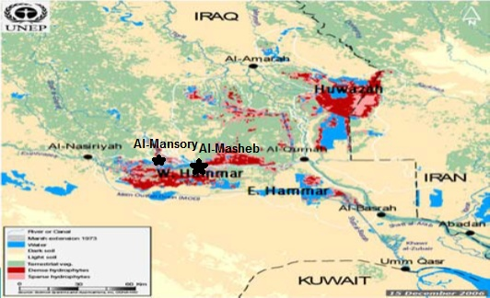F1 = [Number of failed variable/ Total number of variable] ×100 (1)

***Fig.(1) Explain first and second station in present study***

F2 (Frequency) represents the percentage of individual tests that do not meet objectives (failed tests):

F2 = [Number of failed tests / Total number of tests ] ×100 (2)

F3 (Amplitude) represents the amount by which failed test values do not meet their objective. F3 is calculated in three steps.

i) The number of times by which an individual concentration is greater than (or less than, when the objective is a minimum) the objective is termed an “excursion” and is expressed as follows. When the test value must not exceed the objective:

Excursion= [Failed test valuei / objectivei]-1 (3a)

For the cases in which the test value must not fall below the objective:

Excursion= [objectivei / Failed test valuei]-1 (3b)

ii) The collective amount by which individual tests are out of compliance is calculated by summing the excursions of individual tests from their objectives and divided by the total number of tests (both those meeting the objectives and those not meeting objectives). This variable, which is referred to as the normalized sum of excursions, or nse, is calculated as:

𝑛 Nse = Σ𝑒 𝑖 =1 / total number of tests (4)

iii) F3 is then calculated by asymptotic function that scales the normalized sum of excursions from objectives (nse) to yield a range between 0 and 100.

F3 =[nse/ 0.01 nse+ 0.01] (5) After the factors have been obtained, the index itself can be calculated as follows:

CCME WQI = 100-[√F1 +F2 +F3 / 1.732] (6).

**Result and Dissection**:

From the seasonal variation of sampling, the average value of physic-chemical parameters of the above thirteen samples is given in the Table (1) in first station.

Table(1): explains physical, chemical properties of Al-Hammar marsh during Sep2008-Sep2009 in first station

|  |  |  |  |  |  |  |  |  |  |  |  |  |  |
| --- | --- | --- | --- | --- | --- | --- | --- | --- | --- | --- | --- | --- | --- |
|  | Tem c̊ | Do mg/l | Sal ppt | BoD5 mg/l | pH | No3 µg N/l | No2 µg N/l | Po4 µg P/l | Sil µg S/l | Tran cm | Tss mg/l | Tds mg/l | Tur NTU |
| Sep2008 | 15 | 8 | 1.4 | 1 | 7.5 | 2 | 0.4 | 0.9 | 37 | 71 | 16 | 1213 | 11.9 |
| Oct | 14 | 8.4 | 1.4 | 0.9 | 8.3 | 2 | 0.3 | 1 | 25 | 87 | 15 | 1240 | 11 |
| Nov | 15 | 8.7 | 1.3 | 0.7 | 8.5 | 16 | 0.1 | 1.6 | 17 | 93 | 12 | 1235 | 10.5 |
| Dec | 12 | 9 | 1.4 | 0.8 | 8.2 | 4 | 0.2 | 1.2 | 18 | 86 | 13 | 1232 | 13 |
| Jan | 12 | 8 | 1.5 | 1.3 | 8.3 | 4 | 0.2 | 0.9 | 17 | 70 | 15 | 1247 | 16 |
| Feb | 16 | 8 | 1.6 | 0.7 | 8.1 | 2 | 0.3 | 0.8 | 16 | 70 | 20 | 1262 | 16 |
| Mar | 20 | 7.6 | 1.6 | 0.9 | 8.4 | 2.5 | 0.4 | 0.8 | 15 | 63 | 23 | 1262 | 17 |
| Apr | 22 | 7.6 | 1.7 | 1 | 7.5 | 1.9 | 0.6 | 0.7 | 17 | 50 | 25 | 1270 | 18 |
| May | 21 | 7 | 1.7 | 1.4 | 7.3 | 2 | 0.6 | 0.4 | 28 | 44 | 17 | 1280 | 16 |
| Jou | 32 | 7.5 | 2.1 | 1.6 | 8 | 2.1 | 0.5 | 1 | 20 | 50 | 15 | 1282 | 15 |
| Jul | 26 | 8.2 | 2 | 1.5 | 8.3 | 2 | 0.4 | 0.9 | 17 | 51 | 23 | 1261 | 13 |
| Aug | 25 | 8.3 | 2.7 | 1.4 | 8 | 2.3 | 0.6 | 0.8 | 42 | 60 | 20 | 1441 | 11 |
| Sep | 22 | 11 | 6 | 1.9 | 7.9 | 1.2 | 0.9 | 1.1 | 35 | 63 | 22 | 1322 | 12 |

And seasonal variation of sampling, the average value of physic-chemical parameters of the above thirteen samples is given in the Table( 2) second station.

Table(2): explains physical, chemical properties of Al-Hammar marsh during Sep2008-Sep2009 in second station

|  |  |  |  |  |  |  |  |  |  |  |  |  |  |
| --- | --- | --- | --- | --- | --- | --- | --- | --- | --- | --- | --- | --- | --- |
| Tur NTU | Tds mg/l | Tss mg/l | Tran cm | SilµgS/l | Po4µgP/l | No2µgN/l | No3µg N/l | pH | Bod5 mg/l | Sal ppt | Do mg/l | Tem c̊ |  |
| 11 | 1220 | 12 | 80 | 33 | 1.1 | 0.2 | 1.8 | 7.7 | 1.4 | 1.3 | 8.2 | 13 | Sep2008 |
| 9 | 1221 | 11 | 80 | 25 | 1.4 | 0.1 | 1.9 | 8 | 1.3 | 1.1 | 8.2 | 13 | Oct |
| 7 | 1210 | 8 | 85 | 16 | 0.9 | 0.1 | 1.4 | 7.6 | 1.2 | 1 | 8.4 | 11 | Nov |
| 12 | 1212 | 11 | 77 | 12 | 0.4 | 0.1 | 3.9 | 7.5 | 1 | 1.3 | 8.6 | 13 | Des |
| 13 | 1222 | 13 | 75 | 13 | 0.4 | 0.1 | 3.5 | 8.3 | 1.2 | 1.4 | 8 | 13 | Jan |
| 13 | 1235 | 14 | 62 | 12 | 0.3 | 0.3 | 3 | 7.6 | 1.3 | 1.4 | 7.9 | 14 | Feb |
| 14 | 1240 | 14 | 57 | 15 | 0.2 | 0.3 | 2 | 7.5 | 1.4 | 1.6 | 7.6 | 19 | Mar |
| 15 | 1250 | 20 | 45 | 21 | 0.1 | 0.5 | 1.9 | 7.8 | 1.5 | 1.5 | 7.5 | 20 | Apr |
| 13 | 1252 | 18 | 50 | 17 | 0.6 | 0.4 | 1.9 | 7.6 | 1.6 | 1.8 | 7.3 | 21 | May |
| 12 | 1245 | 17 | 49 | 20 | 1 | 0.3 | 1.8 | 7.5 | 2.1 | 1.8 | 7.4 | 27 | Jou |
| 11 | 1240 | 15 | 62 | 17 | 0.9 | 0.3 | 1.9 | 7.6 | 1.8 | 2 | 7.5 | 22 | Jul |
| 10 | 1430 | 14 | 70 | 31 | 0.8 | 0.4 | 2.1 | 7.3 | 1.8 | 3 | 7.7 | 20 | Aug |
| 10 | 1611 | 13 | 72 | 40 | 1 | 1.2 | 3.2 | 8 | 1.8 | 5.8 | 8.2 | 15 | Sep |

and there is was found during general historian assessment of Al-Hammar marsh during Sep2003-Sep2004 in first and second station appeared CWQI value 64 under assessment Marginal in first station while CWQI value 65 under assessment Fair in second station period September 2003 to September 2004 after restrain marshes (Table,3) and( fuger,2).

Table(3): explains Data summary and general historian assessments of Al-Hammar marsh during Sep2003-Sep2004 in first and second station



First station second station

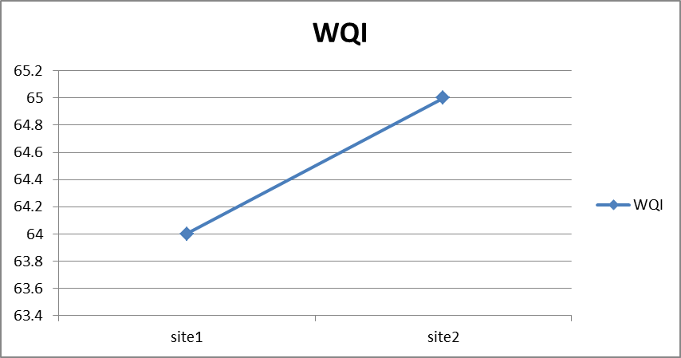

Fiug(2) Explains WQI values for historian tow station

While in this study illustrates CWQI value (72,73) under Fair assessment in first and second station respectively (Table ,4).

Table(5) explain WQI value and F1,F2,F3 that two stations with zone Al-Mashab and Al-Monsory ,while Table (6) explain the classification of water quality index with begins with 95-100 Excellent and last classify 0-44 poor.

Table(4): explain Data summary and general assessments of Al-Hammar marsh during Sep2008-Sep2009 in first and second station



First station Second station

Table (5):explains the WQI value and F1,F2,F3 in the two station

|  |  |  |  |  |
| --- | --- | --- | --- | --- |
| F3 | F2 | F1 | WQI | Station |
| 33 | 23 | 29 | 72 | AL-Mashab |
| 30 | 21 | 29 | 73 | AL-Monsory |

Table(6) classification of water quality on the basis of (WQI)

|  |  |
| --- | --- |
| Suitability | WQI |
| Excellent | 100-95 |
| Good | 94-80 |
| Fair | 79-65 |
| Marginal | 64-45 |
| Poor | 44-0 |

Fig(3) explain water quality index values for (2003-2004)and (2008-2009) first station they were 64 -72 respectively. To compare these values with second station values for the two period 2003-2004 and 2008-2009 and they were 65 and 73 in period 2003-2004 and 2008-2009 respectively. In water quality index in two station appeared in second station was 73 respectively was highest than the first station in Al-Hammar marsh (fig,4).

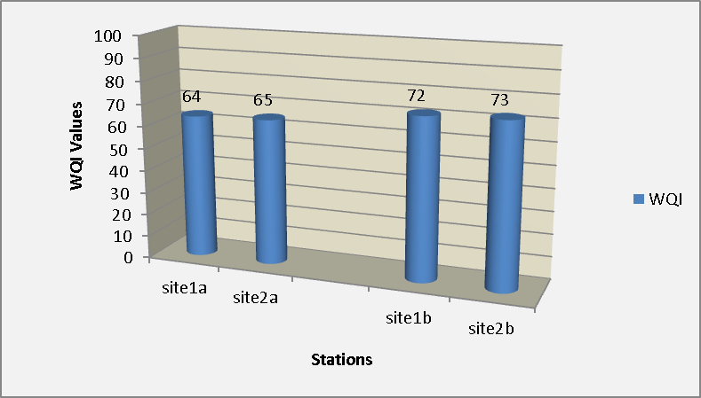

Fiug(3) Explain Wqi values for tow station in last and present study

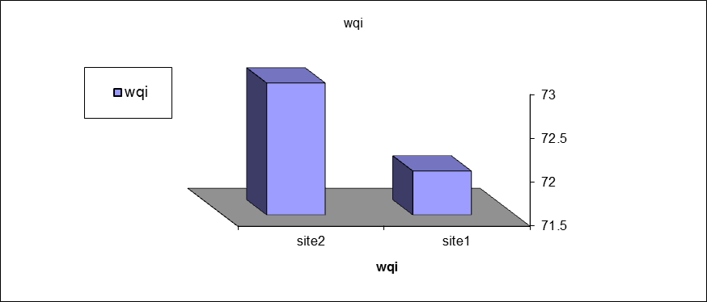

Fiug(4): explain WQI value in first and second station

The present study showed that the quality of Al-Hammar marsh water represented by the two stations were below the assessment of Fair, 2008-2009.The index in the first and second station was 72 and 73 respectively, this index does not agree with what [18]. reached.it was below assessment poor in 2004-2005 in Al-Hammar marsh and my be water quality might be very poor because of big water quantities and high level of water during the period of present study this agrees with what [16]. found in his study on four stations of Shatt-Al-Arab was be under assessment Margenal was below close not agrees with [17]. on the study on sites of Shatt Al-Arab and Garma it was below the poor assessment and not agrees with too [19]. on the study on sites of Al-Hammar marsh under assessment poor , this emphasis sizes in the year 2008 the waters were poorer and in 2009 became bellow poor the assessment because of high level of salinity. The present study gave Fair assessment to the water quality of Al-Hammar marsh, this does not agree with a study of [24]. on Al-Jabayish marsh he gave poor assessment in the same period ,this indicated that the year 2008-2009 was the period of present study and pointed of water quality Al-Hammar marsh was better than the one of 2006-2007 for the same site, it was bellow poor assessment. The studies that were done after 2010 that water quality of assessment mentioned was between poor and Margnal was emphasized by [19]. in his study on Al-Hammar marsh .The present study showed that the environment variables were accepted except September 2009,the salinity was little bit increased in Al-Hammar marsh (6 and 5.8)‰ in the first and second station respectively. water increases that came from Euphrates river to reach 55% according the statistics of Ministry water Resources, these caused the improvement of water quality the rain full also improved water quality .,this does not agree with what Radi mentioned in 2014, it found in the waters of Al-Hamar marsh were under poor assessment, it attributed that to reduced water effluents and raising salt ratio that result from tabbing water .In general estuary that feeds the marsh from Thi Qar governorate via Al-kamisiyah dam and nutrient values were within normal limits in the present study, this led plant cover prosperity and BOD5 improvement and reduced turbidity as it is shown in table 1&2 in first and second stations respectively I,e., the marsh is controlled by tidal phenomenon that comes from sea .As a result of this phenomenon was rising salinity during summer months due to raising temperatures and were does agree with [25]. in study for Al-Hamar marsh . ones CWQI historian value were less than of present study, this was emphasized by [26]. in their study on Al-Hammar marsh during their period.

**References**

**[1] Chougule, M.B.; Wasif, A. I. and Naik,V. R.** Assessment of water quality Index (WQI) for Monitoring pollution of River Panchgange at Ichalkaranji. proceedings of International Conference on Energy and environment, Chandigarh,pp.122-127.2009

**[2] Yisa, J. and Jimoh, T.** Analytical Studies on Water Quality Index of River Landzu. American Journal of Applied Sciences. Vol. 7, No.4, pp. 453-458.2010.

**[3] Rosemo, S. ; Duro, D. C. and Dube, M.** Comparative analysis of regional water qualityin Canada using the Water Quality Index. Environ. Monit. Assess., Vol. 156,pp 223–240.2009.

**[4] Idris, A. B.; Al MAmun, A.; Soom, M. A. M. and Noor, W.** Pollution Res., Vol.22, No.2, pp145.2003

**[5] Panda, R.B. and Sinha, B.K.** Investigation of water quality of Brahmani River. Indi. Jou. Environ. Health, , Vol. 33, No.1,pp 45-49.1991.

**[6] Wadie, A.S.T. and Abduljalil, G.A.D.S.** Assessment of hydrochemical quality of groundwater under some Urban areas within Sana’a Secretariat. Ecletica quimica. www.SCIELO.BR/EQ. Vol. 35, No. 1, pp. 77-84.2010.

**[7] WHO.** Guidelines for drinking-water quality [electronic resource]:incorporating 1st and 2nd addenda , Recommendations. 3rd Ed. World Health Organization, Geneva , Vol.1, pp 515.2008.

**[8]** Canada, J.C. Guidelines for Canadian Drinking Water Quality. Federal- Provincial, Territorial Committee on Drinking Water, pp 20 .2006.

**[9] European Standards(EU).** EU's Drinking-Water Standards. http:// [www.lenntech.com](http://www.lenntech.com) 2004.

**[10]** **House, M. A.** Water Quality Indices. Ph.D. Thesis, Middlesex polytechnic, Queensway, Enfield, Middlesex, UK, pp164.1986.

**[11] House, M. A.** A water quality index for river management. J. of the Institute of Water and Environ. Manage., Vol.3, No.4, pp336-344.1989.

**[12] Bahargava, D.S.** Use of Water Quality Index for River Classification and Zoning of Ganga River. Environmental Pollution Series (B),pp 51-67. 1983.

**[13] Mustafa, O. M.** Impact of sewage waste water on the environmental of Tanjero river and its basin within Sulaimania city/ NE-Iraq. M.Sc thesis, College of Science, University of Baghdad, Iraq, pp 142 .2006.

**[14] AL-Heety, E. M. ; Ahmed, M. T. and AL-Othman, E. M.** Assessment of the water quality index of Euphrates river between Heet and Ramadi cities, Iraq International J. of Basic & Applied Sciences, Vol. 11, No. 6, pp38-50.2012.

**[15] Alobaidy, A.M.J.; Abid, H. S. and Maulood, B. H.** Application of water quality index for assessment of Dokan lake ecosystem, Kurdistan region, Iraq. Journal Water. Resource. and Prot., Vol. 2, pp792-798.2010.

**[16] Moyil, M. S.** Assessment water quality for North part from Shatt Al-Arab river to using water quality index Canadian spacemen" Thesis of Science college. pp 1-100.(in Arabic).2010.

**[17] Essa, A.M. and Mahmood, A.A.** An Assessment of the treated water quality for some drinking water supplies at Basrah. Journal of basrah researchers (sciences) Vol. 38,No.3, pp95-105.2012.

**[18] Al-Saboonchi ,A.M. ; Mohamed, A.M.; Jawad, H.S A., and Maulood, B.K.** On the current and Restoration Conditions of the southern Marshes: Application of the CCME WQI on the East Hammar Marsh .Journal. of Environmental protection .Vol. 2, pp316-322. 2011.

**[19] Radi, F.K.** Assessment of Al-Hamar marsh protectorate nature for uses ecology index Unpublished Msc. thesis Basrah University, Iraq ,pp113.2014.

**[20] Parsons, T. R. ; Matia, Y. and Lalli, C. M.** A manual of chemical and biological methods for sea water analysis. Pergamon press. Oxford, pp 360 .1984.

**[21] APHA,** (American Public Health Association) .Standard method for the examination of water and wastewater – 21th edition. Washington, D. C. pp. 1193 .2005

**[22] AOAC.** Association of officialanaly ticalchemists. 14th Ed., Arlington, Virginia, USA, pp. 1094.1984.

**[23] CCME.** Canadian water quality guidelines for the protection of aquatic life: CCME Canadian Council of Ministers of the Environment.Winnipeg, Manitoba (www.ccme.ca/assets/pdf/wqi_ usermanualfctsht_e.pdf ).2001

**[24] Abd, I.M.** Ecological assessment of Chybaish marsh using water quality index and index of biological integrity of fish and phytoplankton assemblages" (Unpublished Ph D. thesis). Basrah University, Iraq. pp 109.2010.

**[25] AL-Shamary, A.Ch.; AL –Zaowar, G.K. and Younis, K.H.** Effect of some environmental factors on fishes assemblage in AL-Hammar marsh" Journal Mesopotamia ,in press, 2011.

**[26] Richardson, C.J. and Hussain, N.A.** Restoring the Garden of Eden: An ecological assessment of the marshes of Iraq. Journal Biosci. Vol. 56, No.6, pp.477-489.2006.