Antiatherogenic effects of Vitamin E against lead acetate induced hyperlipidemia

Majeda A. J. Alqayim

Department of Physiology and Pharmacology /College of vet. Med/ Univ. Baghdad

Corresponding author: jaafer59@yahoo.com

To cite this article:

Alqayim, M. A. Antiatherogenic effects of Vitamin E against lead acetate induced hyperlipidemia. Mesop. environ. j. 2015, Vol.1, No.2:pp.85-95.

Abstract

The importance of Lead environmental pollutant has long been recognized, to human and animal health. In Iraq Lead pollution was documented in Bagdad and in Sulaimani city.To explore the protective role of vitamin E against lead acetate side effects on lipids profile as a pro- athergenic agent in adult male rabbits.This study was conducted on 30 male adult rabbits divided equally in to 3 groups. 1st group considered as control and 2nd orally administered 2.5 mg/Kg B.W. lead acetate, and the 3rd orally administered 2.5 mg/Kg B.W lead acetate +100 IU / Kg B.W. vitamin E for 90 days. At the end of experiment blood samples were collected for measurement of total cholesterol and triacylglycerides, HDL-cholesterol analysis. Hearts were isolated for aortic sectioning. Results revealed that Lead acetate caused a significant( p<0.05) increase in total- cholesterol; LDL& VLDL –cholesterol; total triacylglycerol ; and CRI , and decrease in HDL- cholesterol and AAI. Otherwise Vitamin E was efficient in restoration these variables to semi normal values with an exception ,significant elevation of HDL( p<0.05) . Histopathological analysis of aortic sections showed marked replacement of myfibers with macrophages lipid loaded cells in lead acetate group, these deleterious changes in the myocardium which were improved in hearts of vitamin E received group. In conclusion Vitamin E was efficient in reducing the side effects of Lead on lipids profile and preventing atherosclerosis development.

Keywords; Lead ; Vit.E; hyperlipidemia ; Antiatherogenic Index; Coronary risk Index. HDL.
Introduction

The term Hyperlipidaemia, is happen when serum cholesterol and or triglycerides levels are elevated and reach levels linked with an increased risk of ischemic heart disease (IHD) [1], this is consistent with the view that for every 1% increase in blood cholesterol levels, there is a 2this is c% increase in the frequency of coronary heart disease and for every 1% decrease in high density lipoprotein cholesterol level (HDL–C), there is a 3% increase in coronary heart disease[2]. Since LDL contains variety of antioxidants able to inhibit its oxidation, increasing the antioxidant content of LDL should be able to retard atherogenesis, the antioxidant content of LDL can be easily increased by dietary supplementation [3]. Supplementation with different diatec antioxidants, such as ascorbic acid and α-tocopherol have been demonstrated to inhibit LDL oxidation [4.5]. The role of vitamin E to affect atherogenesis has been studied in many trials ,when vitamin E was given at reduced risk of cardiovascular death caused by atherogenesis [6, 7 ]. Vitamin E has a potential effects as antioxidative as mentioned by many studies [ 8, 9] α- tocopherol( one of vitamin E) decreased serum total cholesterol and non HDL-ch and increasing HDL-ch, in addition it increased the liver glutathione and reduced serum lipid peoxidation and prevent the macroangiopathy.
Lead is considered as one of the major environmental pollutants, because of worldwide using of the lead in industrial processes, smokes from petrol vehicle, industrial pollution, occupational lead exposure may occur during the manufacture of batteries, painting, printing, pottery glazing, and lead smelting processes [10].The importance of lead as a toxic metal and environmental pollutant has long been recognized, to human and animal health [ 11,12 ], in Iraq, as well as other part of the world, Lead pollution was documented particularly in Baghdad [13].
The mechanism by which lead affects the human and animal body is extremely complex on an atomic level, lead can induce a wide range of adverse effects depending on the dose and duration of exposure [14 ,15]. It is documented that lead interferes with the utilization of iron and causing anemia [16,17]. Lead induces the production of reactive oxygen species (ROS) that result in DNA damage, and depletion of cell antioxidant defense systems, and have incriminated lipid abnormalities lipid peroxidation, and risk of atherosclerosis[18, 19 ] . In vivo and in vitro studies suggest that lipid metabolism is altered both in acute and chronic exposure to lead [ 20],in addition to increase in lipid peroxidation and a reduction in free radical scavenger enzymes in bone marrow [21 ,22].
The aim of the present study was to elucidate the effect of vitamin E on serum lipids profile and it's activity as antiatheroginic agent in sub chronic lead exposure rabbits for 90 days .
Materials and methods
Experimental design
30 adult male rabbits of local breed were divided randomly in to equal 3 groups each group of ten animals treated as follow: Group 1: Control group orally and daily administered with tap water . Group 2: Orally administered with 2.5 mg/KgB.W. lead acetate (250 mg/100ml) dissolved in tap water daily. Group 3: Orally administered with 2.5 mg/Kg B.W. lead acetate (250 mg/100ml) dissolved in tap water+100 IU / Kg B.W. vitamin E+ 100 mg/Kg B.W. methionine \dissolved in two milliliter of tap water daily. The experiment lasted for 90 days, mean while animals were observed daily for their behavior and health performance. At the end of the experiment all the experimental animals were anesthetized by intraperitoneal injection with 35 mg/kg ketamine hydrochloride. After opening the chest cavity, blood was collected by acupuncture through the left ventricle.
Serum lipid profile
Serum total cholesterol and triacyglycerides levels were measured by a colorimetric methods involved enzymatic hydrolysis methods using commercial kits ( Randox Laboratories Ltd., U.K.)
HDL-cholesterol measured by enzymatic colorimetric method with Randox diagnostic kit. The LDL & VLDL- cholesterol were calculated by using Freidewald’s formula:
LDL cholesterol = {total cholesterol – (triglycerides/5) – HDL-cholesterol
VLDL- cholesterol= Total triglycerides / 5.
Determination of antiatherogenic index (AAI) and coronary risk index (CRI) AAI and CRI were calculated using the following formulas cited by [23, 24]:

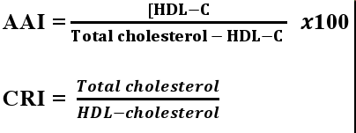

Histopathological examination of the aorta
After blood sample collection , aorta was isolated and flushed from blood gently and fixed in 10% formalin solution. sections were prepared as described in [25]. For histopathological determination of atherosclerosis.
Statistical Analysis

The Statistical Analysis System- [26] was used to effect of different factors in study parameters. Least significant difference –LSD test was used to significant compare between means in this study.

Results
Heart weight /body weight

The results obtained from the present study presented in figure-(1) describe the effects of Lead acetate on heart weight . The results revealed a significant ((P<0.05), decrease in the body weight and increase in heart weight and in the ratio of heart/ body weight of groups received Lead either alone or followed by vitamin E in compare with control.
Serum lipid profile
Results of the present study in table-1, clarify the effects of vitamin E on lipid profile in Pb exposed rabbits. The results indicated that rabbits had sub chronic exposure to Lead acetate (2.5mg/kg) days for 90 had been suffered from significant (P<0.05), elevated total cholesterol, total triacylglycerols, LDL&VLDL- cholesterol and decrease in HDL-cholesterol, when compared with control group. On the other hand results of serum lipid profile analysis of rabbits received vitamin E along with lead acetate had a semi normal values of total cholesterol and triacylglycerol and LDL&VLDL- cholesterol correlated with significant (P<0.01)increase in the HDL-cholesterol .
Antiatherogenic index (AAI) and coronary risk iondex (CRI) , are indices used to evaluate the prognosis of atherosclerosis in responces to lipid abnormalities, the analysis of the present results showed a significant(P<0.01 elevation of CRI in lead group correlated with(P<0.01 a significant decrees in AAI. On the other hand these variables were ameliorated not only to normal but better than normal in group received vitamin E along with lead ( figure-2).

Histopathological examination of aorta
Histopathologically the aorta of control group was normal , no atherosclerosis lesion, normal muscle fiber and no lipid loaded cells were seen(figure-4-A)The examination of the section of aorta from different experimental rabbits exposed to lead acetate showed a pathological changes resembled by, enlargement of endothelial cells and a marked replacement with fatty loaded cells in tunica intima, in addition there was sever vacuolar degeneration and fiber - hyperplasia of the muscle fiber in the tunica media. On the other hand the examination of aortic section of rabbits received vitamin E along with the lead revealed a less replacement of endothelial with fatty loaded cells in the intima and a slight to moderate fiber muscle hyper atrophy in media tunica .
Discussions
The present results reflecting the harmful effects of Lead exposure on animals health confirmed by the reduction of body weight at the same time of increase in mass of the viscera specially heart weight as represented by the increased heart/body weight. Although administration of vitamin E was efficient in correcting these variables to semi normal levels , but still the lead effect was clear.The heart weight increase in lead group could be induced as a result to myocardial infarction and hypertrophy due to the suspected blocked blood supply caused by atherosclerosis as histopathologically improved . According to [27], who stated that risk of coronary heart disease were associated with an increased blood and patella bone Pb . Further more results cited by [28] correlated positively between patients admitted for myocardial infarction (MI) and their lead exposure , whom had a higher hair Pb levels.
Serum lipid profile
With respect to the serum lipid profile, results obtained from the present study indicated that among the different types of lipoproteins - cholesterol , the VLDL-Cholesterol was the highest cholesterol content in lead acetate group meanwhile HDL-cholesterol was the highest in group received vitamin E. The elevation of VLDL&LDL-cholesterol above the normal values in rabbits administrated lead demonstrated either increase in the hepatic cells biosynthesis of cholesterol or decrees in the hepatic reuptake of these molecules from the circulation by a receptor mediated endocytosis [29] . There is some evidence about the positive effects of lead on the activity of enzymes regulate the biosynthesis of cholesterol in Lead exposure also resulted in enhanced hepatic cholesterogenesis and hypertriglyceridemia [30], serum lead level is positively associated with levels of serum total cholesterol, HDL cholesterol and LDL cholesterol . The positive association between serum lead level and serum cholesterol among exposed subjects may have important clinical implications [31]. As well as for this reason, the oxidative stress generated by the exposure to lead acetate [20, 21, 32, 33] may be caused a defect in the receptor and decrease the reuptake of these molecule persist a high serum level of them . HDL molecules which indicate the cholesterol transport from the peripheral tissues to liver for more metabolism and excretion as bile acids[ 34], the reduction of the biosynthesis of this molecule by hepatocyts is traiggered by low intracellular cholesterol level [29]. In the present study the reduced HDL-ch in lead group could be attributed to a defect in the intrahepatic cholesterol metabolismas a result to persisting of serum LDL &VLDL caused by lead oxidative damage.
The present results in regard to the protective role of vitamin E on lipid profile was clear in correcting the deviation of the abnormal levels of these parameters in lead acetate to semi normal . The protective role of Vitamin E could bt contributed to the antioxidant potential against lead as cited by many researchers[32, 35, 36]. Vitamin-E could be useful in protect membrane-lipids and, notably, to prevent protein oxidation produced by lead intoxication. Vitamin E is naturally occurring antioxidants that play important roles in health by inactivating harmful free radicals produced through normal cellular activity and from various stressors [37, 38].The protective mechanism of vitamin E against lead toxicity could be attributed to its antioxidant property or its location in the cell membrane and its ability to stabilize membrane by interacting with unsaturated fatty acid chain [39, 40].A similar result cited by [41, 42] they found increase in in both total cholesterol, triglycerides, HDL and LDL levels. While other researcher indicated an different results , [43] found a positive correlation between serum lead and total and LDL cholesterol but not between blood lead and HDL- Cholesterol. The atherogenic effects of lead acetate is a dosage and time of exposure dependent , the present results showed that the 90 days of 2.5mg/kg lead exposure caused marked decrease in the AAI and increase in CRI. The present results in agree with result of [44, 45] they found that the chronic lead exposure has been linked to atherosclerosis . Combined treatment of vitamin E with lead acetate, the present results clarify the antiatherogenic effects of vitamin E by improvement of these indices with vitamin E administration. The improvement of AAI and CRI could by contributed to the antioxidant effects of vitamin E [8] .
Histopathological examination of aorta
In the present study, the obvious replacement of myfiber with a lipid loaded macrophages in the tonica intima denoted in section of aorta from rabbits exposed to lead acteate for 90 days indicat an atherogenic lesion. Macrophages play a central role during all stages of atherosclerosis [46]. The initiation of atherogenesis start with inflammatory activation of intimal macrophages , these macrophages recognize the modified LDL and scavenges them through a receptor mediated endocytosis to be a foam cell . The most atherogenic modification of LDL is their suscptable oxidizing as a result of lead exposure [21, 32].Although many risk factors for atherosclerosis have been identified ,hyperlipidemia considered the most common. In addition in the present study ,the postulated ROS production in lead oxidative stress , may play an important role as pro- inflammatory factors , as discussed by [47, 48]
In the present study, the antiatherogenic effects of vitamin E were clearly noticed , represented by the increase of AAI and decrease in CRI recorded in the rabbits received vitamin E along with lead acetate , as well as the remark decrease of lipid loaded macrophages( foam cells) in aortic intima. During atherosclerosis and foam cell formation , the macrophages just as her ability to scavange ox-LDL ,her ability to export the cytotoxic intracellular cholesterol efflux lipids to HDL-[49].
In this regard the significant HDL elevation in the present study hight light the positive reverse cholesterol transport to the liver and consecountly slow the development of atherosclerosis by decreasing lipid loading [50, 51]. Referring to the marked regrretion of CRI on HDL (r 2= 0.508), results of the present study strongly suggest the correlation between the significant elevation of HDL by vitamin e administration and reduction of CRI,

Figure- 1:Effects of vitamin E on A-Body weightan B- Heart weight(gm) and C- Heart / body weight ratio in hyperlipidemic Lead acetat exposed rabbits for 90 days.n=10.

Table 1. Effect of Vitamin E on lipid profile in hyperlipidemic Lead acetat exposed rabbits for 90 days . n=10.
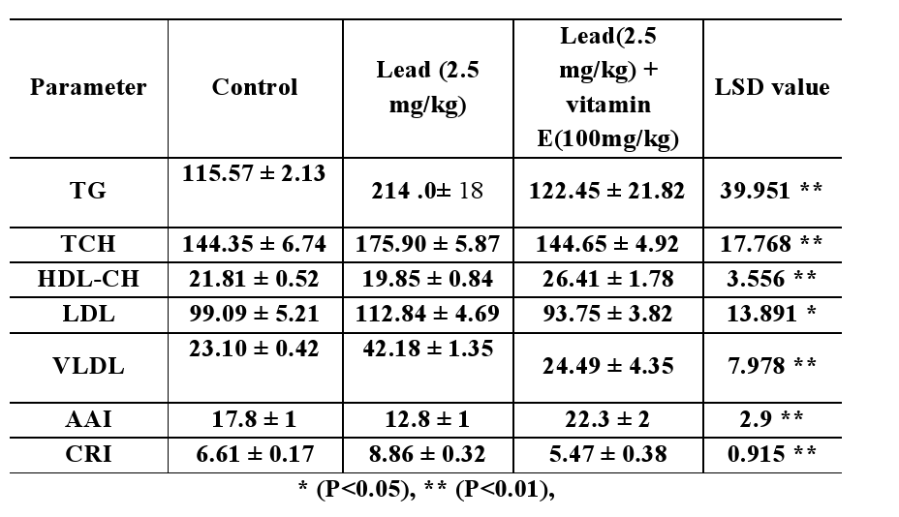

Figur-2: Effect of Vitamin E on A- AAI and B- CRI in hyperlipidemic Lead acetat exposed rabbits for 90 days . n=10.

Figur-3 : Relationship between CRI and HDL-Cholesterol . The R2 value show significant regression of variable in y on variation of x values

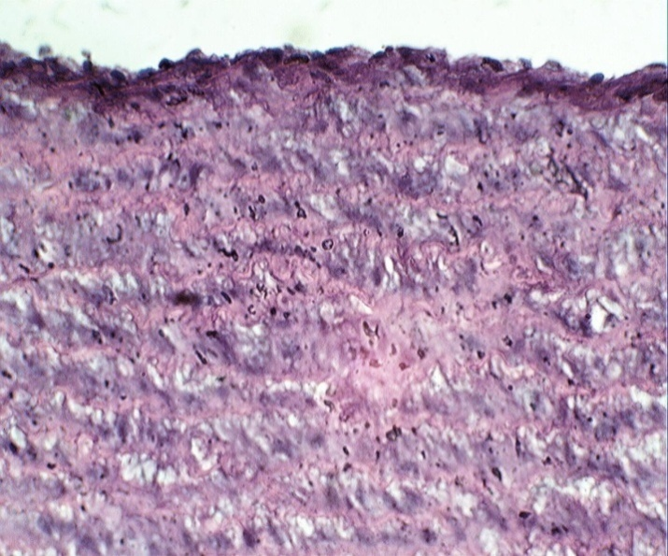  A | 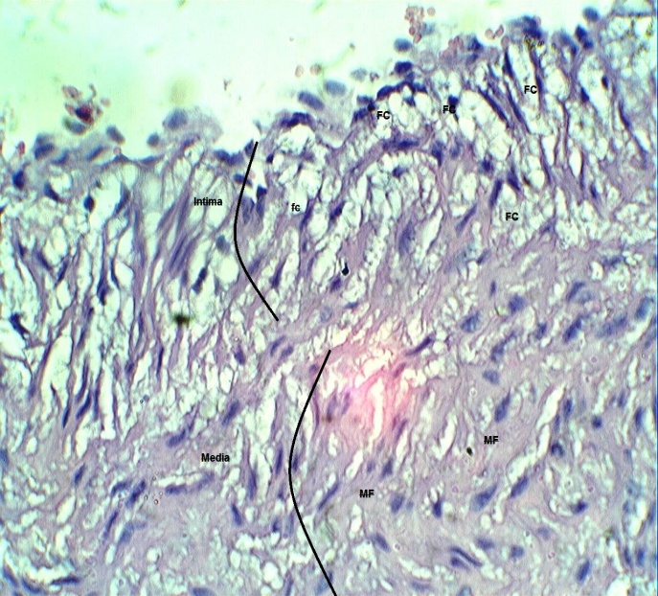  B | 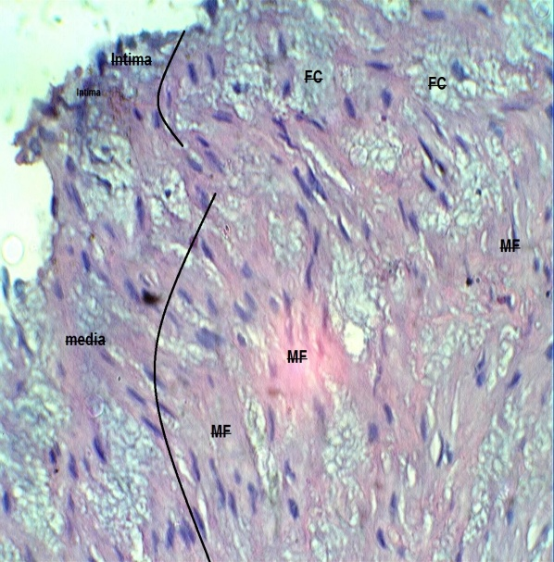  C
Figure-4 Photomicrograph of Sections in Aorta in A- control show the normal structure of tunica intima lined by endothelial and arranged elastic lamina and smooth muscles layers in tunica media , B-Lead group, show enlargement of endothelial cells and a marked replacement with fatty loaded cells in tunica intima, in addition there was asever vacular degeneration and hyper plasia of the muscle fiber in the tunica media.C-Lead+Vitamin E show a less replacement of endothelial with fatty loaded cells in the tunica intima and a slight to moderate fiber muscle hyper atrophy in tunica media . Fc=foam cells, MF=muscle fibers. (E&H,X40)

References
- Walker R, Edwards C. Clinical pharmacy and therapeutics, churchil Livingstone, London, 2nd Ed.,p.p.321–322. 2004.
- Schaefer E, Levy R. Pathogenesis and management of lipoprotein disorders. New England Journal of Medicine Vol. 101, p.p.1200–1202. 2003.
- Esterbauer H, Gebicki J, Puhl H, Jurgens G. The role of lipid peroxidation and antioxidants in oxidative modification of LDL. Free Radic Biol Med, Vol.13, p.p. 341–390, 1992.
- Williams R. J. , Motteram J. M. , Sharp C. H. and Gallagher PJ. Dietary vitamin E and the attenuation of early lesion development in modified Watanabe rabbits. Atherosclerosis, Vol.94, p.p. 153–159, 1992.
- Prasad K. and Kalra J. Oxygen free radicals and hypercholesterolemic atherosclerosis: effect of vitamin E. Am Heart J, Vol.125, p.p. 958–973, 1993.
- Rapola J.M. ; Virtamo J. ; Haukka J. K.; Heinonen O.P.; Albanes, D. and Taylor, P.R. Effect of vitamin E and beta carotene on the incidence of angina pectoris. J. Am. Med. Assoc. Vol. 275,pp 693–698. 1996.
- Parker, R.A.; Sabrah, T. ; Cap, M. and Gill, B. T. Relation of vascular oxidative stress, alpha- tocopherol, and hypercholesterolemia to early atherosclerosis in hamsters. Arterioscler. Thromb. Vasc. Biol. Vol. 15, pp.349–58. 1995.
- Raluca, E. H.; Veronica, M. and Magda, B. Antioxidative and antiatherogenic effects of flaxseed, α-tocopherol and their combination in diabetic hamsters fed with a high-fat diet. Experimental and therapeutic Medicine. Vol. 9, No. 2. 2015.
- Maciej, G.; Małgorzata, B. and Brandys, J. The impact of Triton WR- 1339 induced hyperlipidemia on the effects of benzo(a)pyrene or guaiacol on α- and γ- tocopherol pools and selected markers of pro-/antioxidative balance in rat plasma and erythrocytes. Environmental Toxicology and Pharmacology. Vol. 33, No. 3, pp.336-393 .2012.
- Gambrell, J. Lead Poisoning Outbreak Causes Emergency In Nigeria . Huffpost Social News febreuary, Vol. 22,2011.
- Gambrell J. Lead poisoning Outbreak Causes Emergency In Nigeria. Huffpost Social News(The Internet Newspaper—Personalized New York, NY · huffingtonpost.com/eyes-and-ears/ 2011 Febreuary, 22.
- Birgit, P. and Robert, H. Poppenga Lead And Zinc Intoxication In Companion birds. Compend Contin Educ Vet. Vol. 31, No.1, pp. 13-17. 2009.
- Hana, A.A.K. and Al-Bassam, k.S. A Survey Of Lead Pollution In Baghdad.: Water, Air And Soil Pollution,Vol. 19, No.1, pp.3-14. 1983.
- Mugahi, M. N.; Heidari, Z.; Sagheb,A. H. M. and Barbarestani, M. Effects Of Chronic Lead Acetate Intoxication On Blood Indices Of Male Adult Rat, Daru . Vol.11, No.4, pp.147-151. 2003.
- Klaassen, C. D. Casarett And Doulls Toxicology The Basic Science Of 16. Poisons: Mcgraw-Hill Medical Publishing Division. New York. Seventh Edition. Pp. 2008.
- Anderson, AC; Pueschel S.M. and Linakis J.G. Lead Poisoning in Childhood. Baltimore, MD: PH Brookes Publishing Company. Pp. 75-96. 1996.
- Al-Qayim A.J.M. and Sadat A.A. Protective role of Vitamin E and /or Methionine against Lead-Induced Changes on Hematolodgical Parameters in rabbits. Iraqi journal od medical Sciences. Vol.11, No.2, pp.187-194. 2013.
- Newairy, A.A. and H.M. Abdou, Protective role of flax lignans against lead acetate induced oxidative damage and hyperlipidemia in rats. Food Chem. Toxicol., Vol. 47, No.4, pp. 813-818. 2009. reproductive axis. J. Androl., Vol.11, No.6,pp. 521-526. 2009.
- Skoczynska, A., Smolik, R. and M. Jelen, Lipid abnormalities in rats given small doses of lead. Arch. Toxicol., Vol.67, No.3, pp.200-204. 1993.
- Ponce-Canchihuamán, J. C.; Pérez-Méndez, O.; Hernández-Muñoz, R.; Torres-Durán, P. V. and Juárez-Oropeza, M.A. Protective effects of Spirulina PP6T maxima on hyperlipidemia and oxidative-stress induced by lead acetate in the liver and kidney. 6T 2TLipids Health Dis. (2010).Vol.9, No. 35. 2010.
- Nagaraja, H.; Tan, J.; Srkumer, C. and Anupama, B. Protective effects of Alpha-polic acid against lead acetate – inducwd oxidative stress in the bone marrow of rats. International Journal of Pharmacology, Vol. 7, No.2, pp. 217- 227. 2011.
- Chan-Min, L.; Jie-Qiong, M. and Yun-Zhi, S. Protective role of puerarin on lead- PPPP9T9T induced alterations of the hepatic glutathione antioxidant system and hyperlipidemia in rats. Food and chemical toxicology.Vol.49 ,pp 3110-3127.2011.
- Adeneyea, A. And Olagunju, j. A. preliminary hypoglycaemic And hypolipidemic activities of the aqueous seed extract of Carica papaya linn. In wistar rats. biology and medicine, Vol. 1, No. 1, pp. 1–10, 2009.
- Waqar, M. A. and Mahmmod, y. anti-platelet, antihypercholesterolemia And anti-oxidant effects of ethanolic extract of brassica oleracea in high fat diet provided rats. world\ applied sciences journal, Vol. 8, No. 1, pp. 107–112, 2010.
- Luna, L.G. Processing &tissuehistologic staining methods the amid forces institiute of pathology. 3rd ed. McGraw Hill books comp. New York, Toronto, Sydney. Pp.12-13. 2010.
- Sas. Statistical analysis system, user's guide. Statistical. Version 9.1th ed. Sas. Inst. PP Inc. Cary. N.c. Usa. 2012.
- Kim, K. R.; Lee, S. W.; Paik, N. W. and Choi, K. Low-level lead exposure among South Korean lead workers, and estimates of associated risk of cardiovascular diseases. J. Occup. Environ. Hyg. Vol. 5, pp.399-416. 2008.
- Afridi, H. I., Kazi, T. G., Kazi, N., Kandhro, G. A., Baig, J. A., Shah, A. Q., Jamali, M. K., and Arain, M. B. Evaluation of toxic elements in scalp hair samples of myocardial infarction patients at different stages as related to controls. Biol Trace Elem Res, Vol. 134, pp.1-12. 2010.
- Tietz, N. W. Text book of clinical chemistry. 3rd Ed. C.a. Burtis, e.r. Ashwood, w.b. Saunders . 1698 – 1704. 1999.
- Ademuyiwa, O.; Agarwal, R.; Chandra R. and Behari, J.R. Lead-induced phospholipidosis and cholesterogenesis in rat tissues. Chem Biol Interact , Vol.179, pp.314-20. 2009.
- Hami, J., Dashti, G. R.; Nemat-bakhsh, M.; Afshar, M. and Ghaffari, H.R. The Relationship between High Dose Lead Exposure and Serum Lipids and Lipoprotein Levels.Shiraz E-Medical Journal Vol. 7, No. 2, 2006.
- Samir, A.E. B. Beneficial Effect of Combined Administration of Vitamin C and Vitamin E in Amelioration of Chronic Lead Hepatotoxicity .The Egypttiian Jourrnall off Hospiittall Mediiciine Vol. 23. Pp. 371 – 384. 2002.
- Patrick L. Lead toxicity part II: the role of free radical damage and the use of 432 antioxidants in the pathology and treatment of lead toxicity. Altern Med Rev. Vol.433, pp.114- 127. 2006.
- kwiterovich, J. P. The metabolic pathways of high-density Lipoprotein, low-density lipoprotein, and triglycerides: a current Review. american journal of cardiology, Vol. 86,No. 12, pp. 5–10, 2000.
- Hsu, P.C. and Guo, Y.L. Antioxidant nutrients and lead toxicity. Toxicology, Vol.180, No.1, pp. 33-44. 2002.
- Mishra, M. and Acharya, U.R. Protective action of vitamins on the spermatogenesis in lead treated swiss mice. J. Trace Elements Med. Biol., Vol.18, pp. 173-178.2004.
- Rendón-Ramirez, A.; Cerbón-Solórzano, J.; Maldonado-Vega, M. ; Quintanar-Escorza, M.A. and Calderón-Salinas, J.V. Vitamin-E reduces the oxidative damage on delta-aminolevulinic dehydratase induced by lead intoxication in rat erythrocytes Toxicol In Vitro. Vol.21, No.6, pp.1121-1126. 2007 .
- Gaurav, D.; Preet, S. and Dua K. K. Chronic Cadmium Toxicity In Rats: Treatment With Combined Administration Of Vitamins, Amino Acids, Antioxidants And Essential Metals Journal Of Food And Drug Analysis, Vol.18, No.6, pp. 464-470. 2010.
- Flora, S.j.; Mittal, M. and Mehta A. Heavy Metal Induced Oxidative Stress And Its Possible Reversal By Chelation Therapy. Indian J Med Res. Vol.128, No.4, pp.501–523. 2008.
- El-Nekeety, A.A.; El-Kady, A.A.; Soliman, M.S.; Hassan, N.S. and Wahhab, M.A. Protective Effects Of Aquilegia Vulgaris (L) Against Lead Acetate – Induced Oxidative Stress In Rats. Food Chem. Toxicol., Vol.47, pp.2209- 2215. 2009.
- Peters, J.L.; Kubzansky, L.D.; Ikeda, A.; Fang, S.C.; Sparrow, D.; Weisskopf, M.G.; Wright, R.O.; Vokonas, P.; Hu, H. and Schwartz, J. Lead concentrations in relation to multiple biomarkers of cardiovascular disease: the Normative AgingStudy. Environ Health Perspect. Vol.120, No.3, pp.361-366. 2011.
- Gehan, A. and Elmenoufy, M. Bee Honey Dose-dependently Ameliorates Lead Acetate- mediated Hepatorenal Toxicity in Rats Life Science Journal, Vol.9, No.4.2012.
- Ademuyiwa, O.; Ugbaja, R.N.; Idumebor, F. and Adebawo, O. Plasma lipid profiles and risk of cardiovascular disease in occupational lead exposure in Abeokuta, Nigeria. Lipids Health Dis.Vol. 4, No.19.2005.
- Cheng, Y.J.; Schwartz, P.S.; Vokonas, S.T.; Weiss, A.; H,u A. and Hu, H. Electrocardiographic conduction disturbances in association with low-level lead exposure (the Normative Aging Study). Am J Cardiol, Vol. 82, pp. 594-599, 1998.
- Lustberg, M. and Silbergeld, E. Blood lead levels and mortality. Arch Intern Med, In: Moore KJ, Tabas I. Macrophages in the pathogenesis of atherosclerosis. Cell 2011, Vol. 145, p.p.341–355. 2002.
- Voloshyna, I. ; Seshadri, S. ; Anwar, K. ; Littlefield, M. I.; Belilos, E., Carsons, S. E. and Allison B. ReissInfliximab Reverses Suppression of CholesterolEfflux Proteins by TNF-𝛼𝛼: A Possible Mechanism for Modulation of Atherogenesis. BioMed Research International Volume 2014, p.p.1-8, 2014.
- Xinbing H. and Boisvert, W. A. Interleukin-10 protects against atherosclerosis by modulating multiple atherogenic macrophage function. Thromb Haemost , Vol.113, p.p. 1-20. 2015.
- Kennedy M.A.; Barrera, G.C. and Nakamura K. ABCG1 has a critical role in mediating cholesterol efflux to HDL and preventing cellular lipid accumulation.Cell Metab, Vol.1, p.p. 121– 131. 2005.
- Ye, D.; Lammers, B and Zhao Y. ATP-binding cassette transporters A1 and G1, HDL metabolism, cholesterol efflux, and inflammation: important targets for the treatment of atherosclerosis. Curr Drug Targets, Vol.12, p.p. 647–660. 2011.
- Zhao Y., Van-Berkel T.J. and Van Eck M. Relative roles of various efflux pathways in net cholesterol efflux from macrophage foam cells in atherosclerotic lesions. Curr Opin Lipidol .Vol. 21, pp. 441–453. 2010.

