The effect of acute exposure of Zn and Pb on some Biochemical markers in Fresh Water Snail (Viviparus bengalensis)
Ayad M.J.Almamoori ¹ * Jasim M.Salman¹ Randall Hughes, A²
1 College of science, University of Babylon, Iraq
2 Florida State University, U.S.A.
Email address:
ayad@uobabylon.edu.iq.
Almamoori M.J. ; Salman, J. M. , The effect of acute exposure of Zn and Pb on some Biochemical markers in Fresh Water Snail (Viviparus bengalensis), 2014,Vol.1,No.1:50-58.

ABSTRACT
Biochemical markers (Total protein, Vitamin C, Vitamin E, Acetylcholinesterase, and Metallothioneins) induced by acute exposure of Zn&pb in Snail (Viviparus bengalensis) to show their response against these metals. These makers in snail sp. showed different significance response according to Zn acute exposure. So increased and decreased as reaction against acute exposure, The same trend adapted from biomarkers after pb acute exposure in snail sp. while the different response was appeared from these biomarkers after interaction acute exposure.

KEYWORDS: Biochemical Markers, heavy metals, acute exposure, Molluscs, Fresh water snail.

INTRODUCTION
Biomarkers can be defined as any biochemical, molecular, histological and physiological changes which are produced according to environmental stress or a xenobiotically-induced variation in cellular or biochemical components or processes, structures, or functions that is measurable in a biological system or sample [1]. Metallothionein constitutes an important binding protein with low molecular weight (6-7) KDa and high cysteine content (>30%) which play an important role in detoxification of toxic chemicals [2], and Metallothioneins play a key role in detoxification processing in ollusks and have been proposed as exposure biomarkers. [3]studied the role of metallothioneins (MTs) in Cd and Zn depuration processes in the freshwater bivalve Corbicula fluminea was conducted after in situ exposure on the river Lot (France), The quantity of Cd sequestered by the MT fraction, after size-exclusion liquid chromatography, represents on average 40% of the total Cd bioaccumulated in the soft body of the 51ollusks, compared with only 4-9% for total accumulated Zn. This essential metal was principally bound to low molecular weight proteins, MTs had a key role in Cd detoxicity in the bivalves.
Vitamin C is a water-soluble vitamin. Like vitamin E, it is an effective antioxidant; Vitamin C can protect essential substances in the body such as proteins, lipids, carbohydrates, DNA and RNA from damage by free radicals[4].Vitamin C works in coordination with vitamin E and is able to regenerate vitamin E when vitamin E is used as an antioxidant, Ascorbic acid is well known for its antioxidant activity, acting as a reducing agent to reverse oxidation in liquids. When there are more free radicals (reactive oxygen species, ROS) in the human body than antioxidants, the condition is called oxidative stress [5].
Acetylcholinesterase is responsible for hydrolyzing the neurotransmitter acetylcholine into choline and acetic acid which controls ionic currents in excitable membrane, and is old biomarker may be responding to low level of pollution in the environment [6] and are considered as unique enzyme whose physiological function to remove acetylcholine from synaptic clefts. Measurement of acetylcholinesterase (AchE) is broadly used like present study as biomarker of pollution, AchE activity was monitored in the clam Tapes philippinarum in the Lagoon of Venice (Italy) by[7] with no particular correlation between Ache activity and Condition Index(CI) was found and marked differences in AchE activity were showed when comparing enzyme activity of clams from various sites in the Lagoon of Venice with those of clams collected. Significant reductions in AchE activity were observed in animals collected in both nearby canals and licensed areas, indicating the homogeneous spatial distribution of potentially neurotoxic compounds throughout the Lagoon, On the other hand, Vitamin E is a fat soluble vitamin and its main role is a non-enzymatic antioxidant, it protects body cells from toxic compounds such as heavy metals [8].
Methods
Exposure experiment
Snail Sp. samples were brought a live to laboratory quickly and left in dechlorinated water aquarium for 2 days as acclimation and depuration stage with fixation all environmental factors. After that a group of 6 to 10 of each mollusca species was exposed to 24, 48, 72, 96 hr. as Acute exposure in plastic container to different concentration of Pb ( 20 , 50 , 100μg/L) which is prepared from stock solution 1g/l (CH3COO)2pb.3H2o) and Zn ( 20 , 50 , 100 ) μg/L which is prepared from Stock solution 1g/l (Znso4.7H2O) , with photoperiod 12:12 light & dark cycle with fixation all environmental factors .These concentrations verified by Atomic absorption Spectrophotometer type 6300(Shimadzu, Japan), All samples collected after each exposure to determine all previous biomarkers as soon as possible to detect the early warning signal (different biomarkers) in Snail.
Biochemical markers detection
Protein concentration was estimated according to method of[9] ,Vitamin C is present in both a reduced form ascorbic acid (AsA) and an oxidized form (dehydroascorbic acid (DHAsA).This method measures total vitamin C (i.e., AsA + DHAsA), and according to [10] and [11].Vitamin E was determined according to [12]which includes color reaction with ferric chloride and α,α—dipyridyl to give a red color , Metallothionein was determined by evaluating the sulphyhydryl (-SH) residue content according to method of [13] and [14]. A rapid colorimetric determination was adapted to calculate the Acetylcholinestrase activity in Molluscs according to the method described by [15].
Statistical Analysis
SPSS 17.0 programs used for least significance differences (LSD ≤ 0.05), and Analysis of variance test (ANOVA).
Results and Discussion
Biochemical markers in snail sp. showed different response according to Zn acute exposure. All these markers increased and decreased as reaction against acute exposure, total protein in gills decreased from 7.3 mg/g at 24hr. for 20µg/l to 3.6 mg/g at 96hr. and continued to 2.8 mg/g at 96hr. for 100 µg/l while in digestive gland, total protein decreased from 9.6 mg/g at 96hr. for 20µg/l to 7.2 mg/g at 96hr. for 100 µg/l,Vit.c have decreased from 3.4,3.5 µg/mg at 96hr for 20µg/l to 2.4,2.9 µg/mgat 96hr. for 100 µg/l in both gills&digestive gland while for V.E , values in gills decreased from 7.4 µg/mg at 96hr for 20µg/l to 6.4 µg/mg at 96hr. for 100 µg/l , and increased from 8.5 µg/mg at 96hr for 20µg/l to 12.2 µg/mg at 96hr. for 100 µg/l, Metallothionein values increased in gills from 34.9 mg/g at 96hr for 20µg/l to 59.6 mg/g at 96hr. for 100 µg/l and in digestive gland increased from 41.9 mg/g at 96hr for 20µg/l to 42.3 mg/g at 96hr. for 100 µg/l, acetylcholinesterase in gills decreased from 30.9 nm/min/mg at 96hr for 20µg/l to 20.6 nm/min/mg at 96hr. for 100 µg/l(Table 1,Figure 1&2), According to statistical analysis ,The same trend adapted from biomarkers after pb acute exposure in snail sp(Table 2,Figure 3&4).
Different responses from snail appeared after Interaction acute exposure. Total protein in gills decreased from 10.1 at 24hr. for 20µg/l to 6.3 mg/g at 96hr. and continued to 9.4 mg/g at 96hr. for 100 µg/l while in digestive gland, total protein decreased from 13.7 mg/g at 96hr. for 20µg/l to 11.8 mg/g at 96hr. for 100 µg/l,Vit.c have decreased from 4.9,6.3 µg/mg at 96hr for 20µg/l to 3.2,4.8 µg/mgat 96hr. for 100 µg/l in both gills&digestive gland while for V.E , values in gills decreased from 8.9 µg/mg at 96hr for 20µg/l to 7.2 µg/mg at 96hr. for 100 µg/l , and decreased in digestive gland from 11.3 µg/mg at 96hr for 20µg/l to 9.8 µg/mg at 96hr. for 100 µg/l, Metallothionein values increased in gills from 26.9 mg/g at 96hr for 20µg/l to 35.2 mg/g at 96hr. for 100 µg/l and in digestive gland increased from 28.1 mg/g at 96hr for 20µg/l to 51.2 mg/g at 96hr. for 100 µg/l, acetylcholinesterase in gills decreased from 40.2 nm/min/mg at 96hr for 20µg/l to 30.6 nm/min/mg at 96hr. for 100 µg/l(Table 3,Figure 5&6).
Table 1: Concentrations of biochemical markers in Viviaparus bengalensis in [gills &digestive
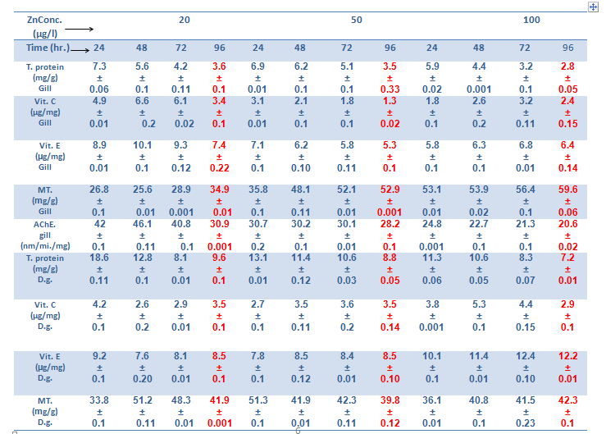
gland (d.g.)] afterZn acute exposure for different concentration (Mean±S.D).
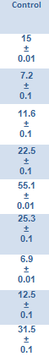

p≤0.05

p≤0.05

p≤0.05

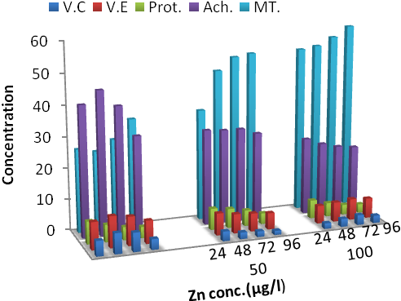
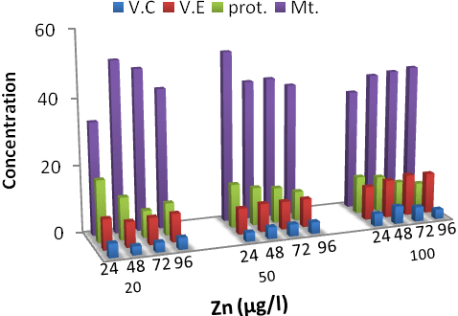

Figure 1: Biochemical markers concentration after Zn acute exposure in Snail (gill)

Figure 2: Biochemical markers concentration after Zn acute exposure in Snail (digestive gland)

Table 2: Concentrations of biochemical markers in Viviaparus bengalensis in [gills &digestive gland (d.g.)] after pb acute exposure for different concentration (Mean±S.D).
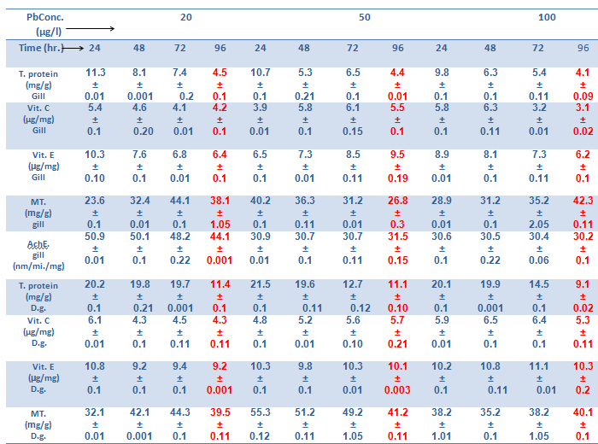

p≤0.05

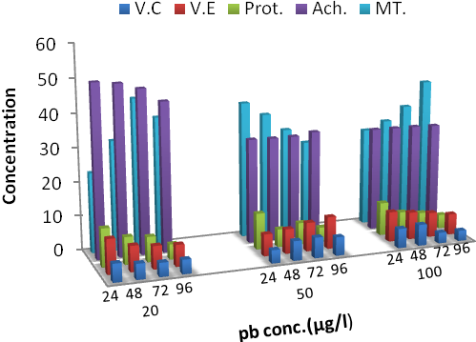
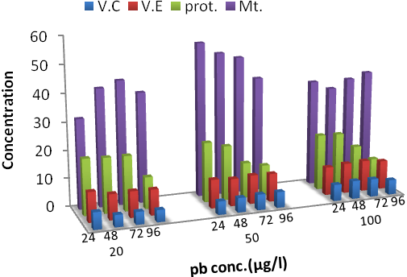

Figure 3: Biochemical markers concentration after Pb acute exposure in Snail (gill)

Figure 4: Biochemical markers concentration after Pb acute exposure in Snail (digestive gland)

Table (3): Concentrations of biochemical markers in Viviaparus bengalensis in [gills &digestive gland (d.g.)] after interaction (Zn+Pb) acute exposure for different concentration (Mean±S.D)
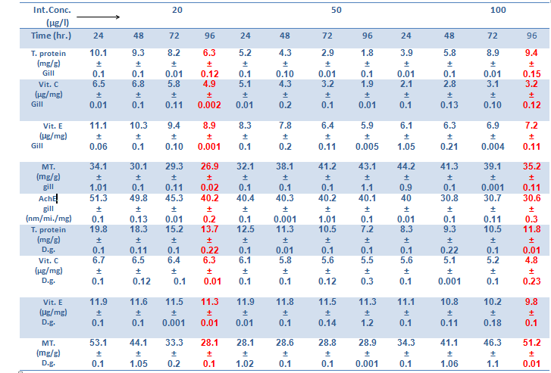

p≤0.05

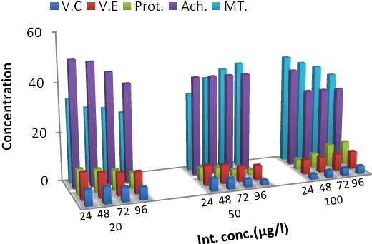
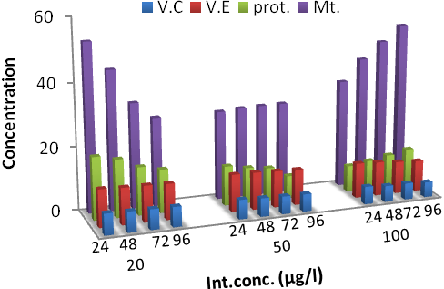

Figure 5: Biochemical markers concentration after int. acute exposure in Snail (gill)

Figure 6: Biochemical markers concentration after int. acute exposure in Snail (digestive gland)

The significance of biomarkers is related to their ability to indicate the interactions between pollutants and the organisms, it can be useful in bioremediation processes before damage of ecological consequence occurs, play important role in diagnosis routes of pollutants, and they are applicable to both laboratory and field studies [16]. The decreasing of protein ,Vitamins after acute exposure 24hr.&96hr.is due the consumption of these compounds for using in energy generation which used for defense mechanisms against heavy metals , and formation of lipoprotein which involve in repair of damaged cells and tissue organelles. This study is compatible with many studies such as [17], and the main cause for protein concentration decreasing due to largest need of energy for the metabolic processes which lead to increasing utilization of protein to meet energy demand, and increase the proteolysis to reach the High energy demands under heavy metal stress[18] .The change in metabolic rate has a consequence towards the change in biochemical composition, so the change in biochemical composition is an indicator of stress of chemical or physical nature in the environment which specifically affects protein contents with increased catabolism and decreased anabolism of proteins [19] The fluctuation in changes for different biomarkers after acute exposure was indicated by many researchers as in this study [18] During exposure, organism tends to shift all the metabolic processes to face the toxic effects of heavy metals and this lead to changes in biochemical and physiological mechanism in the body of organism, both duration of exposure and heavy metals concentration are important in determination of the level of biomarker response [20].
Positive correlations between MTs and heavy metals concentration in Molluscs after exposure have been pointed out in other studies [21].
Conclusion
We have concluded that Biochemical Markers have different response regarding acute exposure of Heavy metals, and this gave a good indication for toxicity by heavy metals.

Acknowledgements
We are grateful to Department of Biology, College of Science, University of Babylon and Marine &Costal Lab / Florida State University for their supporting.

References

[1] Benford,D.J.;Hanley,A.B.;Bottrill, K.; Oehlschlager, S.; Balls, M.; Branca, F. ;Castegnaro, J.J.; Descotes, J.; Hemminiki, K.; Lindsay, D.&Schilter, B. Biomarkers as Predictive Tools in Toxicity Testing, The Report and Recommendations of ECVAM Workshop.Atla, 2000, Vol. 28, pp.119–131.
[2] Huang,Z.;Zhang,Q.;Chen,J.;Zhuang,Z.&Wang,X. Bioaccumulation of metals and induction of metallo-thioneins in selected tissues of common carp (Cyprinuscarpio L.) co-exposed to cadmium, mercury and lead. Applied Organometallic Chemistry, 2007,Vol. 21, No.2, pp.101-107.
[3] Baudrimont, M.; Andres, S.; Durrieu, G.&Boudou, A. The key role of metallothioneins in the bivalve Corbiculafluminea during the depuration phase, after in situ exposure to Cd and Zn. Aquatic Toxicology , ,2003, Vol. 63, pp.89-102.
[4] Padayatty, S.J.; Wang, , Y.; Kwon, O.; Lee, J.; Chen, Sh.; Corpe, Ch.; Dutta, A.; Dutta, S.K.& Levine, M. Vitamin C as an Antioxidant: Evaluation of Its Role in Disease Prevention(Review). Journal of the American College of Nutrition, 2003, Vol. 22, No.1, pp.18-35.
[5] Stinefelt, B.; Leonard, S.S.; Blemings, K.P.; Shi, X.&Klandorf, H. Free Radical Scavenging, DNA Protection, and Inhibition of Lipid Peroxidation Mediated by Uric Acid. Annals of Clinical & Laboratory Science, 2005, Vol.35, No.1, pp. 37-45.

[6] Bouldin, J.; Farris, J.L.; Moor, M.T.; Smith , J.R.S.& Cooper, C.M. Assessment of Diazinon Toxicity in Sediment and Water of Constructed Wetlands Using Deployed Corbiculafluminea and Laboratory Testing. Arch Environ ContamToxicol, 2007, Vol.53, No.2, pp.174-82.
[7] Matozzo, V.; Tomei, A. & Marin, M.G. Acetylcholinesterase as a biomarker of exposure to neurotoxic compounds in the clam Tapes philippinarum from the Lagoon of Venice. Marine Pollution Bulletin, 2005, Vol. 50, pp.1686–1693.

[8] Traber, M.G. Vitamin E regulatory mechanisms. Annu Rev Nutr, 2007, Vol.27, pp.347-62.
[9] Bradford, M.M. A rapid and sensitive method for the quantitation of microgram quantities of protein utilizing the principle of protein-dye binding. AnalytBiochem, 1976, Vol.72, pp.248–254.
[10] Omaye, S.T.; Turnbull, D.J.&Sauberlich, H.E. Selected methods for the determination of ascorbic acid in animal cells, tissues and fluids. Methods Enzymol, 1979, Vol. 62, pp. 3–11.
[11] Burtis, C.A. and Ashwood E.R. Tietz Textbook of Clinical Chemistry, 3rd ed., Philadelphia, W.B.Saunders Co, 1999.
[12] Quaife, M.L.; Scrimshaw, N.S.& Lowry, O.H. A micro method for assay of total tocopherols in blood serum. J Biol. Chem. , 1949, Vol.180, pp.1229–1235.
[13] Ellman, G.L. A colorimetric method for determining low concentrations of mercaptans.Archives of biochemistry and Biophysics,1958, Vol.74, pp. 443-450.

[14] Viarengo, A.; Ponzano, E.; Donderob, F. &Fabbri, R. A Simple Spectrophotometric Method for Metallothionein Evaluation in Marine Organisms: an Application to Mediterranean and Antarctic Molluscs. Marine Environmental Research, 1997, Vol.44, No. 1, pp. 69-84.
[15] Ellman, G. L., Courtney, K. D., Andres, V., Jr. & Featherstone, R. M. A new and rapid colorimetricdetermination of acetylcholinesterase activity, Biochem. Pharmacol., 1961, Vol.7, pp. 88–95.
[16] Sarkar,A.; Sandi, S.P.& Kumar, R.H.P. Measurement of DNA strand breaks as a biomarker of Genotoxic Pollutants, National Conference on Emerging Trendsin Engineering, Technology and Management, MS2K 10. SSBT’s College of Eng., 2010.

[17] Rambabu, J.P.&Rao,M.B. Effect of an organochlorine and three organophosphate pesticides on glucose, glycogen, lipid, and protein contents in tissues of the freshwater snail Bellamyadissimilis (Müller). Bulletin of Environmental Contamination and Toxicology, 1994, Vol.53, No.1, pp.142-148.

[18] Patil, A.G. Protein Changes in Different Tissues of Freshwater Bivalve Parreysiacylindrica after Exposed to Indoxacarb. Recent Research in Science and Technology, 2011, Vol.3, No.3, pp. 140-142.
[19] Jagtap, J.T.; Shejule, K.B. &Ubarhande, S.B. acute effect of TBTCL on protein alteration in freshwater bivalve, Lamellidensmarginalis. International Multidisciplinary Research Journal, 2011, Vol.1, No.8, pp. 13-16.
[20] Lehtonen, K.K.&Leiniö, S. Effects of Exposure to Copper and Malathion on Metallothionein Levels and Acetylcholinesterase Activity of the Mussel Mytilusedulis and the Clam Macomabalthica from the Northern Baltic Sea. Bull. Environ. Contam.Toxicol., 2003, Vol.71, pp.489–496.

[21] Strogyloudi, E.; Angelidis, M.O.; Christides, A.& Papathanassiou, E. Metal concentrations and metallothionein levels in Mytilusgalloprovincialis from Elefsis bay (Saronikos gulf, Greece). Environ Monit Assess. DOI 10.1007/s10661-011-2490-z , 2012.

