Seasonal Variation of Environmental Properties and Phytoplankton Community in Al- Hussainya River, Holly Karbala - Iraq
Fikrat M . Hassan ¹ Jasim M . Salman ² * Sara H . Abdulameer ³
1 .Department of Biology, College of Science for Women, University of Baghdad, Iraq
2. Department of Biology, College of Science, University of Babylon, Iraq
3. Department of Biology, College of Education for Pure Sciences, University of Karbala, Iraq
Email: jasimsalman@uobabylon.edu.iq
Hassan, F.M. et al., Seasonal Variation of Environmental Properties and Phytoplankton Community in Al- Hussainya River, Holly Karbala – Iraq, Mesopotamia Environment Journal, 2014, Vol. 1, No.1, pp. 59-91.
Abstract
A comprehensive ecological study was conducted on Al-hussainya river during the period from October , 2012 To Septemper 2013 . This study includes measuring some chemical and physical properties of water , in addition to the study of Phytoplankton community quantitatively and qualitatively .The values of the parameters ranged between 12.7 – 31.3 C°, 8.5 – 45C° for water and air temperature respectively , 7.5 – 9.4 for PH , 840 – 1416.67 μs/cm , 413.33 – 700 mg/l , 6.33 – 55.07 mg / l , 0.54‰ – 0.91 ‰ for each of electrical conductivity (EC ) , Total dissolved solids (TDS) , Total suspended solids (TSS) and salinity respectively , 11.68 – 37.77 cm / sec. , 33.67 – 148.67 cm for each of water current velocity and water penetration respectively , 4.97 – 12.63 mg/l , 0.4 – 4.84 mg/l for dissolved oxygen (DO) and BOD₅ respectively. Nutrients such as silica , total nitrogen and total phosphorous showed variation during this study , their values ranged between 1.63 – 6.26 mg / l , 1.4 – 3.5 mg/l and 1.33 – 17.29 μg/l for each of them respectively .
A total of 242 taxa of phytoplankton identified during this study belonged to six classes of algae dominated by Bacillariophyceae which constitute 62.81 % of the total number of the species followed by Chlorophyceae by 20.66 % and Cyanophyceae by 11.16 % respectively . Dinophyceae and Euglenophyceae constitute the 2.07 % , while the the Cryptophyceae constitute the lower percentage which amounted to 1.24 % of the total species , some genera like as Nitzschia , Navicula , Cymbella , fragilaria , Scenedesmus and Oscillatoria were dominated by their species numbers in the Phytoplankton community .The total numbers of Phytoplankton cells ranged between (446.8 - 9177) × 10 ³ cell / l recorded for March and October respectively .
Introduction
Phytoplankton are algae adapted to spend part or all of their lives in apparent suspension in the water column [1] . They considered the basic of the aquatic food chain and Primary producers , which provide the aquatic organisms with the oxygen and nutrients that necessary to their survival [2,3]. The density and diversity of algae in aquatic system influenced by the physical – chemical and biological properties of the water , so they can also at the same time act as indicator for the water quality which studied [4] . Many studies are conducted on the phytoplankton community in Iraqi rivers , such as the study which was conducted on Euphrates river in the middle of Iraq , Bacillariophyceae have been dominated during this study followed by Chlorophyceae , respectively , and the total numbers of phytoplankton cells reached their peak during Spring and Autumn [5]. Another studies on phytoplankton community in Euphrates river was conducted showed dominance the Bacillariophyceae such as [6,7,8] . The phytoplankton community also studied in many other Iraqi aquatic systems [9,10] , in addition to many other studies that were conducted on the global aquatic systems [11,12,13,14] .
The present study aims to provide information about the phytoplankton community and some environmental properties of Al - Hussainya river, middle of Iraq because of the lack of studies on this river .
Materials and Methods
Description of study area
Al – Hussainya river is one of the important water sources in Karbala Province , is branched from Euphrates river at the right side in front of Al – Hindya barrage , it's length reached about 30.6 km . This river irrigates about 186000 acres of the agriculture areas and is the only water source, which depends upon the many uses in the areas which follows through them , six sites were chosen along the river two sites at the upstream and two sites at the middle of the river and two sites at downstream to study the phytoplankton community and some water parameters , all the studied sites were padded exception the site 1 ( Fig. 1 ) .
Sample collection
The water samples have been collected from October , 2012 to September , 2013 from six sites along of the river by using 5 liters of polyethylene containers for studying some parameters of the water and phytoplankton algae, another water samples were collected by transparent and dark class bottles to estimate the dissolved oxygen and biological oxygen demand .
Physical – chemical analysis
Air and water temperature were measured by using mercury thermometer , PH and electrical conductivity and total dissolved solids were measured by using Hanna instrument , the total suspended solids , dissolved oxygen , biological oxygen demand were measured by using Azide modification methods [15] and expressed as mg/l . Salinity was estimated according to [16] and expressed as ‰. The water penetration was measured by using secchi disc and the water current velocity measured by calculating the time that required for a certain buoyant object to reach specific point and expressed as cm / sec. [17] . Silica was estimated by Ammonium molybdate method according to [15] . Total nitrogen was determined according to [16], and total phosphorous was measured depending on [18] .
Phytoplankton analysis
The sedimentation method [19] used for quantitative and qualitative study of phytoplankton , and the algae were then identified according to ,[20,21,22,23,24,25,26] . Chlorophyll a and Phaeophytin were determined according to, [27] .

Fig. 1 : The map of Al – Hussainya River, middle of Iraq
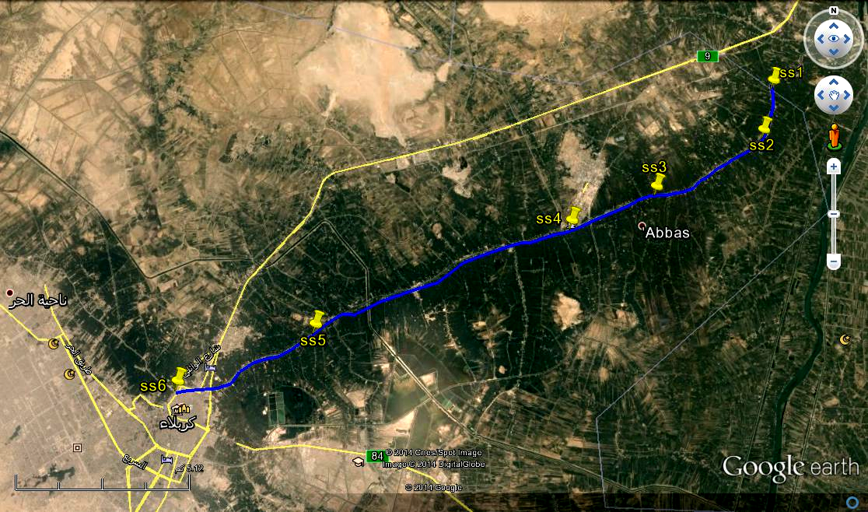

Results and Discussion
Physical and Chemical Characteristics The Physical and Chemical properties of the water are important indicators for its quality and thus determine its suitability for different uses . Table 1 showed the physical - chemical properties of the river during this study . Temperature is an important physical factor which affects on other chemical and biological factors of the water , its also determining the chemical reaction of the aquatic organisms and the solubility of gases [28,29] . In this study air and water temperature showed spatial and temporal variation during this study, water temperature values ranged between 12.7 – 31.3 C° recorded for site 1 and site 6 in February and August respectively , and air temperature values ranged between 8.5 – 45.3 C° recorded for site 1 and site 6 in January and August respectively and the variation in water temperature Accompanied the variation in air temperature as confirmed by positive correlation between air and water temperature ( r = 0.901 , P <0.01 ) , this may be due to the shallow of the water which cause the water susceptible to the variation in air temperature [30] this Corresponds with other Iraqi studies [31,32] . (Fig. 2 and Fig. 3 ).
pH is an important ecological factor which affects on the survival of aquatic organisms , and the solubility and toxicity of many metals in the waters , the acidity of waters increase the solubility of many metals that cause adverse effects on the aquatic organisms [29]. The pH values during this study ranged between 7.5 – 9.42 recorded for August and January respectively this result refers that the water quality of the river ranged between slightly alkalinity to alkalinity . Decrease pH during warm months may be due to elevation of temperature as confirmed by negative correlation between pH and air temperature ( r = - 0.532 , P < 0.01) and water temperature ( r = - 0.648 , P < 0.01) , due to increase the biological activity of microorganisms and increased the level of CO₂ in the water [33,34], while increased the level of PH during the cold months may be due to increase the density of Phytoplankton and increased the level of dissolved oxygen in the water and consumption of CO₂ which cause elevated the PH , the results found there was a positive correlation between pH and Dissolved oxygen ( r = 0.541 , P < 0.01 ) , many Iraqi waters characterized by slightly alkalinity to alkalinity ([35]; [36]; [31] ; [8] ) . The results also showed spatial variation which may be due to the influence of climatic factors [37,38,39] or human activity [40] ,or drift from adjacent land [41] . ( Fig. 4).
Electrical conductivity ( EC ) measures the ability of water to conduct the electric current and its expresses the amount of soluble salts in the water , it also influences by the amount of total dissolved solids (TDS ) in the water [29]. So we noticed from the current study that the variation in the electrical conductivity accompanied by the variation of the salinity and total dissolved solids , and this is confirmed by the positive correlation between EC and TDS ( r = 0.998 , P < 0.01 ) and salinity ( r = 0.999 , P < 0.01 ) , the salinity and TDS are also recorded positive correlation between them ( r = 0. 997 , p < 0.01 ) . The values of each of EC , TDS and Salinity ranged between 840 – 1416.67 μs/cm , 413.33 – 700 mg/l , 0.54- 0.91‰ respectively , recorded for February and May respectively , increased their levels may be due to elevated temperature and increased the rate of evaporation and decreased water levels which cause elevated the concentration of ions in the water [42,38] . while their decline during winter months may be due to rains fall and increased water levels which cause dilution and hence deceased their concentrations in the waters [43], our results are closed to the results of [33] on Euphrates river and [44] on the Bani- Hassan stream in Iraq . while they are higher than the results of [30] on Tigris river . The results also showed spatial variation during this study , site 6 recorded higher concentration of EC and TDS and salinity as compared to other sites this may be due to passes the river through the center of the City , so it exposed to different human activity and throw the waste directly to the water , which therefore increased the pollutants in the river , this line with [45, 40] . Figure 5 , 6 , 7 .
Total suspended solids (TSS) consist of the silt and clay particles , planktons , organic and inorganic mattes , in addition to other microorganisms , their values showed fluctuation during this study ranged between 55.07 – 6.33 mg / l , the concentration of TSS influenced by many natural factors and anthropogenic activity [28] , decreasing their values during winter months may be due to rainfall and elevated the water levels result in dilution the pollutants and particles [46], or they decrease as a result of lack the rate of organic degradation this confirmed by elevating the level of dissolved oxygen during cold months which express about the decline of organic pollution in the river , while their increasing during some autumn months may be result from increasing the density of phytoplankton . Elevated level of TSS during some summer months may be due to blowing winds loaded with dust and particles which then precipitation to the river , or they rise as result of increasing the water flow which cause erosion the adjacent soil and re suspended of sediment . Increasing the rate of organic degradation because of pollution result in elevating the level of TSS in the water [40] .
In addition to that the continuous dredging operations to the river causes increased the level of TSS in the water ( Fig. 8) . The results of the current study corresponded with other study such as [8] on Al-Hilla river , while differed from [31] on Tigris river . Water penetration influenced by the amount of total suspended solids adversely [47] , their values ranged between 33.67 – 148.67 cm during October and January respectively , many studies referred to increase the water penetration during winter months because of rainfall which act to dilute the particles in the water such as [48,49] . (Fig. 9) .
Water current velocity showed spatial and temporal variation during this study ranged between 11.68 – 37.77 cm / sec. this due to several reasons such as steep in the surface gradient, nature of the bottom, wind and depth [50]. Also withdrawals of water for different uses as agriculture, industrial and other uses cause reduction in water velocity [28] . Shape of the river and Wriggles also affect on its velocity, our results were closed to the results of [8] on Al – Hilla river . (Fig. 10).
Dissolved oxygen and biological oxygen demand showed an increased in their values during cold months and decreased during warm months , the values of DO and BOD₅ ranged between 4.97 – 12.63 mg / l and 0.4 – 4.84 mg / l respectively , elevation of temperature decreases the solubility of gases in the water , this confirmed by the negative correlation between DO and water temperature ( r = - 0.695 , P < 0.01 ) , and air temperature ( r = - 0.838 , P < 0.01 ) . In addition to this decreasing the DO during Summer season may be result from elevation the activity of organisms that degrade the organic residues as result of presence some pollution causing higher consumption of dissolved oxygen [51] .
BOD₅ expressed the level of organic pollutants in the water its measuring the amount of a consumption oxygen by the organic degrading organisms [29]. The results revealed increasing the BOD₅ during the cold months and decreased during the warm months and this results differed from many studies that referred to increase the BOD₅ during Summer months and decreased during Winter months such as [5,52], increasing the BOD₅ during the cold months may be result from rainfall and drift the adjacent soil with their carrying pollutants in to the river especially this river passes through agriculture area , so the rainfall and blowing the winds cause precipitation variable pollutants in to the river, despite of this the levels of DO are not affected by this pollution this may be due to the role of photosynthesis operation by the primary producers on the one hand , on the other hand water acquired the enough of oxygen from the air that contact the surface layer of the water , also many factors are controlling the aeration the river such as temperature , water turbulence and the depth of water body [53] , and the our results deal with other studies in Iraq that reffered to increase the BOD₅ during winter season such as [48] on Euphrates river and [44] on Bani-Hassan stream (Fig. 11 and Fig. 12 ).
Silica is an important nutrient to plants and algae , and is one of the main component of the diatoms cell wall components [54,55] .Silica is present naturally in the water because it interventions in the metal composition of the rocks , so the weathering these rocks lead to release it to the water [56]. the results showed spatial and temporal variation in the silica values they ranged between 1.63 – 6.25 in site 6 and site 1 in each of November and February respectively . silica showed icreased during rainy months as aresult of drifting the adjacent soil [57] . they also showed an increasing during summer months as a result of elevation the temperatures and increased the rate of evaporation and solubility the salts ( [43, 5] . Increasing during the summer may be due to death and degradation of diatoms this confirmed by decrease the dissolved oxygen during the summer months [58,8] . Our results closed to [49] on the Bani – Hassan stream , while were higher than other studies on Iraqi rivers such as [5,33] . Decreased silica may be due to high density of phytoplankton [59] , or as a result of elevation water level and increased its velocity [60] . Figure 13 . In addition to silica , nitrogen and phosphorous are also important nutrients to plants and algae , nitrogen values showed slightly spatial and temporal variations ranged between 1.4 – 3.5 mg / l , concentration of nitrogen in water influenced by pollution with pollutants that results from anthropogenic , agriculture and industrial activity [61] , elevation nitrogen concentration during hot months may be due to increase the degrading organic residues by the microorganisms [31] , while its decreasing during winter months may be due to high density of phytoplankton [62] , or elevation water levels and dilution the nutrients [33].( Fig. 14).
Phosphorous values showed spatial and temporal variations during this study ranged between 1.33 – 17.29 μg / l recorded for August and February respectively , increasing phosphorous during February month may be due to rainfall which cause drifting the adjacent soil with their pollutants , in addition to bad anthropogenic activity that lead to pollute the river ( [42]) , while decreasing it during some months may be due to consume it by the algae [63,58,64] . or due to its chemical precipitation or adsorption on clay particles [17] . Figure 15 . The values of Total nitrogen and Total phosphorous were higher than [33] on Euphrates river and [31] , on Tigris river .

Table 1: Some physical - chemical and biological properties of Al-Hussainya river in the period from October 2012 to September 2013 first line (range ) and second line ( mean ± S.D. )

Sites  Ecological  factors | ST1 | ST2 | ST3 | ST4 | ST5 | ST6
Air temperature ( C°) | 8 – 29.8  22.9 ± 7.8 | 12.7 – 39.8  27.5 ± 9.03 | 15.5 – 41.7  28.8 ± 9.4 | 18 – 42.2  30.5 ± 9.5 | 18.5 – 45  31.3 ± 9.1 | 19.3 – 45.3  32.3 ± 9
Water temperature ( C °) | 12.7 – 29.4  21.9 ± 5.9 | 13.7 – 29.6  22.2 ± 5.6 | 14 – 30.1  22.5 ± 5.7 | 13.8 – 30.4  22.7 ± 5.8 | 13.4 – 30.4  23 ± 5.7 | 14.2 – 31.1  23.7 ± 5.6
PH | 7.5 – 8.7  8.06 ± 0.32 | 8.8 – 7.5  8.1 ± 0.38 | 9.3 – 7.6  8.2 ± 0.42 | 9.2 – 7.7  8.2 ± 0.37 | 9.4 – 7.5  8.3 ± 0.45 | 9.3 – 7.6  8.2 ± 0.43
EC ( μs / cm ) | 896.67 - 416.67  1206.61 ± 37.84 | 840 – 1386.67  1191.03 ± 49.6 | 856.67 – 1406.67  1194.22 ± 156.2 | 850 – 1380  1195.19 ± 154 | 980 – 1413.33  1194.25 ± 126.8 | 1046. – 1386.67  1235.47 ± 91.8
TDS ( mg / l ) | 440 – 700  597.28 ± 69.02 | 413.33 – 686.67  590.44 ± 13.8 | 420 – 696.67  592.31 ± 78.59 | 416.67 – 686.67  593.33 ± 77.97 | 503.33 – 700  594.8 ± 60.96 | 516 – 686.67  613.36 ± 46.08
TSS ( mg / l ) | 10.67 – 55.07  21.43 ± 11.78 | 6.67 – 31.2  23.71 ± 7.88 | 18.33 – 35.47  28.34 ± 8.11 | 13.33 – 46.73  24.68 ± 9.47 | 12.73 – 52.2  27.57 ± 12.22 | 6.33 – 40.13  24.03 ± 11.09
Salinity ‰ | 0.57 – 0.91  0.77 ± 0.09 | 0.54 – 0.89  0.76 ± 0.096 | 0.55 – 0.90  0.76 ± 0.10 | 0.55 – 0.88  0.76 ± 0.097 | 0.62 – 0.90  0.76 ± 0.08 | 0.67 – 0.89  0.79 ± 0.06
Water current velocity cm/sec. | 13.83 – 27.54  21.56 ± 5.18 | 20.6 – 32.38  24.72 ± 4.15 | 14.87 – 37.77  25.19 ± 6.86 | 18.87– 31.39  22.74 ± 4.08 | 13.63 – 30.15  19.72 ± 4.86 | 12.3 – 26.6  18.76 ± 4.85
Water penetration (cm) | 54 – 84.33  66.47 ± 10.93 | 47.67 – 100  62.39 ± 13.05 | 48.67 – 101.33  63.25 ± 13.13 | 82 – 48  61.19 ± 11.11 | 33.67 – 148.67  75.67 ± 32.9 | 33.67 – 148.67  64.08 ± 22.16
DO ( mg / l ) | 5.53 - 12.07  8.3 ± 2.19 | 6.07 – 11.9  8.12 ± 2.05 | 5.9 – 11.77  8.3 ± 1.86 | 5.93 – 11.73  8.50 ± 1.86 | 5.57 – 12.63  8.68 ± 2.34 | 4.97 – 11.97  7.84 ± 2.33
BOD₅ ( mg / l ) | 0.5 – 4.7  2.15 ± 1.48 | 0.46 – 4.43  1.96 ± 1.7 | 0.4 – 4.64  1.92 ± 1.26 | 0.57 – 4.84  1.91 ± 1.35 | 0.53 – 3.7  1.77 ± 1.13 | 0.5 – 3.1  1.85 ± 1.04
Silica (mg / l ) | 2.72 – 6.25  4.78 ± 0.97 | 3.92 – 5.97  4.87 ± 0.77 | 1.76 – 5.67  4.66 ± 1.08 | 2.74 – 6.13  4.63 ± 1.1 | 2.94 – 5.77  4.61 ± 0.86 | 1.63 – 5.8  4.32 ± 1.24
Total N ( mg /l ) | 1.4 – 2.8  2.39 ± 0.47 | 1.4 – 2.8  2.38 ± 0.61 | 1.4 – 3.5  2.22 ± 0.71 | 1.4 – 2.8  2.04 ± 0.54 | 2.07 – 3.5  2.51 ± 0.47 | 1.4 – 2.8  2.27 ± 0.57
Total P (μg / l ) | 2.13 – 17.29  6.2 ± 4.1 | 1.995 – 12.64  6.67 ± 3.89 | 4.26 – 15.03  8.2 ± 3.6 | 1.33 – 12.5  7.4 ± 3.73 | 4.39 – 10.11  6.96 ± 2.56 | 3.46 – 14.1  8.17 ± 3.06
Chlorophyll a (μg / l ) | 0.27 – 6.15  2.97 ± 1.7 | 0.27 – 5.26  3.02 ± 1.61 | 0.27 – 5.43  3.13 ± 1.79 | 0.27 – 5.88  2.18 ± 1.53 | 0.27 – 4.1  1.97 ± 1.14 | 0.27 – 6.15  2.97 ± 1.7
Phaeophytin (μg / l ) | 0.59 – 4.55  2.16 ± 1.46 | 0.36 – 4.59  2.26 ± 1.42 | 0.34 – 6.06  1.98 ± 1.64 | 0.48 – 4.17  1.88 ± 1.09 | 0.49 – 4.07  1.82 ± 1.27 | 0.59 – 4.55  2.16 ± 1.46
Total number of phytoplankton cells * 10³ cell/l | 644.7 – 8004.9  2871.4 ± 2157.3 | 730.5 – 6921.4  2378.5 ± 1765.8 | 833.9 – 7137.5  2670.5 ± 1838.4 | 978.8 – 9177.36  2967.4 ±2376.8 | 502.8 – 4098.7  1787 ± 1411.3 | 446.8 – 3853.04  1802.6 ± 1023.5

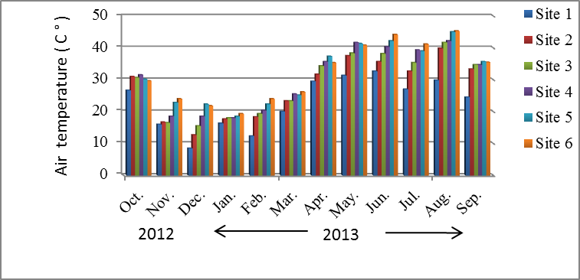
Figure 2 : Monthly variation of Air temperature during study period

Figure 3 : Monthly variation of Water temperature during study period
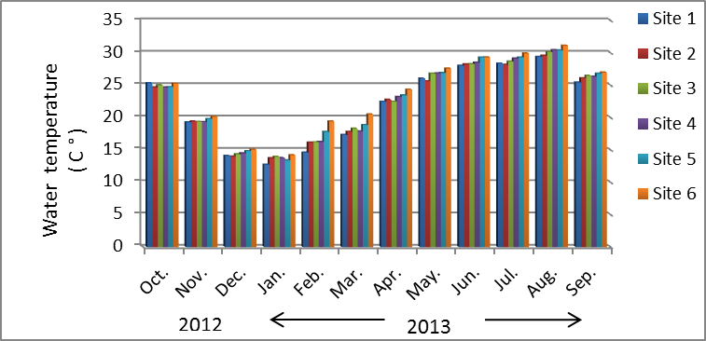

Figure 4 : Monthly variation of PH during study period
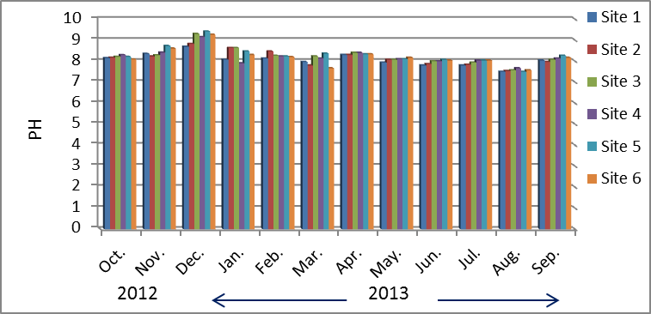
Figure 5 : Monthly variation of Electrical conductivity during study period
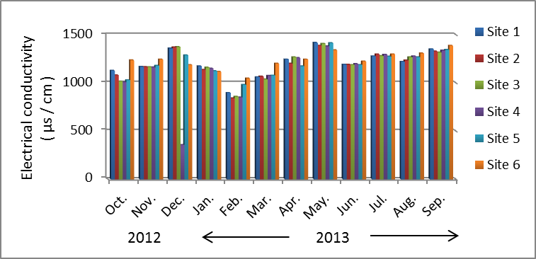
Figure 6 : Monthly variation of Total suspended solids during study period
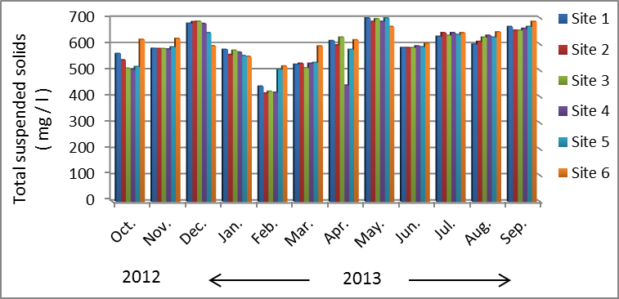
Figure 7 : Monthly variation of Salinity during study period
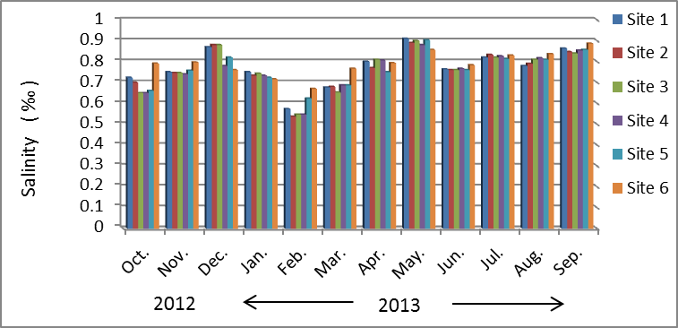
Figure 8 : Monthly variation of total suspended solids during study period
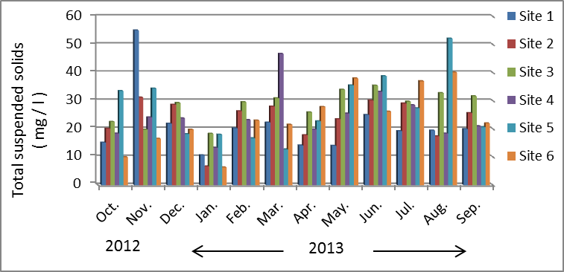
Figure 9 : Monthly variation of Water penetration during study period
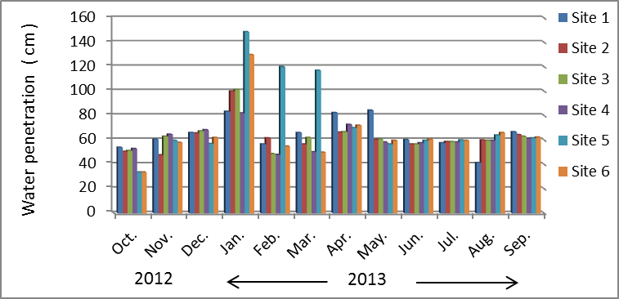
Figure 10 : Monthly variation of Water current velocity during study period
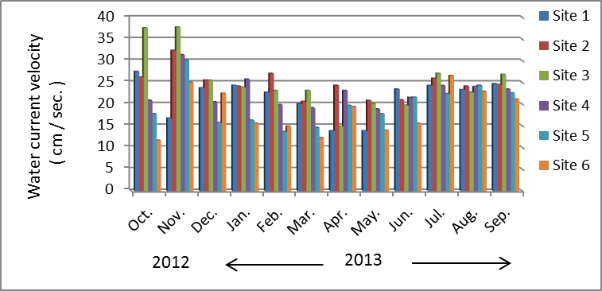
Figure 11: Monthly variation of Dissolved oxygen during study period
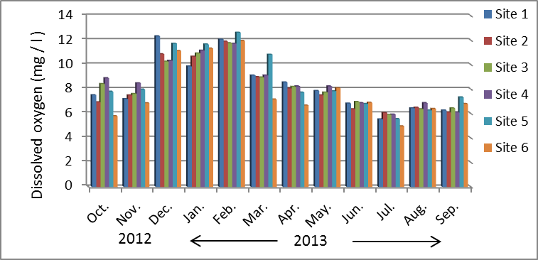
Figure 13 : Monthly variation of Reactive Silica during study period
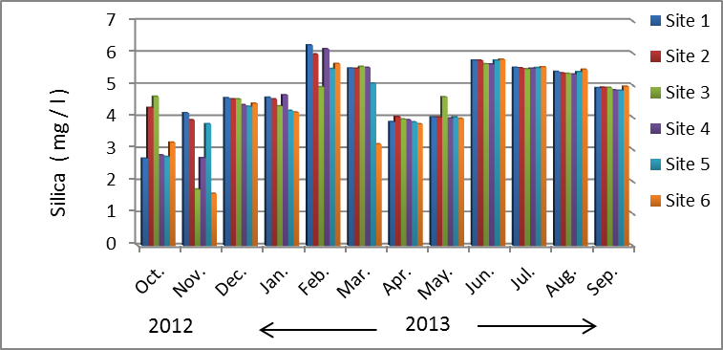
Figure 14 : Monthly variation of Total nitrogen during study period
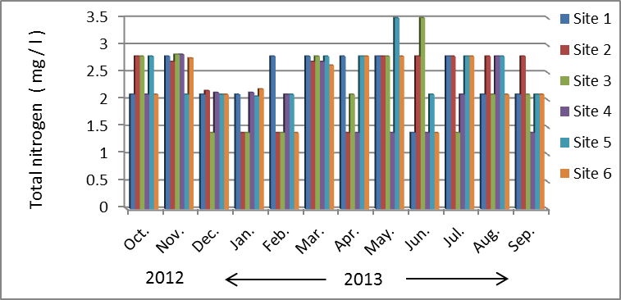
Figure 15 : Monthly variation of total phosphorous during study period
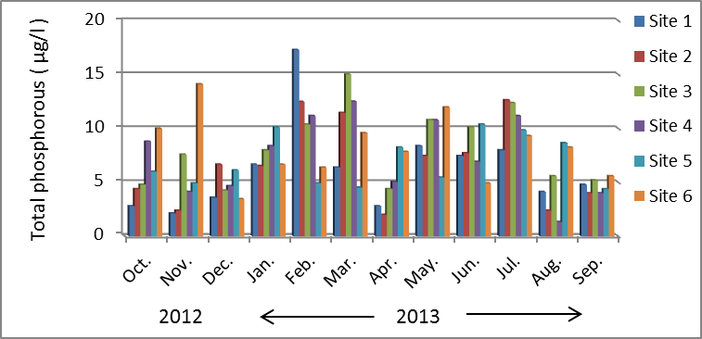
Phytoplankton
A total of 242 taxa and 81 genera of phytoplankton were identified during this study belong to six classes of algae which include Bacillariophyceae , Chlorophyceae , Cyanophyceae , Euglenophyceae , Dinophyceae and Cryptophyceae . Bacillariophyceae are dominated during this study , they constituted the higher percentage during this study which were equal to 62.81 % of the total species ( 152 species and 34 genus ) , followed by Chlorophyceae by 20.66 % ( 50 species and 24 genus ) , Cyanophyceae by 11.16 % ( 27 species and 13 genus ) respectively . Euglenophyceae and Dinophyceae constitute about 2.07 % each of them consist of 5 species and 4 genus , while Cryptophyceae have the lower percentage which equal to 1.24 % .Table 2 and Figure 16 . Some genera are dominated by their species during this study such as Nitzschia , Navicula , Cymbella , Fragilaria , Scenedesmus and Oscillatoria respectively , each of them consist of 28 , 19 , 16 , 14 , 8 ,7 species respectively . Table 3
Table 2 : The number of Phytoplankton genus and species which characterized during this study
Site 6 |  | Site 5 |  | Site 4 |  | Site 3 |  | Site 2 |  | Site 1 |  | Sites  Algal Taxa
Species | Genus | Species | Genus | Species | Genus | Species | Genus | Species | Genus | Species | Genus | Sites  Algal Taxa
104 | 24 | 98 | 23 | 110 | 28 | 110 | 28 | 113 | 27 | 110 | 29 | Bacillariophyceae
9 | 3 | 8 | 3 | 10 | 4 | 8 | 4 | 8 | 3 | 9 | 4 | Centrales - -a
95 | 21 | 90 | 20 | 100 | 24 | 102 | 24 | 105 | 24 | 101 | 25 | Pennales - -b
31 | 18 | 31 | 21 | 34 | 20 | 36 | 22 | 29 | 18 | 39 | 22 | Chlorophyceae
18 | 11 | 20 | 12 | 19 | 11 | 19 | 12 | 18 | 12 | 20 | 10 | Cyanophyceae
3 | 3 | 1 | 1 | 2 | 2 | 2 | 2 | 1 | 1 | 1 | 1 | Euglenophyceae
5 | 4 | 3 | 3 | 2 | 2 | 4 | 4 | 3 | 3 | 4 | 4 | Dinophyceae
2 | 2 | 2 | 1 | 3 | 2 | 3 | 2 | 2 | 1 | 3 | 2 | Cryptophyceae
267 | 86 | 253 | 84 | 280 | 93 | 284 | 98 | 279 | 89 | 287 | 97 | Total

Figure 16 : The percentage of phytoplankton taxa during this study
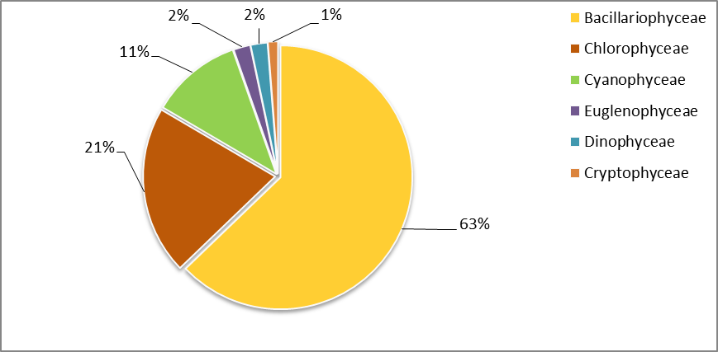

The dominated of Bacillariophyceae during this study due to their ability to tolerate a wide range of environmental conditions , in addition to their silicic solid wall which enabled them to overcome the extreme environmental conditions , also they include many different types which can live in variable environment , so their genetic diversion and the large number of species belonging to them enabled these taxa to dominate and present in many different environments [4] . The increasing of silica levels in the water is another reason to dominate diatoms in the phytoplankton community [65]. Many other studies referred to dominate diatoms in phytoplankton communities [10, 5, 7, 8] . Some species of phytoplankton have appeared over the study period in all locations , these species are Aulacoseira granulate , Cyclotella meneghiniana , C. ocellata , Acnanthes minutissima , Bacillaria paxillifer , Cocconeis pediculus , C . placentula , Cymbella microcephala , Diatoma vulgare , Fragilaria acus , Fragilaria ulna , Navicula cryptocephala , Nitzchia palea , N. longissima and Rhoicosphenia curvata , this indicate the ability of these species to tolerate wide range of environmental conditions , in addition to their competitive ability with other species and possessed certain adaptations enable them to occurrence over the period of study . Several studies mention that the dominance and occurrence of some algae like as Euglena , Nitzschia , Navicula , Aulacoseira , Oscillatoria and Scenedesmus during study referred to organic pollution in the water [66,67]. Other algae classes such as Chlorophyceae , Cyanophyceae , Euglenophyceae , Dinophyceae and Cryptophyceae were less dominance compared with Bacillariophyceae this may be due to have limited number of species , also they need high levels of nutrients to bloom [66,68, 69]. In addition to this most of them prefer moderate temperature , as observed increasing the density of Chlorophyceae and Cyanophyceae during late Spring and Summer in this study , which may be due to elevation temperature and nutrients in the water , many studies referred to increasing Chlorophyceae and Cyanophyceae during Spring and Summer months [10,70,8].
The results of this study showed spatial and temporal variation in the total numbers of phytoplankton cells , their values ranged between 9177 × 10³ cell / l as maximum level in site 4 recorded in October 2012 to 446.8 × 10³ cell / l as minimum level in site 6 recorded in March 2013 . Figure 17 . The high numbers of cells in October month may be due to increase the water velocity which releases many attached species , this can be noticed by presence many planktonic types which are originally attached ( [46]; Yerli et al ., 2012) , or their increasing during this month may be due to presence high concentration of nutrients this can be confirmed by elevating the BOD₅ during this month because of passing the river through agriculture area which used fertilizers and pesticides continuously thus lead to pollute the river in addition to throw the wastes directly to it (Salman et al ., 2008 ; Shekha et al .,2010) . Many other studies referred to increase the density of phytoplankton during Autumn and some other seasons [12,70, 71] . On the other hand the decreasing of the phytoplankton density during March month may be due to lower the nutrient levels especially nitrogen and phosphorous [33,49] , or their decreasing may be due to elevation levels of some pollutants that have negative effects on the phytoplankton [72,73] , or because of elevation levels of waters as result of rainfall [14], in addition to that the grazing effect by zooplankton caused reduction the density of algae [74]. The concentration of Chlorophyll a showed fluctuation during this study ranged between 0.27 – 6.42 μg / l in December , 2012 and September , 2013 respectively , chlorophyll a acts as an indicator for phytoplankton density and nutrients levels in the water , but in the current study the concentrations of chlorophyll a did not correspond with the algal density this results correspond with [7,49] . Many factors affect the rate of photosynthesis and the level of chlorophyll in the water such as low temperature and lack of solar radiation [75] , and water current velocity which increased the levels of total suspended solids in the river by drifting the adjacent soil and released from sediment [76] . The results also showed that the concentrations of chlorophyll a were accompanied the increasing the density of some other non - diatomaceous algae especially Chlorophyceae and Cyanophyceae which incresede during during late Spring and Summer and early autumn because of their content of chlorophyll was higher than other smaller algae as mentioned by [1] , which referred that the amount of chlorophyll Commensurate with the size of cell not with their numbers , and [77] , founded strong positive correlation between Cyanophyceae and the concentration of chlorophyll a in the water . our results correspond with [78] which referred to increase the levels of chlorophyll a during some of autumn and Spring and Summer months and decreasing during the Winter . Figure 18.
Phaephytin is an a pigment result from decomposition of chlorophyll molecule after losing magnesium atom , this pigment can absorb the light at the same wave length for chlorophyll so can interfered with the true value of chlorophyll [17] . the results of phaeophytin showed temporal variation during this study , and their values ranged between 0.34 – 6.21 μg / l , recorded for May and June respectively , also they were opposite of the value of chlorophyll this results are compatible with [33] about the inverse relationship between the content of chlorophyll a and phaeophytin a in phytoplankton community . Figure 19
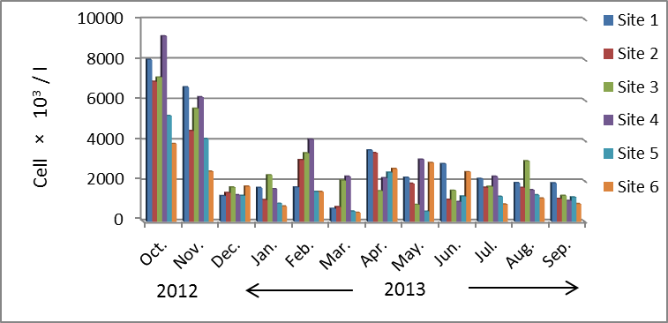
Figure 17 : Monthly variation of total number of phytoplankton cells ( cell × 10³ / l ) during study period
Figure 18 : Monthly variation of Chlorophyll a during study period
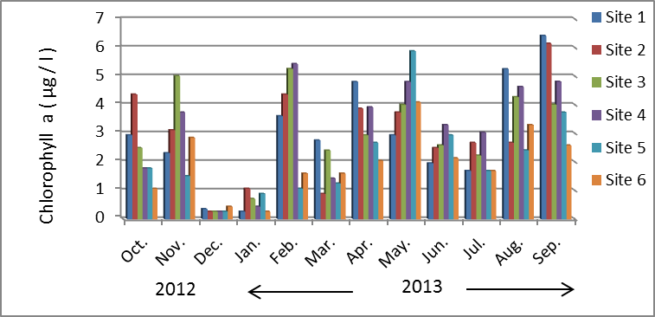

Figure 19 : Monthly variation of Phaeophytin a during study period
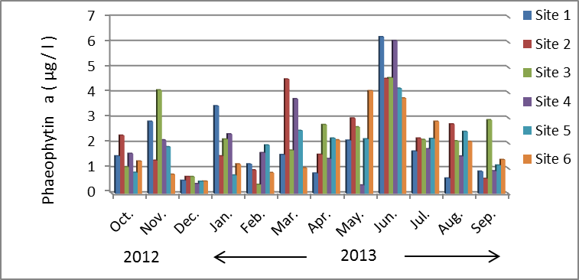
Table 3 : The total numbers of phytoplankton cells ( cell ×10³ / l ) and species in Al- Hussainya river during study period

.Algal Taxa | St1 | St2 | St3 | St4 | St5 | St6
Cyanophyceae
Anabaena sp. | 27.33 | 20.67 | 1.39 | 34 | 36.67 | 12.67
Aphanothece sp . | - | 0.67 | 0.17 | 1.33 | 1.33 | 0.67
Arthrospira sp. | - | - | - | - | 0.67 | -
Chamaesiphon sp. | 2.00 | 2 | 0.17 | 34 | 1.33 | 0.67
Chroococcus limneticus Lemmermann | 1.33 | - | 0.17 | 0.67 | 0.67 | 0.67
C. turgidus (Kützing) Nägeli | 3.33 | 1.33 | 0.61 | 6 | 6.00 | 4.67
UnknownFilament blue green algae | 6.67 | 2.67 | 0.39 | 4 | 4 | 1.33
Gomphosphaeria aponina Kützing | 0.67 | - | 0.39 | 1.33 | - | 0.67
G . lacustris Chodat | 5.33 | 0.67 | 0.44 | 1.33 | 0.67 | 0.67
Lyngbya aestuarii Liebman ex Gomont | 3.33 |  | 1 | 1.33 | 5.33 | 0.67
L. limnetica Lemmermann | 27.33 | 18.67 | 0.28 | 26.67 | 12 | 18.00
Leptolyngbya perelegans (Lemmermann) Anagnostidis & Komárek | - | 0.67 | 0.11 | - | - | -
Merismopedia convolute Brébisson ex Kützing | 1.33 | - | - | - | 1.33 | -
M. elegans A.Braun ex Kützing | 0.67 | - | 0.50 |  | 0.67 | -
M. glauca (Ehrenberg) Kützing | 4.67 | 2 | 0.22 | 8.67 | 4.67 | 4
M. tenuissima Lemmermann | 1.33 | 2 | 0.17 | 0.67 | 0.67 | 1.33
Microcystis aeruginosa (Kützing) Kützing | 2.67 | 1.33 | - | 1.33 | 2.67 | 2.67
M. flos-aquae (Wittrock) Kirchner | - | 0.67 | - | - | - | -
Nostoc sp. | 0.67 | 0.67 | 0.06 | - | - | -
Oscillatoria amoena Gomont |  | 0.67 | 0.22 | - | - | -
O. minima Gicklhorn | 11.33 | 2 | - | 8.67 | 0.67 | 5.33
O. limnetica Lemmermann | 2.00 | - | 0.06 | 0.67 | - | 2.67
O. princeps Vaucher ex Gomont | 0.67 | - | 0.67 | - | - | -
O. splendid Greville ex Gomont | 4.00 | 6.67 |  | 1.42 | 1.33 | 2.67
O.sp. | 0.67 | - | 0.17 | 4 | 0.67 | -
O. tenuis C.Agardh ex Gomont | - | - | - |  | 0.67 | -
Spirulina major Kützing ex Gomont | - | - | - | 0.67 | - | 2
S. meneghiniana Zanardini ex Gomont | - | 1.33 | - | 2.67 | 4 | 2
Euglenophyceae
Euglena sp. | 2.00 | 0.67 | 0.06 | 0.67 | 0.67 | 0.67
Lepocinclis sp. | - | - | - | - | - | 0.67
Phacus sp. | - | - | - | - | - | 0.67
Phacus longicauda _{(Ehrenberg) Dujardin} | - | - | - | 0.67 | - | -
Trachelomonas sp. | - | - | 0.06 | - | - | -
Dinophyceae
Ceratium hirundinella (Müller) Schrank | 0.67 | - | 0.06 | - | 12 | 1.33
Dinobryon divergens Imhof | - | - | - | - |  | 0.67
D. sertularia Ehrenberg | 6.00 | 6.67 | 0.94 | - | 2.67
Glenodinium quadridens (Stein) Schiller | 2.67 | 0.67 | 0.11 | - | 1.33 | 4.67
peridinium sp. | 24.00 | 16 | 1.06 | - | - | 14.67
Cryptophyta
Chroomonas nordstedtii Hansgirg | 8.00 | 16 | 1.06 | 12.00 | - | -
Chroomonas sp. | 70.00 | 50 | 9.61 | 108.67 | 106.67 | -
Cryptomonas sp. | 1.33 | - | 0.33 | 2 | - | -
Chlorophyceae
Actinastrum hantzschii Lagerheim | 6.67 | 7.33 | 0.39 | 7.33 | 6 | 6
Ankistrodesmus falcatus (Corda) Ralfs | 13.33 | 8 | 1.33 | 17.33 | 16.67 | 11.33
Botryococcus braunii Kützing | - | - | - | - | - | 0.67
B. protuberans West & G.S.West | 2.00 | 2 | 0.06 |  | 3.33 | 0.67
Chlamydomonas sp. | 3.33 | - | 0.06 | 3.33 | 1.33 | 0.67
Chlorella vulgaris Beyerinck | 0.67 | 4 | 0.28 | 6 | 5.33 | 2
Closterium ehrenbergii Meneghini ex Ralfs | 3.33 | 0.67 | 0.17 | 1.33 | 2 | 1.33
Closterium sp . | 6.67 | 3.33 | 0.22 | 4 | 4.67 | 4.67
Coelastrum campricum Archer | 0.67 | - | 0.11 | 0.67 | 0.67 | 1.33
C. microporum Nägeli | 4.67 | 3.33 | 0.61 | 7.33 | 4.67 | 9.33
C . reticulatum (P.A.Dangeard) Senn | 4.67 | 6 | 0.17 | 3.33 | 3.33 | 2
C . granatum Brébisson ex Ralfs | 4.00 | 1.33 | 0.17 | 2 | 2 | 3.33
C . leave Rabenh | 0.67 | - | - | 0.67 | - | 1.33
Cosmarium sp. | 0.67 | - | - | - | -
C . subcostatum Nordstedt | 2.00 | - | - | - | - | 0.67
C . subtumidum Nordstedt | - | - | 0.17 | - | - | 0.67
Crucigenia tetrapedia (Kirchner) Kuntze | 3.33 | 1.33 | 0.17 | 4 | - | 2
Dictyosphaerium pulchellum Wood |  | 1.33 | 0.17 | 2.67 | 0.67 | -
Golenkinia paucispina West & G.S.West | 1.33 | 0.67 | 0.11 | 0.67 | - | -
Golenkinia sp. | - | - | - | 0.67 | - | -
Kirchneriella obese West & G.S.West | 2.00 | 2 | 0.17 | 2.67 | 1.33 | 0.67
Lagerheimia ciliate (Lagerheim) Chodat | 2.67 | 4 | 0.33 | 2 | 0.67 | -
Micractinium pusillum Fresenius | 1.33 | - | 0.06 | 0.67 | 0.67 | -
Micractinium sp. | - | - | - | 1.33 | 0.67 | -
Monoraphidium convolutum (Corda) Komárková-Legnerová | 1.33 | 0.67 | 0.17 | 2 | 1.33 | 2.67
Monoraphidium sp. | - | - | - | - | 0.67 | -
Mougeotia sp . | 40.67 | 12 | 2.83 | 31.33 | 20 | 26.67
Oocystis sp . | 7.33 | 2.67 | 0.56 | 8.67 | 4 | 3.33
Pandorina morum (Müller) Bory | 1.33 | - | - | - | - | -
Pediastrum boryanum (Turpin) Meneghini | - | - | 0.11 | 1.33 | - | -
P . duplex Meyen | - | 0.67 | - | - | - | -
P . simplex Meyen | 4.00 | 5.33 | 0.22 | 4 | 5.33 | 4
P. simplex var duodenarium (Bailey) Rabenhorst | 0.67 |  | 0.06 | - | 2 | -
P . simplex var. clathratum Schröter | 1.33 | 0.67 | 0.06 | - | 2 | -
Pediastrum sp. | 0.67 | 0.67 | - | - | - | -
Pediastrum tetras | - | - | - | - | - | 0.67
Scenedesmus acuminatus (Lagerheim) Chodat | 2.67 | 4 | 0.33 | 2.67 |  | 1.33
S . acuminatus var tetradesmoides Smith | 0.67 |  |  |  | - | 0.67
S . arcuatus (Lemmermann) Lemmermann | 4.00 | 1.33 | 0.17 | 3.33 | - | 0.67
S . bijuga (Turpin) Lagerheim | 8.00 | 6.67 | 0.89 | 6.67 | 4 | 6.67
S . dimorphus (Turpin) Kützing | 1.33 | - | 0.11 | 0.67 | - | -
S . opoliensis (Richter) E.H.Hegewald | 0.67 | 0.67 | 0.06 | 2 | 0.67 | 2
S . quadricauda (Turpin) Brébisson | 23.33 | 15.33 | 1.89 | 29.33 | 15.33 | 18.67
Schroederia sp. | 0.67 | - | 0.06 | - | 1.33 | 0.67
Spirogyra sp. | - | - |  | - | 0.67 | 2.67
Staurastrum natator West | - | - | 0.06 | - | 0.67 | -
S . paradoxum Meyen ex Ralfs | 1.33 | - | 0.06 | 0.67 | 0.67 | -
Staurastrum sp. | 4.00 | 3.33 | 0.22 | 3.33 | 4 | -
Tetraedron caudatum | 0.67 | 0.67 | - | - | -
T . minimum (Corda) Hansgirg | 1.33 | 2.67 | 0.11 | 3.33 | - | 0.67
Bacillariophycaeae
- Centrales -
A . italica(Ehrenberg) Simonsen | 469.34 | 384.4 | 36.48 | 478.64 | 300.70 | 188.48
Aulacoseira granulate (Ehrenberg) Simonsen | 1.24 | 1.24 | 0.21 | 1.86 | 1.24 | 0.62
C . comta Hustedt | - | - | - | 0.62 | - | 0.62
C . meneghiniana Kützing | 163.06 | 145.08 | 15.45 | 137.02 | 96.72 | 114.08
C . ocellata Pantocsek | 806.62 | 691.92 | 50.27 | 717.96 | 508.40 | 473.68
C . stelligera Cleve & Grunow | 19.84 | 22.94 | 2.58 | 52.08 | 14.26 | 39.06
C. kuetzingiana Thwaites | 9.30 | 8.06 |  | 3.10 | 2.48 | 3.10
Coscinodiscus lacustris Grunow | 11.78 | 9.92 | 0.67 | 9.92 | 8.06 | 9.30
Melosira varians Agardh | 24.18 | 4.96 | 0.47 | 13.64 | 1.86 | 1.24
Stephanodiscus astrea (Ehrenberg) Grunow | 1.24 | - | 0.05 | 1.24 | - | -
- Pennales -
Achnanthes clevei Grunow | - | - | 0.36 | 0.62 | - | -
A . lanceolata (Brébisson ex Kützing) Grunow | - | - | 0.05 | - | -
A . linearis (Smith) Grunow | 0.62 | - | - | - | 0.62 | 0.62
A . microcephala (Kützing) Grunow | 1.24 | 1.86 | 0.05 | 9.30 | 1.86 | 1.86
A . minutissima Kützing | 40.92 | 27.28 | 3.26 | 37.20 | 27.90 | 22.32
A . sp. | 1.86 | 1.24 | 0.10 | 1.24 | - | 1.86
Amphipleura alata (Ehr.) Kuetzing | 1.24 | - | - | 0.62 | - | -
A . pellucid Kützing | - | 0.62 | 0.05 | 1.24 | 1.24 | -
Amphora coffeaeformis (C.Agardh) Kützing | 1.24 | 1.86 | 0.21 | 1.86 | 3.10 | 10.54
A . ovalis (Kützing) Kützing | 1.86 | 1.24 | 0.05 | 5.58 | 1.86 | 2.48
A . veneta Kützing | 3.10 | 3.1 | 0.26 | 4.34 | 3.10 | 4.34
A . sp. | 3.72 | 4.34 | 0.26 | 4.34 | 3.10 | 6.82
Anomoeoneis exilis (Kützing) Cleve | 14.88 | 18.6 | 2.12 | 54.56 | 8.68 | 4.34
Bacillaria paxillifer (Müller) Marsson | 26.04 | 26.66 | 1.96 | 22.94 | 9.30 | 13.02
Caloneis amphisbaena (Bory de Saint Vincent) Cleve | 1.86 | - | - | - | - | 0.62
Cocconeis pediculus (Ehrenberg) Chmielevski | 0.62 | 0.62 | - | - | - | -
C . placentula Ehrenberg | 48.98 | 34.72 | 2.43 | 33.48 | 18.60 | 17.98
C . placentula var euglypta (Ehrenberg) Grunow | 45.26 | 20.46 | 2.07 | 22.94 | 13.64 | 11.78
C . placentula var lineata (Ehrenberg) van Heurck | 49.60 | 59.52 | 5.32 | 53.32 | 24.18 | 21.70
Campylodiscus clypeus (Ehrenberg) Ehrenberg ex Kützing | 4.34 | 8.06 | 0.88 | 8.06 | 4.34 | 3.72
Cymatopleura elliptica (Brébisson) Smith | 0.62 | - | - | - | - | -
C . solea (Brébisson) Smith | 1.86 | 3.72 | 0.41 | 0.62 | 3.10 | 7.44
Cymbella affinis Kützing | 7.44 | 7.44 | 0.62 | 4.96 | 7.44 | 3.72
C. affinis var excisa (Kützing) Grunow | - | 1.24 | - | - | 0.62 | -
C. aspera (Ehrenberg) Cleve | 1.86 | 0.62 | 0.16 | 2.48 | - | -
C. cistula (Ehrenberg) O.Kirchner | 4.34 | 1.24 | 0.41 | 4.96 | 1.24 | 3.10
C. cistula var maculata (Kützing) Van Heurck | - | - | 0.10 | 3.72 |  | 0.62
C. cymbiformis Agardh | - | - | - | 0.62 | 1.24 | 1.86
C. differta (Cleve-Euler) Krieger | 0.62 | - | 0.05 | - | - | -
C. helvetica Kützing | 0.62 | 0.62 | 0.10 | - | - | 2.48
C. microcephala Grunow | 29.76 | 17.98 | 2.69 | 31.62 | 12.40 | 18.60
C. obtusiuscula Kützing | 0.62 | 2.48 | 0.05 | 3.10 | 4.34 | 4.96
C. prostrata (Berkeley) Grun | 0.62 | 0.62 | 0.05 | 1.24 | 0.62 | 0.62
C. pusilla Grunow | 6.20 | 3.72 | 0.67 | 5.58 | 12.40 | 38.44
C. sinuate Gregory | 1.86 | 0.62 | 0.16 | 0.62 | 1.86 | 0.62
C. tumida (Brébisson) van Heurck | 2.48 | 3.72 | 0.36 | 3.10 | 1.24 | 1.24
C. turgid Gregory | 0.62 | 0.62 | 0.05 | 1.86 | 1.24 | 1.86
C. ventricosa (Agardh) Agardh | 6.82 | 6.2 | 0.67 | 5.58 | 2.48 | 7.44
Denticula elegans Kützing | 0.62 | - | 0.05 | - | - | 0.62
D . sp. | 0.62 | - | - | - | - | -
Diatoma elongatum (Lyngbye) Agardh | 3.10 | 1.24 | 0.52 | - | 0.62 | 0.62
D . elongatum var tenuis (Agardh) Van Heurck | - | 0.62 |  | 0.62 | - | -
D . tenue var elongatumPatrick and Reimer | 1.24 | - | 0.05 | 1.24 | 0.62 | -
D . vulgare (Grunow) Bukhtiyarova | 35.96 | 30.38 | 4.91 | 71.30 | 10.54 | 7.44
Diploneis ovalis (Hilse) Cleve | 1.24 |  | 0.05 | 0.62 | 0.62 | 1.24
D . pseudoovalis Hustedt | 3.10 | 0.62 | 0.31 | 2.48 | - | 2.48
Epithemia sorex Kützing | - | - | - | 0.62 | - | -
E . zebra var porcellus (Kützing) Grunow | - | - | 0.05 | - | - | -
Eunotia pectinalis (Kützing) Rabenhorst | - | - | - | 0.62 | - | -
Fragilaria acus (Kützing) Lange-Bertalot | 26.66 | 34.72 | 3.05 | 46.50 | 17.98 | 31.62
F . capitata (Ehrenberg) Lange-Bertalot | 4.34 | 0.62 | - | - | - | -
F . capucina Desmazières | - | 1.86 | - | - | - | -
F . construens (Ehrenberg) Grunow | 1.86 | - | - | 2.48 | - | -
F . crotonensis Kitton | 86.18 | 70.68 | 7.03 | 100.44 | 23.56 | 28.52
F . fasciculata (Agardh) Lange-Bertalot | 20.46 | 50.22 | 2.58 | 35.96 | 8.06 | 14.88
F . intermedia Grunow | 3.10 | 1.86 | 1.03 | 1.24 | 1.86 | -
F . pinnata Ehrenberg | 1.24 | 0.62 | 0.05 | 0.62 | - | 1.24
F . sp. | - | - | 1.45 | 4.96 | 4.34
F . ulna (Nitzsch) Lange-Bertalot | 56.42 | 27.9 | 1.81 | 32.86 | 16.12 | 21.70
F . ulna var. biceps (Kützing) Compère, | 2.48 | 3.1 | 0.26 | 3.10 | 2.48 | 5.58
F . ulna var oxyhynchus (Keutzing) Van Heurck | 1.86 | 1.86 | 0.10 | 1.86 | 1.24 | 17.36
F . virescens (Ralfs) Williams and Round | 19.22 | 21.7 | 2.02 | 39.68 | 27.28 | -
F. vaucheriae (Kützing).Petersen | 1.24 | 4.34 | - | - | - | 0.62
Gomphoneis olivacea (Hornemann) P. A. Dawson ex R. Ross & P. A. Sims | 1.24 | 0.62 | 0.26 | 4.96 | 0.62 | -
Gomphonema acuminatum var. turris (Ehrenberg) Wolle | - | - | - | - | - | 0.62
G. angustatum (Kützing) Rabenhorst | 1.86 | 4.34 | 0.31 | 1.86 | 2.48 | 1.24
G . attenuatum Pantocsek | 0.62 | 0.62 |  |  | 0.62
G . constrictum var capitata (Ehrenberg) Woodhead & Tweed | 1.86 | 1.24 | 0.05 | 0.62 |  | 2.48
G . gracile Ehrenberg | - | - | - | - | - | 0.62
G . intricatum Kützing | 1.24 | 0.62 | - | 0.62 | - | -
G . lanceolatum Kützing | - | 0.62 | - | - | - | -
G . parvulum(Kützing ) Kützing | - | 0.62 | 0.05 | - | 0.62 | -
G . sphaerophorum Ehrenberg | 0.62 | - | - | - | - | -
Gyrosigma acuminatum (Kützing) Rabenhorst | 0.62 | 1.24 | 0.26 | 1.24 | 1.24 | 1.86
G . peisonis Grunow | 1.86 | 0.62 | 0.16 | 1.86 | 1.86 | 1.24
G . spencerii (Bailey ex Quekett) Griffith & Henfrey | 0.62 | - | 0.05 | 0.62 | 0.62
Hantzschia amphioxys (Ehrenberg) Grunow | 5.58 | 7.44 | 0.36 | 3.72 | 2.48 | 3.10
M . elliptica (Agardh) Cleve | 0.62 | - | - | - | - | -
M . smithii var amphicephala | - | 0.62 | - | - | - | -
Neidium productum (Smith) Cleve | 1.86 | 1.86 | 0.10 | - | 1.24 | 0.62
Navicula anglica Ralfs | - |  | 0.05 | - | - | -
N . atomus(Kützing) Grunow | - | 0.62 | 0.05 | 0.62 | - | -
N . bacillum Ehrenberg | 12.40 | 5.58 | 1.03 | 8.68 | 4.34 | 4.34
N . cincta (Ehrenberg) Ralfs | 18.60 | 16.12 | 1.19 | 22.94 | 12.40 | 17.36
N . cryptocephala Kützing | 3.72 | 1.86 | 0.05 | 2.48 | 8.06 | 0.62
N . cryptocephala var intermedia | 4.96 | 3.1 | 0.47 | 9.30 | - | 6.20
N . cryptocephala var veneta | 8.06 | 4.34 | 0.88 | 8.68 | 3.10 | 3.10
N . gracilis Ehrenberg | - | - | - | 1.24 | - | 0.62
N . inflata Donkin | - | 1.24 | - | 0.62 | - | 0.62
N . mutica Kützing | 1.24 | 1.24 | 0.16 | 1.86 | 3.72 | 3.10
N . parva (Ehrenberg) Ralfs | - | 1.24 | 0.05 | - | 0.62 | 0.62
N . placentula (Ehrenberg) Kützing | 0.62 | 0.62 | 0.10 | 4.96 | 1.24 | 1.24
N . pygmaea Kützing | 1.86 | 3.1 | 0.21 | 3.10 | 2.48 | 0.62
N . radiosa Kützing | 1.24 | 1.24 | 0.26 | - | - | 0.62
N . radiosa var tenella (Brébisson ex Kützing) Van Heurck | - | 1.24 | 0.10 | 1.24 | 1.24 | 1.86
N . rhynchocephala | - | 1.24 | - | 2.48 | 1.24 | 12.40
N . schroeteri Kützing | - | - | 0.05 | - | - | 2.48
N . spicula (Hickie) Cleve | - | - | - | - | 0.62 | 1.86
N . viridula var rostellata (Kützing) Cleve | - | - | 0.05 | - | - | -
Nitzschia acicularis (Kützing)Smith | 13.02 | 10.54 | 0.62 | 5.58 | 4.34 | 0.62
N . amphibia Grunow | 0.62 | 1.24 | 0.21 | 0.62 | 5.58 | 0.62
N . angustata (Smith ) Grunow | 0.62 | 1.24 | 0.05 | 1.24 | 1.86 | 0.62
N . angustata var acuta Grunow |  | 0.62 | 0.05 | 1.24 | 0.62 | 3.72
N . apiculata (Gregory) Grunow | 2.48 | 9.92 | 0.72 | 5.58 | 1.86 | -
N . clausii Hantzsch | - | - | - | 1.24 | 0.62 | -
N . dissipata (Kützing) Rabenhorst | 14.88 | 19.22 | 1.50 | 25.42 | 11.78 | 19.22
N . dubia Smith | - | 0.62 | 0.05 | 1.86 | 1.24 | -
N . filiformis (Smith)Hustedt | 11.16 | 6.82 | 0.67 | 11.16 | 6.82 | 6.20
N . frustulum(Kützing) Grunow | 48.98 | 42.16 | 3.31 | 46.50 | 14.26 | 19.22
N . frustulum var perminuta Grunow | 14.26 | 9.92 | 1.19 | 24.18 | 3.72 | 1.86
N . gracilis Hantzsch | 8.06 | 8.68 | 0.67 | 7.44 | 3.72 | 9.30
N . granulata (Grunow) Mann | - | - | - | - | 0.62 | 4.34
N . hungarica Grunow | 5.58 | 1.86 | 0.41 | 3.72 | 3.72 | -
N . ignorata Krasske | 0.62 | - | - | - | - | -
N . longissima (Brébisson) Ralfs | 49.60 | 31.62 | 2.74 | 26.66 | 29.76 | 41.54
N . lorenziana var subtilis Grunow | 0.62 | 1.24 | - | 0.62 | 0.62 | 0.62
N . microcephala Grunow |  | 2.48 | 0.10 |  |  | 0.62
N . obtuse Smith | 0.62 | 1.24 | 0.05 | 1.86 | 1.24 | 1.86
N . palea (Kützing) Smith | 67.58 | 66.96 | 6.51 | 87.42 | 42.78 | 85.56
N . punctata var coarcata(Grunow) Hustedt | 0.62 | 1.24 | 0.05 | 1.86 |  | 0.62
N . romana Grunow | - | 0.62 | - | 1.24 | 1.86 | 1.24
N . sigma(Kützing) Smith | 6.82 | 6.82 | 0.98 | 15.50 | 6.20 | 6.20
N . sigma var rigidula (Peragallo & Peragallo) Grunow | 0.62 | 4.34 | 0.10 | 3.10 | 1.86 | 0.62
N . sigmoidea (Nitzsch) W.Smith | 2.48 | 1.86 | 0.57 | 5.58 | 1.24 | 3.10
N . tryblionella Hantzsch | - | 1.24 | 0.16 | 3.10 | 1.86 | 1.86
N . tryblionella var levidensis (Smith) Grunow | 0.62 | 0.62 | 0.05 | - | - | -
N . tryblionella var victoriae (Grunow) Grunow | 0.62 | 1.24 | 0.16 | - | 0.62 | 0.62
P. lundii Hustedt |  | 1.86 | - | 1.24 | - | -
P . sp. | 0.62 | 1.24 | - | - | - | 0.62
P . obscurum Smith | 1.24 | 1.86 | 0.26 | 1.86 | 1.86 | 0.62
P . salinarum (Grunow) Grunow | 1.24 | - | - | - | 1.24 | -
P . sp. | - | - | - | - | - | 0.62
Rhoicosphenia curvata (Kützing) Grunow | 53.94 | 28.52 | 3.51 | 42.16 | 14.26 | 17.98
R . gibba var ventricosa (Kützing) H.Peragallo & M.Peragallo | - | 0.62 | - | - | - | -
R. musculus (Kützing) Müller | - | - | - | 0.62 | - | -
Stauroneis phenicenteron (Nitzsch) Ehrenberg | - | - | 0.05 | - | - | -
Surirella angusta Kützing | - | - |  | - | 0.62 | 0.62
S. capronii Brébisson ex F.Kitton | 0.62 | 0.62 | 0.10 | 0.62 | - | -
S . ovata Kützing | 0.62 |  | 0.16 |  | 1.86 | -
S . ovata var africana Cholnoky | 2.48 | 3.72 | 0.42 | 4.34 | 5.58 | 5.58
S . ovata var Salina (Smith) Rabenhorst | 0.62 | - | 0.05 | 0.62 | - | 0.62
S . ovalis Brébisson | - | - | - | 0.62 | - | -

Conclusion
The physical and chemical properties of the water showed spatial and temporal variations during this study . The total number of phytoplankton cells , showed also variations , the highest number of cells recorded during late Autumn 2012 . The results also showed dominance of Bacillariophyceae during this study followed by Chlorophyceae , Cyanophyceae and other classes respectively .

Acknowledgements
We are grateful to Department of Biology , College of Education for pure sciences and University of Karbala for their support to this project .
References
[1] Reynolds , C . S ..The Ecology of Phytoplankton . Cambridge University Press Publisher . New York,2006 .
[2] Addy , K . and Green , L . Algae in aquatic ecosystem . Fact Sheet No.96 - 4 . Natural Resources Facts . University of Rhod Island Collage of Resource Development Department of Natural Resources Science, 1996.
[3] Barsanti , Land Gualtieri , P. Algae : Anatomy , Biocheistry , and Biotechnology . Published by CRC Press . USA, 2006 .
[4] Bellinger , E.G. and Sigee , D. C . Freshwater Algae :Identification and Use as Bioindicators . John Wiley & Sons , LTD , Publication . London, 2010 .
[5] Hassan , F. M ; Al –Taee , M. M . and Mohammed , A . B. A limnological study in Euphrates River from Al - Hindiya Barrage to Al - Kifil city , Iraq. Basrah journal of Science, 2010, Vol. 28, No. 2, pp. 273 – 288 .
[6] Hassan , F. M . ; Saleh ,M .M . and Salman ,J. M . A study of Physicochemical Parameters and Nine Heavy metals in Euphrates River, Iraq . E-Journal s of Chemistry, 2010,Vol.7, No.3, pp.685-692 .
[7] Salman , J . M . ; Alkam , F . M . and Al - Fatlawi , H . J . A Biodiversity of Phytoplankton in Euphrates river , Midd of Iraq . Iraqi Journal of Science . Special issue 1st . Conference of Biology . University of Baghdad , 2012, pp.277 – 293.
[8] Salman , J . M ; Kalifa , A . T . and Hassan , F . M . Qualitative and Quantitative Study Of Epipelic Algae and Related Environmental Parameters In Al - Hilla River , Iraq . International Journal of Current Research, 2013, Vol.5, No.1, pp. 3318 - 3327 .
[9] Al - Zubaidi , A.J .M . ; Abdulla , D . S . ; Houriabi , K. K .and Fawzi , M . Abundance and distribution of phytoplankton in some southern Iraq waters . Marsh Bulletin ,2006, Vol. 1, No. 1, pp. 59 – 73 .
[10] Hassan , F. M . ; Kadhim , N .F . and Hussein , F . H. Effect of Chemical and Physical Properties of River Water in Shatt Al – Hilla on Phytoplankton Communities . E – Journal of Chemistry .2008, Vol. 5, No. 2, pp. 323 – 330 .
[11] Lee , K . and Yoon , S . K . Ecological Studies on Togyo Reservoir in Chulwon , Korea VI . the list of Phytoplankton and Periphyton . Algae, 2003, Vol. 18, No. 4, pp. 263 – 272 .
[12] Yerli , S . V . ; Kivrak , E . ; Gurbuz , H. ; Manav , E . ; Mangit , F . and Turkecan ,O . Phytoplankton Community , Nutrients and Chlorophyll a in Lake Mogan (Turkey ) , with Comparison between Current and Old data . Turkish Journal of Fisheries and Aquatic Sciences, 2012 , Vol.12, pp. 95 – 104 .
[13] Yilmaz , N . The relationship Between Phytoplankton Density and Chlorophyll a in Riva Stream ( Istanbul , Turkey) . Balwois Ohrid . Republic of Macedonia, 2012 .
[14] Faghir , M .B . and Shafii , S. Floristic study on the algae of iahdarvishan River in Guilan Province , North Iran . Caspian . J .Env . Sci ., 2013, Vol. 11, No. 1, pp. 111 – 126 .
[15] APHA ( American Public Health Association ) . Standard Methods For The Examination of Water and Wastewater . 20th edition. Washington . DC . USA, 1999 .
[16] Mackereth , F.J.H. ; Heron , J. and Tailing , J.T. Water analysis some revised methods for liminologist.Sci. Publ. Fresh water , Biol. Ass. (England) , 1978, Vol. 36, pp.1 – 120.
[17] Lind , G . T . Handbook of common methods in Limnology . 2^{n} edition . London, 1979. [18] Eisenreich , S. J .; Bannerman , R .T and Armstrong , D.E. A simplified phosphorous analysis technique . Environ , 1975, Lett .,9:45-53.
[19] Furet , J.E. and Benson. Evans, K. An evaluation of the timerequired to obtain complet sedimentation of fixed algal particles prior to enumeration. Br. Phycol. J. , 1982, Vol. 17, pp. 253-258.
[20] Desikachary , T.V. Cyanophyta. Indian Council Of Agriculture Research. New Delhi, 1959 .
[21] Prescott,G.W. Algea of the western Great Lakes Area. William, C., Brow, Co. Publishers, Dubuque, Lowa, 1973.
[22] Foged,N. Fresh water Diatoms in sprilanka(Ceylon). Bibliotheca phycologia. Herausgeben Von J. Cramer Bond 23, 1976.
[23] Foged , N . Freshwater Diatomsin inIreland . Bibliotheca ghycologia. Herausgegeben Von J. Cramer Band 34, 1977.
[24] Germain , H. flora des diatomees. Diatomophyceae eau douces et saumatres du Massif Armoricion et des contrees voisines d'europe occindental. Sciete Nouvelle des Editim Boubee Paris, 1981.
[25] Hadi, R.A.M.; Al-Sabonchi, A.A. and Haroon, A.K.Y. Diatoms of the Shatt Al-Arab river Iraq, Nova Hedwigia., 1984, Vol.39, pp. 513-557.
[26] Hustedt, F. "The pinnate diatoms 2-An English translation of Husted F. Dickiselal genteilz" ,with supplement by Jensen Iv. Kocwingstein, Gylcoeltz, Sci., Books, 1985.
[27] Lorenzen ,C.J . Determination of Chlorophyll and Pheo - Pigment : Spectrophotometric Equations . Limnol . Oceanog, 1967, Vol.12, No.2, pp. 343 - 346 .
[28] UNEP . Water Quality for Ecosystem and Human Health . United Nations Environment Monitoring System (GEMS) / Water Programme. 2nd edition . Canada, 2008.
[29] Peterson , J. ; McFarland , M. ; Dictson ,N. ;Boellstorff , D.; Berg ,M . and Roberts , G. Texas Watershed Steward Handbook : A Water Resource Training Curriculum . AgriLife Extension . The Texas A & M University System .Department of Soil and Crop Science,2013 .
[30] Corbitt , R . A . Standard Handbook of Environmental Engineering . 2nd edition . McGraw - Hill Handbooks Companies, 2004 .
[31] Hassan , F . M . ; Al – Zubaidi , N . A . j . and Al – Dulaimi , W. A . A . An Ecological assessment for Tigris River within Baghdad ,Iraq . Proceeding of 5th International Conference of Environmental Science, 2013, pp. 26 – 39 .
[32] Salman , J . M and Nassar , A J . Variation of Some Physico- Chemical Parameters and Biodiversity of Gastropods Species in Euphrates River , Iraq. International Journal of Environmental Science and Development, 2014, Vol . 5, No. 3, pp. 328 – 331 .
[33] Al – Fatlawi , H . J . J . Ecological , Qualitative and Quantitative study of algae in Euphrates River between AL- Hindia and AL-Manathera districtes / Iraq .PhD .Thesis. College of Science . University of Babylon, 2011 .
[34] Sharma ,A and Sharma ,V . Correlation between a biotic and biotic variables of stream Ban - Ganga , Karta , Reasi,(J &K). Journal of Chemical , Biological and Physical Sciences, 2014,Vol. 4, No.1, pp.797 – 803 .
[35] Salman , J .M .; Lafta , S .K. and Jawad , H .J. A Limnological Study on Al – Abasya river – Iraq . Al – Qadisiyah Journal for Pure Science, 2008, Vol. 3, No.1, pp. 48 – 53 .
[36] Ismail , A.M . and Saadallah , H . A . A . Seasonal variations of the phytoplankton biomass in Diyala river , Iraq . Diyala Journal for Pure Science, 2010,Vol. 6, No. 2,pp. 142 – 149 .
[37] Deekae ,S . N . ; Abowei , J .F . N . and Ockiya ,A . Seasonal Variation of Some Physical and Chemical Parameters of Luunbara Creek ,Ogoni Land , Niger Delta ,Nigeria .Research Journal Environmental and Earth Sciences , 2010, Vol. 2, No.4, pp. 208 – 215 .
[38] Mandal , H . S . and Das , A . Assessment of seasonal variation in Physico – chemical characteristics and quality of Torsha River water for rigation used in Cooch Behar and Jalpaiguri districts of West Bengal , India . Journal of Chemical and Pharmaceutical Research, 2011, Vol.3, No. 6 , pp. 265 – 270 .
[39] Udoh , J.P .; Ukpatu , J. E . and Otoh , A. J. Spatial Variation in Physico – Chemical Parameters of Eastern Obolo Estuary . Nigeria Delta , Nigeria . Journal of Environmental and Earth Science, 2013, Vol.3, No.12, pp.163 – 171 .
[40] Zaidan , T . H . ; Abdul- Rahman , I . A . and Saaod , W . M . An Environmental Study of Chemical And Physical Pollutants in Euphtares River Water In Ramadi And Fallujah . Journal of university of Anbar for Pure science, 2009, Vol.3, No.3, pp.107 – 117 .
[42] Thitame , S . N. and Pondhe ,G . M. Assessment of seasonal variation in Physico - chemical characteristics and quality of Pravara River water for irrigation use in Sangamner Dist Ahmednagar , Maharashtra . Journal of Chemical and Pharmaceutical Research,2010, Vol.2, No. 2, pp. 316 – 320 .
[43] Ganie , M . A . ; Khan , M . I . and Parveen ,M. Seasonal Variation In Physico - Chemical Charateristics of Pahuj Resrevoir ,District Jhansi , Bundelkhand Region ,Central India . International Journal of Current Research, 2012,Vol. 4, No.12, pp. 115 – 118 .
[44] Al – Sharifi , A . A . H . possible contamination with heavy elements and some ecological parameters of water Bani - Hassan stream in the province of Karbala - Iraq . M.Sc. thesis . College of education for pure sciences . University of Karbala, 2014.
[45] Khwedim , K . H. Influence of sewage water on the water quality of Diyala River in Baqubah City . Iraqi Journal of Science, 2012, Vol.53, No. 1, pp. 113 – 124 .
[46] Onyema ,I . C . The Phytoplankton Composition , Abundance and Temporal variation of a Polluted Estuarine Creek in Lagos, Nigeria . Turkish Journal of Fisheries and Aquatic Sciences, 2007, Vol. 7, pp.89 – 96 .
[47] Iqbal , F . ; Ali , M .; Salam , A. ; Khan , B . A . ; Ahmad , S. ; Qamar , M . and Umer , K . Seasonal Variations of Physico – Chemical Characteristics of RiverSoan Water at Dhoak Pathan Bridge(Chakwal), Pakistan.International Journal of Agriculture & Biology, 2004, Vol.6, No. 1, pp. 89 – 92 .
[48] Al - Saadi , A . J . N . Mollusca Biodiversity and Some Environmental factors Effected in Euphrates River / Middle of Iraq . M . Sc . Thesis . College of Science . University of Babylon, 2013 .
[49] Abdulameer , H .M .T . An ecological study of Phytoplankton on Bani – Hassan Stream – Holy Karbala Province – Iraq . M.Sc. thesis . College of education for pure sciences . University of Karbala, 2014 .
[50] Al - Saadi ,H .A. ;Al - daham , N. K .and Al- Jassan , L.A. The Aquatic Ecology . Dar Alkutub Directorate for Printing and Publishing . University of Mosul, 1986 .
[51] Shakirat , K .T . and Akinepelu , A. T . Study of Heavy metals pollution and Physico - Chemical assessment of water quality of River Owo , Agbara ,Nigeria. International Journal of Water Resources and Environment Engineering, 2013,Vol. 5, No.7, pp. 434 – 441.
[52] Rabee,A. M . ; Abdul - Kareem , B.M . and Al - Dhamin, A .S . Seasonal Variations of Some Ecological Parameters in Tigris River Water at Baghdad Region , Iraq . Journal of Water Resource and Protection, 2011, Vol. 3, pp. 262 – 267 .
[53] Al - Hamim ,F.H. I . The Limnology . Dar Alkutub Directorate for Printing and Publishing .University of Mosul,1986 .
[55] Wetzel, R.G. & Linkens, G.E. Limnological Analysis. 3rd Ed. Springer . New York, 2000.
[56] UNESCO/WHO/UNEP .Water Quality Assessment - A guide to Use of Biota , Sediment and Water in Environmental Monitoring .2nd Edition . Edited by Chapman , D. Published on behalf of United Nations educational Scientific and Cultural Organization ; World Health organization and United Nations Environment Programme .Published by E & FN Spon, an imprint of Chapman & Hall . London, 1996 .
[57] Sun , C. C. ; Wang ,Y. S . ; Wu , M . L .; Dong , J .D. ; Wang ,Y.T. ; Sun , F . L . and Z , Y .Y . Seasonal variation of Water quality and Phytoplankton Response Patterns in Daya Bay , China . International Journal of Environmental Reasearch Public Health, 2011, Vol.8, pp. 2951 – 2966 .
[58] Faragallah , H . M . ; Askar , A . L . ; Okbah , M . A . and Moustaf H.M . Physico - Chemical Characteristics of the Open Mediterranean Sea Water Far about 60 Km from Damietta habor ,Egypt .Journal of Ecology and the Natural Environment, 2009,Vol. 1, No.5, pp. 106 – 119 .
[59]Husnain ; Wakatsuki ,T. and Masunaga , T. Dissolved Silica dynamicsand Phytoplankton Population in Citarum Watershed , Indonesia . Journal of Food , Agriculture & Environment, 2009,Vol.7,No.4, pp.132 – 139 .
[60] Sigleo , A .and Frick ,W. Seasonal Variations in River Flow and Nutrient Concentrations in a Northwestern USA Watershed Conference Proceedings of First Interagency Conference on Research in the Watershed . US Department of Agriculture , Agriculture Research Service Publisher . Benson , AZ .753 : 370 – 376, 2003 .
[61] Jiang , C. D . ; Jun , L. ; Feng ,Y.S . ; Quan , J. S . ; Na , S.Y . Spatial and Temporal variations of water quality in Cao-E River of eastern China . journal of Environmental Sciences, 2006, Vol.18, No. 4, pp. 680 – 688 .
[62] Abdulameer , H .M .T . An ecological study of Phytoplankton on Bani – Hassan Stream – Holy Karbala Province – Iraq . M.Sc. thesis . College of education for pure sciences . University of Karbala,2014 .
[63] Al - Essa , S. A . K . Ecological Study of the Aquatic Plants and Epiphytic Algae In Shatt AL- Arab River . PhD thesis . The college of Agriculture . University of Basrah,2004 .
[64] Al – Nasrawi , S . M. F . An Ecologyical Study of Epipelic Algae on ( Bani - Hassan ) Stream / Karbala – Iraq . M.Sc. thesis . College of education for pure sciences. University of Karbala, 2014.
[65] Husnain ; Wakatsuki ,T. and Masunaga , T. Dissolved Silica dynamicsand Phytoplankton Population in Citarum Watershed , Indonesia . Journal of Food , Agriculture & Environment , 2009, Vol.7, No. 3, pp. 132 – 139 .
[66] Wu , J. T . and Kow , L . C . Alteration of Phytoplankton assemblages caused by changes in water hardness in Feitsui Reservoir , Taiwan . Botanical Studies, 2010, Vol. 51, pp.521 – 529 .
[67] Bordoloi , D.and Baruah , P.P . Water quality assessment using phytoplankton in a historical pond of Upper Assam . Journal of Algal Biomass Utilization ,2014,Vol. 5, No. 2, pp. 1-7 .
[68] Shams , M .; Afsharzadeh , S. and Atici ,T. Seasonal variation in phytoplankton communities in Zayandeh - Rood Dam Lake ( Isfahan , Iran ) . Turk J Bot ., 2012, Vol. 36, pp.715 – 726 .
[69] Alkam . F . M . and Abdulmuneum , I . A . Effect of some ecological factors on the phytoplankton community in the Euphrates river and the main eastern drainage water in the city of Al - Samawa – Iraq . Al - Muthana journal for pure science, 2012, Vol.1, No. 1, pp. 37 – 51 .
[70] Alkam , F . M . and Abdullah , A . H . Seasonly study of the quantity and quality of phytoplankton in the Main outfull drain - Iraq - Qadisiyah . Journal of Thi - Qar Science , 2013, Vol.4, No.1, pp. 26 – 41.
[71] Al - Rawi , A . A . Phytoplankton composition in Alaaras torist Island , lake – Iraq . Baghdad Journal of Science, 2013, Vol.10, No.1, pp. 13 – 21 .
[72] Al - Azawey , A .S .N.Biogeochemical Distribution of Some Polycyclic Aromatic Hydrocarbons (PAHs) in Al-Hilla River - Iraq . PhD thesis . collage of Science . Babylon University, 2012 .
[73] Sbihi , K .; Cherifi ,O . ; El gharmali , A . and Aziz , B . O . Accumulation and toxicological effects of Cadmium , Copper and Zinc on the growth and Photosynthesis of the freshwater diatom Planothidium lanceolatum (Brebisson)Lange - Bertalot : A laboratory study . J . Mater . Environ . Sci ., 2012, Vol.3, No.3, pp. 497- 506 .
[74] Agrawal , S . C . Factors Affecting Spore Germination in Algae – review . Folia Microbiol, 2009, Vol.54, No.4, pp. 273 – 302 .
[75] Jamshidi , S. and Abu Bakar , N . B . A study on Distribution of Chlorophyll - a in the Coastal waters of Anzali Port , South Caspian Sea . Ocean Science Discussions, 2011, Vol.8, pp.435 – 451 .
[76] Pan , B . Z . ; Wang , H . J. ; Liang , X . M . and Wang , H. Z . Factors influencing chlorophyll a concentration in the Yangtze – connected lakes . Fresenius Environmental Bulletin, 2009, Vol . 18, No.10, pp.1894 – 1900 .
[77] Camara , FRA .;Lima , AKA .; Rocha ,O. and Chellappa , NT. The Role of Nutrient dynamics on the Phytoplankton biomass (chlorophyll a ).of a reservoir – channel continuum in a semi – arid tropical region . Acta Limnol . Bras, 2009,Vol.21, No. 4, pp. 431 – 439 .
[78] Alkam , F. M . and Shaawat , A .O . The primary productivity and the ecological factors that affecting them in Al –Daghara river / Al- Diwaniya, Iraq . Euohrates Journal for Agriculture Science, 2010, Vol. 2, No.4, pp. 133 – 150 .

