Seasonal patterns of ecological indices for keystone animals groups in three types of iraqi marshes during 2005 -2007
Najah A. Hussain ¹, Atheer, H. Ali ²*, H. A. Hamzah¹ and Laith F. Lazem³
1- Department of Ecology, College of Science, Basrah University, Iraq
2- Department of Fisheries, College of Agriculture, Basrah University, Iraq
3- Institute of teachers, General Directorate of Education in Basrah, Iraq

E-mail: atheer_h_ali@yahoo.com

Hussain et al., SEASONAL PATTERNS OF ECOLOGICAL INDICES OF KEYSTONE ANIMALS GROUPS IN THREE TYPES OF IRAQI MARSHES DURING 2005-2007. Mesopotomia Environmental Journal, 2014, Vol. 1, No. 1, pp. 8-18.
______________________________________________________________________________________________________________
Abstract
Seasonal ecological indices were calculated for three keystone biological groups (macroinvertebrates, fishes and aquatic birds) during the period 2005-2007 in three types of restored southern Iraqi marshes freshwater non-tidal (Huwaiza), oligosaline non-tidal (West Hammar) and mesosaline tidal (East Hammar). It seem that each marsh have its own timing for increase or decrease of diversity, richness and evenness. In general high modes for ecological indices appeared in summer and spring for macroinvertebrates and fishes lower ones in autumn and winter respectively, aquatic birds have high score in winter–spring period and low one in summer. Differences did existed in styles and timing of highest and lowest values in three types of marshes due to different prevailing ecological situation. Summer was the time for higher score for ecological indices for macroinvertebrates and fishes, winter recorded the lowest values. Aquatic birds have different mode. Non-tidal freshwater marsh was similar to non-tidal oligosaline marsh especially in timing of high mode of ecological indices. Tidal mesosaline marsh partly similar to non-tidal oligosaline and wildly different to that non-tidal freshwater marsh. The ecological indices of aquatic birds improved gradually to reach integrated status. The improvement of hydrological situation of the restored marshes led to improve of ecological indices especially those of aquatic birds.
Keywords: Southern Iraqi Marshes, macroinvertebrates, fishes, birds, ecological indices.
Introduction

Dudgeon et al. [1] indicated that water flow modifications was one of five reasons affected freshwater biodiversity including over exploitation, water pollution, habitat degradation and invasion of alien and exotic species which repercussion ecological indices in wetlands. Abel [2] illustrated the importance of ecological indices to monitor effect of pollution on biological community and counted the most important of them. Izsák and Papp [3] highlighted the importance of ecological indices and their sensitivity to monitor the abundance of different species. While [4) discussed the usage of ecological indices to monitor the spatial and temporal effects of drought and reduced water level on the fish assemblages in freshwater habitat.
Wetlands of southern Iraq consisted of different types of marshes which differ substantially in number of species and individuals they support [5, 6,7]. The prevailing environment of these marshes differ according to the limiting factors controlling like water temperature, salinity, hydro period, nutrients availability and level of ecological diversity or functions of these marshes like primary production, decomposition and major elements cycles [8, 9, 10,11]. Hussain [12] categories the southern marshes to freshwater non-tidal marsh like Huwaiza, oligosaline non-tidal marsh like West Hammar and mesosaline tidal marsh like East Hammar.
Measurements of ecological indices in southern marshes started after 2004 in attempt to elevate the restoration programs initiated by Iraqi government, intentional agencies and several private programs. These schemes and programs were not devoted to measure species biodiversity of key biological groups or functional biodiversity like aquatic plants and filaments algae, as primary producer and base for trophic hierarchy in the restored marshes.
No previous studies were traced deal with ecological indices before the catastrophic desiccation during the nineties of last century. Studies on the biodiversity were resumed after the inundation of the southern marshes in 2003. Recent published articles and reports dealt mostly with one group of organisms in one type of the southern marshes, like [13] on phytoplankton, [14] on macroinvertebrates, [15] on aquatic birds, [16,17,18,19, 20] on fishes, [21] on macrophytes, [22] on gastropod and [23] on mammals, as well as few comprehensive reports of [24, 25, 26] dealt with several main biological groups performed in three major southern marshes.
The aims of present work to highlight the seasonal pattern of ecological indices (diversity, richness and evenness) of macroinvertebrates, fishes and aquatic birds in three types of southern Iraqi marshes, non-tidal freshwater marsh (Huwaiza), non-tidal oligosaline marsh (West Hammar) and tidal mesosaline marsh (East Hammar) in attempt to understand their seasonal fluctuations.
Materials and methods
Row data were obtained from the project reports of IMRP (2006) and ARDI (2006) to calculate the seasonal ecological indices (diversity by [27] richness by [28] evenness by [29] for macroinvertebrates, fishes and aquatic birds in Huwaiza, West Hammar and East Hammar marshes. Rating of ecological indices levels were modified from [30] for ecological indices and modified to suit the ranges of ecological indices of southern marshes, as exhibited by [31].

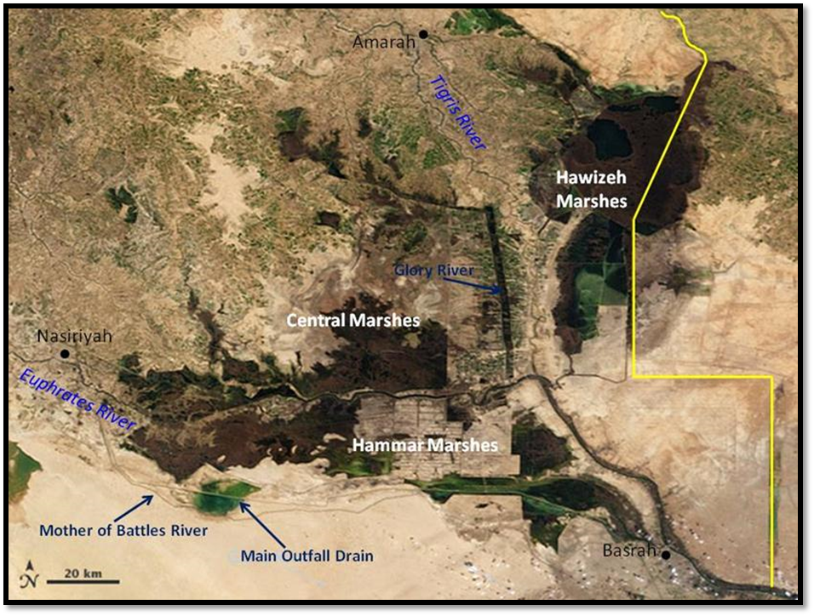
Figure 1. The three monitored southern Iraqi marshes Huwaiza, West Hammar and East Hammar

Results
Data for 2005- 2007 were used to obtain seasonal modes for macroinvertebrates, fishes and aquatic birds because they represent more stable environment after three years of inundation of the restored marshes.

Non-tidal freshwater marsh (Huwaiza)
During 2005- 2006 period, the highest diversity data for macroinvertebrates (0.84), fishes (1.77) and aquatic birds (2.7). High richness scores for macroinvertebrates (4.0), fishes (2.05) and aquatic birds (4.16). Range of evenness values for macroinvertebrates were between 0.25-0.4 ,fishes 0.61-0.83 and aquatic birds 0.65- 0.77, four cases noticed below the acceptable level score (0.6) for macroinvertebrates (tables, 1).
In 2006-2007 period improved scores noticed, the highest diversity data for macroinvertebrates (1.46), fishes (1.76) and aquatic birds (2.79). High richness scores for macroinvertebrates (3.1), fishes (2.04) and aquatic birds (3.64). Range of evenness values for macroinvertebrates were between 0.4-0.8,for fishes 0.5-0.7 and aquatic birds 0.6- 0.8, only two cases encountered below the acceptable level score (0.6) for macroinvertebrates and fishes (table, 1).
Non-tidal freshwater marsh the highest value for diversity, richness and evenness for macroinvertebrates and fishes were noticed in summer and the lowest in winter, spring and autumn respectively. Aquatic birds exhibited the highest seasonal diversity in summer, richness in autumn and evenness in spring. Lower values were in autumn, summer and summer respectively (table, 2).
Patterns appeared in non-tidal freshwater marsh
(i) Diversity was at highest level for macroinvertebrates, fishes and aquatic birds in summer and the lowest in winter and autumn.
(ii) Richness was high in summer for macroinvertebrates and fishes and aquatic birds in autumn.
(iii) Evenness was high for macroinvertebrates and fishes in summer and aquatic birds in spring.
(iv) Summer experienced the highest scores of ecological indices for macroinvertebrates, fishes and aquatic birds. Lower values were noticed in different seasons (figs 2, 3 and 4).
Non-tidal oligosaline marsh (West Hammar)
In 2005-2006 periods the highest diversity data for macroinvertebrates 0.85, fishes 1.46 and aquatic birds 2.89. High richness scores for macroinvertebrates 5.6, fishes 1.45 and aquatic birds 3.48. Range of evenness values were between 0.2- 0.8 for macroinvertebrates 0.81-0.86 for fishes and 0.83- 0.87 for aquatic birds, three cases recorded below the acceptable level score (0.6) for macroinvertebrates (tables, 1).
In 2006-2007 periods the highest diversity record for macroinvertebrates 1.7, fishes 1.46 and aquatic birds 2.68. High richness scores for macroinvertebrates 3.34, fishes 1.45 and aquatic birds 3.62. Range of evenness values were between 0.6-0.8 for macroinvertebrates,0.5-0.63 for fishes and 0.8 for aquatic birds, only two cases appeared below the acceptable level score 0.6 for fishes (tables, 1).
Seasonal pattern of macroinvertebrates ecological indices were noticed, with highest value for diversity, richness and evenness in summer and lowest one in winter, winter-summer and winter respectively. Fishes were different with highest diversity value in spring, richness in summer and evenness in autumn. Lower values of diversity, richness and evenness for fishes were in winter, winter-summer and winter respectively. Aquatic birds have different modes with high diversity, richness and evenness in winter, autumn and spring respectively. Lower values were in summer, winter and summer (table, 2).
Patterns recorded in non-tidal oligosaline marsh
- No pattern for high diversity scores but lower values for macroinvertebrates and fishes have the same timing in winter.
- Richness for macroinvertebrates and fishes have high scored in summer and lower values in winter-summer period respectively.
- No pattern for high evenness, but lower scores happened in winter for both macroinvertebrates and fishes
- Aquatic birds have different timing for high and low values of the three ecological indices (figs. 5, 6 and 7).
Tidal mesosaline marsh (East Hammar)
In 2005-2006 period the highest diversity data for macroinvertebrates (0.63), fishes (1.72) and aquatic birds (2.48). High richness scores for macroinvertebrates (5.3), fishes (2.07) and aquatic birds (3.13). Range of evenness values were low for macroinvertebrates ,for fishes between 0.09- 0.11 and fishes between 0.65-0.86, and aquatic birds 0.75-0.86. Two cases were recorded below the acceptable level score (0.6) for macroinvertebrates (table, 1).
In 2006-2007 periods the highest diversity data for macroinvertebrates 1.6, fishes 1.71 and aquatic birds 2.43. High richness scores for macroinvertebrates 1.12, Fishes 2.07 and aquatic birds (2.92). Range of evenness values for macroinvertebrates vary between 0.6 and 0.8, for fishes 0.5-0.6 and aquatic birds between 0.6 and 0.8 .Two cases appeared below the acceptable level score (0.6) for fishes (tables, 1).
Seasonal changes of macroinvertebrates ecological indices were noticed with highest value for diversity, richness and evenness were in spring respectively. Lower values in summer, winter-spring and autumn-winter respectively. Fishes got the highest values for diversity, richness and evenness were in summer and lower values noticed in autumn-winter, winter-spring and autumn-winter respectively. Aquatic birds showed highest values for diversity, richness and evenness in spring, autumn and winter, lower values were in autumn, spring and summer respectively (table, 2).
Patterns noticed in tidal mesosaline marsh (East Hammar)
- Tidal action, moderate salinity, migration of marine macroinvertebrates, estuarine fishes and coastal birds made high diversity scores in spring for all three main groups.
- Richness exhibited higher pattern in spring season, for macroinvertebrates and fishes, and aquatic birds in autumn. No lower mode formulated.
- Evenness recorded highest modes in summer and spring-summer for macroinvertebrates and fishes respectively and lower modes in autumn- winter. Aquatic birds high mode in winter and lower one summer, (figs 8, 9 and 10).
(iv) Numbers of high ecological indices scores for macroinvertebrates were six in summer and three in spring .In case of fishes were seven in summer and one in spring and autumn respectively. Aquatic birds recorded three in spring and autumn respectively. Low modes for macroinvertebrates were six in winter and two in spring, summer and autumn respectively. In case of fishes were six in winter and two in spring, summer and autumn respectively. Aquatic birds recorded four in summer, two in winter & autumn and one in spring (tables, 2).
(v) Generally, ecological indices rose for aquatic birds during 2006 and 2007, especially during autumn and winter. The highest richness values were recorded in Huwaiza in comparison with other two type marshes.

Table 1. Ecological indices (diversity, richness and evenness) of macroinvertebrates, fishes and aquatic birds in Huwaiza, West Hammar and East Hammar during 2005- 2007
 | Marshes | Indices | Diversity (0-5) |  |  |  | Richness (0-≥5) |  |  |  | Evenness (0-1)
 | Marshes | groups | Win | Spr | Sum | Aut | Win | Spr | Sum | Aut | Win | Spr | Sum | Aut
-2006-2005 | Non-tidal  Freshwater | Macrinv | 0.54 | 0.7 | 0.84 | 0.53 | 3.6 | 2 | 4 | 2.3 | 0.36 | 0.4 | 0.25 | 0.4
-2006-2005 | Non-tidal  Freshwater | fish | 1.14 | 1.56 | 1.77 | 1.5 | 1.33 | 1.78 | 2.05 | 1.5 | 0.61 | 0.83 | 0.63 | 0.66
-2006-2005 | Non-tidal  Freshwater | birds | 2.14 | 2.39 | 2.7 | 2.64 | 3.54 | 4.08 | 4.16 | 2.03 | 0.65 | 0.73 | 0.77 | 0.68
-2006-2005 | Tidal  mesosaline | Macrinv | 0.63 | 0.42 | nill | nill | 5.3 | 5 | nill | nill | 0.11 | 0.09 | nill | nill
-2006-2005 | Tidal  mesosaline | fish | 1.4 | 1.72 | 1.6 | 1.41 | 1.22 | 2.07 | 2.07 | 1.67 | 0.86 | 0.84 | 0.77 | 0.65
-2006-2005 | Tidal  mesosaline | birds | 1.39 | 2.16 | 2.48 | nill | 2.29 | 2.62 | 3.13 | nill | 0.75 | 0.78 | 0.86 | nill
-2006-2005 | Non-tidal  oligosaline | Macrinv | 0.37 | 0.38 | 0.85 | 0.76 | 5.6 | 4.6 | 3.3 | 5.3 | 0.2 | 0.8 | 0.26 | 0.31
-2006-2005 | Non-tidal  oligosaline | fish | 1.07 | 1.46 | 1.27 | 1.28 | 1.19 | 1.41 | 1.45 | 1.21 | 0.82 | 0.81 | 0.86 | 0.85
-2006-2005 | Non-tidal  oligosaline | birds | 2.36 | 2.43 | 2.53 | 2.89 | 2.86 | 3.32 | 3.48 | 2.42 | 0.86 | 0.85 | 0.83 | 0.87
2006-2007 | Non-tidal  Freshwater | Macrinv | 1.18 | 1.46 | 1.37 | 0.53 | 1.4 | 1.3 | 3.1 | 1.5 | 0.8 | 0.8 | 0.8 | 0.4
2006-2007 | Non-tidal  Freshwater | fish | 1.14 | 1.56 | 1.76 | 1.5 | 1.33 | 1.78 | 2.04 | 1.5 | 0.5 | 0.6 | 0.7 | 0.6
2006-2007 | Non-tidal  Freshwater | birds | 2.6 | 2.75 | 2.79 | 2.29 | 3.64 | 3.5 | 3.12 | 3.49 | 0.6 | 0.8 | 0.6 | 0.6
2006-2007 | Tidal  mesosaline | Macrinv | 1.6 | 1.46 | 1.11 | nill | 1.06 | 1.12 | 1.09 | nill | 0.8 | 0. 7 | 0. 6 | nill
2006-2007 | Tidal  mesosaline | fish | 1.4 | 1.71 | 1.59 | 1.41 | 1.22 | 2.07 | 2.07 | 1.67 | 0.6 | 0.6 | 0.5 | 0.5
2006-2007 | Tidal  mesosaline | birds | 2.43 | 2.37 | 2.25 | 2.07 | 2.92 | 2.78 | 2.51 | 2.32 | 0.8 | 0.8 | 0.7 | 0.6
2006-2007 | Non-tidal  oligosaline | Macrinv | 1.16 | 1 | 1.7 | 1.1 | 0.73 | 1.24 | 3.34 | 1.39 | 0.7 | 0.6 | 0.8 | 0.8
2006-2007 | Non-tidal  oligosaline | fish | 1.07 | 1.46 | 1.27 | 1.28 | 1.21 | 1.41 | 1.45 | 1.19 | 0.5 | 0.6 | 0.5 | 0.63
 | Non-tidal  oligosaline | birds | 2.68 | 2.5 | 2.47 | 2.63 | 3.34 | 3.41 | 3.13 | 3.62 | 0.8 | 0.8 | 0.8 | 0.8

Table 2. High and low modes of ecological indices of macroinvertebrates, fishes and aquatic birds in three types of Iraqi marshes (Non-tidal Freshwater, Non-tidal oligosaline and Tidal mesosaline), Wi= winter, Sp= Spring, Su= Summer and Au= Autumn

Marsh  type | Season  mode  average  Ecological  indices | Macroinvertebrates |  | Fishes |  | Aquatic birds
Marsh  type | Season  mode  average  Ecological  indices | High | Low | High | Low | High | Low
Non-tidal  Freshwater | Diversity | Su | Wi | Su | Wi | Su | Au
Non-tidal  Freshwater | Richness | Su | Sp | Su | Sp | Au | Su
Non-tidal  Freshwater | Evenness | Su | Au | Su | Au | Sp | Su
Non-tidal  oligosaline | Diversity | Su | Wi | Sp | Wi | Wi | Su
Non-tidal  oligosaline | Richness | Su | Wi- Su | Su | Wi- Su | Au | Wi
Non-tidal  oligosaline | Evenness | Su | Wi | Au | Wi | Sp | Su
Tidal  mesosaline | Diversity | Sp | Su | Sp | Au-Wi | Sp | Au
Tidal  mesosaline | Richness | Sp | Wi- Sp | Su | Wi- Sp | Au | Sp
Tidal  mesosaline | Evenness | Sp | Au-Wi | Su | Au-Wi | Wi | Su

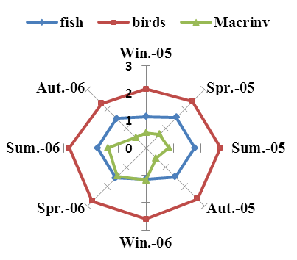
Figure 2. Seasonal variations in values of diversity index in Huwaiza Marsh.
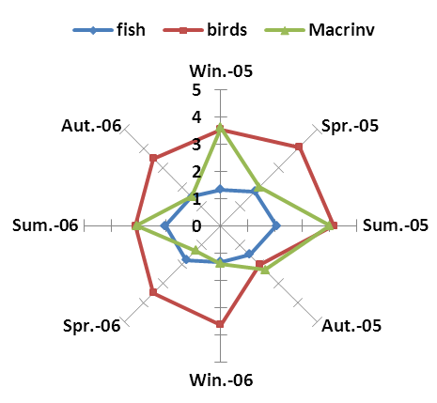
Figure 3. Seasonal variations in values of richness index in Huwaiza Marsh.
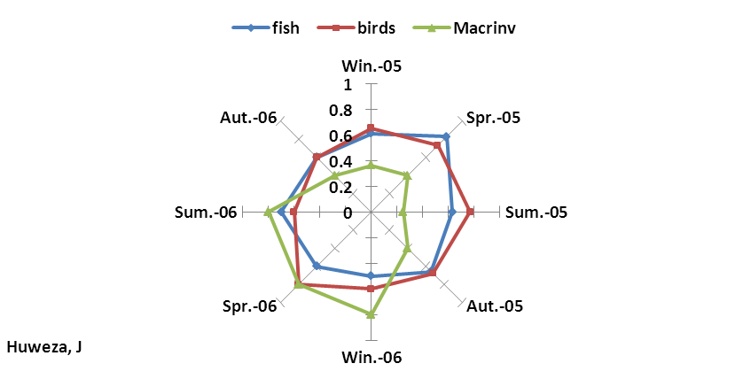
Figure 4. Seasonal variations in values of evenness index in Huwaiza Marsh.
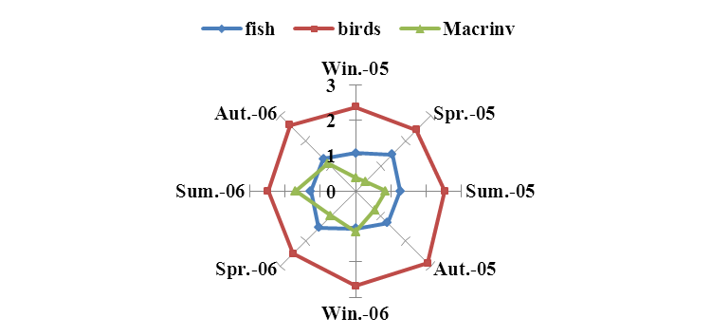
Fig. 5. Seasonal variations in values of diversity index in W-Hammar Marsh.
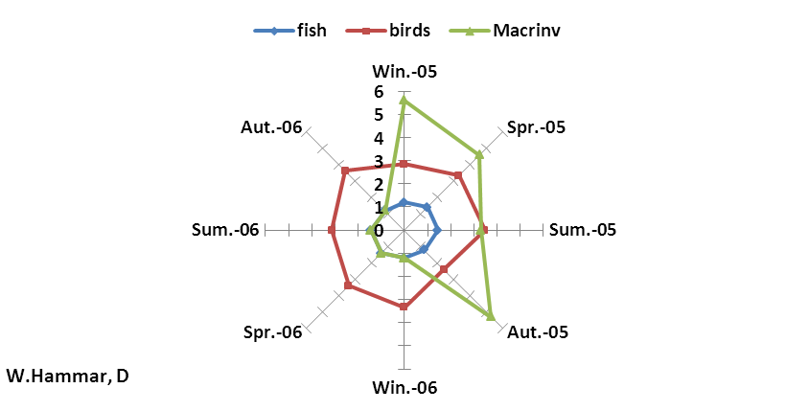
Fig. 6. Seasonal variations in values of richness index in W-Hammar Marsh.
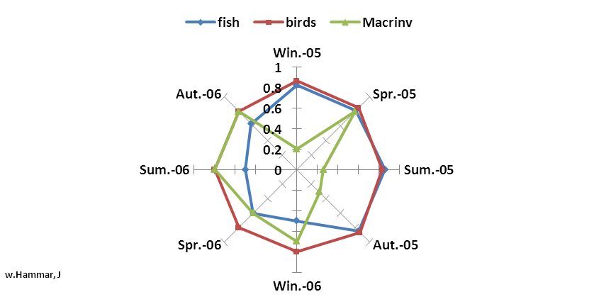
Figure 7. Seasonal variations in values of evenness index in W-Hammar Marsh.

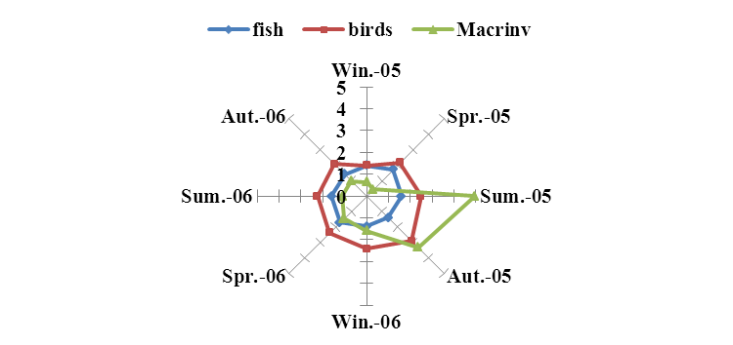
Figure 8. Seasonal variations in values of diversity index in E-Hammar Marsh.
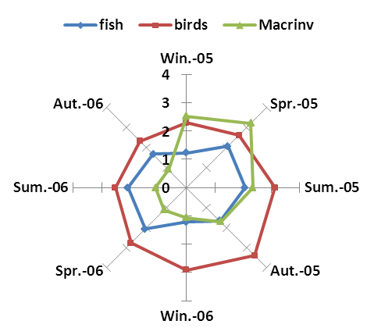
Figure 9. Seasonal variations in values of richness index in E-Hammar Marsh.
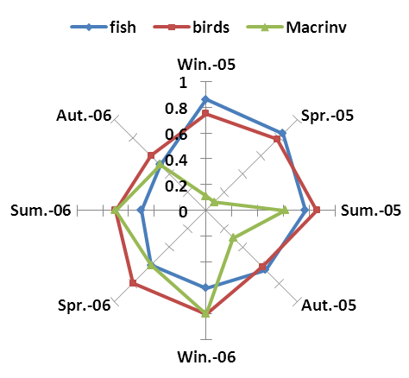
Figure 10. Seasonal variations in values of evenness index in E-Hammar Marsh.

General discussion
Abiotic and biotic factors play the major roles in determining the pattern of changes of ecological indices in southern marshes. The rise of water level in spring and early summer brought nutrient necessary for spring phytoplankton blooms [32] coincide with peaks of zooplankton [33], then followed by congregation of freshwater fishes for spawning season [34]. These ecological events increase diversity, richness and somehow the evenness in spring –summer period. Increase in detritus in summer after spring bloom resulted in flourishing of macroinvertebrates which expressed in shape increase of diversity and richness. Availability of food resource in spring–early summer raises the diversity and richness of fishes [17, 18]. In summer productivity collapse resulted in decline of diversity and richness but increase of evenness as result of recruits of young of the year. During spring– summer period another events happen in tidal mesosaline marsh the migrations of marine fishes and shrimps resulted in increase of diversity and richness of fishes and macroinvertebrates. In late autumn the southern marshes experience the migration of ducks and coastal birds to the marshes which play a major role in rising of diversity and richness. Late spring these migratory birds will return back to their original habitats leading to decrease in ecological indices [15]. These ecological events match well with [9] and [10] postulation that species diversity effect largely by functional diversity.
In general the patterns of seasonal changes of diversity were different according to the prevailing environment of the specific type of the marsh, since they are different in type [31]. Applying Beta diversity index showed a certain degree of species dissimilarity existed between types of southern marshes [35].
It seems that 2006 have better ecological indices records in comparison with 2005 and 2007. Ecological indices in 2006 got higher score values in comparison with 2005 could due to high water impulse to the southern marshes (it was consider as wet year), which led to boost the primary production of aquatic plants and algae; Again the decline in 2007 could be explain by low water discharge since it consider as dry year [31]. Macroinvertebrates in 2005 exceed this limit 2.05 in three types of marshes could be due to the low abundance of predators of carnivores fishes and wader birds. Aquatic birds scored better values and reach to 5.7 indicating the return of winter migrating of waterfowls to the marshes as favorite place for rest and feeding.
Evenness values explain the limited distribution of number of individuals on different groups during 2005, 2006 and 2007 period could be due to the shortage of food supply and shrinking shelter of aquatic plants and filaments algae and increase in numbers of predators like fishes and wader birds especially for gastropod, bivalves and shore crabs [12]. Shortage of freshwater supple as in the case of solely occurrence of pygmy cormorant (Phalacrocorax pygmaeus) in Huwaiza marsh, because of freshwater environment in compression with other marshes [15]. Increase of salinity encourage the migration of several marine fish species (like Liza spp, Thryssa spp. Tenualosa ilisha, etc.) to East Hammar marsh [18, 36].
Lower diversity and richness express that the communities of macroinvertebrates and fishes in the three types of southern marshes expressed disturbed community and environment which need more time and favorable hydrological conditions to recover back to its normal status. Aquatic birds ecological indices indicated that their assemblages were well restored and approach integrated status could be due to late autumn-winter migration of waterfowls from cold area [15] and coastal migration of some terns, gulls and herons.
Similar improvement in ecological indices (diversity, richness and evenness) in 2006 were noted also for aquatic plants, phytoplankton and zooplankton in southern marshes in comparison with that of 2005 [21, 13].
The improvement of hydrological situation of the restored marshes led to improve of ecological indices especially those of aquatic birds as demonstrated during 2006-2007 periods [37].
We concluded that seasonal fluctuations have different pattern depend on environmental condition prevailing, the majority of diversity values recorded in southern marshes were less than the middle range (2.5) of scale (0-5) in Huwaiza, west Hammar and east Hammar, except aquatic birds exceed that limit, mainly due to the abundance of migratory waterfowls in autumn-winter. Diversity values of less than 2 were common in freshwater community, because they are confined and limited number of species and didn’t expose to seasonal migration. [8 , 9].

References
[1] D. Dudgeon, A. H. Arthington, M.O. Gessner, Z . Kawabata, D. J. Knowler, C. Leveque, R.J. Naiman, A.-N. Prieur-Richard, D. Soto, M.L. Stiassny, and C.A. Sullivan, "Freshwater biodiversity: Importance, threats, status and conservation challenges" Biol. Rev., 2006,vol. 81, pp. 163‒182.
[2] P.D. Abel, "Water pollution biology" 2nd ed. Taylor & Francis publishing group. 2002, 297pp.
[3] J. Izsák, and L. Papp, "A link between ecological diversity indices and measures of biodiversity" Ecological Modeling, 2000, vol. 130: pp. 151‒156.
[4] W. Matthews, and , E. Marsh-Matthews, "Effects of drought on fish across axes of space, time and ecological complexity" Freshwater Biology, 2003, vol. 48, pp. 1232‒1253,.
[5] E. Maltby, "An environmental and ecological study of the marshlands of Mesopotamia" Draft Consultative Bulletin, Wetland Ecosystems Research Group. University of Exeter. AMAR Appeal Trus, London, 1994.
[6] H. Partow, "The Mesopotamian marshlands: demise of an ecosystem" Early warning and assessment. Division of Early Warning and Assessment, UNEP, Nairobi, 2000.
[7] M. I. Evans, "The ecosystem" In: The Iraqi marshlands: A human and environmental study E. Nicholson, and P. Clark, Eds., Politico’s Publishing, London, 2002, pp: 201‒219.
[8] W. J. Mitsch, and J. G. Gosselink, "Wetlands" 3rd ed. John Wiley, New York, 2000, 920pp.
[9] A. G.van dear Valk, "The biology of freshwater wetlands" Oxford University Press. 2006, 173pp.
[10] C. J. Richardson, P. Reiss, N. A. Hussain, A. J. Alwash, and J. P. Douglas, "The restoration potential of the Mesopotamian marshes of Iraq" Science, 2005, vol. 307, pp. 1307‒1311.
[11] C. J. Richardson, and N. A. Hussain, "Restoring the garden of eden: An ecological assessment of the marshes of Iraq" BioScience, 2006, vol. 56, pp. 477‒489.
[12] N. A. Hussain, "Biotopes of Iraqi marshlands" Dafaf Publishing, Bierut, 2014,420pp.
[13] G. S. Al-Obaidi, "Study of phytoplankton community in Abo Zirig Marsh, Souhtern Iraq" M. Sc. Thesis. Univ. Baghdad. 2006, 116pp. (in Arabic).
[14] A. H. Ali, N. M. Aziz, and H. A. Hamza, "Abundance, occurrence, seasonal changes and species composition of macroinvertebrates in the restored Iraqi southern marshes" Marsh Bulletin, 2007, vol. 2, 80‒95.
[15] M. Q. Habeeb, "Study on the nature of waterfowls assemblages in some marshes of southern Iraq" M. Sc. Thesis. Basrah University. 2008, 117pp. (in Arabic).
[16] A. R. M. Mohamed, N. A. Hussain, S. S. Al-Noor, F. M. Mutlak, I. M. Al-Sudani, A. M. Mojer, and Toman, A. J. "Fish assemblage of restored Al-Hawizeh marsh, Southern Iraq" Ecohydrol. Hydrobiol., 2008, vol. 8, 375‒384.
[17] N. A. Hussain, H. A. Saoud, and E. J. Al-Shami, "Species composition and ecological indices of fishes in the three restored marshes in southern Mesopotamia" Marsh Bulletin, 2008, vol. 3, 17‒31.
[18] N. A. Hussain, A. R. M. Mohamed, S. S. Al-Noor, F. M. Mutlak, I. M. Abed, and B. W. Coad, "Structure and ecological indices of fish assemblages in the recently restored Al-Hammar marsh, southern Iraq "BioRisk, 2009, vol. 3, 173‒186.
[19] K.H., Youns, M.H. Al-Mossawy, and A.A. Jabir, "Composition structure of fish assemblage in Um Alnaaj, Al-Hawaizah marsh, Iraq" J. Basrah Res. (Sciences), 2011, vol. 37, 49‒59. (In Arabic).
[20] F. M. Mutlak, "Stock assessment of some fish species from East Hammar marsh, southern Iraq" Ph. D. Thesis: University of Basrah, Iraq. 2012,193 pp.
[21] D. A. Al-Abbawy, and A. A. Al-Mayah, "Ecological survey of aquatic macrophytes in restored marshes of southern Iraq during 2006 and 2007" Marsh Bulletin, , 2010,vol. 5, 177‒196.
[22] E. A. M. Qazar, "Concentration of some trace elements in the environment and gastropoda in East Hammar marsh" M. Sc. Thesis. Basrah Univ., 2009,121pp.
[23] A. F. Abbas, "Study of relative abundance and biodiversity for terrestrial mammals of East Hammar marsh" M. Sc. Basrah University. 2013, 80pp.
[24] ARDI (Agriculture Reconstruction and Development Program for Marshland Monitoring Iraq)"Final report to USAID" Washington, D. C, 2006.
[25] IMET (Italian Ministry of Environment and Territory), M. Environment, M. Water resources, M. Municipalities and Iraq Foundation "Overview of present conditions and current use of the water in the marshlands area" vol. 1, book 4 (marshlands) 256 pp. New Edan Master Plan for Integrated Water Resources Management, 2006.
[26] IMRP (Iraq Marshlands Restoration Program) "Monitor marsh ecosystem recovery" Final Report, USAID/ Development Alternative Inc. 528 pp, 2006.
[27] C. E. Shanon, W. Wiener, "The mathematical theory of communication" Univ. Illionis. Press Urbane, 1949.
[28] R. Margalef, "Perspectives in ecology. University of Chicago Press. Chicago, 1968,111pp.
[29] E.C. Pielou, "Mathematical ecology" John Wiely, New York. 1977, 385pp.
[30] S.E., Jorgensen, E F.-L. Xu, F. Salas, and J.C. Marques, "Application of Indicators for the Assessment of Ecosystem Health in Handbook of ecological Indicators for Assessment of Ecosystem Health, S. E. Jørgensen, R. Costanza and F.-L. Xu, Eds. CRC Press, 2000 N.W. Corporate Blvd., Boca Raton, Florida, 577 pp, 2005, pp: 5‒65.
[31] N.A. Hussain, A. H. Ali, and L. F. Lazem, "Ecological indices of key biological groups in southern Iraqi marshland during 2005 -2007 "Mesopot. J. Mar. Sci., 2012, vol. 27, 112‒125.
[32] N. S. Hammadi, A. Q. Jasim, and H. M. Al-Sodani, "Occurrence and seasonal variations of phytoplankton in the restored marshes of southern Iraq" Marsh Bulletin, 2007, vol. 2, 96‒109,.
[33] H. M. Al-Sodani, J. M. Abed, S. A. K. Al-Essa, and N. S. Hammadi, "Quantitative and qualitative study on zooplankton in restored southern Iraqi marshes" Marsh Bulletin, 2007, vol. 2, 43‒63.
[34] N. A. Hussain, S. M. Ahmed, and L. F. Lazem, "Occurrence and abundance of fish larvae in the restored Mesopotamian marshlands, Southern Iraq" JKAU: Mar. Sci., 2013, vol. 24, 15‒27.
[35] N. A. Hussain and S. M. Ahmed, "Smilarity and dissimilarity of macroinvertebrates, fishes and aquatic birds compositions in three major marshes of southern Iraq" Marsh bulletin, 2014, vol. 9, 38‒39.
[36] A. CH. Al-Shamary, K. H. Younis, and G. K. Al-Zawar, "Study of fish assemblage in south east Al Hammar marsh North Basrah city–Iraq" Basrah J. Agric. Sci., 2011, 24, 121‒136.
[37] S. E. Bunn, and A. H. Arthington, "Basic principles and ecological consequencs of altered flow regimes for aquatic biodiversity" Environmental management, 2002, vol. 30, 492‒507.

