Assessment of water quality of the Shatt Al-Arab River, using
multivariate statistical technique

Mohammad S. Moyel

Dept.of Marine Environmental Chemistry, Marine Science Centre, University of Basrah, Iraq

E-mail: ms1977bio@yahoo.com

To cite this article:

Moyel, S. Assessment of water quality of theShatt Al-Arab River, using multivariate statistical technique. Mesopotomia Environment Journal, , 2014,Vol. 1, No. 1, pp. 39-46.

Abstract

This paper presents the results of statistical analysis of a set of physico-chemical water quality parameters, monthly collected from December 2012 to November 2013 at the seven different sampling stations spread over the Shatt Al-Arab River. Seventeen parameters were treated using Multivariate statistical technique, such as principal component analysis (PCA) and cluster analysis (CA) were applied for the evaluation and interpretation of a water quality data set for the Shatt Al-Arab River. The results of PCA identified four latent factors, which are responsible for the data structure explaining 78.64% of the total variance of the dataset these factors are: Water mineralization, Seasonal effect of temperature and organic pollution, Nutrients content and water visibility. CA showed four different groups of similarity between the sampling stations reflecting the different physicochemical characteristics features and natural background sources types. This study suggests that PCA and CA techniques are useful tools for identification of important surface water quality monitoring stations and parameters.

Keywords; water quality assessment, multivariate statistical technique, Shatt Al-Arab River, Iraq.

Introduction
Shatt Al-Arab River is one of the most important interior rivers in Iraq, because of its economic and social values. It is the main source of surface water in Basrah governorate. Water of Shatt Al-Arab has been used for various purposes including potable water supply, irrigation, fisheries, navigation, and industrial uses [1]. Moreover, Shatt Al-Arab River is the conjunction link of freshwater from Iraq into the Arabian Gulf. This river has been subjected to several pollution activities, mostly from domestic waste discharge, industrial waste and agricultural and as put this waste directly into the river without any handle them and this waste be loaded mostly pollutants may pose serious health and can adversely affect the use beneficial to the river [2]. Because rivers constitute the main inland water resource for domestic, industrial and irrigation purposes, it is imperative to prevent and control river pollution and to have reliable information on the quality of river water. In view of the spatial and temporal variations in the hydrochemistry of rivers, regular monitoring programs are required for reliable estimates of the water quality [3]. The quality of water is identified by its physical, chemical and biological properties. The particulate problem in case of water quality monitoring is the complexity associated with analysis a large number of measured variables [4].The data sets contain rich information about the behavior of the water body. The classification, modeling and interpretations of monitoring data are the most important steps in the assessment of water quality. The application of different multivariate approaches, such as principal component analysis (PCA) and cluster analysis (CA) for the interpretation of these complex data matrices offers a better understanding of water quality and ecological status of the studied systems. It also allows the identification of possible factores/sources that influence water system and offer a valuable tool for the reliable management of water resources as well as rapid solutions to pollution problems [5, 6]. In the present paper, the data matrix obtained during one year monitoring program at seven different stations spread over the Shatt Al-Arab River, subjected to different multivariate statistical approaches in order to extract information about the similarities or dissimilarities among monitoring stations, and to determine the influence of possible sources (natural and anthropogenic) on the physico-chemical variables of the Shatt Al- Arab River.

Materials and Methods
Study area and sampling sites
The confluence of the Tigris and Euphrates rivers at the town of Qurna, north of Basra city forms the Shatt Al- Arab River, which flows to the south west to the Arabian Gulf. The Shatt Al-Arab River has a length of 200 km, a width range between 400 m at Basra and up to more than 2 km at the estuary and a depth of between 8-15 m, considering tides [7].The hydrological condition of the Shatt Al-Arab River basin is affected by several factors including conditions at the upper reaches of the Tigris and Euphrates rivers, the status of advancing flood tides from the Arabian Gulf, seepage of saline ground water into the basin, as well as the impact of climate conditions prevailing in the region on discharge rates and the payload of the river [8]. The discharge of moderately saline water from the East Hammar marsh and limited precipitation exacerbates water quality and the hydrology of the region [9]. Seven sampling stations were established along the river course in order to obtain a good knowledge to detect spatial similarity for grouping sampling stations located within the monitoring area, and determine the factors or sources responsible for water quality variations in quality of the river (Table1,Fig.1).

Table 1.Sampling locations and coordinates of sampling stations at Shatt Al-Arab River
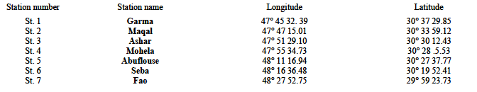

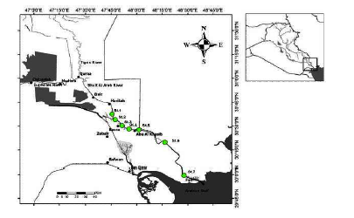

Figure. 1.Map of Shatt Al-Arab River showing the seven sampling stations

Field Sampling and procedures
Monthly water samples were collected from selected seven stations in Shatt Al-Arab River from December 2012 to November 2013. Water samples collected for analysis of nutrient, major ions were filtered using Millipore filter paper (0.45μm) and preserved and analyzed according to the standard methods described in [10]. Water physical and chemical parameters including water temperature (WT), electrical conductivity (EC), salinity and pH were measured insitu using the WTW Multi-meter model 4430. Turbidity was determined insitu by WTW turbidity-meter type Terb 550. Dissolved oxygen (DO) and Biochemical oxygen demand (BOD5) were determined by the Winkler azide method. Alkalinity was determined by acidtitration using methyl-orange as endpoint. Calcium (Ca+2) and magnesium (Mg+2) concentrations were measured by ethylene- ediaminetetra acetic acid (EDTA) complexometricy titration. Sodium (Na+) and potassium (K+)concentrations were measured by flame photometry and chloride (Cl-) concentration by silver nitrate (AgNO3) titration using potassium chromate (K2CrO4) solution as an indicator. Sulphate (SO4⁻²) concentration was determined specrophotometrically by barium sulphate turbidity method. Nitrite nitrogen (NO2-N) was determined according to colorimetric method. Nitrate nitrogen (NO3-N) and orthophosphate phosphorus (PO4-P) concentrations were measured by ultraviolet (UV) and molybdate ascorbic acid methods, respectively. Statistical computations were executed using the statistical software package, XL STAT pro v.4.In this study, each water quality parameter was standardized (z-scale) before PCA and CA analysis was performed in order to minimize the influence of different variables and their respective units of measurements[11].

Results and Discussion
Principal component analysis
It is difficult to draw a clear conclusion directly because the complexity of relationships between parameters of water quality, conclusion directly. However, PCA can explain the structure of the data in detail by extracting the latent information [11].PCA is designed to transform the original variables (parameters in this study) in to new, uncorrelated variables (axes), called the principal components (PCs), which are linear combinations of the original variables [12].In this study, the scree plot was used to identify the number of PCs to be retained in order to comprehend the underlying data structure [3, 5]. According to eigenvalue-onecriterion[13], only four PCs (with eigen value >1) were considered which explaining 78.64% of the total variance in the water quality datasets, the rest PCs were eliminated (Table 2; Fig. 3, 4). In order to make easier interpretation for the PCA results, the first four PCs were rotated according to varimax method with Kaiser Normalization[14]. Results of the PCs from the Varimax rotations are displayed in Table 2 and Fig. 3, 4. The first rotated component (PC1) which explains 32.80% of total variance in the datasets and has strong positive loading on EC, salinity, Cl-, Mg+2, K+, SO4 -2 and Na+, respectively, whereas, it has moderate positive loading on Ca+2 (Table 2) (Table 2; Fig. 3).This component can be related to mineral component of the river water. The parameters on this component indicate fluctuation and reduction in water flow and increase in soluble salts from Arabian Gulf [2, 15]. The PC2 explained 21.41% of total variance in datasets and consists of a strong positive loading of WT, alkalinity and BOD5, while strong and moderate negative loading with DO and pH respectively (Table 2). This component was mainly associated with the seasonal effect of temperature and anthropogenic pollution sources and can be explained that high levels of dissolved organic matters consume large amounts of oxygen, which results in formation of ammonia, CO2 and organic acids leading to a decrease in water pH values (Volga et al., 1998; Shrestha and Kazama, 2007). The PC3explained 14.85% of the total variance and was positively and largely contributed by inorganic nutrients-related parameters (NO3-N, NO2-N andPO4-P) (Table 2; Fig. 4).This component distinguishes the importance of anthropogenic inputs mainly from non-point pollution sources(such as agricultural runoff and atmospheric deposition) [6], and point pollution sources (such as domestic and industrial wastewater effluents) [16].According to [17], high levels of both dissolved inorganic nitrogen and phosphorus in Shatt Al-Arab water ,resulted from both point and non-point pollution sources. PC4explains 9.57% of total variance has strong positive loading on turbidity. This component can be attributed to the water visibility. In summary, four extracted factors (PCs) representing four different processes responsible for water quality variations in Shatt Al-Arab River are: (1) Water mineralization, (2) Seasonal effect of temperature and organic pollution, (3) Nutrients content, and (4) water visibility.
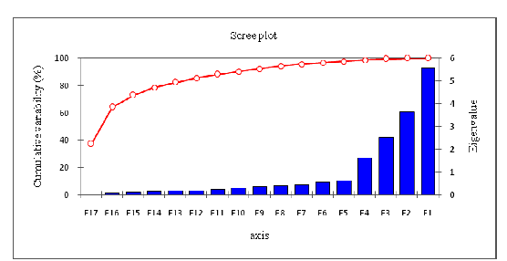
Figure 2.Scree plot of the eigen values.

Table 2. The principal components After Varimax Rotation
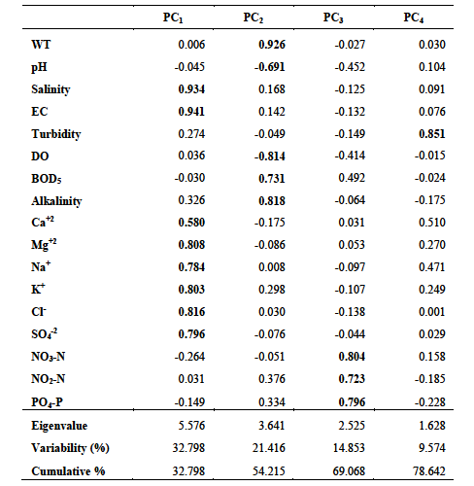

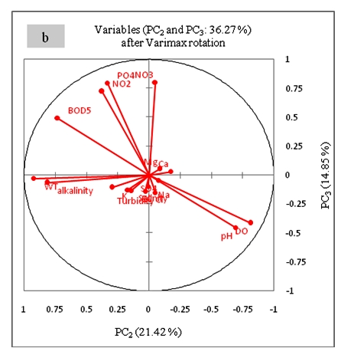
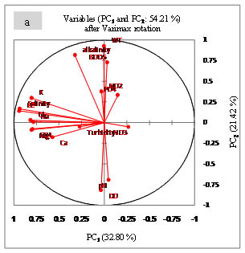
Figure 3.Component loadings for the (a) with PC1 and PC2, and (b) with PC2 and PC3 after varimax rotation
Spatial similarity and sample station grouping using cluster analysis
The purpose of cluster analysis is to identify groups or clusters of similar stations on the basis of similarities within a class and dissimilarities between different classes [18].Hierarchical agglomerative clustering is the most common approach, which provides instinctive similarity relationships between any one sample and the entire dataset, is typically illustrated by a dendrogram (tree diagram)[19]. The dendrogram presents a picture of the groups and their proximity to one another, with a dramatic reduction in the dimensionality of the original data [20].To detect spatial similarity among groups, CA was applied to the seven sampling stations. Hierarchical agglomerative CA was performed on the normalized data set by means of the Ward’s method, using Euclidean distances as a measure of similarity. The clustering procedure generated four groups of stations in a convincing way, indicating relatively high indepen-dency for each group (Fig. 4). In the other word, the stations in these groups have similar characteristic features and natural background sources types. Cluster 1 (X1) consisted St.1and St.2, which were located at the upper reach of the river, were population density is considerably moderate and it's characterized by a large number of orchards and farmland especially on the left bank. The common feature of these stations was well oxygenated and lower soluble salts content compared to the other stations (Fig. 5). Cluster 2 (X2) consisted St. 3 and St. 4,which were located at the middle part of the Shatt Al-Arab River, where impacted by heavily populated areas of Basra City and it is likely that high values of BOD₅ and nutrient concentrations, as well as, depletion in pH and DO concentration in these stations indicate water pollution resulting from, sewage effluents discharged from Basrah city, as well as industrial and agricultural activities (Fig. 5). The cluster 3 (X3), including St.5 and St.6 which located at the river downstream. The common feature of these stations wasrelatively higher turbidity, Na, Cl and SO₄compared to other stations in clusters 1 and 2 (Fig. 5). The cluster 4 (X4), consisted St.7,which were located close the mouth of the Arabian Gulf, and it is negatively affected by the high level of salty water intrusion from the Arabian Gulf (Fig. 5).The common feature of this station was high salinity, EC, major ions, alkalinity concentrations and turbidity, whereas, it was low nutrient content compared to the other stations (Fig. 5).
In summary, hierarchical CA helped to group the seven sampling stations into four clusters of similar characteristics reflecting the different water quality characteristics and pollution (natural and anthropogenic) sources. It is evident that the CA technique is useful in offering reliable classification of surface waters throughout a whole region, and will make it possible to accurately perform spatial assessment in an optimal manner. Thus, it could be employed to design a future spatial sampling strategy in an optimal manner by reducing the number of sampling stations without losing any significance of the outcome.
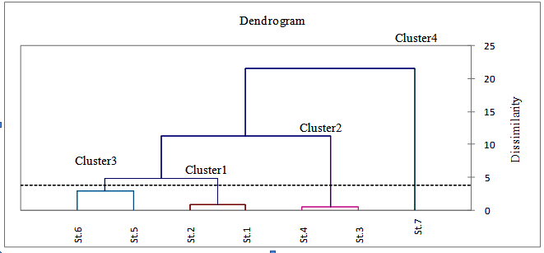

Figure 4.Dendrogram obtained by agglomerative hierarchal clustering analysis for sampling stations

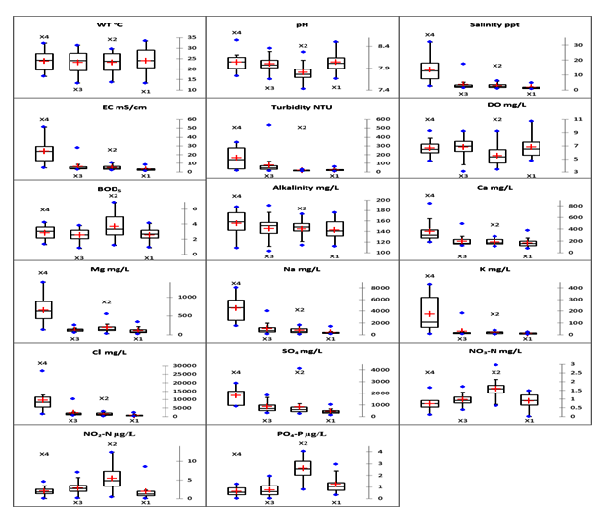
Figure 5. Box plots represent spatial variation of the water quality parameters between clusters in Shatt Al- Arab River

References
[1] N.A.Hussain, H. H. Al-Najar, H. T. Al-Saad, U. H. Yousif, and A. A. Al- Saboonchi, " Shatt Al-Arab basic scientific studies," Marine Science Centre Publ. Basra Univ, pp. 391, 1991.
[2] M.S. Moyel, "Water quality assessment of the northern part of Shatt Al Arab River, using water quality index (Canadian version)," Unpublished M.Sc. Thesis, Science College, Basra Univ., pp.100, 2010.
[3] K.P. Singh, A. Malik, D. Mohan, and S.Sinha, "Multivariate statistical techniques for the evaluation of spatial and temporal variations in water quality of Gomti River (India) – A case study, "Water Research, vol. 38, pp. 3980-3992, 2004.
[4] C.A.Almedia, S.Quintar, P.Gonzalez, and M. A. Mallea,"Influence of urbanization and tourist activities on the water quality of the Potrero de los Funes River (San Luis-Argentina)," Environ. Monit. Assess, vol. 133, pp. 459-465, 2007.
[5] M. Vega, R. Pardo, E. Barrado, and L. Deban,"Assessment of seasonal and polluting effects on the quality of river water by exploratory data analysis," Water Research, vol. 32, pp. 3581-3592.1998.
[6]V. Simeonov, J.A. Stratis, C. Samara, G. Zachariadis, D. Voutsa, A.Anthemidis, M. Sofonioub, Th.Kouimtzis,"Assessment of the surface water quality in Northern Greece, "Water Research, vol. 37, pp. 4119-4124, 2003.
[7] S.S. Abdulla, "An investigation to river load of Shatt Al-Arab in Basrah," Unpublished M.Sc. Thesis, Marine Science Centre, Basrah Univ., pp.98,1990.
[8] H.K. Al-Mahmood, "The monthly variations of discharge and effect that on a total dissolve suspended and salinity in Shatt Al-Arab River (South of Iraq)," Iraqi Journal of science, vol.50 (3), pp. 355-368, 2009.
[9] M.S. Moyel, andN. A. Hussain, "Water Quality Assessment of the Shatt Al Arab River, southern Iraq," In press.
[10] APHA (American Public Health Association) "Standard method for the examination of water and wastewater – 21th edition," Washington, D. C., pp. 1193, 2005.
[11] X. Fan,B.Cui, H. Zhao, Z. Zhang, and H. Zhang, "Assessment of river water quality in Pearl River Delta using multivariate statistical techniques," Procedia Environmental Sciences, vol. 2, pp. 1220-1234,2010.

[12] S. Shrestha, and F.Kazama, "Assessment of surface water quality using multivariate statistical techniques: A case study of the Fuji river basin, Japan," Environmental Modelling and Software, vol. 22, pp. 464-475, 2007.
[13] T.Kowalkowski, R. Zbytniewski, J. Szpejna, and B. Buszewski, "Application chemometrics in river water classification," Water Research, vol. 40, pp. 744-752, 2006.
[14]H.F.Kaiser, "The Varimax criterion for analytic rotation in factor analysis," Psychometrika, vol. 23, pp. 187-200, 1958.
[15] J.H.A. Al Maliky, "Analysis of water quality and the impact of the salt wedge from the Arabian Gulf on the Shatt Al-Arab River," Iraq. MSc. Thesis, Queensland Univ,pp.81, 2012.
[16] J.A. Camargo, and A.Alonso "Ecological and toxicological effects of inorganic nitrogen pollution in aquatic ecosystem: A global assessment," EnvironmentInternational, vol. 32, pp. 831-849, 2006.
[17] A.H. Hameed and Y. H.Aljorany, "Investigation on Nutrient Behavior along Shatt Al-Arab River, Basra, Iraq," Journal of Applied Sciences Research, vol. 7(8), pp. 1340-1345, 2011.
[18] O.O. Omo-Irabor, S.B. Olobaniyi, K.Oduyemi, and J. Akunna "Surface and groundwater water quality assessment using multivariate analytical methods: A case study of the Western Niger Delta. Nigeria," Physics and Chemistry of the Earth, vol. 33, 666-673, 2008.

[19] Y. Zhao, X.H. Xia, Z.F. Yang, and F.Wang, "Assessment of water quality in Baiyangdian Lake usingmultivariate statistical techniques,"Procedia Enviro-nmental Sciences, vol. 13, pp. 1213-1226, 2012.

[20] T.G. Kazi, M.B. Arain, M.K. Jamali, I.N. Jalban, H.I. Afridi, R.A. Sarfraz, J.A. Baiga, Q.Shaha,Abdul "Assessment of water qualityof polluted lake using multivariate statistical techniques: A case study," Ecotox. Environ.Safe,vol. 72 (20), pp. 301-309, 2009.

