Synthesis of Novel N-Phenyl Maleimidyl and Citraconimidyl Esters and Their Applications as Plasticizers for Poly(Vinyl Chloride)

Ahlam Marouf Al-Azzawi and Mohamad Shamil Ali
Department of Chemistry, College of Science, University of Baghdad
Jadiriya, Baghdad-Iraq

(NJC)

(Received on 12/4/2006) (Accepted for publication on 18/2/2007)

Abstract
Several N-(hydroxy phenyl)maleamic and citraconamic acids were prepared in high yields (90-94)% from the reaction of maleic and citraconic anhydride respectively with ortho, meta and p-aminophenols.
Dehydration of the prepared amic acids by fusion technique gave the corresponding N-(hydroxy phenyl)maleimides and citraconimides in good yields (75-85)%.
The prepared imides were esterified to the corresponding benzoate, methacrylate and cinnamate esters in good yields (72-92)%.
Esterification was achieved by reaction of the prepared imides with benzoyl chloride, methacryloyl chloride and cinnamoyl chloride respectively in the presence of triethylamine. The prepared new esters were tested as plasticizers for poly(vinyl chloride) PVC.
Seventy two samples were prepared by mixing and grinding PVC with the prepared esters in certain ratio and their softening points were recorded.
The results showed that addition of the prepared esters to PVC caused a clear depression in softening point and this depression was due to the ability of the prepared esters to form secondary molecular forces with the polymeric chains which inturn reduced the interchain forces between the polymeric chains themselves and this reduced softening point.
Comparison the results with dioctyl phthalate (DOP) and dibutyl phthalate (DBP) the universal plasticizers for PVC indicated that the prepared esters in general had better plasticizing efficiency than both DOP and DBP.

الخلاصة
يهدف البحث الى تحضير استرات جديدة ودراسة امكانيتها على تلدين بولي (كلوريد الفاينيل) PVC ولغرض تحقيق هذا الهدف تطلب الامر انجاز عدة خطوات.
حيث تضمنت الخطوة الاولى تحضير عدد من حوامض N-(هيدروكسي فنيل) مالي اميك وستراكون اميك بمحصلة تراوحت (90-94)% وذلك من تفاعل مركبات اورثو، ميتا وبارا امينوفينول مع انهيدريد الماليك والستراكونيك على التوالي.
في الخطوة الثانية تم سحب الماء والغلق الحلقي لحوامض المالي اميك والستراكون اميك المحضرة باتباع تقنية الصهر وبذلك تم تحويلها الى مركبات N-(هيدروكسي فنيل) مالي ايمايدات وستراكون ايمايدات المقابلة بمحصلة تراوحت (75-85)%.
اما في الخطوة الثالثة فقد تم تحويل المالي ايمايدات والستراكون ايمايدات المحضرة الى استرات بنزوات، ميث اكريلات وسينامات N-فنيل مالي ايمايديل وستراكون ايمايديل المقابلة بمنتوج قدرة (72-92)% وذلك من خلال معاملتها مع كلوريد البنزويل، كلوريد الميث اكريلويل وكلوريد السينامويل بوجود ثلاثي اثيل امين.
تم اختبار قابلية الاسترات المحضرة على تلدين بولي (كلوريد الفاينيل) حيث تم تحضير اثنان وسبعون نموذج بمزج وطحن PVC مع الاسترات المحضرة وفق نسب وزنية محددة ثم تم تعيين درجات التلين لجميع هذه النماذج.
لقد اظهرت النتائج بان اضافة الاسترات المحضرة الى PVC تحدث انخفاضاً واضحاً في درجة التلين للبوليمر ويزداد هذا الانخفاض مع زيادة تركيز الملدن (الاستر) في النموذج.
ان هذا الانخفاض في درجات التلين ناتج عن فعالية الاسترات المحضرة وقابليتها على تكوين قوى جزيئية ثانوية بينها وبين السلاسل البوليمرية مما يضعف القوى البينية الموجودة اصلاً بين السلاسل البوليمرية نفسها وهذا بدوره يسبب انخفاضاً في درجات التلين. اما لغرض معرفة مدى كفاءة التلدين للاسترات المحضرة فقد تمت مقارنة النتائج المستحصلة مع النتائج في حالة استخدام اثنين من الملدنات المعروفة لبولي (كلوريد الفاينيل) وهما (DOP) و (DBP) حيث اظهرت نتائج المقارنة بين درجات التلين لنماذج PVC الملدنة بالاسترات المحضرة وتلك العائدة لنماذج PVC الملدنة بالملدنات المعروفة بان الاسترات المحضرة جميعها ذات كفاءة عالية في تلدين PVC.

Introduction
Interest in plasticizers field have been stimulated during world war II especially when plasticized poly(vinyl chloride) PVC was used as a replacement for rubber in a wide variety of applications⁽¹⁻³⁾.
Since that time plasticizers field had received much attention and many extensive researches have been reported on the synthesis and applications of new plasticizers for PVC plastic⁽⁴⁻⁷⁾.
Plasticized compositions in 1989 represent more than (95%) of the total usage of PVC polymer and PVC applications consume approximately more than (80%) of total plasticizers production⁽⁷⁾.
In the present work a number of new esters were prepared and tested as plasticizers for PVC. Since many high molecular weight esters are reported^{(8,9)} as good plasticizers for PVC plastic.
In the persent paper eighteen N-phenyl maleimidyl and citraconimidyl esters were prepared from the corresponding N-(hydroxy phenyl)maleimides and citraconimides.
The new esters were tested as plasticizers for PVC plastic and all of them showed good plasticizing efficiency.

Experimental
Materials
Chemical materials which used in this work includes : citraconic and maleic anhydrides, aminophenols, acid chlorides including (methacryloyl, acryloyl, benzoyl and cinnamoyl) chlorides, triethylamine and PVC (molecular weight = 10000 and softening point = 212°C).
Instruments
Melting points were determined on Gallen Kamp capillary melting point apparatus and were uncorrected. IR spectra were recorded on Shimadzu FTIR-8300 Fourier Transform and Jasko Infrared Spectrophotometers. C.H.N. analysis were determined by Perkin-Elmer 240 elemental analyzer. Softening points were determined on Thermal Microscope Reichert Thermovar, SP1, 160.

1- Preparation of N-(Hydroxy phenyl) Maleamic and Citraconamic Acids
Amic acids were prepared according to literatures^{(10,11)} by reaction of equimolar amounts of amino phenols and maleic or citraconic anhydride using acetone as a solvent. The prepared amic acids were purified by recrystallization from ethanol.
Melting points, percent yields and major IR absorptions of the prepared amic acids are listed in Table (I).

2- Preparation of N-(Hydroxy phenyl) Maleimides and Citraconimides
Literature procedures⁽¹²⁾ were followed in these preparations with a few modifications.
(0.01 mole) of N-(hydroxy phenyl) maleamic or citraconamic acid was heated in an oil bath to (10)°C above its melting point for a period of (40-45) min. The resulted product was purified by recrystallization from cyclohexane.
Table (II) lists melting points, percent yields and major IR absorptions of the prepared imides.

3- Preparation of N-Phenyl Maleimidyl and Citraconimidyl Benzoates
Literature procedures were followed in these syntheses with minor modifications^{(13,14)}.
To a stirred mixture of (0.01 mole) of N-(hydroxy phenyl) maleimide or citraconimide in (40 ml) of dry acetone, (0.01 mole) of triethylamine was added followed by dropwise addition of (0.01 mole) of benzoyl chloride with cooling then stirring was continued for another (6 hrs) before filtration.
The filtrate was evaporated under reduced pressure then the residue was extracted with water and chloroform and the separated organic layer was dried with anhydrous magnesium sulphate.
After removing of the solvent under reduced pressure the obtained oil product was purified by recrystallization from petroleum ether (60-80)°C.
Table (III) lists melting points, percent yields and major IR absorptions of the prepared benzoates.

4- Preparation of N-Phenyl Maleimidyl and Citraconimidyl Methacrylates
The same procedure used in the preparation of benzoates^{(13,14)} was followed in the preparation of the titled compounds except using of methacryloyl chloride instead of benzoyl chloride. The prepared methacrylate esters were purified by recrystalliztion from cyclohexane or petroleum ether.
Percent yields, melting points and major IR absorptions of the prepared methacrylates are listed in Table (IV).

5- Preparation of N-Phenyl Maleimidyl and Citraconimidyl Cinnamates
The same procedure used in the preparation of benzoates^{(13,14)} was followed in the preparation of the titled compounds except the using of cinnamoyl chloride instead of benzoyl chloride. Purification of the prepared cinnamates was achieved by recrystallization from cyclohexane.
Table (V) lists melting points, percent yields and major IR absorptions of the prepared cinnamates.

6- Testing of the Prepared Esters as Plasticizers for PVC
Four samples for each ester were prepared by mixing and grinding a constant weight (1gm) of poly(vinyl chloride) PVC with four different weights of the prepared ester (plasticizer) (0.1, 0.2, 0.3 and 0.4 gm) respectively.
Softening points for all the prepared seventy two samples were recorded on (Thermal Microscope) apparatus using slides prepared from the plasticized samples.
In the same manner another eight samples were prepared by using dioctylphthalate (DOP) in four of them and dibutyl phthalate (DBP) in the others as plasticizers.
Softening points of the later eight samples were also determined and the results were used for comparison. All the results and details of this study are listed in Table (VII).

Results and Discussion
Many esters are reported to have high efficiency in plasticization of PVC plastic to modify the polymer to desired physical and mechanical properties^{(15,16)} so the target of this work is to synthesize new esters and testing their ability for plasticization of PVC.
The first step in this work includes preparation of six N-(hydroxy phenyl) amic acids from reaction of o, m and p-aminophenols with maleic and citraconic anhydrides respectively.
Fusion of the prepared amic acids is performed in the second step of this work to produce the corresponding N-(hydroxy phenyl) maleimides and citraconimides.
It is necessary to mention here that fusion technique is used in this step instead of using dehydrating agents since fusion is the only method to perform dehydration and cyclization producing imides with keeping hydroxyl groups untouched and this inturn will make possible to perform esterification reaction in the third step of this work, while using of dehydrating agents will esterify hydroxyl groups.
Remaining of phenolic hydroxyl groups in the prepared imides is confirmed through the presence of (O-H) absorption band in IR spectra of the prepared imides as a clear band at (3410-3350) cm⁻¹.
The third step of this work includes esterification of the prepared imides to the corresponding methacrylates, benzoates and cinnamates.
Thus eighteen novel esters are prepared by the reaction of the prepared imides with methacryloyl, benzoyl and cinnamoyl chlorides in the presence of triethylamine. The absence (O-H) absorption band in IR spectra of the prepared esters is a clear evidence for the success of esterification reaction. IR spectra for some of the prepared compounds are shown in Figures (1-6).
Tables I, II, III, IV and V list melting points, percent yields and major IR absorptions of the prepared compounds while Table VI lists C.H.N. analysis for some of these compounds.
Finally the prepared new esters were tested as plasticizers for PVC plastic.
Thus seventy two samples were prepared and their softening points were recorded.
The results showed that the prepared esters caused a clear depression in PVC softening point and the depression increased with increasing of plasticizer concentration.
In general plasticized polymers showed lower softening points⁽¹⁷⁾ since plasticizers contribute to a greater reduction in polar forces between polymer chains due to the formation of secondary molecular forces between plasticizer molecules and polymeric chains and as a result the accumulation of intermolecular forces a long the polymer chains themselves will decrease⁽¹⁸⁾. This reduction of interchain forces is companioned with loss of crystalline regions which inturn lead to reduce softening points, modulus and tensile strength since these properties are influenced by degree of crystallinity.
Plasticization efficiency of the new esters were tested by comparison the results with both (DOP) and (DBP) the universal plasticizers for PVC.
The results showed that all the prepared esters in general have better plasticization efficiency than both (DOP) and (DBP). All the details of this study are listed in table (VII) while softening curves of the prepared esters are shown in figures (7), (8) and (9).

Table (I) Percent yields, Melting points and Major IR absorptions of the prepared Amic Acids
Comp. No. | Compound structure | Yield% | Melting point °C | Major IR absorptions, cm⁻¹
 |  |  |  | νO-H | νN-H | νC=O carboxylic | νC=O  amide
1A |  | 93 | 152-153 | 3325 | 3240 | 1710 | 1650
2A |  | 94 | 147-148 | 3361 | 3226 | 1701 | 1629
3A |  | 90 | 139-140 | 3375 | 3340 | 1705 | 1630
4A |  | 91 | 193-195 | 3300 | 3172 | 1697 | 1618
5A |  | 94 | 178-180 | 3336 | 3161 | 1701 | 1616
6A |  | 92 | 174-176 | 3394 | 3163 | 1697 | 1616

Table (II) Melting points, Percent yields and Major IR absorptions of the prepared Imides
Comp. No. | Compound structure | Yield% | Melting point °C | Major IR absorptions, cm⁻¹
 |  |  |  | νO-H  phenolic | νC=O  Imide | νC=C | νC-N
1B |  | 85 | 166-168 | 3375 | 1690 | 1635 | 1400
2B |  | 81 | 157-159 | 3380 | 1700 | 1640 | 1350
3B |  | 80 | 149-150 | 3410 | 1710 | 1640 | 1350
4B |  | 78 | 208-210 | 3400 | 1702 | 1610 | 1400
5B |  | 75 | 216-217 | 3350 | 1708 | 1620 | 1390
6B |  | 81 | 222-225 | 3360 | 1700 | 1640 | 1400

Table (III) Melting points, Percent yields and Major IR absorptions of the prepared Benzoate Esters

Comp. No. | Compound structure | Yield% | Melting point °C | Major IR absorptions, cm⁻¹
 |  |  |  | νC=O  Ester | νC=O  Imide | νC-O  Ester
1C |  | 80 | 75-78 | 1775 | 1716 | 1200  1155
2C |  | 84 | 98-100 | 1786 | 1718 | 1213  1165
3C |  | 76 | Oil | 1773 | 1720 | 1195  1130
4C |  | 81 | 104-106 | 1785 | 1718 | 1213  1172
5C |  | 87 | 95-96 | 1785 | 1705 | 1215  1170
6C |  | 90 | 81-84 | 1780 | 1720 | 1215  1173

Table (IV) Melting points, Percent yields and Major IR absorptions of the prepared Methacrylate Esters
Comp. No. | Compound structure | Yield% | Melting point °C | Major IR absorptions, cm⁻¹
 |  |  |  | νC=O  Ester | νC=O  Imide | νC-O  Ester | νC=C
1D |  | 88 | 118-119 | 1770  1750 | 1710 | 1210  1190 | 1640
2D |  | 81 | 99-101 | 1770  1760 | 1710 | 1225  1180 | 1640
3D |  | 72 | 93-94 | 1775  1750 | 1720 | 1220  1190 | 1645
4D |  | 86 | Oil | 1760 | 1705 | 1200  1160 | 1625
5D |  | 92 | 108-109 | 1768 | 1718 | 1219  1149 | 1640
6D |  | 84 | Oil | 1770 | 1720 | 1217  1176 | 1640

Table (V) Melting points, Percent yields and Major IR absorptions of the prepared Cinnamate Esters
Comp. No. | Compound structure | Yield% | Melting point °C | Major IR absorptions, cm⁻¹
 |  |  |  | νC=O  Ester | νC=O  Imide | νC-O  Ester | νC=C
1E |  | 84 | 62-64 | 1770 | 1715 | 1220  1150 | 1645
2E |  | 79 | Oil | 1775 | 1720 | 1230  1160 | 1655
3E |  | 75 | 84-85 | 1760 | 1710 | 1200  1140 | 1620
4E |  | 85 | 88-90 | 1775 | 1710 | 1200  1130 | 1635
5E |  | 82 | 116-117 | 1770 | 1710 | 1213  1145 | 1643
6E |  | 72 | Oil | 1770 | 1720 | 1200  1135 | 1635

Table (VI) C.H.N. Analysis of the prepared compounds

Comp. No. | Calculated |  |  | Found
Comp. No. | %C | %H | %N | %C | %H | %N
1B | 65.02 | 4.43 | 6.89 | 65.11 | 4.40 | 6.87
2B | 65.02 | 4.43 | 6.89 | 64.96 | 4.37 | 6.93
5B | 63.49 | 3.70 | 7.41 | 63.20 | 3.70 | 7.70
2C | 70.35 | 4.23 | 4.56 | 70.15 | 4.17 | 4.40
4C | 69.62 | 3.75 | 4.77 | 69.84 | 3.93 | 4.69
1D | 66.42 | 4.79 | 5.16 | 66.64 | 4.85 | 5.32
5D | 65.36 | 4.28 | 5.44 | 65.51 | 4.46 | 5.67
3E | 72.07 | 4.50 | 4.20 | 71.83 | 4.21 | 3.95
5E | 71.47 | 4.07 | 4.38 | 71.21 | 3.84 | 4.22

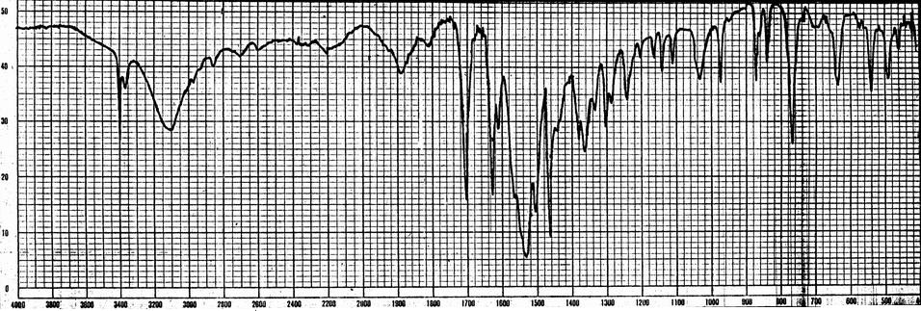
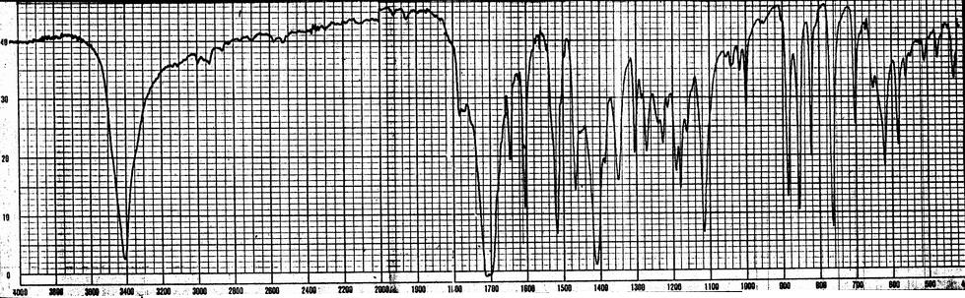
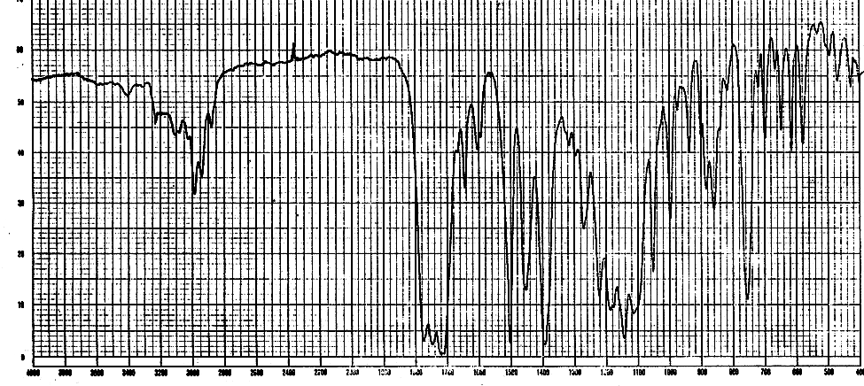
Fig.(1) IR Spectrum of compound (3A)
Fig.(2) IR Spectrum of compound (3B)

Fig.(3) IR Spectrum of compound (3D)

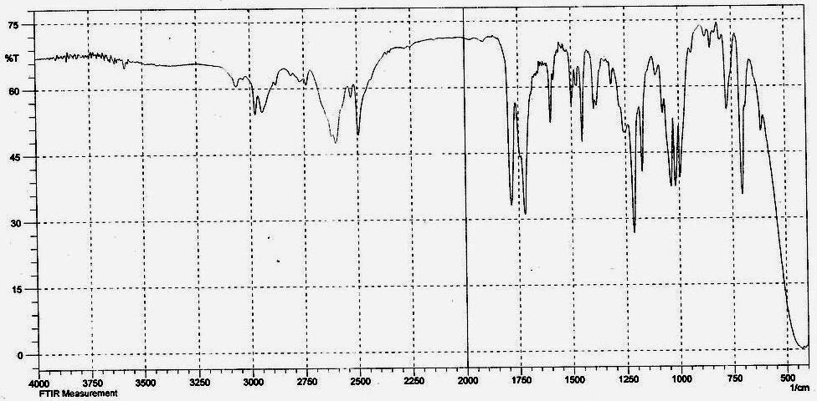
Fig.(4) FT-IR Spectrum of compound (6C)

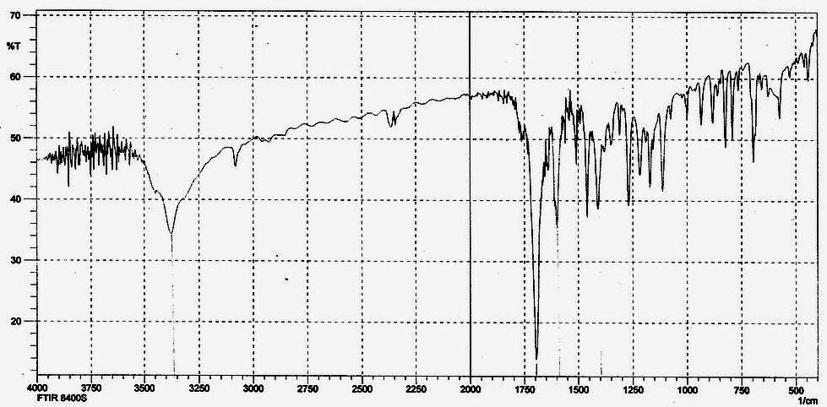
Fig.(5) FT-IR Spectrum of compound (6B)

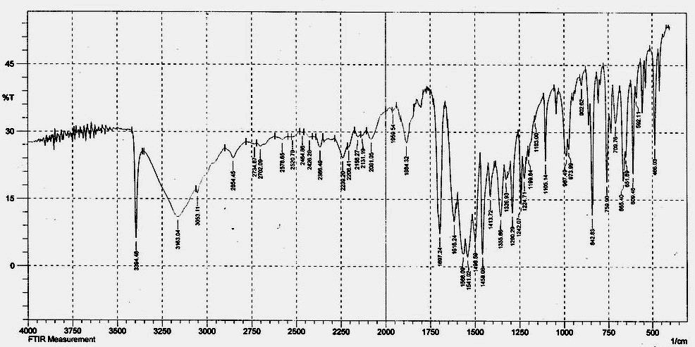
Fig.(6) FT-IR Spectrum of compound (6A)

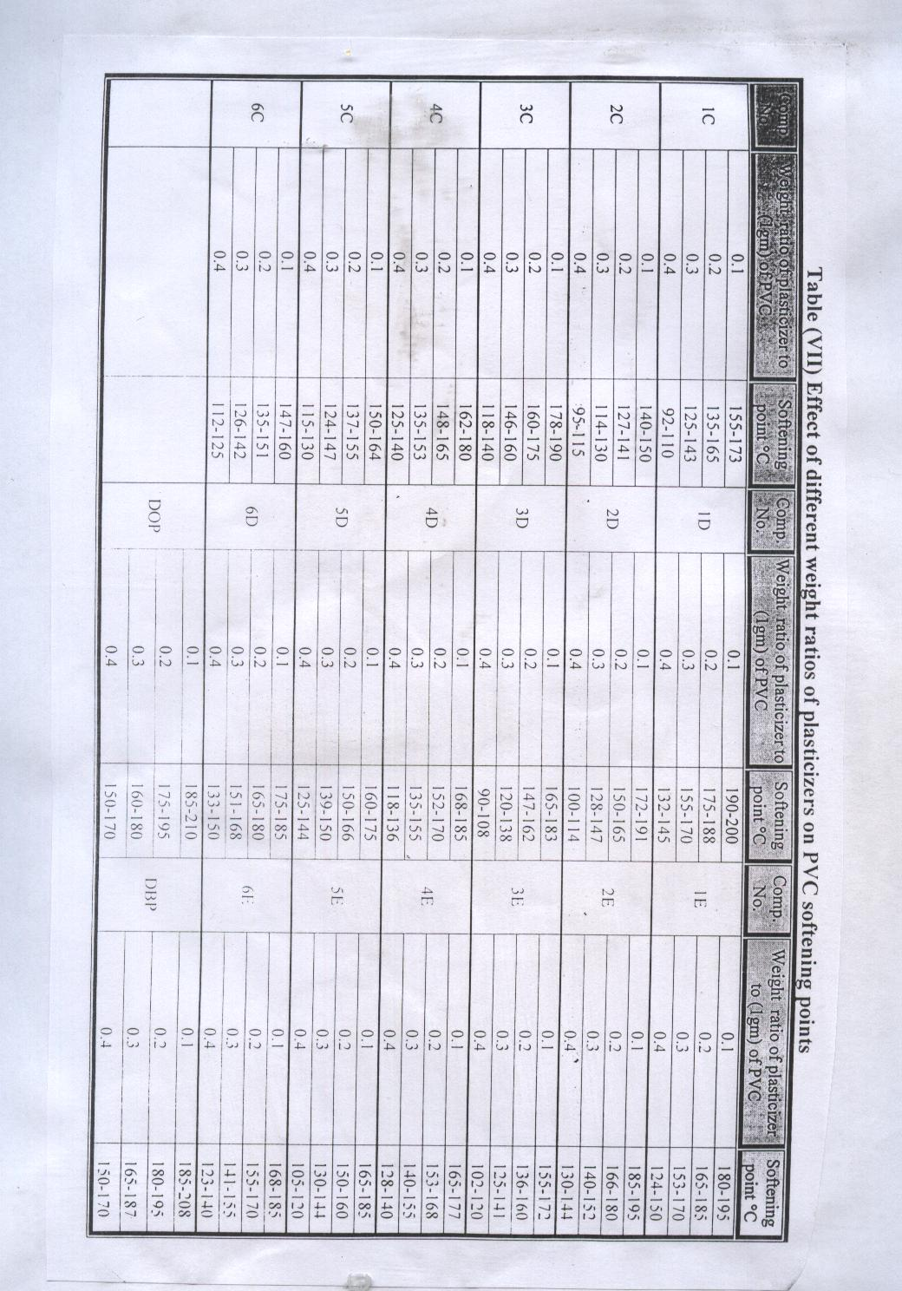

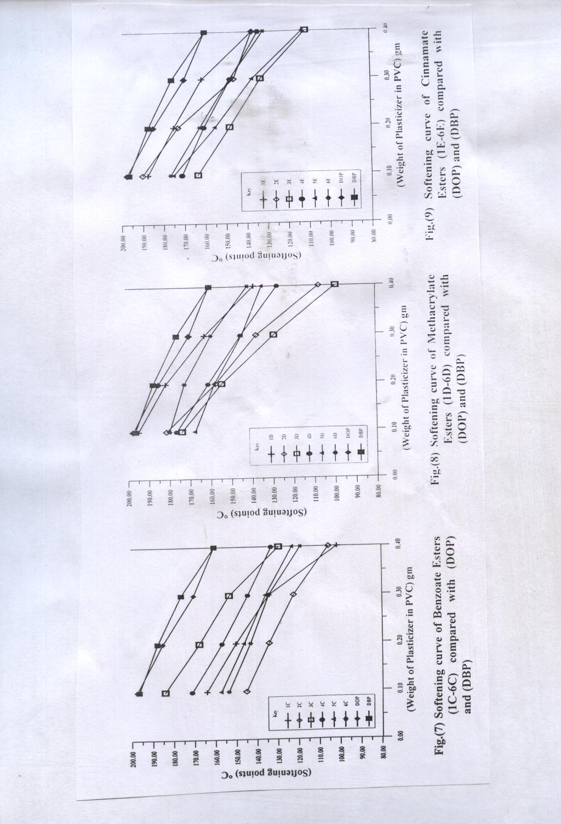

References
- W. L. Semon, U. S. Patent, 1934, 1, 929.
- E. M. Kampouris, Eur. Polym. J., 1975, 11, 705.
- W. J. Frissell, Mod. Plastics, 1961, 38, 232 .
- D. Messadi and J. M. Vergnaud, J. Apply Poly. Sci., 1981, 26, 2315.
- D. Messadi and J. M. Vergnaud, J. Apply Poly. Sci., 1982, 27, 3945 .
- P. D. Calvert and N. C. Billingham, J. Apply Poly. Sci., 1979, 24, 357 .
- G. Saul, Macromolecules, 1989, 22, 3480.
- A. M. Hussien, Iraqi Journal of Chemistry, 2000, 26(4), 813.
- C. D. Papaspyrides and T. Duvis, Polymer, 1990, 31, 1085.
- F. Eking, J. W. Clark and W. A. Swidin, J. Chem. Soc., 1957, 873 .
- N. B. Mehta, A. P. Phillips and R. E. Brooks, J. Org. Chem., 1960, 25, 1012 .
- A. S. Berzinji, Designed Monomers and Polymers, 2003, 6(1), 115.
- T. Mohamed, J. Polym. Sci., 1999, Part A, 37, 427.
- A. H. Hussien, National Journal of Chemistry, 2003, 12, 576 .
- J. R. Darby and J. K. Sears, "Plasticizers" Encyclopedia of Polymer Science and Technology, 1969, 10, 234.
- C. A. Brighton, "Vinyl Chloride Polymers" Encyclopedia of Polymer Science and Technology, 1970, 13, 273.
- E. J. Wickson and R. S. Brookman, J. Vinyl Technology, 1989, 11, 2 .
- J. R. Fried and H. C. Liu, J. Polym. Sci., 1989, Part C, 27, 385.

