Synthesis and Antibacterial Activity of 2-Cinnamyl-5-Substituted-1,3,4-Oxadiazole, 1,3,4-Thiadiazoles and 5-Cinnamyl-3-Substituted-1,2,4-Triazoles

Khalid M. Daoud  College of Education | Shereen R. Mohammed  College of Pharmacy | Zeniab F. Saeed  College of Vet. Med.
University of Mosul, Mosul-Iraq

(NJC)

(Received on 1/8/2006) (Accepted for publication on 18/2/2007)

Abstract
In this work the synthesis of 2-cinnamyl-5-substituted-1,3,4-oxadiazoles, 1,3,4-thiadiazole and 5-cinnamyl-3-substituted-1,2,4-triazoles was achieved. Ethyl cinnamate was refluxed with hydrazine hydrate in ethanol to give the corresponding acid hydrazides, which then treated with ammonium thiocyanate to give thiosemicarbazide. The thiosemicarbazide cyclized to 5-amino-2-cinnamyl-1,3,4-thiadiazole and 5-cinnamyl-1,2,4-triazole-3-thiol with sulfuric acid and sodium hydroxide solution respectively.
The acid hydrazide was treated with substituted benzaldehyde to yield hydrazone, which then treated with PbO₂ to give 2-cinnamyl-5-aryl/phenyl-1,3,4-oxadiazoles. 2-Cinnamyl-1,3,4-oxadiazole was obtained from acid hydrazide by its reaction with formic acid followed by PbO₂. Acid hydrazide was converted to substituted thiosemicarbazode by the reaction with phenyl isothiocyanate.
The synthesized conpounds (1, 2, 5, 6, 9, 11 and 13) were tested against Escherichia coli, Staphylococcus aureus, Salmonella typhi and Pseudomonas.
The structures of the synthesized compounds were established by physical and spectral means.

الخلاصة
تم في هذا البحث تحضير 2-سيناميل-5-معوضات-4،3،1-اوكسادايازول و 4،3،1-ثايادايازول و 5-سيناميل-3-معوضات-4،2،1-ترايازول. حولت سينامات الاثيل الى هيدرازيد حامض السيناميك من خلال مفاعلته مع الهيدرازين المائي في الايثانول. تم مفاعلة هيدرازيد الحامض مع ثايوسيانات الامونيوم ليعطي ثايوسيميكاربازيد. اعطت مفاعلة الثايوسيميكاربازيد مع حامض الكبريتيك 5-امينو-2-سيناميل-4،3،1-ثايادايازول ومع هيدروكسيد الصوديوم 5-سيناميل-4،2،1-ترايازول-3-ثايول. حضرت الهيدرازونات من خلال مفاعلة هيدرازيد الحامض مع البنزالديهايد او معوضاته. وتم مفاعلتة الهيدرازونات مع PbO₂ ليعطي 2-سيناميل-5-اريل/فنيل-4،3،1-اوكسادايازول. كما تم تحضير 2-سيناميل-4،3،1-اوكسادايازول من خلال مفاعلة هيدرازيد الحامض مع حامض الفورميك ثم PbO₂ .
اختبرت فعالية المركبات(1،2، 5، 6، 9، 11، 13) تجاه البكتريا Escherichia coli, Staphylococcus aureus, Salmonella typhi, Pseudomonas . شخصت المركبات المحضرة بالطرق الفيزياوية والطيفية.

Introduction
The synthesis of substituted 1,3,4-oxadiazoles, 1,3,4-thiadiazoles and 1,2,4-triazoles, the biological activities and some of their uses were investigated and they show various applications as antibacterial and antifungal properties^{(1,2)} such as compound (1)⁽³⁾. Other triazoles act as blood glucose level regulator⁽⁴⁾.

(1)

Some 1,3,4-oxadiazole act as plant growth regulator⁽⁵⁾, and act against tuberculosis⁽⁶⁾. 1,3,4-Oxadiazole and 1,3,4-thiadiazole and 1,2,4-triazole derivatives are thermally stable⁽⁷⁾.
The importance of these heterocyclic compounds draw the attention of many research works to the synthesis of the above mentioned diazoles. 1,3,4-Oxadiazoles were synthesized from the reaction of acid hydrazide with carbon disulfide in ethanolic potassium hydroxide as compound (2)⁽⁸⁾ and (3)⁽⁹⁾.

(2)
(3)
n = 3,4,8

Thiosemicarbazides were oxidized by mercuric oxide, lead oxide or iodine/potassium iodide to substituted 1,3,4-oxadiazoles^{(10,11)}.
Microwave assisted reaction of acid hydrazide with carboxylic acid in presence of phosphorous oxychloride gave 2,5-disubsituted-1,3,4-oxadiazole⁽¹²⁾.
While 1,3,4-thiadiazoles were synthesized from substituted thiosemicarbazides by their reaction with concentrated sulfuric acid⁽¹³⁾ or phosphoric acid as in synthesis of 5-(3-indolyl methyl)-2-amino-1,3,4-thiadiazole and 5-(2-methyl-3-indolyl methyl)-2-anilino-1,3,4 thiadiazole⁽¹⁴⁾. Whereas substituted 1,2,4-triazoles were synthesized from substituted thiosemicarbazide by their reaction with sodium hydroxide, for example 1-(3-methoxy benzoyl) thiosemicarbazide was treated with 2N NaOH to give 5-(3-methoxy phenyl)-1,2,4-triazole-3-thione⁽¹⁵⁾.
In the present work the synthesis of substituted 1,3,4-oxadiazoles, 1,3,4-thiadiazoles and 1,2,4-triazoles were investigated (Scheme 1).

Experimental
All chemicals were purchased from Flucka and BDH Chemical Ltd. The melting points were measured on an Electrothermal 9300 Engineering LTD and were uncorrected. IR spectra were recorded on Infrared Spectrophotometer Model Tensor 27, Bruker Co., Germany, using KBr discs. UV spectra were recorded on Shimadzu Double-Beam Spectrophotometer UV-210 A using chloroform as a solvent.

Cinnamic acid hydrazide (1):
A mixture of ethyl cinnamate (1.76 g, 0.01 mole) and hydrazine hydrate (10 ml, 0.2 mole) in absolute ethanol (100 ml) was refluxed for 3 hours. The solvent was evaporated to give the hydrazide as oil, yield 75%, Table (2).

Substituted thiosemicarbazide (2):
A mixture of acid hydrazide (1) (3.24 g, 0.02 mole), ammonium thiocyanate (4.56 g, 0.06 mole), hydrochloric acid (8 ml) in absolute ethanol (50 ml) was refluxed for 22 hrs. The solvent was evaporated and the residue poured on crushed ice with stirring, the solid formed, filtered dried and recrystallized from ethanol, Tables (1, 2).
5-Cinnamyl-1,2,4-triazole-3-thiol (3):
A mixture of substituted thiosemicarbazide (2) (2.30 g, 0.01 mole) and 1% aqueous sodium hydroxide (15 ml) was refluxed for 3 hours, the mixture was treated with charcoal and the charcoal then removed by hot filtration. The solution was acidified by 10% hydrochloric acid with cooling, the precipitate filtered, and recrystallized from ethanol, Tables (1, 2).
2-Cinnamyl-5-amino-1,3,4-thiadiazole (4):
Concentrated sulfuric acid (10 ml) was added to substituted thiosemicarbazide (2) (1.15 g, 0.005 mole). The mixture was heated on water bath at 90 °C with stirring for 2 hours. The mixture then poured onto ice-water and neutralized with concentrated ammonium hydroxide solution with cooling, the formed precipitate filtered, washed with cold water, dried and recrystallized from benzene, Table (1, 2).

1-Acyl-4-phenyl thiosemicarbazide (5):
A mixture of acid hydrazide (1) (3.24 g, 0.02 mole), phenyl isothiocyanate (2.7 g, 0.02 mole), concentrated hydrochloric acid (8 ml) in ethanol (30 ml) was refluxed for (10) hours, the solvent was evaporated and the residue poured on crushed ice, the solid then filtered, dried and recrystallized from ethanol, Tables (1, 2).

Hydrazones (6-9):
Benzaldehyde/substituted benzaldehyde (0.01 mole), acid hydrazide (1) (1.62 g, 0.01 mole) in ethanol (20 ml) was refluxed for (2) hours. The solvent was condensed and the precipitate filtered and recrystallized from benzene, Tables (1, 2).

1-Acyl-2-formyl hydrazine (10):
A mixture of acid hydrazide (1) (1.62 g, 0.01 mole) formic acid (0.46 g, 0.01 mole) in ethanol (20 ml) was refluxed for 3 hours. The mixture was cooled and the solid filtered, dried and recrystallized from ethanol, Tables (1, 2).

Cyclization of 1-acyl-2-formyl hydrazine and hydrazones to substituted 1,3,4-oxadiazoles (11-15):
To a homogenous solution of hydrazones (6-10) (0.01 mole) in glacial acetic acid, PbO₂ (2.39 g, 0.01 mole) was added the mixture then stirred with mechanical stirrer at 25 °C for 1 hr. The reaction mixture was diluted with ice-water and left to stand for 24 hours. The precipitate was filtered and recrystallized from benzene, Tables (1, 2).

The Biological Activity Test:
In the present work the following bacteria were used, Escherichia coli, Staphylococcus aureus, Salmonella typhi and Pseudomonas. The procedure of Bauer⁽¹⁶⁾ was used in sensitivity test as five colonies of the above mentioned bacteria which were transferred to the nutrient broth. The medium was incubated at 37 °C for 15-16 hours, and the diluted with normal saline and then (0.1) ml of this medium was transferred to the nutrient agar and distributed on the surface of the Petri-dishes, then left for about 30 minutes at 37 °C in the incubation.
To determine the inhibitory effect, filter paper discs were saturated with different concentrations of solutions for tested compounds (1, 2, 5, 6, 9, 11, 13) in DMSO and were distributed on the surface of the agar medium and then incubated for (15-16 hours).
The antibiotic Ampicillin, Tetracycline and Vancomycine were used for Staphylococcus aureus and Pseudomonas, Table (3).

Results and Discussion
The synthesis of substituted 1,3,4-oxadiazoles, 1,3,4-thiadiazoles and 1,2,4-triazoles is reported. The ethyl cinnamate was treated with hydrazine hydrate in ethanol give acid hydrazide (1), the hydrazide show absorption ν cm⁻¹ at 1660 (C=O), 1614 (CH=CH) and 3340 (N-H).
The hydrazide then converted to thiosemicarbazide (2) by its reaction with ammonium thiocyanate / hydrochloric acid, the thiosemicarbazide (2) then transferred to 2-substituted-1,3,4-thiadiazole-5-thiol and 5-substituted-1,2,4-triazole-3-thiol by their reaction with sulfuric acid and sodium hydroxide solution respectively, through the following mechanisms:

Mechanism (1)

Mechanism (2)

The 1,2,4-triazole (3) show absorption ν cm⁻¹ at 1625 (CH=CH), 1206 (C=S), while 1,3,4-thiadiazole (4) show absorption at ν cm⁻¹ 1619 (CH=CH) and 3380 (N-H). In order to synthesis monosubstituted oxadiazole, acid hydrazide (1) was treated with formic acid to give 1-formyl-2-acyl hydrazine (10) which transferred to 2-cinnamyl-1,3,4-oxadiazole by its reaction with PbO₂. Compound (10) show absorption ν cm⁻¹ at 1699 and 1647 (2C=O), 1620 (CH=CH), while compound (15) show absorption at 1614 (CH=CH), 1088 (C-O-C) and ν cm⁻¹ 1656 (C=N). The acid hydrazide (1) was treated with benzaldehyde or substituted benzaldehyde to give hydrazones (6-9). Compound (6) show absorption ν cm⁻¹ at 1663 (C=O), 1616 (CH=CH) and 3300 (N-H). Hydrazones (6-9) was then cyclized to 2,5-disubstituted-1,3,4-oxadiazoles (11-14) by PbO₂. Compound (11) show absorption at ν cm⁻¹ 1624 (CH=CH) and 1197 (C-O-C) while compound (12) show absorption ν cm⁻¹ at 3566 (O-H), 1640 (CH=CH), 1120 (C-O-C) and 1667 (C=N).
The hydrazide (1) then treated with phenyl isothiocyanate to give substituted thiosemicarbazide (5), ν cm⁻¹ at 1698 (C=O), 1598 (CH=CH) and 1189 (C=S). The U.V spectra of the synthesized compounds (1-15) show higher absorption λ_{max} range from 298 to 242 nm and ε_{max} range from 4000 to 1101, Table (2).

(1)
(2)
(5)
(3)
(4)
(10)
(15)
(6-9)
(11-14)
R = PhCH=CH
X = H, 2-OH, 3-NO₂, Cl
H₂SO₄

Scheme (1)

Table (1): Physical data of compounds (2-15)
Comp. No. | Molecular formula | Yield (%) | m.p. (°C) | Color
2 | C₁₀H₁₁NO₃S | 55 | 197-199 | White
3 | C₁₀H₉N₃S | 40 | 210-212 | Pale brown
4 | C₁₀H₉N₃S | 52 | > 300 | White
5 | C₁₆H₁₄N₂OS | 65 | 164-166 | Yellow
6 | C₁₀H₁₄N₂O | 65 | 160-162 | Pale yellow
7 | C₁₆H₁₄N₂O₂ | 70 | 206-208 | White
8 | C₁₆H₁₃N₃O₃ | 50 | 152-154 | Dark yellow
9 | C₁₆H₁₃N₂OCl | 55 | 122-125 | Pale orange
10 | C₁₀H₁₀N₂O₂ | 60 | 151-154 | White
11 | C₁₆H₁₂N₂O | 35 | 213-215 | White
12 | C₁₆H₁₂N₂O₂ | 40 | > 280 | White
13 | C₁₆H₁₁N₃O₃ | 45 | 177-179 | Yellow
14 | C₁₆H₁₁N₂OCl | 30 | 178-180 | White
15 | C₁₀H₈N₂O | 40 | 71-73 | White

Table (2): Spectral data of synthesized compounds (1-15)
Comp. No. | IR (KBr) ν cm⁻¹ |  |  |  |  |  |  | UV, EtOH
Comp. No. | C=O | C=C | N-H | C=S | C-O-C | C=N | O-H | λ_{max} (nm) | ε_{max}
1 | 1660 | 1614 | 3340 | - | - | - | - | 244 | 2800
2 | 1650 | 1609 | 3350 | 1280 | - | - | - | 268 | 1884
3 | - | 1625 | 3380 | 1206 | - | 1660 | - | 266 | 3311
4 | - | 1619 | 3382 | - | - | 1662 | - | 242 | 1101
5 | 1698 | 1598 | 3211 | 1189 | - | - | - | 250 | 4000
6 | 1663 | 1616 | 3300 | - | - | - | - | 298 | 4000
7 | 1669 | 1624 | - | - | - | - | 3600 | 256 | 4000
8 | 1698 | 1643 | 3314 | - | - | - | - | 252 | 4000
9 | 1670 | 1625 | 3320 | - | - | - | - | 250 | 4000
10 | 1699  1647 | 1620 | 3340 | - | - | - | - | 246 | 2474
11 | - | 1624 | - | - | 1197 | - | - | 286 | 4000
12 | - | 1640 | - | - | 1120 | 1667 | 3566 | 280 | 3311
13 | - | 1625 | - | - | 1075 | 1653 | - | 252 | 4000
14 | - | 1624 | - | - | 1089 | 1653 | - | 258 | 4000
15 | - | 1613 | - | - | 1088 | 1656 | - | 290 | 3763

Biological Activity:
Antibacterial activity of compounds (1, 2, 5, 6, 9, 11 and 13) was evaluated by agar plate diffusion technique against Escherichia coli, Staphylococcus aureus, Salmonella typhi and Pseudomonas.
The result indicate that some of the tested compounds were active against certain bacteria, the activity of these compounds shown in Figure (1) and Table (3).

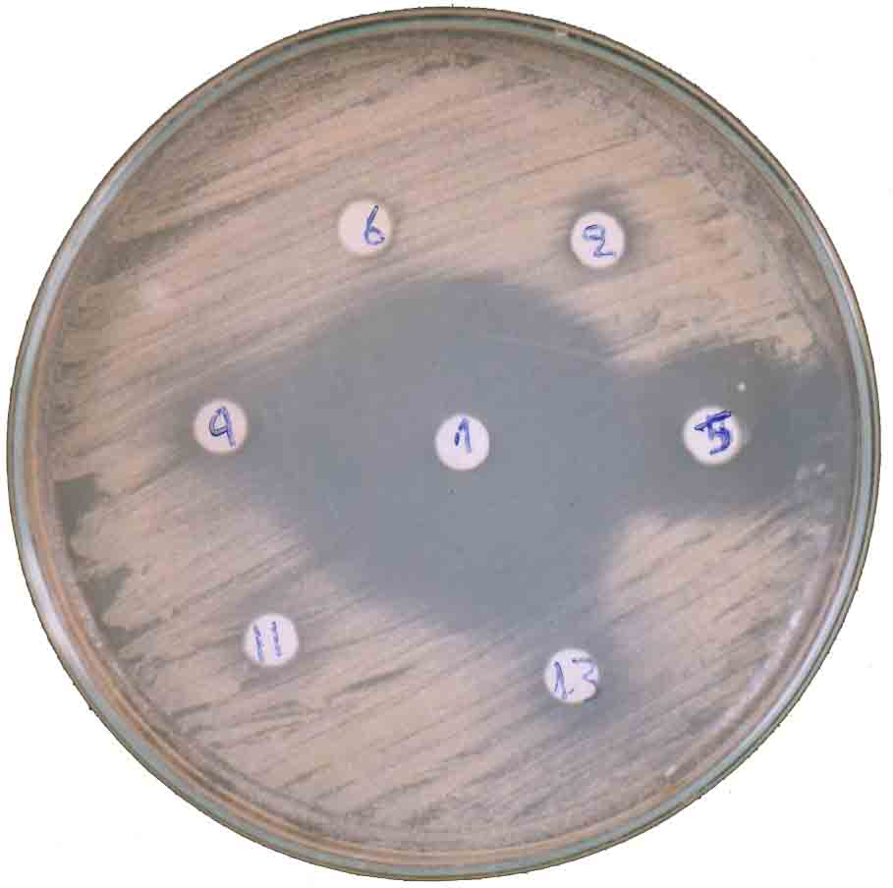

Figure (1): The effect of some synthesized compounds against Staph. aureus

Table (3): The activity of compounds (1,2,5,6,9,11 and 13) as antibacterial
Comp. No. | Test organism*
Comp. No. | Staph. aureus | Strept. pyo. | Salmonella | E. coli | Pseudomonas
1 | S | S | S | S | S
2 | R | R | S | R | R
5 | S | R | S | R | R
6 | R | R | R | R | R
9 | S | R | R | S | R
11 | R | R | R | R | R
13 | R | R | R | R | R
Ampicillin | 14 m
Tetracycline | 26 m
Vancomycin | 18 m
R = resistance
S = sensitive

References
- S.B. Bhavsar, D.B. Shinde and M.S. Shingare, Indian J. Chem., 1955, 34, 70.
- R.B. Pathak, U. Srivastava and S.C. Bahel, J. Indian Chem. Soc., 1982, LIX, 776.
- M.A. Kuba’a, 1999, “Synthesis of new nitrofuran derivatives from agricultural waste”, M.Sc. Thesis, University of Nahrain, College of Science, Baghdad-Iraq.
- Agarwal, Indian J. Pharm. Sci., 1991, 53, 912.
- Z. Ziyi, F. Xiaoming, L. Haixln, C. Maoqi and L. Youbang, Xouji Huaxue, 1989, 9(4): 355.
- D.N.R. Libermann and F. Grumbach, Congr. Intern. Biochem. Rsumes Communs., 1955, 3° Congr., Brusse 15, 136.
- C. Ainsworth, J. Am. Chem. Soc., 1965, 187, 5800.
- R.S. Sharma and S.C. Bahel, 1982, “Synthesis and antifungal activity of 5-substituted 1,3,4-oxadiazole and related compounds”, Bokin Bobai, 10, 293; Chem. Abst., (1982), 97, 216081c.
- A.O. Maslat, M. Abussad, H. Tashtoush and M. Al-Talib, Pol. J. Pharmacol., 2002, 54, 55.
- A. Amir and Shikha, J. Europ. Med. Chem., 2004, 39, 535.
- R.S. Sharma and S.C. Bahel, J. Indian Chem. Soc., 1982, LIX, 877.
- K.M. Khan, Zia-Ullah, M. Roni, S. Perveen, S.M. Haider, A. Choudhany, A. Rehmn and U. Velter, Mendeleev Communication Electronic Version, Issue, 2004, 4, 129.
- S. Karakus and S. Rollas, IL Farmaco., 2002, 57, 577.
- A. Varvaresou, P.T. Siatra, T.A. Dalla and K. Tsantili, IL Farmaco., 1998, 53, 320.
- L. Labanauskas, E. Udrenaite, P. Gaidelic and A. Brukstus, IL Farmaco., 2004, 59, 255.
- A.W. Bauer, W.A.M. Kirby, J.S. Sherris and M. Turk, Am. J. Clin. Pathol., 1966, 45, 493.

