Synthesis of the new 2-[(6– Methyl–2- Benzothiazolylazo]-4-Chloro phenol Organic reagent for Spectrophotometric determination of Copper(II).

Hakeem . Jabbar . Ilaybi
Dept. of Chemistry , College of Science , University of Kufa
Kufa -Iraq

(NJC)

(Received on 2/11/2006) (Accepted for publication on 15/3/2007)

Abstract
Anew 2-[(6-Methyl-2-Benzothiazolyl)azo]-4-Chloro Phenol (6-MeBTAClP)Organic reagent was synthesized . A sensitive and selective spectrophotometric method was proposed for the rapid determination of Cu(II) by using (6-MeBTAClP) reagent.The reaction between Cu(II) and (6-MeBTAClP) reagent is instantaneous at pH=4.0, and the absorbance remains stable for over 24 h. The method allows for the determination of Cu(II) over the range (0.05 -4.0)µg.ml⁻¹,with molar absorptivity of( 1.271x10⁴ )l.mol⁻¹.cm⁻¹ and a detection limit of 0.12 µg.ml⁻¹ .Recovery and relative error values of precision and accuracy of method were found to be R.S.D%=0.421,Re%=98.67% ,and Erel=1.33% .Study of complex nature shows that ; (m: r) ratio was 1:2 at pH=4.0 ,and the stability constant of (1.256 x 10¹⁰) l². mol⁻² . The interferences of ions (CrO₄⁻²,Pb⁺² ,Hg⁺² ,Zn⁺²,Cd⁺², Ni⁺², MoO4⁻²,WO4 ⁻²) and masking agents effect on absorbance were studied.

الخلاصة
حضر الكاشف العضوي الجديد 2-](6-مثيل -2-بنزوثيازوليل)آزو[-4-كلورو فينول, و استخدم في التقدير الطيفي لآيون النحاس (II),التفاعل بين الكاشف و أيون النحاس (II) يتم عند دالة حامضية= 4.0و امتصاصية المحلول تبقى ثابتة لأكثر من 24 ساعة.
الطريقة تسمح لتقدير أيونات النحاس (II) ضمن مدى بين(4.0-0.05) ميكرو غرام.مل⁻¹,و بمعامل امتصاص مولا ري (⁴10 x 1.27) لتر.مول⁻¹.سم⁻¹, و بحد كشف (0.12) ميكروغرام.مل⁻¹.
تم حساب دقة الطريقة التحليلية و ضبطها فكانت قيم (R.S.D=0.421 % ) و (Re=98.67% ) و (Erel=1.33% ).
درست طبيعة المعقد الذائب فكانت نسبة الفلز إلى الكاشف (2:1) عند دالة حامضية=4.0 , و ثابت الأستقرارية (¹⁰10 x 1.256)لتر².مول⁻²,كما درست تداخلات الأيونات MoO4⁻²,) ⁻CrO₄⁻²,Pb⁺²,Hg⁺²,Zn⁺²,Cd⁺², Ni⁺², WO₄⁻²) و تأثير عوامل الحجب المختلفة على امتصاصية المعقد.

Introduction
The copper element has a wide use in number of industries ⁽¹⁾ . The most important application of copper in the metallurgic industry is its use as an alloy element with tin ⁽²⁾ , production of cooling and heating coils , electric lines , and in printing of fiber ⁽³⁾ .
Some chromogenic reagents have been used in spectrophotometric methods of determination of copper such as ,1-(pyridyl-2-azo)-2-naphthol ⁽⁴⁾ , salicylodehyde thiosemicarbazone ⁽⁵⁾ , 2-(6-bromo-2-benzothiazolylazo) – 4-chloro phenol ⁽⁶⁾ , 2,5- imercapto-1,3,4-thiadiazole ⁽⁷⁾ ,and benzildithiosemicarbazone ⁽⁸⁾.
Thiazolylazo compounds have attracted the attention ,as they are sensitive chromogenic reagents in addition to being important complexing agents . These dyes are useful in spectrophotometric determinations due to their good selectivity over a wide range of pH and because they are relatively easy to synthesize and purify⁽⁹⁾ .
In this paper ,a new (6-MeBTAClP) chromogenic reagent was synthesized ,and used in simple method involving spectrophotometric determination of Cu(II) .

Experimental
Reagents;
All reagents were of analytical grade . Freshly distilled and deionized water was used for solutions preparations .
Preparation of Reagent⁽¹⁰⁾
To a mixture of (2.142 gm of para methyl aniline and 3.650 gm of thiocyanate ammonium) in 70 ml glacial acetic acid ,was added drop by drop from burette (1.2 ml Br2 + 15 ml glacial acetic acid) with keep temp. 10 °C.
After 15 min alkaline solution was added to precipitate the thiazole derivative . 1.330 gm of thiazole and in 50 ml glacial acetic acid then add (5 ml conc. HCl +25 ml water) to the solution . After that drop by drop from burette a solution ( 0.69 gm NaNO2 +50 ml H2O ) with stirring at 10 °C to diazonium salt , then (1.300 gm of para chloro phenol +50 ml ethanol ) to diazonium salt to the 2-[(6–Methyl–2-Benzothiazolyl) azo]- 4-Chloro phenol (6-MeBTAClP) Organic reagent. .
Standard solution
-Stock Cu(II) solution ;A solution of Cu(II) (100 µg.ml⁻¹ )was prepared by dissolving (0.0392)g of CuSO₄.5H₂O in (100 ml)distilled water. Other standard solutions of Cu(II) were prepared by dilution of stock solution with distilled water .
-1x10⁻³ M (6-MeBTAClP) standard solution was prepared by dissolving (0.754)g in 250 ml of absolute ethanol .
-Buffer solution (pH=4.0) was prepared by mixing 7.71 ml of (0.2)M Na₂HPO₄(which was prepared by dissolving 2.83 gm in 100 ml distilled water ) and 12.29 ml of (0.1) M Citric acid(which was prepared by dissolving 1.92gm in 100 ml distilled water)⁽¹¹⁾ .
Apparatus
Spectrophotometric measurements were made with a Shimadzo scientific equipment with 1.00 cm cell. The Sp8-100 ,Pye Unicam, England , was used in the others measurements . The pH-meter , PW9421 , Philips , England . The water bath - 90 , Hambury , England . The electronic sensitive balance BP3015 , Sartorios , Germany ., Perkin-Elmer , U.S.A ,and Testscan shimadzo 8000 series ., Japan.,were used in this work .

Procedure ;
To an aliquot containing ≤100µg.ml⁻¹ of Cu(II) in a 10-ml volumetric flask , was added 2 ml of buffer solution , and 3 ml of (1x10⁻⁴ M )of (6-MeBTAClP) solution .The solution was diluted to the mark with distilled water, and absorbance was measured at 25°C and wave length of 612 nm against the reagent solution as a blank solution prepared under the same conditions.
Results and Discussion;
1- FT-IR spectrum of reagent (6-MeBTAClP)
The following table shows the main frequency vibration of main absorption bands characteristic of reagent:

Groups | Wave number (Cm⁻¹)
υ O-H,N-H,H2O(crys.) | 3750-3200
υ C-H Aliphatic | 2856
υ C-H Aromatic | 2922
υ C=N | 1700
υ N=N | 1483
υ C=C | 1510
υ C-S | 1173
υ C-Cl | 816
υ C-O Phenolic | 1280

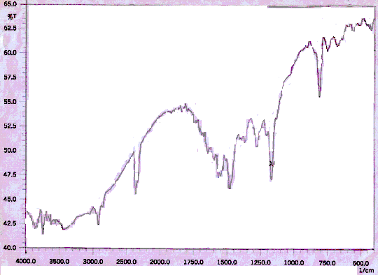
Fig(1);FTIR-Spectrum of (6-MeBTAClP) reagent

2-Properties of the (6-MeBTAClP)
(6-MeBTAClP) reagent is slightly (hardly) soluble in water, red powder , orange and stable solution for suitable period time , but in basic medium pH≥8.0 the solution being pink . Such behavior may be interpretated by the following equilibria ;

pH≥8.0
pink
7.0≥ pH
yellow

800 700 600 500 400 300 200
2

1.5

1

0.5

0
Wavelength(nm)
Abs
1
2
3
6
5
4
pH=6.0(1
2) pH=7.0
3) pH=7.5
4) pH=8.0
5) pH=8.5
6) pH=9.0
430 nm
510 nm

Fig(2);Absorption spectra of (6-MeBTAClP) reagent at various pH

Study of Copper(II)_(6-MeBTAClP) complex
Absorption spectra
a-Ultra violet - visible absorption spectra of (6-MeBTAClP) reagent , Cu (II) ion , and Cu (II) - (6-MeBTAClP) complex solutions are shown in fig(3).The reagent showed an absorption maximum at 430 nm , the copper ion at 258 nm , and the complex at 612 nm .

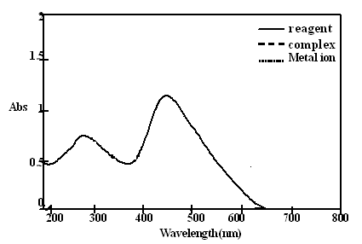

(3);Absorption spectra of Cu- reagent complex.

b-FT-IR of Cu (II)- (6-MeBTAClP) complex
The following table show the main frequencies of absorption bands related to functional groups of Cu (II) - (6-MeBTAClP) complex

Groups | Wave number (Cm⁻¹)
υ H2O(crys.) | 3750-3200
υ C-H Aliphatic | 2854
υ C-H Aromatic | 2920
υ C=N | 1685
υ N=N | 1463
υ C=C | 1510
υ C-S | 1175
υ C-Cl | 814
υ C-O Phenolic | 1294
υ N-Cu | 410
υ O- Cu | 420-500

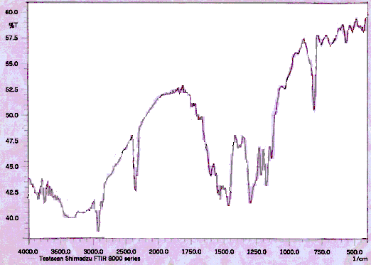

of Cu (II) - (6-MeBTAClP) complex Fig(4);FTIR-Spectrum

Effect of pH
The influence of pH was studied over the range (2-8) adjusted by means of dilute HCl and NaOH solution; fig(5)shows the relationship between absorbance and pH , where the maximum absorbance obtained in the range of pH=(3.5 – 5.0) . At 5.5≤pH≤3.0 a decrease in absorbance . Therefore , the optimum pH was 4.0 , where the absorbance was maximum and stable.

.

Fig(5);Effect of pH on the absorbance of Cu- reagent complex

Effect of time
The stability of absorbance of complex was studied from (0-120)min with 5 min intervals till 24 h . fig (6) shows the maximum absorbance reached at 10 min , after that the absorbance remains stable .
Effect of temperature
The effect of temperature on the absorbance of complex was studied ;the study was performed at temperature between (0-80) °C .Fig (7) shows the maximum absorbance obtained at temperature range (20-40) °C which was regarded as a proper temperature of complex formation .At temperatures higher than 40 °C the absorbance decrease due to dissociation of complex gradually .

Fig(7) effect of temperature on Fig(6) effect of time on
The stability of complex The stability of complex

Determination of stiocheiometry and formation constant
The composion of complex was studied by Jobs method of continuous variations and ( mole-ratio ) method ⁽¹²⁻¹³⁾ . Fig(8,9). Both methods indicate that the ratio of metal ion to reagent molecules (M:L) was (1:2) at pH=4.0 . The formation constant calculated by applied procedure , was found to be (1.256 x 10¹⁰) l².mol⁻².

Fig(8); Mole ratio plot [Reag]=[Cu²⁺] Fig(9); Jobs plot [Reag]=[Cu²⁺] =1x10⁻⁴,pH~4.0 =1x10⁻⁴,pH~4.0

Suggestion of structural formula of Cu (II)- (6-MeBTAClP) complex
From the obtained results of metal to reagent ratio,FTIR-Spectrum ,and depending on thiazolylazo compounds properties; the following structure can be suggested :

.XH2O

Where M=Cu

Analytical characteristics
Calibration curve
Linear calibration graph through the origin was obtained which obeyed Beers law over the range (0.05 – 4.0) µg.ml⁻¹ 0f Cu²⁺ .The average molar absorptivity was found to be (1.271 x 10⁺⁴) l. mol⁻¹. cm⁻¹ .
The sandells sensitivity ⁽¹⁴⁾ was(0.0018) µg. of Cu²⁺ .Cm⁻² ,and correlation coefficient(r) was 0.9986.

.

Fig(10); Calibration curve of Cu (II) - (6-MeBTAClP) complex

Precision and accuracy
The relative standard deviation (R.S.D%) , evaluated from seven independent determination of 3 µg.ml⁻¹ of Cu²⁺ was 0.421% , this result show that this method is highly precise . Also the accuracy of this method was determined by calculating the Erel% for (3) ppm standard solution of Cu (II) which was found to be 1.33 and Re%=98.67.
Interferences ;
The effect of the ions (MoO4⁻²,WO4 ⁻², CrO₄⁻²,Pb⁺²,Hg⁺²,Zn⁺²,Cd⁺², Ni⁺²) which form complex with the reagent during its reaction with Cu⁺² were studied . On the other hand , suitable masking agents examined for eliminating the effect of the eight ions , where the mixture of oxalic acid , 5-sulfosalcylic acid ,sodium fluoride , and 1,10-phenanthroline were found to be a suitable masking agents .

References
1-B.Purachat et al , Anal.Sci., 2001, 17 , 443.
2-موري و داوسن , "الكيمياء اللاعضوية المقارنة و التركيبية" , ترجمة مهدي ناجي الزكوم
مطبعة البصرة ,ص 396 (1982).
هلموت ستايف,"الكيمياء الصناعية الأسس التكنلوجية",ترجمة محمد إسماعيل عبد اللطيف -3
دار الأهرام – دار النشر الشعبية للتأليف في لايسبرغ ,ص 145 (1969).
4- M.Thakur, and M.K.Deb , Talanta , 1999, 49 , 561.
5- N.S.Reddy , and D.V.Reddy , Microchem.J., 1985, 31 ,318.
6- A.A.J.Kassam,M.Sc.Thesis , University of Babylon(2005).
7- M.J.Ahemed , I.Jahan, and S.Banoo,Anal.Sci., 2002, 18 ,805.
8- B.K.Reddy , J.R.Kumar, K.J.Reddy, L.S.Sarma, and A.V.Reddy, Anal.Sci., 2003, 19, 423.
9-Texeirra. L.S.G.,A.C.S.Costa , S.L.C.Ferreira,C.M.S.Carvalho,and , M.L.Freitas, J.Braz.Chem.Soc., 1999, 10,519
10-S.I.Gusev, M.V.Zhvakina , and I.A.Kozhevnikov, Zh. Analit.Khim., 1971, 26, 859.
11- I. Vogel Arther , Macro and Semi micro Qualitative Inorganic Analysis , 661(1953) .
12-Jop, Ann.Chim., 1928, 9,113.
13-A.E.Harvey,andD.L.Manning, J.Am.Chem.Soc., 1950, 72,4488.
14-Marczenko.Z,"Spectrophotometric Determination of Element", John Wiley &Sons,Inc.,Warsaw(1976).

