Photoreduction of Cd⁺² in aqueous TiO₂ suspention

S.M.Aliwi,
Ministry of higher education and scientific research.
S.S.Al-Saleh, F.M.Hussein
Chemistry Department,College of Science, Universty of Mustansiriah
Bagdad-Iraq

(NJC)

(Received on 12/4/2006) (Accepted for publication on 15/11/2006)

Abstract
This paper describes the activity of different crystal forms ofTiO₂ catalyst(Anatase,Rutile,Hombikat,DegussaP25 and Melenium) to eliminate the contaminated Cd(II) from its aqueous solutions by photoreduction process.It was found that the type Degussa P25 was more efficient than other types.Different parameters were also studied in order to undersand and predict the kinetic of the photoreduction process.These parameters are initial Cd(II)ions concentration,TiO₂ loading,solution pH and the presence of hydrogen peroxide.
The kinetic studies of these systems indicate that the photoreduction process is first order under the optimum conditions employed.
الخلاصة
تم خلال البحث الحالي دراسة عملية الاختزال الضوئي لايون الكادميوم(II)في المحلول المائي العالق لخمسة انواع مختلفة من ثنائي اوكسيد التيتانيوم TiO₂وهي:الانتيز،الروتايل،همبوكايت،ديكوزا P25والميلينيوم.
لقد وجد ان النوع ديكوزا P25كان الاكفأ نسبة الى الانواع الاخرى في ازالة ايون الكادميوم(II)من محلوله المائي.
درست حركية الاختزال الضوئي لهذه الانظمة وتبين انها من المرتبة الاولى وتم خلال هذا البحث ايضا دراسة تأثير العوامل المختلفة مثل كمية TiO₂،حامضية المحلول،التركيز الابتدائي لايون الكادميوم(II)،ووجود بيروكسيد الهيدروجين H₂O₂ على سرعة الاختزال الضوئي لايون الكادميوم(II).
من خلال هذه النتائج تم اقتراح ميكانيكية عملية الاختزال الضوئي لايون الكادميوم(II)من محلوله المائي.

Introduction
It is well known that Cd(II) ion is very toxic among other metal ions present in the environment.It is close in toxicity to lead and mercury.The source of the cadmium ion is electroplating process(protective coating for iron and steel),Ni-Cd batteries and paint industries.⁽¹⁾
Reports in literature⁽²⁾reveal that are many methods used for removing Cd(II)and other metal ions from waste water such as:precipitation methods,activated carbon adsorption,ion exchange and membran separation.All these methods have their own advantages and disadvantages according to the source of waste water and the concentration level of contaminants ions.
In the last ten years the removal of traces of metal ions from waste water by using irradiated TiO₂ as a semiconductor is presented as a new Advanced Oxidation Technique(AOT).
This process is based on the reduction of metal ion by the photogenerated electrons in the conduction band,at the same time the oxidation process is taking place by the photogenerated holes.
Prairie,Stage and Evans⁽³⁾in 1993 first studied the catalytic reduction of different metal ion by anatase TiO₂ catalyst in the presence of salicylic acid.They found that Hg(II) and Ag(I) were reduced onto the catalyst surface while Cd(II) and Ni(II)were not reduced according to their experimental conditions employed.
These authers also studied the reduction of Cr(VI) to Cr(III) in acidic medium.
Many researchers⁽⁴⁻⁶⁾also studied the reduction of Cu(II) in a solution either containing organic species or organic free solutions.Pb(II)⁽⁸⁾and Pt(IV⁾⁽⁸⁾could also reduced by AOT process to the corresponding free metals.
Chen and Ray⁽⁹⁾used this method to reduced Ag(I),Hg(II),Cr(VI),Pb(II) and Cu(II) ions in the presence of two forms of TiO₂semiconductor(Deguss P25 and Hombikat UV100) and they found that Degussa P25 exhibited good activity for these metal ions compared with that of Hombikat UV100 type.

In the present work the photoreduction of Cd(II)was investigated by using five different crystal forms of TiO₂ such as Anatase,Rutile,Hombikat,Melenium and Degussa P25 in irradiated aqueous suspension systems.

Experimental details
Materials:
Five different forms of TiO₂ have been used in this study.The specifications of these types are shown in table(1).Other materials such as cadmium chloride was supplied by Fluka(A.G.)100%, Diphenyl carbazone was supplied by B.D.H..Table (1) shows the BET surface area and particle size of the TiO₂ forms used in the work.

Table (1)-BET surface area and particle size(µm) for five different crystals forms of TiO₂.

Photocatalyst | BET surface area m²/g | Particle size(µm) | source
Anatase | 12.77 | 0.157 | Aldrich
Rutile | 14.82 | 0.13 | Fluka
Degussa P25 | 30.57 | 0.03 | Sachtleben chemie
Hombikat | ----- | 8.81 | Sachtleben chemie
Melennium | ----- | 22.14 | Sachtleben chemie

Experimental apparatus:
Absorption spectra were measured using Shimadzu UV-240 double beam spectrophotometer;the UV-light is generated from 125W medium-pressure mercury lamp and the solution pH changes were measured using Orien 5A720 pH meter.The photolysis experiments were carried out in photolytic pyrex cell 35ml in volume.The temperature of the reaction cell was controlled by circulating thermostate type Hakke FE2.
Photolysis procedure and Cd(II) concentration measurments:
A known amount of TiO₂ photocatalyst was add to aqueous solution of cadmium chloride(with initial concentration of 5x10⁻⁴M).The reaction mixture was magnetically stirred for 20 minute and the resulting suspended solution was irradiated for 120 minute.Two ml of samples were withdrawn at irradiation time intervals and immediately centrifuged to remove catalyst particles,then added to a solution of diphenyl carbazone chelating agent(0.5mM)to form pink color complex with absorption at λmax.=527nm.Then from the standared calibration curve prepared in this work,the concentration of Cd(II) ion solution were determined.
Result and discussion
Blank experiments:
In order to determine whether any photochemical reductions coud occur or not in the absence of TiO₂,blank experiments free of photocatalyst were carried out for Cd(II) ion photoredution.It was observed that no reduction took place after 120min of illumination.Another series of experiments show that a little physical adsorption of Cd(II)that occurred over an optimum amount of different forms of TiO₂ in the absence of UV-light(dark experiments).These results are shown in table(3).
Effect of the different crystal forms of TiO₂ on the photoreduction of Cd(II):
In this work a series of experiments were performed in order to measure the optimum amount of each type of TiO₂photocatalyst to remove Cd(II) ion with an initial concentration of 5x10⁻⁴M in natural pH(≈6.8)at 298K.The results are summarized in table-2.
Fig(1)represent the relation between the rate of photocatalytic reduction of Cd(II)ion and the anatase load(g/l) keeping other parameter constants(e.g.:initial Cd(II)ion conc.=5x10⁻⁴M,pH=6.8)it is clear from Fig(1)that the optimum load of anatase in photoctalytic reduction of Cd(II)is 1.00g/l.These results could be explained with respect to the differences of surface areas and particle sizes between them.

Table(2):The optimum load for the five different types of TiO₂ photocatalysts.

Photocatalyst type | Optimum amount g/l
Anatase | 1.0
Rutile | 1.0
Degussa P25 | 0.5
Hombikat | 0.5
Melenium | 1.0

Kinetic analyses
To measure the order of the photoreduction, many experiments have been carried out.A plot of ln(concentration) verses the time of irradiation(min.)gives first order relationship as shown in Fig(2).From the slope of the straight line a specific rate constant, half life time of reaction(t_{1/2}) and rate of photoreduction were measured for each form of TiO₂(optimum weight).The percentage residue of Cd(II) ion was also calculated.All these results are shown in table(3).
Different parameters that influence the efficiency of the photoreduction process which were studied in this work such as:

i-Effect of crystal form of TiO₂ on the photoreduction:
Many experiments have been carried out to study the effect of five different forms of TiO₂ to remove the Cd(II) from aqueous solution of CdCl₂.The rate of photoreaction was measured by plotting lnC against irradiation time,when the initial concentration of Cd(II)was 5x10⁻⁴M at natural pH and 298K.Figure(2) shows the initial rate of the photoreduction of Cd(II) over different forms of TiO₂ photoctclyst.

Table(3)-The first order rate constant k and t_{1/2},the rate of photoreduction process, and the % residue of Cd(II) either in the light and in the dark after 120 min. illumination.

Photocatalyst  type | k  min⁻¹ | t_{1/2}  (min) | Rate of  Photoreduction  (M⁻¹min⁻¹) | %Resdue
 |  |  |  | In  light | In  dark
Anatase | 0.0122 | 56.8 | 6.1x10⁻⁶ | 20.2 | 79.8
Rutile | 0.0066 | 105 | 3.3x10⁻⁶ | 51.4 | 81.8
Degussa P25 | 0.0144 | 48.2 | 7.2x10⁻⁶ | 24.2 | 68
Hombikat | 0.0116 | 60 | 5.8x10⁻⁶ | 20.5 | 72
Melenium | 0.01136 | 61 | 5.6x10⁻⁶ | 30.2 | 86

It is clear from this table that Degussa P25 a better catalyst form than other forms of TiO₂ to remove Cd(II)ion.This result was in a good agreement with that found by Chen and Ray^{(9).}Other researchers^{(10,11)}also found that Degussa P25 is more efficient than Hombikat Melenium on the photocatalytic degradation of different organic substances.The differences in surface properties between different types of TiO₂ lead to the difference in adsorption coefficient of these substances onto the TiO₂ surface.
Hombikat consists of pure anatase have a large surface area,and high porosity.Melenium shows a large particle sizes,a very low porosity and thus a much lower surface area than Hombikate.Degussa P25 has vno pores,moderate surface area and consist of 20% stable Rutile.Therefore these properties lead to decrease the recombination process and increase the adsorption onto the surface.
ii-Effect of Cd(II) initial concentration:
In order to determine the adsorption constant of Cd(II) ion on the TiO₂ surface.The Langmuir-Hinshelwood equation(L-H)was adopted as shown in equation(1-1):

1/rate = 1/k + 1/k.K.C_{o} …………….(1-1)

Where k is the specific rate constant,K was the adsorption constant,C_{o} is the initial concentration.
Result presented in table(4)show that the rate of photoreduction on different crystal form of TiO₂ was directly proportional with initial concentration of Cd⁺² ion.
Plot of 1/Rate versus 1/C_{o} gives a straight line.From the slope of this line,adsorption constant values were measured for different types of TiO₂ photocatalyst,while the intercept gives the value of reaction rate constants k as shown in figure(3).
From the results one might conclude that the adsorption constant of Cd⁺² ion was higher value on the Degussa form of TiO₂ comparing with other values of adsorption constants for Cd⁺² ion on other form of TiO₂.
Table(5) also declare that the rates of photoreduction are approximatly equal to that deduced from first-order equation.

Table ( 4):The initial rate of Cd⁺² photodegradation at various initial concentration in presence of different forms of TiO₂

Ratex10⁶/1  (.M⁻¹.min) | x conc/1  (¹⁻M)10⁴ | %Residue  in light | Rate(M.min⁻¹)  x10⁻⁴ | k  min⁻¹ | C₀(M)  x10⁻⁴ | Crystal form
0.207 | 0.33 | 49.2 | 0.0483 | 0.0161 | 3 | Anatase(1g/l)
0.178 | 0.25 | 45.1 | 0.056 | 0.0140 | 4
0.164 | 0.2 | 20.2 | 0.061 | 0.0122 | 5
0.176 | 0.14 | 22.3 | 0.0567 | 0.0081 | 7
0.362 | 0.33 | 67.1 | 0.0276 | 0.0092 | 3 | Rutile(1g/l)
0.321 | 0.25 | 65.3 | 0.0312 | 0.0078 | 4
0.303 | 0.2 | 51.4 | 0.033 | 0.0066 | 5
0.246 | 0.14 | 49.5 | 0.0406 | 0.0058 | 7
0.370 | 0.33 | 50.3 | 0.0267 | 0.0089 | 3 | Degussa  P25(0.5g/l)
0.214 | 0.25 | 35.0 | 0.0468 | 0.0117 | 4
0.139 | 0.2 | 24.2 | 0.072 | 0.0144 | 5
0.121 | 0.14 | 21.1 | 0.0826 | 0.0118 | 7
0.350 | 0.33 | 35.8 | 0.0285 | 0.0095 | 3 | Hombikat  (0.5 g/l)
0.223 | 0.25 | 41.2 | 0.0448 | 0.0112 | 4
0.172 | 0.2 | 20.5 | 0.058 | 0.0116 | 5
0.163 | 0.14 | 23.8 | 0.0614 | 0.00877 | 7
0.480 | 0.33 | 54.6 | 0.016 | 0.0053 | 3 | Melenium  (1g/l)
0.397 | 0.25 | 52.0 | 0.0252 | 0.0063 | 4
0.176 | 0.2 | 57.8 | 0.0568 | 0.01136 | 5
0.112 | 0.14 | 57.2 | 0.0896 | 0.0128 | 7

Table (5) : The observed rates and calculated rates ( µM.min.⁻¹) of Cd⁺² at various initial conc .

Adsorption  constant ( K )  ( µM⁻¹ ) | Calculated rate  ( µM.min.⁻¹) | Observed rate  ( µM.min.) | Types of TiO₂
0.0052 | 6.85 | 6.10 | Anatase
0.0029 | 5.78 | 4.06 | Rutile
0.0130 | 2.67 | 2.00 | Degussa P25
0.0102 | 2.80 | 1.80 | Hombikat
0.0072 | 1.60 | 1.72 | Melenium

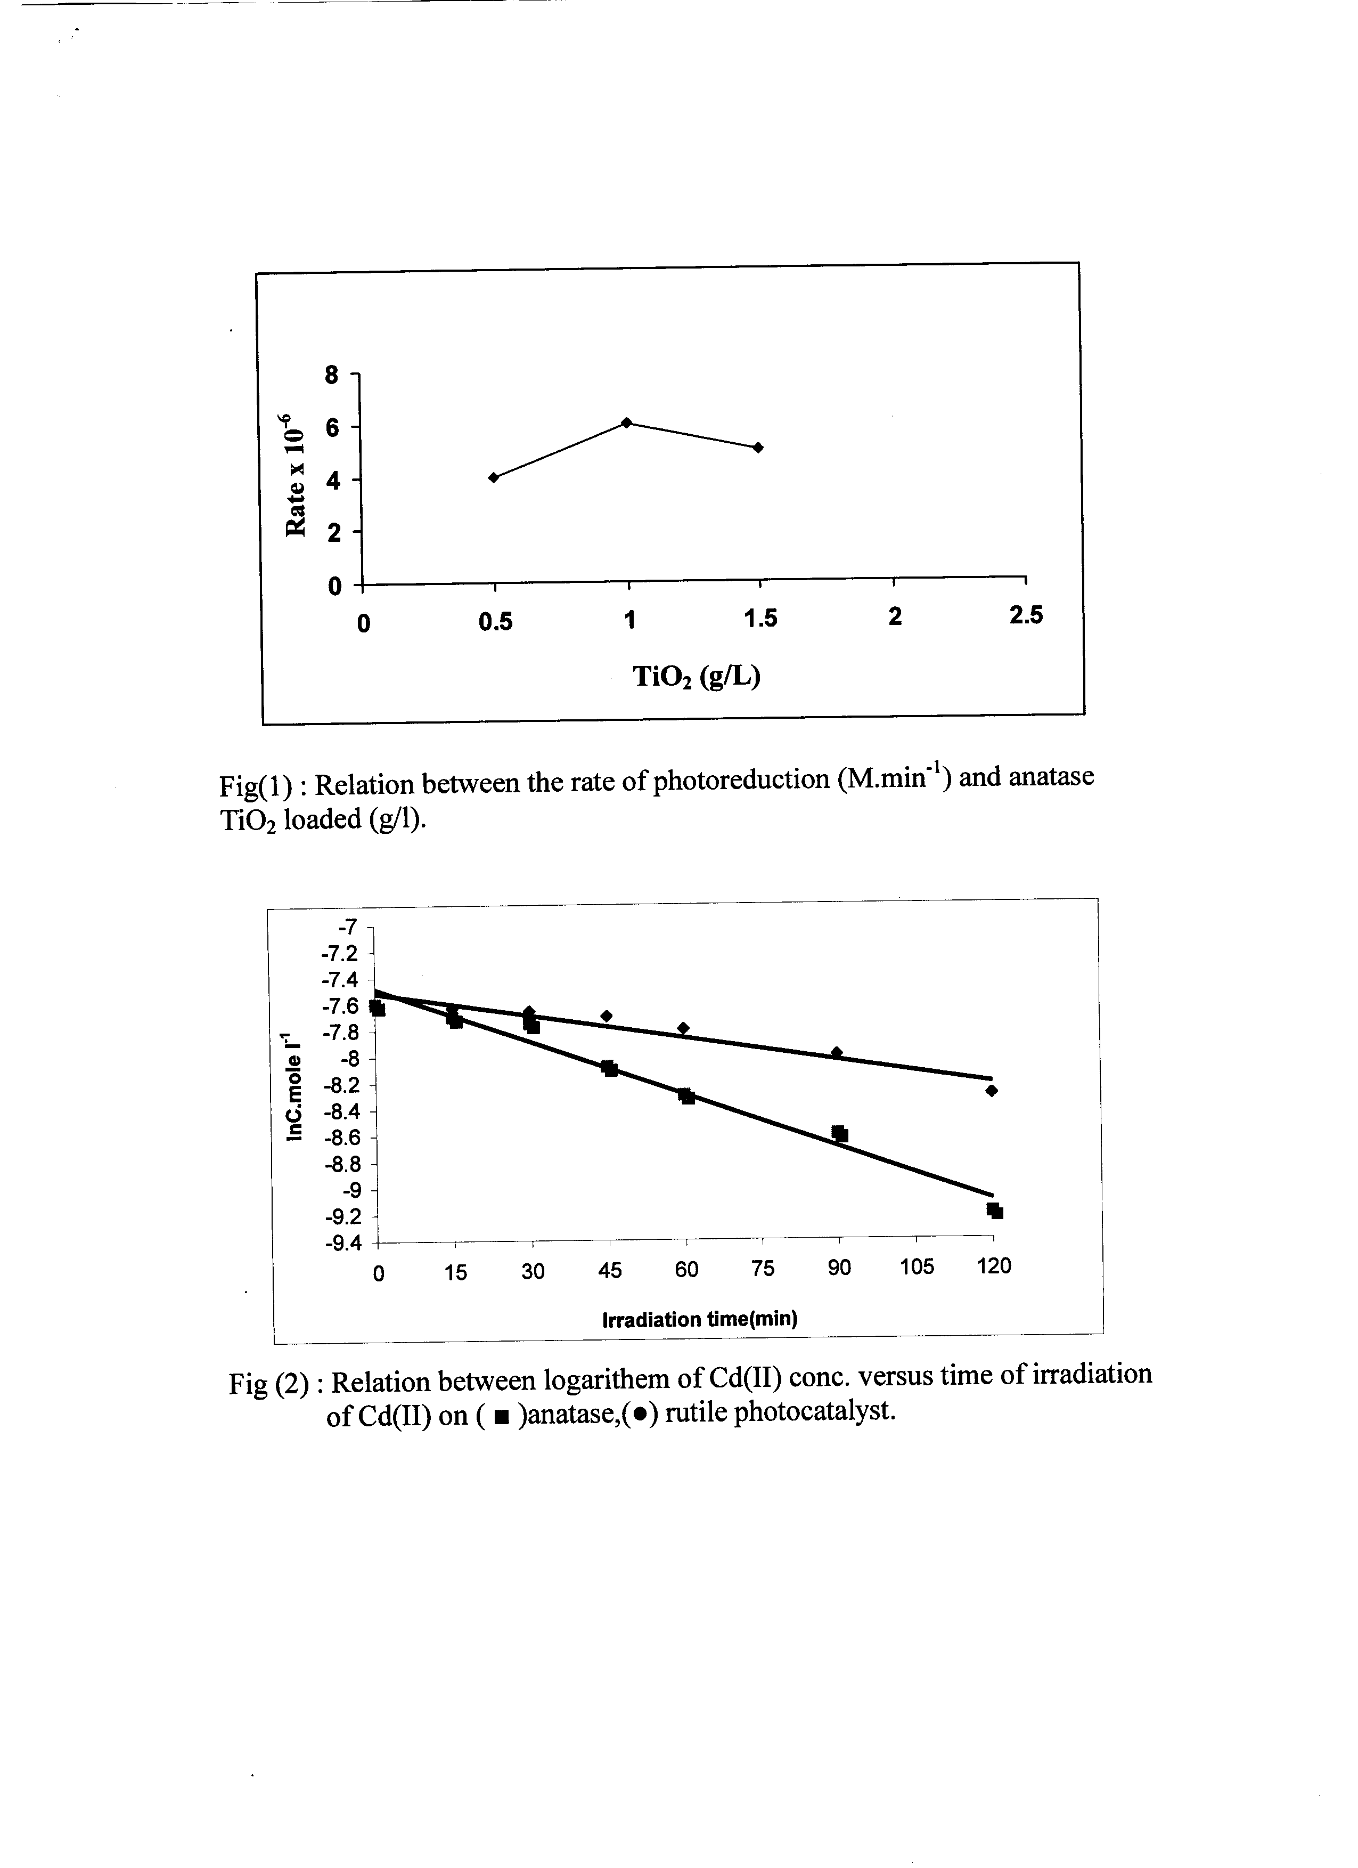
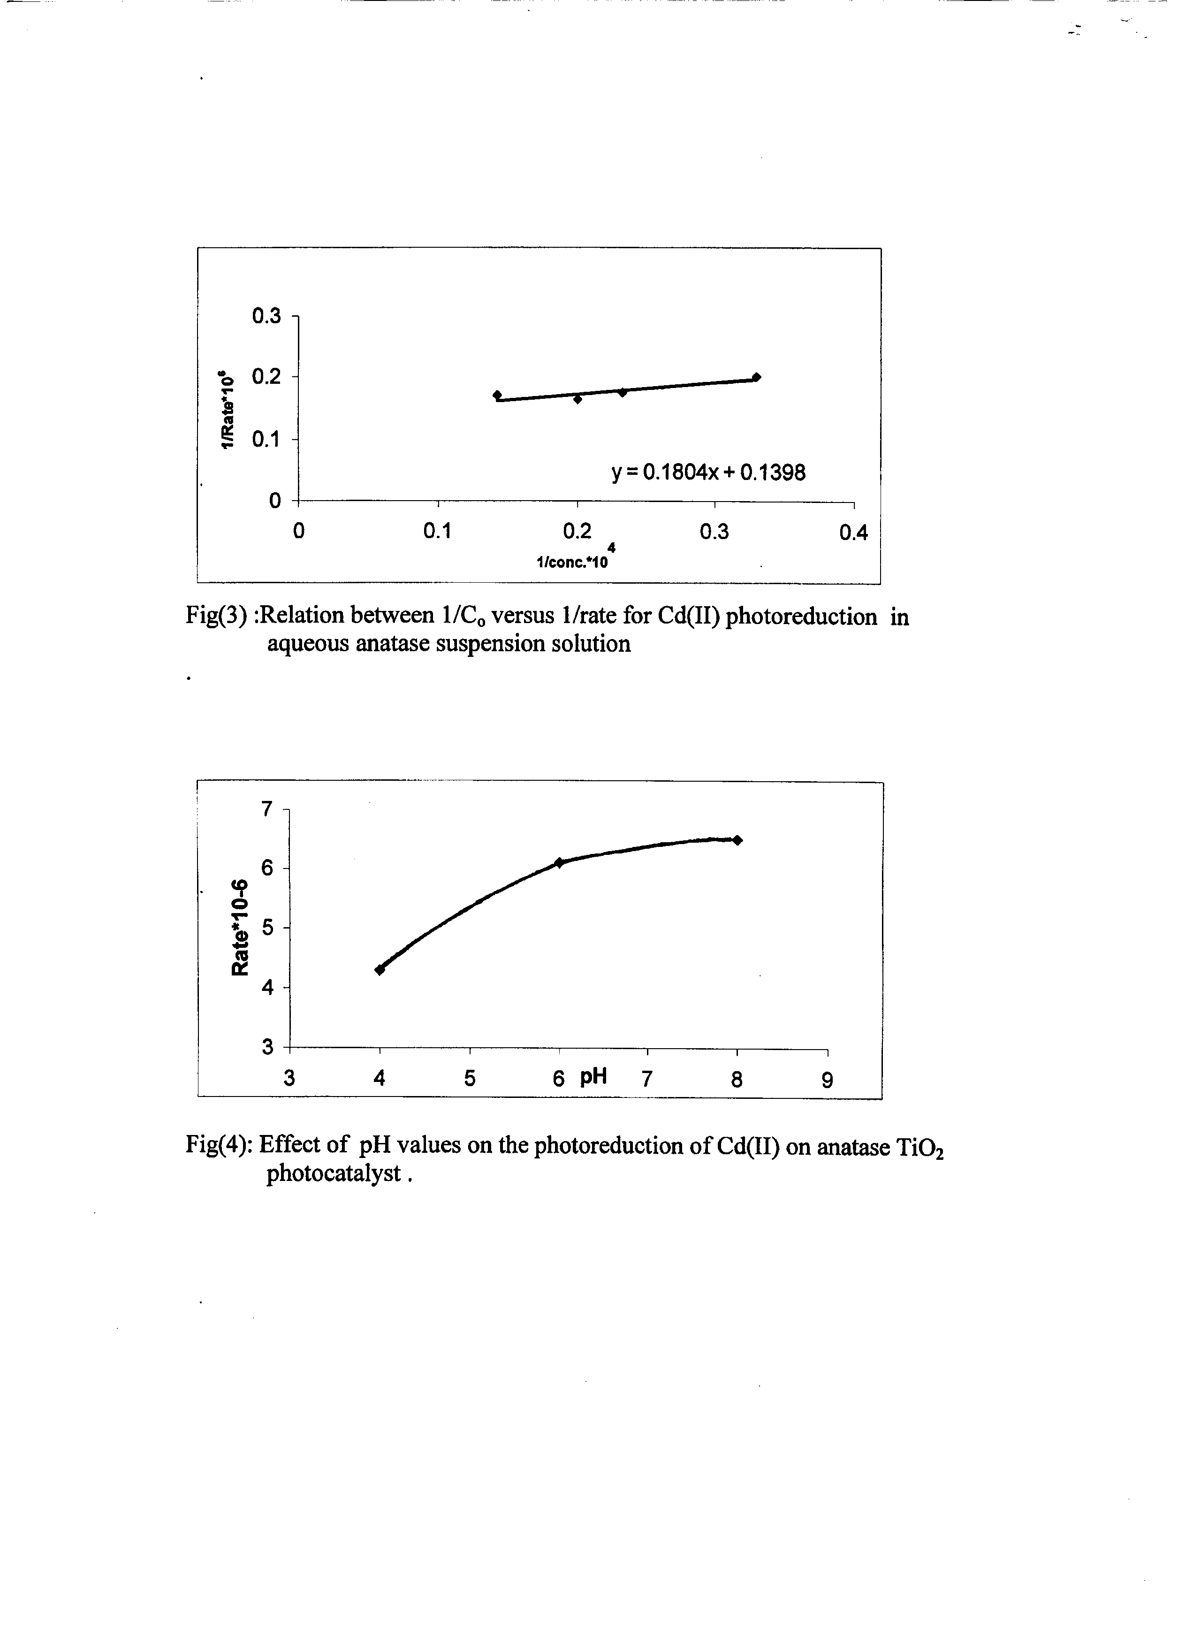

iii-Effect of pH:
Under optimum conditions,different pH values ( pH 4,6,8) were used in order to study the effect of varied pH solution on the photoreduction process.
Results show that the order of photoreduction is not changed with these pH values . In spite of that the rate of photoreduction increases from pH =4 to pH=6 then to pH =8 value. The rate was remained constant as shown in figure (4) . This is because the negatively charged OH group on TiO₂ at high pH, and positively at low pH. Therefore the Cd⁺² ion adsorbed more efficient on TiO₂ surface at natural pH , because the pH*_{pzc}of TiO₂ is at pH= 6.6 . Since the optimum pH during this work was at pH =6.8 (natural pH of water)
*pzc ( point of zero charge )
iv- Effect of H₂O₂ addition :
The rate of photoreduction increased with the addition of H₂O₂ , It has been found that rate of photoreduction under optimum condition and in the presence of H₂O₂ was equal to 9.2x10⁻⁶M.min⁻¹. This is because H₂O₂ increases the generation of ۠OH radicals conc. as shown in the following equation :

H₂O₂ +e_{c.b} → ۠OH + ⁻OH
c.b.: conduction band
v.b.: valance band

3-4. Mechanism of the photoreduction :
From the results already presented and discussed the following scheme might be suggested for the mechanism of the photoreduction of Cd(II) ion in the presence of TiO₂ photocatalyst :

TiO₂ ^{hν≥Eg} TiO₂(e⁻_{c.b}./h⁺_{v.b}.)...…………..(1)

Cd⁺² +2e_{(c.b.)} → Cd_{(ad.)} …………….(2)

H₂O + h⁺_{(v.b.)} → ۠۠OH + H⁺ …………….(3)

In presence of H₂O₂ :
H₂O₂ + Cd⁺² → CdO + H₂O …………….(4)

H₂O₂ + h^{+(v.b.)} → ۠OH + ⁻OH …………….(5)
۠OH + Cd → CdO + H ……………….(6)
O_{2(ad.)} + e_{(c.b.)} → O⁻۠₂ ………….(7)
Or:
H₂O
O⁻۠₂ + Cd → CdO + ۠O 2 ۠OH ……………….(8)

Similar mechanism has been suggested for the photocatalytic reduction of Hg(II) and Pb(II) ions.⁽¹⁰⁾
Finally , one might conclude that titanium dioxide could be successfully used as photocatalyst for the photoreduction (elimination ) of the Cd(II) ions known as poison ion in water (e.g drinking water ) .
Among several types of TiO₂ photocatalyst used in this work Degussa P25 shows the highest activity in photoreduction of Cd(II) ion to harmless nontoxic cadmium oxide or cadmium free element .

References
- Toxicology; Edited by John Doull,M .D; curtisD.KIaassen and Mary O .Amdur , Macmillan publishing Co.,pp 423( 1995)
- Standard method for the examination of water and waste water : Edited by A.E.greenberg R.R.Trussell and L.S. clesceri,American public Health Association ( 1985 ) .
- M.R.Prairie . B.M.Stange , and L.R Evans . In the photocatalytic purification and Treatment of water and Air D.F Ollis and H.AL – Ekabi ( Editors ) , pp. 353 ( 1993) .
- M . Bideau : B.Glaudel ; L .Faure and M. Rachimoellah, chemical Engineering and communication , 1990, 93, 167.
- Y.Wang and C.Wan . Journal of photochemistry and photobiology . A: chemistry . 1994, 84 , 195.
- N.S.Foster.R.D.Noble and C.A.Koval ; Environment Science and Technology, 1993, 27 , 350.
- K.Tennakone and K.G.U.Wijayantha; J.of photochemistry and photobiology A; chemistry , 1998, 113, 89.
- T.N.Angelidis, M.Koutlemani and I.poulios.Applied catalysis B;Environmental , 1998, 16 , 347.
- D.Chen and A.K.Ray, Chemical Engineering science, 2001, 56, 1561.
- M.Bekbolet,A.Suphandag , C.Uyguner, J of photochem .and photobiol .A;chem., 2002, 148, 121.
- D.Hufschmidt , D.Bahnemamm,J,Testa,C.Emilio, M.Litter, J.of photochem. and photobiol . A; chem., 2002, 148 , 223.

