Photocatalytic Oxidation of Toluene to Benzoic Acid over Titanium Dioxide and Zinc Oxide

Abass J.Attia
Chem. Department , College of Science, Babylon University.

(NJC)

(Received on 29/3 /2006) (Accepted for publication on 15/11/2006)

Abstract
The photocatalytic oxidation of toluene to benzoic acid, over naked titanium dioxide and zinc oxide has been done in this study . The formation of the product was followed by using infrared spectroscopy . The concentration of the produced acid was determined by titration with standard solution of potassium permanganate . The reaction were done at 293 and 298 K and irradiation with ultraviolet light from a middle pressure mercury lamp . It has been found that the concentration of the formed acid is increased with the increase in reaction time and at higher temperature. Also its found that titanium dioxide was more photoreactive than zinc oxide in this reaction .

الخلاصة
لقد تم في هذا البحث اجراءتفاعل الاكسدة الضوئية المحفزة للتلوين الى حامض البنزويك وبأستخدام عالق ثنائي اوكسيد التيتانيوم واوكسيد الخارصين كعامل مساعد ضوئي لقد تم متابعة التحول الضوئي للتلوين الى حامض البنزويك اعتماداً على اطياف الاشعة تحت الحمراء .
لقد تم تقدير كمية الحامض المتكون بفعل الاكسدة الضوئية بأستخدام طريقة التسحيح مع محلول قياسي من برمنكنات البوتاسيوم . لقد تم اجراء جميع التفاعلات عند درجتي 293 و298 كلفن وباستخدام الأشعة الفوق البنفسجية المنبعثة من مصباح زئبقي متوسط الضغط . لقد وجد ان تركيز الحامض المتكون يزداد مع تقدم زمن التفاعل وكذلك مع رفع درجة الحرارة للتفاعل . وكذلك وجد ان ثنائي اوكسيد التيتانيوم كان اكثر فعالية من اوكسيدالخارصين في هذا التفاعل.

Introduction
A catalyst can be defined as a substance that increases the rate of a chemical reaction , without being consumed or transformed in the catalyzed reaction. Semiconductors are considered an important type of catalysts which are widely used in most of the modern industry⁽¹⁾. Generally, catalysts can promote the reaction to occur with a short time or at low temperature as a result of changes that they induce in the reaction system . In the presence of a catalyst reaction would occurs with low activation energy which in turn leads to reduce the amount of energy that required for the desired chemical reaction ⁽²⁾ . There are two main types of catalysis systems, they are; heterogeneous and homogeneous. In the first one ,the catalyst is present in a different phase from the reactants in the catalyzed system, whilest in the second type catalyst is present in the same phase .
In the heterogeneous photocatalysis systems, the catalyst such as TiO₂, provides a surface upon which the reaction molecules are adsorbed . After the adsorption ,the bonds of adsorbates will break , the new bonds between products and surface of the photocatalyst are weakly formed , so that the products can be released from the surface . The reaction between catalyst and reactants in a general form can be represented in the following equations ⁽³⁾:-

A + C AC ………………. (1)

(2) .....................AC + B AB + C

In spite of catalyst (C) is consumed apparently in reaction ( 1) , it is subsequently released in reaction ( 2) . The overall reaction can be written as

A + B + C AB + C ………….. (3)

The photocatalysts are an important type of catalysts , which are used in the photocatalysis reactions , which involve chemical conversion of organic compounds into CO₂ , and H₂O . Also it may involve oxidation of terminal group in the aromatic rings . This process needs the presence of oxygen or air , and another oxidizing agent⁽⁴⁾ .
Titanium dioxide (TiO₂) is the most important photocatalyst which is used widely in photocatalytic processes , because of its ideal properties such as moderate band gap (Eg = 3.23 ev )for anatase , and (Eg=3.01 ev) for rutile,as well as, its high resistance toward photocorrosion under illumination as it is compared with the other photocatalysts⁽⁵⁾ .
The photocorrosion occurs as a result of oxidation of the anion in the particle of the photocatalyst by positive hole of the valence band as shown for CdS particles(6) :

(4) CdS + 2 h⁺ Cd²⁺ + S …………
(s) (aq) (s)

The irradiation of TiO₂ particles with ultraviolet light ( h υ ≥ Eg ) can promot electron from its valence band (V_{B}) to the conduction band (C_{B}) as follow ⁽⁷⁾

TiO₂ h υ ≥ Eg e⁻ _{cb} + h⁺_{vb} .................. (5)

This process produces (e ⁻_{cb}, h⁺_{vb}) pair in conduction band and valence band, respectively . These speices are contributed in the photocatalytic oxidation and reduction for the adsorbed substrates on the active sites of the photocatalyst particle ⁽⁸⁾
The modern development in this field is the use of these photocatalysts in many environmental applications such as production of new fuel (clean fuel ),such as hydrogen which is better than the classical type which may be consumed in the near future , as well as, its pollution effects on air , water ,and soil⁽⁹⁾ . The high levels of pollution of the environment in the recent years with different organic and inorganic pollutants , makes photocatalysts play a significant role in the removal of these pollutants from the environment . It has been found that ,the presence of treatment system as (cat-hυ ) can lead to complete mineralization of organic pollutants into CO₂ ,H₂O, and anothers unpolluted products⁽¹⁰⁾ .
In the present work , the photocatalytic oxidation of toluene to benzoic acid over naked TiO₂ and ZnO had been done under irradiation with ultraviolet light from mercury lamp at 293 and 298 K .
Experimentals
Naked TiO₂ (anatase form) is used in this study , it has a surface area of 55 m² .g⁻¹ ,also naked ZnO is used , it has a surface area of 24 m² .g⁻¹ ⁽¹¹⁾ .These catalysts are supplied by (Degussa.p-25)⁽¹¹⁾
The apparatus which is used in the study consist of reaction cell which was made up of quartz, and it was fitted with a middle pressure mercury lamp. The lamp is provided with a suitable lens to condense the emitted light and directe it toward reaction cell with a high density .The cell contains an outlet and inlet connections for air flows .
Also it contains two arms for circulation water to keep the temperature at a certain value with a high precision .The cell also has an arm for withdrawn reaction mixture for analysis . The whole apparatus is shown in Fig(1).
In all experiments, 150 mg of TiO₂ , and ZnO is suspended in 35 ml of toluene in separated experiment for each catalyst ,the reaction mixture is kept homogeneous by a contonious stirring with a magnetic stirrer . Periodically ,(3)mL of a reaction mixture is withdrawing by a microsyringe , and then centrifuged to separate a solid catalyst. The supernatant liquid is titrated with standard solution of KMnO₄ to determine the concentration of the produced benzoic acid⁽¹²⁾ .
Results and Discussion
The photocatalytic oxidation of toluene
in this work was done over naked TiO₂ and ZnO powder under irradiation with ultraviolet radiation from middle pressure mercury lamp . The photocatalytic conversion of toluene to benzoic acid was followed by using (FTIR) spectroscopy which exhibits a peak at (1700-1750) cm⁻¹ which belongs with the absorption of carboxyl group in the produced benzoic acid as it shown in Fig(3). This peak gives a good evidence for the reaction because it is not present in the (IR) spectrum for the starting matter of reaction as shown in Fig(2) .
In addition to the (FTIR) spectroscopy , the formation of benzoic acid was characterized by formation of sodium benzoate , as a result of treated the product with sodium hydroxide . The identification of sodium benzoate was detected by comparision with the laboratory one. The results of the photocatalytic conversion of toluene to benzoic acid are shown in tables (1) and (2) .
From these results it is found that , the concentration of the produced acid was increased with the time as a result of advancement of reaction with the time under reaction conditions .These results also showed that , the concentration of the produced acid at 298 K is higher than at 293K for the same time . The increasing in the amount of the produced acid with the increasing in temperature of reaction at the same conditions , may be attributed to the effect of temperature on the reaction .
Generally , photocatalytic reactions which are commonly occur on the photocatalysts surface have a weak dependence of reaction rate toward a minor change in temperature as it is compared with that for the thermal reaction⁽¹³⁻¹⁴⁾ .
The effect of the temperature on the rate of the photocatalytic reaction is probably resulted form the potentially temperature reaction steps which are depend on the temperature . These steps which are involved in the phptocatalytic processes include adsorption of reaction species , and desorption of the reaction products ⁽¹⁵⁻¹⁷⁾ .
The results of the photocatalytic oxidation of toluene to benzoic acid in case of used ZnO as a photocatalyst are shown in table (2). These results showed , that the concentration of the produced benzoic acid were lower than , that produced with TiO₂ , under the same conditions of the reaction .
Form these observations, it could be concluded that ,although TiO₂ and ZnO are nearly similar in their band gap energy (Eg= 3.23ev) and (3.20 ev) respectively, for each of them , zinc oxide exhibits low efficiency as a photocatalyst⁽⁵⁾ .
The low efficiency for the reaction by using ZnO may be result form its small surface area (24 m².g⁻¹) , which considered very small in comparison with that for TiO₂ (55 m².g⁻¹) . The surface area of the photocatalyst is very important factor for its photocatlytic activity , because its determines the active sites , which are play a main role in the adsorption of the reacted molecules . The adsorption of the reacted molecules is very important step in their photocatalytic oxidation ⁽¹⁸⁾ .
The second reason which made TiO₂ more active than ZnO, as a photocatalyst in this reaction , is the high stability of TiO₂ under irradiation conditions , zinc oxide has a low stability as it compared with TiO₂⁽⁶⁾ .
It has been found that zinc oxide undergoes photodegradation when its illuminated for a long time . When ZnO photodegraded it loses its photoactivity , which in turn gives low concentration for the produced benzoic acid as it compared with that produced with TiO₂ under the same conditions ⁽¹⁹⁾ .

Table(1) Photocatalytic oxidation of toluene to benzoic acid over naked TiO₂ at 293and 298K .
Time / min | Benzoic acid  con*10² /mol.dm⁻³ at 293K | Benzoic acid  con*10² / mol.dm⁻³ at 298 K
00 | ------ | -------
60 | 0.022 | 0.030
120 | 0.038 | 0.048
180 | 0.055 | 0.074
240 | 0.0820 | 0.095

Table(2) Photocatalytic oxidation of toluene to benzoic acid over naked ZnO at 293,and 298K.
Time / min | Benzoic acid  con*10² / mol.dm⁻³ at 293K | Benzoic acid  con*10² / mol.dm⁻³ at 298 K
00 | ------ | -------
60 | 001 | 0.018
120 | 0.015 | 0.028
180 | 0.025 | 0.040
240 | 0.045 | 0.060

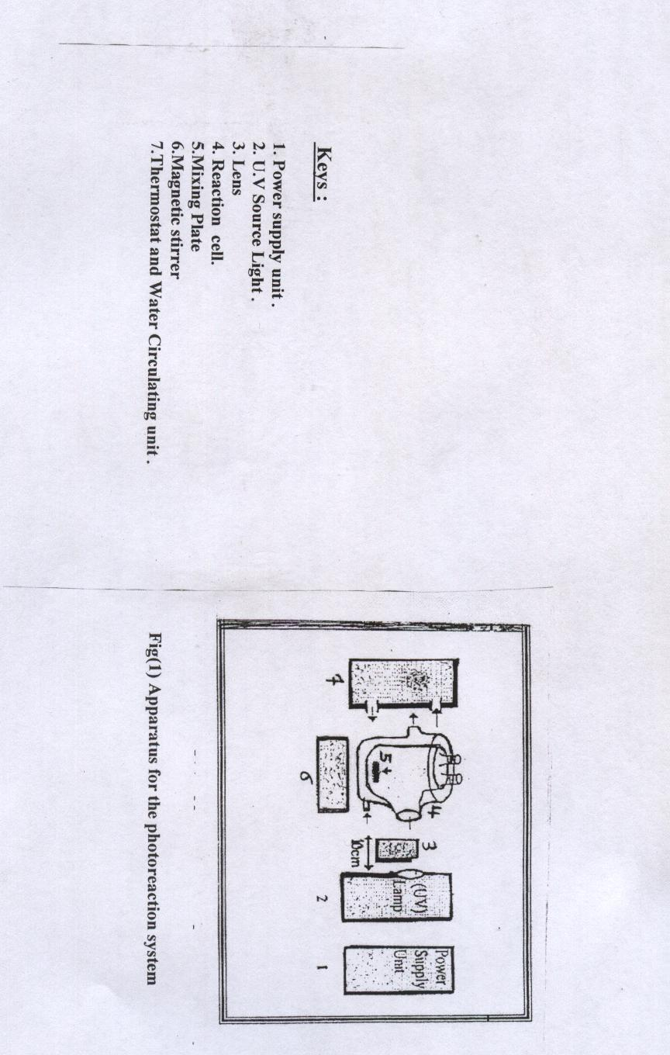
575

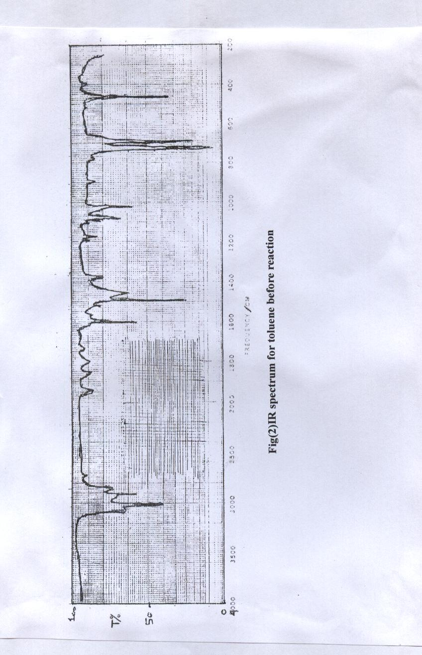

576

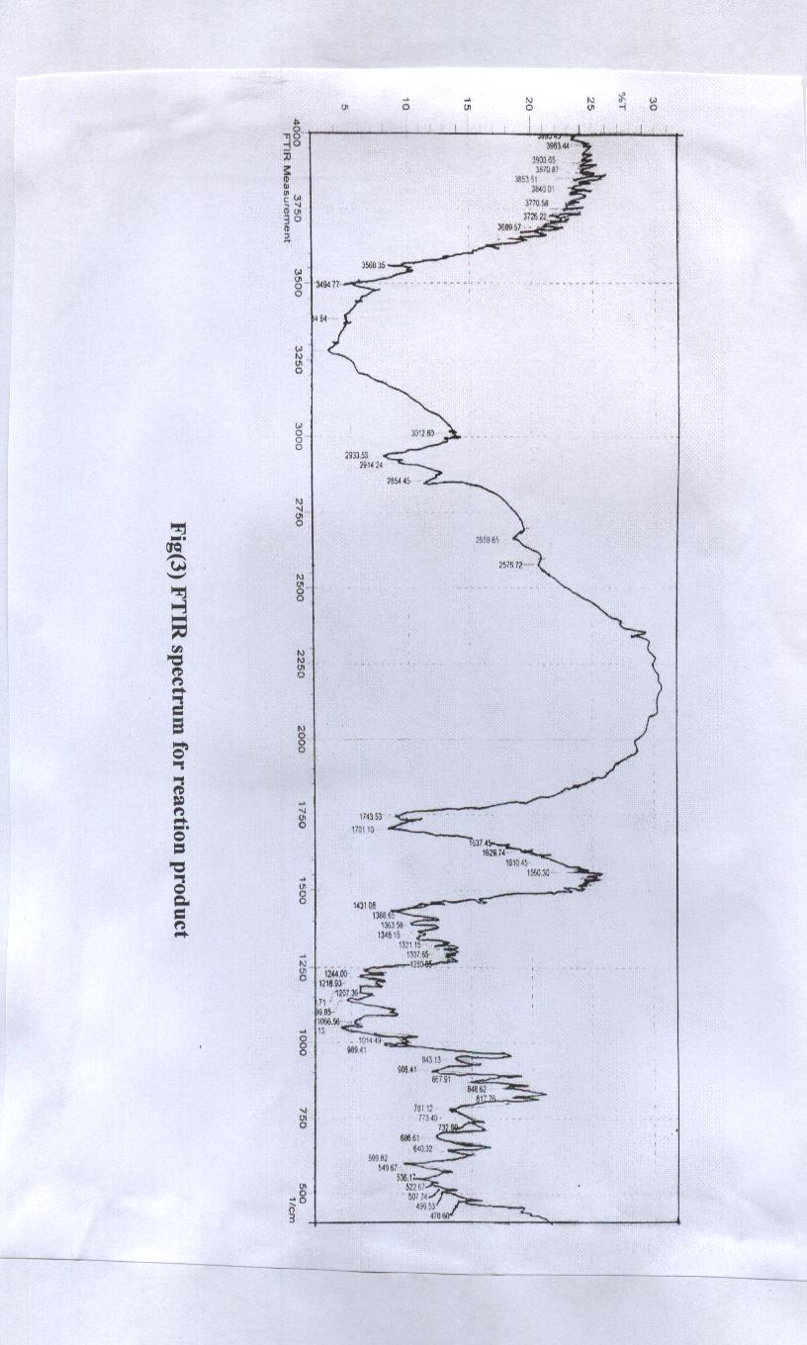

577
578
Conclusions
AS a conclusion , it has been found that the photocatalytic oxidation of toluene to benzoic acid required photocatalyst TiO₂ or ZnO, and ultraviolet light to proceed according to the following reactions .

hυ
NO Product
NO Cat

dark
NO Product
Cat

Cat

hυ

References
- A. Fujishima , and K. Honda, Nature , 1972,37,328.
- S.N.Frank , and A.J. Bard , J.Amer.Chem.Soc,1977,99,303.
- M.Sehiavello, Ed.Photocatalysis , and Environment, Kluwer Academic Publisher
, Dordercht , 1988 ,p.105
- R.M.Alberici ,and W.E.Jardim,Applied Catalysis B: Environmental ,1997,14,55.
- R.Breckenridge,W.Wyatt,J.Phys.Chem.,1963,24,1025.
- I.Bedja,P.V.Kamat,J.Phys.Chem.,1994,48,4133 .
- A.Sirisuk,and G.Anderson ,Catalysis Today , 1999,54,159 .
- J.Herrman,J.Disdier,and P.Pichat,J.Chem.Soc.,Faraday Trans.I,1981,7,2815.
- .V.Kamat,The Spectrum ,1993,p.14 .K.Vinodgopal,and P.V.Kamat,
J.Phys.Chem.,1992,96,5053 .
- F.Sabin,T.Turk and A.Vogler, J.Photochem .Photobiol A:Chem.,1992,63,99.
- N.Serpone,EPANewslestter,1997,59,54.
- F.H.hussien,Ph.D.Thesis,Notingham University, U.K, 1984.
- C.Yogonasimhong,J.Phys.Chem.Soc., Faraday Trans .I,1962,58,1579.
- P.Pichat,Mozzanega and J. Herrman,Nouv .J.Chem.,1982,11,559.
- N.R.Blake,andG.L.Griffin,J.Phys.Chem.,1988,92,5697.
- K.Okamoto,Y.Yamamoto,and H.Tanaka,Bull.Chem.Soc.Jpn., 1985,58,2023.
- D.Bahnemann,D.Bockelman,and R.Goslich,Sol. Energy Mater ., 1991,24,564.
18. Handbook of Chemistry ,and Physic , 57th Edition ,Chemical
Rubber Puplishings,1977,P.B-234,E-104.
19.N.KaKuta , J.White, and M. Finiayson, J.Phys. Chem . ,1985, 89,48.

579

