Lanthanide metal complexes of 1,3,4- thiadiazole ligands

Khalil K. Abid
Department of Chemistry, College of Science, Al-Mustansiryah University

(NJC)

(Received on 25 /10/2006) (Accepted for publication on 15/ 11 /2006)

Abstract
Complexes of Y (III), La(III) and Ce(III) with 2,5-bis (1-thiopentane-2-one) –1,3,4- thiadiazole (TPTD), and 2,5-bis (N, 2-aminopyridyl) –1,3,4- thiadiazole (APYTD) have been prepared and characterized on the basis of chemical analysis by: I.R, UV-visible, C.H.N atomic absorption and molar conductivity. All the complexes have a chemical formula, [M₂L₂X4]X2(X=Cl)
الخلاصة
يتناول هذا البحث تحضير معقدات لأيونات العناصر Ce⁺³, La⁺³, Y⁺³ مع المشتقات 5,2-بس (1- ثايوبنتان-2-اون) 1،3،4- ثايادايازول(TPTD) و 5,2-بس( N,2-امينو بيريدايل) 1,3,4-ثايادايازول(APYTD ) ودراسة المعقدات المحضرة باستخدام التقنيات: التحليل الدقيق للعناصر، الأشعة تحت الحمراء، الأشعة فوق البنفسجية والمرئية، المطياف الذري وكذلك دراسة التوصيلية المولارية لهذه المعقدات من خلال تللك الفحوصات تبين بأنَّ المعقدات تمتلك الصيغة M₂L₂X₆ حيث يمثل X=Cl و M أيونات العناصر Ce⁺³, La⁺³, Y⁺³.

Introduction
A little work has been done concerning the preparation and investigation of the metal complexes having 1,3,4- thiadiazole nucleus. Metal complexes has been used as photographic layer stabilizer ¹, and in marine anti- fouling and anti- corrosion paints ^{2,3}. The ligand has also been used as an analytical reagent in the detection and determination of metal ions ⁴⁻⁶. Mono and disubstituted 1,3,4- thiadiazole ligands and their complexes have pharmacological properties ⁷⁻⁹.
The wide range of application of 1,3,4- thiadiazole ligands aroused our interest in the preparation of a new ligands derived from the reaction of 2,5- dimercapto-1,3,4- thiadiazole and the reagents; Chloro acetone and 2-amino pyridine. These ligands have two adjacent compartment sites; S₂O₂ and N₂N₂ (I and II) which could coordinate to metal ion:

Physical Measurements:

The following physical measurements were carried out for the synthesized ligands and their complexes .
1- Melting point for the ligand and the complexes were measured by Gallenkamp melting point apparatus.
2- Elemental analysis ( C.H.N.) were made at Al-Nahrain University College of Science using Carlo-Erba microanalyser
3- Infra-red spectra were recorded in the 4000-200cm-1 region using a Pye-Unicom 2000 infra-red spectrophotometer with KBr and CsI disc at Ibn-Albitar center laboratories.
4- UV-Visible spectra were carried out in the region 190-800nm at Chem. Department, College of Science, Al-Mustanserya Univ.
5- Molar conductivity was measured on WTW F56 by Platinum electrode with cell constant 1.01cm-1.

Experimental
The ligands were prepared by use the procedure was described as bellow:
* 2,5-bis (1-thiopentane-2-one)- 1,3,4- thiadiazole (TPTD):
In a 100ml round bottom flask a solid 2,5- dimercapto- 1,3,4- thiadiazole (1.5 gm, 10 mmole) and KOH (1.12 gm, 20 mmole) added to (20ml) of absolute ethanol and the resulting mixture was warmed on hotplate and stirred until a white suspension was obtained. A solution of Chloro acetone (1.85 gm, 20 mmole) in (20ml) absolute ethanol was added slowly to the white suspension at room temperature with efficient stirring over 30 minutes (scheme 1).
The mixture was stirred for additional 30 minutes at room temperature, and then refluxed for 15 minutes. A pale yellow crystalline precipitate was filtered off and washed with cold water to remove the adhered mother liquor containing KCl. Recrystallization from absolute ethanol gave off- white crystals (2.2 gm, 85% yield).

Scheme –1-

* 2,5-bis (N-2-aminopyridyl)- 1,3,4- thiadiazole (APYTD):

Solid 2,5- dimercapto- 1,3,4- thiadiazole (1.5 gm, 10 mmole) was dissolved in (25ml) of 1,4-dioxane using a 100ml round bottom flask.To this solution 2-amino pyridine (1.86 gm, 10 mmole) dissolved in (25ml) of 1,4-dioxane was added , and the resulting mixture refluxed for 3 hrs. (scheme 2). A yellow oily layer was formed which solidified on cooling, filtered off and washed with 1,4-dioxane. Recrystallization from absolute ethanol afforded pale crystals (1.65 gm, 65% yield).

Scheme –2-

* Metal complexes of C₈H₁₀N₂S₃O₂ (TPTD) ligand:
A (0.262 gm, 1 mmole) of TPTD was dissolved in (10ml) of absolute ethanol ,this solution was mixed together with a solution containing metal chloride; (YCl₃.6H₂O, LaCl₃.6H₂O and CeCl₃.4H₂O) dissolved in (10ml) of
absolute ethanol . The resulting mixture was refluxed for 1 hr., then cooled and left overnight. A precipitate was obtained which was filtered and then recrystallized from hot absolute ethanol. The fine crystalline were filtered and washed with distilled water, then with small volume of acetone before drying. Physical properties of resulting complexes were presented in table
* Metal complexes of C₁₂H₁₀N₆S (APYTD) ligand:
A (0.27 gm, 1 mmole) of APYTD dissolved in (10ml) of absolute ethanol ,this solution was mixed together with a solution containing metal chloride; (YCl₃.6H₂O, LaCl₃.6H₂O and CeCl₃.4H₂O) dissolved in (10ml) of absolute ethanol . The resulting mixture was refluxed for 30 minutes, then cooled and left overnight. A precipitate was obtained which was filtered and then recrystallized from hot absolute ethanol. The fine crystalline were filtered and washed with distilled water, then with small volume of acetone before drying. Physical properties of resulting complexes were presented in Table-1

Table –1-: Physical properties of 1,3,4- thiadiazole ligands and complexes
No | Symbols | Compound | Yield % | m.p °C | Color | Elemental analysis % calc. (found)
 |  |  |  |  |  | C | H | N | M
1 | TPTD | C₈H₁₀N₂S₃O₂ | 85 | 89 | Off-white | 36.64 (36.92) | 3.81 (3.70) | 10.68 (10.81 | ⎯
2 | Y(TPTD) | Y(C₈H₁₀N₂S₃O₂)Cl₃ | 47 | 191d | White | 20.75 (19.97) | 2.16 (2.41) | 6.05 (5.22) | 20.32
3 | La(TPTD) | La(C₈H₁₀N₂S₃O₂) Cl₃ | 58 | 210d | White | 18.91 (18.30) | 1.97 (1.64) | 5.51 (5.01) | 27.38 (26.11)
4 | Ce(TPTD) | Ce(C₈H₁₀N₂S₃O₂) Cl₃ | 36 | 162d | Off-white | 18.81 | 1.96 | 5.50 | 27.53 (26.48)
5 | APYTD | C₁₂H₁₀N₆S | 65 | 139 | Pale- yellow | 53.33 (53.19) | 3.70 (3.63) | 31.11 (31.54) | ⎯
6 | Y(APYTD) | Y(C₁₂H₁₀N₆S)Cl₃ | 63 | 145d | White | 30.60 (29.78) | 2.12 (2.37) | 17.85 (16.61) | 19.98
7 | La(APYTD) | La(C₁₂H₁₀N₆S)Cl₃ | 72 | 186d | White | 27.93 | 1.94 | 16.29 | 26.96  (25.81)
8 | Ce(APYTD) | Ce(C₁₂H₁₀N₆S)Cl₃ | 45 | 160d | Off-white | 27.87 | 1.93 | 16.26 | 27.10 (26.35)
d*= decomposed

Results and Discussions
Infra-red spectra:
The prepared ligands didnot show any (SH) stretching band in the region (2300-2500)cm⁻¹, which is belong to the original starting material. This clearly indicated that the substitution had taken place on the 2,5 positions. A strong peak for the ligand TPTD was located on 1710 cm⁻¹ assigned to the keto group, and another two strong absorption bands found at 2920 and 2880 cm⁻¹ for the terminal methyl and (>CH2) groups respectively( Fig-1a-). Two weak bands located on 3400 and 2900 cm⁻¹ for the hydroxyl (OH) group and (>C=C<) for the tautomeric form of the ligand (scheme 3). The complexes of this ligand showed a shift in the position of the carbonyl group band by (15-30) cm⁻¹, with the formation of a new absorption bands for the coordination bonds (M-O) and (M-S) in the region (320-400) cm⁻¹⁽¹⁰⁾. Another band attributed to the (M-Cl) bond appeared on the region (220-240) cm⁻¹. All the complexes showed a broad band in the region (3400-3500) cm⁻¹, which can be associated with the molecule of water present in these complexes (Table 2).

Scheme –3-

Table –2-: Major infra- red absorption bands (cm⁻¹) for the ligand TPTD and its complexes

No. | Structure | C=O | M-S | M-O | M-Cl
1 | C₈H₁₀N₂S₃O₂ | 1710vs | - | - | -
2 | Y(C₈H₁₀N₂S₃O₂)Cl₃ | 1700s | 390m | 372m | 240m
3 | La(C₈H₁₀N₂S₃O₂) Cl₃ | 1695 | 365m | 330w | 220m
4 | Ce(C₈H₁₀N₂S₃O₂) Cl₃ | 1692 | 345w | 330w | 225m

For the ligand of APYTD two strong bands at 3230 and 3180 cm⁻¹, assigned for the two (>NH) groups stretching due to the presence of two forms of the ligand (scheme 4). A medium absorption band assigned to the heterocyclic (=CH-) of pyridine was located on 2940cm⁻¹. The strong bands assigned to (>C=N-) stretching of pyridine and the terminal (>C=N-) were found on 1610 and 1660 cm⁻¹ respectively( Fig-1b-). Metal complexes of this ligand exhibit small shift to a lower region (10-15 cm⁻¹) for the two (C=N) stretching, which were weakened as well. No shift recorded for the absorption band of the (NH) group, which indicated that the coordination occurred only through the nitrogen atom of the (C=N)group. A new bands for the coordination bonds; M-N and M-Cl were appeared at 330-350 and 220-230 cm⁻¹ respectively⁽¹¹⁾. (Table 3).

Scheme –4-

Table –3-: Major infra- red absorption bands (cm⁻¹) for the ligand APYTD and its complexes
No. | Structure | C=N | M-N | M-Cl
5 | C₁₂H₁₀N₆S | 1660vs, 1610vs | - | -
6 | Y(C₁₂H₁₀N₆S)Cl₃ | 1650m, 1600m | 335m 440m | 225m
7 | La(C₁₂H₁₀N₆S)Cl₃ | 1645m, 1605m | 330m 420m | 235m
8 | Ce(C₁₂H₁₀N₆S)Cl₃ | 1648m, 1600m | 325m 410m | 230m

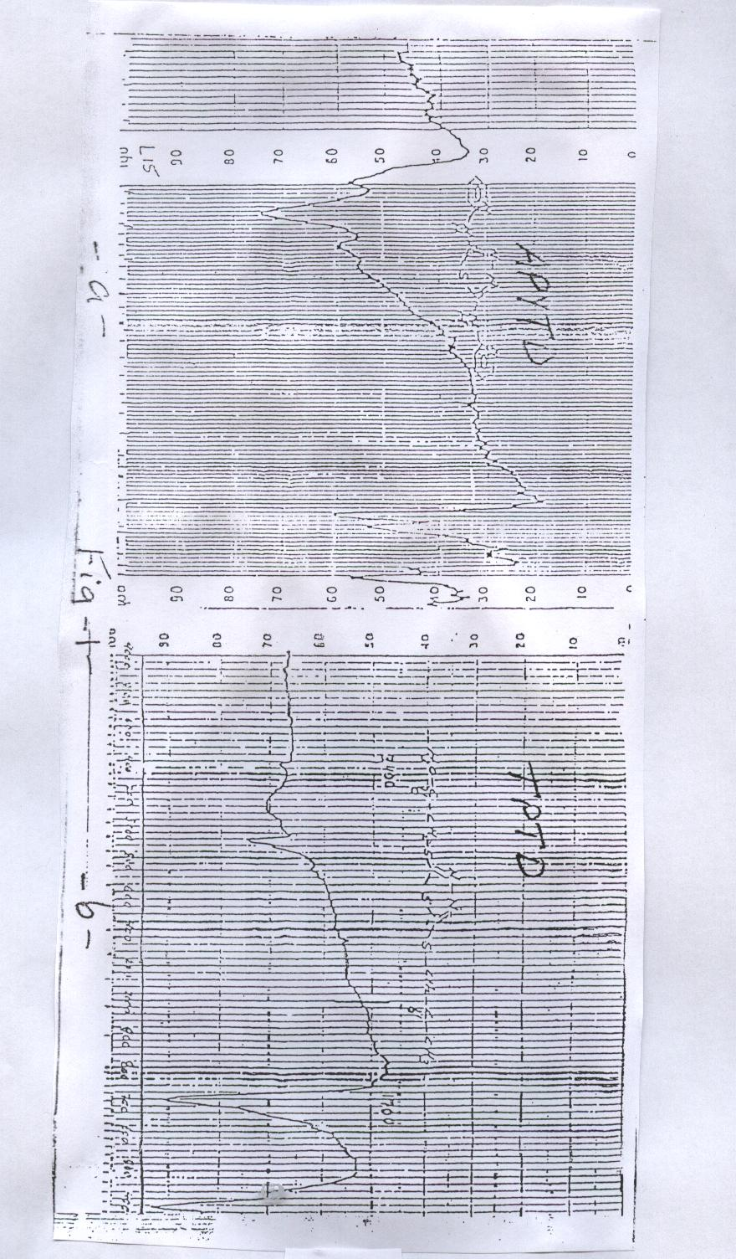

U.V- visible spectra:
The ultra- violet spectrum of 2,5- dimercapto-1,3,4- thiadiazole showed one maximum absorption band on 337 nm ⁽¹²⁾ due to the π-π* of C=S. this band disappeared in both ligands, TPTD and APYTD, due to the substitution occurred on 2,5 positions, and a new bands appeared due to the structure of the substituents attached on these positions. For TPTD a new absorption band found on 290 nm for n-π* of the carbonyl group, while the ligand APYTD showed two absorption bands on 362 and 271.5 nm for the conjucated system of the ligand and the heterocyclic ring aromaticity respectively( Fig-2a and b). Both ligands showed a high intensity for the absorption bands due to the presence of the conjugated system, and the concentration been used to record the spectra was 10⁻⁴ M using DMSO as a solvent. Even though the intensity been higher for the complexes and the concentration of 10⁻⁵ was used to obtain the spectra. Metal complexes of the ligand TPTD showed a small shift to long wave length, while the absorption bands shifted to short wave length for the complexes of the ligand APYTD (Table 4). All the complexes does not show any absorption bands in visible region due to the absence of d-d transition for the metal ions.

Table –4-:Molar Conductivity and Electronic spectral bands (nm) for the ligand TPTD, APYTD and thier complexes
No. | Structure | Molar conductance | λmax
No. | Structure | Λm ohm-1. cm2. mole-1 | 1 | ε mole.L⁻¹.cm-1 | 2 | ε mole.L⁻¹.cm-1
1 | C₈H₁₀N₂S₃O₂ | - | 290 | 19,500 | - | -
2 | Y(C₈H₁₀N₂S₃O₂)Cl₃ | 119 | 302 | 31,610 | - | -
3 | La(C₈H₁₀N₂S₃O₂) Cl₃ | 105 | 291 | 29,340 | - | -
4 | Ce(C₈H₁₀N₂S₃O₂) Cl₃ | 102 | 297 | 30,270 | - | -
5 | C₁₂H₁₀N₆S | - | 362 | 21,260 | 271 | 16,600
6 | Y(C₁₂H₁₀N₆S)Cl₃ | 104 | 346 | 30,100 | 272 | 19,210
7 | La(C₁₂H₁₀N₆S)Cl₃ | 107 | 355 | 29,360 | 271 | 18,460
8 | Ce(C₁₂H₁₀N₆S)Cl₃ | 96 | 342 | 29,860 | 361 | 18,900

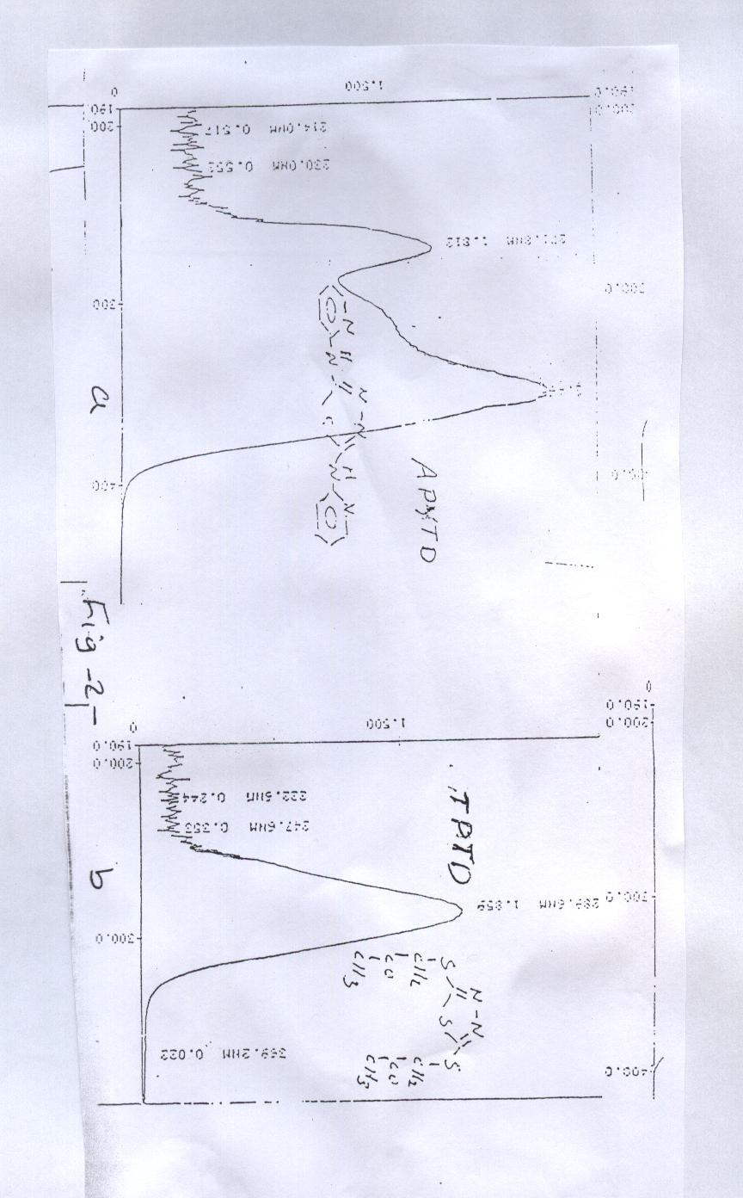

Molar Conductivity:
The molar conductivity of the prepared metal complexes dissolved in dimethyl sulfoxide(DMSO) have a concentration of (10⁻³ M) was determined. All the complexes shows a high molar conductance corresponding to two chloride ions not coordinated directly to the metal ions ¹³⁻¹⁴, and that give as an information about the coordination sphere of the complexes( Table-4-).
Molar Conductivity was increased as the concentration decreased for the conductance complexes, due to that at infinite dilution (zero concentration) the chloride ion act completely independently of each other. Plotting the values of molar conductivity against the square root of the concentration “Fig. –3”, showed a slope line for weak electrolyte for all the complexes as a result for the relation between the negative ions (chloride) and the positive ion (complex ion).

Λ_{m}
×10⁻³

Fig-3-

Conclusion
After the combining all the physical measurements that carried out for the ligands and their complexes, the chemical structures, geometry and the type of bonding of the prepared ligands and complexes can be suggested as shown in “Fig. –4a and b” which indicate ionic nature of the complexes with an octahedral geometry.

.2X

.2X

References

1- Eyva and E. Z. Wiss; Photogr. Photophys. Photochem., (1967),60, 145.
2- N. Rajendran, K. Ravichandran and S. Rajeswari; Anticorrosion method and materials, (1995) 42, 8.
3- M. Nagasawa; U.S. Patent, 1966, 3, 268, 347.
4- Z. Fresentus; Anal. Chem., 1968, 239(2), 87.
5- K. G. Majumdar; J. Ind. Chem. Soc., 1942, 19, 308.
6- G. A. Pnevmaticakis and E. C. Statnis; Chem. Ind., 1963 1240.
7- G. Maffii, E. Tesla and R. Ettorre; H. Farmaco, Ed. Scientifica, (1958). 13, 187 .
8- E. Tesla, G. G. Gallo, F. Fava and G. Weber; Gazz. Chim. Ital., 1958, 88, 812 .
9- M. M. Ciotti, S. R. Humphrey, J. M. Venditti, N. Kaplan and A. Goldin; Cancer Research, 1960, 20, 1195.
10- A. C. Fabretti, g. C. Franchini and G. Peyronel; Trans. Metal Chem., 1982, 7, 105.
11- M. R. Gajendragad and U. Agarwala; Aust. J. Chem., 1975, 28, 763.
12- J. Sandstrom; Acta Chem. Scand., 1961,15, 1300 .
13- A. Z. Al-Rubaie, H. A. Al-Shirayda, P. Granger and S. Chapella; J. Organometallic Chem., 1985, 287.
14- J. D. M. Cullongh; Inorg. Chem., 1975, 14, 1142 .

