Transition metal complexes of 1,3,4- Oxadiazole ligands

Najat Al- Obaidy, Khalil K. Abid, Yusra J. Al- Niami
Department of Chemistry, College of Science, Al-Mustansiryah University

(NJC)

(Received on 25 /10/2005) (Accepted for publication on 15/ 11 /2006)

Abstract
Some transition metal ions Cr(III) , Mn (II), Fe(III) Co(II)and Cu(II), were used to prepare complexes with a new ligand [2-(acetyl methyl thio)-5- (o-hydroxy phenyl) –1,3,4- oxadiazole. These complexes were characterized by using: I.R, UV-visible spectroscopy, Atomic absorption, molar conductivity and Magnetic susceptibility measurements.
الخلاصة
استخدمت بعض أيونات العناصر الانتقالية Cu⁺², Co⁺², Fe⁺³, Mn⁺², Cr⁺³, , في تحضير معقدات مع المشتق الجديد [2-(اسيتايل مثيل ثايو)-5- (اورثو هايدروكسي فنيل) 1،3،4- اوكسادايازول. وقد تم تشخيص هذه المعقدات من خلال إجراء الفحوصات: الأشعة تحت الحمراء، الأشعة فوق البنفسجية والمرئية، المطياف الذري، التوصيلية المولارية والحساسية المغناطيسية.

Introduction
Three main derivatives of 1,3,4- Oxadiazole were prepared “I, II, III”⁽¹⁾, and from these three derivatives a large number of compounds were prepared depending upon the nature and type of the substituents on the position 2 and 5⁽²⁻⁶⁾.

We concentrated our attention on derivative I due to the presence of biological activity of the thiol group, and the ligand ability to form complexes with many transition metal ions⁽⁷⁾. Derivative I can exist in two tautomeric forms Ia and Band the shift to any one form might be induced by reaction conditions.

Complexes of some transition metals were prepared with different derivatives of I⁽⁸⁻¹⁰⁾, like 2- thiolaetic acid -5- phenyl-1,3,4- oxadiazole with the metal ions; Co⁺², Ni⁺², Cu⁺², Cd⁺², and the analysis of the complexes were assigned an octahedral geometry (IV).

IV

Other complexes with dimer forms were also prepared with hydroxyl binding bridges⁽¹¹⁾ (V).

Derivatives of compound I and its complexes exhibit biological activity and medical uses as drugs ⁽¹²⁻¹⁵⁾, and this encourage searchers to prepare new derivatives and complexes and to study their biological activity .
Physical Measurements:- The following instruments were used in the physical measurements of the ligand and it's complexes:
1-C.H.N. analysis were measured by using Elemental Analyser EA1108
2-Metal percentage was identified using Flame Atomic Absorption
3-m.p for the ligand and the complexes were measured by using Gallenkamp MFB-600 Melting Point Apparatus
4- Spectroscopic Measurements : Hitachi U.V. Spectrophotometer was used for Electronic spectra (1100-200nm), while the Infra-red Spectra were measured using Pye Unicam Spectrophotometer(4000-200)cm-1 with KBr disc for the ligand and CsI for the complxes.
5- Molar Conductivity were calculated for the complexes using DMSO as a solvent and the instrument(Electrolytic Conductivity Measuring Set Model MC-1-Mark V).
6- Magnetic Measurements with Faraday Method were measured for the complexes using the instrument ( Balance Magnetic Susceptibility ).

Practical work:
a- Preparation of the ligand “2-(acetyl methyl thio)-5- (o- hydroxy phenyl) 1,3,4- oxadiazole
(1.94 gm, 10 mmole) of 2-(acetyl methyl thio)-5- (o- hydroxy phenyl) 1,3,4- oxadiazole and (0.561 gm, 10 mmole) of KOH were dissolved in absolute ethanol. The mixture then warmed with water bath and stirring until a white suspension is formed. (0.804 gm, 10 mmole) of 1- chloro acetone dissolved in (20 ml) absolute ethanol was added to the suspention with stirring at room temperature for 30 minutes and then refluxed for additional 30 minutes. The resulting precipitate filtered then washed with cold water to remove the adhered KCl. Recrystallization from absolute ethanol gave white crystals (2.11 gm, 84% yield), (scheme 1).

Scheme –1-

b- Preparation of the complexes:
One mmole of the metal chloride (MnCl₂.4H₂O, CoCl₂.6H₂O, FeCl₃ and CrCl₃.6H₂O) dissolved in (10ml) of absolute ethanol and (2mmole) of the ligand (one mmole in case of Cr⁺³ complex) dissolved in (10ml) of absolute ethanol were mixed and the mixture refluxed for 1 hr., cooled and filtered. Recrystallization from hot absolute ethanol afford a fine crystals. For Ni⁺² complex the mixture was stirred at room temperature for 30 minutes, and the product was recrystallized form “DMSO/ Ethanol, 50/50”. Table -1- show some physical properties of the prepared complexes:

Table –1-: Physical properties of the ligand and complexes
Symbol | Molecular Formula | Nomenclature | Yield % | m.p °C | Color
A₁ | [Cr(C₁₁H₁₀N₂O₃S)Cl₃] | Tri chloro[2- (acetyl methyl thio) –5- (o-hydroxy phenyl) 1,3,4- oxadiazole] Chromium (III) | 59 (0.240) | 298-288 | Light green
A₂ | [Mn(C₁₁H₁₀N₂O₃S)₂]Cl₂ | Bis [2- (acetyl methyl thio) –5- (o-hydroxy phenyl) 1,3,4- oxadiazole] Manganese (II) chloride | 60 (0.751) | 258-256 | White
A₃ | [Fe₂(C₁₁H₁₀N₂O₃S)₂Cl₄]Cl₂ | μ- Tetra chloro bis [2- (acetyl methyl thio) –5- (o-hydroxy phenyl) 1,3,4- oxadiazole] di Iron (III) chloride | 67 (0.552) | Over | Black
A₄ | [Co(C₁₁H₁₀N₂O₃S)₂]Cl₂ | Bis [2- (acetyl methyl thio) –5- (o-hydroxy phenyl) 1,3,4- oxadiazole] Cobalt (II) chloride | 45 (0.56) | 292-290 | Light green
A₅ | [Ni(C₁₁H₁₀N₂O₃S)₂]Cl₂ | Bis [2- (acetyl methyl thio) –5- (o-hydroxy phenyl) 1,3,4- oxadiazole] Nickel (II) chloride | 52 (0.654) | 250d | Light green

d*= decomposed

Results and Discussions:
Infra-red spectra:
The ligand VI showed a weak band at 2327cm⁻¹ referring to S-H stretching bond ⁽²⁾, which subsequently disappeared in the prepared ligand VII indicating a substitution occurred on position 2, and a new absorption band appeared at 1700, 2852 and 2922 cm⁻¹ referring to the stretching frequency of the keto (>C=O), methyl (>CH) and terminal methyl (-CH₃) groups( Fig-1).

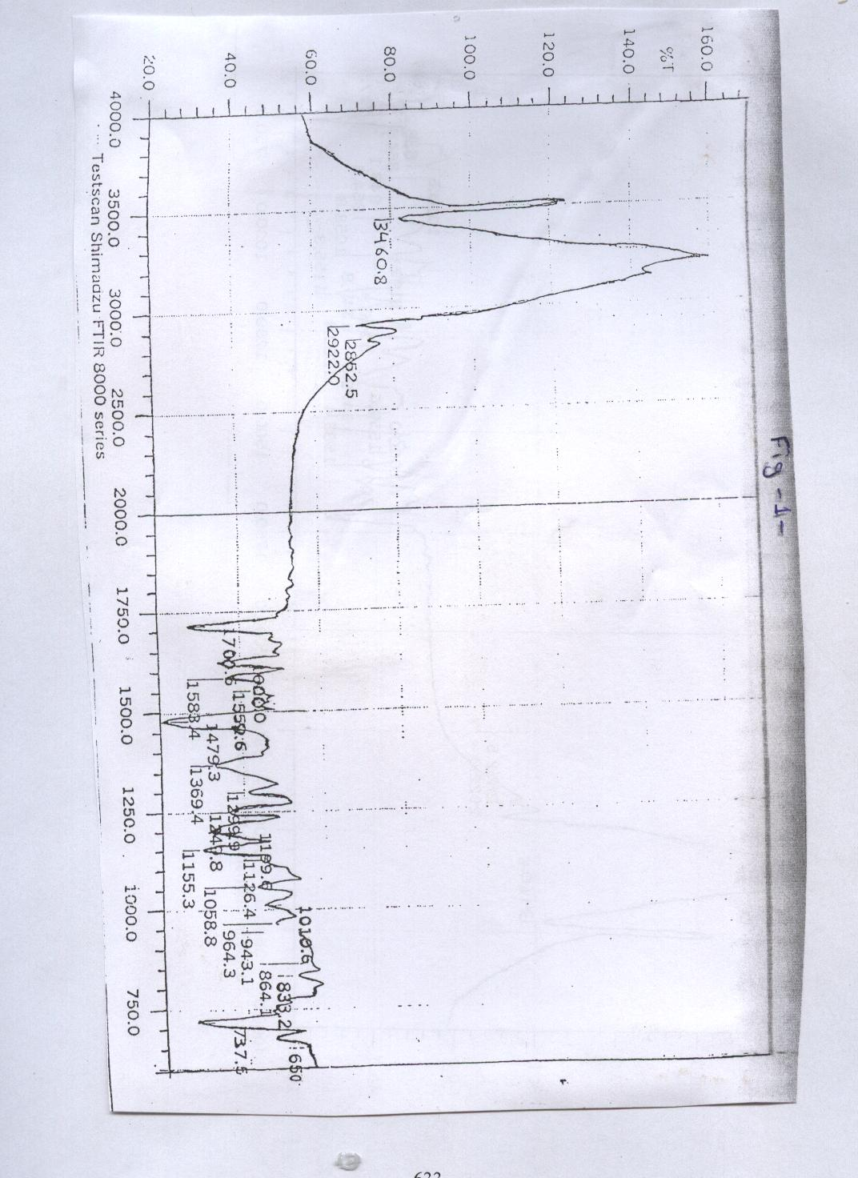

The complexes showed some shifts in the stretching frequencies of the main absorbing bands “ν_{C-S}, ν_{C=O}, ν_{C=N}” and the shifts was download for some complexes and upwards for the others, indicating the formation of the coordinating bonds by with N, O and S atoms ^{(16,17)}, and that was supported by the appearance of a new bands in the region (200-600) cm⁻¹ ^{(18,19)}. Also detected the non-ligand band for M-Cl bond in the region (233-289) cm⁻¹ ⁽²⁰⁾, and the bridging M-Cl-M for Fe⁺³ complex at the region 215 cm⁻¹ ⁽²¹⁾. Table –2-.

Table –2-: Major infra- red absorption bands (cm⁻¹) for the ligands and its complexes
No. | Compounds | υ_{C=O} | υ_{C=N} | υ_{C-S} | υ_{M-N} | υ_{M-S} | υ_{M-O} | υ_{M-Cl} | υ_{M-Cl-M}
L₅ | C₈H₁₀N₂S₃O₂ | 1700 | 1600 | 737 650 | _ | _ | _ | _ | _
A₁ | [Cr(C₁₁H₁₀N₂O₃S)Cl₃] | 1716 | 1618 | 719 678 | 464 | 356 333 | 576 | 233 289 | _
A₂ | [Mn(C₁₁H₁₀N₂O₃S)₂]Cl₂ | 1718 | 1625 | 719 675 | 543 | 327 | 572 | _ | _
A₃ | [Fe₂(C₁₁H₁₀N₂O₃S)₂Cl₄]Cl₂ | 1720 | 1615 | 700 715 | 490 | 335 370 | 500 | 250 | 215
A₄ | [Co(C₁₁H₁₀N₂O₃S)₂]Cl₂ | 1718 | 1625 | 719 677 | 505 | 324 | 572 | _ | _
A₅ | [Ni(C₁₁H₁₀N₂O₃S)₂]Cl₂ | 1720 | 1618 | 750 | 4747 | 368 | 576 | _ | _

Continuous variation method for detecting the chemical formula of the prepared complexes were applied, and it showed that the complexes were coordinated with 2:1 “ligand: metal” for the metal ions (Ni⁺², Co⁺² and Mn⁺²) and 1: 1 for the metal ions (Fe⁺³, Cr⁺³), Figure -2- a and b.

V_{m} | V_{L} | Abs.
10 | 0 | 0
9 | 1 | 0.13
8 | 2 | 0.35
7 | 3 | 0.5
6 | 4 | 0.71
5 | 5 | 0.93
4 | 6 | 0.693
3 | 7 | 0.421
2 | 8 | 0.213
1 | 9 | 0.111
0 | 10 | 0

L: Fe⁺³ (λ_{max}= 552 nm)

V_{m} | V_{L} | Abs.
10 | 0 | 0
9 | 1 | 0.181
8 | 2 | 0.392
7 | 3 | 0.592
6 | 4 | 0.782
5 | 5 | 0.962
4 | 6 | 0.773
3 | 7 | 0.595
2 | 8 | 0.391
1 | 9 | 0.16
0 | 10 | 0

L: Cr⁺³ (λ_{max}= 405 nm)
Figure –2-: Continuous variation slop for Fe⁺³ and Cr⁺³ ions

Magnetic measurements:
Magnetic suseptibiliy were measured for the prepared complexes, the complexes (Cr⁺³, Mn⁺², Co⁺² and Ni⁺²) showed magnetic moment values of (6.9, 5.98, 2.9 and 4.7) B. M. which are very close of the theoretical values for the octahedral configurations ^{(22,23)}, while the Fe⁺³ complex showed magnetic moment of 0.0 B.M, which mean that the complex had a diamagnetic properties with octahedral configuration “dimer” ⁽²⁴⁾. Table –3-.
Molar Conductivity:
The molar conductivity for the complexes were measured. With the concentration of (10⁻³ M) in DMSO. Some of the complexes showed very little value and good value for the others, Table –3-. And the presence of chloride ion outside of the coordinated sphere was checked by using AgNO₃ solution.

Table –3-:Molar conductivity and Magnetic measurements for the complexes
Symbol | Structure | Molar conductivity | μ _{eff} (B.M) | Geometry
A₁ | [Cr(L₁)Cl₃] | 25 | 3.69 | o.h
A₂ | [Mn(L₁)₂]Cl₂ | 88 | 5.98 | o.h
A₃ | [Fe₂(L₁)₂Cl₄]Cl₂ | 163 | 0 | (o.h)₂
A₄ | [Co(L₁)₂]Cl₂ | 65 | 4.7 | o.h
A₅ | [Ni(L₁)₂]Cl₂ | 72 | 2.95 | o.h

Electronic spectra:
The electronic spectra for the ligand showed three bands at 304, 256 and 224 nm corresponding to the electronic transition n-π* for C=O, π-π* for C=N and π-π* for C=S which interact with π-π* of C=N ⁽²⁵⁾ ( Fig-3-).
Three bands for the Cr⁺³ complexes detected at 16292, 23096 and 26595 cm⁻¹ corresponding the transition of $A_{2}g_{(F)}\vec{ν_{1}}T_{2}g_{(F)}$, $A_{2}g_{(F)}\vec{ν_{2}}T_{1}g_{(F)}$ and $A_{2}g_{(F)}\vec{ν_{3}}T_{1}g_{(P)}$ respectively, and that agree with octahedral configuration ⁽²⁶⁾. Three bands as well detected for Mn⁺² complex in the regions 32786, 38314 and 44444 cm⁻¹ for the transition $A_{1}g_{(F)}\vec{ν_{1}}T_{1}g^{4_{(G)}}$, $A_{1}g\vec{ν_{2}}E_{1}g^{4}A_{1}g_{(G)}$ and $A_{1}g\vec{ν_{3}}T_{1}g^{4_{(F)}}$ respectively, and again these value agree with octahedral configuration⁽²⁷⁾. A broad band in the region 450-650 nm containing three bands corresponding to the transitions $A_{1}g\vec{ν_{1}}T_{1}g_{(G)}$,$A_{1}g\vec{ν_{2}}{\text{Eg}}^{4}A_{1}g_{(G)}$and $A_{1}g\vec{ν_{3}}{\text{Eg}}_{(D)}$ at the 17271, 22421 and 27777 cm⁻¹ respectively. These values agree with the octahedral configuration ⁽²⁸⁾ (low spin). Again the cobalt complex showed three bands in the regions 16393, 21321 and 28571 cm⁻¹ corresponding to the transition$T_{1}g_{(F)}\vec{ν_{1}}T_{2}g_{(F)}$, $T_{1}g_{(F)}\vec{ν_{2}}A_{2}g_{(F)}$ and $T_{1}g_{(F)}\vec{ν_{3}}T_{1}g_{(P)}$ respectively and these values agree with the octahedral configuration ⁽²⁹⁾ (high spin), while Ni⁺² complex showed only two bands in the region 18214 and 26385 cm⁻¹ corresponding to the transition $A_{2}g\vec{ν_{3}}T_{1}g_{(P)}$ and $A_{2}g\vec{ν_{2}}T_{1}g_{(F)}$respectively. The first band did not appear but we measured it theoretically at the region 10910 corresponding to the transition $A_{2}g_{(F)}\vec{ν_{1}}T_{2}g_{(F)}$and these values agree with the distorted octahedral configuration ⁽³⁰⁾, Table –4-.

Table –4-: Electronic spectra bands (nm) for the ligand and the complexes
Symbol | Band I |  | Band II |  | Band III |  | Charge transfer |  | Geometry
Symbol | λ_{max} | υcm⁻¹ | λ_{max} | υcm⁻¹ | λ_{max} | υcm⁻¹ | λ_{max} | υcm⁻¹ | Geometry
L₁ | 304 | 32894 | 256 | 39062 | 224 | 44642 | ⎯ | ⎯ | ⎯
A₁ | 613 | 16292 | 432.9 | 23096.3 | 376 | 265957 | 305 | 32786.8 | O.h
A₂ | 305 | 32786 | 261 | 38314 | 225 | 44444 | ⎯ | ⎯ | O.h
A₃ | 579 | 17271 | 446 | 22421 | 360 | 27777 | ⎯ | ⎯ | (O.h)₂
A₄ | 610 | 16393.4 | 469 | 21321 | 350 | 28571.4 | ⎯ | ⎯ | O.h
A₅ | 916 | 10910 | 549 | 18214 | 379 | 26385 | ⎯ | ⎯ | O.h

Conclusion
According to all the chemical and physical measurements as the prepared complexes, we can suggested the chemical configuration for the complexes as shown in the figures 4, 5 and 6.

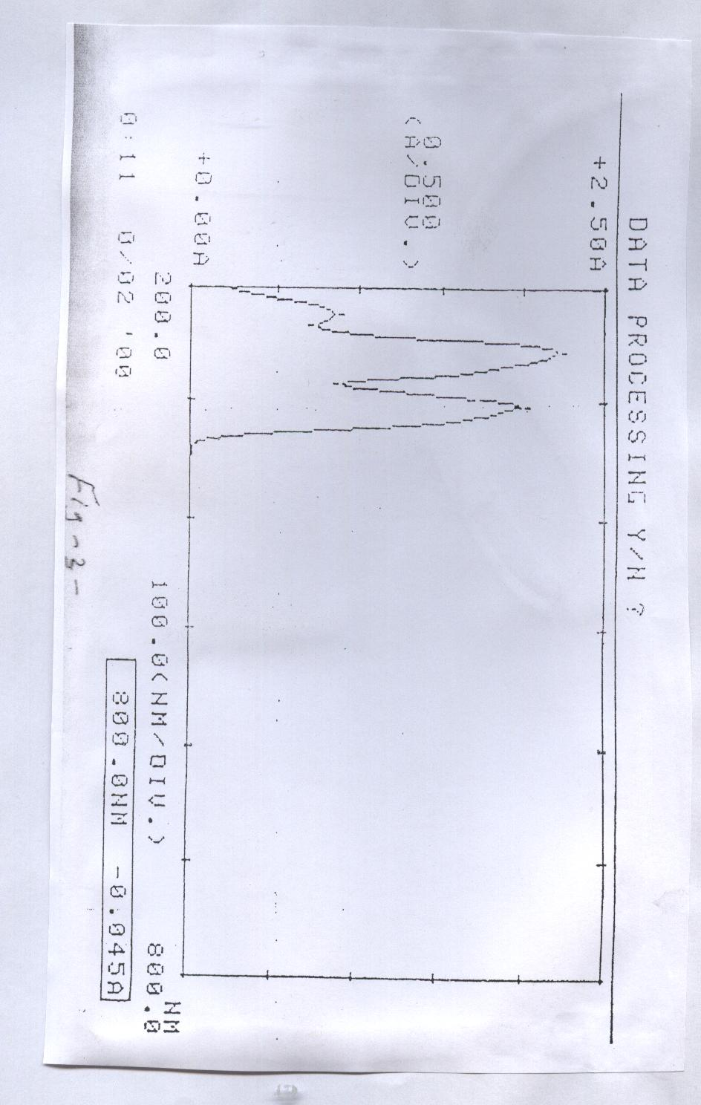

Figure: -4-
Figure:-5- where: M= Mn⁺², Co⁺², Ni⁺²

Figure:-6 -

References
1- A. R. Katritzky, “The Chemistry of Heterocyclic Compounds”, vol. 17, p: 183-224, 6th ed., (1978); 3rd ed., (1986).
2- G. Rama Rao, K. Mogilaiah and B. Sreenivasulu, Indian J. Chem., vol. 35B, p: 339-344, April (1996).
3- Hassan A. Al-bar, Mohamad S. I. Makki and Hassan M. Faidallah, Indian J. Chem., 1996, 35B, 23, Jan.
4- B. S. Vashi, D. S. Metha and V. H. Shah, Indian J. Chem., 1996, 35B, 111, Feb..
5- G. S. Gadaginamath, S. A. Patil and A. S. Shyadligevi, Indian J. Chem., 1996, 35B, 681, July .
6- L. D. S. Yadar, Sandhya Saigai and Supriya Shukla, Indian J. Chem., 1996, 35B, 385, April.
7- Kadhim K. Al- Janabi, Fuad H. Kamel, Ahmmad M. Al- Meshhadani and Khalid T. Al- Rasoul, Iraqi J. Chem., 2001, 27, no. (2), 325.
8- W. David Ollis “Hetrocyclic Compounds”, p: 2-122 (1976).
9- Frederick Kurzer and Michael Wilknson, Chemical Reviews, (1970).
10- A. R. Katritzky, “Hetrocyclic Compounds”, (1997).
11- Lallan Mishra and Mustafa Kamil Said, Indian J. Chem., 1996, 35A, 304.
12- H. Shaihaja Rani, K. Mogilaiah, J. Sudhakar Rao and B. Sreenivasulu, Indian J. Chem., 1996, 35B, 745, July.
13- Anil K. Sengupta and Madhuri Goyal, J. Indian Chem. Soc., 1983, LX, 766, August.
14- El- Sayed H., El-Tamaty, Mohy E. Abdel- Fattah and Ibrahim M. El- Deen, Indian J. Chem., 1996, 35B, 1067, Oct.
15- Hansong Chen, Ahengmingli and Yufeng Han, J. Agric Food Chem., 2000, 48, 5312.
16- Patricia Gomez- Saiz, Javier Garcia- Tojal, Miguel A. Maestro, Francissco J. Arnaiz and Teofilo Rojo, Inorg. Chem., 2002, 41, 1345.
17- K. N. Thimmaiah, G. T. Chandrappa, Winston D. Lloyd and Cyril Parkanyi, Inorganica Chimica Acta, 1985, 107, 1.
18- A. Jassim, A. J. Abdul- Ghani and G. A. Alwan, I. J. of Chem., 2001, 27, no. 1, 135.
19- Z. Muhi- Eldeen, Al- Obaidi, M. Nadir, and Vf. Roche, Med. Chem., 1992, 27, 101.
20- Lallan Mishra, Ashok Kumar, Pandey and Rajendra Prasl Singh, Indian J. Chem., 1992, 31A, 195, March.
21- Lallan Mishra, Mustafa Kamil Said, and Koichi Takeya, Bioorganic and Medicinal Chemistry, 1995, 3, Issue 9, 1241, Sep.
22- ديفيد نيكلس، ترجمة د. وسام إبراهيم عزيز "المعقدات وعناصر الدورة الانتقالية الأولى" الطبعة العربية (1988).
23- A. M. Saade and A. Mihsan “Inorganic and coordination Chemistry” Arabic Version (1988).
24- Muthar Y. M., Iraqi J. of Sciences, 1999, 40A, No.(1).
25- A. b. P. Lever “Inorganic Electronic spectroscopy”, Elsevir Amsterdam London (1968).
26- M. S. Patial and J. R. Shah, Indian J. Chem. Soc., 1981, LVIII, 944.
27- R. K. Lonibala and T. R. Rao, Proc. Indian Acal. Sci., (Chem. Sci.), vol. III,
28- J. C. Bailer, H. J. Emeleus and R. Nypholm “Comperhenisve Inorganic Chem.” Pergamon Press (1973).
29- N. B. singh and J. Singh, J. Inorg. Nucl. Chem., 1979, 41, 1384.
30- N. N. green Wood and A. Eamshaw “Chemistry of the Elements” Perganmon Press (1986).

