Thermal Decomposition of Lanthanum
O-Hydroxybenzoate and O-Bromobenzoate

Hadi Hessen Jusim, Abed Al- Kader. M.N and Mustaffa .Taha
Chemistry Department, College of Science, Mustansiriah University, Baghdad, Iraq.

(NJC)

(Received on 15/4 /2006) (Accepted for publication on 15/11/2006)

Abstract
The conditions of thermal analysis of Lanthanum -O-Hydroxybenzoate and Lanthanum -O-Bromobenzoate were studied .
The Hydrated complexes lose water of crystallization in two steps . Lanthanum -O-Hydroxybenzoate starts to lose water of crystallization between (60-230)ºC , but Lanthanum -O-Bromobenzoate loses water of crystallization between (100-320)ºC .
The intermediate products La₂O₃(OHC₆H₄COO)₅ and La₂(BrC₆H₄COO)₆ were obtained by heating the two complexes at(320-350)ºC and (320-380)ºC respectively . In the fourth step , anhydrous structures of the complexes decomposed in one step and then were transformed to La₂O₃ . These results are using TG,DTG,DTA,IR and (X – ray) diffraction techniques . DTA curves revealed exothermic peaks for the decomposition steps , but endothermic peaks were obtained from the dehydration of complexes .
الخلاصة
درست في هذا البحث ظروف التحلل الحراري لكل من المعقدين اورثوهيدروكسي بنزوات اللنثنم المائية واورثوبروموبنزوات اللنثنم المائية . وتبين ان المعقدين يفقدان ماء التبلور في خطوتين منفصلتين ، وان المعقد اورثوهيدروكسي بنزوات اللنثنم يفقد ماء التبلور عند التسخين ما بين (60-230)ºم ولكن المعقد اورثوبروموبنزوات اللنثنم فقد ماء التبلور عند التسخين ما بين (001-320)ºم ، وتم الحصول على نواتج وسطية هي La₂O₃(OHC₆H₄COO)₅ , La₂(BrC₆H₄COO)₆ كخطوة ثالثة عند تسخين المعقدين منزوعي الماء ما بين (350-320) ºم و (380-320) ºم على التوالي .
اما الخطوة الاخيرة فتضمنت تحلل التراكيب في الخطوة السابقة بخطوة واحدة انتهت بتكوين اوكسيد اللنثنم La₂O₃ . تم الحصول على هذه النتائج باستخدام تقنيات كل من IR,DTA,DTG,TG وحيود الاشعة السينية (X-RAY) ، واظهرت منحنيات التحليل الحراري التفاضلي DTA قمماً باعثة للحرارة في خطوات التحلل في حين اظهرت قمماً ماصة للحرارة في خطوتي نزع ماء التبلور من المعقدين .

Introduction
Lanthanum-O- Hydroxybenzoate ( La(OHC₆H₄COO)₃.3H₂O) was known by Soge et. al ^{(1,2)} and lost water of crystallization at 220ºC Sove et.al^{(3,4)} have obtained anhydrous complexes of Lanthanum -O-Hydroxy-benzoate at 320 ºC . Prozorovskaya et al.^{(5,6)} studied the thermal decomposition of Lanthanum-O- Bromobenzoate by TG and IR spectra and determined its density and solubility in water and dilute acids. Matyukhin et al ⁽⁷⁻⁹⁾ studied water of crystallization in Lanthanum –O-Hydroxybenzoate and Lanthanum –O- Bromobenzoate by TG , DTG , DTA , X-ray , and IR spectra. The aim of this work is to anextension the study of thermal decomposition of these complexes in air atmosphere .
Experimental
Lanthanum -O-Hydroxybenzoate precipitate⁽³⁾ was prepared in decomposition reaction by adding equivalent amounts of 0.2 M solutions of O-Hydroxybenzoate at pH 4.3 to a hot solution of La(NO₃)₃ at pH 3.8 .
The precipitate formed was heated in water solution for two hours , filtered off , washed with water and dried at 50 ºC .
Lanthanum -O- Bromobenzoate precipitate⁽³⁾ was prepared by adding equivalent amounts of 0.2 M solution of O-Bromobenzoate at pH 4.2 to a hot solution of La(NO₃)₃ at pH 3.8 . The precipitate was heated in water solution for two hours , filtered off , washed and dried at 60ºC .
The stability of the prepared complexes was studied by thermal decomposition in air atmosphere by TG , DTG , and DTA .
The TG , DTG and DTA curves were recorded . The measurements were made on a derivatograph at a heating rate of 10 deg. Min⁻¹ . The samples were heated in air atmosphere in platinum crucibles .
The results are compiled in table (1) and the typical thermograms are illustrated in fig(1) . The water content was determined from the TG and DTG curves and the elemental analysis data are given in table (2) .
The carbon and hydrogen content of the prepared complex were determined by elemental analysis using V₂O₅ as an oxidizing agent⁽⁶⁾ .
The bromine content was determined by the schoniger method⁽⁴⁾ . The Lanthanum content was determined from the TG and DTA curves by converting the complexes into La₂O₃ at 550ºC .
The thermal decomposition of the compounds were studied by Derivatograph (Q- 1500 D ) Hungarian Optial works MOM Budapest , in platinum crucible , at temperatures 20-1000 ºC and heating rate of 10 deg / min , FTIR Spectroscopy using ( Perkin – Elmer 684 infrared Spectro-photometer , and X-ray diffraction using (Philips Corporation type PW 1051 / 30 ) on the data in cluded in the ASTM cards .
Result and discussion
Thermal studies of Lanthanum -O- Hydroxybenzoate (La(OHC₆H₄COO)₃. 3H₂O ) were obtained by heating in air atmosphere and the decomposition occurred in four steps .
In the first step it begins to lose water of crystallization at low temperature (60-170 ºC ) which lost two molecules .

60-170 ºC
La(OHC₆H₄COO)₃. 3H₂O La(OHC₆H₄COO)₃. H₂O + 2 H₂O
The third water molecule is lost at 210-230 ºC and the anhydrous salt is formed . Therefore , the water molecules are bound in different forms .
210-230 ºC
La(OHC₆H₄COO)₃. H₂O La(O HC₆H₄COO)₃ + H₂O

The water molecules of crystallization lost between 60-170 ºC may be outer sphere , but the third water molecule is coordinated in the inner sphere .
The two steps of dehydration are endothermically steps , as shown in DTA curve ( fig 1 ) .
The anhydrous Lanthanum -O- Hydroxybenzoate that was heated at the third step between 320-350ºC is transformed exothermally to La₂O₃(OHC₆H₄COO)₅ in the presence of air , as follows :
16.5 O₂

4La(OHC₆H₄COO)₃ 2La₂O₃(OHC₆H₄COO)₅ + 14CO₂ + 5H₂O

These results suggest that Lanthanum -O- Hydroxybenzoate exists as a dimer in this temperature range . Which was confired by the X-ray diffraction .

Table (1) Elemental analysis of La₂O₃(OHC₆H₄COO)₅ complex .
Elemental analysis | La % | C % | O % | H %
Found | 26.52 | 42.71 | 28.39 | 2.39
Calculated | 27.497 | 41.543 | 28.486 | 2.472

The DTA curve in this study recorded exothermic peak between 210 ºC due to polymorphic transformation⁽⁶⁾.
The fourth step , the anhydrous Lanthanum Hydroxybenzoate decomposes exothermically to La₂O₃ between 400-550 ºC , Which were obtained in TG and DTA curves , (Fig 1) were observed by X-ray diffraction and ASTM cards .
Lanthanum -O-Bromobenzoate [La₂(BrC₆H₄COO)₃.2H₂O] was studied on heating in air at mosphere in five steps .
In the first two steps , the molecules are dehydrated endothermically in the temperature range 100-180 ºC which lost one and half molecules of water .

100-180 ºC
La(BrC₆H₄COO)₃.2H₂O La(BrC₆H₄COO)₃.0.5H₂O + 1.5 H₂O
The third step involves the loss of the remaining half water molecules between 220-320 ºC and the anhydrous salt is formed .
220-320 ºC
La(BrC₆H₄COO)₃.0.5H₂O La(BrC₆H₄COO)₃ + 0.5H₂O

Propably the water of crystallization at the first step is outer sphere water , but some molecules of complex have one water molecule coordinated in the inner sphere .
The three steps of dehydration are endothermically . The results are given by DTA curves ( fig 2) .
The anhydrous La(BrC₆H₄COO)₃ compound between 320-380 ºC DTA curve were observed exothermic peak , but endothermic peak were observed at the same range by DTG curve Brzyska⁽¹⁰⁾ concluded that in this temperature range poly morphic transformation takes place .

320-380 ºC
2La(BrC₆H₄COO)₃ La₂(BrC₆H₄COO)₆

The fifth step of anhydrous La₂(BrC₆H₄COO)₆ decomposes exothermically to produce La₂O₃ between 450 – 600 ºC , these results were obtained in TG and DTA curves⁽¹¹⁾ .
La₂(BrC₆H₄COO)₆ + 7O₂ La₂O₃ + 6HBr + 7CO₂ + 9H₂O
DTG curve gives endothermic peak at 540 ºC .
Table (2) : Thermal decomposition results of La(OHC₆H₅COO)₃.3H₂O
in air atmosphere
TG  Loss of weight | Types of decomposition | Loss of weight % |  | Temperature  Range ºC | DTG  Peak ºC | Exo or Endo reaction | Loss of H₂O molecules
TG  Loss of weight | Types of decomposition | Found | Calculated
First step H₂O | Dehydration of outer sphere water molecules | 6.01 | 5.96 | 60-170 | 150 | Endothermic reaction | 2
Second step H₂O | Dehydration of inner sphere water molecules | 2.88 | 2.98 | 210-230 | 220 | Endothermic reaction | 1
Third step | Oxidation and decomposition | 11.25 | 11.34 | 320-350 | 327 | Exothermic  reaction | ---
Fourth step | decomposition | 55.01 | 54.718 | 400-550 | 516 | Exothermic  reaction | ---

Table (3) : Thermal decomposition results of La(BrC₆H₅COO)₃.2H₂O
in air atmosphere
TG  Loss of weight | Types of decomposition | Loss of weight % |  | Temperature  Range ºC | DTG  Peak ºC | Exo or Endo reaction | Loss of H₂O molecules
TG  Loss of weight | Types of decomposition | Found | Calculated
First step H₂O | Dehydration of outer sphere water molecules | 2.21 | 2.15 | 100-180 | 157 | Endothermic reaction | 1.5
Second step H₂O | Dehydration of inner sphere water molecules | 0.91 | 0.717 | 220-320 | 302 | Endothermic reaction | 0.5
Third step Polymorphic transformation | Dimer formed | ---- | ---- | 320-380 | 362 | Exothermic  reaction | ---
Fourth step O- Bromobenzoate | Decomposition of complex to metal oxide | 82.92 | 84.14 | 450-600 | 574 | Exothermic  reaction | 9

Table (4) : Elemental Analysis of La₂(BrC₆H₅COO)₆ complex .
 | La % | Br % | O % | C % | H %
Found | 18.1 | 33.01 | 12.68 | 34.3 | 1.59
Calculated | 18.8 | 32.47 | 12.99 | 34.1 | 1.62

The FTIR spectra recorded for prepared complexes over the range 7000-200 cm⁻¹ confirmed the elemental analysis results . The IR spectrum of the first complex heated at 350ºC , the position of absorption bands of asymmetrical and you should mention these vibration, C=O ester and C–O do not change compared with the spectrum of Lanthanum -O- Hydroxybenzoate .
The bands for OH¯ in complexes (3550 cm⁻¹) and from hydrated at (3450 and 1630 cm⁻¹) disappear , but the bands of La-O- La bond appears at 620 cm⁻¹ ⁽⁴⁾ .
It is preperred to give the spectra of at least the original complexes before thermal treatment in order to compare the absorption of the products .
Conclusion
The high temperatures of dehydration of Lanthanum -O- hydroxybenzoate (60-230) ºC , O- bromobenzoate (100-320 ) ºC suggest that some of water molecules crystallization is inner sphere .
Lanthanum O- hydroxybenzoate at low temperature range of (60-170) ºC it loses two molecules the remaining water molecules are lost at (210-230) ºC these results indicat that water molecules are bound in different ways . Probably the water of crystallization lost at low temperature is outer sphere . These results suggest that Lanthanum -O- hydroxybenzoate exists as a dimer at the third step between (320-350) ºC which was confirmed the results by the X-ray diffraction .
The anhydrous Lanthanum dimer decomposes exothermically to La₂O₃ between (400-550)ºC which were obtained in TG and DTA curves (Fig 1).Lanthanum -O- bromobenzoate at low temperature range (100-180 ) ºC it loses one and half molecules of water which is outer sphere . The third step in volves the loss of the remaining half water molecules at (220 – 320 ) ºC .
Polymorphic transformatiom takes place⁽¹⁰⁾ at the fourth step between (320-380 )ºC . Anhydrous Lanthnum -O- bromobenzoate decompose oxothermically to La₂O₃ between ( 450 – 600 ) ºC .

Note : all the stractures were observed in study was confirmed by X-ray diffraction analysis .

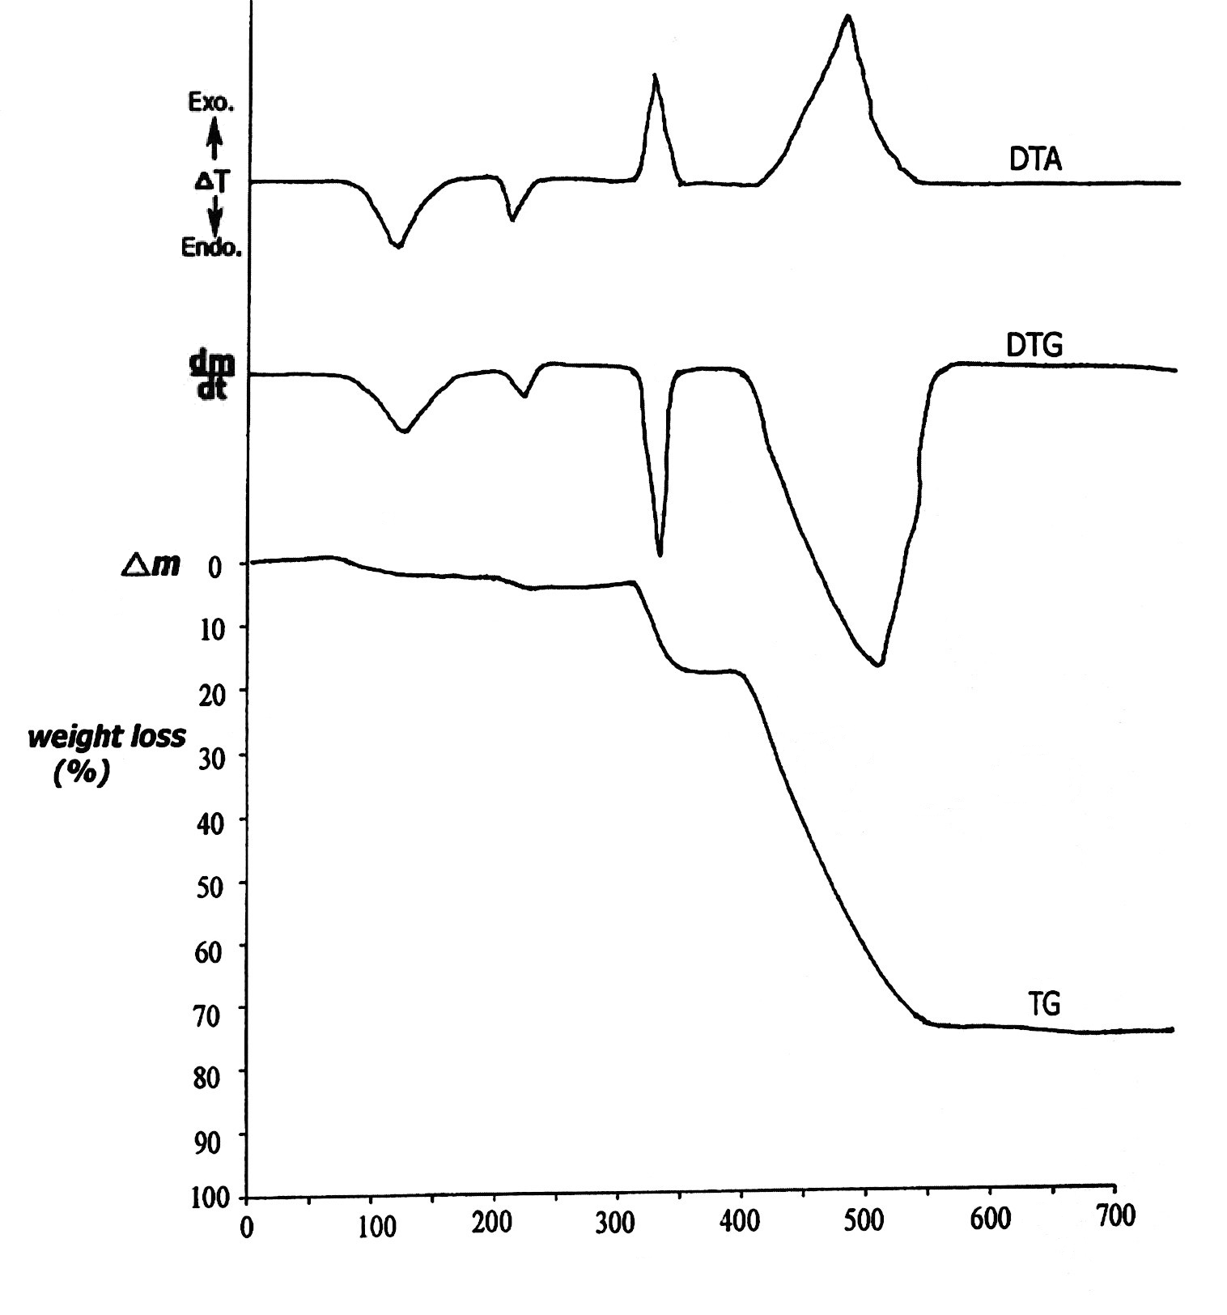
TºC
Fig (1) TG , DTG and DTA curves of Lanthanum -O- Hydroxybenzoate
thermal decomposition ( La (OHC₆H₄COO)₃.3H₂O ) .

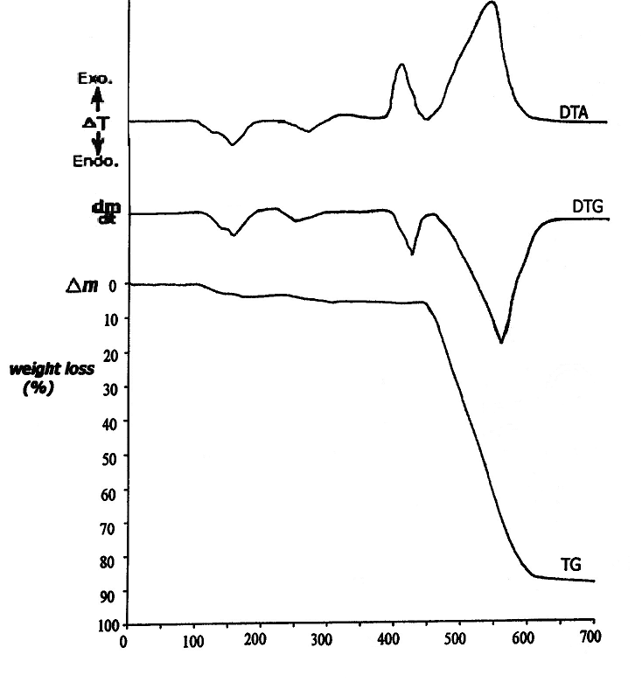
TºC

Fig (2) TG , DTG and DTA curves of Lanthanum -O- Bromobenzoate
thermal decomposition ( La (BrC₆H₄COO)₃.2H₂O ) .

References
1- K.Soge. Vecgum and S.V.Levchik , J.Appl. Polym., Sci , 2001, 21, 910.
2- K.Soge. Veegum , A.I.Lesnikovich and S.V. Levchik , J.Appl. Polym.,
Sci , 2000, 18 , 637.
3- R.Sove.Holler , E.G. Teterin and W.Archangelskiy , Reactions of the
solid state, Elserier , Amsterdam . April (2002 ) .
4- R. Sove . Ho, O.I. Baldova and Tomsk . Amsterdam Univ., 2001, 102 , 182.
5- Z.N. Prozorovskaya , T.W. shestakova and L.N. Komissarova
TesisyDoki-Vses . Chugaevskoe Sovesh . Khim. Komplekson . Soedin , 1994,
12 , 386 .
6- K.O.d . Baran, Z.N.Prozorvskaya and L.N. Komissarova , Reaction of the
solid state, Amsterdam, (1995) .
7- A.A.Matyukhin and R.C.Mackenzie, Thermal analysis, Academic Press ,
London- New York (1972) .
8- A.A.Matyukhin and L. Stoch, J.Thermal Anal ., 1981, 20, 291.
9- J.Wame and A.A.Matyukhin, J. Thermal Anal., 1978, 14, 325 .
10-W.Brzyska and J.A. Motylow, J.Chem. Abst., 2002, 22, 362 .
11- J.Walczak and M.Kurzawa , Thermal Anal., 1988, 34 , 679.

