Synthesis of New Derivatives of N- Substituted Saccharin Via Glycine Derivatives.

Kasim Mohammed Hello
Department of Chemistry, AL-Mothna College of Sciences, Al- Qadssiya University

(NJC)

(Received on 18 /4/2006) (Accepted for publication on 17/ 10 /2006)

Abstract
The present work include the synthesis of N – α- saccharylbenzyl-N-phenylglycine and its derivatives were achieved which expected to have some biological activity. The first step was the treatment of primery aromatic amine with primery aromatic aldehyde in boling ethanol to give Schiff's bases , which is converted to N- α- chlorobenzyl-N-phenylglycine by its reaction with chloroacetic acid in dry benzene. The synthesized glycine derivatives were reacted with saccharine to give N – α- saccharylbenzyl-N-phenylglycine. The new prepared compounds were identified by physical properties and UV/Vis., IR and ¹HNMR spectrum.
الخلاصة
تم في هذه الدراسة تحضير مشتقات جديدة للسكرين يؤمل أن تكون فعالة بيولوجيا, الخطوة الأولى لتحضير هذه المشتقات تمت بتحضير قواعد شف بتفاعل الأمينات الاروماتية الأولية مع الالدهيدات الاروماتية الأولية يلي ذلك مفاعلة قواعد شف المحضرة مع كلوريد حامض ألخليك للحصول على مشتقات الكلايسين ثم مفاعلة السكرين مع مشتقات الكلايسين المحضرة . تم تشخيص المركبات المحضرة بقياس درجات الانصهار وأطياف الأشعة فوق البنفسجية وكذلك أطياف الأشعة تحت الحمراء وأطياف الرنين النووي المغناطيسي لذرة الهيدروجين.

Introduction
Twenty amino acid comprise the building blocks of proteins, which are chemical species indispensable to perform a huge number of biological functions, as exemplified by the role of enzymes¹.
Glycine (⁺H₃NCH₃COO⁻) is the simplest one among the twenty natural amino acid, representing approximately one-third of the collagen composition. However, its loss of hydrogen atom make it available to act as hydrogen bond former¹. The oxygen and nitrogen centers in the structure of amino acid enable them to act as potential sites for binding metal ion².
Glycine can be prepared by the interaction of chloroacetc acid and ammonia^{3,4}, and by the hydrolysis of methyleneaminoacetonitrile by successive treatments with barium hydroxide and sulfuric acid⁵.
Many kinds of glycine derivatives were prepared, compound (1) which possessed biological activity⁶.

(1)

Many of Schiff bases have biologic activity, compound (2) for example, was used as anti bacterial⁽⁷⁾ .

(2)

The compounds (3),(4) was prepared as saccharine derivatives which possessed biological activity ^{(8),(9)}.

- (4)

Experimental
Melting points were determined by Stuart melting point apparatus and uncorrected; IR spectra were recorded on a Shimadzu S.N A2 10\4000 188LP FT- IR- 84005 spectrophotometer in the 4000 – 200 cm⁻¹ range using KBr discs, UV/Vis. spectra were recorded on TRSP – Spectrophotometer, triup International Corp in the 320 - 1000 nm range, 10⁻³ M solution of compounds in ethanol. The ¹HNMR spectra were recorded on a Bruker 400 MHz in Baath university collage of science in Syria, CDCl₃ was used as solvent and TMS as internal reference.
1- Synthesis of Schiff's Bases:
A mixture of 0.01mole (0.93 ml) of aromatic amine, 0.01 mole (1.1ml) of aromatic aldehyde , 10 ml ethanol and one drop of glacial acetic acid, was heated in a water bath at ( 70- 80º C) for 30 min. then left to cool in a bath of ice-water, whereby yellowish white crystals separated out . The crystals were filtered, washed with 2% HCl, then with water and recryastallized from ethanol^{8,9}. Table (1) give m.p, λ_{max} and percent of yield . Table (2) give IR data.
2- Synthesis of N-α- chlorobenzyl-N-phenylglycine and its derivatives.
To 0.011 mole (1.9gm ) of Schiff's bases in 10 ml of dry benzene was added 0.011 mole (1.03 ml) of chloroacetic acid and the reaction mixture was heated in water bath for 1 h. The solvent was evaporated and the remaining green crystals was separated and recrystallized from ethanol. Table ( 3 ) give the physical data and Table ( 4) give IR data.
3- Synthesis of N- α- Saccharylbenzyl -N-phenylglycine and its derivatives.
A mixture of 0.0036 mole (1gm) of N-α- chlorobenzyl-N-phenylglycine and 0.0036 mole (0.66gm) of Saccharine in 15 ml DMF was heated at 140 Cº for 4h . The crystals were recrystallized from ethanol. Table (5) give the physical data and Table ( 6 ) give FT- IR absorption bands.
Results and Discussion
Schem (1) summarizes all reactions in this work

+ H⁺/ EtOH

ClCH₂COOH

The starting material Schiff's bases was prepared from the reaction between primary aromatic amine and aromatic aldehyde in presence of acetic acid glacial^{10,11}. The IR absorption spectra of Schiff's bases showed the absence of two absorption band due to NH₂ stretching of aniline derivatives, and appearance of a C=N absorption bands near 1630 cm⁻¹, the major infra red absorption of Schiff's bases are given in Table ( 2 ) and Table (1 ) shows all physical data.

Table (1) :- Physical data of Schiff's bases, UV deduct in ethanol.
λ _{Max} nm,  (Absorbance) | Yields % | m.p Cº | substituents
360,(1.74) | 80.00 | 50 | R,R₁ =H
355(1.60) | 93.50 | 102-103 | R= NO₂  R₁= N(Me)₂
350,(098) | 90.60 | 53 - 54 | R= NO₂  R₁= H
345,(0.89) | 90.00 | 88 - 90 | R= H  R₁= N(Me)₂

Table (2) : IR spectral data of Schiff's bases.
substituents | Characteristic absorption bands cm⁻¹
substituents | υ*C=N | υ C=C  Aromatic | Additional bands
R,R₁ =H | 1630 | 1585 – 1480 | 1190 υ C-N Bend
R= NO₂  R₁= N(Me)₂ | 1610 | 1590-1485 | 1410  δCH₃.
R= NO₂  R₁= H | 1620 | 1590 – 1490 | 750δ C-H  o.o.p** disubstituted  benzene
R= H  R₁= N(Me)₂ | 1630 | 1575 – 1505 | 1400  δCH₃.
υ *= vibration , o.o.p**= Out of plain

We found that Schiff's bases react with chlroacitic acid in dry benzene to give N – α- chlorolbenzyl-N-phenylglycine. The reaction is followed by disappearance of C=N absorption bands at 1630 cm⁻¹, appearance of O-H absorption bands at (3450) cm⁻¹, appearance of C=O absorption bands at (1670) cm⁻¹and appearance of C-Cl at (850) cm⁻¹ in their IR spectra . The ¹HNMR of compound (2) showed :- δ(ppm) 0.9(S,6H,2CH₃),1.1(S, 2H, -CH₂), 4.2(S,1H,CH) ,7-8 (m,8 H, Aromatics), 9.9(S,1H, -OH). See Tables ( 3,4 ) and Figs (1,2).

Table (3) physical data for N – α- chlorolbenzyl-N-phenylglycine
_{Max} nm, λ  (Absorbance) | Yields % | m.p Cº | substituents | Compounds  No.
350(1.849),430(0.63) | 70 | 120-122 | R,R₁ =H | 1
360(1.999),410(1.966) | 75 | 220-223 | R= NO₂  R₁= N(Me)₂ | 2
360(1.999), 420(1.952) | 80 | 170-172 | R= H  R₁= N(Me)₂ | 3
360(1.90)  415(0.44) | 85 | 160-165 | R= NO₂  R₁ =H | 4

Table (4) FT-IR absorption bands for functional groups in KBr disc.
Characteristic absorption bands cm⁻¹ |  |  |  |  | substituents | Comp.No.
υ C-H St.  Benzylic | υ C-H  St*.  Ar. | υ C=C  Aromatic | υ C=O | υ *O-H | substituents | Comp.No.
2600 | 3050 | 1600 | 1650 | 3400 | R,R₁ =H | 1
2650 | 3040 | 1600 | 1620 | 3450 | R= NO₂, R₁=NMe₂ | 2
2650 | 3050 | 1600 | 1750 | 3450 | R= H  R₁= NMe₂ | 3
2600 | 3050 | 1600 | 1650 | 3450-3350 | R= NO₂  R₁ =H | 4

υ *= Vibration, St*= Stretching.

N – α- chlorolbenzyl-N-phenylglycine have one chiral center, and are expected to be optically active. However, since they are prepared from a chiral starting compounds, they are actually racemic mixtures. No attempt to resolve these racemic mixtures was made. It was found that N – α- chlorolbenzyl-N-phenylglycine reacts with saccharin in DMF to give N – α- Saccharylbenzyl-N-phenylglycine .
The reaction is followed by disappearance of C-Cl absorption band at 850 cm⁻¹ and appearance of SO₂ absorption band at 1330 to 1150 cm⁻¹ in their FT-IR spectra. The ¹HNMR of compound (6) showed :- δ 0.9 (S, 6H, 2CH₃) , 1.1(S, 2H, -CH₂),4.2(S,1H,CH),7-8.1(m,14H, Aromatics), 10.1(S,1H, -OH). The new synthesized compounds identified by their melting points, U.V/Vis. and FT-IR, ¹HNMR spectra see Table (5,6).Fig 3,4.

Table (5) physical data of N – α- Saccharylbenzyl-N-phenylglycine , ethanol used as a solvent in rome temperature.

_{Max} nm, λ  (Absorbance) | Yields % | m.p Cº | substituents | Comp. No.
330(1.288),595(0.206) | 60 | 167-170 | R,R₁ =H | 5
340(1898),570(0.097) | 42.23 | 290 | R= NO₂  R₁= N(Me)₂ | 6
335(1.999),560(0/078) | 46.12 | 213-215 | R= H  R₁= N(Me)₂ | 7

Table (6) FT-IR for N – α- Saccharylbenzyl-N-phenylglycine in KBr disc.
Characteristic absorption bands cm⁻¹ |  |  |  |  |  | substituents | Comp. No.
υ SO₂  II | υ SO₂  I | υ C=C  Aromatic | υ C=O  II | υ C=O  I | υ *O-H | substituents | Comp. No.
1165 | 1320 | 1600 | 1690 | 1700 | 3440 | R,R₁ =H | 5
1160 | 1310 | 1600 | 1650 | 1740 | 3400 | R= NO₂ R₁=NMe₂ | 6
1170 | 1330 | 1610 | 1680 | 1700 | 3430 | R= H  R₁= NMe₂ | 7

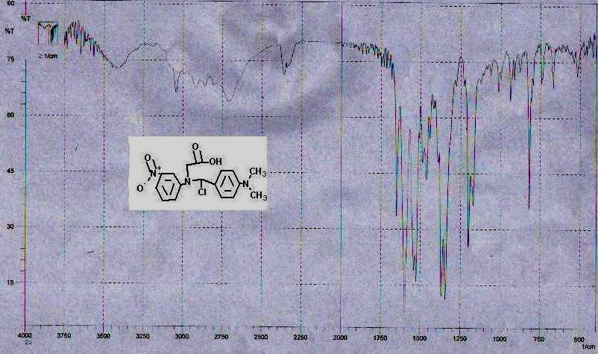

Fig (1) FT-IR spectra of compound (2) in KBr .
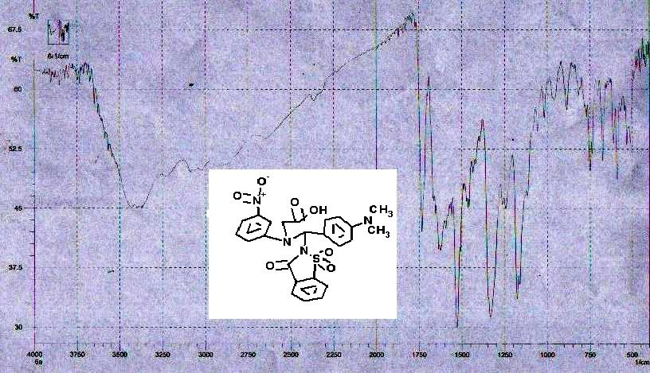

Fig (2) FT-IR spectra of compound (6) in KBr .

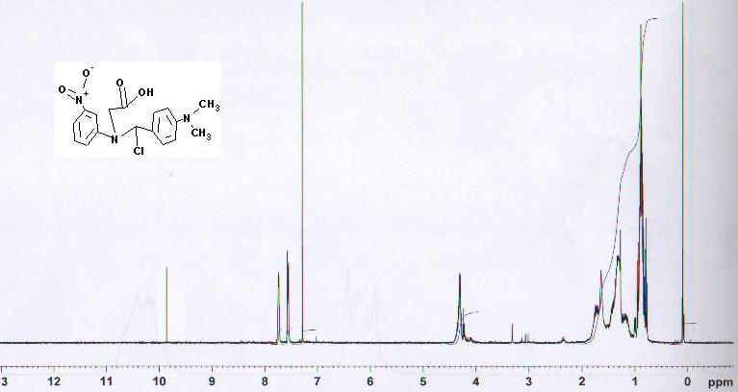

Fig (3) ¹HNMR spectra of compound (2) in CDCl₃.

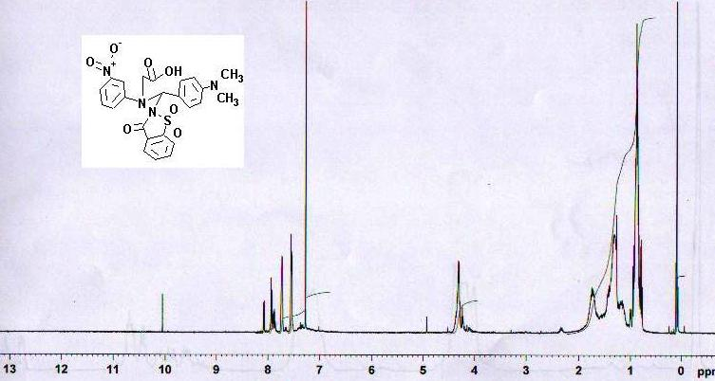

Fig (4) ¹HNMR spectra of compound (6)in CDCl₃.

References
1- R. H.Garret, C. M.Grisham, Biochemistry, Saunders: New York, 1995.
2- J. J. R. F. Da Silva, R. J. P.Williams, The Biological Chemistry of the Elements, Oxford University Press: Oxford, 1991.
3-Kraut, Ann. 1891,266, 295.
4-Cheronis and Spitzmueller, J. Org. Chem. 1941,6, 349.

5- Ling and Nanji, Biochem. J. 1922,16, 702.
6- Internet References 2005: web\\ http://www.orgsyn.org/orgsyn/ chemname.asp/namID=33861.
7- H. J. Fawzi, Takrit Journal of Pure Science,2005, 10 (1) , 144,.
8- F.A Hussein, K.M. Hollo, Iraqi, J. of Chem., 2000, 26(1),35.
9- F.A Hussein, K.M. Hollo, Iraqi, J. of Chem. ,2000,26( 2), 42.
10-H.Schiff,Ann; 1864,131,118.
11- S. Patai "The Chemistry of The Carbon- Nitrogen Double Bond, John Wiley and
Sons, New York, 1970, 68.

