Spectrophotometric Determination of Some Sulphonamide Drugs via oxidative coupling with Phenothiazine and Benzoyl peroxide using flow-injection technique

Yousif. J.Azeez,
Department of Chemistry, College of Science, University of Salahaddin , Arbil-Iraq
Mouayed. Q. AL-Abachi and Issam.M.A.Shakir
Department of Chemistry, College of Science, University of Baghdad, Baghdad-Iraq.

(NJC)

(Received on 1 /11 /2005) (Accepted for publication on 19/8/2006)

Abstract
A novel flow injection Spectrophotometric method is described for the determination of microgram amounts of sulphonamides in aqueous and biological samples. The method is based on the oxidative coupling reaction of phenothiazine with sulphonamide drugs in the presence of benzoyl peroxide as oxidising agent. Intense bluish-green, water soluble stable dye was obtained which has a maximum absorption at 614 nm. Linear calibration graphs were obtained for different sulphonamides with a molar absorptivities of 3250-4720 1. mol'' cm " and a relative standard deviation of better than 0.84 %. The proposed method has proved to be highly sensitive (detection limit range 0.30-0.63 p g ml⁻¹ sulphonamide) and accurate (recovery % was 97.9-100.2 %)).
Optimum concentrations of chemical reactants, physical instrumental conditions and effects of interferences from certain additives have been investigated. The nature of the coloured produced dye and its stability constant were determined. The method was applied successfully for the determination of sulphonamide drugs in pharmaceutical preparations, blood and urine samples.

الخلاصة
تضمن البحث امكانية استخدام تفاعلات الازدواج التاكسدي لتقدير ادوية السلفوناميد في الوسط المائي طيفياً وبتقنية الحقن الجرياني. اعتمدت هذه الطريقة على تفاعلات الاقتران التاكسدي للفينوثايزين مع ادوية السلفوناميد بوجود بيروكسيد البنزويل كعامل مؤكسد لاعطاء صبغة مستقرة ذات لون ازرق-مخضر ذائبة في الماء لها اعلى امتصاص عند طول موجي مقداره 614 نانومتر، تم دراسة جميع المتغيرات الكيميائية والفيزيائية للتوصل الى الظروف المثلى حيث تم الحصول على منحنيات معايرة للسلفوناميدات المختلفة. تراوح معامل الامتصاص المولاري للطريقة بين 3250الى 4220 لتر مول⁻¹.سم⁻¹ والتطابقية افضل من 0.84%. وبلغ ادنى حد للكشف بين 0.30 الى 0.63 مايكروغرام لكل مللتر سلفوناميد، نسب الاستعادية بين 97.9 الى 100.2%، وشمل البحث ايضاً دراسة تاثير المتداخلات على طريقة التقدير، ودرست طبيعة الصبغة الناتجة بطريقة للنسب المولية وبتقنية الحقن وكذلك طبقت الطريقة بنجاح في تقدير ادوية السلفوناميد في نماذج الدم والادرار والمستحضرات الصيدلانية.

Introduction
Sulphonamides are widely used in the treatment of urinary tract infection burn therapy, conjunctivitis and chloroquine resistant malaria. They are also the drugs of choice for the treatment of nocardiosis, toxoplasmosis, severe travellers diarrhoea and meningococcal infections⁽¹⁾.
Various methods have been reported for the determination of sulphonamides. These include gravimetric⁽²⁾, titrimetric^{(3,4)}, potentiometric⁽⁵⁾, amperometric⁽⁶⁾, polarographic⁽⁷⁾, chromatographic^{(8,9)}, flame spectroscope⁽¹⁰⁾, fluorimetric⁽¹¹⁾ and spectrophotometric methods⁽¹²⁻¹⁷⁾ . Colorimetric methods based on diazotisation and coupling with phenols or arylamines such as N - (1 - naphthyl) ethylene diamine (Bratton and Marshall reagent). The latter seems to be the most popular method.
The object of the investigation reported in this paper was to evaluate an automated flow injection spectrophotometric method for the microdetermination of sulphonamide drugs in an aqueous medium using phenothiazine as a chromogenic reagent and benzoyl peroxide as oxidant. The application of the method for the analysis of drugs in blood, urine and pharmaceutical samples will also be considered.
Experimental
Apparatus and flow maniflod:
Figure (1) shows the manifold used for the spectrophotometric determination of sulphonamides. The manifold consists of a peristaltic pump (P) of the type (Desaga Heidel Berg England) with six channels. A sample injection via a rotary valve (S) type Rehodyne U.S.A, with ,a sample loop was used to inject the sample volume into the flowing carrier stream . Teflon tubes and mixing (reaction) coil (L) of 0.88 mm i.d were used in this flow manifold, also a home made (Y) piece (perspex) was used to mix two stream of reagents.
A spectrophotometric detector (D) type 4050 uv-visible beam linear readout provided with 60 μl flowthrough cell. DC-microvoltmeter (UV) for increasing sensitivity a power supply were used as associated electronics and single pen x-t recorder (R) was used .
Reagents
All chemicals used were of analytical reagent grade. All sulphonamide drugs were obtained in a highly pure form and pharmaceutical preparations from the state drug industry (SDI) Sammara-Iraq.
Standard Sulphonamide (500 μg ml'¹) solutions : were prepared by weighing accurately 100 mg of sulpha drug, dissolved in 10 ml of absolute ethanol and diluted to 200 ml in a volumetric flask with distilled water .
Phenothiazine solution(1x10⁻³M) : 0.01992 g of pure phenothiazine was dissolved in 100 ml of absolute ethanol. The solution was prepared daily and used⁽¹⁹⁾ .
Benzoyl peroxide (2.5x 1 O^M): 1.51250 g of benzoyl peroxide is dissolved in 250 ml of absolute ethanol .
Recommended procedures:
Procedure for calibration curve:
Take 5 ×10⁻⁴ M bonzoylperoxide 0.5 M H₂SO₄ and 6×10⁻⁵ M of phenothiazine at flow rate 4 ml/min (Fig.1). Inject increasing volumes of sulphonamide working solution (100 μg/ml). Measure the absorbance at 614nm against reagent blank, prepared in the same way but containing no sulphonamide using 1cm cells. In all subsequent experiments, 100 μg/ml of sulphonilamide as sulphanilamide and sulphadiazine were used. The absorbance is plotted against the final concentration to obtain a calibration curve.
Procedure for tablets :
20 tablets were finely powdered and weighed accurately. A portion of the powder equivalent to about 100 mg of the sulphonamide, was extracted with 10 ml of absolute ethanol. The solution was warmed and then, the mixture was filtered and washed with 5 ml ethanol. The combined filterate and washings were diluted to 200 ml with distilled water (final concentration was 500 μg ml⁻¹). 10 ml of this solution was diluted to 100 ml with distilled water to obtain 50 μg ml⁻¹ , 10 μl of the latter solution was injected into the phenothiazine line (Fig.l)using the optimum conditions, and the absorbance peak height was measured .
Procedure for prednisolone-s eye drops :
Five bottles of the prednisolone-s were mixed together and 1 ml of the prednisolone-s 10% sulphacetamide sodium (SAC) which contains 10 mg of sulphacetamide was mixed with 10 ml of ethanol and then diluted to a final volume 200 ml to contain a SAC.50 μg ml⁻¹ solution was prepared by dilution of 10 ml of 500 ug ml'¹ to 100 ml with distilled water. The latter solution was injected into phenothiazine line (Fig.l).
Procedure for blood sample :
2 ml of serum was mixed with 30 ml of distilled water and 8 ml of 15% trichloro acetic acid, and then centerfuge for 5 min at a speed of 3000 rpm. and the supernatant liquid was filtered.
For the determination of free sulphonamide in the blood, the supernatant liquid was injected into the phenothiazine line (Fig.l). The absorbance peak height of the solution was recorded at 614 nm.
For the determination of total sulphonamide (free and conjugated), 0.5 ml of 2M HC1 was added to 10 ml of the supernatant liquid (after precipitation of protein), then heated on a boiling water-bath for 1 hour. Cooled and adjusted to a volume of 10 ml, proceeding as for the determination of free sulphonamide .
Procedure for urine sample :
The urine sample was diluted five times with distilled water and the diluted urine solution was used for further experiments. For the determination of free sulphonamide in urine, 2 ml of the diluted urine was mixed with 30 ml of water and 8 ml of 15% trichloro acetic acid. The solution filtered and the supernatant liquid was injected into the phenothiazine line (Fig.l). The absorbance peak height of the solution was recorded at 614 nm.
For total sulphonamides (free and conjugated) after precipitation of protein, 5 ml of the diluted urine was placed in a 100 ml volumetric flask, 5 ml of 4 M HC1 was added and the solution was diluted to the mark with distilled water, 10 ml of this solution was heated in a boiling-water bath for 1 hour. Cooled and adjusted the volume to a 10 ml, and the procedure was followed as for sulphonamides .

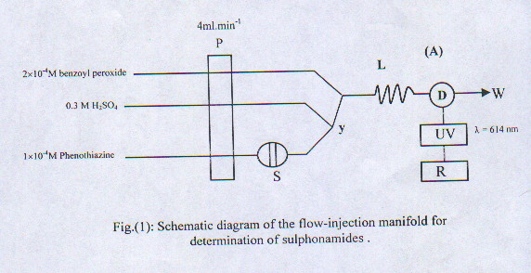
Fig.(l): Schematic diagram of the flow-injection manifold for determination of sulphonamides .

Results and Discussion
The reaction of sulphonamides with phenothiazine in the presence of benzoyl peroxide produces highly coloured bluish-green condensation product with a maximum absorption at 614 nm (Fig.2). The absorbance of the coloured product was measured using flow-injection analysis (FIA) system Fig.(l).
Initial studies were directed toward optimisation of the experimental conditions in order to obtain a good sensitivity, stability and reproducibility of the coloured product. The influence of various reaction variables on the coloured product was tested to establish the most favourable conditions for the determination of 50 μg ml⁻¹ sulphanilamide as an underivatised sulphonamide and sulphadiazine as an example of derivatised sulphonamide. Each sample was injected three times and the average peak height in mV is presented .

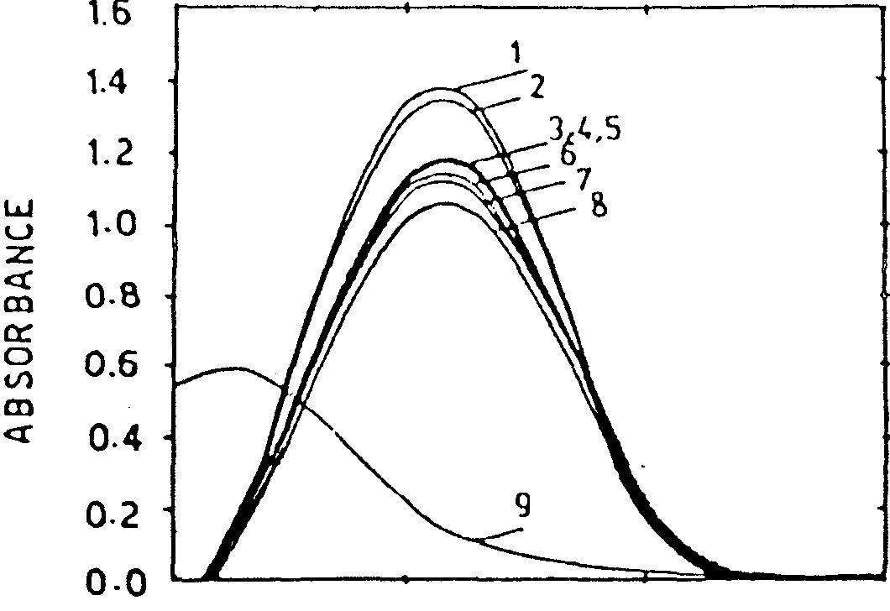
500.0 600.0 700.0 800.0
WAVELENGTH nm
Fig.(2): Absorption spectra of the product obtained by the injection of 50u,g ml"¹ sulphonamides into a stream of 1x10^M phenothiazine, is combined with 0.3M H^O^ and they mixed with 2x lO^M benzoyl peroxide of: 1-Sulphacetamide sod., 2-Sulphanilamide; 3-Sulphaguanidine;4-Sulphathiazole; 5-Sulphamethoxazole; 6-Sulphadiazine; 7-Sulphamerazine;8-Sulphadimidine; 9-Absorption spectra of blank solution.

Optimization of conditions :
A- chemical optimizations:
Sulphuric acid concentration :
Table (1) tabulates the variation of H₂SO₄ concentration (M) versus peak height (mV). A concentration of 0.3 M was found optimum and was used throughout the work .
Phenothiazine concentration :
Using optimised H₂SO₄ concentration at 0.3M and keeping all other chemical concentrations and physical parameters constant as indicated in the preceding section, effects of different phenothiazine concentrations are investigated. Table (2) tabulates the results, it is found that 1xl0⁻⁴ M gives most sensitive result.
Benzoyl peroxide concentration :
Using optimised H₂SO₄ (0.3M), phenothiazine (1xl0⁻⁴ M) and other conditions mentioned in various sections, effect of different benzoyl peroxide concentrations are investigated. Table (3) tabulates the results, it is found that 2x10⁻⁴ M gave the best significant results.
B- Physical optimisations :
Length of delay reaction coil:
Using the optimum concentration of reactants. Different lengths of delay reaction coil (190-280 cm) were tested.
Fig.3 shows that 235 cm coil length gives the best significant results. Longer reaction coil caused more sample dispersion⁽²⁰⁾. Longer diameter coil was avoided to prevent excessive dispersion reagent consumption⁽²¹⁾. Therefore 0.88 mm i.d. was selected and used through out the work.

Table (1) Effect of H₂SO₄ concentration*:
Concentration of sulphuric acid (M) | Absorbance expressed as average (n=3) peak height in mV of
Concentration of sulphuric acid (M) | Sulphanilamide | sulphadiazine
0.0  0.1  0.2  0.3  0.4  0.5  0.6 | 0  54  126  160  150  135  126 | 0  51  120  153  142  129  120
* Phenothiazine concentration 1x10⁻³ M, benzoyl peroxide 2x 10⁻⁴ M. the system was operated at flow rate of 3ml min⁻¹, reaction coil length was 220 cm, sample volume 60u.l at room temperature (25°C) and injection sample concentration 50μg ml⁻¹.

Table (2) Effect of phenothiazine concentration:-
Concentration of phcnothiazine  (M) | Absorbance expressed as average (n=3) peak height in mV of
Concentration of phcnothiazine  (M) | Sulphanilamide | sulphadiazine
1x10⁻⁵  6xl0⁻⁵  1x10⁻⁴  5xl0⁻⁴  1xl0 ⁻³ | 43  125  167  160  157 | 40  120  161  153  151

Table (3) Effect of benzoyl peroxide concentration:-
Concentration of benzoly peroxide  (M) | Absorbance expressed as average (n=3) peak height in mV of
Concentration of benzoly peroxide  (M) | Sulphanilamide | sulphadiazine
2xl0⁻⁵  5xl0⁻⁵  1xl0⁻⁴  2xl0⁻⁴  4xl0⁻⁴  2xl0⁻³ | 36  84  167  173  160  108 | 32  80  161  165  156  103

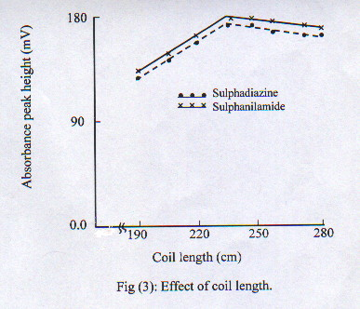

Flow-rate :
The FIA system (Fig.l) was operated at different flow rates (2-10 ml min⁻¹), and it was found that 4 ml min⁻¹ is the optimum flow-rate (Fig.4).
Sample volume:
Different sample volumes (60-180 μl) were tested. The results obtained (table 4), showed that 60 μl is the optimum sample volume, and was used throughout the work.
Effect of temperature :
Table 5 indicated that the absorbance of the coloured product was decreased when the reaction was carried out at 0 °C , this may be due to the decrease in the reaction rate by decreasing the temperature, but when the reaction was carried out at 50 °C, the absorbance also decreased, which probably due to partial decomposition of the product. Therefore, the reaction mixture should be carried out at room temperature (25°C). The optimum working conditions were tabulated in table 6.
Calibration graph :
The results for the calibration graphs of sulphonamides obtained under the optimised conditions using the FIA manifold are illustrated in Table 7. Intense blue-green, water soluble stable dye was obtained which has a maximum absorption at 614 nm it appear from the results that the slopes of the calibration graphs vary considerably. This is probably due to the difference in the reaction rate and different substituents of each sulphonamide, therefore, individual working calibration graphs are required and so that the method can be applied only to samples containing one sulphonamide. Sulphanilamide, the simple molecule, has the fastest reaction, probably because the other sulphonamides are sterically hindered⁽²²⁾. A t-test are conducted for linearity relation and it shows that t_{cal.}= 620.17 compared with t_{tab.}= 2.23 at 95% confidence limit which indicates rejection of H_{o} (non linearity) against alternative hypothesis (linearity). The linear regression equation for the range of concentration 0.7-75.0 μg ml⁻ sulphanilamide at 95% confidence limit is Abs. (av. Pk. hgt. (n=3)) mV = (4.347 ± 0.513) + (3.476 ± 0.016) [sulphanilamide] μg ml⁻.
Precision and accuracy :
Using the optimum conditions (Table 6), the precision for the determination of sulphonamides by FIA were studied. Table 8 shows the relative standard deviation(R.S.D) for five injections of each sulphonamides containing 10,30,50 μg ml⁻¹ concentrations.
For estimation the accuracy of the method, five injections were performed containing 30 ug ml'¹ of each of the sulphonamide of the same solution investigated. The results obtained indicated that the average range between 97.90% and 100.20%.

Table (4) Effect of sample volume:-
Sample Volume(µl) | Absorbance expressed as average (n=3) peak height in mV of
Sample Volume(µl) | Sulphanilamide | Sulphadiazine
60  80  100  120  130  140  180 | 173  161  154  143  135  130  123 | 165  154  148  137  129  126  120

Table (5) Effect of temperature:

*at 95% confidence limit.
Temp.(°C) | Absorbance expressed as average (n=3) peak height in mV of
Temp.(°C) | Sulphanilamide | Sulphadiazine
0  10  15  25  30  40 50 | 150±1.23  162±1.65  165±1.24  173±1.02  161±1.50  150±1.23  141±1.49 | 143±1.07  149±1.11  158±1.25  165±1.10  148±1.33  140±1.55  133±1.63

Table (6) Optimum working condition for spectrophotometric determination of sulphonamide by FIA system using phenothiazine and benzoyl peroxide:-
parameter | Value
Flow rate  Reaction coil length  Sample Volume  Sulphoric acid concentration  Phenothiazine concentration  Benzoyl peroxide concentration  Wave length selected  Temperature  Reaction tubing diameter | 4ml min⁻¹  235cm  60 μl  0.3M  1x10⁻⁴M  614nm  25⁰C(room temp.)  0.88 mmi.d

Table (7) Spectral characteristics of the products from the reaction of sulphonamides with phenothiazine and benzoyl peroxide by automated FIA:-

Sulphonamidcs | Detection limit  (µg ml⁻¹) | Σmax  (1. mol ⁻¹. cm ⁻¹) | Linear range  (µg ml⁻¹) | Intercept (mV) (a±tSa) | Slope (mm.ml. µg⁻¹ ) (a±tSa) | Correlation coefficient  (r)
Sulphanilamide | 0.30 | 3.30x103 | 0.7-75.0 | 4.347±0.729 | 3.476±0.018 | 0.9999
Sulphadiazinc | 0.52 | 3.35x103 | 0.7-100.0 | 4.113±0.729 | 3.178±0.020 | 0.9996
Sulphaguanidine | 0.58 | 3.43x103 | 2.0-90.0 | 4.036±0.821 | 3.265±0.019 | 0.9997
Sulphadimidine | 0.46 | 3.25x103 | 1.0-75.0 | 4.157±0.639 | 3.283±0.017 | 0.9993
Sulphacetamide sod. | 0.33 | 4.72x103 | 0.7-100.0 | 4.259±0.782 | 3.093±0.25 | 0.9996
Sulphamerazine | 0.63 | 3.37x103 | 1.0-100.0 | 4.538±0.631 | 3.642±0.019 | 0.9999
Sulphamethoxazole | 0.56 | 3.42x103 | 2.0-100.0 | 4.231±0.372 | 3.356±0.018 | 0.9998
sulphathiazole | 0.42 | 3.45x10' | 2.0-90.0 | 4.623±0.523 | 3.216±0.015 | 0.9997
* at 99% confidence limit.

Table (8) Precision of the method:

Compound | R.S.D %
Compound | 10 µg ml⁻¹ | 30 µg ml⁻¹ | 50 µg ml⁻¹
Sulphanilamide | 0.84 | 0.49 | 0.34
Sulphadiazine | 0.52 | 0.32 | 0.00
Sulphaguanidine | 0.43 | 0.40 | 0.20
Sulphadimidine | 0.67 | 0.51 | 0.30
Sulphacetamide sod. | 0.30 | 0.25 | 0.10
Sulphamerazine | 0.51 | 0.43 | 0.22
Sulphamethoxazole | 0.43 | 0.38 | 0.11
sulphathiazole | 0.47 | 0.31 | 0.23

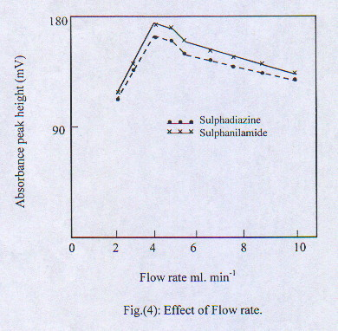

Nature of the product:
The mole-ratio method for the monitoring of stoicheometry of the products was adopted to flow techniques. The results (Fig.5&6) proved the existance of 1:1 sulphonamide :
phcnothiazine and the structure of the dye may be written as follows :

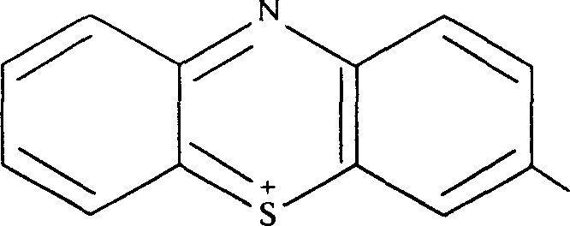

where R=
NH-R
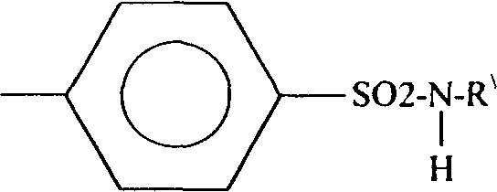

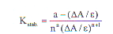
The stability constant (K_{stab}.) can be calculated using the following equation⁽²³⁾:

Where a = concentration of sulphonamide.
ε = molar absorptivity
n = mole ratio.
ΔA= A_{m}-A_{s}
A_{m}= absorbance of a solution containing sulphonamide five times excess amount of phenothiazine.
A_{s} = absorbance of a solution containing a stoicheometric amounts ofsulphonamide and henothiazine.
The conditional stability constant of different sulphonamide products are summarised in Table 9.
Analytical applications :
Sulphonamides are usually formulated in tablet form, therefore the effect of common tablet excipients and additives on the procedure was investigated. It was found that glucose, lactose, sucrose, starch and magnesium stearate had no effect on the assay (Table 10).
The effect of other drugs which are commonly prescribed with sulphadrugs, e.g., chloromphenicol, phthalyl sulphathiazole and succinyl sulphathiazole were also investigated and it was found that non of these drugs interferes in the method.
(Table 11) shows the results obtained from the determination of sulpha drugs in some of their dosage forms by means of the proposed method, these data indicate that the method has a good recovery (99.4-99.8%), except trimethoprim (147.0% recovery) since it contains an additional primary aromatic amine. A satisfactory results (Table 12) was obtained for the analysis of blood and urine samples.

Compound | Stability constant l. mol⁻¹
Sulphanilamide | 2.52xl0⁶
Sulphadiazine | 2.61X10⁶
Sulphaguanidine | 2.74x10⁶
Sulphadimidine | 2.45xl0⁶
Sulphacetamide sod. | 5.28xl0⁶
Sulphamerazine | 2.64xl0⁶
Sulphamethoxazole | 2.72xl0⁶
sulphathiazole | 2.77xl0⁶
Table (9) The stability constant of the products obtained by the reaction of sulphonamides with phenothiazine and benzoyl peroxide using FIA system:-

Table (10) Effect of excipients an additiveson the recovery of sulphonamide drugs FIA-phenothiazine
-benzoyl peroxide method.
Excipient | Amount add  μg ml⁻ | Amount add to know the fold excess | Amount per 10 mg of drug/mg | Sulphanilamide* |  | Sulphadiazine*
 |  |  |  | Recovery% | R.S.D% | Recovery% | R.S.D%
Glucose | 50 | 80 | 0.5 | 99.6 | 0.51 | 100.5 | 0.70
Lactose | 20 | 50 | 2.0 | 99.7 | 0.53 | 99.4 | 0.73
Sucrose | 50 | 70 | 0.5 | 100.4 | 0.54 | 99.7 | 0.69
Starch | 20 | 40 | 2.0 | 99.8 | 0.62 | 99.7 | 0.78
Magnesium Stearate | 20 | 70 | 0.5 | 9.5 | 0.57 | 100.2 | 0.80
*average of five determinations.

Table (11) Mean recovery of sulpha drugs in dosage form by FIA - phenothiazine-benzoyl peroxide procedure:-
Compound | Amount mg or ml per tablet Found by |  | Mean recovery%
Compound | Nominal | present method | Mean recovery%
Methoprim tablets^{X} | 400 | 588 | 147.0
Sulphaguanidine tablets | 500 | 497 | 99.4
Sulpadimidine tablets | 500 | 499 | 99.8
Prednisolone*-S eye drops | 500 | 498 | 99.6
+ average of five determinations .

^{x} Each tablet contains 400 mg of sulphamethoxzole and 80 mg of trimethoprim. Few tablets
crushed, sieved then weight a known amount equivalent to one tablet weight, because no single tablet contain the same amount of active ingredient.
* Each 100 ml contain 10 g sulphacetamide sodium and 0.25 g of Prednisolone-S The Darow
Co Tehran-Iran.

Table (12) Assay of sulphonamide drugs in blood and urine using FIA-phenothiazine-benzoyl peroxide procedure.
Sample | Drug administered | Amount found μg ml⁻¹
Sample | Drug administered | Free | Total
Blood | Sulphanilamide | 0.974±0.019 | 1.135±0.033
Blood | Sulphadiazinee | 0.864±0.022 | 1.027±0.024
Urine | Sulphanilamide | 1.462±0.035 | 2.108±0.040
Urine | Sulphadiazinee | 1.415±0.031 | 2.201 ±0.045
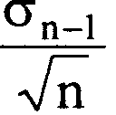

* For 95% confidence limit (n=3) at U = X ±1

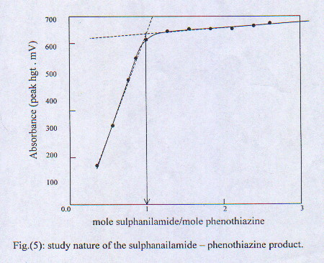

Fig.(5) Mole-ratio plot of the sulphanilamide-phenothiazine product

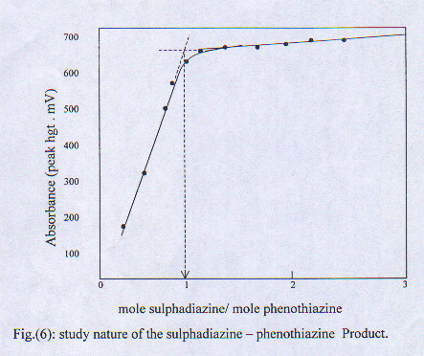

References
1- Doerge, R.F, Editor (1982) Wilson and Gisvold's, "Text book of organic. medicinal and pharmaceutical chemistry". Eighth edition, J.B.Lippincott, Philadelphia, P.A., P. 190.
2- Ismaiel, S.A. and Yassa,D.A.(1973),"Determination of sulphadimidine in presence of benzocaine and procaine gravimetrically", Phamazine (in German), 28,244(Anal.Abstr.,26,(1974),2307).
3- Kumar, K. G. and Indrasenan, P., (1988),"Titrimetric methods for the determination of some sulpha drugs using N-Bromo phthalimide and N-bromo succharin ,113,1369.
4- Trieff,M.N.,Ramanujam,M.V and Cantelli,G.F., Talanta, 1977, 24,188.
5- Cilianu,S.,Bunaciu,A.A. and Cosofert, V.V., Talanta, 1998, 28,383.
6- Lebedeva, L.M.,Osaeva, I.B. and Pogartseva, I.M.,(1978) "Amperometric titration of sulphonamides in anhydrous acetic acid medium",Farmatsiya, (in Russian), 27,71,(Anal.Abstr.,36,(1979),5E56).
7- Fogg, G.A. and Ahmed, Z.Y., Anal. Chim. Acta., 1974, 70, 241.
8- Szymanski, A. and Szozepaniak,W., Chem. Anal.,(Warsaw), 1998, 34(3), 34.
9- Ricci, M. C. and cross, R. F., J. of liquid chromatography and related technologies, 1996, 19 (19), 3155.
10- Hassan,M.,S. and Eldesouki.H.M., J.Assoc. off anal. Chem., 1981, 64,H58, (Anal. Abstr., 1982, 42,5E62.
11- Babilev,V.P., (1979),"Spectrofluorimetric determination of sulphanilamides" Farm.Zh. (in ukranian),4,36, (Anal. Abstr.,39,(1980), 6E71).
12-Nevado, J.J.B.,Salmas, F.,Deorbe, I. and capitanvallv,S.L., Anales de quimica, 1994, 90(l),103.
13- Garcia,C.M.,Sanchezpedreno, C., Albero,I.M. and Rodenas,V., J.of pharmaceutical and biomedical analysis, 1997, 15(4),453.
14- Vallvey.L.F.C., Deorbe, I., Valencia, C.M. and Juan, J.B., Talanta, 1994, 41(8),1327.
15-Tena,M.T.,Luque de Castro,M.D. and Valcarcel,M., Analyst, 1994, 19,1625.
16- Nevado.J.J.B., GallegoJ.M.L. and Penalvo.G.C., Analytical letters, 1995, 28(l), 93.
17-.Al_Abachi Mouayed,Q, Salih, E.S. and Salem.S.M., Fresenius, J. Anal.Chem., 1990, 337,408.
18- Bratton, A.C.and Marshall, F.K., J. Biol. chem., 1939, 128, 537.
19- Abdine, H., Korany, M. A., Wahbi, A.M. and El-Yazbi, F., Talanta, 1979, 26,1046.
20- Calatayud,J.M.,Falco, P.C. and Marti,M.C., Analyst, 1986, 111,1317.
21- Azad.T.Faizullah and Kamal,M.Mahmoud, (1997),"Determination of some sulpha drugs by flow_injection analysis with chemiluminescence detection, 3-4,229.
22- Xenakis,G.A. and Karayannis, I.M.,Anal. Chim. Acta., 1984, 159,343.
23- Al-Hadidi, N.R.A.,(1997), Ph.D.Thesis, University of Mosul, p.39.

