ADENOSINE 3' , 5' – CYCLIC MONOPHOSPHATE : EXT RACION AND PURIFICATION FROM URINE OF β – THALASSAEMIA
PATIENT

Hamid Ghafory Hassan
University of Sulaimani, College of Science, Chemistry Dept
Sulaimania, IRAQ.
Mufeed Jalil Ewadh
University of Kerbala, College of Medicine
P.O.Box 1152 , IRAQ .
gaforiiq@yahoo.co.uk Email:

Key wards : cAMP , Urine , β-Thalassaemia.

(NJC)

(Received on 28/ 5 / 2006 ) (Accepted for publication on 5/7/ 2006 )

Abstract
Cyclic adenosine 3',5'-monophosphate has been extracted and purified using column chromatography ( Dowex 50-w column of 1.5x 5 cm dimentions ). Levels of the purified adenosine cyclic monophosphate peak was determined and it was seen to be elevated in urine of thalassaemic patients in comparison with that of healthy controls objects. The purified peak was identified using UV analysis.
الخلاصة
تم استخلاص وتنقية الادينوسين 3',5' الاحادي الفوسفات الحلقي باستخدام عمود الكراماتوغرافيا (D50-w) وبقياسات 1.5x 5 سم . وتم تحديد مستويات الادينوسين احادي الفوسفات الحلقي بتحديد المنحنى الخاص به باستخدام تقنية الاشعة فوق البنفسجية وتبين بان مستوياته ترتفع في نماذج البول المأخوذة من مرضى الثلاسيميا مقارنة مع الاصحاء .

Introduction
Hormones action can be understand as a basic principles of binding of hormone to its specific receptor. An achivment of an intracellular messenger molecule was recognized due to this specification binding and can leading to stimulation / depression of some biological activities inside cell. A common metabolite, Adenosine 3',5'- Monophosphate (cAMP) was recognized as a second messenger of the polar, water soluble hormones epinephrine and glucagons ^{[1]}. Adenosine cyclic monophosphate (cAMP) has been found to distributed widely in different tissues ^{[2-4]}. Proliferative tissues, include normal and abnormal, reflectes elevation in cAMP concentrations ^{[5]}. A study of urinary cAMP level were found to be derived from plasma and kidney ^{[6,7]} Plasma cAMP is filtered by the kidney without being reabsorbed and presents about two third to one half of the total urine cAMP ^{[1]}. Although little is known about the tissues from which plasma cAMP by stimulating extrarenal adenylate cyclases, a target of parathyroid hormone (PTH) action in renal tubule, is a release into urine. Surprisingly, the filtrated cAMP fraction is relatively constant in healthy subjects, which is reflected a narrow range of plasma cAMP. There is a role for cAMP excretion measurement in the evaluation of differentiation of sporadic cases from those of multiple endocrine neoplasia type assay of nephrogenous cAMP has been applied to the monitoring of calcium intake in case of osteoporosis, a target of parathyroid hormone (PTH) action is the renal tubule ^{[8]}. This will results in a release of cAMP into the urine. Thus, cAMP output in the urine can be consider an indirect measure of parathyroid action. As it was realized that β-thalassaemia disorder can be observed with patients of osteoporosis, a case affected by elevation of PTH, thus an elevation in PTH concentration that affects kidney that led to activation of adenyl cyclase, the enzyme catalyzed the formation of cAMP ^{[9]}, thus , it is concluded that an increase in cAMP concentration can be correlates with β-thalassaemia . For then above expectation, the study has been adopted to investigate the level of cAMP in urine of patients with β-thalassaemia.

Materials and Methods
Chemicals:
These were ZnSO4, Ba(OH)2, NaOH, cAMP, HCl, and Dowex-50w. They were of analar grade.

Instruments:
UV – visible spectrophotometer
Centrifuge.
PH – meter.
Column of the dimension 1.0×5.0 cm.

Sampling:
Fifty volunteers of each of : healthy controls , Patients with β – thalassaemia major were used throughout the research. They were of male gender. Thalassaemic patients were under blood transplantation.

Urine collection :
Patients and controls were provided with a clean container supplied with chloroform for preventing bacteria growth. Urine samples were collected during a period of 24 hrs. After collection of urine, 10 mls of urine was aspirated and centrifuged to separate impurities.

Isolation of urine cAMP :
A method of Brocker (1974), has been adopted. The protocol based on the pricipation of proteins, phosphates, pyrophosphate, and correlated nucleotides. 200 µL of 5% ZnSO₄ sol and 200 µL of 0.3N Ba(OH)₂ sol were mixed. The mixture were added to 1ml of urine (control and thalassaemic respectively). Mixture were centrifuged and supernatrnt was aspirated and collected. Separated urine were stored in freezer otherwise used at the same time.

Purification of cAMP using Ion-Exchange chromatography :
A developed method of Abdulla and Hamadah ^{[11]} were adopted. A colum of 1.0 × 5.0 cm dimension was replaced the commonly one used and the elution was carried out using continuous washing with distilled water. Two mls of the eluted fractions were collected. These fractions were spectrophotometrically analyzed for cAMP concentration. A scanner was connected and cAMP peak was seen with highest concentration in fraction 2 (fig -1). cAMP peak was absorbed at wavelength at 258 nm under neutral PH.

Identification of cAMP peak :
A UV analysis was used. The protocol was as that cited in Mohammad ^{[12]}. For basic analysis (pH 11), 2 drops of 1N NaOH sol. Were added to fraction 2 that eluted from the Dowex column (cAMP peak), mixed and scanned between 200-300nm. Same protocol was applied using 1N HCl sol.for acidic analysis (pH 3). A flow diagram was obtained showed in fig-3.

Determination of cAMP concentration :
Purified fraction 2 represented cAMP peak for both control and thalassaemic urine were absorbed at neutral pH at wavelength 258 nm. The concentration of the peak calculated for both respectively (Table-1). Calculation achieved using Beers – Lambert law :
A = a b c.
A is the extinction coefficient of cAMP absorbed and equal to 14650 mol⁻¹cm.^{[13]}.

Results and Discussion
Column chromatography purification using single layered Dowex-50w column resulted in a one peak represented the purified cAMP. This peak provide the highest activity for both control and thalassaemia (Fig-1; Table-1). A suggestion in support was adopted about glucagons and catecholamines to have their own influence on the sources of secreted cAMP, which can be explained to be due to the stimulating adenylyl cyclases ^{[7,14,15]}. As previously estimated^{[7]} , urinary cAMP level is generated by the kidney occurs under the PTH influence. Published works ^{[16,17]} were reported that there were no 5’-nucleotides observed in human urine, they only found in rat urine. A supported evidence for the occurrence of human urinary cAMP (nephrogenous cAMP) was that depends on the UV analysis applied in different pH values (basic, neutral, acidic) in which the cAMP peak absorbed at 258nm in neutral pH was found to be shifted to longer wavelength (260nm)^{[18]} in basic pH and return back in acidic pH to its origin ^{[19]}. This is in support of our study as observed in Fig-2. the concentration of cAMP (table-1) were found to be in aggrement with those previously obtained ^{[19]}. This concentration was obtained during 24hr using excretion without any dietry restriction. This study has been provides a reliable biomarker for diagnosis of a suspected disorder of the parathyroid gland, especially primary hyperparathyroidism ^{[14,20-22]}. Therefore, a case study, β-thalassaemia major, has been investigated to highlights the role of cAMP in such disorder that distributed around middle and north of IRAQ.

Table -1 : cAMP concentration(µmol/L) in normal and thalassaemic urine.
cAMP concentration | Status
7.5139±25 | Normal urine
18.82±11 | Thalassaemic urine

Fig-1: cAMP profile elution of standard , normal and thalassaemic urine using 1.5x5 cm Do wex-50W column ochromatography
■Standard ● Normal o Thalassaemic

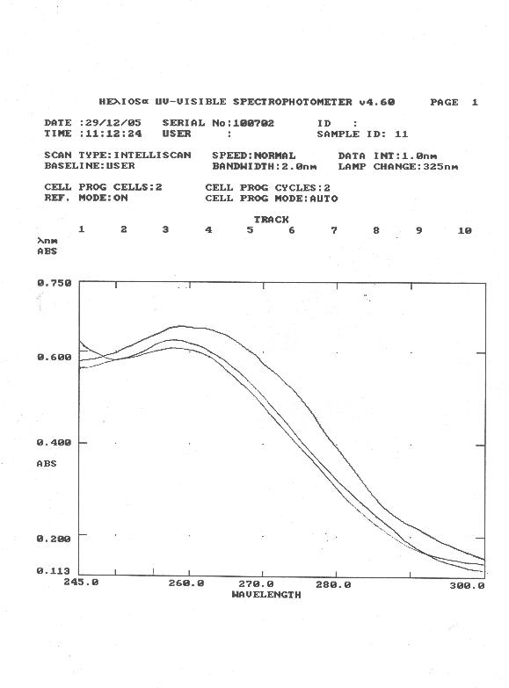

References
1. Lihningr AL "Text book of Biochemistry" 2nd ed. WORTH INC. (1978) p.811. 2. Fujita T, Meguro T, Fukuyama K, Nakamuta H, and Koida M, J. Bio. Chem., 2002, 277(25), 22191.
3. Evans LS, and Romeo DP., Amer. J. Bot., 1977, 64(9),1170.
4. Gazdic MA, and McDonough KA., J. Bactreol., 2005, 187(8), 2681.
5. Hassan HG. (1990) PhD Thesis, Wales university, UK.
6. Broadus AE, Kaminsky NI, Northcutt R , Hardman JG,Sutherland EW, Liddle GW, j. Clin. Invest., 1970b, 49, 2237.
7. Kaminsky NI, Broadus AE, Hadman JG, Jones JrDJ, Ball JH, Sutherland EW, and Liddle GW, J. Clin. Invest., 1970, 49, 2387.
8. Marshall WJ (2000) "Clinical Chemistry" 4th ed mosby, Hatcourt publisher , p. 203.
9. WWW. Metabolic and Endocrine Disorders. Htm (2003).
10. Brooker G, Method of biochemical analysis., 1974, 22, 95. Edited by david Glick.
11. Abdulla YH, Hamada K, Lancet Feb., 1970, 21, 378.
12. Mohamad AL: AA (1991) An MSC thesis, Mosul University.
13. Budavari S. (1989) The Merck index, 11th , Published by merk and Co. Inc. P. 2718.
14. Broadus AE, Mahffey JE, Bratter FC, and Neer RM, J. Clin. Invest., 1977, 60, 771.
15. Ball JH, Kaminsky NI, Hardman JG, Broadus AE, Sutherland EW, and Liddle GW, J. Clin. Invest., 1972, %1 , 2124.
16. Price TD, Ashman DF, and Melicow MM, Biochemica Biophysica Acta, 1967, 138, 452.
17. Ashman Df, Lipton R, Melico MM, and Price TD, Biochemical Biophysical research Communication, 1963, 11, 330.
18. Robinson GA, Butcher BW, and Sutherlsnd EW, " Cyclic AMP " academic Press., 1971, P.63.
19. Newton RP, Chiatante D, Ghosh D, Brenton g, Walton TJ, harrist FM, and Brown EG, Phytochemistry, 1989, 28(9) , 2243.
20. Drenzer MK, Neelon Fa, Curtis HB, and Lebovitz HE, Metabolism , 1976, 25, 1103.
21. Alston WC, Allen KR, and Tovey JE, Clin. Endocrinol. , 1980, 13, 17.
22. Pak CYC (1980) Advanced cyclic nucleotide research, 12: 393.

