The Key Role Correlation Of Creatine Kinase Activity and Antioxidants Status in Diabetic Patients Type I and II.

Mahmoud H.Hadwan
Babylon University, Science College ,Chemistry Dept., Iraq
Mufeed J.Ewadh
Babylon University, College Of Medicine
P.O.Box 473 Hilla,Iraq
Oda M. Al-Zamily
Babylon University, Science College ,Chemistry Dept., Iraq

(NJC)

(Received on 26/4 /2006) (Accepted for publication on 5/7/2006)

Abstract
The activity of creatine Kinase (CK) estimated, in sera of diabetic patients (36 males, 18 females) type I & II and the concentration of antioxidant variables such as Glutathione, uric acid compared with healthy controls has been also estimated, CK activity was found to be significantly decrease in patients with Diabetes Mellitus; while isoenzyme (MM-CK,BB-CK and MB-CK) levels fluctuated between decrease and relatively constant in patients with Diabetes mellitus .
Glutathione, uric acid was found to be reduced when compared with those of healthy controls. The depletion in antioxidant concentrations may be due to their protective role against oxidative stress in those patients.
الخلاصة
تم قياس فعالية أنزيم الكرياتين كاينيزفي أمصال مرضى داء السكري النوع الأول , والثاني (36 ذكور,18 إناث ) اضافه إلى قياس المتغيرات في تراكيز مضادات الاكسده كالكلوتاثايون وحامض اليوريك لتبيان العلاقة بين الطرفين وقد دلت النتائج بان فعالية الإنزيم ومضادات الاكسده تناقصت بشكل ملحوظ في مرضى السكري بينما أظهرت متماثلات الإنزيم تغيرات تراوحت بين ثبوت ونقصان عند نفس المرضى .إن النقصان الحاصل في تراكيز المضادات قد يعود إلى قابليتها على مقاومه الجهد التاكسدي الحاصل في هؤلاء المرضى وبذلك هدفت الدراسة إلى خلق علاقة مهمة بين الإنزيم من جهة وبين المضادات من جهة أخرى للاستدلال على القيم المعنوية لهذه العلاقة البايولوجيه.

Introduction
Diabetes mellitus can be defined as a group of metabolic disorders of carbohydrate metabolism due to glucose under utilized, producing hyperglycemia ⁽¹⁾.There are three types of diabetes mellitus, Type I (Juvenile or insulin – dependent diabetes mellitus) characterized by the autoimmune destruction of the pancreatic beta Cells ⁽²⁾.Type II diabetes (non insulin depended diabetes mellitus) which represents over 80% of clinical cases ⁽³⁾generally developed at later time from patient, the case of type II is insulin resistance ⁽⁴⁾.The reasons behind this resistance to insulin involve environmental causes and genetic causes ⁽⁵⁾. The third type called Gestational Diabetes Mellitus (GDM) which is carbohydrate intolerance of variable severity with onset or first recognition during the present pregnancy (i.e., diabetic women who become pregnant are not induced in this category) this paper aims the investigate the relationship between the CK activity and antioxidant such as glutathione and uric acid in diabetes mellitus type I and II . Also to separate the isoenzyme of CK to know which of these isoenzyme influences with oxidation stress.

Free Radicals in Medicine:
It is difficult nowadays to open a medical journal without seeing some papers on the role of free radicals in humane diseases. These species concern with over l00-conditions ⁽⁶⁾. Reactive Oxygen Species (ROS·) are the most famous of this species which founds due to oxidative stress, however Sies described the oxidative stresses as a change in pro-oxidant antioxidant balance in favor of the pro-oxidant state , Antioxidant is defined as any substance that, when presented at low concentration compared with an oxidizable substrate, prevents or inhibits oxidation of the oxidizable substrate, however free radicals are not always harmful , They also serve useful substances in the human body ⁽⁷⁾.
Several researches indicate that the oxygen radicals in living system are very necessary species in the mutarotaion process of cellular structures for example white blood cells destroy invading pathogenic microbes by the release of free radicals as part of body's defense mechanism against disease , thus the complete elimination of these radicals would not only be unnecessary, but also harmful ⁽⁸⁾.

Hyperglycemia and Free Radicals:
Although the diabetes control and complications trial describe hyperglycemia as a risk factor for the development of diabetes complication⁽⁹⁾ ,there is no consensus about the pathogenic link between hyperglycemia and complication ⁽¹⁰⁾. There are number of hypotheses on the origin of complications, including advanced glycation end product (AGE) hypothesis, oxidative stress, reductive stress, carbonyl stress, and increased protein kinase activity⁽¹¹⁻¹⁵⁾. These hypotheses overlap and interact with others like AGE formation and altered polyol pathway activity which may be due to oxidative stress⁽¹⁰⁾.
Hyperglycemia can increase the levels of free radicals through different pathways such as protein glycation, autoxidation glycation, protein kinase and increase in the polyol pathway.
Glucose enolizes by the autoxidation process. This process entails the reduction of oxygen, to produce oxidizing intermediates, such as O⁻₂, OH⁻, H₂O₂ and α-keto aldehydes ⁽¹⁶⁾.
Creatine Kinase (CK, EC 2.7.3.2)
Creatine Kinase is a key enzyme of cellular energy metabolism , catalyses the reversible transfer of the high energy N-phosphory1 group from creatine phosphate to ADP ⁽¹⁷⁾. Three cytosolic (MM-CK, MB-CK, BB-CK) and two mitochondrial isoenzyme (Ubiquitous Mia-CK and sarcomerc Mio-CK) of CK enzyme are known ⁽¹⁸⁾.
CK isoenzyme are associated with site of ATP production (e.g. Mi-CK in the mitochondrial intermembrane space ) and with ATP consumption (e.g. cytosolic CK bond to the myofibril M line or the plasma membrane ) and fulfill the function of transport demand of high -energy phosphate ^{(19).}
Glutathione
Glutathione is a major intracellular peptide sulfhydryl compound, and it has many biological functions such as maintenance of membrane protein sulfhydryl groups in its reduced form and it functions in catalysis, metabolism, transport and in the protection of cells against foreign
Compounds, free radicals and ROS. Glutathione is an active compound in reactions that destroy H₂O₂ and other peroxides and acts also as a cofactor for many enzymes such as glutathione peroxidase, which catalyzes detoxification of intracellular. Thus, it maintains of glutathione levels in its natural state for cellular defense against oxidative injury and for cellular integrity ⁽²⁰⁾. The physiological role of glutathione as an antioxidant described and substantiated in studies of numerous disorders reflecting the increased oxidation result of abnormal glutathione⁽²¹⁾.
Materials and Methods
A- Materials : All chemical used were highly purified and imported from fluka – company, Germany .
B- Methods :
Collection of Blood
Blood collected from vein (about 5 ml) and then it was allowed to clot for 15 minutes , the clot shrinks and serum can be obtained by, centrifuging for approximately 10 min. At 2000 xg ⁽²²⁾.
Patients and Controls
Thirty patients (21 males, 9 female) with diabetes mellitus type I and twenty-four (15 males, 9 females) with diabetes mellitus type II has been subjected to the present study, as well as fifty apparently healthy individuals as a control (31 males,19 females) after having been asked about their health. (All the samples is collected from the laboratories of Mergan hospital in Hilla city).
Determination serum creatine Kinase Activity
In the present study, the creatine kinase activity was measured by using commercially available kits (randox laboratories Ltd, UK) ⁽²³⁾ ,while the separation of the serum creatine kinase isoenzyme has been done by ion-exchange column chromatography according to the method described by Mercer's ^{(24,25)} ,however this method modified to increase sensitivity by using DEAE- cellulose rather than DEAE-sephadex-A-50, and by changing the ionic strength of the eluting buffer⁽²⁶⁾.

Determination of serum reduced glutathione
More than one type of analytical methods are used to determine serum glutathione (GSH) depending on the action of sulfhydryl groups. The method used in this study described by alta’ee .et al.,⁽²⁷ ⁾
Determination of Serum Uric Acid
The determination of uric acid in serum was measured enzymatically by the biomagreb kit ^{(28).}

Statistical analysis
The results are expressed as number , rang , confidence interval C.I 95% and whenever possible as mean ± SD(SE) of number observations. The data are analyzed by using student's "t" test and correlation test take P≤0.05 as the lowest limit of significance.

Results and Discussio
In the present study, the control values of different variants were determined in sera of apparently healthy individuals, compared with different in-patients group.
Then, the determination of different variants was done in sera of patients with DM type I and II.
The age of healthy controls and patients subjected to the present study are shown in Table (1). Groups, sex, No., mean (years), SD (Upper value, lower value).

Table (1):The age of healthy controls and patients with diabetes mellitus.

 | No. | Sex | Mean | SD | Upper | Lower
Control | 31 | Male | 35.2 | 9.22 | 60 | 22
Control | 19 | Female | 32.6 | 8.7 | 57 | 22
Type l | 21 | Male | 30.8 | 10.7 | 55 | 28
Type l | 9 | Female | 31.07 | 9.3 | 56 | 27
Type 2 | 15 | Male | 38.7 | 10.2 | 62 | 36
Type 2 | 9 | Female | 37.11 | 10 | 55 | 38

Effect of Diabetes on Creatine Kinase:-
Compared with healthy controls, CK activity was found to be significantly decreased in sera of patients with diabetes mellitus types l and II as shown in Table (2) and Fig. (1)

Table (2): CK activity (U/L) in sera of patients and healthy control
M=males, F= females, S= significant (when P<0.05), NS= not significant).

 | Sex | Mean | SD | CK |  | SE | 95% C.I. |  | P | Sign
 |  |  |  | Upper | Lower |  | Upper | lower
control | M | 115.58 | 25.2 | 180 | 76 | 4.25 | 122.8 | 105.63 | — | —
 | F | 112.8 | 38.7 | 183 | 70 | 8.87 | 135.95 | 95.82 | -- | --
Type 1 | M | 86.8 | 36.8 | 140 | 56.6 | 7.14 | 106.58 | 70.18 | 0.001 | Sign
 | F | 81.23 | 34.98 | 98.4 | 52.8 | 11.26 | 106.7 | 55.76 | 0.001 | Sign
Type 2 | M | 87.33 | 3331 | 168 | 50 | 8.6 | 106.78 | 100.33 | 0.001 | sign
 | F | 79.55 | 38.37 | 150 | 50 | 12.79 | 108.48 | 50.16 | 0.001 | sign

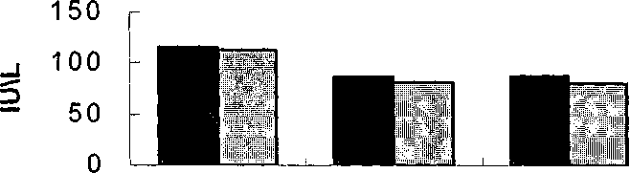

Male Female
Control Type I Type II

Fig (1) :The level CK activity in sera of patients and healthy control

There is much evidence, which suggests that, the decrease of CK activity in serum is beyond ROS :-

1- Oxygen free radicals are implicated in mediating various pathological processes such as diabetes ⁽²⁹⁾. Free radicals are known to interact with enzyme and other biomolecules and affect their structure and function then leads to pathophysiological condition. The active sites of CK contain cysteine residues, which are very essential for enzyme activity and substrate binding ⁽³⁰⁾,Thus cysteine could be the targets for oxygen free radicals due to the modification of this group which could be the reason for the enzyme inactivation.
The addition of superoxide dismutase SOD or catalase CAT almost completely reveres the effect of superoxide or H₂O₂ on the CK activity respectively ⁽³¹⁾ .The depressed activities of CK due to oxygen free radicals were reversed to control values by addition of dithiotheritol DTT. This protection can be due to two reasons; the first is that this compound reduces the oxidized sulfhydryl group of enzyme at the active site oxidized by oxygen free radicals ,or the sulfhydryl group of DTT may react directly with oxygen free radicals to protect the enzyme active sites from the attack by oxygen free radicals.
2- Alloxan and streptozotocin are widely used to induce experimental diabetes in animals. The mechanism of their action in B-cells of the pancreas has been found to occur by the action of nitric oxide ⁽³²⁾. Chiarelli et al ⁽³³⁾ demonstrated in vivo that the nitrosative stress increases in DM.

3- MM-CK incubated with hypoxanthine plus xanthine oxidase inhibited to lower value of activity, adding DTT or GSH prevents this effect⁽³⁴⁾.
All these observation suggest that decreased creatine kinase activity occurs because of the effect of free radicals on the thiol group (a constant amount of protein but decrease the CK activity) .The decrease of creatine kinase may occur also because of diabetes decreased (CK-Mm-RNA) to 61.1% due to decreased CK-M sub unit, (decrease the amount of protein) ⁽³⁵⁾. The result of this study is more agreement with the last suggestion because (BB-CK) stays constant relatively as shown in Fig (2).
The Effect of Diabetes on Glutathione:
Glutathione (GSH), cysteine and ergothionine are three compounds, which make up the non-protein thiol compounds (NPSH)⁽³⁶⁾,however many investigators using methods, which measure NPSH, have interpreted the result as GSH because GSH makes at least 90% of the NPSH ⁽³⁷⁾. Compared with healthy controls, GSH concentrations were found to be significantly decreasing in sera of patients with different types of Diabetes mellitus. In the present study it was found that GSH is decreased statistically significantly as shown in table (3) and fig (3). Previous studies have shown low levels of GSH in patients with renal failure, liver failure, and CHD vitamin B12 deficient and multiple organ failure ⁽³⁸⁻⁴¹⁾. .

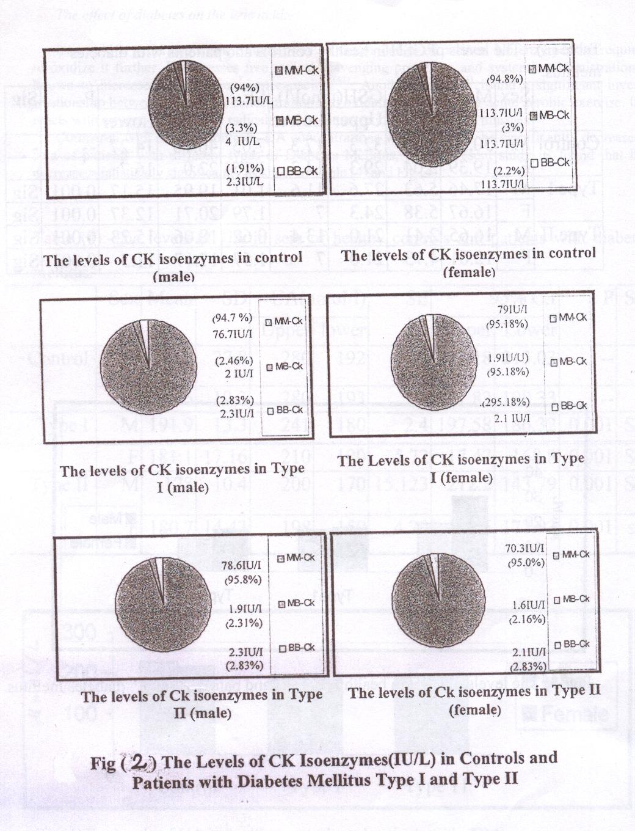

Table (3): -The levels of GSH in healthy controls and patients with diabetes mellitus.
 | Sex | Mean | SD | GSH(umol/l) |  | SE | 95% C.I |  | P | Sign
 |  |  |  | Upper | Lower |  | Upper | Lower
Control | M | 30.22 | 5.06 | 32.3 | 17.3 | 7.05 | 46.16 | 14.27 | -- | -
 | F | 19.39 | 5.04 | 29.3 | 14.3 | 1.15 | 22.0 | 16.7 | - | -
Type l | M | 17.46 | 5.63 | 27.6 | 11.6 | 1.01 | 19.95 | 15.17 | 0.001 | Sign
 | F | 16.67 | 5.38 | 24.3 | 7 | 1.79 | 20.71 | 12.37 | 0.001 | Sign
Type II 111 2 | M | 16.65 | 2.41 | 21.0 | 13.4 | 0.62 | 18.06 | 15.23 | 0.001 | Sign
 | F | 12.61 | 4.73 | 21.0 | 7 | 1.577 | 17.17 | 11.3 | 0.001 | Sign
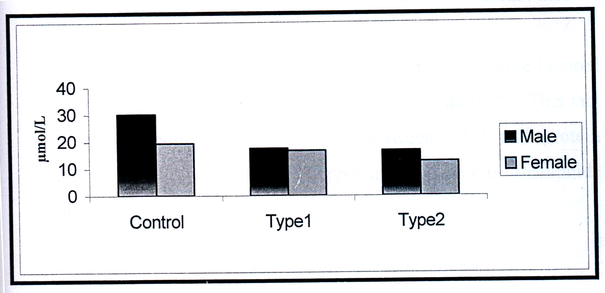

Fig (3) The levels of GSH in healthy controls and patients with diabetes mellitus.

The effect of diabetes on the uric acid:-
Uric acid is generated in the human body by the oxidation of purines. No enzymes are required to oxidize it further. It possesses free radical scavenging properties and systemic administration is known to increase serum antioxidant capacity ⁽⁴²⁾. Another study ⁽⁴³⁾ found a significant inverse relationship between serum UA concentration and oxidative stress during acute aerobic exercise. UA reacts with oxygen-derived free radicals and becomes oxidized in skeletal muscles^{(44).}
Compared with healthy controls, UA concentrations were found to be significantly decrease in sera of patients with different types of Diabetes Mellitus, In the present study its found that UA decreases statistically significantly as show in Table (4) and Fig (4).

Table (4):-The levels of UA in sera of healthy controls and patients with diabetes mellitus.
 | Sex | Mean | SD | UA(nmoI/l) |  | SE | 95% C.I |  | P | Sign
 |  |  |  | Upper | lower |  | Upper | Lower
Control | M | 225.6 | 27.8 | 280 | 192 | 5.56 | 238.18 | 213.03 | -- | --
 | F | 214.6 | 19.3 | 280 | 193 | 7.2 | 221.83 | 198.33 | -- | --
Type I  + | M | 191.9 | 13.3 | 241 | 180 | 2.4 | 197.58 | 186.32 | 0.001 | Sign
 | F | 181.1 | 17.16 | 210 | 180 | 5.72 | 17.47 | 168.8 | 0.001 | Sign
Type II | M | 178 | 10.4 | 200 | 170 | 15.123 | 212.2 | 143.79 | 0.001 | Sign
 | F | 180.7 | 14.43 | 198 | 150 | 4.79 | 191.6 | 177.93 | 0.001 | sign
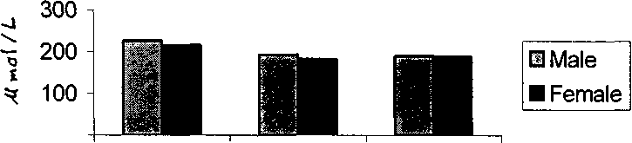
Type 11
0
Contrololol
Type I

Fig.(4)The levels of UA in healthy controls and patients with (DM)

A previous study has shown low levels of UA in patients using the drug "pyrazinamide" because this drug induces increment urate excretion^{(44).} Increased dietary protein elevates plasma uric acid and is associated with decreasing oxidative stress ⁽⁴⁵⁾,however the decrease of UA in diabetes may be related to:
1- UA acts as scavenger for peroxynitrate ⁽⁴⁶⁾ (this radical increases in DM'^{(32,33)}) to produce nitrated uric acid.

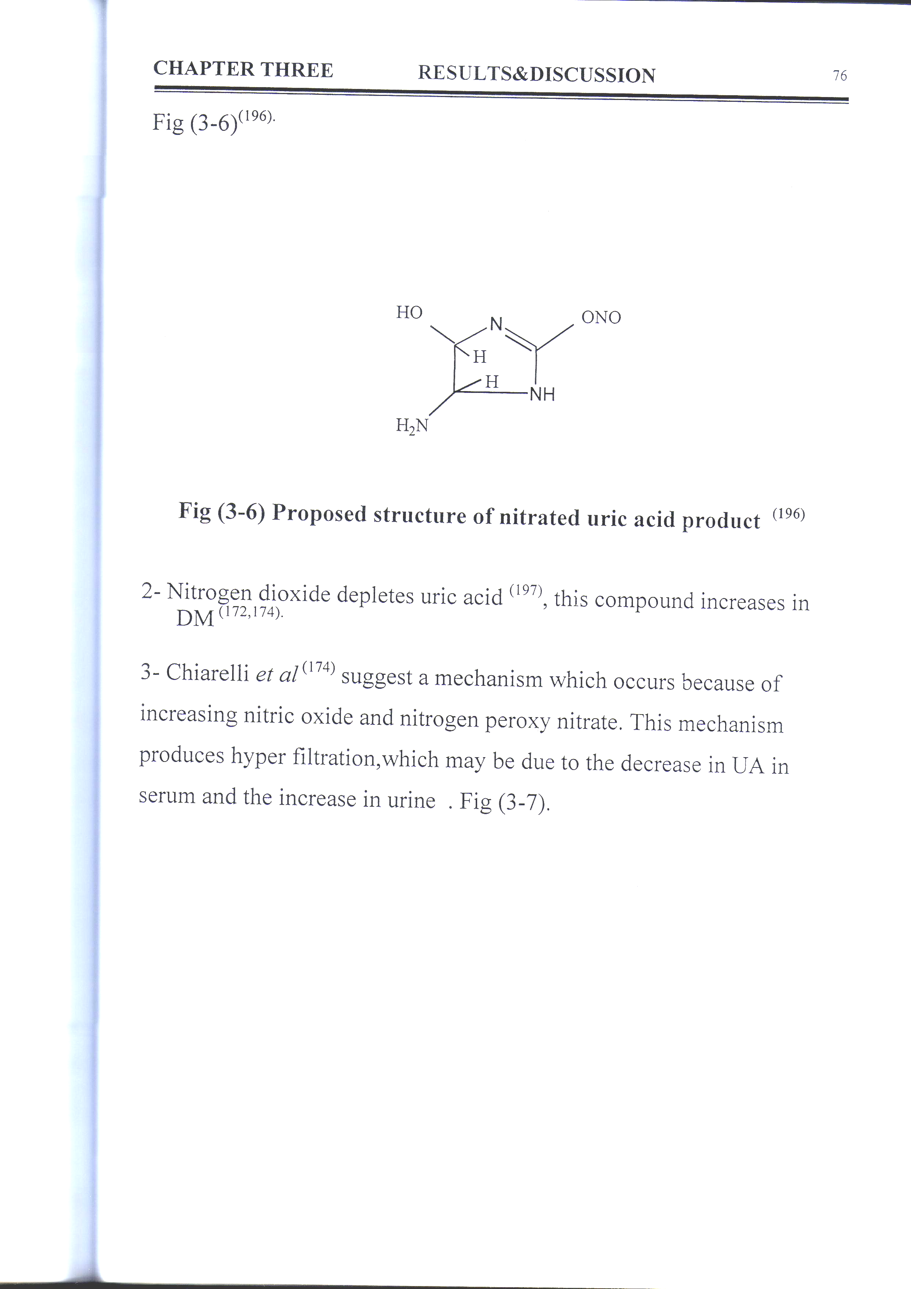

Fig (5) Proposed structure of nitrated uric acid product⁽⁴⁶⁾

2- Nitrogen dioxide depletes uric acid, this compound increases in DM ⁽⁴⁶⁾
3- Chiarelli et al ⁽³³⁾ suggest a mechanism which occurs because of increasing nitric oxide and nitrogen peroxy nitrate. This mechanism produces hyper filtration , which may be due to the decrease in UA in serum and the increase in urine . Fig (6).

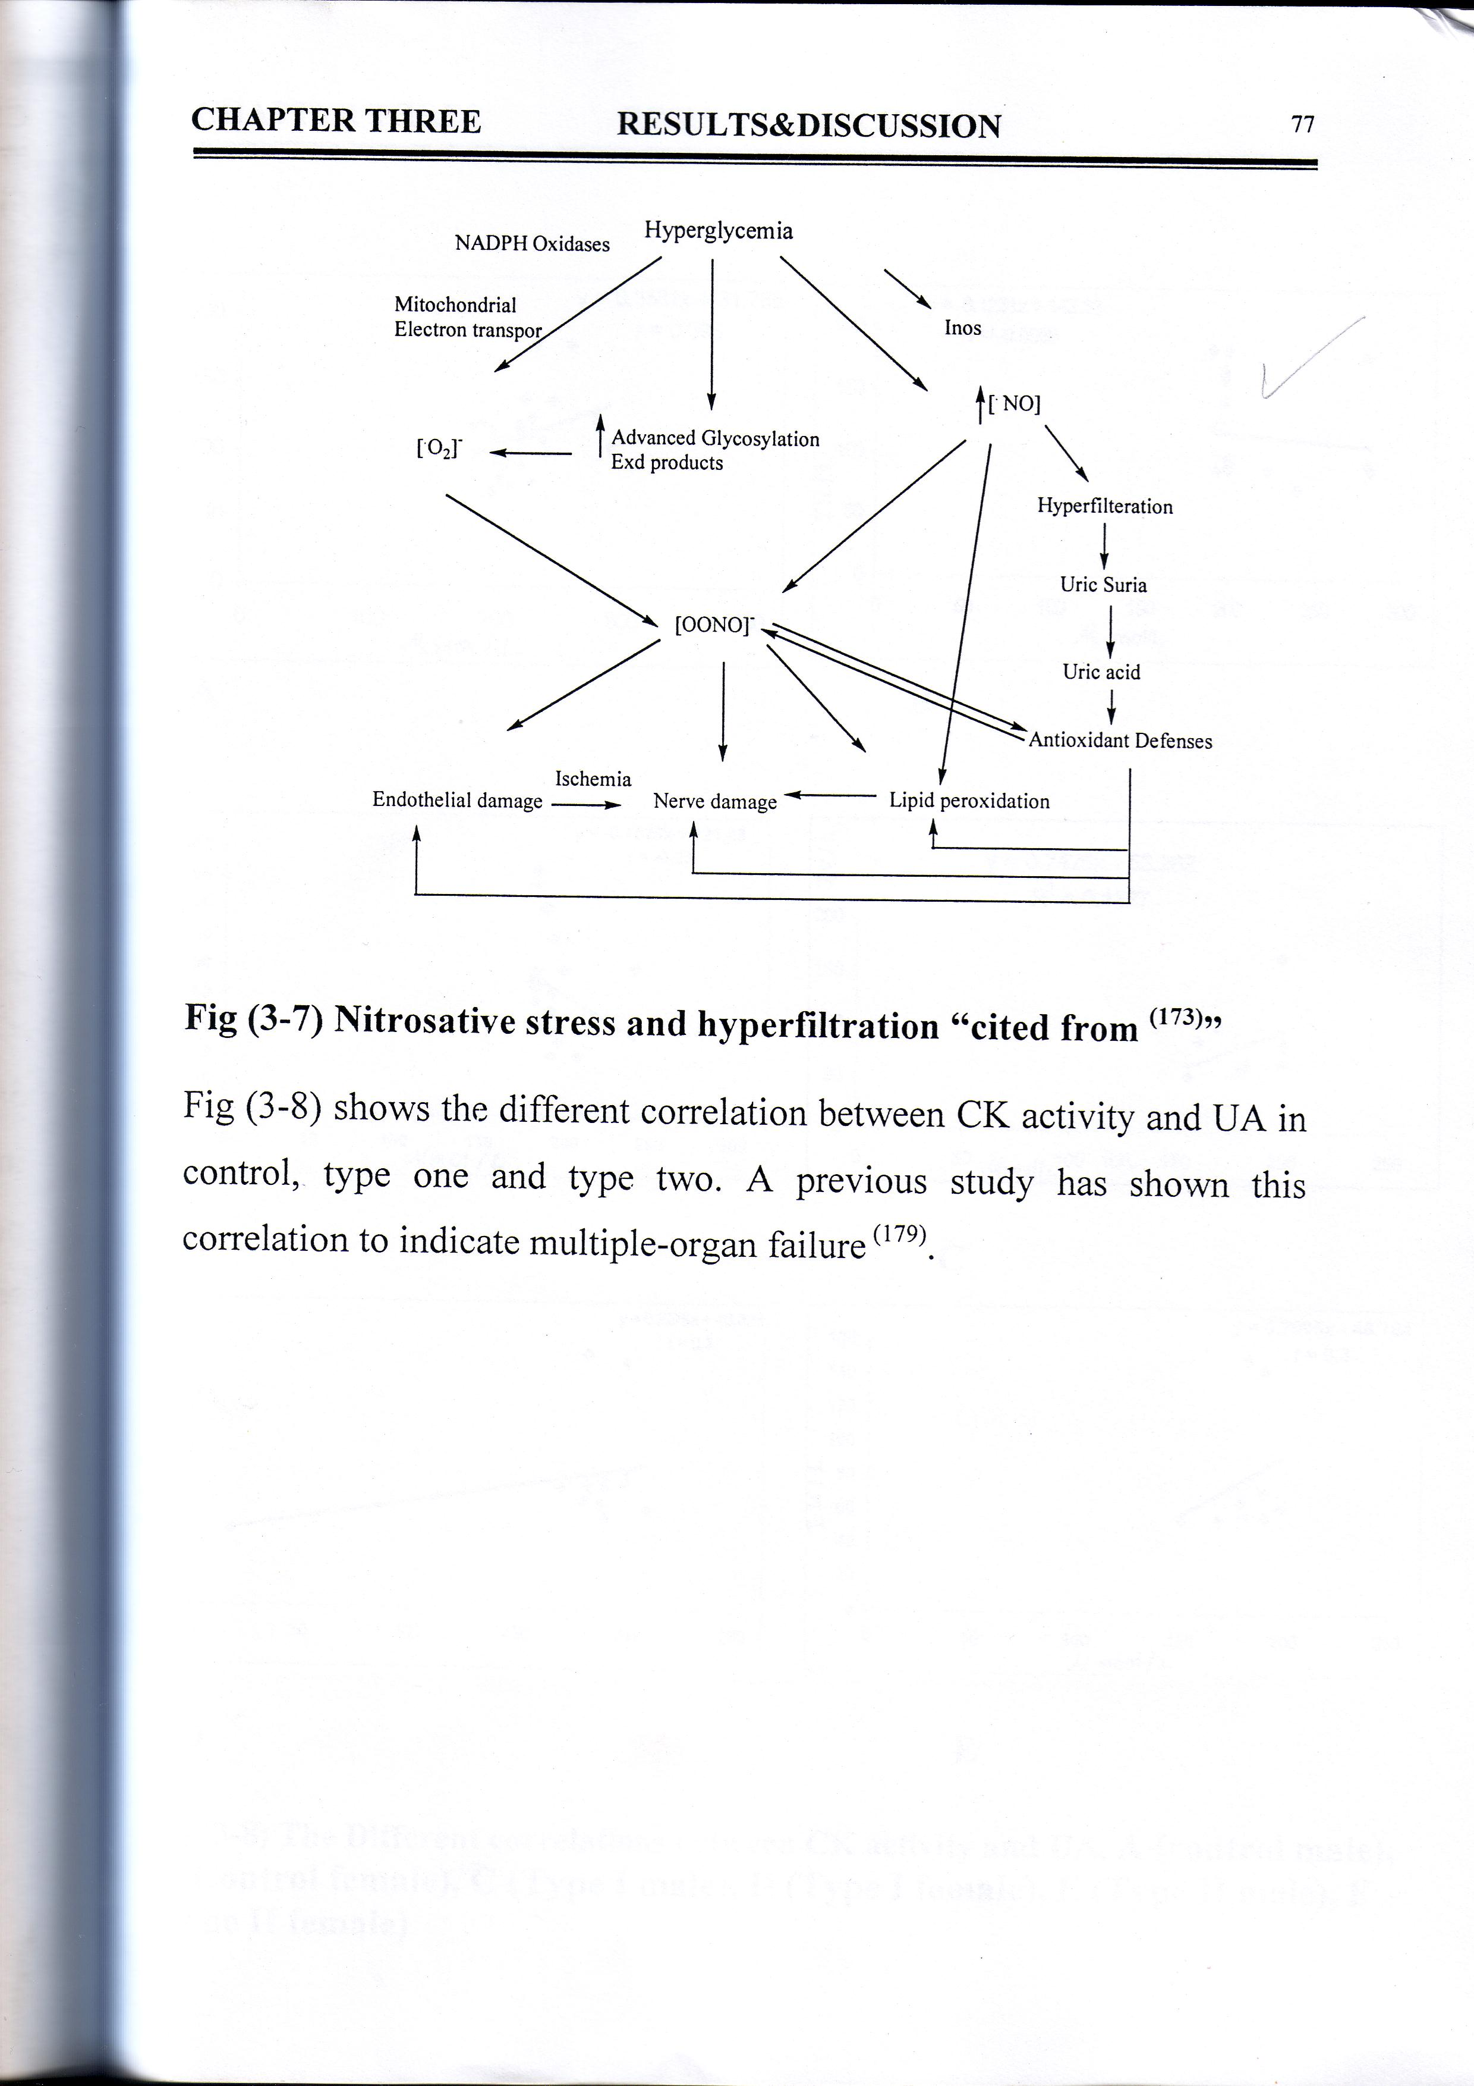

Fig (6) Nitrosative stress and hyper filtration "cited from ⁽⁴⁷⁾"

Fig.(7)shows the different correlation between CK activity and glutathione in control, type I and type II. A previous study has shown this correlation to indicate multiple-organ failure⁽³⁵⁾.

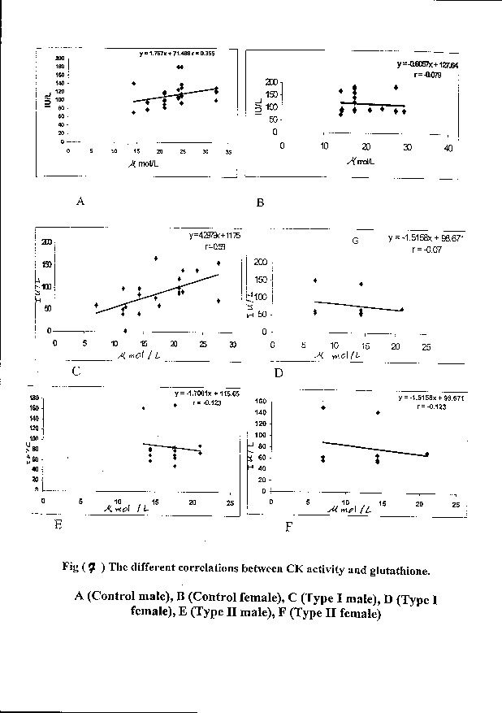

References
1- Reese S. J,.Thesis M Se , East Tennessee State university , USA, 2003.
2- Thompson K.H., Godin D. B., Nutrition Research ., 1995;16;1377.
3- Eisenbarth G.s., N. Engl.J.Med ., 1986; 314, 1360.
4- De Fronzo R. A., Diabetes, 1988; 37, 667.
5- National Diabetes Data group, Diabetes, 1979; 28, 1039.
6- Bagchi K., S., Eastern Mediterrancean Health J., 1998; 4(2), 353.
7- Halli well B., Gutteridge J. M., Arch. Biochem . Biophys., 1990; 280, 1
8- Wess S. G.,. N. Engl. J. Med., 1989; 320,365.
9- The DCCT Research group, N. Engl. J Med ., 1993 ; 329, 977.
10- Baynes J. W., Thorp S. W., Diabetes, 1999; 48, 1.
11- Brownlee M., Ann. Rev. Med ., 1996 ; 46, 223.
12- Vandam P. s., Van Asbeck B.s., Erkelens B. w., Diabetes Metab. Rev ., 1995;11, 181.
13- Willamson J. R., Chang K. S., Diabetes, 1993; 42, 801.
14- Lyons T. J., Jenkins A. J., Diabetes Rev ., 1997; 5, 365.
15- Ishii H., Daisuke K., King G. L., J. Med ., 1998; 76, 21.
16- Hunt J. U., smith C.C., Wolf S. P., Diabetes , 1990, 39, 1420.
17- Forstener M., Kriechbaum M., Laggner P., and Wllimann T., Biophysical J.,1998; 344, 41.
18- Wallimann T., Wyss M., Brdiczka D., Nicolay K., and Eppenberger H., Biochem J., 1992 ; 281, 21.
19- Kushmeric MJ., Comp Biochem Physiol B Biochem, 1998, 120, 109.
20- Jain S. K., J. Bio.Chem., 1989, 264, 21340.
21- Ueno Y., Kizaki M., Nakagiri R., Kamiaya T., Sumi H., and Osawa T., J. Nutr.,2002; 132, 897.
22-Bioshop M. L., Duben- Engel Kirk, and Foby E. P., Clinical Chemistry,4thed.,Piladelia, Lippincott Williams and WilKins, 2000.
23- Allain C.C.,Clin.Chem.,1973;19(6), 223.
24- Mercer, Clin. Chem., 1974; 20, 36.
25- Rej R., Clin. Chem., 1998; 44(6), 1149.
26- NealonD.A.., Hendrosn A.R., Clin. Chem., 1975; 21(3), 392.
27- AL-taee,A.S.et al., M Sc.thesis ,Babylon university (2003).
28- Fossati P., Clin. Chem., 1980; 28, 227.
29- Burstein M., Lipid Res ., 1970; 11, 583.
30- Liu Z. J., Zhou J., Biochem. Biophye.Acta., 1995; 1253, 6
31- Genet S., Kale R. K., Baquer N. Z., Mol. Cell. Biochem., 2000; 210, 23.
32- Szudelski T., Physiol. Res., 2001; 50, 536.
33- Chiarelli F., Cipollone F., Romano F., Tumini S., Costantin F., Ricco L. D., Pomilio M., Pierdomenico S. D., Marini M., Cuccurullo F., and Mezzetti A., Diabetes, 2000; 49, 1258
34- Banerjee A., Grosso M. A., Brown J. M.,Rogers K. B., and Whitman G. J. R.., Am. J. Physiol., 1991, 261, H 590.
35- Popovich B. K., Boheler K. R., and Dillmann W. H., Am. J.Physiol., 1989; 257(20), E 573
36- Jocelyn P.C., CLINICAL CHAMICA ACTA,1958; 3, 401
37- Wood ward G. E., J. Biol. Chem., 1935:
38- Andersson A., Lindgren A., Arnadottir M., Prytz H., and Hultberg B., Clin. Chem., 1999, 45(7), 1084
39-Morrison J. A., Jacobsen D. W., Specher D. L., Robinson K., Khoury P., Daniels S./R., Circulation, 1999; 100, 2244.
40- Register U. D., J. Biol. Chem., 1954; 206, 705.
41- Gunst J. J., Langlois M. R., Delanghe J. R., Clin. Chem., 1998; 44(5), 939.
42- Zitnanova L, Korytar P., Aruoma O. I., Sustrova M., Garaiova L, Muchova J., Kalnovicova T., Pueschel S., Durackova Z., Clinica Chemica Acta, 2004; 341, 139.
43- Mikami T., Yoshino Y., and Ito T., Free Radical Res., 2000; 32, 31.
44- Roch- Ramel F., Guisan B., News Physiol. Sci., 1999; 14, 80.
45- Machin M., Simoyi M. F., Blemings K. P., Klandorf H., Comparative Biochemistry and Physiology, 2004; 137 B, 383.
46- Skinner K.A., White C.K., Patel R., Tan S., Barnes S., Kirks M., Dorle-Usmar V., and Parks D. A., J. Biol. Chem., 1998, 273(38), 244491.
47- Hoeldtke R. D., Bryner K. D., Mc Neill D. R., Hobbs G. R., Riggs J. E., Warehime S.S., Christic I., Gancer G., and Dyke K. V., Diabetes, 2002; 51, 2817.

