Synthesis and Characterization of Some Transition Metal Complexes
with New Thiazolylazo Ligand

A. M. Ali.
Dep. Of Chemistry, College of Education for Women, University of Kufa
Najaf – Iraq

(NJC)

(Received on 26/ 3 / 2006 ) (Accepted for publication on 19/ 8/ 2006 )

Abstract
The preparation structural identification of some transition metal complexes of new thiazolylazo ligand 2-[ (2-Thiazolyl) azo ]-4-benzyl phenol (TABP = HL) are studied on the basis of their analytical, spectroscopic, magnetic susceptibility and conductance data. The stability constant of prepared complexes have been determined by spectrophotometric method. The stability of complexes follows the sequence; Cu(II) > Co(III) > Ni(II) > Hg(II) > Cd(II) > Zn(II) > Ag(I). The isolated solid complexes are found to have the general formula [ ML₂ ].x H₂O (M = Ni(II), Cu(II), (x = 1), M = Zn(II), Cd(II), Hg(II), (x = 2) or [ CoL₂ ]Cl.H₂O and [ AgL(H₂O) ]. H₂O. Structural information has been taken from spectroscopic, magnetic and molar conductance measurements. The coordination number of all metal ions is found to be six, except of Ag(I) complex was found four, with binding through the phenolate O, azo N and with thiazole N atom.
الخلاصة
تضمن البحث تحضير وتشخيص لبعض من معقدات العناصر الانتقالية مع ليكاند ثيازوليل آزو جديدة 2- [ (2-ثيازوليل) آزو ]-4-بنزايل فينول (TABP = HL). وقد شخصت الليكاند ومعقداتها بواسطة التحليل الدقيق للعناصر وطيفياً باستخدام الاشعة تحت الحمراء والاطياف الألكترونية ودراسة الخواص المغناطيسية والتوصيلية المولارية ، كما تضمن البحث أيضاً تعيين ثوابت استقرار المعقدات المحضرة وقد اتخذت الترتيب التالي النحاس (II) > الكوبلت < (III)النيكل< (II) الزئبق< (II) الكادميوم < (II) الخارصين < (II) الفضة (I). وبالاستناد الى معطيات النتائج التحليلية المذكورة أعلاه فقد تم اقتراح الصيغ التركيبية للمعقدات الصلبة وكانت [ML₂].x H₂O وكانت 1 = x لكل من النيكل (II) والنحاس (II) فيما كانت = x 2 لكل من الخارصين (II) والكادميوم (II) والزئبق (II). أما معقد الكوبلت (III) فقد اتخذ الصيغة [ CoL₂ ]Cl.H₂O فيما أتخذ معقد الفضة (I) الصيغة [Ag L(H₂O)].H₂O. وقد تبين أن عدد التناسق ستة لجميع الأيونات بينما أنفرد أيون الفضة (I) بعدد التناسق أربعة ، وذلك نتيجة لأرتباط الأيونات مع مواقع التناسق المتاحه في جزيئة الليكاند وهي أوكسجين مجموعة الهيدروكسيل وأحدى ذرتي نيتروجين مجموعة الآزو وذرة نيتروجين حلقة الثيازول.

Introduction
Chemists, in recent years have shown a growing concern is studying thiazolylazo phenols and its derivatives formed by thiazole, benzothiazole and other related compounds as these are common components to some important material sciences⁽¹⁻³⁾. However one of the major interests continues to be their possible use as dyeing fibers^{(4,5)}, and have been used as analytical reagents⁽⁶⁻¹⁰⁾, in addition to the use a staining agent⁽¹¹⁾. The ligand is iso - electronic with (α-imine) and the active function is the (π-acidic) azo imine group (─N═N─C═N─) consequently a number of these ligands were prepared as chelating ligand⁽¹²⁻¹⁶⁾.
This work describe the preparation and characterization of some transition metal complexes, using the new thiazolyazo ligand (TABP).

Experimental
Materials and Measurements
All chemicals used were of (BDH, Fluka or Aldrich) and used with out further purification. Elemental analysis was carried out by means of Micro analytical unit of 1108 CHN Elemental analyzer. IR spectra were recorded on a (Pye – Unicom SP3 – 300), spectrophotometer, in the (4000 – 200) cm⁻¹ using CsI disc. Magnetic susceptibilities were measured on powder samples using Farady method, Balance Magnetic MSB – MKI was employed for this purpose. Electronic spectra were made using Shimadzu UV-Vis1700 spectrophotometer. Metal amounts were determined using atomic absorption technique by Shimadzu – AA – 160. The conductance measurements were carried out at room temperature and (10⁻³M) concentration using conductivity bridge model 31 A. pH measurements were carried out using HANNA pH meter model HI 9321.

Synthesis of the Ligand (TABP)
The azo (TABP) ligand Fig. (1), has been synthesized by the diazotization coupling reaction using (Fan) et al ⁽¹⁷⁾, method ( with some modification ) for synthesis this kinds of azo compound 2-aminothiazole (1.5 g 15 mmol) was dissolved in 5ml of formic acid and 6ml of concentrated hydrochloric acid, then 20ml of water was added. To this mixture a solution of (1.1g, 16mmol) of sodium nitrite in 20ml of water was added drop wise at 0 – 5°C and the mixture was stirred for 30min. Separately, 4-benzyl phenol (2.76g, 15mmol) was dissolved in 150ml alkaline ethanol and cooled to 0 – C°, this solution was then added drop wise to the above diazotized solution with vigorous stirring. The mixture was stirred for additional 3hrs, in an ice – bath and allowed to stand over night. The precipitate formed was filtered off and first purified by the basic – acid recrystallization method and further purified by recrystallization twice from hot ethanol and dried in a desiccator over anhydrous CaCl₂.

Fig. (1): Structure of the (TABP) Ligand

Synthesis of the Complexes
The complexes were prepared by dissolving (2mmol.) from ligand in hot ethanol 50ml then added drop wise with vigorous stirring to a stoichiometric amount of, 1:1 for Ag(I) nitrate and 2:1 for Co(II), Ni(II), Cu(II), Zn(II), Cd(II), and Hg(II), chloride salts dissolved in 15ml hot distilled water. The mixture was heated to 50°C for 30min, then left over night. The solid product thus formed was filtered off, washed with 5ml hot ethanol and dried in a desiccator over anhydrous CaCl₂.
Results and Discussion
The ligand and its solid complexes are stable in air, insoluble in water, but completely soluble in common organic solvents. The analytical and physical data for synthesized compounds are listed in (Table 1). Attempts to propose the structure of the isolated complexes come from available investigation using the following studies.

Metal: Ligand Ratios
The metal: ligand ratios of complexes were determined by the method of molar ratio at the wave lengths of maximum absorption, and fixed pH. The results are summarized in (Table 2). The ligand (TABP) was found to form 1:2 chelates with all metal ions except of Ag (I) complex was found 1:1, these results are in agreement with the values reported for some thiazolylazo phenol complexes⁽¹⁸⁻²⁰⁾.
Calculation of the Metal Complexes Stability Constant (β)
Stability constant of complexes are obtained spectrophotometrically by measuring the absorbance of solutions of ligand and metal mixture at fixed wave length λ_{max}, and pH values. The degree of formation of the complexes is obtained from the relationship⁽²¹⁾ β = (1 – α)/(α²c) for Ag(I) complex and β = (1 – α)/(α³c²), for remaining metal complexes, and α = A_{m} – A_{s} / A_{m}.
Where Am and As are the absorbance’s of the partially and fully formed complex respectively at optimum concentration. The calculated log β values for the prepared complexes are given in (Table 2). The stability follows the sequence; Cu(II) > Co(III) > Ni(II) > Hg(II) > Cd(II) > Zn(II) > Ag(I). The high stability of (TABP) toward Cu(II) is remarkable over the other ions. This implies a considerably higher affinity toward this ion.
IR Spectral Studies
The most characteristic bands of the ligand and their complexes are summarized in (Table3). These spectra are complicated owing to the extensive overlap of a number of bands arising due to ν(O─H), ν(C═N), ν(N═N) and other bands originate due to phenyl and thiazole rings appeared in the region below 1790 cm⁻¹, the shifts in the positions or change in shape of the complexes bands compared with those absorption bands due to free ligand suggest the probable modes of bonding in the complexes. Some of there main shifts along with conclusions are given below.
The spectrum of ligand shows a very weak absorption band around 3350 cm⁻¹ due to ν(O─H). This suggests a strong inter-molecular hydrogen bonding^{(22,23)}. In the spectra of metal complexes the broad weak absorption bands around 3550 – 3300 cm⁻¹ indicates the presence of water in these complexes⁽²⁴⁾, two weak bands had been observed at 3080 and 2910 cm⁻¹ in the ligand spectrum which are due to ν(C─H) aromatic and aliphatic respectively. These bands are stable in position in both ligand and metal complexes.
Ligand spectrum show another band at 1630 cm⁻¹, which is considered to be ν(C═N) of thiazole ring⁽²⁵⁾. It is observed with a little change in shape and shifted to lower frequencies 1605 – 1590 cm⁻¹ in prepared complexes spectra. These differences suggest the linkage of metal ions with nitrogen hetero cyclic ring ⁽²⁶⁾.
Tow absorption bands are observed at 1490 and 1460 cm⁻¹ in the ligand spectrum, which are due to the azo group, while in complexes spectra these bands are shifted to a lower frequencies 1470 and 1430 cm⁻¹ with decreased in intensity. This may indicates that it has been affected on coordination with metal ions^{(26,27)}.
A band at 1230 cm⁻¹ has also been appeared in the ligand spectrum this absorption band is due to ν(C─S) of thiazole ring⁽²⁸⁾. The fixed position of this band in all chelate complexes means that the sulfur atom of hetero cyclic ring does not participate in coordination⁽²⁶⁾.
Finally in the far IR spectra of all complexes, there are new bands observed in the region of 280 – 530 cm⁻¹ which are never been observed in the free ligand spectrum, this may attributed to ν(M─O), ν(M─N), and ν(M─Cl) bands^{(29,30)}.
Thus, the above IR spectra data lead to suggest that ligand behaves as a tridentate chelating agent coordinating through the positions of phenolic oxygen, nitrogen of azo group and thiazole ring nitrogen. Fig. (2) shows the spectra of [CoL2] Cl.H2O and (HL) ligand
Magnetic Properties and Electronic Spectra
As further structural tools, magnetic and electronic spectral studies have been used to confirm the geometry of the complexes. The spectral data and the magnetic moments are listed in (Table 4).
The magnetic moment of the Co(III) complex has been found to be diamagnetic, the low spin behavior of this complex indicates that Co(II) is oxidized to Co(III) during complexation. The change of the oxidation state agrees with earlier observation that the aqueous solution of Co(II) salts are spontaneously oxidized to Co(III) in the presence of strong ligand such as thiazolyazo compounds ^{(26,31)}. The electronic spectra of this complex shows two absorption bands at 16077 cm⁻¹ and 21376 cm⁻¹ characteristic of octahedral stereo chemistry⁽³²⁾. They were assigned to the transition ¹A1g → ¹T1g and ¹A1g → ¹T₂g respectively. For the Ni(II) complex, its magnetic moment (3.12 B.M.), which can be a normal value for octahedral high – spin Ni(II) complex compared with that has been found in the literature⁽³³⁾. The electronic spectrum of this complex show bands at 10205 cm⁻¹, 14815 cm⁻¹ and 23696 cm⁻¹, which are suggesting the existence of ³A₂g → ³T₂g (F) ³A₂g → ³T₂g(F) and ³A₂g → ³T₁g(p) transitions with an octahedral spatial configuration⁽³⁴⁾.The magnetic moment value of the Cu(II) complex is (1.71B.M), which may suggest an octahedral structure. It’s electronic spectrum shows a band centered at 16393 cm⁻¹ which may assigned to ²Eg → ²T₂g transition in an approximately octahedral environment⁽³⁵⁾. Zinc, Cadmium, mercury and silver complexes do not show any d – d transition bands. There were three absorption bands appear
at the free ligand (TABP) spectrum those are appearing at the positions, 44052 cm⁻¹, 35587 cm⁻¹ and 22321 cm⁻¹, the bands 44052 cm⁻¹ , 35587 cm⁻¹ referring to the π → π* transitions while the bend at 22123 cm⁻¹ is due to the charge transfer characters⁽³⁶⁾.
The electronic spectra of Co(III), Ni(II) and Cu(II) chelate complexes in ethanol solution are given in Fig. (3).
Conductivity Measurements
All complexes except of Co(III) complex show the conductivity measurement values ranging between 5.2 - 9.34 S.mol⁻¹ cm² (Table 4), in DMF at room temperature, these values indicating that there is no conductivity existence⁽³⁷⁾. But the low value of molar conductivity of the Co(III) complex (81.45 S.mol⁻¹ cm²) indicate that the complex is (1:1) ionic structure.
According to these results the structural formula of prepared complexes in this work may be proposed in Fig. (4) and Fig. (5).

(Table 1): Analytical and physical data of the ligand and its complexes

No. | compound | Color | M.p °C | Yield% | Formula | Found (Caled) %
 |  |  |  |  |  | C | H | N | M
1 | HL | Dark brown | 112 | 53 | C₁₆H₁₃N₃OS | 65.17 (65.08) | 4.29  (4.40) | 14.37  (14.23) | ------
2 | [CoL₂]Cl.H₂O | Green | 183 | 65 | C₃₂H₂₆N₆O₃S₂ClCo | 54.91  (54.82) | 3.59  (3.71) | 11.87  (11.99) | 8.21  (8.42)
3 | [NiL₂].H₂O | Greenish blue | 169 | 68 | C₃₂H₂₆N₆O₃S₂Ni | 57.65  (57.74) | 3.78  (3.91) | 12.81  (12.63) | 9.12  (8.87)
4 | [Cu.L₂].H₂O | Dark green | 227 | 71 | C₃₂H₂₆N₆O₃S₂Cu | 57.42  (57.35) | 3.92  (3.88) | 12.35  (12.54) | 9.25  (9.48)
5 | [Zn.L₂].2H₂O | Greenish blue | 192 | 61 | C₃₂H₂₈N₆O₄S₂Zn | 55.61  (55.70) | 4.01  (4.06) | 11.76  (11.60) | 9.72  (9.54)
6 | [Cd.L₂].2H₂O | Blue | 204 d | 58 | C₃₂H₂₈N₆O₄S₂Cd | 52.27  (52.14) | 3.72  (3.80) | 11.23  (11.40) | 15.02  (15.26)
7 | [Hg.L₂].2H₂O | Blue | 216 d | 63 | C₃₂H₂₈N₆O₄S₂Hg | 46.44  (46.56) | 3.46  (3.39) | 10.02  (10.18) | ------
8 | [Ag.L(H₂O)].H₂O | Red | 178 | 67 | C₁₆H₁₆N₃O₃SAg | 43.75  (43.83) | 3.57  (3.65) | 9.72  (9.59) | ------
d = decompose

(Table 2): Metal: Ligand ratios determination by the method of mole ratio and stability constant values

ligand | Metal ion | pH | λ_{max} nm | Metal : Ligand | β | Log β
(TABP) | Co(III) | 7.0 | 622 | 1 : 2 | 2.158×10⁹ | 9.334
(TABP) | Ni(II) | 6.5 | 675 | 1 : 2 | 1.031×10⁹ | 9.013
(TABP) | Cu(II) | 7.0 | 610 | 1 : 2 | 4.927×10¹⁰ | 10.692
(TABP) | Zn(II) | 6.0 | 668 | 1 : 2 | 8.527×10⁶ | 6.930
(TABP) | Cd(II) | 6.5 | 680 | 1 : 2 | 1.316×10⁷ | 7.119
(TABP) | Hg(II) | 6.5 | 683 | 1 : 2 | 1.826 ×10⁸ | 8.261
(TABP) | Ag(I) | 6.0 | 521 | 1 : 1 | 3.122×10⁴ | 4.494

(Table 3): Characteristic IR absorption bands of the ligand and its complexes in cm⁻¹ units
Compound | ν(O─H) | ν(C═N) | ν(N═N) | ν(C─S) | Ν(M─O) | ν(M─N) | ν(M─Cl)
HL | 3350 wbr | 1630 m | 1490 m 1460 m | 1290 m | ------ | ------ | ------
[CoL₂]Cl.H₂O | 3450 w | 1600 m | 1460 msh  1430 s | 1290  m | 530 w | 400 w | 280 v.w
[NiL₂].H₂O | 3550 wbr | 1600 mbr | 1470 msh  1435 m | 1290 m | 490 w | 410 w | ------
[Cu.L₂].H₂O | 3400 wbr | 1590 msh | 1465 m 1440 msh | 1285 s | 510 w | 400 w | ------
[Zn.L₂].2H₂O | 3300 wbr | 1605 m | 1460 m  1435 w | 1290  s | 480 w | 390 w | ------
[Cd.L₂].2H₂O | 3500 wbr | 1590 m | 1470 msh  1445 m | 1290 m | 495 w | 410 w | ------
[Hg.L₂].2H₂O | 3450 wbr | 1600 msh | 1465 m 1430 msh | 1285 s | 490 w | 400 w | ------
[Ag.L(H₂O)].H₂O | 3440 wbr | 1600 msh | 1470 msh  1435 m | 1285  s | 480 w | 390 w | ------

HL = ligand, v = very, w = weak, s = strong, m = medium, br = broad, sh = shoulder.

(Table 4): Electronic spectra, conductivity and magnetic moment of complexes

Complex | Absorption bands (cm⁻¹) | Transition | Conductivity S.mol⁻¹.cm² | μeff (B.M)
[CoL₂]Cl.H₂O | 16077  20200 | ¹A₁g → ¹T₁g  ¹A₁g → ¹T₂g | 81.45 | dia
[NiL₂].H₂O | 10205  14815  23696 | ³A₂g → ³T₂g(F)  ³A₂g → ³T₁g(F)  ³A₂g → ³T₁g(p) | 9.34 | 3.12
[Cu.L₂].H₂O | 16645 | ²Eg → ²T₂g | 8.15 | 1.71
[Zn.L₂].2H₂O | ----- | ----- | 7.53 | dia
[Cd.L₂].2H₂O | ----- | ----- | 6.94 | dia
[Hg.L₂].2H₂O | ----- | ------ | 6.18 | dia
[Ag.L(H₂O)].H₂O | ----- | ------ | 5.23 | dia

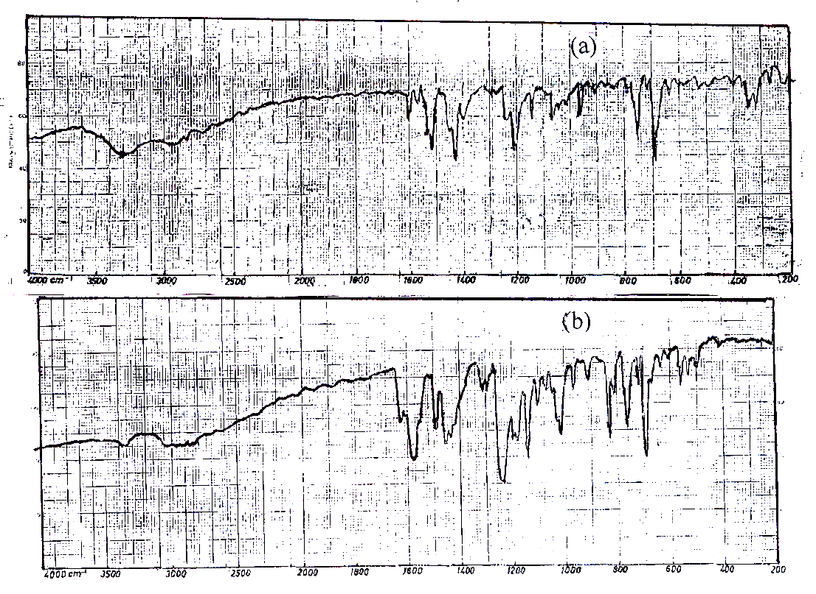

Fig. (2): IR spectra of ; (a) [CoL₂]Cl.H₂O and (b) the ligand (TABP = HL)

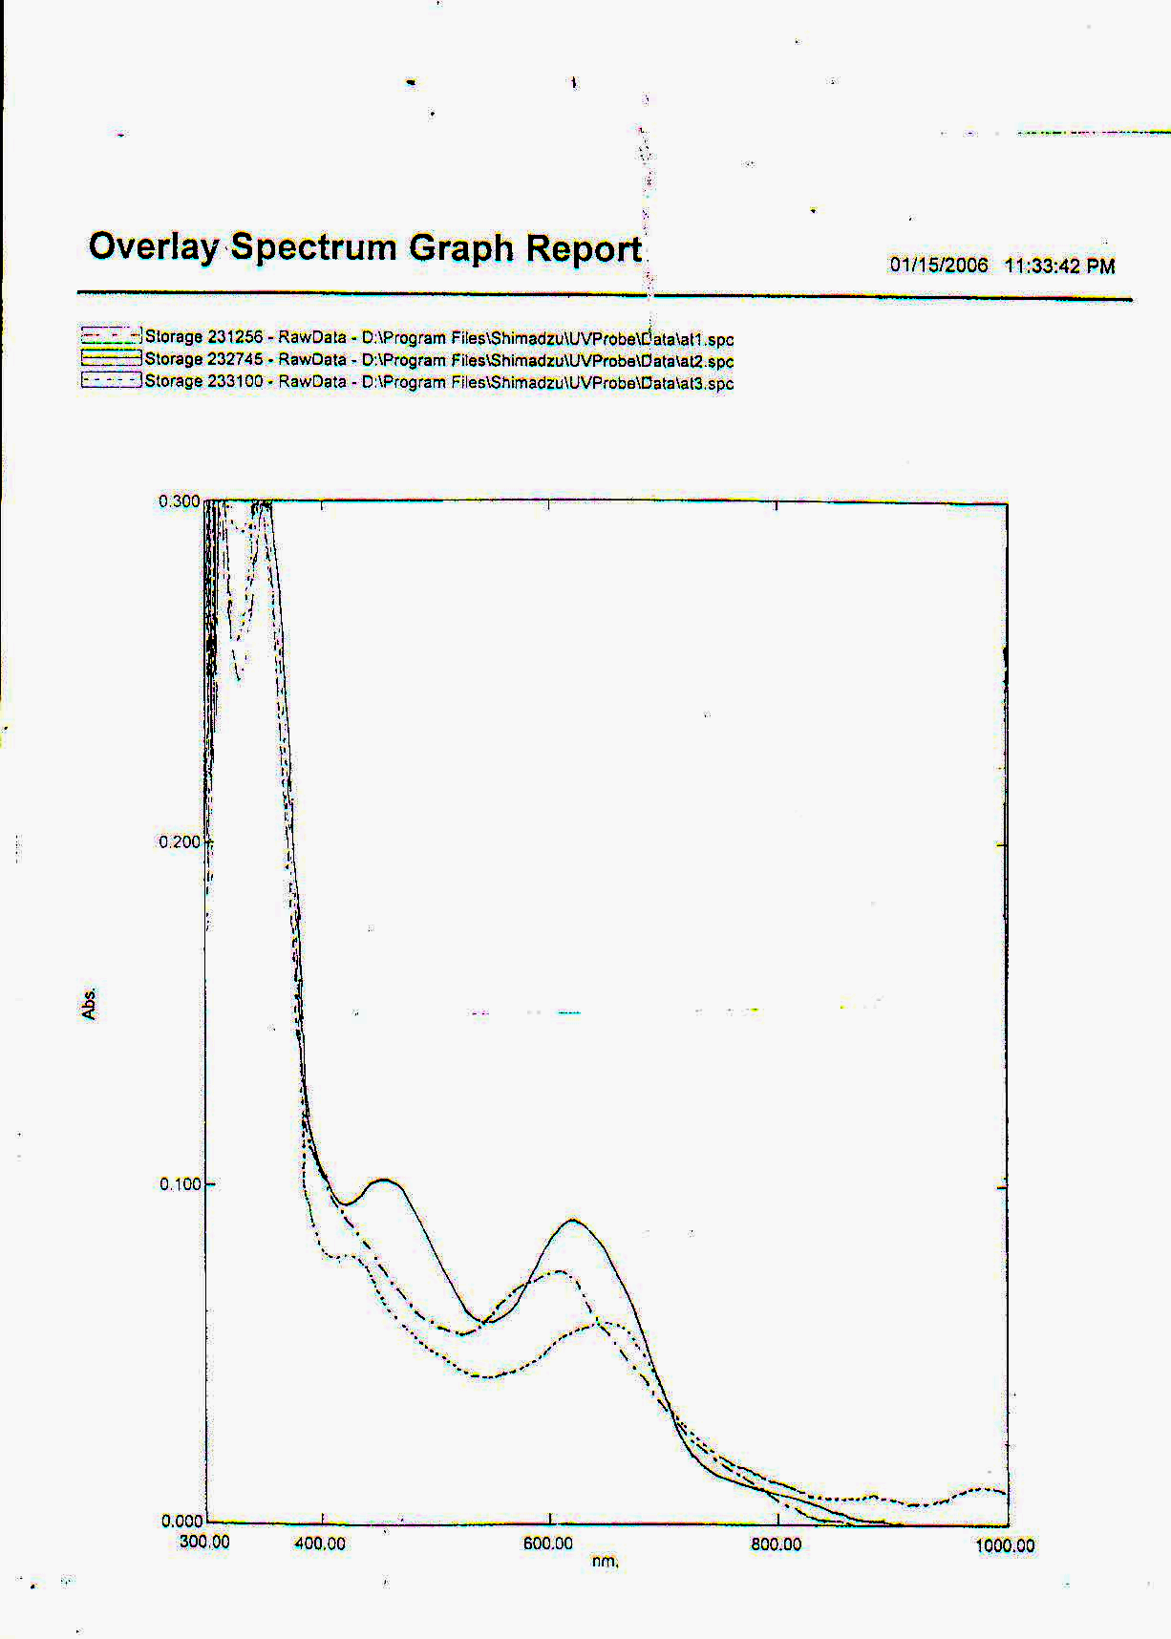
a

b

c

Fig. (3): Electronic Spectra of (a) [CoL₂]Cl.H₂O, (b) [NiL₂].H₂O and (c) [Cu.L₂].H₂O

Fig. (4): The proposed structural formula of Ag(I) complex

M = Co(III), n = 1, m = 1
M = Ni(II), Cu(II), n = 0, m = 1
M = Zn(II), Cd(II), Hg(II), n = 0, m = 2
Fig. (5): The proposed structural formula of Co(III), Cu(II), Ni(II), Zn(II), Cd(II) and Hg(II) complexes

References
- L. Qiu, Y. Shen, J. Hao, J. Zhal, F. Zu, and T. Zhang, J. Mater. Sci., (2004), 39, 2335.
- W. Lee, S.E. Lee, M. K. Kim, C. H. Lee, and Y. S. Kim, Bull. Korean Chem. Soc., (2002), 23, 1067.
- B. Kuswandi, and R. N. Swamy, J. Environ. Monit., (1999), 1, 109.
- F. M. Mohareb, and S. M. Sheriff, American Dye stuff reporter., (1992), 81, 43.
- A. Pencher, and N. Gadjiv, Dyes and Pigments., (1992), 19, 113.
- M. K. Khlool, K. H. Kadhim, and A. N. Al – Sharify; Nat. J. of Chem., (2005), 20, 493.
- A. A. R. Jewad, K. H. Kadhim, and A. N. Al-Sharefy Nat. J. of Chem., (2005), 19, 331.
- L. S. D. Carvalho, A. C. S. Costa, S. L. C. Ferreira, and L. S. G. Teixeira, J. Braz. Chem. Soc., (2004), 15, 153.
- V. A. Lemos, M. D. L. Guardia, and L. G. Ferreira, Talanta., (2002), 58, 475.
- L. S. G. Teixeira, A. C. S. Costa, and J. C. R. Assis, Micro Chem., Acta., (2001), 137, 29.
- Y. Sumi, M. T. Itoh, M. Yoshida, and Y. Akama., Histochem. Cell. Biols., (1999), 112, 179.
- R. T. Mehdi, and A. M. Ali, Ibn Al-Haitham. J. for pure and appl. Sci., (2005), 18(3), 50.
- L. A. Mohammed, M.Sc., Thesis, University of Kufa, (2005).
- A. M. Ali, Sic. J. Babylon University., (2004), 9 (3), 841.
- M. S. Masoud, G. B. Mohamed, and Y. H. Abdul – Razek, J. Korean. Chem.. Soc., (2002), 46 (2), 110.
- M. J. Sanchez, B. Santana, F. Jimenez, and F. G. Motelongo, J. Coord. Chem., (1988), 17, 319.
- X. Fan, G. Zhang, and C. Zhu, Analyst, (1998), 123, 109.
- M. J. Sanchez, B. Santana, V. Gonzalez, and F. G. Motelango, polyhedron., (1990), 9, 501.
- M. Kurahashi, Bull, Chem. Soc. Jpn., (1976), 49, 127.
- B.S.Marshall,I.Telford,and R.Wood;Analyst.,(1971),96,569
- W. C. Vosburgh, and G. R. Cooper., J. Am. Chem. Soc., (1941), 63, 437.
- F. A. Snavely, and C. H. Yodeer, J. Org. Chem., (1968), 33, 513.
- A. G. Catchpole, W. B. Foster, and S. Holder, spectro Chim. Acta., (1962), 18, 1363.
- H. Bervera, J. Sola, and J. M. Vinas, Trans. Met. Chem., (1985), 10, 233.
- S. I. Gusev, M. V. Zhvakina, and I. A. Kozhevnikov, Zh. Analitkhim., (1971), 26, 859.
- L. Mangsup, S. Siripaisarnpipat, and N. Chaichit, Anal. Sci., (2003), 19, 1345.
- M. W. Bes, S. F. Kettle, and D. B. Powell, Spectrochem Acta, (1974), 30 (A), 139.
- N. B. Colthup, L. H. Daly, and S. E. wiberley; “Introduction to infrared and Raman Spectroscopy”, 2nd Ed. Academic press. Inc. J. R. Dyer., (1975).
- B. Singh, R. N. Sign, and R. C. Aggarwal, Polyhedrone., (1985), 4, 401.
- Y. Saito, C. W. Schlapfer, M. Cordes, and K. Nakamoto, Applied Spectra., (1973), 27, 213.
- A. M. Ali, Ph.D., Thesis, University of Baghdad (1999).
- J. C. Bailer, H. Emeleus, and R. Nypholm; “Comperehesive Inorganic Chemistry”, pergamon press, (1973).
- B. N. Figgis, and J.Lewis; “Modern Coordination Chemistry”, Interscience, New York., (1980).
- W. Manch, and W. C. Fernetins, J. Chem. Educ., (1961), 38, 192.
- L. Sacconi, and M. Champolini, J. Chem. Soc., (1964), 276.
- Z. A. Ahmed, F. M. Atta, and M. A. Abd Alla, Spectro Chim. Acta., (1989), 45(A), 699.
- W. J. Geary, Coord. Chem., Rev., (1971), 7, 81.

