Flow Injection Spectrophotometric and Reverse Phase-High Performance Liquid Chromatography Determination of Ranitidine.Hydrochlrid inPharmacetical Preparations.

Mohammed. J.M. Hussan, Mouayed Q. Al-Abachi* and Mohammed A. Mustafa

*Chemistry Dep., College of Science, Baghdad University

(NJC)

(Received on 29 /6/2005) (Accepted for publication on 29 / 4 /2006)

Abstract
This study describes development of a new flow injection spectrophotometric method and a reverse phase-high performance liquid chromatography RP-HPLC method for the determination of Ranitidine.HCl (RH) in aqueous solution and in pharmaceutical preparations.
The FIA method was based on the reaction of RH with ferric nitrate and the produced Fe(II) was reacted with potassium hexacyanoferrate (III) forming a Prussian blue colored dye that has a maximum absorption at 800 nm. Linearity was in the range of 2-80 μg.ml⁻¹, correlation coefficient of 0.9996, detection limit of 0.613 μg.ml⁻¹ and relative standard deviation percent of 2.17%. The method was applied successfully to the determination of RH in pharmaceutical preparations with a recovery of 100.23 – 101.04%.
RP-HPLC method with a Supelco BDS-C₁₈ –DS (25 cm x 46 mm i.d) analytical column (5 μm particle size) and isocratic elution with a mobile phase containing 30% methanol in 0.05 M KH₂PO₄ buffer (pH 6.0), at a flow rate of 1 ml.min⁻¹, 20 μL sample loop, and a UV detector at λ_{max} 330 nm. The calibration graph was linear in the range of 0.1 – 1.5 μg.ml⁻¹ with the correlation coefficient of 0.9994. The method was applied successfully for the determination of pharmaceutical preparations containing Ranitidine.HCl with a recovery of 100.63–101.31%.
الخلاصة
اشتملت الدراسة على تطوير طريقة طيفية باستخدام نظام الحقن الجرياني لتقدير عقار هيدروكلوريد الرانتدين في المحاليل المائية والمستحضرات الصيدلانية، إذ استندت الطريقة على تفاعل من نوع انتقال الشحنة بين الحديد الثنائي الناتج من تفاعل الحديد الثلاثي مع العقار المذكور مع كاشف بوتاسيوم سداسي سيانيد الحديديك إذ يعطي معقد ملون (صبغة بروسيان) الزرقاء التي تعطي أقصى امتصاص لها عند 800 نانوميتر. وأعطت الطريقة خطية بمدى 2–80 مايكروغرام/ مل وبمعامل ارتباط مقداره 99963. 0 وحد كشف 0.613 مايكروغرام/مل وانحراف قياسي نسبي مئوي 2.17%. وتم دراسة التداخلات لوجود بعض المضافات عند تحضير المستحضر الصيدلاني وطبقت الطريقة بنجاح على المستحضرات الصيدلانية وكان الاسترداد المئوي بين 100.23 – 101.04%.كذلك تم تطوير طريقة كروماتوغرافية جديدة لتقدير العقار المذكور أعلاه باستخدام طريقة كروماتوغرافيا السائل ذات الأداء العالي- الطور المعكوس RP-HPLC باستعمال عمود جديد لم يسبق استخدامه وهو من نوع BDS-C₁₈ (25 cm x 46 nm) Spleco محشو بدقائق ذات أقطار 5 مايكروميتر بازاحة ايزوكراتيكية Isocratic elution وبطور تحرك مكون من مزيج يحتوي على 30% ميثانول ومحلول بفر بتركيز 0.05 مولاري من KH₂PO₄ ذو دالة امضية = 6.0 وبسرعة جريان مقدارها 1 مل/دقيقة. ودرجة حرارة 30 ْم وحجم مادة محقنة 20 مايكروليتر باستخدام مكشاف UV-Vis عند طول موجي مقداره 330 نانوميتر.وكانت المعطيات التحليلية لهذه الطريقة،خطية معايرة بمدى 0.1–1.5 مايكروغرام/ مل ومعامل ارتباط 0.9996. وانحراف قياسي نسبي مئوي 1.89%. وحد كشف مقدراه 4.4 نانوغرام/ مل وطبقت الطريقة بنجاح على المستحضرات الصيدلانية الحاوية على هيدروكلوريد الرانتد ين. وكان الاسترداد المئوي بين 100.63 – 101.31%.

Introduction
Ranitidine.HCl is a compound of, N-[2-[[[5-[(dimethylamino) methyl]furan-2-yl]methyl] thio]ethyl]- N-methyl- 2-nitroethane- 1,1-diamine hydrochloride ^{1,2}. It has a molecular formula of C₁₃H₂₂N₄O₃S.HCl.Its molecular weight 350.9 gm/mol. It melts at 140ºC. It exists as two crystalline polymorphs, known as form 1 (mp: 134-140ºC) and form 2 (mp: 140-144ºC), and in several pseudopolymorphic form ³. Many methods have been developed to determine Ranitidine.HCl in pharmaceutical preparation and other matrices such as urine and blood. It has been determined spectrophotometrically ⁴-⁶ , colorimetrically⁷ Sertsou and Rades ⁸ developed a method to determine the composition of two crystalline form of Ranitidine.HCl in a binary mixture using diffuse reflectance infrared Fourier transform spectroscopy method (DRFTS). Rantidine.HCl was determined using ion-pair ⁹ association complex with [AuBr₄]⁻and [PdI₄]²⁻ . polarygraphy was used by Honnoun and zuhrik¹⁰ .Near-IR method was described by Dreassi ¹¹. Clark¹²determined Ranitidine.HCl using electrophoresis method in 1977.HPLC technique has been used for the separation and determination of Ranitidine.HCl in a various matrices of blood, urine, aqueous solutions and pharmaceutical preparations. ¹³ - ²¹
The present study describes a new FIA spectrophotometric (A) and HPLC (B) methods for the determination of Rantidine.HCl in pharmaceutical preparations. In (A) Ranitidine.HCl was reacted with ferric nitrate in the presence of potassium ferricyanide forming Prussian blue colored product that has a maximum absorption at λ_{max} 800 nm. In HPLC method C₁₈-BDS-C18 column and methanol:KH₂PO₄ as a mobile phase were used.
Experimental
FIA Apparatus
Shimadzu 120 UV-VIS spectrophotometer equipped with a (Cecil) 50 μL flow cell was used. A Shimadzu 1650 PC UV-VIS double beam spectrophotometer was used for λ_{max.} determination. A three-channel manifold (Fig. 1) was employed for the FIA Spectrophotometric determination of Ranitidine.HCl. A peristaltic pump (Gilsason minipuls (2)) was used to transport the carrier solution equipped with flexible polyvinyl chloride tubes of 0.8 mm internal diameter. Injection valve (Rheodyne-USA) was employed to provide appropriate injection volumes of standard solutions and samples. Channel A in the Manifold was used to transport ferric nitrate while channel B to transport potassium hexacyanoferrate solution served as oxidizing agent,and channel c to transport the stream of alkaline oxalate. The sample introduced into carrier stream of ferric nitrate, and was mixed well in the reaction coil RC#1. The product was mixed with potassium hexacyanoferrate stream in the reaction coil RC#2. The stream of alkaline oxalate was combined with the result product after mixing coil RC#2 at y.

A

B

K₃[Fe(CN)₆]
Fe(NO₃)₃
P
Water Bath
RC#1

y
w
RC#2

Flow cell

O
H₂C₂O₄
C

D
Alkaline

Fig (1): Manifold employed for the FIA Spectrophotometric determination of.
Ranitidine.HCl

HPLC Apparatus
The analysis was performed on a Shimadzu HPLC (Tokyo-Japan). Two solvent reservoirs of about 500 ml capacity round bottle were used. Two groups Model – (LC-6A Shimadzu), high performance pumps (pressure range 0 – 500 kg.cm⁻¹), which delivered the mobile-phase (A) and (B) from solvent reservoirs to the mixing cell. (Rcrheodyne 7125 USA) injection valve fitted with 20 μL sample loop. Separation of drugs were carried out on a (25 cm x 46 mm i.d) stainless steel, (5 μm particle size) BDS-C₁₈-DB, reversed-phase deactivated base column provided from Supelco.
Reagents and Chemical Materials Used
All reagent and chemical materials used were analytical reagent grade. All drugs obtained were in a pure form from Samarra Drug Industries, SDI-Samarra-Iraq. Ranitidine.HCl, C₁₃H₂₂N₄O₃S.HCl, M.wt 350.9 g/mole (SDI) Samarra-Iraq .Hydrous ferric nitrate. Fe(NO₃)₃.9H₂O, M.wt 4.04 g/mole, BDH Analar. Potassium hexacyanoferrate (III), K₃[Fe(CN)₆], M.wt 329 g/mole, BDH AnalaR. Oxalic acid, C₂H₂O₄, M.wt 78 g/mole, Merk. Sodium hydroxide, NaOH M.wt. 40 g/mole, BDH AnalaR. Nitric acid, HNO₃, M.wt. 63.01 g/mole, 70%. Puris, Fluka.
Methanol, CH₃OH, HPLC grade. Acetonitrile, CH₃CN, HPLC grade. Potassium dihydrogen phosphate, KH₂PO₄, M.wt. 136 g/mole, BDH AnalaR.Rantisam tablets. Containing 150 mg of Ranitidine.HCl provided from (SDI) Samarra-Iraq, average wt. 0.2450g.HISTAC 150 tablets, containing 150 mg of Ranitidine.HCl provided from Ran Baxy Co. India.
Solutions of the Materials Used:
Rantidine.HCl stock solution (1000 μg/ml) was prepared by dissolving 0.1000 g in 100 ml o Rantidine.HCl f deionized water. Required concentrations were prepared by dilution of the corresponding stock solution with deionized water. Hydrous ferric nitrate (0.1 M) stock solution was prepared by dissolving 4.0400 gm of Fe(NO₃)₃.9H₂O in deionized water containing 1 ml of nitric acid and the solution was made up to 100 ml with deionized water. Potassium hexacyanoferrate (III) (0.1 M) stock solution was prepared by dissolving 3.2900 g of K₃[Fe(CN)₆] in 100 ml of dionized water. Sodium oxalate solution (5%0), 5.0000 gm oxalic acid was dissolved in deionized water containing 0.4000 gm of sodium hydroxide, and the solution was made up to 100 ml with deionized water.
Solutions of Pharmaceutical Preparations Containing Ranitidine.HCl
Rantisam tablets (150 mg).10 tablets were grinded well and a certain portion of the final powder was accurately weighted to give an equivalent to about 50 mg of Rantidine.HCl and was dissolved in deionized water. The prepared solution was transferred to 500 ml volumetric flask and made up to the mark with deionized water forming a solution of 100 μg.ml⁻¹. The solution was filtered by using a Whatman filter paper No. 42 to avoid any suspended particles. Required concentrations were prepared by dilution of the corresponding stock solution with deionized water.
HISTAC tablets (150 mg)..The solution of 100 μg.ml⁻¹ was prepared as in the same previous approach.
Results and Discussion
The chemical and physical optimization of the conditions, the applicability of the methods for the analysis of pharmaceutical preparations and a comparison of the two methods with each other shall be discussed. The influence of various reaction variables on the colored product was tested to establish the most favorable conditions for the Flow Injection spectrophotometric method for the determination of Rantidine.HCl
Through out the preliminary investigation on the reaction of Randitine.HCl with ferric nitrate and potassium hexacyanoferrate (III). A Prussian blue colored product was formed. It has a maximum absorption at λ_{max} 800 nm as shown in Fig. (2)

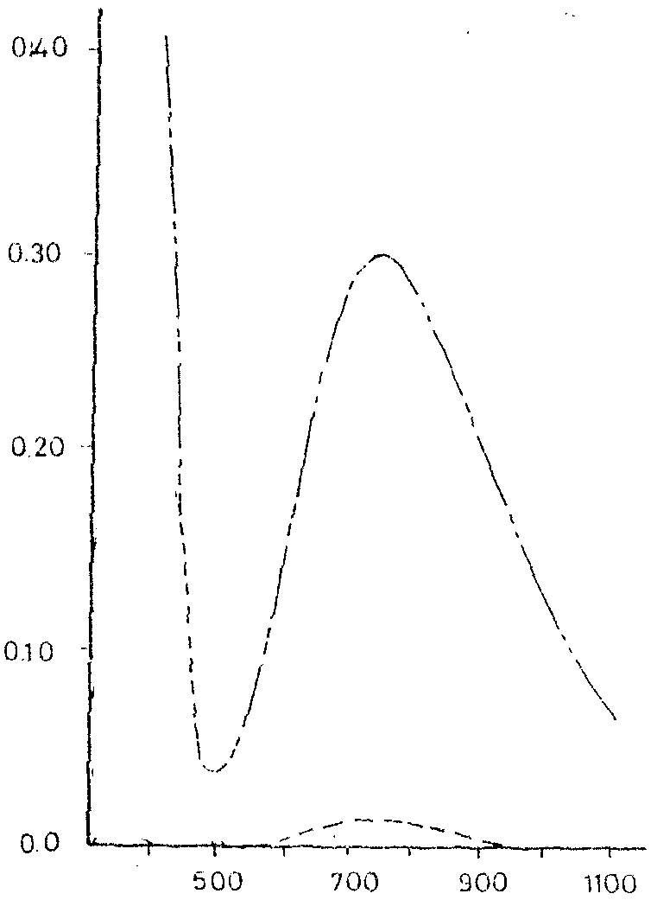
Abs
λ (nm)
B
A

Fig (2): Absorption spectra of A (40 μg.ml⁻¹) of Ranitidine.HCl treated as described under procedure and measured against a reagent blank and B the reagent blank measured against distilled water.

The effect of temperature on the reaction was optimized first .A water bath was set at a temperature of 0º, 27 and 45ºC. The results obtained showed that a 45ºC gave the best sensitivity and a minimum blank value and was chosen for further use.
The Effect of Oxidizing Agent and Potassium hexacynoferrate (III)Concentration on the absorption of the colored product (from 1x10⁻¹ – 1x10⁻⁴ M) were investigated The results obtained are show A concentration of 1x10⁻²M gave the highest absorption as shows in Fig3.

Fig. (3): Effect of the(■ iron III) and(▲ Potassium hexacyano ferrate) concentrations on the absorption of the colored product.

The effect of total flow-rate in the range of 1.2–9.6 ml.min⁻¹ was studied after keeping all other optimized parameters constant. A 4.5 ml.min⁻¹ total flow rate gave the highest absorption .All streams were pumped at an individual flow rate of 1.5 ml.min⁻¹, and were chosen for further use.
Coil length is an essential parameter for the reaction. Two coils have been used in the manifold as shown in Fig. (1). Different coil lengths were investigated. Both coils were submerged in a 45ºC water bath. A remarkable increase in the absorption was obtained when 100 cm and 250 cm lengths were used for the first and second coil respectively . and were used in the recommended procedure as shows in Fig4.

.
Fig. (4): Effect of reaction coil length (■Rc#1, ▲ Rc#2)

The effect of sample volume of 50 μg.ml⁻¹ Ranitidine.HCl was investigated by injecting different volume using different lengths of sample loops 50, 100, 150, 200 and 250 μg.ml⁻¹. It was found that a volume of 100 μL gave the best sensitivity.
According to the results obtained previously, the optimum experimental conditions were established for the determination of Rantidine.HCl using FI spectrophotometric method, and are given in Table (1).

Table (1): Recommended analytical conditions for the determination of Ranitidine.HCl.
Parameters | Value
Conc. of ferric nitrate | 1 x 10⁻² M
Conc. of K₃[Fe(CN)₆] | 1 x 10⁻² M
Total flow rate | 4.5 ml.min⁻¹
Reaction coil length | First 100 cm  Second 250 cm
Injected volume | 100 μL
Temperature | 45ºC
Wavelength | 800 nm
Reaction tubing diameter | 0.5 mm i.d.

Also the best experimental conditions for the determination of anitidine.HCl
using HPLC-RP system were studied .The effect of different percentage of
organic modifier on the mobile phase was studied. A best sensitivity, high peak
symmetry and reasonable analysis time were obtained by
using 30% MeOH. The effect of pH on the retention time, peak symmetry and
capacity factor of Ranitidine.HCl. The results show that the retention time of the drug
Was decreased as the pH rose from 4.0 to 7.0. The results obtained indicated that a
pH of 6.0 was the optimum value since it give a best symmetry and high sensitivity.
Effect of the flow rate of the mobile phase was investigated. A change in the mobile phase flow rate from 0.6 to 2.0 ml.min⁻¹ caused a decrease in analytical time from 7.34 to 2.62 minutes. A flow rate of 1 ml/min was chosen since it gives a best symmetry and sensitivity.
The effect of column temperature in the range of 25 to 50ºC on the retention time, peak symmetry and sensitivity was investigated using a mobile phase consisting of 30% MeOH and 70% KH₂PO₄ buffer 0.05 M at pH 6.0. t. The results also indicated that a good separation, sensitivity and peak symmetry. According to the results obtained previously, the optimum experimental conditions established for the RP-HPLC determination of Ranitidine.HCl in pharmaceutical preparations are given and summarized in Table (2). Fig (3) illustrated the shape and retention time of the peak signals of Ranitidine.HCl.

Table (2) Recommended analytical conditions for the determination of Ranitidine.HCl using RP-HPLC-system.
Parameter | Recommended value
Column | BDS-RP-DS 250 x 46 mm
Organic modifier | 30% methanol
Injected sample volume | 20 μL
Buffer | 0.05 M KH₂PO₄
pH | 6.0
Flow rate | 1.0 ml.min⁻¹
Column temperature | 30ºC
Detector | U.V detector at 330 nm

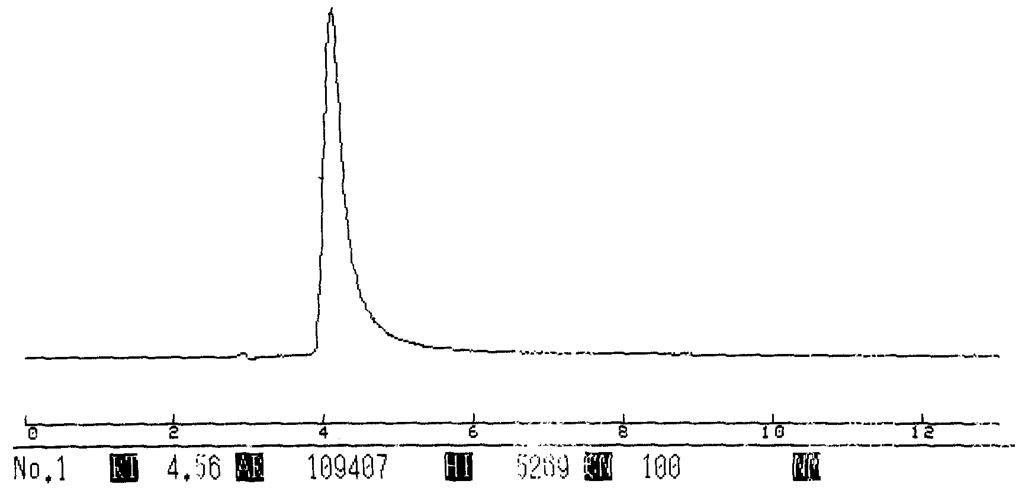
Fig. (3): Analysis of Rantidine.HCl under recommended procedure.
Analytical data

The recommended analytical conditions, given in Tables (1) and (2) were utilized for the construction of the two linear calibration graph for the FI spectrophotometric and RP-HPLC methods for determination of Ranitidine.HCl in pharmaceutical preparations are given and summarized in Table (3).

Table (3): Analytical data for the determination of Ranitidine.HCl using FI- Spectrophotometric and RP-HPLC methods
Analytical data | FI spectrophotometric | RP-HPLC
Detection limit (D.L) | 0.613 μg.ml⁻¹ | 4.5 ng.ml⁻¹
Sensitivity | 0.0064 | 33.8523 x 10⁴
Correlation coefficient | 0.9996 | 0.9997
Linear range | 2-80 μg.ml⁻¹ | 0.1-1.5 μg.ml⁻¹
RSD % | 2.17% | 1.89%

Analytical Application
Application of the proposed methods for the assay of pharmaceutical tablets was investigated using two types of tablets containing Rantidine.HCl. A good precision and recovery were obtained according to the results obtained in Table (4).

Table (4): Application of the proposed methods for the determination of Ranitidine.HCl.

Comparison the two methods
Sample | FI spectrophotometric |  | RP-HPLC
Sample | Recovery % | RSD % | Recovery % | RSD %
Pure Ranitidine.HCl | 100.23 | 2.173 | 100.63 | 1.89
Rantisame | 100.89 | 2.15 | 101.31 | 2.17
Histac | 101.04 | 2.08 | 100.83 | 1.87
The accuracy and precision of the proposed methods for Rantidine.HCl were compared as shows in Table (5) by measuring three different concentration levels, replicated five times. In addition, the two proposed methods were compared statistically using the analytical data from the information of two calibration curves

Table (5): Accuracy and precision of the proposed method.
Conc. of Ranitidine.HCl  μg.ml⁻¹ |  | FI spectrophotometric |  |  | RP-HPLC
Present | Found | RSD% | REC% | Error% | RSD% | REC% | Error%
0.1 | 0.098 | 2.30 | 97.80 | -2.20 | 2.00 | 98.0 | -2.00
0.5 | 0.511 | 2.14 | 101.05 | 1.05 | 1.93 | 102.00 | 2.20
1.0 | 1.019 | 2.08 | 100.40 | 0.40 | 1.75 | 101.9 | 1.90

Conclusion
A simple flow injection spectrophotometric and RP-HPLC systems were developed for the determination of Ranitidine.HCl in pharmaceutical Preparations. In part(1) A simple, accurate and sensitive FIA system was designed, constructed and used in conjunction with a spectrophotometer detector. The proposed method can be carried out at room temperature with no need for solvent extraction step or pH control.
Part(2) include a simple and sensitive RP-HPLC method also proposed for the determination of Ranitidine.HCl in pharmaceutical preparations. The method was based on using a new type of column supleco BDS-C₁₈ (25 cm x 46 mm i.d). Multi factor such as flow rate, pH of mobile phase temperature and percentage of organic modifier were carried out.

References
- “The Merck Index on CD-ROM”, 12th Ed., Copyright by Merck Co. Inc., Whiteho;2000.
- “British Pharmacopoeia on CD-ROM”, 3rd Ed., Copyright by System Simulation Ltd., The Stationary Office, London,2000.
- U.S. Pharmacopoeia, on CD-ROM, Copyright by system simulation Ltd.,2000.
- B. Guvener, Acta Pharm. Turc.,1986, 28(1),35.
- J. Emmanuel, Indian Drugs,1986, 26(5),249.
- N.K. Raut and S.D. Sabins. Indian J. Pharm/ Sci.; 1987,49(2), 65.
- E.V. Rao, Indian J. Pharm. Sci., 1987,49(4), 143.
- G. Sertsou and T. Rades., The Internet Journal of vibrational spectroscopy;1999, 3, 5 ed.
- A.A. ABAS, M.Sc. Thesis, Baghdad University, 2002.
- Z. Hannoun, A. Zuhri, Anal. Lett., 1988, 21(10), 1845.
- E. Dreassi, Analyst; 1996, 121(2), 219.
- B. Clark, Today’s chemist at work, 1997, 6(8), 31.
- P.F,Cary and L.E Maryin, Chromatographia, 19,(1984),2000.
- K.I. Al-Khamis, Y.M. El-Sayed, K.A., Al-Rashood, S.A. Bawazir. J. Liq. Chromatogr., (1995), 18, 277.
  - Tracqui, P. Kintz, P. Mangin, J. Forensic., Sci., 1995, 40, 254.
- M.E. Van Gelderen, M. Olling, D.M. Barends, J. Meulenbett, P. Salomons, A.G. Rauws, Biopharm. Druf Dispos., 1994, 15,775.
- G.L. Hoyer, L. LeDoux, P.E. Nolan., J. Liq. Chromatogr;1995,18,, 1239.
- J.P. Burm., S.S. Jhee, A. Chin, Y.S.K. Moon, E. Jeong, L. Njj, J.L. Fox, M.A. Gill, Am. J. Hosp. Pharm., 51, (1994), 1201.
- G. Mullersman, H. Derendorf, J. Chromatogr., 381, (1986), 385.
- C.Y. Oo, R.J. Kuhn, N. Desai, P.J. McNamara, Clin. Pharmacol. Ther., 58, (1995), 548.
- T.L. Lloyd, T.B. Perschy, A.E. Geoding, J.J. Tomlinson, Biomed. Chromatogr., 6, (1992), 311.
- M. Shimokawa, K. Yamamoto, J. Kawakami, Y. Sawada, T. Iga., Pharm. Res., 11, (1994), 1519.

