Bioequivalence of two-amlodipine formulation using high-performance liquid chromatography (HPLC)

Fadhil M Abid , Hamoudi A Hameed

Ministry of Science and Technology , Ministry of Industry and Minerals

A-w R Hamed , Abbas A. A. Kadhum

University of Al-Nahrin, College of Medicine, Al-Qadisya University

(NJC)

(Received on 27 /7/2005) (Accepted for publication on 29/4 /2006)

Abstract

Amlodipine is chemically described as (R.S) 3-ethyl-5-methyl-2-(2 aminoethoxy methyl) – 4 – (2- chlorophenyl) – 1, 4- dihydro – 6 – methyl – 3,5 pyridine dicarboxylate benzene sulfonate , its empirical formula C₂₀H₂₅ Cl N₂ O₅ C₆ H₆ O₃ S. It is one of the most widely used drugs for the management of essential hypertension. In this study an accurate and sensitive reversed phase liquid chromatographic method was adopted on deactivated ODS column using tetrahydrofuran: phosphate buffer pH 6.0 as mobile phase. The injected volume used was 750 μl to elevate the detection limit up to 5 ng/ml. The bioquivalence trial was carried out on 20 healthy volunteers aged 25-55 years with a weight range from 60-90 kgm. The time interval used for collected blood samples from volunteers was from 1- 96 hr.
Subjects were administrated a single 5 mg dose of Samadipin from SDI and reference product Norvasc (pfizer) according to two period, Two – sequence crossover design, with wash out period of one week. After oral administration of 5 mg of both formulations, maximum peak plasma absorption were about 9 hours in both formulations with values of 59.5±4.39 ng/ml for Samadipin and 65.11±3.95 ng/ml for Norvasc (pfizer) respectively. The peak concentration and area under the curve of plasma concentration were analyzed to obtain 92% confidence intervals. The elimination half-life of boh formula were ranged from 30-45 hours with mean value of 37.86 and 39.026 hours for test and reference drugs respectively.
The calibration curve for peak area verses concentration were linear with regression of 0.998, the detection limit was 5 ng/ml. The standing diastolic pressure was reduced by 4.2 mm Hg six hour after 5 mg amlodipine .There was no significant change in pulse rate .Highly significant postive correlation were observed between dose and AUC (0-96 hrs). Due to long half-life and gradual absorpion , amlodipine should be effective in lowering blood pressure giving once daily , and the incident of side effects due to rapid absorotion should be minimized.
In conclusion , both test and reference product show no statistically significant difference), Therefore the two drugs were Bioequivalent.

الخلاصة
اميلودين هو احد الادوية الاساسية المستخدمة في معالجة ضغط الدم، تم اعطاء تركيبين من هذا الدواء لـ 20 متطوع اصحاء ذو اعمار تتراوح بين 25-55 سنة ومتوسط وزن يتراوح بين 60-90 كغم، بواسطة استخدام تقنية كروموتوغرافيا الطور العكوس ذات الانتقاء العالي وباستخدام عمود وفي ظروف عمل الجهاز التالية: الطور المتحرك فوسفات الامونيوم-ثلاثي هيدروفيوران، حجم السائل المحقون 750 مايكرولتر، حدود الكشف 5 نانوغرام/مل. كان الزمن المستخدم لجمع عينات الدم بعد تناول 5 ملغم من سيميدبن وكذلك من نور فسك (الموجع) كان من 1-96 ساعة، وكان اعظم منحني امتصاص للبلازما في حدود 9 ساعة مع قيم 4.39 ± 59.5 نانوغرام/ مل لسيميدبن و 65.11 ±3.95 لنور فسك (المرجع).
كان منحني المعايرة بين مساحة القمة والتركيز على خط مستقيم وبتوافق 0.998. وحد الكشف كان 5 نانوغرام/مل. لقد تم تخفيض الضغط الواطي بواسطة 4.2 ملم زئبق بعد حوالي 6 ساعات بعد تناول 5 ملغم من اميلودين ولم يكن يوجد تغير ملحوظ بنسبة النبض، نتيجة نصف العمر الكبير والامتصاص التدريجي للدواء يجب ان يكون مؤثرا في تخفيض ضغط الدم عند تناوله يومياً، ولامتصاصه السريع يجب ان يكون التاثيرات الجانبية في تناقص. في النهاية لا يوجد هناك اختلاف احصائي بين الدواء والمرجع لذلك كلا الدوائين في توافق حيوي.

Introduction
Amlodipine is calcium channel antagonist of dihydropyridine group. It is effective for treating hypertension, chronic stable angina and vasospastic (1). It is difficult clinically to pinpoint the maximum dosage for antihypertensive activity of the drug without having parallel data on the plasma drug concentrations. (2).
The important concentration of hypertensive to the progression of renal failure is well documented (3) However, amlodipine is a renal protective in early stages of renal failure with hypertension, however, in advance stages of renal failure , amlodipine is superior in its renal protective effect.
The methods of assaying amlodipine are either gas chromatography with electron capture detector (ECD) or Liquid chromatography coupled with tandem mass spectrometry (4,5).
In this study we developed a sensitive, accurate and reliable method for analyzing of amlodipine in plasma using reversed phase mode chromatograph.

Materials and Methods
Twenty adult healthy volunteers with mean age 30±16 years , cross over between two groups of this study by using 10 volunteers for each drug (10 volunteers for SDI as test drug and the other 10 volunteers for pfizer as reference drug , both drug 5 mg tablets, was administered orally., Blood samples were collected in polyethylene test tubes at 0, 1, 2, 3, 4, 6 , 9 , 12 , 24 , 48 , 72, and 96 hours intervals of oral administration. The samples were centrifuged and the plasma layer was kept frozen until analysis. 600 µl of plasma was diluted with 200 µl of acetonitrile later 750 µl l were subjected to HPLC analysis. One week later, the same procedures were repeated on the same
Volunteers and under the same conditions.

Chromatographic Procedure
A Shimadzu LC-6A mode, Japan, high performance liquid chromatography equipped with two LC-6A pumps were used with a Shimadzu Sil-6A controller unit, a Shimadzu UV/Visible detector set at 254 nm, the assay method has been developed for the quantitative determination of amlodipine in human plasma .
The drug plasma concentrations were determined by deactivated reversed-phase (250 X 4.6 mm I.d) C18-DB column, 5 µm particle size, 7125 Rheodyne injector was used, using THF :buffer phosphate as mobile phase. Amlodipine was eluted at 3.3 minutes without interference from endogenous substances as shown in chromatograms (Figures 1 and 2). The data processor of the system is capable of calculation, peak area, height, concentration and drawing chromatogram simultaneously.
The method is a simple, rapid and sensitive to detect amlodipine in human plasma following administration of single dose 5mg of two different formulation of 20 healthy volunteers to assay the oral bioequivalency of those formulations.

Result and Discussion
The study was carried out in 20 healthy volunteers to assess bioavaialability of two different oral formulations of Amlodipine (Samadipin from SDI and norvasc from pizer. A single 5 mg oral dose of drug was given orally. The blood samples were drawn at selected time (0, 1, 2, 3, 4, 6, 9, 12, 24, 48, 72, and 96 hours). Amlodipine retention volume was adjusted by tuning the percentage of organic modifier until 5 minutes were obtained for authentic standard, to avoid the expected interference of blood serum. The known concentrations of Amlodipine were spiked in normal plasma, with mean recovery of 96.9%
Fig. 1 and 2 show the retention volume of amlodipine standard, blank serum and serum from volunteers treated with single dose (5mg) Amlodipine . A standard curve between area and concentration was linear in the range 0-200 ng/ml (Fig.3) with correlation coefficient r = 0.996. The developed procedure was used for quantitative determination of Amlodipine in plasma of 20 healthy volunteers for each formulation (SDI and pfizer) over the planned time from 1- 96 hours .This could be related to the absorption rate (Ka) of Amlodipine obtained from both formulas.
The concentration of amlodipine in each sample was assyed by comparing the peak area of sample with that of authentic standard ,.The result observed is that Amlodipine was slowly absorbed after administration of either formulation. However, the concentration time profiles of the two formulations were constructed as shown in Figure 4, 5 and the comparision between the reference and test drug shown in table 6.
The maximum concentrations (C-max) were 59.5 ±4.38 ng/ml for (SDI) and 65.11±3.92 ng/ml for Norvvasc .
The mean values of the pharmacokinetic parameters following oral administration of 5 mg of SDI as test formula and the reference one Norvasc (pfizer) are given in Table 1. The data showed that the time of peak concentration (T-maximum), which corresponds to the time required to reach a maximum concentration of amlodipine after the administration of both formulas were the same, reached after 9 hours, while the peak concentration, which represents the maximum drug concentration obtained after drug administration of SDI tablet was slightly lower than that obtained for Norvasc tablet .
The results showed that the two formulations from pfizer and SDI have the relative bioavaialability and the area under curve is about 99.25%.
In conclusion, it appeared that pharmacokinetic parameters obtained in the present work including t0.5 _{elm}., T _{max} and C _{max} are not significantly different after the administration of Samadipin 5 mg tablets produced by SDI Pharmaceutical industries and Norvasc 5 mg tablets produced by Pfizer. The pharmacokinetic parameters showed no-clear individual variations.
Therefore the two drugs are considered to be similar bioequivalent.

Side effect of amlodipine
Gingival overgrowth has long been associated with phenytoin therapy but recently, it has also been linked to calcium channel blockers, especially the dihydropyridines and ciclosporin. The pathogenesis is not clearly understood but it has been suggested that these drugs cause a change in the fibroblast function, which leads to an increase in extra cellular matrix of the gingival connective tissue. Most of the cases where gum hyperplasia were associated with calcium channel blockers involved patients over the age of 50 years who took these drugs for post myocardial infarction, angina pain, essential hypertension, and Reynard’s syndrome.
In one clinical report, 3 patients on amlodipine 5 to 10 mg daily developed gingival problems within 2 to 3 months after starting therapy. Gingival hyperplasia has also been identified in 76% of geriatric patients receiving diltiazem. Gingival overgrowth has been observed in patients treated with nifedipine at low dosages (30 mg/ kg). Up to December 1999, The Australian ADR Monitoring Centre has received 114 reports of drug-induced gingival overgrowth. Out of these, the five main drugs, nifedipine, amlodipine, felodipine, phenytoin and ciclosporin, contributed to 68% of the reports. Recovery was slow, ranging from weeks to more than a year after drug cessation (7,8,9). The high incidence of gingival hyperplasia in patients receiving calcium channel blockers emphasizes the role of physicians and dentists in detecting this ADR and taking steps to minimize this problem in patients.

Table 1: Pharmacokinetic parameters of 5 mg samadipin tablet and
Norvasc 5 mg tablet in plasma 20 healthy volunteers.

No. | Ka | Ka0.5t | Kelem. | Kelem 0.5t | C_{max} | T_{max} | AUC
Mean samadpine | 0.296 | 2.476 | 0.0189 | 37.864 | 59.5 | 9 | 2863.295
±SD | 0.0598 | 0.717 | 0.0034 | 6.619 | 4.387 | 0 | 140.413
Mean Norvasc | 0.296 | 2.476 | 0.0189 | 37.864 | 59.5 | 9 | 2863.295
±SD | 0.0598 | 0.717 | 0.0034 | 6.619 | 4.387 | 0 | 140.413

Fig 1. Calibration curve of amlodipine.
Fig 2:Mean serum concentration-time profile of Samadipine 5 mg tablet after oral administration to 20 healthy volunteers.

Fig 3. Mean serum Concentration-time profile of Amlodipine 5 mg tablet after oral administration to 20 healthy volunteers

Fig 4. Comparison between concentration –time profile of samadipin test drug and

amlodipine as reference drug.
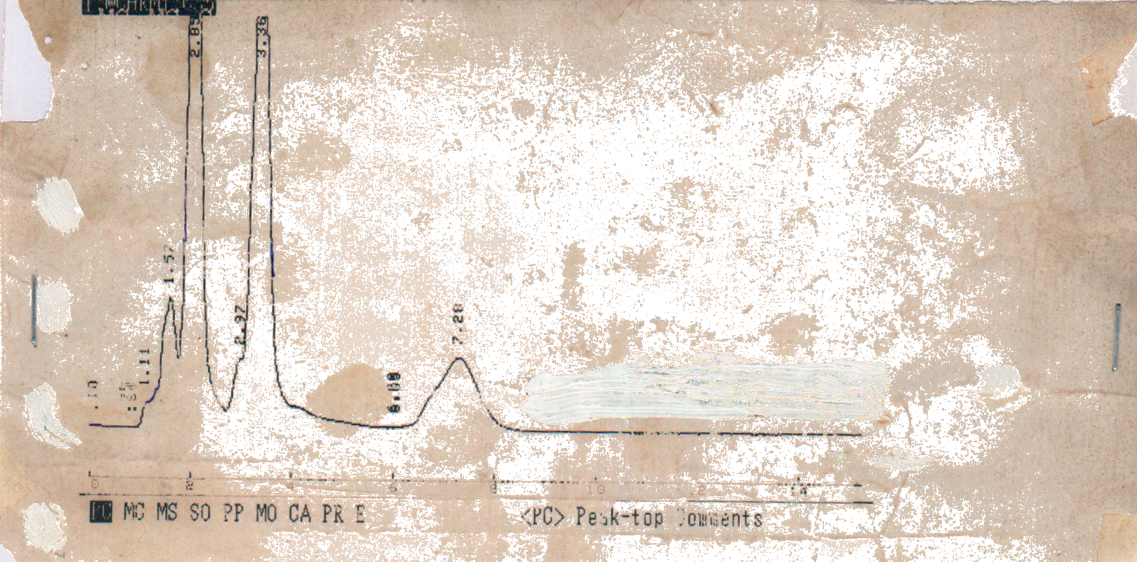

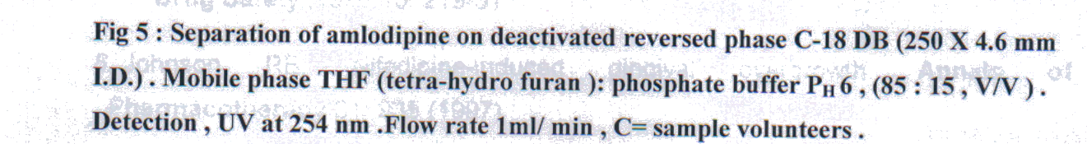

Mechanism of Action
Amlodipine is a calcium ion influx inhibitor (calcium entry blocker or calcium ion antagonist). Amlodipine is a member of the dihydropyridine class of calcium antagonists.
The therapeutic effect of this group of drugs is believed to be related to their specific cellular action of selectively inhibiting transmembrane influx of calcium ions into vascular smooth muscle and cardiac muscle. The contractile processes of these

tissues are dependent upon the movement of extracellular calcium ions into these cells through specific ion channels. Amlodipine inhibits calcium ion influx across cell membranes selectively, with a greater effect on vascular smooth muscle cells than on cardiac muscle cells. Serum calcium concentration is not affected by amlodipine (10) . Within the physiologic pH range, amlodipine is an ionized compound and its kinetic interaction with the calcium channel receptor is characterized by the gradual association and dissociation with the receptor binding site. Experimental data suggest that amlodipine binds to both dihydropyridine and nondihydropyridinebindingsites.
Hypertension: The mechanism by which amlodipine reduces arterial blood pressure involves direct peripheral arterial vasodilation and reduction in peripheral vascular resistance (11).
References
1. Natalka K, El-Thaher T, Saleem M, Arafat T JehanLi A and Badwan A, J. Clin. Lab. Anal, 2001; Sl(1), 47.
2. Stangier J and Su C.A , J. Clin. Pharmacol. 200; 40(12), 1347:54.
3. Kanno Y., Okada H, Takenaka T, Sartutat and Suzuki H , Clin. Exp
Hypertens., 2000, 22 (5) , 9.
4. Marazo A. Dal-Bo L, Mazzucchelli P manti N.C, Crivelli F, Ismaili
S. Arzneimitt Eloforschung ; 2000 , 50 (8) : 688-94.
5. William CD; Am.J. health. Syst. Pharm , 2000, 15; 57 (24) : 2287-8.
6. Willershausen-Zönnchen B, Klug C, Darius H. Clinical Assessment of periodontal conditions in patients treated with nifedipine. Eur. J. Med. Res. , 1996, Mar 19 1:6 273-9
- Brunet L, Miranda J, Farré M et al. Gingival enlargement induced by drugs. Drug Safety 1996 15: 219-31
- Johnson RB. Nifedipine-induced gingival overgrowth.Annals of Pharmacotherapy 31: 935 (1997)
- Micromedex Healthcare Series Volume 104 Second Quarter 2000.
- Neumann C WHO Pharmaceutical Newsletter. Sept-Dec 1999 Nos 9-12: 6
11. Ellis JS, Seymour RA, Thomason JM et al. Gingival sequestration of amlodipine and amlodipine-induced gingival overgrowth. Lancet 1993; 341: 1102-3

