Thermodynamic study on tautomerism reaction of phenolic Schiff base. A comparative tautomerism study in solution
And gaseous states

A.S.P. Azzouz
Department of Chemistry, College of Education
University of Mosul, IRAQ

(NJC)

(Received on 3 /12/2005) (Accepted for publication on 29/ 4 /2006)

Abstract
The study deals with the tautomerism reaction of type enol keto in benzylidene-o-hydroxyaniline (I), beside the thermodynamic study of such reaction in solution state. The results show the enol content in molecule (I) is predominant as evident from the positive value of average ΔG function of value 4.4 kJ.mole⁻¹. Moreover, others calculated ΔH and ΔS parameters have an average negative values of about -1.1 kJ.mole⁻¹ and -18.0 J.mole⁻¹.K⁻¹ respectively, these support the tautomerism reaction.
Finally a comparative study between the tautomerism constant values in solution and gaseous states for the reaction stated above, is given.
الخلاصة
يشتمل البحث على تفاعل توتومرية نوع اينول كيتو بمركب بنزلديين – اورثو هايدروكسي انيلين المرقم (I)بجانب دراسة ثرموديناميكية التفاعل بالحالة السائلة . اثبتت النتائج توافر نسبة الاينول و المدعمة بالقيمة الموجبة للدالة الثرموديناميكيةΔG و بقيمة 4.4 كيلو جول مول⁻¹ . كما تضمن البحث حساب المتغيرين ΔHوΔS و بمعدل قيم سالبة بلغت -1.1 كيلو جول مول⁻¹ و -18 جول.مول⁻¹.مطلقة ⁻¹ على الترتيب ، و ان هذه القيم تدعم حصول تفاعل التوتومرية .
اخيراً تضمن البحث دراسة مقارنة لتفاعل التوتومرية بالمركب (I) في الحالتين السائلة و الغازية .

Introduction

During the last few years, a considerable importance has been paid to the spectroscopical studies of imines by U.V¹⁻², IR³, NMR⁴ and mass spectra^{2,5-6}, beside other kinetic⁷⁻⁸, thermodynamic⁸ and association⁹ properties. This is because of their wide application is various fields⁷⁻¹⁰.
The extent of enol keto tautomerism study, in phenol¹¹ or phenolic Schiff bases^{12,13} have received a great deal of attention by many workers. NMR¹⁴ and UV¹⁵ spectroscopical methods had mainly been used for the evaluation of tautomerism equilibrium constants in these phenolic compounds. Various factors are experimentally^{13,16} observed in affecting the extent of tautomerism reaction in Schiff bases as, temperature, type of solvent and pH of the medium.
A little tautomerism study is observed for phenols in the gas state if compared with solution state, due to experimental difficulties¹⁷⁻¹⁸. This encourages Azzouz¹⁹ to use the integrated ion current curve by mass spectrometry to study the tautomerism reaction in some carbonyl and phenol compounds. This study shows that all enolization reaction of deoxybenzoin, benzoin and dibenzoylmethane are non spontaneous as evident from the positive value of ΔG function, the negative signs of ΔH and ΔS thermodynamic parameters support the enolization reaction stated before.

The lack of tautomeric data in benzylidene-o-hydroxyaniline in both solution and gaseous states promoted this work. The study deals with the evaluation of thermodynamic parameters in such molecule. Finally, a comparative study on the extent of ketonization reaction in I is given and discussed.

Experimental
Materials and Methods
All chemicals used through this work are of Fluka origin.
Pure benzaldehyde was obtained by distillation of commercial sample under reduced pressure. Its boiling point is 95°C at 20 mmHg¹⁹ . o-aminophenol is used without any further purification.
Benzylidene-o-hydroxyaniline is prepared by standard method^{9,20} as follows:
In a 100 ml round bottom flask, attached to a reflux condenser, 2.18g of solid o-aminophenol was placed and dissolved with sufficient methanol. 2.1 ml of pure benzaldehyde was mixed in the reaction vessel and the final mixture was refluxed for about one hour, cooled, filtered and the precipitate washed with about 10ml of methanol. The product has a faint yellow color, m.p = 75-78°C. The IR spectrum of the product shows the following absorption peaks, 3400 cm⁻¹(m), 1645-1630 cm⁻¹(s) and 1600 cm⁻¹(s). They are assigned to the phenolic group, the azomethine group and the aromatic structure, respectively.

Determination of enol in benzylidene-o-hydroxyaniline
1. Solution state
The enol content of I at pH = 7 had been described in our previous communication³¹.

2. Gaseous state
The gas tautomerism reaction in I is measured by the application of integrated ion current curve (IIC) as shown elsewhere⁶.

Determination of equilibrium constant (K):
1. Solution state:
[Schiff base] = [enol] + [keto]. The concentration of enol is determined by above using diazotization method³¹. Hence [keto] is evaluated. Finally
K = [Keto]/Kenol

2. Gaseous state:
A measured volume of 1-5 L of 2% solution of the compound was introduced into the probe tip with the aid of calibrated microsyringe (Hamilton). The probe was then inserted through the vacuum lock and into the vacuum system of the mass spectrometer, so that the tip and the sample were located in the cool part of the ion source region. During this stage the volatile solvent evaporates but the compound under investigation remains in solid state within the probe tip. Then IIC curves for I was measured as shown in Fig .2 .

Determination of thermodynamic parameters:
The thermodynamic parameters for the enol-keto tautomerism were evaluated using a standard equations of forms:
lnK = constant - ΔH/RT
ΔG = - RTlnK
ΔG = ΔH - TΔS
pH 7 is maintained during a study, by using buffer³³ solution prepared from 11.0 ml of 0.05 M borax + 29.0 ml of solution containing 12.4 g H₃BO₃ and 2.93 g NaCl in liter.

Instruments
All absorbance and spectral measurements are performed on Pye Unicam SP 3000 UV double beam digital spectrophotometer using 1cm optical silica matched cells.
The IR spectrum of the solid benzylidene-o-hydroxyaniline is measured by KBr disc using the Pye Unicam SP 1100 spectrophotometer.
The IIC curve is an early measurement performed by the author at the University of Birmingham, England, using AEI MS902 mass spectrometer.

Results and Discussion
The free energy²³ of ketonization of phenol had been estimated to be 18.6 Kcal.mole⁻¹, corresponding to K_{t} = [enol]/[keto] = 10¹⁴ at 25 °C making it impossible to determine the equilibrium concentration of keto of phenol by direct methods. This indicates that phenol exists nearly in a 100% enol form²³⁻²⁴ and can be used as internal standard in the determination of enol keto form of benzylidene-o-hydroxyaniline, using a standard addition method²⁵.
The extent of enol keto forms in phenolic compounds is pH dependent^{26,27}. In a recent study²⁸ and in our laboratory, it is proved that the most stable favorable form of phenol is enol, under acidic condition. This agrees with the greater stability of aromatic structure of phenol. On the contrary to that, the keto form of phenol is predominant under basic condition.
One of the problems facing chemists for longtime, is the ease of tautomerization reaction of phenols or phenolic compounds under the action of acid-base catalysis¹⁷. To avoid the acid-base catalyzed tautomerism of phenol, it is of great importance to study the tautomerism reaction of benzylidene-o-hydroxyaniline at neutral condition, i.e. pH = 7. The benefit of such study to evaluate the real tautomerism reaction taking place in benzylidene-o-hydroxyaniline under ordinary conditions. In other words, the catalysed tautomerism reaction is completely omitted.
The most sensitive and generally applicable method for trace quantities of phenol is the coupling with diazotized sulphanilic sodium salt, to yield a colored azo dye. So the reaction of benzylidene-o-hydroxyaniline with the diazotized aromatic amine passes through the following steps:

So the azo group couple at para²² with respect to phenolic group. When such method is applied for the determination³¹ of enol content of benzylidene-o-hydroxyaniline, it is found to be simple, precise and selective for the determination of microgram amounts of I in the range of 0.78 to 2.72 ppm.
For any constant concentration value of I, which contains total enol and keto forms at any temperature, if the enol content of I is determined by our method³¹, hence the remaining concentration of keto form can be simply evaluated. This surely lead to the evaluation of tautomerism equilibrium constant value for the ketonization reaction.
The thermodynamic of tautomerism in benzylidene-o-hydroxyaniline is studied by measuring the tautomerism equilibrium constant (K) at a range of temperatures between (288-328) K, the result obtained is tabulated in Table 1.
It is clear from Table 1 that all equilibrium constant values of ketonization reaction are less than unity and inversely proportional to the absolute temperatures. In other words, the extent of keto form in the Schiff base is less than its enol form. This is highly accepted, since enol form has a greater stability by its resonance aromatic structure over its keto form which lost its aromaticity partially as show in the following tautomerism reaction scheme:

Another confirmation of the smaller predominant structure of keto is obtained from the positive value of ΔG thermodynamic function. This indicates that ketonization process in the Schiff base is non spontaneous.
The heat of ketonization reaction ΔH in benzylidene-o-hydroxyaniline is evaluated by plotting a graph between logK versus the inverse of absolute temperature using statograph program as shown in Fig.l. The plot shows the straight line of slope equal 98.489, intercept value equal
-0.9421, correlation coefficient 0.989183 and standard error 0.0175. The calculated heat of ketonization ΔH values, listed in Table 1 has negative signs with a values near to 0.4-1.18 KJ.mole⁻¹K⁻¹. This means that ketonization process is exothermic. In addition to that, the ΔH values are comparable with literature^{14,17}. The entropy of ketonization is listed in Table 1 has a value of about -18.0J.mole⁻¹K⁻¹. In other words ketonization is directed toward less random process. This can happen either with higher solvation²⁸ of keto form or with moleculars association of keto by dipole-dipole^{29,30} association method.
Finally, both signs and values of ΔH and ΔS thermodynamic parameters of ketonization reaction in benzylidene-o-hydroxyaniline are compared with literature¹⁷.
Although, the tautomerism reaction in gaseous state had been performed for limited systems^{17,18}, due to experimental difficulties in measurements of equilibrium constants, but it is thought of great importance to study such gas tautomerism reaction exerted in the molecule under study. This study is considered to be of high importance from comparative point of view in solution and gas states. In this work, the gaseous tautomerism reaction of benzylidene-o-hydroxyaniline is achieved by the application of integrated ion current curve⁶ (IIC) obtained by mass spectrometry. The method is difficult to manipulate experimentally, but it is selective and sensitive . In our laboratory, the method had been applied previously by Azzouz¹⁹ to determine the
keto enol tautomerism reaction in various mono and bicarbonyl systems.
A satisfactory IIC curve starts to appear to benzylidene-o-hydroxyaniline at lower temperature of 363 K and other higher values as shown in Fig.2. The curve shows two peaks at t_{m} values of 5 and 10 seconds, respectively. They are assigned to the enol and keto forms of benzylidene-o-hydroxyaniline respectively. The greater volatility¹⁹ of enol form is due to the capability of formation of five membered hydrogen bonded system, between OH group with nitrogen atom of Schiff base. Actually the IIC curves of such molecule, are measured at temperatures 363 K and 388 K. Their tautomerism equilibrium constants of ketonization reaction, as measured from the relative peak high have a values of 0.70 and 0.62 respectively. Comparison of these values in the gaseous state with any value listed in Table (1) in solution state show that the keto form of benzylidene-o-hydroxyaniline is more predominant in gaseous state¹⁷. Although, such comparison is difficult to be considered, due to the variation of temperatures of measurement of equilibrium constants in these two states, but generally the tautomerism constant has a higher value in gaseous state. This means that higher proportion of keto form of benzylidene-o-hydroxyaniline is formed. This result coming in agreement¹⁷ with the enolization of acetylacetone and ethylacetoacetate in gaseous phase higher than that of the neat liquids.
Finally, the tautomerism equilibrium constant in the gaseous state, does not represent the precise value, but it may contain a contribution of thermal catalysed⁶ reaction

.

Table (1): Thermodynamic of enol-keto tautomerism of benzylidene-o- hydroxyaniline at pH = 7

T (K) | K | logk | ΔG  J.mol⁻¹ | ΔH  J.mol⁻¹ | ΔS  J.mol⁻¹.K⁻¹
288 | 0.251 | -0.6003 | 3309.82 | - 1885.78 | - 18.04
298 | 0.1933 | -0.7134 | 4071.88 | - 1304.12 | - 18.04
308 | 0.1778 | -0.7499 | 4422.34 | - 1134.06 | - 18.04
319 | 0.1547 | -0.8105 | 4934.22 | - 802.6 | - 18.04
329 | 0.1338 | -0.8736 | 5485.67 | - 432.15 | - 18.04
$\bar{Δ}\bar{G}$ = 4444.66 J.mole⁻¹
$\bar{Δ}\bar{H}$ = 1111.74 J.mole⁻¹
$\bar{Δ}\bar{S}$ = -18.04 J.mole⁻¹.K⁻¹

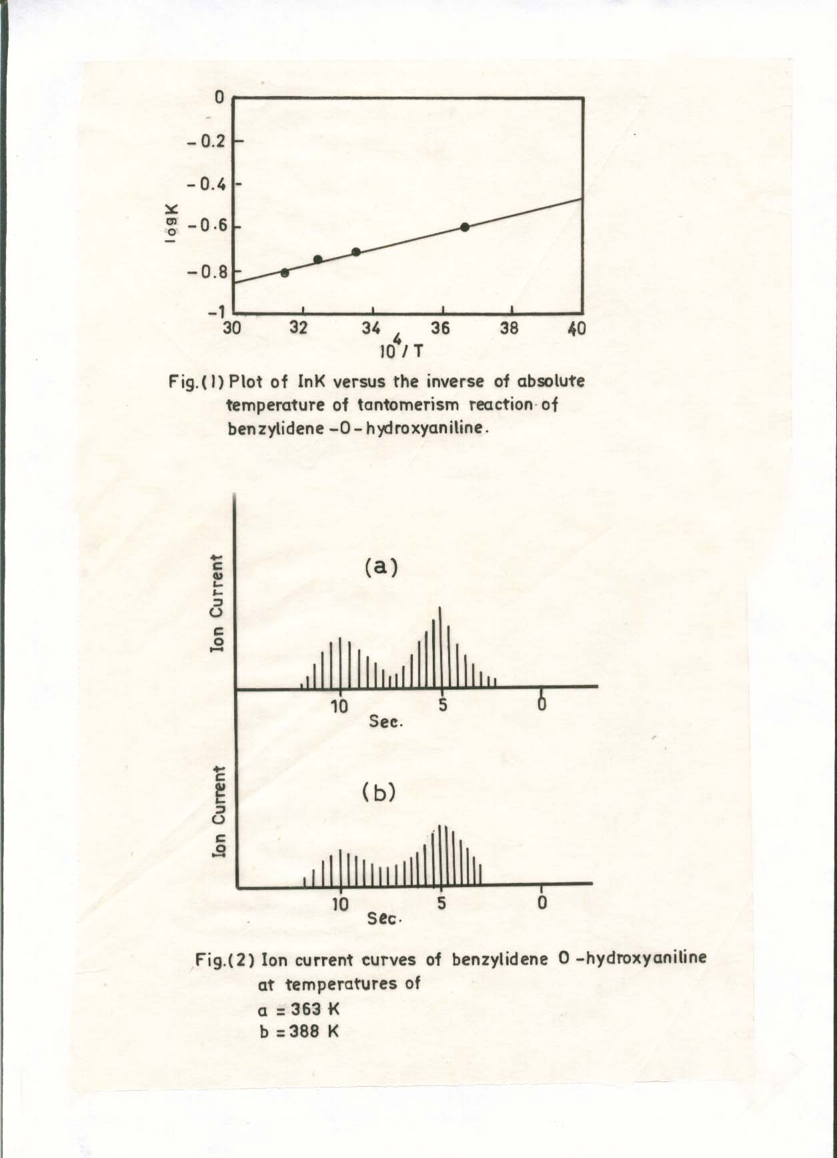

Conclusions
1. The possibility of enol keto tautomerism reaction in benzylidene -o-hydroxyaniline is achieved in our previous study³¹, by the development of a new spectrophotometric method for the determination of enol content using a diazotized sulfanilic acid sodium salt. The advantage of the diazotized coupling method is twofold as follows:
a. It is simple, precise and selective.
b. It permits the evaluation of real tautomerism equilibrium constant exerted in benzylidene-o-hydroxyaniline at a neutral condition, the side catalysed^{17,26,27} acid-base tautomerism reaction is completely omitted.
2. The tautomerism reaction of benzylidene-o-hydroxyaniline in solution state is confirmed from the evaluation of ΔH and ΔS thermodynamic functions¹⁷ which have an average values of about -1.1 KJ.mole⁻¹ and
-18 J.mole⁻¹.K⁻¹ respectively. In addition to that, the tautomerism process is nonspontaneous as evident from positive signs of ΔG thermodynamic parameter which has a value of about 4.4 KJ.mole⁻¹. This is highly accepted, because a greater stability is expected for the enol form by its greater resonance aromatic structures. Hence, conversion of enol tautomer to keto form is regarded to be unfavorable process. This will reduce the possibility of occurrence of tautomerism reaction stated above.
3. The gaseous tautomerism reaction happening in benzylidene-o-hydroxyaniline is evaluated by the application of the integrated ion current (IIC) curve by mass spectrometry⁶. The method shows two curves for enol and keto forms in the molecule under study, at evaporation times of 5 and 10 seconds respectively. The greater volatility¹⁹ of enol over its keto is due to the occurrence of enol form in an intramolecular hydrogen bond form or chelate structure.
4. Finally, the paper-ends with an essential comparison between tautomeric equilibrium constants exerted in benzylidene-o-hydroxyaniline at solution and gaseous states. The greater values of tautomerism constants in gaseous state as compared with solution may come from the possibility of weakening hydrogen bonding of enol form at relatively an elevated temperature of measurement of the IIC curve. In other words, the chelate structure of the tautomer enol form, increases the stability of Schiff base and reduce its tautometric reaction.

References
- L.N. Ferguson and I. Kelly,
J. Am. Chem. Soc.,1951,73,3707.
- A.A. Saeed, A.W.A. Sultan, S.A. Selman and N.A. Abood, Can. J. Spectrosc.,1983,28,104.
- A.A. Saeed, N.A. Abood, N.A. Al-Mosoudi and G.T. Matti, Can. J. Spectrosc.,1985,30,142.
- Ed. S. Patai, The Chemistry of Carbon Nitrogen Double Bond, John Wiley, New York (1970) 149-180.
- A.A.Saeed, J. Chem.Eng.Data, 1984, 29, 358.
- A.S.P. Azzouz, Spectrosc.Lett., 1995,28,1.
- A.S.P. Azzouz, K.A. Abdullah and Kh. I. Niemi, Microchem. J.,1991,43,45.
- A.S.P. Azzouz and S.S. Othman, J. Edu. Sci.,2001,48,32.
- A.S.P. Azzouz and, S.M. Saleh, J. Edu. Sci;2002,46,51.
- S.S.Othman,M.Sc.Thesis, Mosul University,1994.
- S.H.Pine, J.B.Hendrickson, DJ. Cram and G.S. Hammond, Organic Chemistry, 4th.ed. McGraw Hill, London, (1981), p.183.
- G.D. Dudek and E.P. Dudek, J.Am. Chem.Soc;1964,86.2483.
- M.D. Cohen, T. Hirshberg and G.M.J. Schmidt, J. Chem. Soc;1964, 2060.
- G.D. Dudek and E.P. Dudek, J. Am. Chem. Soc.,1966, 88,2407.
- D.A. Nelson and J.J. Worman, Chem. Commun,1966, 487.
- A.G. Taki, Ph.D. Thesis, Mosul University,2000.
- Ed. J.Zabicky,The Chemistry of the Carbonyl Group, Interscience, London,Vol.2, p.162-207.
- A.E.Jenkins and J.R. Majer, Talanta,1967,14,777.
- A.S.P. Azzouz, Mu'tah J. Res and Stud,1993,8,93.
- A.I. Vogel, A Text Book of Practical Organic Chemistry, Longman London. 3rd. ed., (1964) 106.
- A.A.H. Saeed, M.N. Al-Zagoum and M.H. Watton, Can. J. Spectrosc,1980,25,137.
- Sidney, Siggia and J. Gordon Hanna,Quantitative Organic nalysis Via Functional Groups, John Wiley, 4th ed. New York (1979) 63-93.
- J.B.Conant and G.B. Kistiakowsky, Chem. Rev;1937,20, 181.
- G.W. Wheland, Advance Organic Chemistry, 2nd. Ed., John Wiley, London, (1949) 580-610.
- H.H. Willard, L.L. Merritt and J.A. Dean,Instrumental Methods of Analysis, Litton Educational Publishing, London, (1974).
- I.R. Whitlock, S. Siggia, and J.E. Smola, Anal Chem,1972, 44,532.
- K.K. Chatterjee and B.E. Douglas, Spectrochimica Acta,1965m21,1625.
- A.S.P. Azzouz, A.A.B. Rahman and A.G. Taki, J.Edu.Sci,2003,15,1.
- J. Emsiey, Chem. Soc. Rev;1980,9,1.
- M. Ladd, Introduction to Physical Chemistry, 3rd. Ed., Cambridge, (1998).
- A.S.P. Azzouz and I.Z.Sulyman, J.Edu. Sci,2004,16, 125.
- A.S.P.Azzouz and M.M.H.A-Niemi,Z.Phys.Chem,2005,219,1591
- Findlay and J.A. Kitchener, Practical Physical Chemistry, Longmans,1963, p,268.

