Synthesis and Study of Acetylenic Amines Derivatives
from p-Aminophenol
M.A. Sheat and S.R. Ali

Chemistry Dept., College of Science, University of Mosul

(NJC)

(Received on 10 /7 /2005) (Accepted for publication on 29 / 4 /2006)

Abstract
New acetylenic amines derivatives from p-aminophenol have been synthesized through Mannich reaction which involved reaction of
p-acetamidophenyl propargyl ether and p-phthalimidophenyl propargyl ether with paraformaldehyde and secondary amines. Some of the synthesized acetylenic amines passed through alkaline hydrolysis to release free amine group which was allowed to be reacted with aldehyde or ketone to produce shiff bases. The synthesized compounds were investigated by physical and spectroscopic methods.

الخلاصة
حضرت مشتقات جديدة لأمينات استيلينية من استخدام البارا-امينوفينول من خلال تطبيق تفاعل مانخ الذي تضمن مفاعلة البارا-اسيتاميدوفنيل بروبرجيل ايثر والبارا-فثاليميدوفنيل بروبرجيل ايثر مع البارا-فورمالدهايد والأمينات الثانوية، وأجري تحلل مائي في محيط قاعدي لقسم من مركبات الأمينات الاستيلينية المحضرة لتحرير مجموعة أمين حرة فوعلت مع الالدهايد أو الكيتون للحصول على قواعد شيف. تم تشخيص المركبات المحضرة باستخدام الطرائق الفيزياوية والطيفية.

Introduction
Mannich reaction was found to be one of well known reaction in syntheses of pharmaceutically active compounds especially acetylenic amines derivatives. This reaction involves condensation of formaldehyde with ammonia or a primary or secondary amine with a compound containing reactive hydrogen to form Mannich bases ^{[1]}. Among compounds containing reactive hydrogen are pyrazolinines ^{[2]}, benzimidazol and benzotriazol ^{[3]}, 6-acylbenzoxazolinones ^{[4]}, acetylenic compounds^{[5]} and phenols ^{[6]}. It was noticed that the acetylenic amines derivatives showed different pharmacological activities such as anticholinergic agents ^{[7]}, hypertensive agents ^{[8]}, anticancer agents ^{[9]}, oxotremorine antagonists ^{[10]} and antibacterial agents ^{[11]}.
p-Aminophenol has been used in synthesis of well known drugs named
p-acetamol (acetaminophen) ^{[12]} and phenacetin ^{[13]}. Acetaminophen (the active metabolite of phenacetin) is preferred over aspirin as an analgesic and antipyretic agent for patients who suffer from gastric ulcer or a coagulation disorder,
also acetaminophen does not interfere with the actions of uricosuric agents as aspirin can ^{[14]}. The mixture of aspirin, phenacetin and caffeine (APC) is a nonpresciption analgesic preparation sold for relief of headache, muscular aches and pains, arthritis, and other common afflictions, besides APC is also antipyretic and anti-inflammatory and also acts as a central stimulant ^{[15]}.
On the other hand, the phthalimide dervatives also showed biological activity such as acetylenic amines of succinimides and phthalimides which are used as anticholinergic agents and anti-Parkinsonian agent ^{[7, 16]}, while N-substituted phthalimides demonstrated inhibitory effect on the tested micro organisms ^{[17, 18]}.
Whereas, the biological activities of Shiff bases compounds were appeared as analgesic and antipyretic agents ^{[19]}, Fungicides ^{[20]} and anti-inflammatory agents ^{[21]}.
This paper is concerned with the syntheses of new compounds of expected biological activity not for they are acetylenic amines derivatives but also they are derivatives for well known drugs (p-acetamol and phenacetin), also derivatives for phthalimides and shiff bases.

Experimental
Melting points were measured by Gallenkamp melting point apparatus and are uncorrected. I.R. spectra were recorded by Pye Unicam SP 2000 Infrared Spectrophotometer as KBr disc. U.V. spectra were obtained from Cintras GBS Scientific Equipment.
Methods of Preparation:
Three series of acetylenic amines derivatives have been synthesized by following different methods of preparations.
I-Preparation of Acetylenic Amines Derivatives for p-Acetamol or Phenacetin:
1. Preparation of Acetaminophen (p-Acetamol) [1]:
In a 250 ml round bottom flask containing p-aminophenol (0.1 mole) and water (30ml). Acetic anhydride (0.127mole) was added with constant shaking. The mixture was heated on a water bath for about 15 mint. until the solid dissolves completely to produce a clear solution. Upon Cooling, p-acetylaminophenol is precipitated which is filtered, washed with cold water, drained well and recrystallised from hot water to yield a fine milky crystals of p-acetylaminophenol (p-acetamol) of 68% yield and m.p. (168-169°C) (lit. m.p. 169°C) [1].
2. Preparation of p-Acetamidophenyl propargyl Ether (I_{a}) [1]:
In a 250 ml round bottom flask filtted with a reflux condenser, sodium (0.8gm) was dissolved in absolute ethanol (20ml). The solution is cooled and
p-acetylaminophenol (0.033mole) and propargyl bromide (0.05mole) were added dropwise. The reaction mixture is heated under reflux for about one hour and then cooled in an ice-bath. The formed precipitate was filtered, washed with cold water and recrystallized from methanol to give the new desired product (I_{a}) as a deep brown crystals as shown in Table (1,2).
3. Preparation of N-(4-Amino-2-Butynyl)-p-Acetamidophenyl Ethers (I_{b-l}):
General Method (Mannich Reaction) ^{[22]}.
The acetylenic compound (0.03mole) was mixed with the secondary amine (0.036mole) in a round bottom flask fitted with a reflux condenser. The mixture was cooled to 0°C in an ice bath and paraformaldehyde (0.036mole) and CuCl (0.06gm) in peroxide-free dioxane (16ml) were added. The reaction mixture was cooled again to 0°C, and glacial acetic acid (4.5ml) was added dropwise with shaking. The mixture was stirred at room temperature for 5minutes, then at 90°C for 2hrs.
After cooling, water (100ml) was added and the reaction mixture was acidified to (pH=1) by dropwise addition of 1:1(HCl-H₂O) with stirring, then extracted with (2×50ml) of ether (ether layer was neglected). The aqueous phase was made alkaline with saturated solution of sodium bicarbonate. The formed precipitate was filtered, washed several times with water, then dried and recrystallized from methanol or benzene to obtain the desired products (I_{b-l}) as shown in Tables (1,2).

Table (1): The physical properties of compounds (I_{a-l})
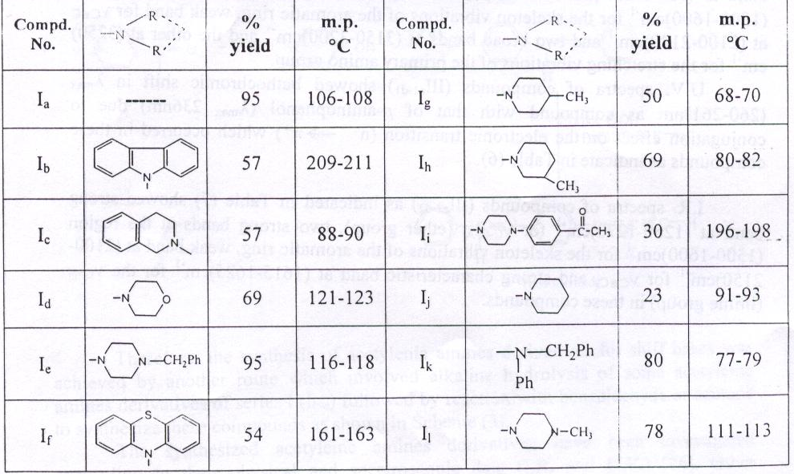

Table (2): Spectroscopic data of compounds (I_{a-l})
Compd. No. | I.R. cm⁻¹ (KBr) |  |  |  |  |  | U.V. (CHCl₃)  λ_{max} (nm)
Compd. No. | ν_{C-O-Ar}  (s) | ν_{CC}  (s) | ν_{C=O}  (s) | ν (br) | ν_{C-H}  (s) | ν_{N-H}  (br) | U.V. (CHCl₃)  λ_{max} (nm)
I_{a} | 1275 | 1610  1500 | 1650 | 2100 | 3230(s) |  | 248
I_{b} | 1270 | 1600  1580 | 1640 | 2120 |  | 3230 | 260
I_{c} | 1275 | 1600  1580 | 1640 | 2100 |  | 3230 | 258
I_{d} | 1275 | 1610  1500 | 1660 | 2100 |  | 3230 | 263
I_{e} | 1275 | 1600  1580 | 1640 | 2100 |  | 3175 | 261
I_{f} | 1270 | 1580  1500 | 1650 | 2100 |  | 3180 | 262
I_{g} | 1275 | 1610  1580 | 1650 | 2100 |  | 3170 | 262
I_{h} | 1275 | 1610  1580 | 1650 | 2100 |  | 3175 | 262
I_{i} | 1275 | 1600  1580 | 1640 | 2080 |  | 3230 | 261
I_{j} | 1275 | 1600  1580 | 1650 | 2100 |  | 3180 | 258
I_{k} | 1270 | 1600  1500 | 1640 | 2100 |  | 3230 | 252
I_{l} | 1275 | 1600  1580 | 1640 | 2120 |  | 3180 | 260
Note: compound (I_{i}) showed ketonic νC=O at 1670cm⁻¹.

II- Preparation of Acetylenic Amines Derivatives for Phthalimides:
1. Preparation of p-Phthalimidophenol ^{[23]}:
In a round bottom flask (250ml), p-aminophenol (0.1mole) was mixed with phthalic anhydride (0.1mole) and acetic acid (20ml). The mixture was refluxed for 1hr. After cooling, the precipitate was filtered, washed with acetic acid then with cold water and recrystallized from methanol to obtain the desired product as a deep brown crystals of 66%yield and m.p. (300-302°C).
2. Preparation of p-Phthalimidophenyl propargyl Ether (II_{a}):
This new compound (II_{a}) was prepared according to the modified method for the method in ref. ^{[1]} as shown below:
In a round bottom flask (250ml) fitted with a reflux condenser,
p-Phthalimidophenol (0.033mole) was added to the cooled solution of sodium (0.08gm) in absolute ethanol (25ml). The mixture was stirred at room temperature for 1hr, then cooled to (0-10°C) and propargyl bromide (0.05mole) was added. The mixture was stirred at room temperature for 3hrs. After cooling, the precipitate was filtered, washed with cold water and recrystallized from ethanol to obtain the desired product (II_{a}) as a pale yellow fine crystals as shown in Tables (3,4).
3. Preparation of N-(4-Amino-2-Butynyl)-p-Phthalimidophenyl Ethers (II_{b-j}):
These compounds (II_{b-j}) have been prepared according to Mannich reaction as described in method (I-3), and purified by recrystallization from ethanol or benzene to obtain these compounds (II_{b-j}) as shown in Tables (3,4).
III-Preparation of Acetylenic Amines Derivatives for Shiff Bases (III_{a2-e2}):
The alkaline hydrolysis of some compounds of series I(I_{b-e}) afforded the new acetylenic amines (III_{a1-d1}). When the latter compounds were allowed to be reacted with benzaldehyde or acetone, new acetylenic amines for shiff bases (III_{a2-e2}) were obtained as shown below:

Table (3): The physical properties of compounds (II_{a-j})
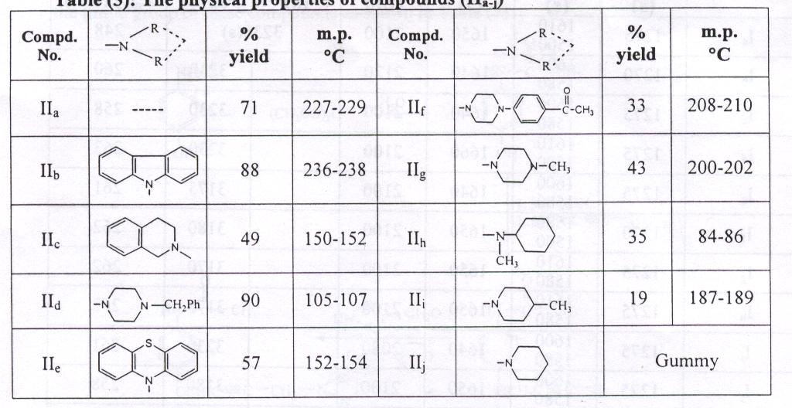

Table (4): Spectroscopic data of compounds (II_{a-j})
Comd. No. | I.R. cm⁻¹ (KBr) |  |  |  |  |  | U.V. (CHCl₃)  λ_{max} (nm)
Comd. No. | ν_{C-O-Ar}  (m) | ν_{C} _{C}  (w) | Imidic group |  | ν_{CC}  (w) | ν_{C-H}  (s) | U.V. (CHCl₃)  λ_{max} (nm)
Comd. No. | ν_{C-O-Ar}  (m) | ν_{C} _{C}  (w) | ν_{C=O}  (s) | ν_{C=O}  (w) | ν_{CC}  (w) | ν_{C-H}  (s) | U.V. (CHCl₃)  λ_{max} (nm)
II_{a} | 1270 | 1600  1500 | 1700 | 1615 | 2120 | 3230 | 256
II_{b} | 1275 | 1600  1500 | 1700 | 1620 | 2156 |  | 259
II_{c} | 1260 | 1600  1500 | 1700 | 1620 | 2100 |  | 259
II_{d} | 1250 | 1600  1500 | 1680 | 1615 | 2110 |  | 258
II_{e} | 1270 | 1610  1500 | 1680 | 1625 | 2150 |  | 264
II_{f} | 1275 | 1600  1500 | 1700 | 1615 | 2170 |  | 260
II_{g} | 1250 | 1600  1500 | 1715 | 1630 | 2170 |  | 262
II_{h} | 1275 | 1600  1500 | 1705 | 1625 | 2150 |  | 261
II_{I} | 1240 | 1600  1500 | 1715 | 1630 | 2100 |  | 258
II_{j} | Gummy | - | - | - | - |  | -

1. Preparation of N-(4-Amino-2-Butynyl)-p-Anilino Ethers (III_{a1-d1}) ^{[24]}:
In a round bottom flask (100ml), acetylenic amines (I_{b-e}) (0.07mole) was dissolved in absolute ethanol (10ml) with heating, then a solution of sodium hydroxide (5ml, 80%) was added. The mixture was refluxed for 30mint. then diluted with water (10ml) and concentrated by heating to about half its volume. After cooling, crushed ice was added with stirring till solid precipitate was formed. The precipitate was filtered, washed with cold water and recrystallized from methanol-water to obtain the desired products (III_{a1-d1}) as a fine crystals as shown in Tables (5,6).
2. Preparation of N-(4-Amino-2-Butnyl)-p-Benzylidene Anilino Ethers (III _{a2-e2}) (Shiff Bases) ^{[25]}:

Equimolar (0.003mole) of acetylenic amines (III_{a1-d1}) and benzaldehyde or acetone, each one dissolved in absolute ethanol (10ml) with heating to be homogenous solutions. The solution of acetylenic amine was added gradually to the solution of aldehyde or ketone. The mixture was refluxed for 30mint with stirring. After cooling, the precipitate was filtered and recrystallized from ethanol to obtain the desired products (III_{a2-e2}) as a fine crystals as shown in Tables (5,7).

Table (5): The physical properties of compounds (III_{a1-d1}) and compounds
(III_{a2-e2})

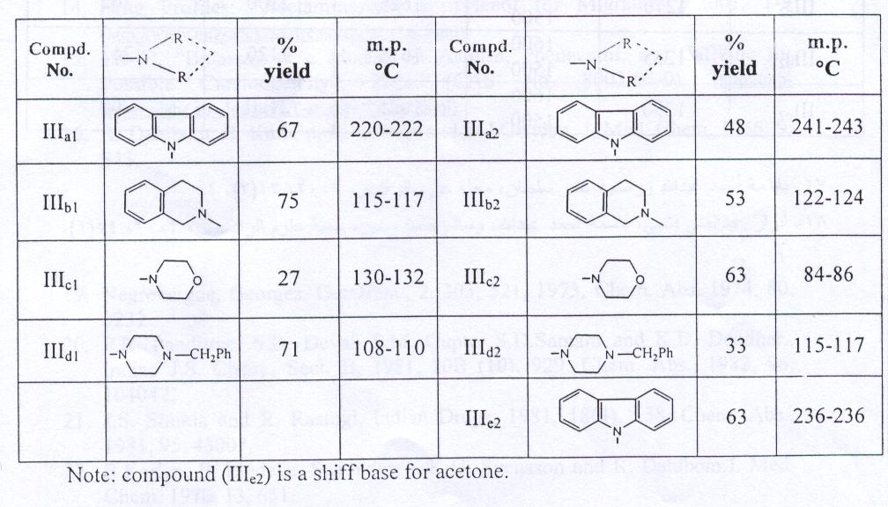

Table (6): Spectroscopic data of compounds (III_{a1-d1})
Compd. No. | I.R. cm⁻¹ (KBr) |  |  |  | U.V. (CHCl₃)  λ_{max} (nm)
Compd. No. | ν_{C-O-Ar}  (s) | ν_{C C}  (s) | ν_{CC}  (w) | ν_{N-H}  (br) | U.V. (CHCl₃)  λ_{max} (nm)
III_{a1} | 1275 | 1610  1500 | 2110 | 3250  3200 | 260
III_{b1} | 1250 | 1610  1500 | 2120 | 3250  3200 | 260
III_{c1} | 1260 | 1610  1500 | 2100 | 3250  3150 | 261
III_{d1} | 1240 | 1600  1500 | 2100 | 3250  3150 | 260

Table (7): Spectroscopic data of compounds (III_{a2-e2})
Compd. No. | I.R. cm⁻¹ (KBr) |  |  |  | U.V. (CHCl₃)  λ_{max} (nm)
Compd. No. | ν_{C-O-Ar}  (s) | ν_{C C}  (s) | ν_{C=N}  (s) | ν_{CC}  (w) | U.V. (CHCl₃)  λ_{max} (nm)
III_{a2} | 1250 | 1600  1500 | 1620 | 2150 | 260
III_{b2} | 1260 | 1600  1500 | 1620 | 2100 | 262
III_{c2} | 1270 | 1610  1500 | 1625 | 2100 | 262
III_{d2} | 1255 | 1600  1500 | 1615 | 2120 | 262
III_{e2} | 1250 | 1600  1500 | 1625 | 2120 | 260

Results and Discussion
The high interest of the pharmaceutical active acetylenic amines derivatives encourage researchers to continue synthesis of new compounds of this type of class. Accordingly, the synthesis of new acetylenic amine derivatives for the well known drugs (p-acetamol or phenacetin), phthalimide compounds and for shiff bases may lead to compounds with some biological activities. Furthermore, to the best of our knowledge, this is the first time to synthesize acetylenic amines derivatives for shiff bases and this synthesis is considered as a new field in the respect.
Therefore, three series of acetylenic amines derivatives have been synthesized. Two series (I and II) were obtained from the reaction of p-acetamidophenyl propargyl ether (I_{a}) and p-phthalimidophenyl propargyl ether (II_{a}) through Mannich reaction with paraformaldehyde and secondary amines to produce new Mannich products as shown in Scheme (1) and (2).

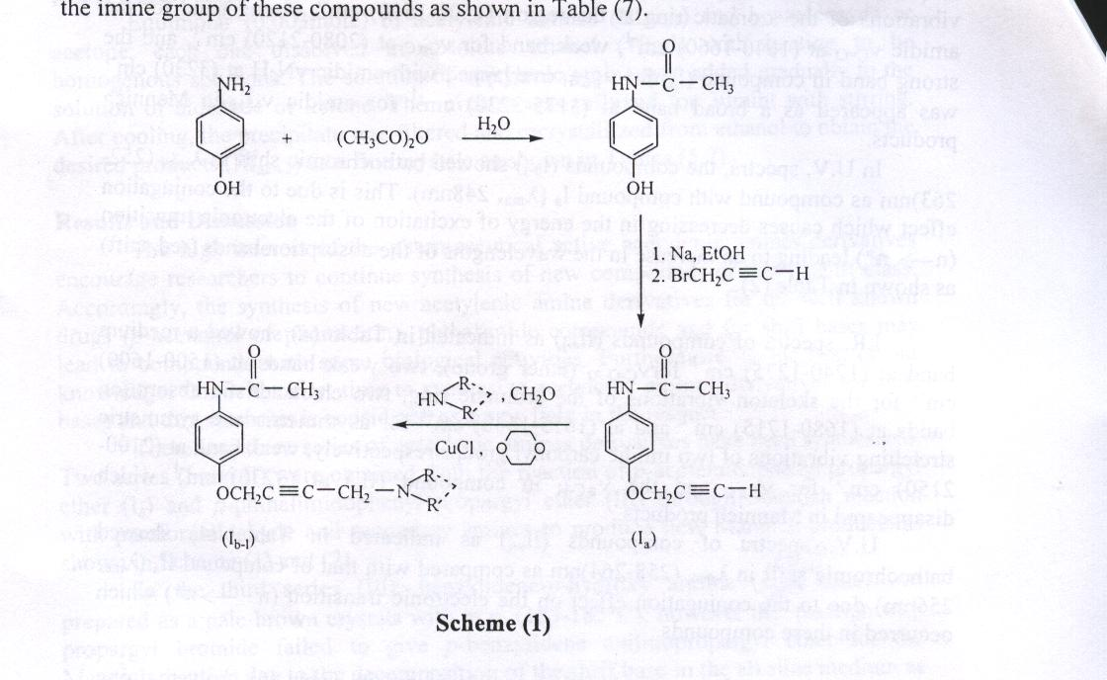
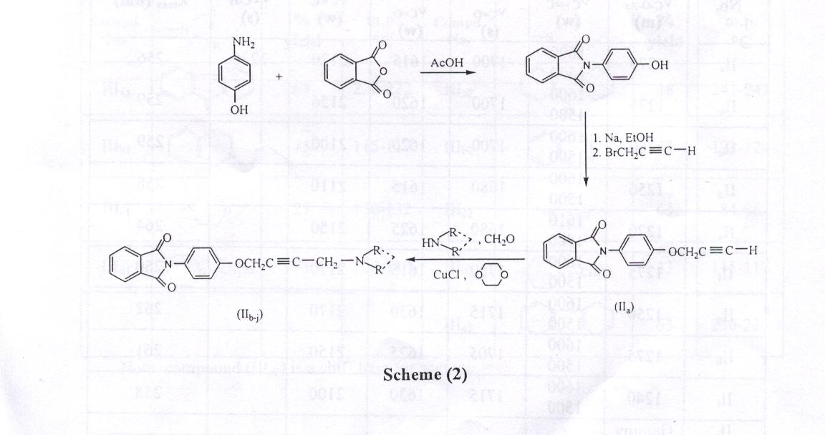

In the third series (III), benzylidene-p-hydroxy aniline (shiff base) was prepared as a pale brown crystals with m.p. (183-185°C), however the reaction with propargyl bromide failed to give p-benzylidene anilinopropargyl ether for the Mannich reaction due to the decomposition of the shiff base in the alkaline medium as shown below:
Therefore, the synthesis of acetylenic amines derivatives for shiff bases was achieved by another route which involved alkaline hydrolysis of some acetylenic amines derivatives of series I (I_{b-e}) followed by reaction with benzaldehyde or acetone to synthesize these compounds as shown in Scheme (3).

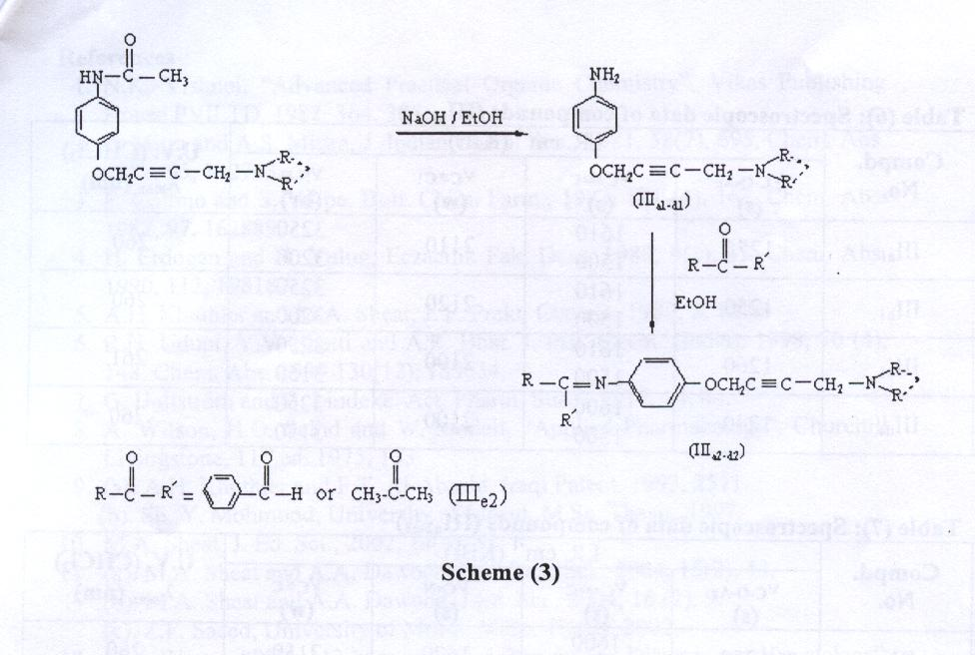

The synthesized acetyleinc amines derivatives have been investigated accrording to their physical and spectroscopic data (I.R. and U.V.) [26]. Other supporting evidences is the positive Tollen test for acetylenic hydrogen which became negative test in Mannich products, also the positive picrate formation test for the tertiary amino group in these compounds, and the positive Hinsberg test for the free primary amino group in compounds (III_{a1-d1}) ^{[27]}.
I.R. spectra of compounds (I_{a-l}) as indicated in Table (2) showed strong band at (1270-1275)cm⁻¹ for ν_{C-O-Ar} (ether group), two strong bands for the skeleton vibrations of the aromatic ring at the region (1500-1610) cm⁻¹, strong band for the amidic ν_{C=O} at (1640-1660) cm⁻¹, weak band for ν_{CC} at (2080-2120) cm⁻¹, and the strong band in compound (I_{a}) for ν_{C-H} overlapped with amidic νN-H at (3230) cm⁻¹ was appeared as a broad band at (3175-3230) cm⁻¹ for amidic ν_{N-H} in Mannich products.
In U.V. spectra, the compounds (I_{b-l}) showed bathochromic shift in λ_{max} (252-263)nm as compared with compound I_{a} (λ_{max} 248nm). This is due to the conjugation effect which causes decreasing in the energy of excitation of the electronic transition (n π*) leading to an increase in the wavelengths of the absorption bands (red shift) as shown in Table (2).
I.R. spectra of compounds (II_{a-j}) as indicated in Table (4) showed a medium band at (1240-1275) cm⁻¹ forν_{C-O-Ar} (ether group), two weak bands at (1500-1600)
cm⁻¹ for the skeleton vibrations of the aromatic ring, two characteristic absorption bands at (1680-1715) cm⁻¹ and at (1615-1630) cm⁻¹ for asymmetric and symmetric stretching vibrations of two imidic carbonyl groups respectively, weak band at (2100-2150) cm⁻¹ for ν_{CC} and the ν_{C-H} in compound (II_{a}) at (3230) cm⁻¹ which disappeared in Mannich products.
U.V. spectra of compounds (II_{a-j}) as indicated in Table (4) showed bathochromic shift in λ_{max} (258-264)nm as compared with that of compound II_{a} (λ_{max} 256nm) due to the conjugation effect on the electronic transition (n π*) which occurred in these compounds.
I.R. spectra of compounds (III_{a1-d1}) as indicated in Table (6) showed strong band at (1240-1275)cm⁻¹ for ν_{C-O-Ar} (ether group), two strong bands at the region (1500-1600)cm⁻¹ for the skeleton vibrations of the aromatic ring, weak band for ν_{CC} at (2100-2120)cm⁻¹ and two broad bands at (3150-3200)cm⁻¹ and the other at (3250)
cm⁻¹ for the stretching vibrations of the primary amino group.
U.V. spectra of compounds (III_{a1-d1}) showed bathochromic shift in λ_{max}
(260-261)nm as compound with that of p-aminophenol (λ_{max} 236nm) due to conjugation effect on the electronic transition (n π*) which occurred in these compounds as indicate in Table (6).
I.R. spectra of compounds (III_{a2-d2}) as indicated in Table (7) showed strong band at (1250-1270)cm⁻¹ for ν_{C-O-Ar} (ether group), two strong bands at the region (1500-1600)cm⁻¹ for the skeleton vibrations of the aromatic ring, weak band at (2100-2150)cm⁻¹ for ν_{CC}, and strong characteristic band at (1615-1625)cm⁻¹ for the ν_{C=N} (imine group) in these compounds.

U.V. spectra of compounds (III_{a2-d2}) showed the wavelengths of the absorption bands at (260-262)nm due to the electronic transition (n π*) which occurred on the imine group of these compounds as shown in Table (7).

References
- N.K. Vishnoi, “Advanced Practical Organic Chemistry”, Vikas Publishing House PVILTD, 1982, 364, 375.
- P. Mitra and A.S. Mittra, J. Indian Chem. Soc., 1981, 58(7), 695. Chem. Abs. 1982, 95, 132743.
- F. Collino and S. Volpe, Boll. Chim. Farm., 1982, 121 (4), 167. Chem. Abs. 1982, 97, 162889.
- H. Erdogan and N. Yulug, Eczacilik Fak. Derg. 1989, 9(1), 35. Chem. Abs. 1990, 112, 198187.
- A.H. Khuthier and M.A. Sheat, J. F. Prakt. Chemie. 1989, 2, 187.
- R.H. Udupi, Y.V. Shetti and A.R. Bhat. J. Inst. Chem. (India), 1998, 70 (4), 148. Chem. Abs. 1999, 130(12), 153634.
- G. Hallstrőm and B. Lindeke. Act. Pharm. Suec., 1977, 14, 44.
- A. Wilson, H.O. Sclhd and W. Modell, “Applied Pharmacology”, Churchill Livingstone, 11th ed. 1975, 133.
- (a). A.H. Khuthier and F.T. Al-Abachi, Iraqi Patent, 1993, 2511.
(b). Sh. Y. Mohmood, University of Mosul, M.Sc. Thesis, 1997.
- M.A. Sheat, J. Ed. Sci., 2002, 14(4), 51.
- (a). M.A. Sheat and A.A. Dawood, Raf. Jour. Sci., 2004, 15(2), 44.
(b). M.A. Sheat and A.A. Dawood, J.Ed. Sci., 2004, 16 (2), 9.
(c). Z.F. Saeed, University of Mosul, M.Sc. Thesis, 2002.
- P.M. Woster, “PHA 413-Immunology, Inflammatory, Diseases and Hematology”, 2001, 656-673. (http://www.wiz2.Pharm.Wayne,edu/module/pha413.html).
- J.B. Conant and A.H. Blatt, “The Chemistry of Organic Compounds”, Macmillan Company, New York, 4th ed. 1982, 464.
- Drug Profiles: “Acetaminophen or Tylenol for Migraines”, 2001, 1-9 (http://www.migranes.org/treatment/protyln.html).
- TR-67, “Bioassay of a Mixture of Aspirin, Phenacetin, and Caffeine for Possible Carcinogeicity”, 2001, (CAS No. 8003-03-0). (http://ntp-server.niehs.gov/htdocs/LT-studies/TR067.html).
- R. Dahlbom, B. Karle`n, R. George and D.J. Jenden. J. Med. Chem. 1966, 9, 843.
.17باسمة أحمد عبدالله ورسمية عمر سلطان، مجلة علوم الرافدين، 2002، 13(2)،.1
.18أنوار عبدالغني فتحي، باسمة أحمد عبدالله، وسالم حامد حسين، مجلة علوم الرافدين،2003, (1)14,.1
19. Negrevergne, Georges. GerOffen., 2, 303, 521, 1973, Chem. Abs. 1974, 80, 3232.
- P.R. Panditrao, S.D. Deval, S.M. Gupte, S.D.Samant and K.D. Deodhar., Indian J.S. Chem., Sect. B, 1981, 20B (10), 929. Chem. Abs., 1982, 96, 104042.
- J.S. Shukla and R. Rastogi, Indian Drugs, 1981, 18(4), 138. Chem. Abs., 1981, 95, 43007.
- B.Karlen, B. Lindeke, S. Lindgren, K-G. Svensson and R. Dahlbom.J. Med. Chem. 1970, 13, 651.
- A.I. Vogel, “Text Book of Practical Organic Chemistry”, Longman, London, 4th ed., 1972, 423.
- P.R. Singh, D.S. Gupta and K.S. Bajpai, “Experimental Organic Chemistry”, Tata McGraw-Hill Publishing Company Limited, New Delhi, 1980, I, 149.
- M.A. Bayoumi, M.El-Aasser and F. Abdel-Halim. J. Am. Chem. Soc., 1971, 93, 586.
- V.M. Parikh, “Absorption Spectroscopy of Organic Molecules”
ترجمة: عبدالحسن شربة، جاسم الراوي ومحمد العراقي، مديرية مطبعة الجامعة، جامعة الموصل، .1985
- N.D. Cheronis and J.B. Entrikin, “Identification of Organic Compounds”
ترجمـة: موفق شندالـة، روعـة غياث الدين ونزار الجبـور، مديـريـة دار الكتب للطباعـة والنشـر، جامعة الموصل، 1986.

