Synthesis and Characterization of Some Transition Metals Complexes with 1,2-Bis-[3-(Phenyl Amino)-5-Imino-1,2,4-Thiadiazolyl] Ethene

Mahmood N. AL-Jibouri, Redha I. AL-Bayati and Najat J. AL-Obaidi
Department of Chemistry, College of Science, AL-Mustansiriya University
Baghdad, Iraq

(NJC)

(Received on 16 / 10 /2004) (Accepted for publication on 29 / 4 /2006)

Abstract
A new Schiff base, 1,2-bis-[3-(phenyl amino)-5-imino-1,2,4-thiadiazolyl] ethene, was prepared, which was used as ligand to prepare a number of metal complexes of Cr(III), Mn(II), Co(II), Ni(II), Cu(II), Zn(II), Cd(II) and Hg(II). The products were isolated, studied and characterized by FT.I.R. spectroscopy, electronic spectroscopy, magnetic susceptibility measurements, conductivity measurements, melting point and elemental analysis (C.H.N.M.). probable structures of the complexes have been assigned.
الخلاصة
نظراً للأهمية البايولوجية والصناعية لمشتقات 4,2,1-ثاياديازول فقد تم في هذا البحث تحضير قاعدة شيف جديدة بالتفاعل التكثيفي لمعوض 3-فنيل امينو -5-امينو-4,2,1-ثاياديازول مع الكلايوكسال.
وقد استخدم هذا الليكند للتعقيد مع بعض العناصر الانتقالية وهي [Cr(III), Mn(II), Co(II), Ni(II), Cu(II), Zn(II), Cd(II), Hg(II)]، ثم دراسة وتشخيص الليكند ومعقداته بواسطة التحليل الدقيق للعناصر (C.H.N.M.) والطرق الطيفية (FT.I.R.) و (UV-Vis) وقياس التوصيلية المولارية عند تركيز 10⁻³ مولاري في مذيب DMF لتقدير النسبة المولية (M:L “Molar Ratio") وكذلك دراسة الحساسية المغناطيسية لاثبات الصيغة التركيبية المقترحة.

Introduction
The thiadiazole ring is associated with antifungal ⁽¹⁻³⁾, hypoglycemic ^{(4,5)} and antimycrobacterial ⁽⁶⁻⁹⁾ properties.
The (NH-ph) group attached to the heterocyclic nucleus may induce fungicidal activity ⁽¹⁰⁾. Compounds containing (N-S-C) linkage is reported as anti-irradiation agent ⁽¹¹⁾. The 3,5-disubstituted-1,2,4-thiadiazole possess central advantage in the field of herbicides and antiviral agents ^{(12,13)}.
The presence of nitrogen and sulfur atoms provide more than atom for comlexation with metal ions ⁽¹⁴⁾, this may lead to synthetic models in studying the effect of metal ion in some structurally related enzyme activities.
Experimental
All chemicals used were of reagent grade (Merck, Fluka) and used as supplied. The FTIR spectra in the range (4000-200 cm⁻¹) were recorded as cesium iodide disc FTIR-8300 Shimadzu spectrophotometer. The UV spectra were measured in ethanol using ShimadzuUV-Vis. 160A-Ultra-Violet Visible spectrophotometer in the range (200-100 nm). Magnetic susceptibility measurements for the complexes were obtained at room temperature using (Magnetic susceptibility Balance) of Johnson Mattey catalytic system division. Gallen-kamp MFB-600.010F melting point apparatus was used to measure the melting points of all prepared compounds. Elemental microanalysis was carried out using C.H.N. elemental analyzer model Perkin-Elmer B240. Flame atomic absorption data were obtained using Shimadzu AA-670. Conductivity measurements were done by using Conductivity meter 220 in DMF (10⁻³ M) as solvent.

1.Preparation of 3-(phenyl amino)-5-amino-1,2,4-thiadiazole ⁽¹⁵⁾:
It is prepared by oxidative cyclization of 1-phenyl thiourea (2 mmole, 2.04 gm) was dissolved in (10 ml) of DMSO (oxidizing agent) with stirring at 50 °C for (24 h). The sulfur precipitated was collected by filtration, the solution was poured in (25 ml) of distilled water to afford above resultant, (0.175 gm, 91%).

2.Preparation of 1,2-bis-[3-(phenyl amino)-5-imino-1,2,4-thiadiazolyl] ethane:
3-(amino phenyl)-5-amino-1,2,4-thiadiazole (1.92 gm, 0.01 mole) was dissolved in (25 ml) of absolute ethanol and (0.29 gm, 0.005 mole) of glyoxal is added. The mixture was refluxed for (5 h), then the solvent was removed under evaporation to about half of the original volume. A bright yellow precipitate was obtained which is filtered and washed with cold ethanol. The product was recrystallized from hot absolute ethanol to afford bright yellow crystals (2.85 gm, 73% yield), m.p. was 180 °C.


1,2-bis-[3-(phenyl amino)-5-imino-1,2,4-thiadiazolyl] ethane

3.Preparation of metal complexes:
To a solution of (0.812 gm, 2 mmole) of the ligand dissolved in (10 ml) of ethanol, 1 mmole of the transition metal salts (MCl₂.xH₂O)orCrCl3.6H2Odissolved in(10 ml) of hot absolute ethanol was added. The mixture was refluxed for one hour, the solvent was removed under evaporation to half of the original volume and then cooled, the resulting precipitate was filtered. Recrystallization from ethanol afforded crystalline solid of the complexes, table (1).

Table 1: Physical properties of the ligand and it’s metal complexes

No. | Compound | Color | M.p. °C | Yield % | Conductivity ohm⁻¹.cm².mol⁻¹
1 | C₈H₈N₄S | Yellow | 180-182 | 91 | -
2 | C₁₈H₁₄N₈S₂ | Pale yellow | 220-222 | 48 | -
3 | [Cr(C₁₈H₁₄N₈S₂) ₂Cl₂]Cl | pale green | 330 | 65 | 39
4 | [Mn(C₁₈H₁₄N₈S₂) ₂]Cl₂ | Olive | 340-342 | 55 | 75
5 | [Co(C₁₈H₁₄N₈S₂) ₂]Cl₂ | Violet | 339 d | 70 | 25
6 | [Ni(C₁₈H₁₄N₈S₂) ₂]Cl₂ | Bright red | 336-338 | 85 | 80
7 | [Cu(C₁₈H₁₄N₈S₂) ₂Cl₂]Cl | Green | 350-352 | 95 | 15
8 | [Zn(C₁₈H₁₄N₈S₂) ₂]Cl₂ | Off white | 370 d | 65 | 69
9 | [Cd(C₁₈H₁₄N₈S₂) ₂]Cl₂ | Yellow | 360-362 | 65 | 78
10 | [Hg(C₁₈H₁₄N₈S₂) ₂]Cl₂ | Pale brown | 355-357 | 70 | 87
d = decomposed

Table 2: Elemental analysis (C.H.N.M.) of the compounds

No. | Compound | Calculated (Found)
No. | Compound | C% | H% | N% | M%*
1 | C₈H₈N₄S | 50.00(49.81) | 4.16(4.00) | 29.16(28.99) | -
2 | C₁₈H₁₄N₈S₂ | 53.20(52.99) | 3.44(3.12) | 27.58(27.01) | -
3 | [Cr(C₁₈H₁₄N₈S₂) ₂Cl₂]Cl | 44.10(43.61) | 1.99(1.33) | 21.60(20.90) | 4.31(3.99)
4 | [Mn(C₁₈H₁₄N₈S₂) ₂]Cl₂ | 46.05(45.75) | 2.98(2.60) | 23.88(22.93) | 5.85(4.77)
s5 | [Co(C₁₈H₁₄N₈S₂) ₂]Cl₂ | 45.86(45.01) | 2.97(2.11) | 23.78(22.79) | 6.25(6.01)
6 | [Ni(C₁₈H₁₄N₈S₂) ₂]Cl₂ | 45.87(44.99) | 2.97(2.01) | 23.78(22.53) | 6.25(5.99)
7 | [Cu(C₁₈H₁₄N₈S₂) ₂Cl₂]Cl | 45.64(44.93) | 2.95(2.66) | 23.66(22.92) | 6.70(6.01)
8 | [Zn(C₁₈H₁₄N₈S₂) ₂]Cl₂ | 45.55(44.77) | 2.95(2.01) | 23.61(22.98) | 6.89(6.01)
9 | [Cd(C₁₈H₁₄N₈S₂) ₂]Cl₂ | 43.39(42.98) | 2.81(2.09) | 23.61(21.99) | 10.95(11.29)
10 | [Hg(C₁₈H₁₄N₈S₂) ₂]Cl₂ | 39.86(38.99) | 2.58(2.07) | 20.67(19.91) | 18.51(17.99)
* = analysis by atomic absorption

Table 3: Electronic spectra of the compounds
No. | Compound | Absorption bands (λ_{max} nm) | Assigned transition | ε_{max}  (mol⁻¹.lit.cm⁻¹)
1 | C₁₈H₁₄N₈S₂ | 254 | π → π* | 10225
1 | C₁₈H₁₄N₈S₂ | 275 | π → π* | 3900
1 | C₁₈H₁₄N₈S₂ | 335 | n → π* | 3500
2 | [Cr(C₁₈H₁₄N₈S₂) ₂Cl₂]Cl | 250 | π → π* | 9500
2 | [Cr(C₁₈H₁₄N₈S₂) ₂Cl₂]Cl | 265 | n → π* | 3800
2 | [Cr(C₁₈H₁₄N₈S₂) ₂Cl₂]Cl | 350 | Charge transfer | 3520
2 | [Cr(C₁₈H₁₄N₈S₂) ₂Cl₂]Cl | 450 | A⁴_{2g}→ T⁴_{1g} | 980
3 | [Mn(C₁₈H₁₄N₈S₂) ₂]Cl₂ | 252 | π → π* | 10152
3 | [Mn(C₁₈H₁₄N₈S₂) ₂]Cl₂ | 270 | n → π* | 4000
3 | [Mn(C₁₈H₁₄N₈S₂) ₂]Cl₂ | 325 | Charge transfer | 23500
4 | [Co(C₁₈H₁₄N₈S₂) ₂]Cl₂ | 255 | π → π* | 3911
4 | [Co(C₁₈H₁₄N₈S₂) ₂]Cl₂ | 270 | n → π* | 3422
4 | [Co(C₁₈H₁₄N₈S₂) ₂]Cl₂ | 335 | Charge transfer (M → L) | 3422
4 | [Co(C₁₈H₁₄N₈S₂) ₂]Cl₂ | 500 | T⁴_{1g}^{f}→ T⁴_{1g}^{p} | 125
5 | [Ni(C₁₈H₁₄N₈S₂) ₂]Cl₂ | 250 | π → π* | 10444
5 | [Ni(C₁₈H₁₄N₈S₂) ₂]Cl₂ | 275 | π → π* | 3852
5 | [Ni(C₁₈H₁₄N₈S₂) ₂]Cl₂ | 330 | n → π* | 3500
5 | [Ni(C₁₈H₁₄N₈S₂) ₂]Cl₂ | 380 | A¹_{1g}→ B¹_{1g} | 2000
5 | [Ni(C₁₈H₁₄N₈S₂) ₂]Cl₂ | 450 | A¹_{1g}→ E¹_{1g} | 195
6 | [Cu(C₁₈H₁₄N₈S₂) ₂Cl₂]Cl | 250 | π → π* | 10452
6 | [Cu(C₁₈H₁₄N₈S₂) ₂Cl₂]Cl | 265 | π → π* | 3627
6 | [Cu(C₁₈H₁₄N₈S₂) ₂Cl₂]Cl | 325 | n → π* | 3400
6 | [Cu(C₁₈H₁₄N₈S₂) ₂Cl₂]Cl | 375 | Charge transfer | 1500
6 | [Cu(C₁₈H₁₄N₈S₂) ₂Cl₂]Cl | 650 | ²E_{g}→ ²T_{2g} | 82
7 | [Zn(C₁₈H₁₄N₈S₂) ₂]Cl₂ | 250 | π → π* | 10339
7 | [Zn(C₁₈H₁₄N₈S₂) ₂]Cl₂ | 340 | n → π* | 3321
7 | [Zn(C₁₈H₁₄N₈S₂) ₂]Cl₂ | 330 | Charge transfer (M → L) | 330
8 | [Cd(C₁₈H₁₄N₈S₂) ₂]Cl₂ | 260 | π → π* | 10254
8 | [Cd(C₁₈H₁₄N₈S₂) ₂]Cl₂ | 300 | π → π* | 1250
9 | [Hg(C₁₈H₁₄N₈S₂) ₂]Cl₂ | 254 | π → π* | 10632
9 | [Hg(C₁₈H₁₄N₈S₂) ₂]Cl₂ | 262 | π → π* | 3852
9 | [Hg(C₁₈H₁₄N₈S₂) ₂]Cl₂ | 320 | n → π* | 13401
9 | [Hg(C₁₈H₁₄N₈S₂) ₂]Cl₂ | 335 | Charge transfer (M → L) | 339

Table 4: Infrared spectra of the compounds (ν cm⁻¹)
No. | Compound | ν(C=N) | ν(N-H) | ν(C-S) | ν(M-N), ν(M-Cl)
1 | C₁₈H₁₄N₈S₂ | 1630(s) | 3330(m) | 735(m) | -
2 | [Cr(C₁₈H₁₄N₈S₂) ₂Cl₂]Cl | 1610(s) | 3290(m) | 735(m) | 400, 350(w)
3 | [Mn(C₁₈H₁₄N₈S₂) ₂]Cl₂ | 1595(s) | 3290(m) | 730(m) | 555(m)
4 | [Co(C₁₈H₁₄N₈S₂) ₂]Cl₂ | 1610(s) | 3300(m) | 729(m) | 400, 300(w)
5 | [Ni(C₁₈H₁₄N₈S₂) ₂]Cl₂ | 1615(s) | 3200(m) | 732(m) | 390(w)
6 | [Cu(C₁₈H₁₄N₈S₂) ₂Cl₂]Cl | 1525(s) | 3300(m) | 735(m) | 315(m)
7 | [Zn(C₁₈H₁₄N₈S₂) ₂]Cl₂s | 1620(s) | 3250(m) | 732(m) | 275
8 | [Cd(C₁₈H₁₄N₈S₂) ₂]Cl₂ | 1615(s) | 3300(m) | 730(m) | 290(w)
9 | [Hg(C₁₈H₁₄N₈S₂) ₂]Cl₂ | 1590(s) | 3300(m) | 730(m) | 250(w)

1.The suggested stereo chemical structure:
According to the results obtained from elemental and spectral analysis, the structure of the above mentioned complexes can be illustrated as follows:

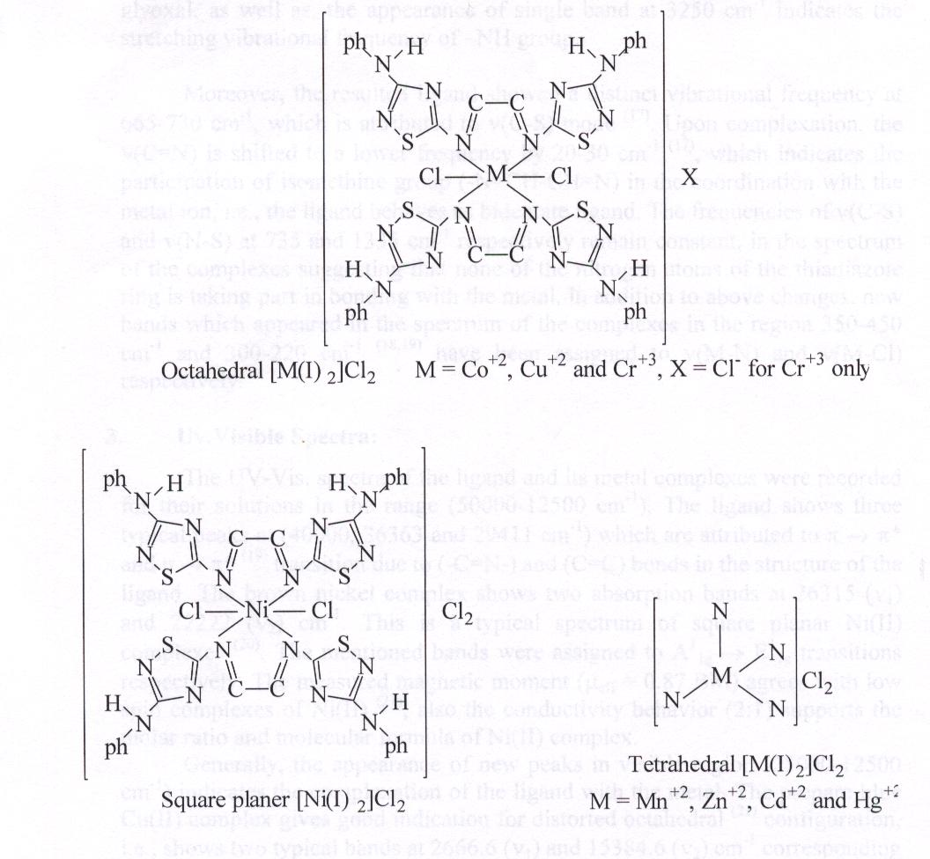

Results and Discussion:
1.Elemental analysis:
The physical and analytical data of the ligand and metal complexes are given in table (1, 2). Results obtained from elemental analysis are in satisfactory agreement with the calculated values, the suggested molecular formula were also supported by spectral and molar ratio, as well as magnetic moments.

2.Infrared spectra:
The characteristic stretching vibrational modes concerning the ligand and its metal complexes are described in table (4). The IR spectrum of the free ligand exhibited two high intensity bands at 1600, 1630 cm⁻¹ due to ν(C=N) ⁽¹⁶⁾ of the thiazole ring and terminal isometric of Schiff base group formed as condensation reaction of –NH₂ at 5-position of thiadiazole ring with carbonyl of glyoxal, as well as, the appearance of single band at 3250 cm⁻¹ indicates the stretching vibrational frequency of –NH group.

Moreover, the resulted ligand showed a distinct vibrational frequency at 665-730 cm⁻¹, which is attributed to ν(C-S) mode ⁽¹⁷⁾. Upon complexation, the ν(C=N) is shifted to a lower frequency by 20-30 cm⁻¹ ⁽¹⁷⁾, which indicates the participation of isomethine group (-N=CH-CH=N) in the coordination with the metal ion, i.e., the ligand behaves as bidentate ligand. The frequencies of ν(C-S) and ν(N-S) at 735 and 1335 cm⁻¹ respectively remain constant, in the spectrum of the complexes suggesting that none of the nitrogen atoms of the thiadiazole ring is taking part in bonding with the metal, in addition to above changes, new bands which appeared in the spectrum of the complexes in the region 350-450 cm⁻¹ and 300-220 cm⁻¹ ^{(18,19)} have been assigned to ν(M-N) and ν(M-Cl) respectively.

3.Uv.Visible Spectra:
The UV-Vis. spectra of the ligand and its metal complexes were recorded for their solutions in the range (50000-12500 cm⁻¹). The ligand shows three typical peaks at (40000, 36363 and 29411 cm⁻¹) which are attributed to π → π* and n → π* ⁽¹⁹⁾ transition due to (-C=N-) and (C=C) bonds in the structure of the ligand. The brown nickel complex shows two absorption bands at 26315 (ν₁) and 22222 (ν₂) cm⁻¹. This is a typical spectrum of square planar Ni(II) complexes ⁽²⁰⁾. The mentioned bands were assigned to A¹_{1g} → E¹_{1g} transitions respectively. The measured magnetic moment (μ_{eff} = 0.87 BM) agrees with low spin complexes of Ni(II) ⁽²¹⁾, also the conductivity behavior (2:1) supports the molar ratio and molecular formula of Ni(II) complex.
Generally, the appearance of new peaks in visible region (25000-12500 cm⁻¹) indicates the complexation of the ligand with the metal. The prepare blue Cu(II) complex gives good indication for distorted octahedral ⁽²¹⁾ configuration, i.e., shows two typical bands at 2666.6 (ν₁) and 15384.6 (ν₂) cm⁻¹ corresponding to the transition ²E_{1g} → ²T_{2g}. Moreover, the magnetic moment (μ_{eff} = 1.19 BM) in agreement with octahedral geometry of paramagnetic properties. The Zn(II), Cd(II) and Hg(II) complexes of pale colors don’t give distinct spectrum in the visible region due to absence of d-d transitions (d¹⁰), which is in agreement with the expected diamagnetic properties of (d¹⁰) configuration ⁽²²⁾.

References
- H. Sumi and Y. Takahi, Japan, Kokai, 1974, 74, 29697 .
- S. Kamada, K. Nishio and K. Takita, Japan Kokai, 1974, 74, 04241.
- A. B. George and E. M. Carig, U.S. Patent, 4209522 (1980).
- E. K. Lamrence, U.S. Patent, 4263312 (1981).
- B. Muefit, N. Sigfried, P. Itrun and K. Friedhelm, J. Agric. Food Chem., 1979, 27, 815.
- A. G. Walter, U.S. Patent, 4207089 (1980).
- H. Rene and Landrene, Fr. Demande, 2381053 (1979).
- T. Teraji, K. Sakane and J. Goto, Eur. Pat. Appl. 13762 (1981).
- A. G. Schering, Chem. Abstr., 1981, 95, 43132y .
- S. Singh, L. D. S. Yador and H. Singh, Chem. Abstr., 1981, 94, 103250.
- C. Parkani, H. Liang Yuan, N. Sook and J. Hwa, J. Heterocyclic Chem., 1989, 26, 331.
- S. Patrick, B. Bryson and M. Jolanta, J. Med. Chem., 2000, 29, 104.
- V. F. Konev, T. Regis and F. Leung, J. Med. Chem., 2001, 113, 229.
- B. Desh and S. K. Mahapatra, J. Inorg. Nucl. Chem., 1975, 32, 271.
- M. N.,AL-Jibouri, Ph. D. Thesis, AL-Mustansiriyah University (2003).
- N. C. Mishra, J. Indian Chem. Soc., 1978, 55, 839 .
- J. Sandstrom and I. Wennerback, Acta Chim., 1993, Second 20, 701.
- H. B. Gray, Trans. Metal Chem., 1965, 1, 239.
- I. P. Khullar and U. Agarwala, Canad. J. Chem., 1975, 53, 1165.
- A. B. Lever, Inorg. Electronic Spectra, Elsevier Publishing Company, London (1968).
- B. N. Figgis, “Introduction to Ligand Fields”, Interscience, New York
- K:Dey and K:K:nandi ,Indian ,J:Chem, 1999, 35A,2101

